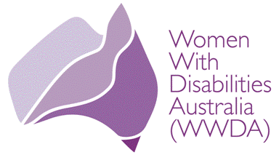

Women With Disabilities Australia (WWDA)

Report from the Sixth Session of the Conference of States Parties (COSP) to the Convention on the Rights of Persons with Disabilities

New York, 17-19 July 2013

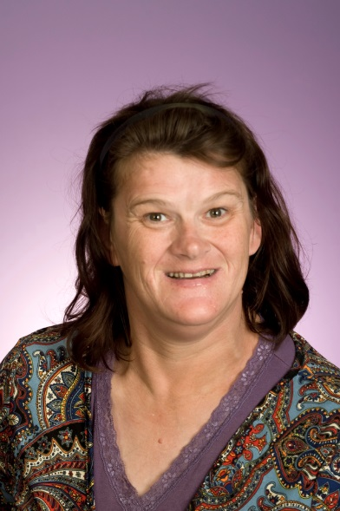

Report prepared by: Margie Charlesworth, WWDA Vice President and Delegate to the COSP Sixth Session

© Women With Disabilities Australia (WWDA)
PO Box 605, Rosny Park, Tasmania 7018 AUSTRALIA
Ph: +61 3 62448288 Fax: +61 3 62448255
Email: carolyn@wwda.org.au
Web: www.wwda.org.au
Contact: Carolyn Frohmader, Executive Director

Introduction
The Convention on the Rights of Persons with Disabilities (CRPD) was adopted by the General Assembly in its resolution 61/106 of 13 December 2006. Article 40 of the Convention stipulates that “The States Parties shall meet regularly in a Conference of States Parties in order to consider any matter with regard to the implementation of the present Convention.”

The Sixth session of the Conference of States Parties (COSP) to the CRPD was held in New York from 17-19 July 2013. The theme of the 6th Session was "Ensuring adequate standard of living: empowerment and participation of persons with disabilities within the framework of the CRPD". The sub-themes of the 6th Session COSP were:
- Economic empowerment through inclusive social protection and poverty reduction strategies;
- Disability-inclusive development in national, regional and international processes; and,
- Community-based rehabilitation and habilitation for inclusive society.

Women With Disabilities Australia (WWDA), the national peak organisation representing women and girls with disabilities, sought a grant from the Australian Human Rights Commission (AHRC) under its Disability International Participation Funding Program to contribute to the costs of a WWDA delegate (Ms Margie Charlesworth) to attend and participate in the sixth session of the COSP to the CRPD. WWDA’s application was successful, with WWDA receiving $5000 (GST inclusive) to contribute to the costs of Margie’s attendance at the COSP.

This Report has been compiled by Margie Charlesworth following her return to Australia from the 6th Session of the COSP, held in New York 17-19 July 2013. The Report describes Margie’s experiences as a woman with a disability representing WWDA for the first time at an international event.

WWDA takes this opportunity to thank the Australian Government and the Australian Human Rights Commission (AHRC) for supporting WWDA to be represented at the 6th Session of the COSP.

Disclaimer
This post-event report is prepared by and reflects the views of WWDA and
not that of the Australian Human Rights Commission or the Australian Government.

My Experience Attending the CRPD COSP - By Margie Charlesworth
I was asked to represent Women With Disabilities Australia (WWDA) at the Sixth session of the Conference of States Parties (COSP) to the CRPD, which was held in New York from 17-19 July 2013. It is my understanding that this was to be the first time that WWDA has been represented at the CRPD COSP, and it was indeed a privilege to be invited to be there.

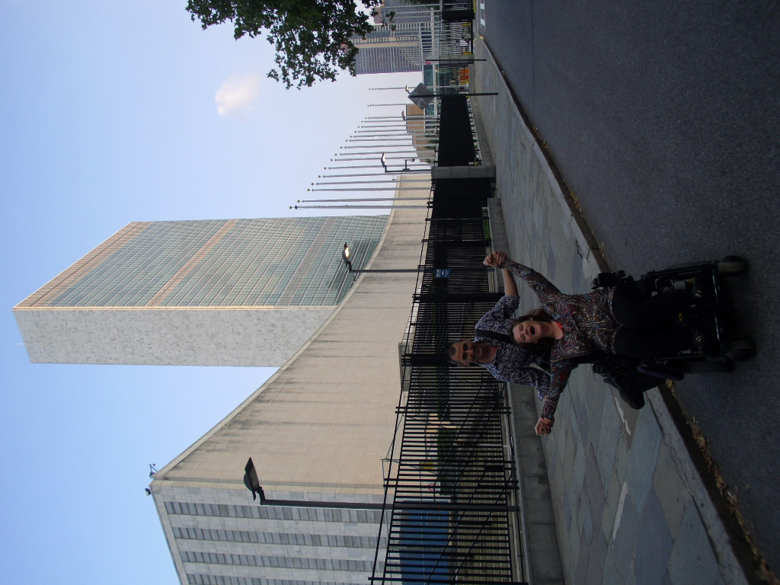

Margie outside the UN Building in New York

Before Leaving Australia
I have long wanted to represent WWDA on the international stage. But being a woman with a strong Cerebral Palsy accent, I wondered if it would ever happen. After all, WWDA has such a well-respected international reputation that we need to ensure that we are articulate and can adequately represent all that WWDA stands for. And rightly so.

But this was my chance, and while my role at the COSP was to be as an observer it didn’t escape me that I needed as much background information as I could grasp before leaving for New York. So I read – or should I say listened. Because there was so much preparation material to absorb I decided to download the materials onto my iPad and let my speech app do the reading. This enabled me to listen and learn while I went about organising everything to ensure I was totally ready to leave for New York.

I’d been overseas once and had vague memories of everything that I needed to do, in terms of paper work. One of these things included filling out a VISA waiver; if you are staying in the US less than 90 days everyone needs to complete this form. This is reasonably easy to complete – although one of the questions on the form had me scratching my head. It asked (all in the one question) whether I had a communicable disease, a mental or physical disorder, was a criminal, or a drug addict!

In the week I left, I decided not to take my mobile phone – I thought that if I needed to I could buy one when I got there. I did not do this, because it would need to be switched off for most of the time. And it was a relief to be without a phone for ten days!

When it came to money I used a cash passport; I found that easy to use when paying for things like the hotel, but I also needed to carry some cash on me for incidentals. The other benefit to this was loading money onto the card before leaving Australia meant that I didn’t need to account for the exchange rate being deducted while in the States because it had already been accounted for when I loaded the card in Australia.

The other thing I attempted to do in the days before leaving was to book transport from the airport to the hotel. As I would find out, this was not necessary. If you book a car the company expects payment when you make the booking. I was advised of one company which quoted me the amount of $275.00 (US). This amount was after I requested that they come 45 minutes after the plane landed, because they wanted a plane tracker fee and waiting fee! I managed to get the costs down, but for some reason they would not accept my card, so I cancelled the booking while at Sydney airport waiting to board my flight to LA.

The flight
I flew into Sydney the night prior to leaving Australia. It was relatively smooth going until the staff at Sydney airport told me that I could not stroll to the airport hotel! I was tired, and anxious about the week ahead, but when they began patting my arm and saying in a patronising tone “we can’t let you walk to the hotel”, as condescending as they could be, I turned around and whizzed away before I totally lost my cool…….the problem was though, that I still had to get to the hotel and it was nearly 9pm. So I went back, and humbly apologised for being rude and succumbed to their offer of paying my taxi, for then and in the morning as well.

My lesson learned here is that I should have done more research, so that I knew exactly where the airport hotel was, and not have to ask where it was. Oh, yes, the taxi driver agreed with me, the hotel was in fact within walking distance! Sometimes it’s difficult to reconcile with myself that well-meaning people will always want to prevent me from doing things that come naturally to me – such as strolling less than 500 metres to a hotel!

The next morning I left the hotel and caught the pre-booked taxi to the International airport (paid for by QANTAS). It was then I realised that it might have been good to stay at the international airport hotel rather than the one at the domestic airport. Something to keep in mind if anyone is flying from another state.

One thing I noticed throughout the exercise of checking in, going through various customs and checks, is that there is not as much waiting in line times, especially when there is an airport staffer assisting you. So I got checked in relatively quickly, and it just happened that I was at the same check-in as the other Australian delegate to the COSP (Samantha French from PWDA), so I asked to sit with her so that we could begin to get to know each other.

On the flight over we sat just behind business class, so there was the petition, which also meant leg room, and that we weren’t squished in by someone sitting in front of us. We also sat in a row of four seats with no-one else but us in the row. I would advise anyone travelling internationally, to speak to a travel agency about the possibility of pre-booking seats behind a partition, as there are a few on international flights. While there is the benefit of a more comfortable flight, there were more practical benefits like being able to go to the toilet independently and not having to stress about trapping other people in as happened on the way home.

Arriving in New York
Thirteen hours later we landed in LA. Despite completing the journey on the same plane, we needed to get off the plane, collect our luggage and proceed through customs. Having landed in LA on a previous trip overseas, I knew to expect a thorough “pat down”. Might I add, it is one thing to expect it, but it’s another to experience it. A little too intimate for my liking, but it is something we have no choice over. Maybe it’s less threating to go through the body scanner.

Back to the taxi issue. I had cancelled my booking in Sydney, and because I had no idea of what to expect when we landed in New York, I sought advice from the check-in desk at the Sydney boarding gate. While it was not their concern about what happens after disembarking from the plane in New York, they did reassure me that transport from JFK Airport shouldn’t be an issue. So when we landed and retrieved or luggage, we wandered outside and after a short wait we were able to get an accessible taxi. The other thing we discovered along the way was that ALL cabs charge a flat Rate from JFK to Downtown Manhattan – where our hotel was. We paid $70 one way! Normally I would baulk at paying that much for a taxi – but in comparison to what I would have paid had that first company accepted my Master card, $70 seemed cheap.

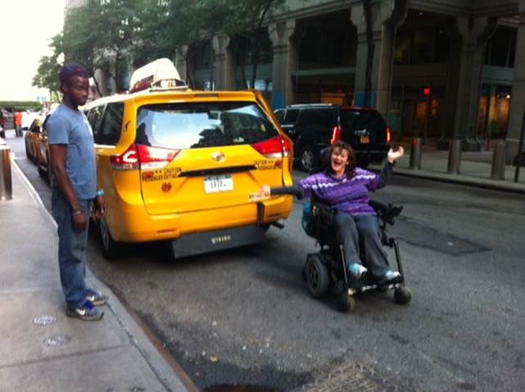

Monday was a free day so we went for a wander around the streets. I was still a little awe struck that I was in New York, I think I either kept saying “Wow!” and “Awesome!” and that was probably when my mouth wasn’t open in amazement! Sam and I also thought we would complete registrations for the COSP on the Monday to save time on the Tuesday. We had to go through security – in fact this would become a daily ritual!

Four Full Days of Meetings: July 16th – 19th

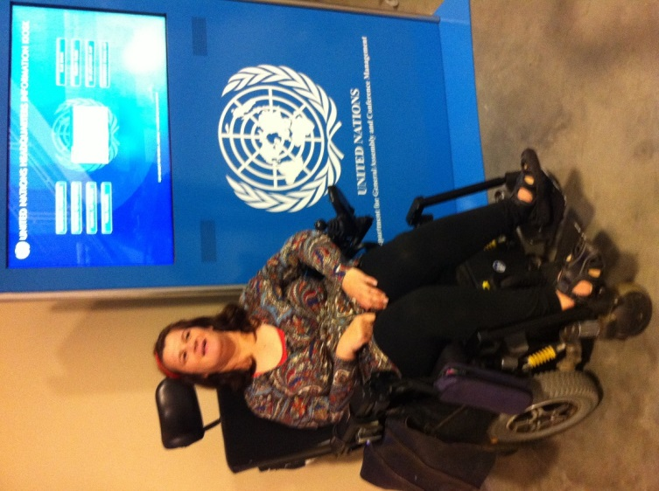
The first thing I learned about attending high level meetings was that it was not just one three day meeting - in fact there were three meetings spanning five days. This began on the 16th, with the Civil Society meeting. The meeting was opened by the Chair of the International Disability Alliance (IDA), who welcomed delegates on behalf of the Honourable Ambassador of the Republic of Kenya, who was to become President Elect of the COSP the next day. Present at this meeting as well were Human Rights Watch, the International Disability and Development Consortium, Rehabilitation International as well as many disabled people organisations.

One of the key discussions not just at the Civil Society meeting but throughout the COSP, was the issue that despite the world having 1 billion people with disabilities, the Millennium Development Goals (MDG’s) made no reference to the issue of disability. As such it was also proposed by speakers that with the “end date” for the current MDG’s fast approaching, there needed to be a strong stance on incorporating the CRPD and a disability inclusive agenda attributed to the MDG’s post 2015. There were two common messages when the subject of the MDG’s came up. The first was the mantra of “leaving no-one behind” and the second was about the need to “mainstream” disability.

Another common subject of these meetings was poverty. The Ambassador was the first to mention this when he signalled his regret that there might have been more representatives from Africa had they not been in situations of abject poverty.

In his remarks, the CEO of the Pacific Disability Forum remarked that the development agenda was a somewhat crowded one, with many minorities clambering to have their issues included; such groups including, youth, women, and indigenous. In highlighting this, the CEO suggested the in order to progress the development agenda and to lobby with a clear vision, it was necessary to be strategic, which also meant that some issues would inevitably be left off.

We then heard from the the Special Advisor of the Secretary-General on Post-2015 Development Planning, who expanded the “leave no one behind” statement to include “take every one forward”. In her speech the Secretary General spoke about employment and education for people with disabilities. Here she suggested that there needs to be deeper thinking applied to both subjects which needed more inclusive and realistic outcomes for people.

Others commented on the issues of data and how it needed to be disaggregated, so that it can be used to inform governments about pockets of the population. This point is in particular relation to people who are included as being amongst the more vulnerable populations.

After the opening speeches we then heard reports from the members of the Civil Society Forum. There was very little reference specifically given to women with disabilities. In fact, apart from hearing our name Women With Disabilities Australia mentioned in relation to other Disability Peaks in Australia, the only other reference was in relation to a planned study in India of women with disabilities - but the study would be focused mostly on women who had disabled children.

Despite the lack of mention of women with disabilities, it was still interesting to hear about what Nations were doing to promote and uphold the rights of people with disabilities. I won’t go into detail here, but if interested please see: http://www.un.org/disabilities/default.asp?id=1606

The day ended at 6pm, the end of a very long first day. I was worried about when the jet lag would set in. Before I left for New York I expressed my wish that the jet-lag not hit until I got home again. I’m not sure whether it was a wish come true due to the excitement of being at the United Nations. But I woke early each morning, eager to have my day unfold. I enjoyed hearing what each country was doing in relation to upholding the Convention on the Rights of Persons with Disabilities. It was such a privilege.

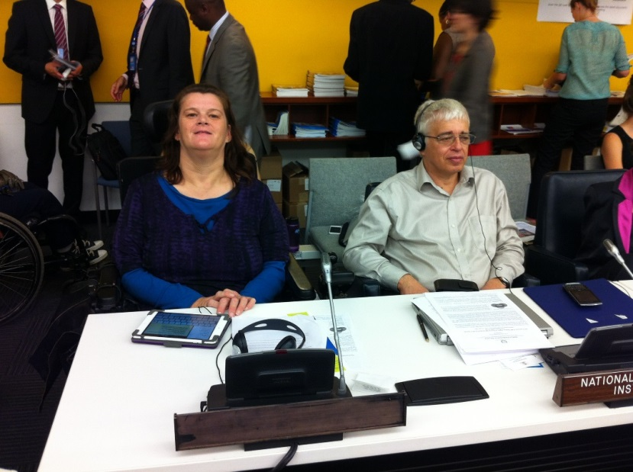
Margie and the Canadian Human Rights Commissioner
July 17th – So the day before went well, and there had been plenty of tables to choose from, so we strolled over to the UN, went through security… and entered the meeting room. WHOA! The first challenge was where to sit! There was no space, and when we did find somewhere, we would be hurried away because the seat was already taken by a delegate from a country. I ended up sitting next to the Human Rights Commissioner from Canada.

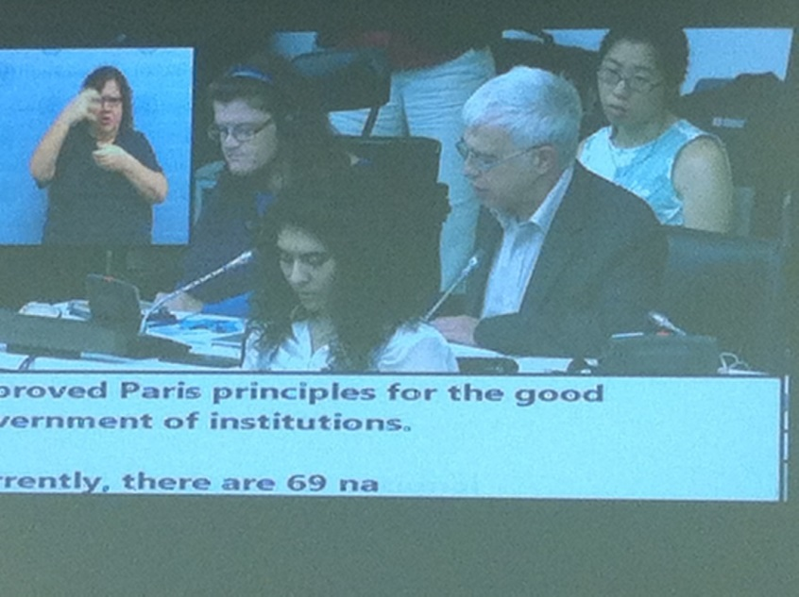
The sixth session of the Conference of States Parties was opened by Ms. Daniela Bas, representing the UN Secretary General, who proceeded with the election of the President and other officers of the Conference. Kenya was elected as President, and Bulgaria, Bangladesh, El Salvador and Israel as Vice-Presidents, by acclamation.

We heard how there are 1 billion people living with disabilities, and that there are more than 132 states parties to the Convention, and it is the goal of these parties to implement the convention for the full benefits for citizens with disabilities. It was also recognised that although there had been progress made in the six years of the implementation of the Convention, such progress has not been realised by everyone living with disability and that there is a long way to go before this would be achieved. However it was recognised that a good start to meeting this objective is to build broad based partnership between government, civil societies, and organisations along with the “full participation of people with disabilities”.

It was also emphasised that the states parties were in a transitional phase in the development of a global agenda. This was in part initiated by the Rio +20 Conference held last year, where a linkage was drawn between sustainability and development; and also with the looming issue of the Millennium Development Goals needing to be renegotiated beyond 2015.

A common message throughout the four days was that the inclusion the Convention of the Rights of People with Disabilities was missing from the Millennium Development Goals (MDG). It was briefly mentioned that the CRPD Conference of State Parties usually meets in September; however this was brought forward because the September meeting will be extraordinary in that for the first time, the world’s leaders will hold a General Assembly High-level Meeting on Disability and Development. It was recognised that such a high level meeting should promote the inclusivity of a disability agenda to post-2015 discussions in relation to the Millennium development Goals. The theme for the September meeting will be “The Way Forward: A Disability Inclusive Agenda Towards 2015 and Beyond”.

In brief, the Millennium Development Goals are a set of international development goals which were established in the year 2000; and endorsed by 189 United Nation member states. These consisted of eight goals that were to be achieved by the year 2015. The goals were designed to do things such as end poverty and hunger, achieve universal primary education, promote gender equality and empower women, reduce child mortality, improve mental health, combat diseases such as HIV/AIDS, malaria and other diseases, ensure environmental sustainability and develop a global partnership for development. However, because these goals were not disability inclusive, the September meeting would need to have an agenda that was inclusive of disability and keep in mind the notion of “leaving no one behind” when developing new goals.

It was stated that:

Sustainable development is not, and will not be possible, without inclusion of the disability perspective, and the participation of persons with disabilities in all its processes.

In recognising the achievements since the Convention was ratified and in echoing sentiments from the newly elected President, and when commenting about empowering people with disabilities to take full and rightful citizenship Ms. Daniela Bas from the Department of Economics and Social Affairs, commented:

Enabling people with disabilities to reach their full potential will advance progress for all.

Framing her comments in the context of the theme of this year’s conference which was “to promote the empowerment and full participation of people with disabilities on an equal basis with others”, Ms Bas also recognised that to date the Convention had 155 signatories, and had been ratified by 132 countries; she then added that 77 had ratified the Optional Protocol. She then urged all countries to ratify the Convention so that all of the 1 billion people with disabilities throughout the world might enjoy what should be their natural rights of citizenship.

Ms Bas proceeded to make three points. The first was that economic empowerment, through social protection and poverty reduction strategies can not only reduce poverty, but also enhance income, thus increasing the autonomy of people with disabilities. Her second point was that “disability-inclusive development” was a process that required regional, national and international action. Her third point was in regard to community based rehabilitation facilities and community based development which is for people with disabilities. Here Ms Bas emphasised that community based rehabilitation facilities have the responsibility to remove the barriers that prevent people with disabilities to accessibility. She concluded this point by stating that there needs to also be a focus put on empowering people with disabilities who have previously been excluded from these facilities.

In speaking about the high-level meeting in September, Ms Bas stated that the intention of the meeting would be to bring the attention of the issue of disability development to the fore. She concluded that the “share mission” was to integrate the Convention of the Rights of People with Disabilities and the Millennium Development Goals to the post 2015 agenda.

We then heard from the Assistant Secretary-General Office of the High Commissioner for Human Rights, Mr. Ivan Simonovic. The Commissioner reminded the audience that when the Convention was adopted, States were committing themselves to respect, protect, and assist all people with disabilities to realise their human rights and fundamental freedom on an equal basis with others.

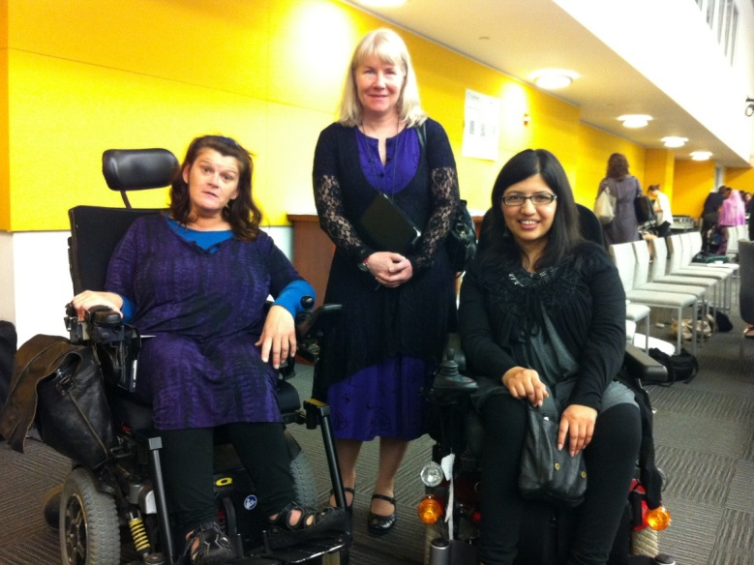
Margie with Samantha French PWDA, and delegate from Pakistani CSO
In his remarks about the upcoming high-level meeting in September, the Commissioner inferred that there would need to be a paradigm shift in the way the Millennium Development Goals are constructed post 2015. He remarked that rather than thinking of people with disabilities as objects of charity (and as objects of charity needing medical care), that they be perceived and respected as full members of society who are deserving of full rights of citizenship. It will also be emphasised that the change of thinking will also need to extend to people with disabilities themselves which would be achieved by empowering people with disabilities to take up their individual rights of citizenship.

The Commissioner also focused his remarks on the empowerment of people with disabilities through encouraging engagement in employment. He pointed to Article 27 which suggests that an adequate standard of living is linked with the right to work. He went on to suggest that:

The only way to secure a sustained adequate standard of living is ensuring that persons with disabilities can live independently in their societies providing for themselves and their families by having access to the labor market on an equal basis with others.

Commissioner Simonovic then went on to say that the CRPD “draws a unique link between development and human rights”, because state parties who have signed onto the Convention are committed to developing programs which are inclusive and accessible to people with disabilities. In further arguing for a disability inclusive agenda, the Commissioner highlighted the fact that when people with disabilities are denied access to programs such as sanitation, not only do they sit closer to the margins in society, their needs continue to be ignored because they remain excluded and stigmatized by the community they reside in.

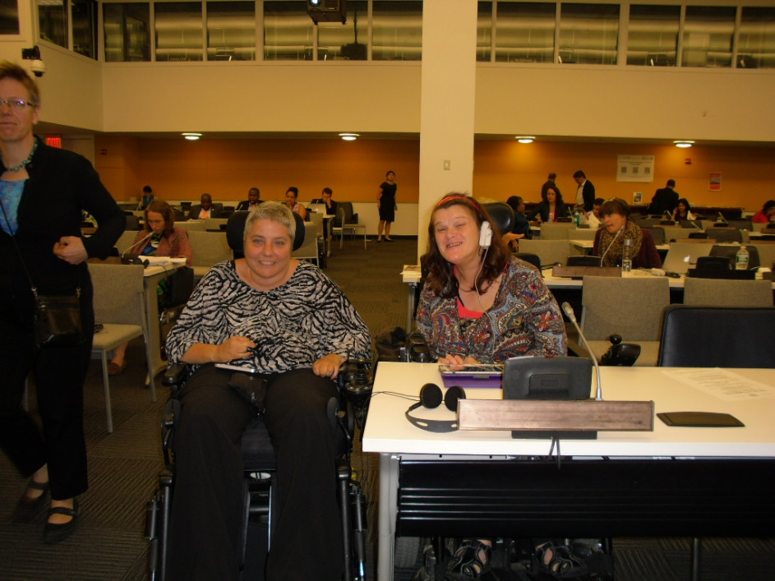
Margie with Isabelle from Quebec

Speaking on behalf of civil society organizations, Mr. Yannis Vardakastanis, echoed the previous speaker by stating that considering that 15% of the world’s population live with disability, it should not be tolerable for the conversations in relation to the Millennium Development Goals to continue to be exclusive of a disability agenda post 2015. Mr Vardakastanis focused his remarks on the worlds Disabled Peoples Organisations (DPO’s) involving them in the conversations to be held about the Millennium Goals post-2015 becoming inclusive of the CRPD.

Delegate Observations - Member States Reporting
When the reporting began I tried to write the main points that were raised by each member state, however I soon learned that this might not be achievable, so then I proceeded to note what I thought to be the most interesting achievement by each member. This too was difficult to do especially when there were also Side Events which coincided with reporting.

There were a few new Member States to the Convention, who only signed up this year; these included Barbados and Norway. And as mentioned, most if not all member states made mention of the need for a disability inclusive agenda for the Millennium Development Goals post 2015.

Many made reference to the fact that their country has paid great attention to the economic security and empowerment of persons with disabilities. While some countries have included tax concessions for workers with disabilities others spoke about the need for social protection programs for more vulnerable people with disabilities who are at greater risk of poverty. In this regard Ghana spoke about setting aside funding specifically for the capacity building or people with disabilities.

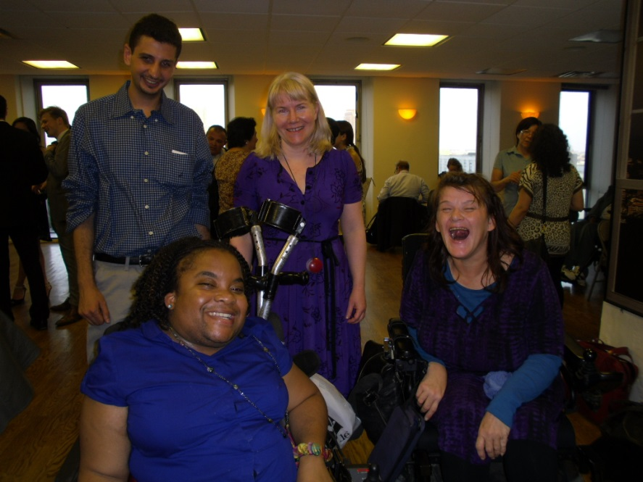

Margie, Sam and CSO colleagues

Many also mentioned the need for inclusive education, healthcare and access to services; or mainstreaming services. For some (such as Honduras), the focus was on young people with disabilities to reach their full potential because they are the future in the disability sector. Honduras also invests in programs to deal with employment, and sporting activities as well as placing emphasis on supporting both mental and physical well-being. Other Member states mentioned the use of funding and credit, which I understood to mean another form of social support for people with disabilities. This was a common theme throughout the reporting, and as another example of social support, Nicaragua mentioned that they lend social support to whole families where there is a child with a disability.

Member States such as Ghana and South Africa, both made mention that as well as focusing on societal barriers, it is also necessary to address issues in the home. The representative of Ghana reminded us that often prejudices against people with disabilities begin in the home. This is because in many cultures around the world, to have a family member with a disability brings shame and condemnation upon the entire family. In order to address this issue, Ghana has introduced education and support for families to think about their family member differently – especially when there is a heightened sense of vulnerability.

South Africa spoke of promoting the rights of people with disabilities. The speaker acknowledged that South Africa owes a debt of thanks to the disability activists and also the government as, if it was not for their combined actions, “the fate of persons with disabilities in South Africa could have been very different”. The representative also spoke about the need for programs such as those of rehabilitation to be a process which invests in the empowerment and input by people with disabilities. They go on to say that without this investment it is just a “technical exercise”.

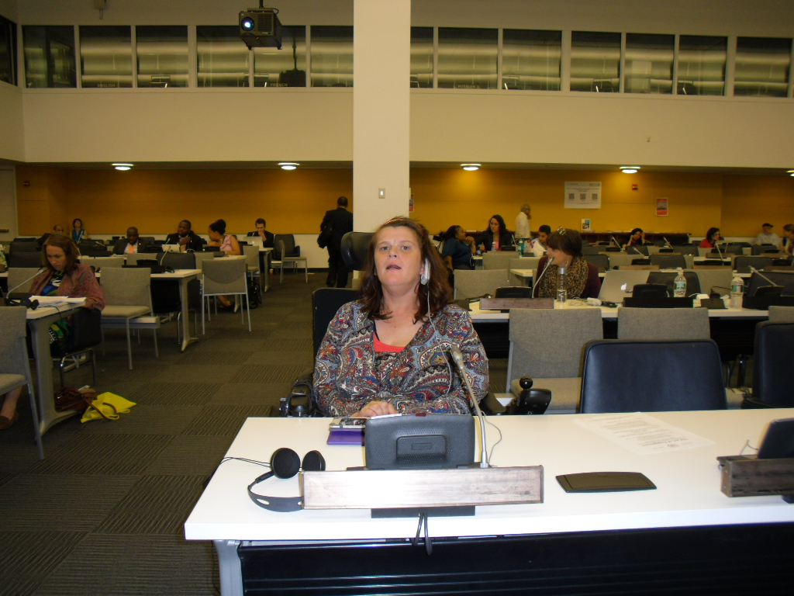

Countries such as Ghana, Nicaragua, Honduras, have either introduction laws or acts which promote the rights and inclusion of and full citizenship of all people with disabilities. The European Union has a ten year strategy to develop an accessible European union for all. And Panama was the first country in the world to incorporate the Convention into its own laws – referred to as Law 27, and introduced on June 10, 2007. Kenya was another member state to mention that there are laws in Kenya which prohibit discrimination again all persons with disabilities. I was particularly interested to hear from delegates for Iran and El Salvador who were reminding us that there were many countries in the world where a high percentage of the disabled population was a direct result of either weapon chemical warfare.

One of the things I found difficult was the lunch breaks. Morning sessions went from 10am-1pm and afternoon sessions (on paper) went from 3pm – 6pm. However, when we added in things like round tables and side events (which started at 1.15pm), we went from a two hour lunch break, to a 15 minute break to line up and buy lunch, eat lunch and go to the toilet. All three can be done, but not when there are at least 100 plus people with the same objective! Another factor here was that the main UN building was undergoing renovations so there was a make-shift canteen that actually ran out of sandwiches and rolls on the first day of the COSP. This didn’t happen on the Tuesday because it was a smaller meeting, on the Thursday I decided to buy something before I went to the UN. And on the Friday I went and brought lunch on my way to a side event!

It took me a day to figure out that there were no visible or audible reminders about the Side Events, in fact what threw me was that there were still main events such as round table discussions going on in the main meeting room. This meant that I missed out on the first couple of side events. And while I still got so much from the round tables, I missed the one side event that I was particularly interested in – this side event was first up on the Thursday and called “Mental Disabilities: A Mental Health Perspective”. It was when I asked someone whether that side event was cancelled that I was informed that side events just roll on regardless of what’s going on in the main arena. Lesson learned!

The Round Tables were also held in the main meeting arena. The first round table was a discussion on the empowerment of people with disabilities. Member States such as Argentina detailed how they were transforming lives of people with disabilities with disability inclusive policies. While other countries like Brazil reported that they believe that empowerment of people with disabilities start with things like inclusive mainstream services such as education, health and transport. Other states mentioned how they found that the promotion of leadership amongst people with disabilities was just as effective in empowering individuals with disabilities.

While we know all this in Australia, I think it is important to be mindful that here we were hearing from countries who have disjointed histories when talking about how they include people with disabilities. We were hearing from countries where disability is seen as a curse and a black mark on families. But because they are signatories to the CRPD they have a strong commitment to educating the nations about the rights of people with disabilities who also have natural and equal rights to citizenship.

Side Events
Despite taking a while to figure out that there were events going on simultaneously, I managed to get to a number of interesting side events. Side events were just smaller information sessions that were on a specific subject and speakers would reflect on how their countries were progressing in that particular field.

The first event I attended was a film screening. This was a series of short films produced by a man from Melbourne. It surprised me that these films were produced all over the world. Two of the films were most memorable for me. The first was of a deaf mugger, who booked an AUSLAN interpreter to assist him to communicate while he was mugging people. It was particularly funny when the interpreter refused to interpret what the mugger was saying because committing crime is not in her job description!

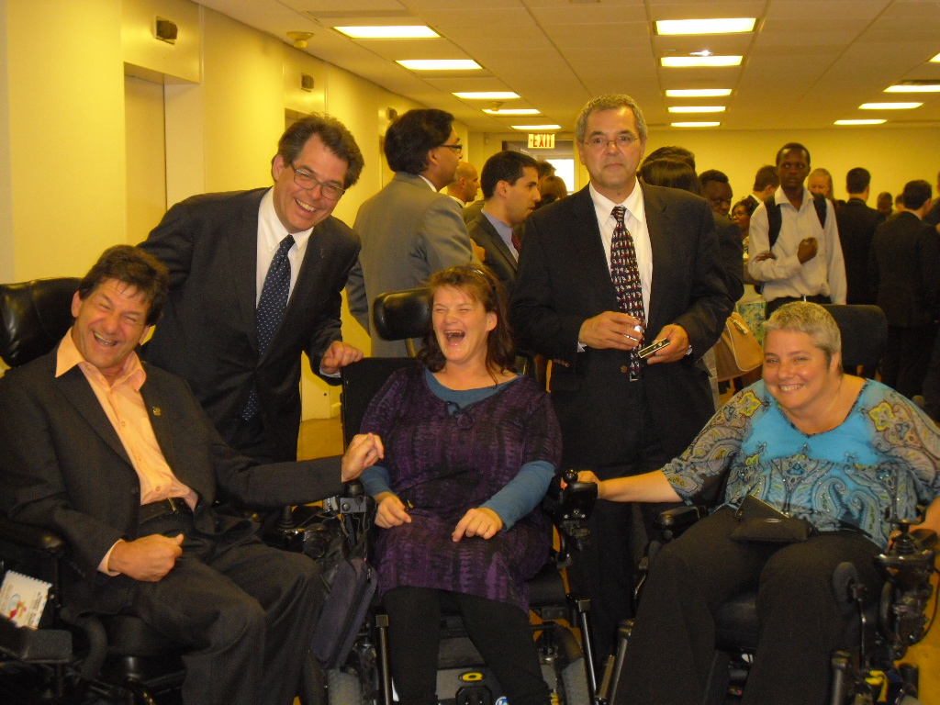
Margie hanging out with the Canadian CSO delegates

There were about 5 or six short films, some I just didn’t get, others were just obscure. But the second film I liked was of a documentary of an African American man who was vision impaired. Because it was filmed it New York the man and his family were invited to this event. The film followed him as he was going about day-to-day life and told of him trying to work with and develop his trust in his new guide dog. He made two statements that resinated with me. The first was that we all have two choices in life – we can have the choice, we can either stay in our own small world of disability and limitations, and miss out on life; or we can get out there and be part of change. But the second thing he said is something that I have heard in my own life, and this is that those closest to him don’t think of him as being blind or having any sort of disabilities.

One thing that I haven’t mentioned is that the week in New York was reported as being the hottest week of the year. To me Friday was the hottest day, so I decided to spend the afternoon at the beginning of the DESA meeting (earlier that week we were all extended the invitation to stay for the meeting). I do wish I had gotten a date extension on my daily pass because I found this an extremely interesting meeting.

The discussion point of this meeting centred on Disaster Risk Management. In years gone by I might have suggested that the subject was more important in countries that experiences severe weather events; but our recent history tells us that we do not escape these events.

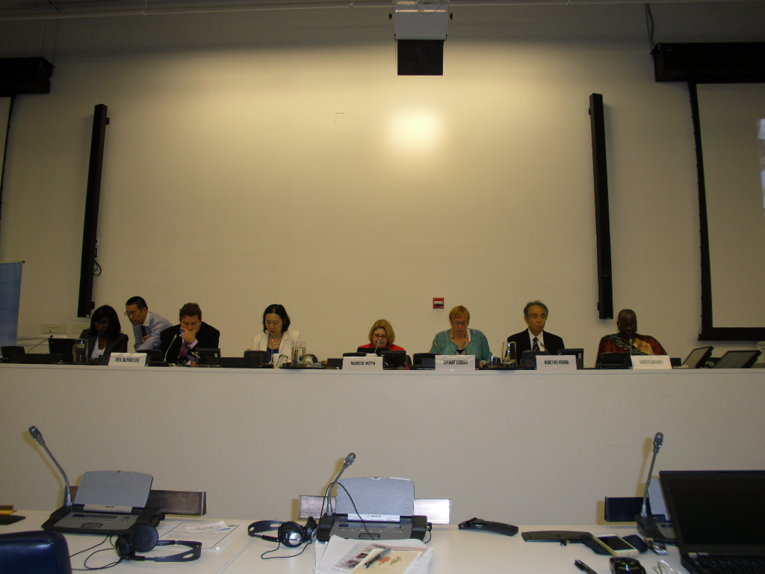

The point of this meeting was to hear what countries are doing to include populations of people with disabilities in their Disaster Risk Management Plans. One of the key message throughout the afternoon was that it was of utmost importance to blend the CRPD into such plans and in doing so, would make the disaster risk management plans accessible to all. Another point that sticks clearly in my mind is that accessibility is often expensive, because it is an after thought. In other words if accessibility is included at the beginning point of anything, whether it be a building, a service or an evacuation plan then it would not require modification later on because it would have been all inclusive from conception.

Accommodation and Access in New York
I stayed at the One UN Hotel, this was the hotel recommended to us by the PWD Representative. To be honest, this hotel would not have been my first choice. All the staff from the bell boys (who were gentlemen) to bar staff, reception and restaurant staff were extremely helpful and nothing was too much trouble. But like so many hotels I’ve stayed in, the only accessible feature about my room was the hand rails in the bathroom, and my door, which was easy for me to use.

Although the room was easy enough for me to live in for the week, had I been someone who was unable to walk, it wouldn’t have been a room I could use independent of assistance. The hotel has two towers and is currently being renovated. My tower (or at least from my observation) had been renovated. The lights in the room were controlled by one main panel (although reading lights can also be controlled at the head of the bed); however the main panel is on the outside of the bathroom wall. And because I literally had to physically climb up onto the bed I needed to limit the times I got in and out of bed. I soon realised that the panel to control all the lights really needed to be at the bed, especially in an accessible room. On the Tuesday night I had gotten an early night, maybe I should say I tried to get an early night. At around 11.30 that night, my bathroom lights came on and started to make sparking noises. I was not in the mood for a disco! So I needed to ring for assistance, again nothing fazed the staff and I think an hour later I had climbed up into bed and was snoring happily again.

One of the first things I noticed when wandering the streets surrounding the UN was that there were police standing on every second corner – so I felt safer in that respect. And it wasn’t long before I remember how they put the garbage out for collection. Rather than using bins or min-skips as we do, garbage is just piled up on the “side-walk”. The other thing I noticed was that access was not great in New York. We couldn’t get into some pubs (Irish pubs were a favourite for the PWD rep I was with)!

From the six full days I had in New York I had part of two days to take in the sights and sounds. So we managed to find Grand Centre Station as well as Grand Central Park. I would have liked to have seen more but somehow time got the better of us. On the Saturday I did get to do some exploring on my own. It was here I made an interesting observation.

I kind of knew my way back to the hotel, but because there was the odd footpath that was inaccessible, I needed to either back track to find another way to continue in that direction. However this also threw me off track, because I couldn’t be sure of particular landmarks and when I last saw them. I also had a map which helped a little, especially when the corresponding street name were present but it became harder when some names were not on the map.

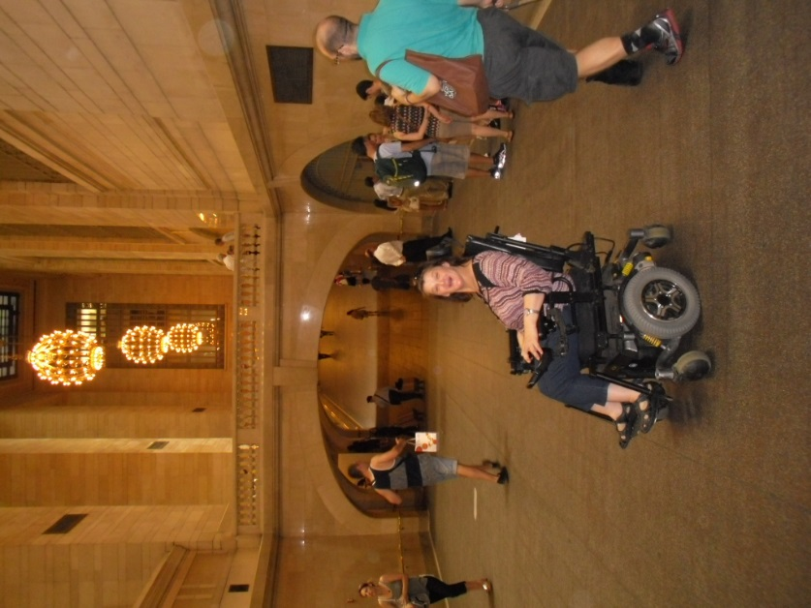

The time that I did have to explore New York, I saw many people with disabilities begging for money. This was a reminder to me about what we have in Australia, and while what we have may not be perfect, I appreciate how we don’t have to struggle for health care or income support because of our healthcare and income support system. However, because I was I was a little lost, I was trying to ask for help, but not everyone was willing to stop and find out what I was asking. And while I was able to find people who would stop and give me directions. I couldn’t help but wonder if some people who didn’t stop to hear what I was asking, assumed I was begging. Just an interesting observation.

Coming Home
By the end of the week I was ready to come home. The taxi I had booked the night before took its time to show up, and when it did, the driver didn’t want to take my suitcase because he didn’t want the wheels to damage the seats. I think this is the first time in a long time that I had been fearful when catching a taxi. And this fear was because he appeared resentful of wanting me as passenger. To ensure he wouldn’t rip me off, I asked him to quote the price of the trip in front of witnesses; he then told the man at the hotel to tell me because he didn’t want to talk to me. Great, this only made me more nervous.!

However, as the trip began he started to realise he needed to talk to me, for a start he needed to know which carrier I was flying with. Then to me surprise he began to ask if I was ok. But then he also wanted me to get my money out and have it ready…….was he going to push me out the moving cab – I wondered??…But he didn’t, and all was well.

We flew from New York to LA, and I’ve already mentioned the need to ask for a seat behind a petition, to enable me to move as independently as I need to throughout the flight. I decided to go to the toilet during the stopped over In LA. There were two issues with this, the first being that I had a male attendant assisting me to the lounge gate. He became nervous when I asked him to wheel me to the women’s toilets! I was quick to reassure him that all he needed to do was drop me to the front of the facilities, and I could walk from there and that I didn’t need any other assistance. The other issue occurred when I was coming out of the toilet, a woman wandered into the toilets, saw me and started yelling out “WHEELCHAIR PATIENT!” It was late, I was exhausted…I just shuddered and mumbled something about not being a wheelchair patient.

Summary & Acknowledgments
In summing up my New York experience I would say it was a six day experience that I have learned so much from. My experience began when writing the application form to the AHC, as I had never applied to partake in such high-level work before. I drew on the experience of the WWDA CEO to assist me with writing the application. Once we learned my application had been successful, I needed to start reading to familiarise myself bout the CRPD and the recent meetings that had been held. Throughout this report I have reflected on the many things that I learned. From flying internationally, learning about local transport, to how to network with people from other countries.

In closing, I wish to express what a privilege it was to be able to sit in the United Nations, representing Women With Disabilities Australia (WWDA), and indeed people with disabilities in Australia, surrounded by people from all over the world. This was such a humbling experience for me. I would like to extend my thanks to WWDA CEO Carolyn Frohmader, for her support in preparing me for the CRPD COSP, to Samantha French (PWDA) for her friendship and support during the event, and to the Australian Government and the Australian Human Rights Commission (AHRC) for the funding grant of $5000 (GST inclusive) to contribute to the costs of my attendance at this amazing event.

Transcript from the Sixth Session of the Conference of States Parties To the Convention on the Rights of Persons with Disabilities – July 17, 10-1 Session. http://www.un.org/disabilities/default.asp?id=1606
Ibid.
Ibid.
Ibid: Mr. Ivan Simonovic Assistant Secretary-General Office of the High Commissioner for Human Rights
http://en.wikipedia.org/wiki/Millennium_Development_Goals
Ibid
President Macharia Kamau. Macharia Kamau is also co-chair of the Open Working Group on Sustainable Development
Ms. Daniela Bas, is from the Department of Economics and Social Affairs, and presented a statement by the Secretary-General and by DESA.
Ibid.
Ibid.
ENABLE DAILY BULLETIN FROM THE CONFERENCE Sixth session of the Conference of States Parties to the Convention on the Rights of Persons with Disabilities (COSP6)
Ibid, Honduras delegate, p, 28
Ibid. South African delegate p,40
Ibid p, 41
Ibid, European Union Delegate, p, 45
Ibid; Panama Delegate, p, 59
Ibid p, 44

