“Work Will Set You Free……..Just Don't Expect Anyone To Employ You”

Women with disabilities in Western Australia and their experiences with DES providers

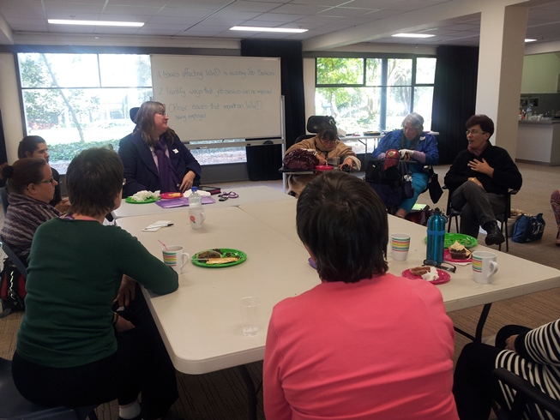

Women With Disabilities Western Australia (WWDWA)

for the

Women With Disabilities Australia (WWDA)
Disability Employment Services (DES) Consumer Engagement Project

Prepared by Rayna Lamb, on behalf of WWDA, June, 2014
Introduction

WWDWA Inc is a non-profit organisation for women with disabilities in Perth, Western Australia. The organisation is run and managed entirely by women with disabilities. WWDWA has no paid staff, receives no funding, and is run by volunteers. WWDWA works to promote the participation of women with disabilities in Western Australia in all aspects of social, economic, political and cultural life. WWDWA Inc actively participates in providing support, information and education to women with disabilities, by regularly engaging the participation of women with disabilities in forums to address their identified needs. WWDWA Inc undertakes, where possible, relevant systemic advocacy and research as well as providing support and advice to individuals, agencies and governments which relate to the objectives of WWDWA Inc.

In early June 2014, Women With Disabilities Western Australia (WWDWA) conducted a Forum with 20 women with disabilities, to learn about their experiences with Disability Employment Services (DES) and to identify issues for women with disabilities in WA regarding their access to, and experiences of, employment. The Forum was conducted on behalf of Women With Disabilities Australia (WWDA) as a component of the second phase of WWDA’s Disability Employment Services (DES) Consumer Engagement Project. WWDA was provided funding for the Project by the Australian Government to assist in improving the delivery of Disability Employment Services (DES).

The main objectives of the WWDWA Disability Employment Services (DES) Forum were to:
- Identify issues affecting women with disabilities in relation to their access to, and use of, Disability Employment Services (DES);
- Identify ways that future Disability Employment Services can be improved to better meet the needs of women with disabilities;
- Provide information to women with disabilities about the DES Program; and,
- Identify any other issues that impact on women with disabilities seeking, finding and maintaining employment.

This brief report provides narratives and stories from women with disabilities participating in the WWDWA Forum. In order to do justice to the experiences of the women, this report uses the women’s own words and narratives.

Feedback from the WA DES Forum for Women with Disabilities

1. What experiences have you had with DES, good or bad?

‘One DES agency didn't want to have anything to do with me because I "didn't look disabled enough". They advised me not to even bother seeking work because I'd have a hard time getting back onto the pension if I was no longer able to work.’

‘The agency failed to tell me I could and should suspend my job seeking obligations with them when I was life-threateningly ill, thus making my life much harder than it needed to be. They didn’t tell me about appropriate home and community care resources, or attempt to link me up with appropriate support when I couldn't meet my basic needs for daily living. When I was in extreme physical pain, the DES worker told me “God never gives us more than we can handle”. He accused me of faking the pain in my neck, shoulders, hands, wrists, lower back, hips, and knees – he said that I was “too young to have arthritis and too young to be using mobility aids.” Another DES worker told me that I needed to “make more eye contact” because “you're never going to get a job otherwise.” He would also repeatedly touch me, despite being asked not to. He said: "You have to get comfortable with this so you can get a job". When I told the agency that I had Post Traumatic Stress Disorder (PTSD) from severe violence in my childhood, they told me "that's just what parenting was like back then" and that I would just need to “get over it” if I wanted a job.’
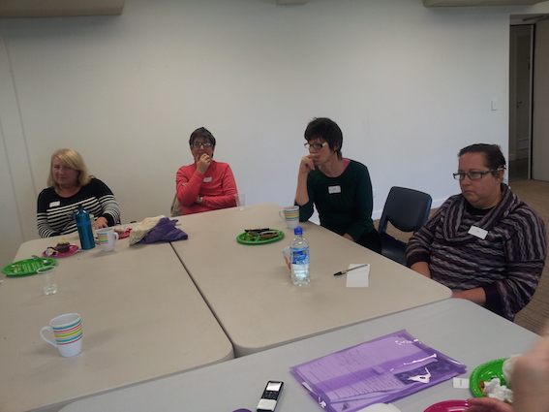

‘I was with Edge Employment Solutions from 2009 until January this year. Edge helped me in prepping for the job interview, which I was very nervous about. When I got the job, Edge then helped me to adjust to working over my probational period. I was not a high needs client as many of the other clients were and so I rarely called on them for advice. When I did call on them they funded modifications to my workstation so that I could be more comfortable at work and they also gave me advice when going through tough times. Some time last year the government cut their funding dramatically and the low needs client program, which I was a part of, was concluded for good. So that was basically the end of my relationship with Edge. Since then I have felt like I am on my own if an issue arises. I have joined my Union to help curb my anxiety about this but I still feel vulnerable from time to time. Don't get me wrong, I like my job very much, it has great pay and conditions, but I still feel like without Edge's service available to me, I am, for lack of a better word "trapped" in this job as I feel I can’t gain better employment on my own unaided. If a miracle occurred and I did change jobs/employers on my own how could they accommodate me fully without funding from organisations like Edge?’

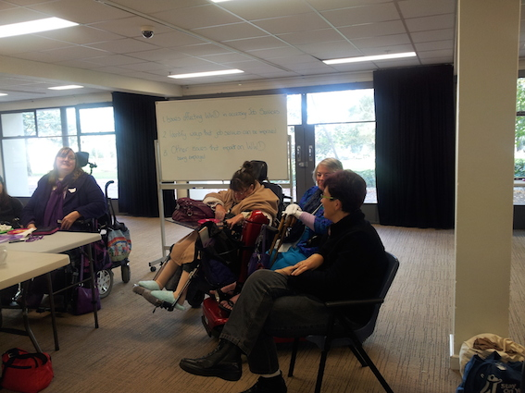

‘A DES agency kept sending me to job interviews where the person doing the interviews asked me why I was bothering as they couldn't accommodate my disabilities. I think that disability employment agencies were given funding (from the Federal Government) for how many people they sent along to job interviews.’

‘I got a part time job through a Disability Employment Service. The job I got was as a hostess at a restaurant. The job description was hostessing, some waitressing, and working the till etc. After a week, the boss started adding unpaid hours and other jobs to these duties. I managed to avoid the heavy cleaning and the cleaning of toilets. He thought he could save paying for a cleaner by getting me to do these jobs as unpaid labour by adding them to my duty list. I overheard him speaking to the Chef – he said: "the retard can do more for no money because she won't know any better". When I walked into the office, the chef went red in the face and the boss told me to "do as I'm told or I'd get the sack and I should be grateful that someone was willing to employ someone like me." I didn't say anything, I just walked out, went home and phoned the employment agency and told them what happened. The agency told me that this place couldn't keep staff and probably only took on disabled people to get the money from the Federal Government.’

‘Well, to be honest, I don’t think that DES workers know very much about disability. I don’t think they have enough training about how to work with people with disabilities. They seem to think that everyone with a disability is the same and has the same needs and issues.’

‘I know of people with disabilities who have been found a job (by a disability employment service) in small business. The small business got money off the government for employing someone with a disability. But the experience of the people with disabilities was that they experienced discrimination by the employers and were treated really horribly. I think that some disability employment services don’t really care where they get you a job – its just about them being able to tick the boxes and say that they got a job for someone with a disability.’

‘I did get a job through a Disability Employment Service. However, when I began my employment, I wasn’t given an orientation or induction and I never felt part of the ‘team’. In the whole time that I was employed, I was never once offered any training to further my career, and I feel I was kept at a very low rate of pay because of my disability.’

2. How can DES services help you in better ways?

‘They need to learn more about women with disabilities. About our issues, and the fact that we are so much more disadvantaged in employment than men with disabilities.’

‘DES service workers should have to do specific training on gender, disability and human rights. Particularly around the intersection between disability, gender and employment. It’s no point just assuming that women with disabilities can get a job without the recognition and proper understanding of the structural issues that prevent women with disabilities from finding and securing employment.’

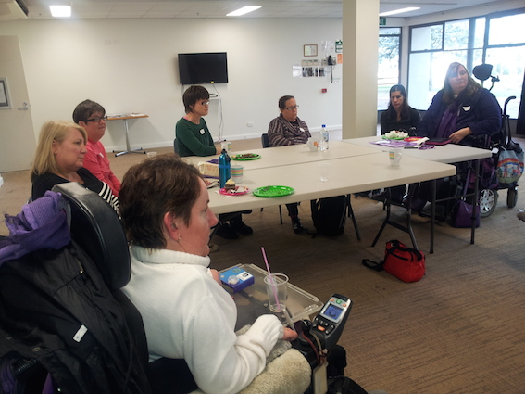

‘Women with disabilities experience such severe discrimination in our society. Workplaces are no different. It’s the attitudes hat need to change.’

‘Many women with disabilities don’t know their rights and disability employment services should be working with women with disabilities to educate them about their rights in the workplace.’

‘There is almost an assumption and an expectation from disability employment services that women with disabilities should be grateful for ANY job. But we don’t want just ANY job – we have a right to meaningful employment, with proper conditions, and opportunities to pursue a career path.’

‘I think that disability employment services could be improved if they directly employed women with disabilities as staff. There should also be women with disabilities represented on DES advisory structures and governance bodies. This should be a requirement of government funding and should be built into DES funding contracts.’

‘Disability employment services should be required to have set targets for the employment of women with disabilities. The United Nations has recommended this to the Australian government in the past but there doesn’t seem to have been any action on this.’

‘I would say that there is an assumption within DES that women with disabilities aren’t parents and/or carers, but many of us are, are this means we also need access to flexible working hours and conditions, including access to affordable child care.’
‘We really need proper, national research into the issue of women with disabilities and employment in Australia. The Federal Government should fund a national research study into this issue so that we can find out what really is the current employment situation for women with disabilities; identify what systemic problems exist and, identify priority areas for action that all State and Territory governments could commit to.’

3. What makes it difficult for you to find a job? What would help you find a job?

‘Because of the nature of my disability, I have periods when I can function really well, and other times I am so fatigued that I can’t get out of bed. It’s really difficult to try to find employment in this situation. I can’t always predict how I’m going to be. I wish there was more understanding and accommodation of, the episodic nature of some disabilities, and the need for more flexible approaches to work.’

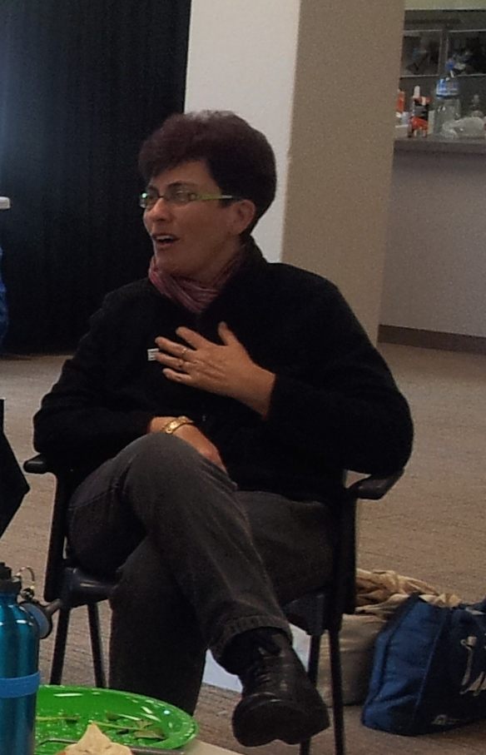

‘There are so many women with disabilities who could be in the workforce if they were given the opportunity to work from home. But there is still this old fashioned view that work can only be performed in certain settings and in fairly traditional ways. There should be a more contemporary view of the ways in which women with disabilities can participate in the labour market. Disability employment services could be more innovative in their approaches and look at avenues for women with disabilities to participate in the workforce in ways that benefit both the employee and the employer.’

‘Transport is obviously a major issue for many of us. We need accessible and reliable transport services. It’s difficult for example, if you get a job but cant get there because you are reliant on public transport that isn’t always accessible or affordable.’

‘I think there should be more programs and opportunities for women with disabilities to have skill development around issues like self-esteem, assertiveness, prevention of sexual harassment, violence prevention, and so on. Many of us need these types of opportunities so that we can not only secure employment, but also be aware of our rights when we do get a job.’

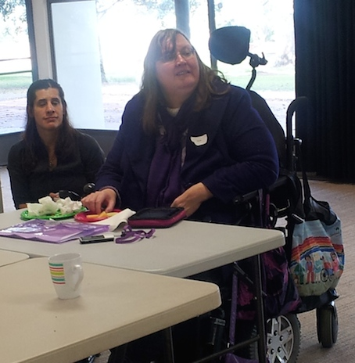

‘There are so many workplaces that are simply inaccessible for women with disabilities. This narrows our choices of workplaces. Its not just about being able to ‘get into’ a workplace, its also being able to get to and from the workplace, being able to get around inside the workplace, having access to accessible toilets, sanitary facilities, staff rooms and so on.’

‘The sad reality is that there are many employers who just won’t employ us – they see us as a burden and a ‘cost’. I have been to so many job interviews in my life – I have qualifications, but I always miss out. I’m always old that its ‘merit based’ but I don’t believe this. It is demoralising when you go for interview after interview and you know you can do the job – but you are never given a chance. I am certainly not ‘unemployable’ – but how am I supposed to change discriminatory attitudes?’

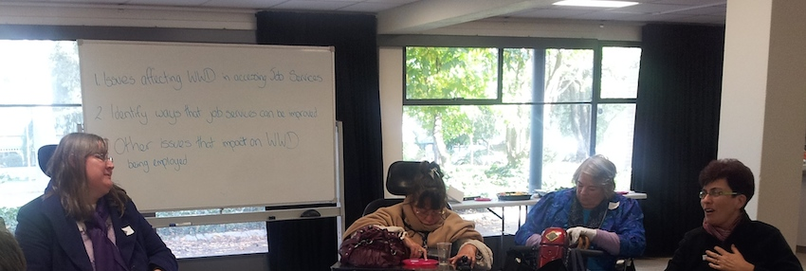

WWDA Disability Employment Services (DES) Consumer Engagement Project, Background Briefing Note, March 2014.

