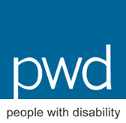

c/- Women With Disabilities Australia (WWDA)
PO Box 407
Lenah Valley TAS 7008
Ph: 0438535123
E: carolyn@wwda.org.au
The Hon. Tony Abbott, MP
Prime Minister
Parliament House
CANBERRA ACT 2600

20 January 2015

Dear Prime Minister

As a coalition of national organisations of and for people with disability in Australia, and on behalf of the many organisations from around the country that have endorsed this letter, we write to request your strong leadership and action to urgently establish an independent National Inquiry into violence and abuse perpetrated against people with disability in institutional and residential settings in Australia.

Violence and abuse perpetrated against people with disability in institutional and residential settings is an epidemic in Australia. This epidemic affects some of the most vulnerable, marginalised people in our communities, with specific implications for women and children with disability, Aboriginal and Torres Strait Islander peoples with disability and people with disability from non-English speaking and culturally and linguistically diverse backgrounds. It remains Australia’s hidden shame. The evidence is extensive and compelling. It is a deeply shameful blight on our society and can no longer be ignored.

For more than a decade now, Disabled Peoples Organisations (DPOs), civil society organisations (CSOs); the United Nations, people with disability themselves, their families, allies, friends and advocates, have implored successive Australian Governments to show national leadership and act to ‘address and investigate, without delay, violence, exploitation and abuse experienced by people with disability, particularly women and girls with disability, in institutional and residential settings’. Yet these calls and recommendations have been ignored. Our leaders have failed to act, and in their apathy and indifference, have failed people with disability in institutional and residential settings, who continue to experience the most appalling violations of their most fundamental human rights.

Regrettably, current national frameworks and strategies such as the National Plan to Reduce Violence against Women and their Children 2010-2022 and the National Disability Strategy 2010-2020 fail to include or address violence perpetrated against people with disability in institutional and residential settings. In addition, with no national, legal, administrative or policy framework for the protection, investigation and prosecution of violence against people with disability, we are left with piecemeal frameworks at state and territory levels (such as domestic and/or family violence legislation) which exclude people with disability who live in residential and institutional settings due to limiting and restrictive definitions and understandings.

On Wednesday 26th November, finally heeding the pleas of people with disability from around the nation, the Senate passed a motion calling on the Australian Government to ‘take urgent action and set up a national inquiry into the violence, neglect and abuse against people with disability in residential, institutional and home care settings.’ In so doing, the Senate noted ‘the disturbing evidence shown in the Four Corners report on the 24th November 2014 in regards to abuse of people with disability, in institutional and home care.’

Within a matter of days of the airing of the Four Corners Program ‘In Our Care’, more than 11,000 individuals from around Australia signed a national petition (organised by people with disability themselves), calling on the Prime Minister of Australia to launch a national inquiry into violence and abuse of people with disability in residential and institutional settings. The petition can be viewed at:

https://www.change.org/p/tony-abbott-to-urgently-launch-a-national-inquiry-into-violence-neglect-and-abuse-against-people-with-disability-in-residential-and-institutional-settings

The shocking events aired in the Four Corners Program ‘In Our Care’ on Monday 24th November, are by no means restricted to one State or Territory, or to one service provider organisation. Australian DPOs, advocacy, legal, women’s and human rights organisations, bear witness to the horrific violence and abuse perpetrated against people with disability – particularly women and girls – in institutional and residential settings, and we are united in calling for an urgent, independent national inquiry.

As peak organisations of people with all types of disability, we continue to bear witness daily to the most horrific cases of violence, abuse, neglect and exploitation of people with disability in institutional and residential settings. We have thousands of ‘stories’, of ‘cases’, of ‘incidents’ – and we are not the only organisations witnessing and listening to these horrific ‘cases'. We have taken this opportunity to provide you with an Attachment to this letter - a ‘snapshot’ of some of the ‘cases’ we deal with on a daily basis. The examples we provide represent some of the stories most people will never hear – stories of people with disability in residential and institutional settings who are ‘voiceless’, hidden away from public scrutiny, their ‘cases’ written off as ‘service incidents’ or covered up by staff, management, and/or government agencies.

It is now well established that people with disability are at a far greater risk of violence than others in the population and that this violence often goes unrecognised or addressed. For example, 18% of people with disability report being victims of physical or threatened violence compared to 10% without disability; and people with intellectual disability are ten times more likely to experience violence than people without disability.

People with disability who live in institutional and residential settings are particularly susceptible to violence from numerous perpetrators and frequently experience sustained and multiple episodes. Due to the ‘closed’ nature of institutional and residential settings, away from public scrutiny, this violence is very difficult to detect, investigate and prosecute. This is hardly surprising, given the fact that institutional settings are widely acknowledged to be breeding grounds for the perpetration of violence and abuse, and of cultures that condone violence and abuse.

The gendered nature of violence against people with disability sees more than 70% of women with disability having been victims of violent sexual encounters at some time in their lives. A staggering 90% of women with an intellectual disability have been subjected to sexual abuse, with more than two-thirds (68%) having been sexually abused before they turn 18 years of age. The rates of sexual victimisation of women with disability range from four to 10 times higher than for other women. Regrettably, women and girls with disability are often not believed when reporting sexual assault and other forms of violence. And most shamefully, crimes of violence committed against people with disability (particularly those in institutional and residential settings) often go unreported, and even if they are reported, are inadequately investigated, remain unsolved or result in minimal sentences.

We wholeheartedly support your recent statement regarding the prevention of violence, that “as policy makers, we have a responsibility to ensure that perpetrators should have nowhere to hide, nor victims reason to hide.” However, it is well known that in Australia, perpetrators deliberately target people with disability in institutional and residential settings - particularly those who are least able to resist, or make a formal complaint, or who have no or limited communication, or who simply are not believed when they do try to make a complaint. It is in fact a very common scenario that perpetrators move from facility to facility, from service to service in order to avoid detection. And the ‘victims’ often have no alternative to the violence and abuse – they are unable to escape; they are not considered ‘credible’; disclosure leads to further violence; they are often reliant on the perpetrator/s for care and support; and they have no independent access to police, support services, lawyers or advocates.

On 25th November 2014, Senator the Hon Mitch Fifield, Assistant Minister for Social Services, addressed the Senate and expressed his view that there is no need for a national inquiry into the violence and abuse of people with disability in residential and institutional settings, and that it is up to the States and Territories to deal with the issue. Whilst we have great respect for Senator Fifield, we express our deep regret and disappointment at his statement to the Senate and do not accept his position.

Rather, we say to you as Prime Minister of Australia:

- People with disability, particularly women and girls, in institutional and residential settings in this country, continue to experience widespread and multiple forms of violence and abuse, including rape, sexual violence, unauthorised restrictive practices, and denial of their most fundamental human rights.

- We need a national inquiry into this national epidemic as a matter of urgency. If Australia can have a Royal Commission into a Home Insulation Scheme; into Trade Union Governance and Corruption; or as in 2004, into Grain Storage, Handling and Transport – then surely our Government can call a Royal Commission into this most pervasive, systemic epidemic that is violence and abuse of people with disability in residential and institutional settings.

- For more than a decade, the United Nations has made strong recommendations to successive Australian Governments to show national leadership and act to ‘address and investigate, without delay, violence, exploitation and abuse experienced by people with disability, particularly women and girls with disability, in institutional and residential settings’. Merely a few weeks ago, in expressing its deepest concern at the high rates of violence perpetrated against women with disability in Australia, the United Nations Committee Against Torture added its voice, and called on the Australian Government to redouble its efforts to prevent and combat ALL forms of violence against women, particularly violence perpetrated against women with disability and indigenous women.

- We are ready to work in partnership with the Australian Government to assist in all aspects of an independent National Inquiry to end this national disgrace.

- We implore you to act urgently in order to do justice to those people with disability in residential and institutional settings, especially our women and girls, who are experiencing violations of one their most fundamental human rights – the right to live free from violence, abuse, exploitation and neglect. We implore you, as our Prime Minister and your Government as our policy makers – to act on your responsibility to ensure that the perpetrators of violence against people with disability in institutional and residential settings “have nowhere to hide, nor their victims reason to hide”.

On behalf of people with disability in Australia, we are asking you, as the Prime Minister of our country, to please take urgent action to secure the establishment of an independent National Inquiry into the violence and abuse of people with disability in residential and institutional settings. In considering this, we urge you to listen to the stories, voices and pleas of people with disability, show disabled persons the recognition and respect that has been denied them to date, and understand their deepest pain and hurt.

Yours sincerely

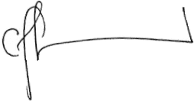  Carolyn Frohmader  Executive Director  Women With Disabilities Australia (WWDA) | 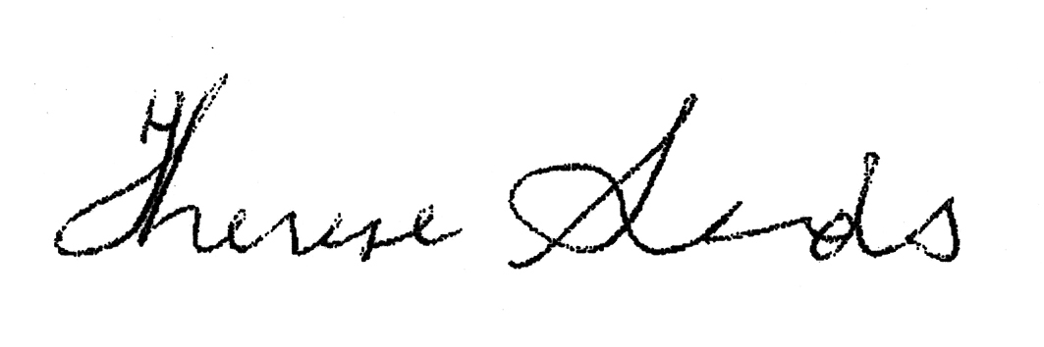  Co-Chief Executive Officer  People with Disability Australia (PWDA) | Dwayne Cranfield  Chief Executive Officer  National Ethnic Disability Alliance (NEDA) | 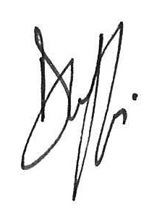  Damian Griffis  Chief Executive Officer  First People’s Disability Network Australia (FPDN) | 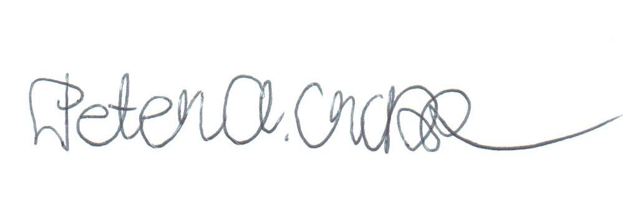  Peter Cross  President/Convenor  United Voices for People with Disabilities

Contact for Correspondence:

Carolyn Frohmader
Executive Director
Women With Disabilities Australia (WWDA)
PO Box 407, Lenah Valley TASMANIA 7008
Ph: 0438535123
E: carolyn@wwda.org.au

Committee on the Elimination of Discrimination against Women (2010) Concluding Observations of the Committee on the Elimination of Discrimination against Women: Australia. CEDAW Forty-sixth session, 12 – 30 July 2010. UN Doc. CEDAW/C/AUS/CO/7; Committee on the Rights of Persons with Disabilities (2013) Concluding observations on the initial report of Australia, adopted by the Committee at its tenth session (2-13 September 2013); UN Doc. CRPD/C/AUS/CO/1; Committee on the Elimination of Discrimination against Women, Concluding comments of the Committee on the Elimination of Discrimination against Women: Australia, 3 February 2006, UN Doc. CEDAW/C/AUL/CO/5; Committee Against Torture, Concluding observations on the fourth and fifth periodic reports of Australia; Advance Unedited Version; UN.Doc. CAT/C/SR.1284.
‘Senate calls for inquiry into abuse against people with disability in institutions’; accessed online at: http://rachel-siewert.greensmps.org.au/content/video/senate-calls-inquiry-abuse-against-people-disability-institutions
ABC TV, In Our Care; By Nick McKenzie, Karen Michelmore and Peter Cronau; 24 November 2014, available online at: http://www.abc.net.au/4corners/stories/2014/11/24/4132812.htm
French, P., Dardel, J., Price-Kelly, S. (2009) Rights Denied: Towards a National Policy Agenda about Abuse, Neglect and Exploitation of Persons with Cognitive Impairment. People with Disability Australia. Available online at: http://www.pwd.org.au/issues/preventing-violence.html
Council of Australian Governments (2011) National Disability Strategy 2010-2020, Commonwealth of Australia.
Attard, M., & Price-Kelly, S. (2010) Accommodating Violence: The experience of domestic violence of people with disability living in licensed boarding houses, PWDA, NSW.
French, P. et al. (2009) OpCit.
See: Frohmader, C. (2014) ‘Gender Blind, Gender Neutral’: The effectiveness of the National Disability Strategy in improving the lives of women and girls with disabilities. Prepared for Women With Disabilities Australia (WWDA), Hobart, Tasmania. ISBN: 978-0-9585268-2-1. Available online at: http://wwda.org.au/wp-content/uploads/2013/12/WWDA_Sub_NDS_Review2014.pdf
Ibid.
Australian Law Reform Commission (ALRC) (2010) Family Violence — A National Legal Response. ALRC Final Report 114. Accessed online January 2013 at: http://www.alrc.gov.au/publications/family-violence-national-legal-response-alrc-report-114
Dowse, L., Soldatic, K., Didi, A., Frohmader, C. and van Toorn, G. (2013) Stop the Violence: Addressing Violence Against Women and Girls with Disabilities in Australia. Background Paper. Hobart: Women with Disabilities Australia. Available online at: http://wwda.org.au/wp-content/uploads/2013/12/STV_Background_Paper_FINAL.pdf
Frohmader, C. (2011) Submission to the Preparation Phase of the UN Analytical Study on Violence against Women and Girls with Disabilities, (A/HRC/RES/17/11). Prepared for Women With Disabilities Australia (WWDA). Available online at: http://wwda.org.au/wp-content/uploads/2013/12/WWDASubUNStudyViolenceWWDDec2011.pdf
Hon Tony Abbott, Prime Minister; The Hon. Kevin Andrews MP, Minister for Social Services; Senator The Hon. Michaelia Cash, Minister Assisting the Prime Minister for Women (27 June 2014) Prime Minister: Joint Press Release - Addressing Violence Against Women and Their Children. Available online at: http://www.liberal.org.au/latest-news/2014/06/27/prime-minister-joint-press-release-addressing-violence-against-women-and
See for eg: Dowse, L. et al (2013) OpCit.; See also: Victorian Equal Opportunity and Human Rights Commission (2014) Beyond doubt: The experiences of people with disabilities reporting crime – Research findings. ISBN 978-0-9875444-9-3; Melbourne, Victoria; See also: Frohmader, C. & Cadwallader, J. (2014) Joint Submission from National Cross-Disability Disabled People’s Organisations (DPO’s) to the Senate Standing Committee on Finance and Public Administration ‘Inquiry into Domestic Violence in Australia’. Prepared for and of behalf of: Women With Disabilities Australia (WWDA); First People’s Disability Network Australia (FPDNA); People with Disability Australia (PWDA); Children with Disability Australia (CDA) and, National Ethnic Disability Alliance (NEDA). Available online at: http://wwda.org.au/wp-content/uploads/2013/12/Final_Draft_DPO_Sub_DV_Senate2014.pdf
Committee Against Torture, Concluding observations on the fourth and fifth periodic reports of Australia; Advance Unedited Version; UN.Doc. CAT/C/SR.1284.

