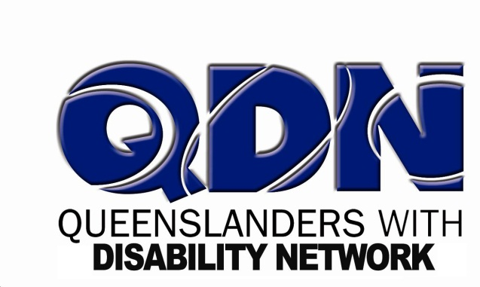

QDN in partnership with WWDA
invite you to participate in a conversation
to prepare for having your say in the Sterilisation Inquiry

The meeting will be facilitated by Karin Swift, Jen Barrkman and Fran Vicary.

Date: Tuesday, 22 January
Time: 10:30am to 2:00pm
Venue: 11/7 O’Connell Terrace, Bowen Hills

RSVP to Karen at QDN on 07 3252 8566 or admin@qdn.org.au by

Support and refreshments will be provided.
Taxi vouchers will be available for travel to and from QDN.
Please advise us if you have specific support needs or require interpreters.

The Australian Government, Senate
QDN in partnership with WWDA
invite you to have your say in the Sterilisation Inquiry

Speak to Senators involved in the Sterilisation Inquiry.

What: Senate Hearing, Sterilisation Inquiry
Date: Wednesday, 30 January
Time: 1:45pm to 5:00pm
Venue: 11/7 O’Connell Terrace, Bowen Hills

RSVP to Karen at QDN on 07 3252 8566 or admin@qdn.org.au by

Support and refreshments will be provided.
Taxi vouchers will be available for travel to and from QDN.
Please advise us if you have specific support needs or require interpreters.

