Women With Disabilities Australia (WWDA)

Report from the United Nations Committee Against Torture (CAT)
53rd Session - Review of Australia
Geneva, 3-28 November 2014
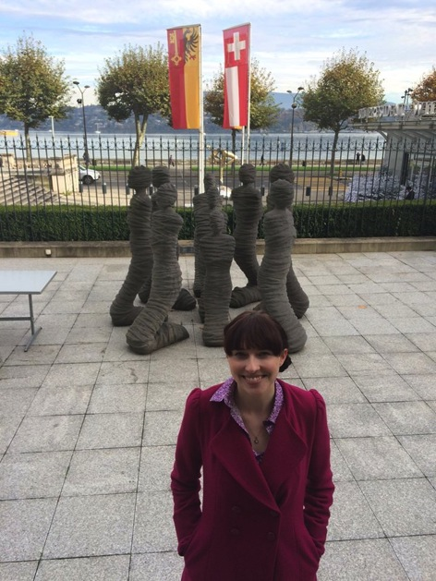

Report prepared by: Cashelle Dunn, WWDA Representative and Member of the Australian Civil Society Delegation to the
CAT 53rd Session – Review of Australia

Contents

Acknowledgment........................................................................................................................................... 3
Introduction..................................................................................................................................................... 4
Background...................................................................................................................................................... 5
Delegation Preparation Meetings........................................................................................................... 8
Day One to Three - Getting to Geneva / Orientation...................................................................... 9
Day Four - CAT Committee Formal NGO Meeting & Informal NGO Side-Event.................. 11
Day Five to Six - Produce, Distribute...and Explore......................................................................... 14
Day Seven - Australian Government Session One........................................................................... 15
Day Eight - Australian Government Session Two............................................................................ 19
Day Nine to Eleven - Swiss Countryside.............................................................................................. 22
Release of CAT Concluding Observations........................................................................................... 24
Where to From Here..................................................................................................................................... 25
Appendix 1: Civil Society Delegation Formal Opening Statement............................. 26
Appendix 2: Open Statements - Civil Society Disability Organisations................... 28
Appendix 3: Australian Government Delegation Opening Statement..................... 33
Appendix 4: CAT Concluding Observations - Australia................................................. 39

DISCLAIMER
This post-event report is prepared by Cashelle Dunn for members of Women With Disabilities Australia (WWDA) and other interested stakeholders. Apart from where specifically stated otherwise, this report does not reflect the views of the Australian Human Rights Commission nor the Australian Government.

Acknowledgment

Callan & Cashelle Dunn

It was an enlightening opportunity and a deep honour to represent Australian women with disabilities at the 53rd Session of the United Nations Committee Against Torture (CAT), held in Geneva, 7-11 November 2014. I would like to acknowledge, with sincere thanks, those who helped make it possible for me to attend, including those who supported me out of public view, and all those who made it such an unforgettable and truly life-altering experience:

Australian Civil Society Delegation Members and support persons (Ngila, Damian, Scott, Sophie, Daniel, Michelle, David, Olivia, Nicky, Leonie, Natalie, Shazeera and Matthew) – thank you for the fantastic work, the mutual support, and the friendship.

- Board and members of Women With Disabilities Australia (WWDA) – for your assistance, trust and respect;
- Carolyn Frohmader – for your indomitable support, encouragement and friendship. You are a phenomenal warrior, and I am proud to call you my mentor;
- The Australian Department of Social Services (DSS) and the Australian Human Rights Commission (AHRC) [Disability International Participation Funding Program] for providing a funding grant to enable WWDA to be represented at the 53rd Session of CAT;
- CAT Committee Members – for your commitment to engaging with our Civil Society Delegation. For asking questions and seeking detailed information to learn more about the situation of women with disabilities in Australia;
- My wonderful brother, Callan – for being the greatest support person a girl could ask for. You helped with reminders before we left, calmed me when I was stressing out, helped me when I was sick, were the official photographer for everyone, and always made me smile.

Introduction

In October 2014, Women with Disabilities Australia (WWDA) successfully applied to the Australian Human Rights Commission (AHRC) [Disability International Participation Funding Program] for a funding grant to enable a WWDA delegate (Cashelle Dunn) to represent the views and issues of women with disabilities in Australia to the Committee Against Torture during its formal review of Australia's compliance with the United Nations Convention against Torture and Other Cruel, Inhuman or Degrading Treatment or Punishment (Convention against Torture). The Review took place during the CAT's 53rd Session in Geneva, 3-28 November 2014.

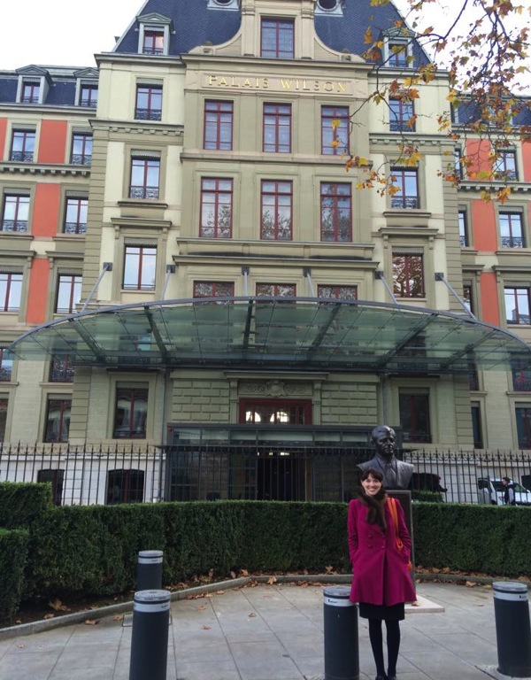

The United Nations Palais Wilson building in Geneva, where the CAT Committee met for the 53rd session

Cashelle spent 3 days at the United Nations in Geneva, working with the CAT committee as a member of the Australian Civil Society Delegation to the 53rd Session of CAT. Cashelle was also able participate in, and attend, a number of other events during her time at the United Nations in Geneva.

This report has been prepared by Cashelle to highlight her work and experiences during her time in Geneva.

Background

The Convention against Torture and Other Cruel, Inhuman or Degrading Treatment or Punishment (Convention against Torture) was ratified by Australia on 8 August 1989, and it entered into force for Australia 7 September 1989. The Convention against Torture covers a broad spectrum of issues, and requires governments to prohibit and prevent 'torture'. Its fundamental purpose is to promote the equality and inherent dignity of every human being, and universal respect for, and observance of, human rights and fundamental freedoms.

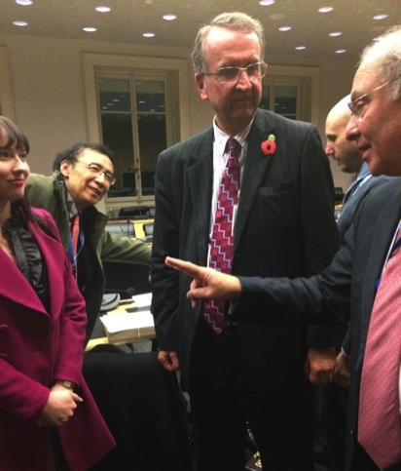

Cashelle with Committee Member Zhang, Australian Ambassador Quinn,
& CAT Chairperson Grossman

The Committee against Torture (CAT) is the body of independent experts that monitors implementation of the Convention by the State Parties, including Australia. All States parties to the Convention are required to submit regular reports to the Committee on how the rights are being implemented. States must report initially within one year of accepting the Convention and then every four years. The Committee with then examine each report and engage in a formal dialogue with the State Party under review. The Committee also accepts reports from civil society organisations (CSO's), and/or non-government organisations (NGO's) as part of the State Party review.

CSO's and NGO's are a critical part of the review process, and there is a range of mechanisms available for civil society involvement, including the official CSO Reports and through interactive dialogue between the Committee and NGO delegations from the State Party under review. At the completion of the Review process, the Committee addresses its concerns and makes suggestions and general recommendations to the State party for how it can improve and/or accelerate its implementation of the CAT.
The CAT began its fifth review of Australia at its 53rd Session in Feb 2011. At this session the Committee developed a List of Issues for Australia emerging from Australia’s baseline report. The List of Issues contained 49 specific questions (under articles from the CAT), where the Committee felt more detailed information and responses were needed. The Australian Government was then required to formally respond to the questions posed by the Committee. The Australian Government submitted its initial report to the CAT in July 2013.

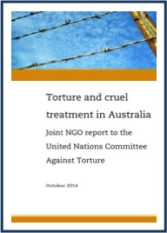

In October 2014, the Australian Joint NGO Report to the Committee against Torture was launched. The Report was developed by Australian non-government organisations (NGO's), Disability Peak Organisations (DPO's), disability advocacy and human rights organisations. The Report, entitled Torture and Cruel Treatment in Australia, was endorsed in whole or in part by 77 organisations. Torture and Cruel Treatment in Australia was sent to the CAT Committee for its review of Australia’s compliance with the Convention against Torture.

Further detailed NGO submissions were provided to the CAT Committee for review, including WWDA's Submission to the CAT Committee, which highlighted urgent issues for women with disabilities in Australia. Additional WWDA documents were tabled to inform the Committee's review of Australia, including WWDA Submission to the Senate Inquiry into the Involuntary or Coerced Sterilisation of People with Disabilities in Australia, and the sentencing transcript of DPP vs. Kumar.

In October 2014, the Australian Human Rights Commission (AHRC) sought applications under its Disability International Participation Funding Program [funded by the Department of Social Services], for representatives of disability peak organisations to attend the 53rd session of CAT in Geneva. Three disability peak organisations, including WWDA, were successful in securing a funding grant. A number of other representatives from Australian NGO’s were also able to secure funding from different sources to enable them to attend. In all, ten representatives were able to come together to form the official Australian Civil Society delegation to the 53rd session of CAT, with a further five delegates assisting the official delegation by providing additional expertise, support and assistance.

The members of the official Australian Civil Society Delegation to the 53rd session of CAT were:

Cashelle Dunn  Women with Disabilities Australia (WWDA) |  | Ngila Bevan  People with Disabilities Australia (PWDA) |  | Damian Griffis  First Peoples Disability Network (FPDN)
Sophie Nicolle  Amnesty International Australia |  | Daniel Webb  Human Rights Law Centre (HRLC) |  | David Manwaring  Queensland Advocacy Incorporated (QAI)
Leonie Sheedy  Care Leavers Australia Network (CLAN) | Nicky Davis  Survivors Network of those Abused by Priests (SNAP) |  | Olivia Ball  Remedy Australia |  | Shazeera Zawawi  Association for the Prevention of Torture (APT)

The five additional members providing additional expertise, support and assistance were:
 | Scott Avery  First Peoples Disability Network (FPDN) | Paul Calcott  First Peoples Disability Network (FPDN)

Natalie Wallace  Care Leavers Australia Network (CLAN) | Michelle O'Flynn  Queensland Advocacy Incorporated (QAI) | Matthew Sands  Association for the Prevention of Torture (APT)

We were also given wonderful support by our various support workers who were an integral part of our delegation, including:

Callan Dunn

Delegation Preparation Meetings

The members of the Australian Civil Society Delegation arranged a conference call for October 24th to develop an advocacy strategy for the event in Geneva, particularly for the formal NGO briefing. It was unfortunate that most of us would not be meeting face-to-face until we were in Geneva; however, it was still a good opportunity to introduce ourselves, and our organisations primary issues. It was important to establish our roles and areas of expertise, which would be critical when the CAT sought specific information from delegation members as a part of the Review process. It was also very important that we, as delegates, presented as a unified, organised and professional Civil Society delegation. This required being reasonable about dividing speaking time during the formal meeting so key issues of concern were heard; and ensuring key contributions to the Joint NGO report by organisations not attending would be raised as well.

In this, and a follow-up delegation conference call on October 30th, we finalised our Delegation run sheet on the key issues; arranged priority fact sheets to distribute when necessary; and discussed best possible opportunities to provide committee members with more detailed information, including Ngila Bevan (PWDA) arranging a informal NGO briefing side-event.

Day One to Three: Getting to Geneva/ Orientation

I left for Geneva via the red-eye flight on Tuesday 4th November. My support person, who was fortunately also my brother, Callan Dunn, accompanied me. After my trip earlier this year to the UN CRPD COSP in New York, which started with a seizure alone in my hotel room shower, shadowed by a black eye and a week of persistent blood noses, I did not feel comfortable travelling alone again. So I was pleased to have somebody who knows how to deal with my health issues, and who is a positive influence in my life, accompany me. I was able to fully concentrate on the job at hand, and I was very grateful to WWDA, the Australian Human Rights Commission, and also the Australian Civil Society delegation for understanding and accommodating my needs as a woman with a disability.

The flight from Melbourne to Geneva was quite the journey! We flew from Melbourne to Dubai, had a 2-hour layover, and then flew Dubai to Geneva. Thankfully due to the late hour of our primary flight, there were copious empty seats, so virtually everyone on the flight had an entire row to stretch out and sleep. Thankfully, I was advised to book to arrive with a day to recover and adjust. I was very drained when I arrived, but that additional recovery day allowed me to get rested and prepared.

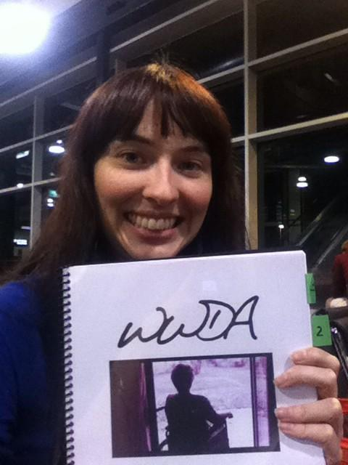

At Melbourne Airport preparing to leave for the journey to Geneva

Although quite exhausted when we arrived in Geneva, we found our hotel (Hotel Jade) and were welcomed by the delightful staff and shown to our lovely room. After a much-needed shower, we decided to go and find a place to get a coffee as we determined it was necessary to stay awake until at least 8pm if we wanted to try and manipulate our body clocks. We walked rather aimlessly amongst the beautiful buildings until we found the lake's edge, and an adorably unique (and warm) cafe. Trying to order a soy latte turned out to be quite a dilemma, as the extent of my French was "Bon Jour", and the Swiss do not seem to have much time for anything that isn't dairy. Regardless, I was determined to have a coffee in this adorable coffee shop on the edge of Lake Geneva, even if it would give me a stomach-ache. As Callan and I sat and played cards, I glanced over to a group of women fluently gossiping in French, and suddenly a small dog's head popped out of her purse. This adorable puppy surprised me, but after an elderly man brought his terrier in as well, I realised we weren't "in Kansas anymore"! This was the land where dogs can go anywhere, from 5 star restaurants and Louis Vuitton stores, to trains and hotel rooms. There were no restrictions on dogs in this country... and I loved it!

On the Thursday (6th Nov) I met with some of the other members of the delegation in the Hotel Jade restaurant. Not all the delegation had arrived yet as a number of flights had been delayed, however, it gave us an opportunity to casually meet each other and raise any concerns or questions we had about the impending formal NGO meeting. After the meeting, I arranged with the hotel manager to print our numerous factsheets, and then Callan and I went to the UN Office of the High Commission for Human Rights (OHCHR) at Palais Wilson to collect our entry badges to avoid waiting the next day.

Although the Palais Wilson was walking distance, we decided to utilise the public transport system later in the day. On arrival at our hotel in Geneva we were issued free public transport cards, which meant that were were able to travel on any form of public transport (bus, tram, train) for free during our time in Geneva. It is a very easy and clean system, and fully accessible.

Public Transport in Geneva

Day Four: CAT Committee Formal NGO Meeting & Informal NGO Side-Event

I woke early, a mix of anxiety and excited anticipation. After breakfast, I walked to the Palais Wilson building, where I met Ngila Bevan and a number of other delegates outside. On arrival, we presented our passports and official passes to the security officers and went through electronic screening.

Our first meeting was at 9.30am with Ambassador John Quinn (Permanent Representative to the United Nations, Geneva); Stephen Bouwhuis (Assistant Secretary, Human Rights Policy Branch, Attorney Generals Office); and numerous other Australian Government officials. We attempted to raise some of our primary issues with the Government delegation, however, as the meeting with them was before our formal briefing to the CAT Committee they were unwilling to discuss a great deal. Consequently, it was quick, superficial, and teeming with pleasantries and politically favorable statements. Nevertheless, it gave us an opportunity to see their faces and know who was who, and where they were from.

An OHCHR official met us in the cafeteria to prepare us for our upcoming meeting with he committee and warn us about the strict time restraints. We were all forced to attempt to quickly further cut down our speeches, a feat that proved quite difficult as the day before I had already done that as much as I could realistically see possible. It was important to present the issue with the weighting and concern it deserved in the limited time provided.

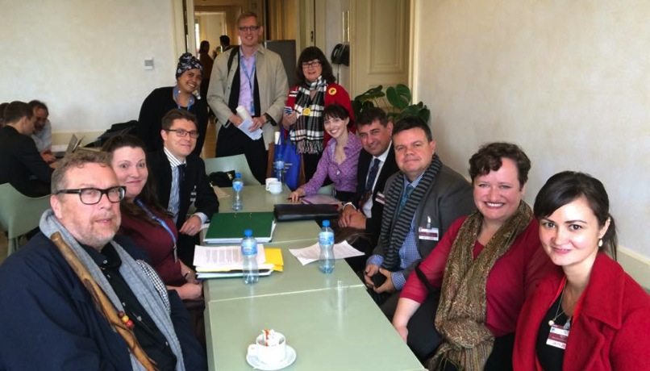
Civil Society Delegation meeting in the UN Cafeteria

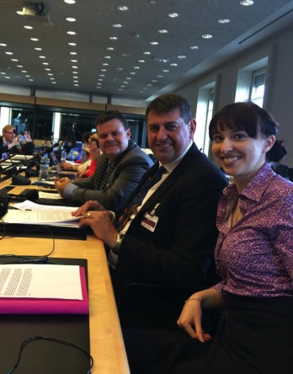
Our formal briefing to the CAT commenced at 12pm. I entered feeling very nervous, and slightly overwhelmed. I knew the importance these issues I was presenting had and I wanted to be able to represent the women back in Australia with the dignity and strength they deserved. It was a rush of action in the room, as our fact sheets and speeches were taken for copying and distribution to the Committee members and translators. Our delegation took our seats in the central seating area, surrounded in the outer seating area by the members of the Committee. We all put our headsets on and assisted each other in finding the English 'channel', and took photos of ourselves and others for our respective organisations and followers back in Australia.

The CAT Committee 53rd Session Formal Civil Society Briefing commenced with the Vice Chairperson, Ms. Essadia Belmir from Morocco, welcoming our delegation and providing an overview of the important role of Civil Society in State Party reviews. The briefings with Civil Society organisations are private, and this private nature of the sessions is very important, as it enables the civil society delegation to be frank and honest in their statements to the Committee, without fear of reprisal from their Governments.
Scott Avery, Damian Griffis and Cashelle Dunn in Formal NGO Meeting

As one of the Civil Society delegation coordinators, Ngila Bevan delivered the formal introduction statement to the Committee on behalf of the delegation. The focus of the introduction was vulnerable populations and how the risk of ill treatment is heightened through systemic failures. Some key points made in our formal opening statement to the Committee included:

- Failing mechanisms for victims of sexual abuse and domestic violence;
- Failure of the Australian Government to protect the marginalised from violence in disempowering contexts;
- Australian Government's lack of comprehensive human rights legislation and protection from cruel, inhuman or degrading treatment or punishment;
- Australia's alarming and disturbing treatment of asylum seekers;
- The common governmental perception that Australia is somehow beyond the need for human rights law;
- Australia should be held to the highest standard of human rights implementation, as it is a stable, wealthy and democratic country.

After the private session with the CAT Committee, the Civil Society delegation hosted an informal side-event and invited the Committee members. This was a far more relaxed atmosphere where we each were able to go into further clarification on our key issues, and the Committee members in attendance were able to ask additional questions.

At the side-event, I spoke specifically about violence against women and girls with disabilities, expanding on WWDA's key issues of:
- The shortcomings of the National Plan to Reduce Violence Against Women and their Children as a response to the numerous forms of violence experienced by women and girls with disabilities;
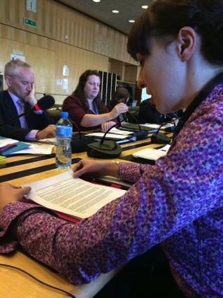
- The disregard of successive Australian governments to address violence, exploitation and abuse of people with disabilities in institutional and residential settings, and the government's refusal to commission a national inquiry into the issue;
- The Australian Government's continued sanctioning of the practice of 'forced' and 'coerced' sterilisation of women with disabilities, despite being a party to numerous human rights treaties (including the CAT) that specifically protect the right to bodily integrity and bodily autonomy;
- The significant increase in the use of forced and involuntary electroshock (ECT) on women in Australia, and the government's reluctance to commission a national inquiry into the use of forced and compulsory medical and psychiatric treatments on people with disabilities.
Cashelle Dunn Speaking to the CAT Committee

Involuntary sterilisation and abuse in institutional and residential settings were of particular concern to the Committee. Committee Member Ms. Sapana Pradhan-Malla asked additional questions in the informal meeting, however, as she had to leave early I arranged to email her the necessary information.

Day Five to Six: Produce, Distribute……….and Explore

After the exciting meetings on Friday we had a hiatus weekend to respond to Committee questions, send any additional information, and then... go and travel. I spent some of the weekend in correspondence with Carolyn Frohmader back in Australia, and we arranged to draw up a number of additional factsheets for the Committee. These answered their additional questions and provided further detail on areas of concern. Once these were compiled I sent them to the CAT Committee Secretary for distribution amongst the Committee Members.

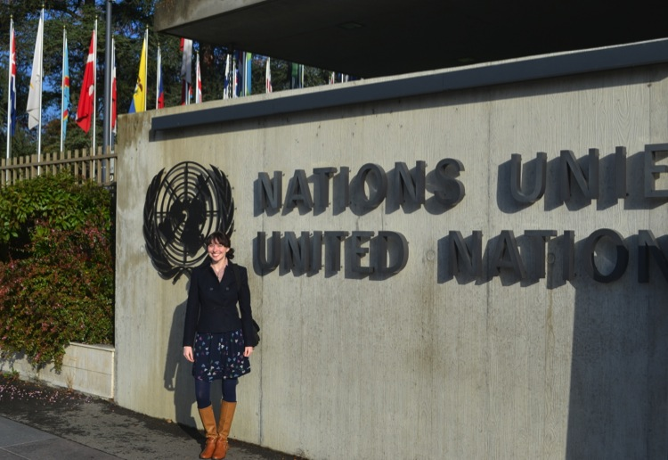
Cashelle Dunn at Palais de Nations

Some of the Civil Society delegation went out of the country for the weekend, including trips to France and Denmark. However, I was really excited to spend Saturday exploring Geneva. The weather was absolutely beautiful as Callan and I visited the United Nations Palais de Nations (The Palace of Nations), the CERN Large Hadron Collider museum, and Geneva's beautiful Old Town.

On Sunday we got up early and went on a day trip to Lyon in France. It was such a picturesque train journey as we passed tiny villages at the base of large and intimidating mountains in the French countryside. The weather was grim and rainy in the medieval town, but the food was incredible enough to lift the mood of any dark day. Whilst the city was certainly not at the same level of idyllic cleanliness that Switzerland has become known for, it had it's own charms, including the Notre-Dame de Fourvière which overlooked the city from on high like an image straight out of a fairytale book.

Day Seven: Australian Government Session One - Presentation of the Periodic Report

It was time for the Australian Government to begin its official dialogue with the CAT Committee. The Government dialogue is an open session, therefore we were able to sit in for the entire process, and people back in Australia could tune in through the live webcast. It was important for us to be taking notes on what the Government was saying, particularly what was said (or not said) about our key issues. This way, we could follow up with Committee members on any issues that we felt required clarification. The Australian Government delegation consisted of:
- John Quinn, Australia’s Permanent Representative to the United Nations and Ambassador for Disarmament, Geneva;
- Dr Wendy Southern PSM, Deputy Secretary, Policy and Programme Management Group, Australian Department of Immigration and Border Protection;
- Mr Mark Cormack, Deputy Secretary, Immigration Status Resolution Group, Department of Immigration and Border Protection;
- Mr Stephen Bouwhuis, Assistant Secretary, Human Rights Policy Branch, Australian Attorney-General’s Department;
- Ms Tracey Pearce, Principal Legal Officer, Human Rights Policy Branch, Australian Attorney-General’s Department;
- Mr Kevin Playford, Director, Human Rights and Gender Equality, Department of Foreign Affairs and Trade;
- Several assisting staff from Australia's Permanent Mission in Geneva.
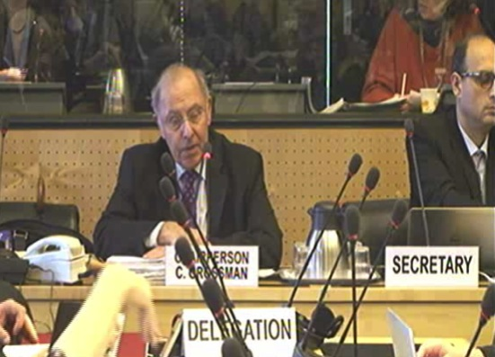
The session commenced with an Opening Statement from The Chairperson of the CAT Committee, Mr. Claudio Grossman of Chile, who explained the processes for the meeting. He noted that Australia would be given the floor for an Opening Statement; two Rapporteurs would then question them based on Committee concerns from Articles within the Convention; followed by an open floor for the other Rapporteurs to raise any questions and concerns.
Chairperson Grossman making Opening Statement

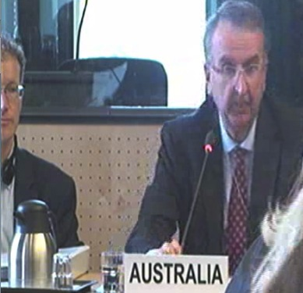
Mr. Quinn gave the Opening Statement on behalf of the Australian Government. He spoke on a number of achievements in Australia regarding torture and abuse prevention, specifically citing the implementation of the Torture Act 2010; the strengthening of human trafficking related offences in the Slavery Act 2013; the amended Vulnerable Witness Act 2013; the prevention of people smuggling through the Anti-People Smuggling Bill 2010; the establishment of the Human Rights (Parliamentary Scrutiny) Act 2011; and the prioritisation of Indigenous Australians through the Prime Minister’s Indigenous Advisory Council and the Indigenous Advancement Strategy. Quinn stated that the Australian Government is constantly reviewing and evaluating existing measures to ensure effective implementation of the Convention. However, he noted that Australia recognises that more can always be done. As predicted, there was no mention of violence against women or violence against people with disabilities. The full transcript of the Opening Statement is provided in Appendix.
John Quinn giving Opening Statement

Mr. Grossman was the first Rapporteur to question the government, focusing on Articles 1-9. He spoke a number of issues that the Committee found concerning, particularly Mandatory Detention and, for the first time, the CAT Committee began asking Australia questions about Violence Against Women (VAW). Mr. Grossman was appalled that the Australian government believed violence against women 'does not fall in the convention because it is private', and questioned the government of why Australia would fall outside the convention on this issue.

Mr. Kening Zhang of China was the second Rapporteur to question the government, and he focused on Articles 10-16. Mr. Zhang commenced on a positive note by complimenting Australia on a number of issues, including its funding for human rights education programs in primary and secondary schools. Mr. Zhang then asked numerous questions surrounding the Australian Prison System, particularly around issues of overcrowding; overrepresentation of people with disabilities, Indigenous Australians, and women; and deaths in custody. He also noted that Police Officers and Detention Centre Staff should be receiving training to stay abreast of necessary human rights knowledge and duties.

The other Rapporteurs were then given an opportunity to raise any issues of concern, and this included:
- Mr. Abdoulaye Gaye of Senegal, raising concern for the indeterminately imprisoned people with mental illnesses;
- Ms. Felice Gaer of United States of United States of America, raising the need for Australia to act on VAW, and noting that it is the State's responsibility to "protect against gender based violence";
- Ms. Sapana Pradhan-Malla of Nepal, asked about prevention of family violence, assistance for vulnerable groups, what the government was doing to stop barriers in reporting incidents of abuse, and measures the government was putting in place to ensure sterilisation only occurs under conditions of free and informed choice.

Particular Articles of the CAT being commonly sited by the Committee as key areas of concern regarding Australia's implementation, or lack there of, were Articles 2, 11, 12, 13, 14, and 16:

CAT Article 2
- Each State Party shall take effective legislative, administrative, judicial or other measures to prevent acts of torture in any territory under its jurisdiction.
- No exceptional circumstances whatsoever, whether a state of war or a threat of war, internal political instability or any other public emergency, may be invoked as a justification of torture.
- An order from a superior officer or a public authority may not be invoked as a justification of torture.

CAT Article 11
Each State Party shall keep under systematic review interrogation rules, instructions, methods and practices as well as arrangements for the custody and treatment of persons subjected to any form of arrest, detention or imprisonment in any territory under its jurisdiction, with a view to preventing any cases of torture.

CAT Article 12
Each State Party shall ensure that its competent authorities proceed to a prompt and impartial investigation, wherever there is reasonable ground to believe that an act of torture has been committed in any territory under its jurisdiction.

CAT Article 13
Each State Party shall ensure that any individual who alleges he has been subjected to torture in any territory under its jurisdiction has the right to complain to, and to have his case promptly and impartially examined by, its competent authorities. Steps shall be taken to ensure that the complainant and witnesses are protected against all ill-treatment or intimidation as a consequence of his complaint or any evidence given.

CAT Article 14
- Each State Party shall ensure in its legal system that the victim of an act of torture obtains redress and has an enforceable right to fair and adequate compensation, including the means for as full rehabilitation as possible. In the event of the death of the victim as a result of an act of torture, his dependents shall be entitled to compensation.
- Nothing in this article shall affect any right of the victim or other persons to compensation, which may exist under national law.

CAT Article 16
- Each State Party shall undertake to prevent in any territory under its jurisdiction other acts of cruel, inhuman or degrading treatment or punishment which do not amount to torture as defined in article I, when such acts are committed by or at the instigation of or with the consent or acquiescence of a public official or other person acting in an official capacity. In particular, the obligations contained in articles 10, 11, 12 and 13 shall apply with the substitution for references to torture of references to other forms of cruel, inhuman or degrading treatment or punishment.
- The provisions of this Convention are without prejudice to the provisions of any other international instrument or national law, which prohibits cruel, inhuman or degrading treatment or punishment or which relates to extradition or expulsion.

Pressure was placed onto the Australian Government delegation regarding a number of issues during the session, in particular, Australia's legal responsibility under the convention for endemic violence against women to be prevented; concern for genuine refugees that use people smugglers but are turned away; Australia's responsibility for the human rights abuses occurring in Australian funded detention centres and prisons both on and offshore; and counter-terror laws.

After all questions were asked, the first formal session with the Australian Government was concluded around 12pm, with the Government delegation given overnight to organise its responses to questions asked by the Committee during the session.

Upon conclusion, Ngila Bevan (PWDA) and I went and planned an email to be sent to the Committee members (under the endorsement of WWDA and PWDA) to stress the importance of the CAT Committee reiterating the formal recommendation to prohibit forced and coerced sterilisation of people with disabilities. The Convention on the Elimination of All Forms of Discrimination Against Women (CEDAW), Convention on the Rights of People with Disabilities (CRPD), Convention on the Rights of Children (CRC), Centre for Civil and Political Rights (CCPR) and the Human Rights Council (HRC) treaty monitoring bodies have already made such recommendations. I then left the Palais Wilson to go back to the hotel and email the Committee. Overall, the delegation was pleased with the day and the issues that had been raised.
Day Eight: Australian Government Session Two - The Delegation Responds

The second session with the Australian Government occurred on Tuesday November 11th, which in Commonwealth Nations is known as Remembrance Day (a memorial day to remember the armed force members who died in the First World War). Fittingly, the Australian Government delegation entered all wearing artificial red poppies, the symbol of Remembrance Day.

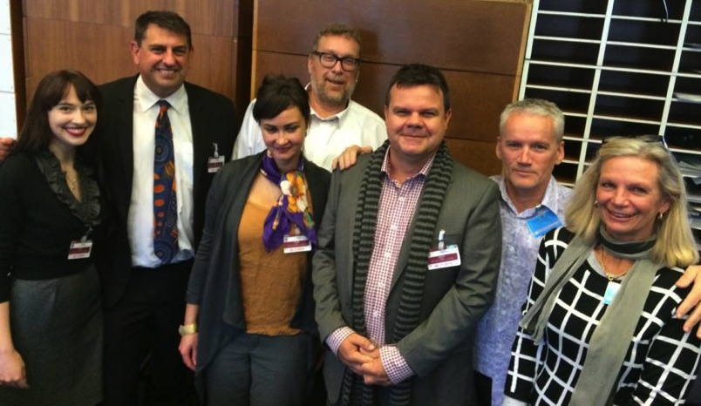
Australian Disability NGO Representatives
The day commenced with the Australian Government delegation responding to the extensive number of questions that the Committee had asked the previous day in Session One. The questions, and issues under question, had been divided up amongst various Government officials to answer. Mr. Quinn discussed Articles 2 and 16 in relation to Domestic Violence, stating that the Australian Government 'do recognise that if a government consents or acquiesce in violence in commission that the country may be in breach of the convention. However we had understood, perhaps mistakenly, that it was not being alleged that the Government consents or acquiesce in cases of Domestic Violence'. He went on to make it clear that Australia takes domestic violence very seriously. However, it was made clear by the government in their Report to the CAT Committee that:

'As a matter of international law, domestic violence does not fall within the scope of the Convention under articles 2 and 16, as it is not conduct that is committed by or at the instigation of, or with the consent or acquiescence of a public official or other person acting in an official capacity'.

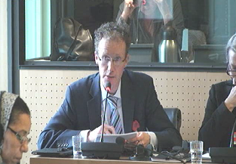
Regarding Sterilisation, Mr. Bouwhuis stated that 'the Australian government is committed to respecting the rights of persons to physical integrity and to retain their fertility'. It was noted that the Senate Inquiry into Involuntary Sterilisation in 2013 considered an outright ban, however came to the conclusion that an outright ban would be unequal for people with disabilities. Therefore it was the government's opinion that the "best interest test" undertaken by a court would provide the necessary equality.
Stephen Bouwhuis responding to the CAT Committee

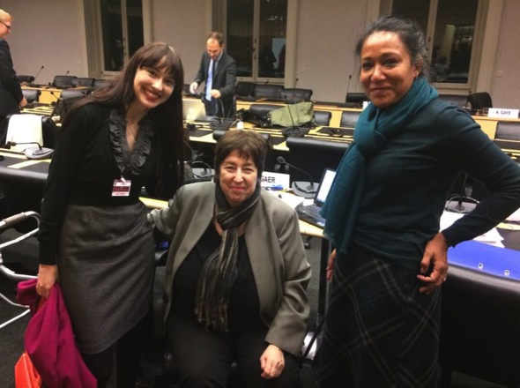
After the government delegation spoke, the Committee members were given another chance to ask questions. Both Mr. Grossman and Ms. Gaer expressed deep concern for the high instance of domestic violence and its affect on vulnerable groups. Mr. Grossman was particularly concerned for "vulnerable" groups, including Indigenous, people with disabilities, and children, and pressed the government on vindication of rights for victims of violence. Ms. Gaer was unsatisfied with the Governments response to violence against women, especially considering the evidence she had already seen regarding domestic violence in Australia. She stated that surely if Australia 'is not responsible for domestic violence, it is the only country in the world'.

The Government was given five minutes to meet and agree on responses for the questions. Given the time, they responded to a limited number of questions. For most of the questions, it was stated that they needed more time to contact other sources or find the required information, and they would respond within 24 hours. Mr. Quinn made an attempt to respond to the issue of domestic violence in his closing statement, concluding that Australia takes the issue seriously, however, 'every country has a problem here'.
Cashelle Dunn with Committee Members Felice Gaer
& Sapana Pradhan-Malla

As the second session closed, I raced over to talk to Committee members Gaer and Pradhan-Malla, who were both particularly concerned about violence against women, and sterilisation of women with disabilities. I wanted to make sure I cleared up any misconceptions they felt after the government feedback, and reiterate our key issues of concern. Ms. Pradhan-Malla expressed frustration at the Australian Government's ignorance toward her question on sterilisation of people with disability and measures they were taking to ensure it was a free and informed choice. We discussed the "best interest test" and the fact that a third party was still making the decision for the person with a disability, without free, informed and prior consent of that person concerned. Rapporteur Gaer was shocked at the Australian Government's ambivalence toward the issue of violence against women. We discussed the Government's rigid view of VAW, and unwillingness to incorporate the other forms of torture and abuse that women with disabilities experience into the National Plan. I also had the opportunity to have a brief discussion with Special Rapporteur Grossman before he went to his next meeting. He told me that issues of women’s empowerment and the protection of vulnerable groups were very important to him. I thanked him for his hard work, and encouraged him to make strong recommendations around the issues of violence against women with disabilities, and forced and coerced sterilisation of women with disabilities.
It was a rushed goodbye to the members of the delegation, and a number of them had to leave quickly from the meeting to go to the airport to go back to Australia. Other delegates had decided to stay on a few extra days at the OHCHR in Geneva to sit in on the open sessions for the United States CAT Review, and some delegates were travelling to other parts of Europe.
Callan and Cashelle Dunn with the Matterhorn

Day Nine to Eleven: Swiss Countryside

I decided to stay a couple of extra days in Switzerland to see a small part of what the country has to offer. Callan and I travelled to Zermatt first. The train ride was incredible, and I was breath taken by the unique beauty of the countryside. It was certainly something I had never come across before. Zermatt is the village at the base of the famous Matterhorn Mountain. Unlike Geneva where the common language is French, they more commonly speak German in Zermatt; however, everyone was very accommodating to speak English to us. Snow-capped mountains surround Zermatt, and the village streets were so small that they only had tiny cars/trucks in the village. It reminded me of 'Whoville' from the tale of "The Grinch who Stole Christmas" by Dr. Seuss. Needless to say, the whole town was so pretty, clean and cute, it did not feel real. I woke in Zermatt to a view of the Matterhorn from my bed, and proceeded to catch the train up mountain that would give "the best view of the Matterhorn". It was not oversold, everything from the train ride up, the snow that surrounded us at the top of the mountain, and the tiny dogs that also came along, made it a thrilling experience!
Lucerne

That afternoon we went to Lucerne, arriving after dark. Lucerne is a medieval city, with cobblestone streets, town square water fountains in the traditional French style, and a beautiful river running through the town. Walking around at night, although cold, was so beautiful. The Christmas lights had already started to be put up, so this Dark-Age style town was twinkling with fairy lights. They had managed to incorporate modernity (e.g. clothing and electronics stores) whilst maintaining the Gothic exterior. When it was clear in the morning, it was also possible to see the snow-capped mountains overlooking this town. That day we decided to go to Pilatus, a mountain near Lucerne, which has a cogwheel train to go to the top. It felt like I was in a fairy tale at that point. Below me I could not see ground, just the parts of mountains, and cloud. I felt spoilt just having the opportunity to stand there and be surrounded by such beauty.

However, all incredible, amazing, life-altering experiences come to an end, and it was time to go home. We got up early, caught the train to Geneva, and prepared for the very long journey ahead.
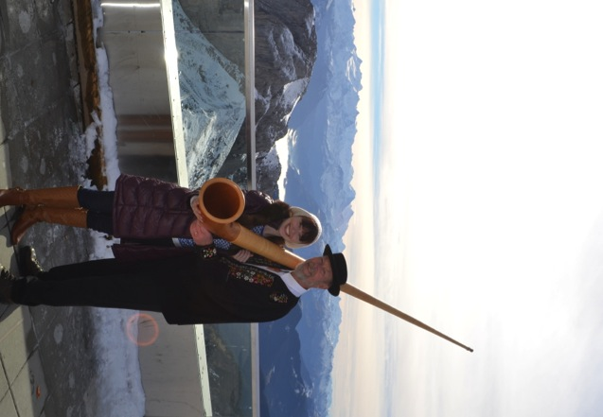
Old Town, Geneva
Pilatus, near Lucerne

Release of CAT Concluding Observations

On November 28th, the CAT Concluding Observations of Australia's review was officially released. They contain very strong recommendations to the Australian Government regarding its international obligations to ensure people can realise their human rights and be free of torture, and other cruel, inhuman or degrading treatment or punishment. The Concluding Observations are attached in full in the Appendix.

The Concluding Observations congratulate Australia for the positive reforms that have been implemented, such as:
- The Torture Act 2010;
- The Human Rights (Parliamentary Scrutiny) Act 2011;
- The Family Violence Act 2011;
- The National Action Plan to reduce Violence against Women and their Children 2010-2022.

However, the Concluding Observations outline principal subjects of concern and corresponding recommendations. The Committee expressed concern at the rates of violence perpetrated against women with disabilities and has called on the Australian Government to redouble its efforts to prevent and combat ALL forms of violence against women by:
- Effectively addressing the barriers that may prevent women from reporting act of violence against them;
- Promptly, effectively and impartially investigating all reports of violence and prosecuting and punishing perpetrators in accordance with the gravity of their acts;
- Strengthening pubic awareness-raising activities to fight violence against women and gender stereotypes;
- Increasing efforts to address violence against indigenous women and women with disabilities;
- Guaranteeing in practice that all victims benefit from protection and have access to sufficient and adequately funded medical and legal aid, psychosocial counselling and social support schemes, that take into account their special needs;
- Guaranteeing in practice that victims who are not placed under the “safe at home” model have access to adequate shelters;
- Further intensify community-based approaches to address violence against women with the involvement of all relevant stakeholders.
The Committee expressed its concern that involuntary or coerced sterilization of children and adults with disabilities is an ongoing practice in Australia, and recommended that Australia enact national uniform legislation prohibiting, except where there is a serious threat to life or health, the use of sterilisation without the prior, free and informed consent of the person concerned, and ensure that, once adopted, this legislation is effectively applied.

Where to From Here

In many ways, the Concluding Observations from Australia’s review under the CAT represent just the beginning of work. Our job is to actively use the Concluding Observations in our advocacy efforts to lobby for implementation of the recommendations at all levels of government. The Concluding Observations need to be used by women, people with disabilities, and their representative and advocacy organisations. They should also be used by governments throughout Australia to review, plan and implement further actions for progressing the human rights in Australia. WWDA will be looking at ways to ensure that the Abbott Government as a matter of urgency acts upon the CAT Committee’s recommendations concerning women and girls with disabilities.

Appendix 1: Civil Society Delegation Formal Opening Statement

Friday 7th November 2014

Good afternoon my name is Ngila Bevan, and on behalf of the Australian Civil Society Delegation I thank the Committee for taking the time to meet with us today.

The organisations present today represent the voice of some of the most vulnerable and marginalised populations in Australia: Aboriginal and Torres Strait Islander people, people with disability, women, children, care leavers, prisoners and people seeking asylum. The lives of far too many of the people in these groups are coloured by systematic violence, abuse, mistreatment, and ill treatment: all of which is preventable but currently continues unaddressed and unabated. In many instances the vulnerability of the person, the prolonged and repeated nature of the abuse, and the identity of the perpetrator leads these experiences to constitute torture.

Systemic failures in our policing and criminal justice systems do not only heighten the risk of ill treatment, particularly for Aboriginal and Torres Strait Islander people and people with disability. The systems also fail as mechanisms of redress for violations, especially for survivors of sexual abuse and domestic violence.

The risk of ill treatment is also heightened whenever a person is disempowered, whether it be by a partner or carer; institution such as a school, church, disability support service, prison, or immigration detention centre; or discriminatory provisions within the law. The failure of Australian governments to protect the marginalised from violence in these contexts is illustrated by the lack of comprehensive human rights legislation and protection from cruel, inhuman or degrading treatment or punishment. The failure to provide protection from and redress for human rights abuses experienced by Australians also extends to those who come to our shores seeking help.

As alarming and disturbing as Australia’s treatment of asylum seeks may be, in many respects this attitude towards the vulnerable is not a radical departure from the way that many people and some communities within Australia are regarded. Indeed the common governmental perception that Australia is somehow beyond the need for human rights law still persists.

Our overarching request to you today is to reiterate that this is firmly not the case. Australia is a wealthy country; a lack of political will as opposed to a dearth of resources leading to our stagnation in the realisation of human rights - the flagrant disregard for treaty body views is testament to this. Australia is a stable and democratic country, which should be held to the highest standard of human rights implementation. We are also keen to see Australia’s ratification of OPCAT as a priority – to shine a light on some of our darkest institutions and to act as a positive catalyst for reform.

There is a considerable amount of expertise from Australia here today, and we are keen to leave as much time for questions as possible. Being mindful of the time, each organisation will make a very brief statement highlighting the key issues they wish to address.

Appendix 2: Opening Statements - Civil Society Disability Organisations

Australia’s NGO discussion with the Committee against Torture
Friday 7th November 2014

Damian Griffis

As the only indigenous organisation within this delegation, the First Peoples Disability Network thanks the Committee for an opportunity to speak to our concerns on Australia's compliance with its Treaty obligations and its commitment to securing the human rights of Australia's First Peoples.

There are many concerns for our Peoples in relation to Australia's compliance with the Treaty, and the time allotted would not do justice to the scope nor the people who are affected by them. Accordingly, we focus our comments on the operation of Article 11, with reference to the rate of incarceration of Indigenous people and secondly, the continuation of deaths of Indigenous people in custody. These matters are not new to the Committee, as it made recommendations on these issues following its last meeting in 2008.

We can report to the Committee that since its last meeting, Australia's compliance has not improved. In fact, the situation has deteriorated. Australia's official statistics agency recently reported that the imprisonment rate of Indigenous people is now 1,958 per 100,000; fifteen times that of other Australians. This represents an 11.9% increase since the Committee's last report in 2008. By contrast, over the same period, the imprisonment rate for other Australians declined slightly.

There have also been deaths of Aboriginal people in custody, which highlight a continued failure in the Australian Government's duty of care to safeguard the right to health of people in detention. Members of our Aboriginal communities have reported to us that the behaviours of State Government Agencies and private contractors within the justice system relating to First Peoples in custody continue unabated, showing the lessons of past deaths in custody has not been learned. This leaves whole families and communities with a lingering sense of injustice, which compounds and prolongs their grief. It is our concern that the lack of accountability of the Government Agencies responsible for the criminal justice system, and the increased use of private contractors are signs that the Australian Government seeks to outsource its duty of care as to avoid it. Whilst we come here as an Indigenous organisation, we also come here as an organisation for the rights of people with disability. In noting that disability is a common attribute in many of the cases, which have been used to illustrate the Australian Government's failure in its duty of care to people in detention, it is the untold story in justice. A number of jurisdictions have inadequate processes to administer the justice system to effectively process people with mental impairment in a timely manner, leaving them subject to indefinite detention in prison without conviction, sometimes for many years.

Disability is largely ignored in public policy; therefore Indigenous people with disability can experience "double discrimination" - judged once by stereotypes about their Indigeneity and judged twice by stereotypes about their disability. There are some jurisdictions in particular which have defects in their judicial administration systems. The consequence is that a significant number of Indigenous peoples are subjected to lengthy and unjustified spells of indefinite incarceration without conviction. It is a lack of awareness of disability, which perpetuates institutional discrimination as a causal factor in the escalating rates of unwarranted detention of our Peoples, and the discharge of their rights whilst in detention.

A disability-informed justice policy provides constructive means for aiding Australian compliance with the Treaty. We commend a disability-informed action plan for much-needed justice reforms, which if developed in genuine consultation with Indigenous people, could act as a catalyst for addressing Australia's current noncompliance and reforming the dire situation it is presently in.
Ngila Bevan
As the representative from People with Disability Australia I am pleased that there are other organisations here that will raise many of our priority issues.

I simply draw your attention to Section 3 of our submission, which looks at the denial of legal capacity as a gateway to practices which constitute ill-treatment.

Related to this I highlight the increasing use of prisons to manage unconvicted people with disability including the establishment of Disability Justice Centres (section 4.4 and 7 of our submission). These Centres are a new form of disability based detention which although essentially function as prisons actually sit outside of this system in terms of oversight.

Moreover, despite recommendations made by the Committee in 2008, little has been done to address the over representation of people with disability in the prison system particularly children and young people. Failures to provide reasonable accommodation to prisoners with disability and the use of restrictive practices such as seclusion and solitary confinement also continue.

PWDA wants to see an end to the unwarranted use of prisons for the management of unconvicted people with disability, and mandatory guidelines and practice to ensure that people with disability in the criminal justice system are provided with appropriate supports and accommodations.

I am happy to take questions on this and any other aspects of our submission. Thank you.

David Manwaring

My name is David Manwaring and I am from Queensland Advocacy Incorporated. We thank the Committee for the opportunity to speak about the treatment of persons with disability in Australia – specifically Restrictive Practices and Involuntary Treatment.
In spite of previous recommendations and findings of this Committee, and or the Special Rapporteur, many people with disability continue to be routinely subject to both regulated and unregulated restrictive practices and or behaviour modification.
Restrictive practices include seclusion, containment, mechanical, chemical and physical restraint as well as detention and time out. The alleged aim of these practices is to manage behaviour that is deemed ‘challenging’ or which may cause harm to the person or others. However, restrictive practices are used as a means of coercion, discipline, and punishment.

Discrimination plays large part in the application of Restrictive Practices and therefore can constitute torture. At the very least restrictive practices constitutes cruel, inhuman or degrading treatment or punishment.

- The Special Rapporteur on Torture Juan Mendez previously concluded that seclusion (solitary confinement) on a person with disability is cruel, inhuman or degrading treatment and if for prolonged periods it is torture.
- Restrictive practices occur not only in disability services, but also within mental health, schools, prisons settings.
- Research and data on the use and impact of restrictive practices on people with disability is limited. However the available research suggests ‘challenging behaviour’ exhibit by a person with a disability is the result of the maladaptive environment.
- Changing systems, services and environment should be the starting point for changing behaviour – rather than changing the person.

The Queensland and Victoria government have legislated to regulate the use of restrictive practice, other states rely on policy – nonetheless restrictive practices are sanctioned by all governments in Australia. A permissive rather than a preventive attitude exists.

An example of this is Australia’s National Framework for Reducing and Eliminating the Use of RP in the disability sector appears to focus more on when and how to use RP’s rather than preventing them. Whilst there are references to the CRPD it is arguable that obligations arising under the CRPD are not being met in this framework. Additionally the framework fails to extend to all settings that RP occur. The framework would work better if consideration was given to Australia’s obligations under CAT – including ratification.

People with disability who refuse treatment can be detained under mental health laws across Australia. These laws fail to prevent the use of invasive and or irreversible treatments such as psychosurgery, ECT and sterilisation (including the use of anti-libidinal drugs). Mental health laws also fail to adequately protect people with disability from arbitrary detention or involuntary treatment. They can be confined to residential facility, forensic disability services and even mental health facilities where they are subject to seclusion and timeout.

Australia’s interpretative declaration on CRPD Art 17 (protecting integrity of person) affects how the government sees current mental health legislation, policy and frameworks surrounding involuntary treatment. The Government interpretation allows for compulsory/involuntary treatment when it is necessary, as a last resort with appropriate safeguards. It is arguable that these safeguards are sufficient.

Cashelle Dunn

Thank you for this opportunity to speak to you today.

Violence against women in Australia is being described in our communities as ‘a national human rights emergency’. And the epidemic that is violence against women in Australia is getting worse, not better. A national study commissioned by the Australian Government and released in September 2014, found that there has been minimal progress over the past 5 years in addressing gender inequality and violence against women in Australia.

In our country, one woman is killed every week by a current or former partner. One in three women have experienced physical and/or sexual violence. Our Aboriginal women are 35 times more likely to experience family violence than non-Aboriginal women. Our disabled women are 40% more likely to be the victims of domestic violence than women without disability. More than a quarter of rape cases reported by females in Australia are perpetrated against women with disabilities. Our women from culturally and linguistically diverse backgrounds and communities are more likely to be murdered as a result of domestic violence. And in our country, more than 67% of domestic violence incidents go unreported.

Yet, in Australia, there is no national, coordinated legislation to prevent and address all forms of violence against women. The Australian Government's primary response to addressing violence against women is set out in the 12 year National Plan to Reduce Violence against Women and their Children. Although there have been some positive developments under the Plan, it has significant limitations, in that it focuses only on domestic violence and sexual assault in intimate partner relationships, and fails to consider or address the many other forms of violence perpetrated against women and girls (such as violence in institutions, forced sterilisation or forced abortion). Although for example, the National Plan is a shared initiative of Commonwealth, State and Territory Governments, the Australian Government is yet to enforce state and territory collaboration on domestic violence death reviews and establish a national public database of death review recommendations.

Given the legislative and policy vacuum to address all forms of violence against women in Australia, we remain deeply concerned at the high rates of all forms of violence perpetrated against women and girls with disabilities, particularly those in institutional and residential settings. In 2013, the CRPD Committee recommended that Australia take urgent action to investigate and address, without delay, violence and abuse experienced by women and girls with disabilities living in institutional and residential settings. These recommendations from the CRPD Committee echo the 2006 and 2010 Concluding Recommendations to Australia from the CEDAW Committee, yet none of these recommendations have been acted upon. Violence against women and girls with disabilities in institutional and residential settings remains an urgent, unaddressed national crisis, of epidemic proportions. We re-iterate our decade long call to the Australian Government to urgently launch a national inquiry into violence against people with disabilities in residential and institutional settings.

We remain deeply concerned that forced sterilisation of women and girls with disabilities is a practice that remains legal and sanctioned by Governments in Australia. Since 2005, the United Nations treaty monitoring bodies have consistently and formally recommended that the Australian Government enact national legislation prohibiting the use of sterilisation of boys and girls with disabilities, and of adults with disability in the absence of their prior, fully informed and free consent. Yet these recommendations have to date, been ignored.

We express our concern at the significant increase in the use of forced/involuntary electroshock (ECT) on women in Australia, including on very young women. Nearly three times as many women are receiving involuntary ECT compared with men. Civil society organisations have called on the Australian Government to conduct an urgent national Inquiry into the use of forced and/compulsory medical and psychiatric treatments and interventions on people with disabilities. The CRPD Committee has also recently recommended that Australia “repeal all legislation that authorises medical interventions without free and informed consent of the persons with disabilities concerned”.

Thank you.

Appendix 3: Australian Government Delegation Opening Statement

Australia’s appearance before the Committee against Torture
Australia’s Opening Statement
10 November 2014

Chairperson, distinguished members of the Committee.
It is an honour to meet you today to discuss Australia’s Fifth Report under the Convention, and Australia’s implementation of the rights and obligations under the Convention.
The Australian Government takes its obligations under the Convention very seriously. Since ratifying the Convention in 1989, Australia has worked to ensure Australia’s laws, policies and practices are consistent with our international obligations both under the Convention as well as more generally.
Australia welcomes the opportunity provided by this constructive dialogue with the Committee over the next two days to reflect on progress achieved and consider possible areas for further improvement.
We note that Australia has made progress on a number of the concluding observations issued by the Committee in 2008 following our fourth periodic report, several of which we will discuss and share with the Committee in this during opening statement and during our dialogue with the Committee over the next two days.
In the spirit of cooperation, the Australian delegation will attempt to provide the Committee with detailed and thorough answers to the questions posed by the Committee, whether or not the questions or information provided in response to them bear directly on obligations arising under the Convention.
As a reflection of the great importance Australia places on the Convention and meeting our obligations under it and we have brought together a senior, multi-agency delegation whose members are will do their best to answer your questions.
- I am John Quinn, Australia’s Permanent Representative to the United Nations and Ambassador for Disarmament in Geneva.
I am joined by the following representatives:
- Dr Wendy Southern PSM, Deputy Secretary, Policy Group, and
- Mr Mark Cormack, Deputy Secretary, Immigration Status Resolution Group, both from the Department of Immigration and Border Protection.
The Department of Immigration and Border Protection is responsible for ensuring the integrity of Australia’s borders through well-managed migration programs, including for humanitarian entrants.
- Mr Stephen Bouwhuis, Assistant Secretary, Human Rights Policy Branch, and
- Ms Tracey Pearce, Human Rights Policy Branch, both from the Attorney General’s Department.
The Attorney General’s Department is responsible for providing legal and policy advice on Australia’s federal human rights laws and its international obligations and for issues relating to law and justice.
- Mr Kevin Playford, Human Rights and Gender Equality, Department of Foreign Affairs and Trade.
The Department of Foreign Affairs and Trade works to advance the interests of Australia and Australians internationally by providing foreign, trade and development policy advice to the government and ensuring that Australia’s pursuit of its global, regional and bilateral interests is coordinated effectively.
We are also joined by several colleagues from Australia’s Permanent Mission based here in Geneva who will be assisting with the appearance over the next two days.
Overview of Australia’s federal system
Firstly, I would like put into context Australia’s system of government as this affects fundamentally the ways in which Australia implements and adheres to its obligations under the Convention through its laws, policies and practices.
Australia has a federal constitutional system in which legislative, executive and judicial powers are shared or distributed between the Australian Government and the six States and two internal self-governing Territories. This means that nine governments in Australia share responsibility for implementing the Convention.

The Australian Government works and consults closely with the State and Territory governments across a range of key law and policy areas. We have consulted closely with States and Territories in responding to the Committee’s list of issues in preparing Australia’s Fifth Report and in preparing information for the Committee at this meeting.

The Australian Government also works closely with Australia’s national human rights institution, the Australian Human Rights Commission, to understand and address human rights issues for individuals and groups within Australia.

I would also like to acknowledge the contribution of other non-government organisations and the constructive dialogues the Australian Government has had with them in preparation for this hearing. We recognise the important role played by civil society in implementing the Convention in Australia, and in monitoring the Government’s policies and programs with respect to Australia’s international obligations.

Initiatives

Mr Chairperson, distinguished members of the Committee, I would now like to set out a number of significant achievements in Australia in terms of deepening and strengthening implementation of our obligations under the Convention over the past few years.

- Torture offences
I am pleased to advise that, since Australia’s last appearance before the Committee, the Australian Government has introduced a specific offence of torture in the Commonwealth Criminal Code which has extended geographical jurisdiction, as recommended by the Committee in its 2008 concluding observations.
The offence was implemented in 2010 through amendments to the Criminal Code to more clearly and explicitly fulfil Australia’s obligations under the Convention. In recognition of the serious nature of the crime of torture and its widespread condemnation internationally, the federal offence of torture under the Commonwealth Criminal Code applies to acts of torture, whether or not the conduct constituting the alleged offence occurs in Australia, and whether or not the result of the conduct occurs in Australia.

The specific wording of the new offence has been chosen to ensure that Australia now proscribes unambiguous offences, while still capturing the full scope of prohibited conduct. The enactment of such criminal offences demonstrates the Australian Parliament’s commitment to rejecting and condemning torture in all circumstances.

- Strengthening human trafficking related offences
The Australian Government has taken an effective, comprehensive, whole-of-government approach to combating human trafficking and slavery, and forced marriages.

In 2013, the Commonwealth Criminal Code was amended to strengthen existing offences of human trafficking, slavery and slavery-like practices and to introduce new stand-alone offences of forced marriage and forced labour. These amendments include a new offence of causing a person to enter into a forced marriage and being a party to a forced marriage.
In 2013, the Commonwealth Crimes Act was also amended to protect vulnerable witnesses giving evidence in Commonwealth criminal proceedings, including victims of human trafficking, slavery and slavery-like offences.

Key amendments include the ability for trafficked people to: give evidence by closed-circuit television, video-link or video recording; have their contact with the defendant or members of the public limited; and have a support person with them while they give evidence. It is also an offence to publish material identifying a trafficked person.
The Australian Government has also provided more than $150 million over the past ten years to support a range of domestic, regional and international anti-trafficking initiatives.

- Immigration
The Australian Government remains strongly committed to an effective and robust international protection regime for immigration matters. The global protection environment is now more complex than ever before. And the emergence of new situations of grave protection concern continues to challenge us all. Australia recognises that it is not alone in meeting these challenges. We thank our bilateral, regional and multilateral partners for their continued cooperation in finding durable situations for those people who have been displaced.
In response to increasing numbers of women, men and children lost at sea over recent years while seeking to come to Australia, the Australian Government has strengthened its policies to ensure the protection of migrants, including asylum seekers, and prevent their exploitation at the hands of people smugglers.

The Australian Government’s success in preventing people smuggling ventures from reaching our shores has clearly had a significant humanitarian dividend. In two years, we have increased our Special Humanitarian Programme from 500 to 5,000 places, out of a humanitarian programme of 13,750 places. This success has also allowed us to respond to the call by the United Nations High Commissioner for Human Rights for a coordinated resettlement response to humanitarian crises. For example, in 2014-15 the Australian government has committed a minimum of 2,200 places for Iraqis, including ethnic and religious minorities escaping the violence in northern Iraq by fleeing to neighbouring countries.

The Australian Government has striven to improve the design and procedures of its migration programmes to enhance fairness, accountability and integrity, and continues to do so.

The Australian Government recognises the dual humanitarian imperative both to afford protection where it is owed, and to protect people from abuse and exploitation. We are committed to working with regional countries and international agencies to enhance protection, including through the implementation of effective refugee status determination processes. However, we emphasise that a robust returns process for dealing with those found not to be in need of protection is fundamental to the integrity of status determination processes.

- Human rights legislative scrutiny
Australia has a range of laws, policies, processes and practices that ensure Australia’s compliance with our international obligations is subject to independent and judicial review. An addition to this is a new specialised Committee of the Australian Parliament which explicitly scrutinises all federal legislation against Australia’s international human rights obligations, including the Convention against Torture. The Parliamentary Joint Committee on Human Rights was established in March 2012.
The new legislation also requires that all Bills and disallowable legislative instruments brought before the Parliament are tabled with a Statement of Compatibility setting out how the legislation is consistent with Australia’s international human rights obligations.

The Committee engages directly with the sponsors of legislation, writing to Ministers, Private Members or other rule-makers, to seek further information before forming a view as to the compatibility of proposed legislation with these obligations.

These human rights scrutiny processes are designed to encourage early and ongoing consideration of human rights issues in policy and legislative development. The new processes have been welcomed by the Parliament and the Australian public.

- Indigenous Australians
The Australian Government is committed to improving the lives of and opportunities for Indigenous Australians. The Government has made significant changes to the way it manages the portfolio of Indigenous affairs, prioritising it at the highest levels of government, including by establishing the Prime Minister’s Indigenous Advisory Council and working towards recognition of Indigenous peoples in Australia’s Constitution.

The Australian Government is working in close cooperation with states and territories to further the rights and interests of Australia’s Indigenous population. The Australian Government has committed $4.8 billion in spending over four years to the Indigenous Advancement Strategy. This strategy, through a variety of programs, will support the two key priorities of getting children to school and adults to work.

The Indigenous Advancement Strategy will also provide an opportunity for practical engagement with Indigenous Australians, service providers, business and government to make sure solutions are tailored to local needs, and targeted to the Government’s priority areas.

The Australian Government remains committed to the Closing the Gap targets and is currently considering ways to improve community safety and reduce Indigenous contact with the justice system. Reducing Indigenous disadvantage in other areas, such as the priority areas of education and employment, will have wider positive impacts on Indigenous communities throughout Australia.

The Australian Government shares an underlying, fundamental and ongoing international commitment to deliver real and lasting improvements to the lives of Indigenous peoples and to their communities.
Conclusion
Mr Chairperson, distinguished members of the Committee.
I am pleased to share this information on Australia’s laws, policies, and programs that promote, strengthen and protect Australia’s obligations under the Convention. We do, however, recognise that more can always be done. We endeavour to review and evaluate constantly existing measures to ensure they remain appropriate and relevant to achieving the most effective implementation of Australia’s obligations under the Convention. We see our appearance before the Committee as an integral part of that evaluation.
On behalf of the Australian delegation, I wish to thank you for this opportunity for constructive, forward looking dialogue.

Appendix 4: CAT Concluding Observations - Australia

Committee against Torture
Concluding observations on the fourth and fifth periodic reports of Australia
ADVANCE UNEDITED VERSION
1. The Committee against Torture considered the combined fourth and fifth periodic reports of Australia (CAT/C/AUS/4-5) at its 1260th and 1263th meetings, held on 10 and 11 November 2014 (see CAT/C/SR.1260 and 1263), and adopted at its 1284th and 1285th meetings, held on 26 November 2014 (see CAT/C/SR.1284 and 1285), the following concluding observations.
A. Introduction
2. The Committee expresses its appreciation to the State party for having accepted the optional Simplified Reporting Procedure (LOIPR) allowing for a more focused dialogue between the State party and the Committee.
3. The Committee welcomes the interactive dialogue held with the State party’s high- level multisectoral delegation, as well as the additional information and explanations provided by the delegation to the Committee.
B. Positive aspects
4. The Committee welcomes the State party’s ratification of or accession to the following international instruments:
(a) The Convention on the Rights of Persons with Disabilities, in 2008;
(b) The Optional Protocol to the Convention on the Elimination of All Forms of Discrimination against Women, in 2008;
(c) The Optional Protocol to the Convention on the Rights of Persons with Disabilities, in 2009.
5. The Committee welcomes the legislative changes in areas of relevance to the Convention, including:
(a) The Crimes Legislation Amendment (Torture Prohibition and Death Penalty Abolition) Act 2010, enacting a new offence of torture in the Criminal Code and ensuring non-reintroduction of the death penalty by a State or a Territory;
(b) The Human Rights (Parliamentary Scrutiny) Act 2011, which requires an assessment of compatibility of new legislation with human rights and establishes a Commonwealth Parliamentary Joint Committee dedicated to human rights scrutiny;
(c) The Family Law Legislation Amendment (Family Violence and Other Measures) Act 2011;
(d) The Extradition and Mutual Assistance in Criminal Matters Legislation Amendment Act 2012;
(e) The Crimes Legislation Amendment (Slavery, Slavery-like Conditions and People Trafficking) Act 2013;
(f) The Crimes Legislation Amendment (Law Enforcement Integrity, Vulnerable Witness Protection and Other Measures) Act 2013.
6. The Committee welcomes the efforts of the State party to give effect to the Convention, including:
(a) The release of the National Human Rights Action Plan, in December 2012;
(b) The adoption of a National Action Plan to reduce Violence against Women and Their Children 2010-2022;
(c) The creation of the position of the Independent National Security Legislation Monitor in 2010, to, inter alia, review counter-terrorism and national security legislation taking into account international human rights obligations;
(d) The establishment of a public online database of recommendations from United Nations human rights mechanisms.
7. The Committee notes with appreciation the existence of a vibrant civil society that significantly contributes to the monitoring of torture and ill-treatment, thereby facilitating the effective implementation of the Convention in the State party.
C. Principal subjects of concern and recommendations
National Human Rights Institution
8. The Committee welcomes the work of the Australian Human Rights Commission. However, it notes that the Commission does not yet have statutory powers to monitor the implementation of the State party’s obligations under the Convention (art. 2).
The State party should consider strengthening the Commission by providing it statutory powers to monitor the implementation of the State party’s obligations under the Convention.
Violence against women
9. While welcoming the legislative and other measures adopted by the State party to prevent and combat violence against women, the Committee notes with concern reports on the persistence of violence against women, which disproportionately affects indigenous women and women with disabilities. The Committee is also concerned at information received that over 50 percent of the cases of violence against women are not reported (arts. 2, 12, 13, 14 and 16).
In light of its General Comment No. 2 (CAT/C/GC/2), the Committee recommends that the State party redouble its efforts to prevent and combat all forms of violence against women throughout its territory by inter alia:
(a) Taking measures to facilitate the lodging of complaints by victims and to effectively address the barriers that may prevent women from reporting acts of violence against them;
(b) Ensuring the effective enforcement of the existing legal framework by promptly, effectively and impartially investigating all reports of violence and prosecuting and punishing perpetrators in accordance with the gravity of their acts;
(c) Strengthening public awareness-raising activities to fight violence against women and gender stereotypes;
(d) Increasing its efforts to address violence against indigenous women and women with disabilities;
(e) Guaranteeing in practice that all victims benefit from protection and have access to sufficient and adequately funded medical and legal aid, psychosocial counselling and social support schemes, that take into account their special needs, and that victims not placed under the “safe at home” model have access to adequate shelters;
(f) Further intensify community based approaches to address violence against women with the involvement of all relevant stakeholders.
Trafficking in persons
10. The Committee greatly values the comprehensive and strong legislative framework and other measures adopted to address trafficking in persons. Human trafficking remains however a matter of concern as the State party reportedly continues to be a destination country. The Committee notes with satisfaction the Human Trafficking Visa Framework adopted by the State party. Temporary Bridging F visas are granted to any person identified as a suspected victim of human trafficking, but the further visas that would allow victims inter alia to have access to benefits of family reunification and effective support are linked to the involvement of the victim in criminal proceedings (arts. 2, 12, 13, 14 and 16).
The State party should continue and strengthen its efforts to combat trafficking in persons. In this respect, additional necessary measures required include:
(a) Vigorously enforce the existing legislative framework and promptly, thoroughly and effectively investigate, prosecute and punish with appropriate penalties trafficking in persons and related practices, ensuring the allocation of all means required for such purpose;
(b) Guarantee that sustained, equal and effective assistance is provided to all victims of trafficking, in particular taking into consideration that in numerous circumstances victims are in a psychological or familiar situation that prevents them from participating in criminal proceedings.
Arrangements for the custody and treatment of persons deprived of liberty
11. The Committee is concerned at reports that, despite remedial measures taken by authorities, overcrowding remains a problem in many places of deprivation of liberty. It is also concerned at reports that, in a number of places of deprivation of liberty, the material conditions, including in the Roebourne Regional Prison, and health care services, in particular mental health services, are inadequate. The Committee, while taking note the information provided by the delegation, is also concerned that, during the reporting period, the reported number of deaths in custody, including of indigenous people, is high. In this respect, the Committee takes note of the information provided by the delegation that all deaths in custody must be referred to a coroner for investigation (arts. 2, 11 and 16).
The State party should strengthen its efforts to bring the conditions of detention in all places of deprivation of liberty in line with relevant international norms and standards, including the Standard Minimum Rules for the Treatment of Prisoners and the Bangkok rules, in particular by: a) continuing to reduce overcrowding, particularly through the wider application of non-custodial measures as an alternative to imprisonment, in the light of the Tokyo Rules; and b) ensuring that adequate somatic and mental health care is provided for all persons deprived of their liberty, including those in immigration detention. It should also increase its efforts to prevent deaths in custody and further strengthen its efforts to ensure that all incidents of death in custody are promptly, effectively and impartially investigated and, on a finding of criminal responsibility, lead to a penalty proportional to the gravity of the offence.
Indigenous people in the criminal justice system
12. Noting with satisfaction the measures taken by the State party to address the situation of indigenous people, including the Indigenous Advancement Strategy, the Committee is concerned at information received that indigenous people continue to be disproportionately affected by incarceration, reportedly representing around 27 percent of the total prisoner population while constituting between two and three percent of the total population. In this respect, the Committee notes with concern the reports indicating that overrepresentation of indigenous people in prisons has a serious impact on indigenous young people and indigenous women. The Committee is also concerned at reports that mandatory sentencing, still in force in several jurisdictions, continues to disproportionately affect indigenous people. Furthermore, and while welcoming the information concerning the legal assistance services available for indigenous people, the Committee is concerned at reports that these services are not adequately funded (arts. 2, 11 and 16).
The State party should increase its efforts to address the overrepresentation of indigenous people in prisons, in particular its underlying causes. It should also review mandatory sentencing laws with a view to abolishing them, giving judges the necessary discretion to determine relevant individual circumstances. The State party should also guarantee that adequately funded, specific, qualified and free-of-charge legal and interpretation services are provided as from the outset of deprivation of liberty.
Use of conducted energy weapons (Tasers)
13. While noting the information provided by the delegation that the use of conducted energy weapons is tightly regulated and controlled in each jurisdiction and subject to oversight and scrutiny processes, the Committee is concerned at reports of cases of inappropriate or excessive use (arts. 2, 12, 13, 14 and 16).
Taking into consideration the lethal and dangerous impact of conducted energy weapons on the physical and mental state of targeted persons, the State party should consider abolishing their use. If that is not the case, it should adopt the necessary measures to effectively ensure that, in all jurisdictions, conducted energy weapons are used exclusively in extreme and limited situations – where there is a real and immediate threat to life or risk of serious injury – as a substitute for lethal weapons and by trained law enforcement personnel only. In this respect, the State party should consider adopting national uniform rules governing the use of such weapons with a view to ensuring that a high threshold for their use is established and expressly prohibiting their use on children and pregnant women. The State party should also ensure that all jurisdictions strengthen their efforts to effectively provide regular adequate training to law enforcement personnel entitled to use conducted energy weapons. In addition, the State party should ensure that all allegations of excessive or inappropriate use of these weapons are promptly, impartially and thoroughly investigated and that victims obtain redress and fair and adequate compensation.
Counter-terrorism legislation
14. Bearing in mind its previous concluding observations (CAT/C/AUS/CO/3, para. 10) and the latest concluding observations of the Human Rights Committee (CCPR/C/AUS/CO/5, para. 11), the Committee remains concerned about aspects of the State party’s counter-terrorism legislation, including the broad definition of “terrorist act”
As well the reports concerning the need to further restrict the warrant powers provided to the Australian Security Intelligence Organisation (ASIO) to detain a person for the purpose of questioning with the possibility of restricting access to a lawyer of choice. In this respect, the Committee appreciates the information provided by the State party that ASIO’s detention powers have never been utilised (art. 2).
The State party should take the necessary legislative or other measures to adopt a more precise definition of terrorist act as well as to ensure that all counter-terrorism and national security legislation, policies and practices are in full compliance with the Convention and that adequate and effective legal safeguards are in place.
Non-refoulement
15. The Committee is concerned at policies and practices currently applied in relation to persons who attempt to arrive or arrive irregularly in the State party, in particular the policy of intercepting and turning back boats, without due consideration of the State party’s obligations under article 3 of the Convention. In addition, the Committee is concerned at bills introduced into Parliament that would reduce some of the existing statutory standards against refoulement, in particular the Migration and Maritime Powers Legislation Amendment (Resolving the Asylum Legacy Caseload) Bill 2014, which inter alia establishes that “An officer’s duty to remove as soon as reasonably practicable an unlawful non-citizen under section 198 [of the Migration Act 1958] arises irrespective of whether there has been an assessment, according to law, of Australia’s non-refoulement obligations in respect of the non-citizen” (arts. 2 and 3).
The State party should adopt all the necessary legislative and other measures with a view to ensuring that it effectively meets its non-refoulement obligations under the Convention, in particular with regard to all asylum seekers and other persons in need of international protection who attempt to arrive or arrive in the State party, regardless of the mode and date of arrival. The State party should guarantee that all asylum claims are thoroughly examined and that the persons concerned have a real opportunity to effectively challenge any adverse decisions adopted concerning their claims. It should also guarantee that all asylum seekers have access to independent, qualified and free-of-charge legal assistance during the entire asylum procedure. The State party should also refrain from adopting any legislative or other measures that may lower the existing safeguards and standards of protection which could constitute a violation of its obligations under the Convention.
Mandatory immigration detention, including of children
16. The Committee remains concerned that detention continues to be mandatory for all unauthorised arrivals, including for children, until the person concerned is granted a visa or removed from the State party. It is also concerned that the law does not establish a maximum length for a person to be held in immigration detention, reportedly resulting in protracted periods of deprivation of liberty. The Committee is further concerned at reports that stateless persons whose asylum claims have not been accepted and refugees with an adverse security or character assessment can be detained indefinitely (arts. 2, 11 and 16).
The State party should adopt the necessary measures with a view to considering: a) repealing the provisions establishing the mandatory detention of persons entering its territory irregularly; b) ensuring that detention should be only applied as a last resort, when determined to be strictly necessary and proportionate in each individual case, and for as short a period as possible; and c) establishing, in case it is necessary and proportionate that a person should be detained, statutory time limits for detention and access to an effective judicial remedy to review the necessity of the detention. It should also ensure that persons in need of international protection, children and families with children are not detained or, if at all, only as a measure of last resort, after alternatives to detention have been duly examined and exhausted, when determined to be necessary and proportionate in each individual case, and for as short a period as possible. The State party should also continue and redouble its efforts with a view to expanding the use of alternatives to closed immigration detention. It should also adopt all necessary measures to ensure that stateless persons whose asylum claims were refused and of refugees with adverse security or character assessments are not held in detention indefinitely, including by resorting to non-custodial measures and alternatives to closed immigration detention.
Offshore processing of asylum claims
17. The Committee is concerned at the State party’s policy of transferring asylum seekers to the regional processing centres located in Papua New Guinea (Manus Island) and Nauru for the processing of their claims, despite reports on the harsh conditions prevailing in these centres, including mandatory detention, including for children; overcrowding, inadequate health care; and even allegations of sexual abuse and ill-treatment. The combination of these harsh conditions, the protracted periods of closed detention and the uncertainty about the future reportedly creates serious physical and mental pain and suffering. All persons who are under the effective control of the State party, because inter alia they were transferred by the State party to centres run with its financial aid and with the involvement of private contractors of its choice, enjoy the same protection from torture and ill-treatment under the Convention (arts. 2, 3, 16).
The State party should adopt the necessary measures to guarantee that all asylum seekers or persons in need of international protection who are under its effective control are afforded the same standards of protection against violations of the Convention regardless of their mode and/or date of arrival. The transfers to the regional processing centres in Papua New Guinea (Manus Island) and Nauru, which in 2013 were deemed by UNHCR not to provide “humane conditions of treatment in detention”, does not release the State party from its obligations under the Convention, including prompt, thorough and individual examination of the applicability of article 3 in each case and redress and rehabilitation when appropriate.
Identification of victims of torture among asylum seekers
18. While taking note of the information provided during and after the dialogue, the Committee considers that it does not have sufficient information on the screening carried out with regard to persons who irregularly seek to arrive or arrive to the State party, in particular in the context of the policy of intercepting and turning back boats, so as to be able to assess whether adequate conditions to conduct thorough evaluations that permit to effectively identify victims of torture are in place (arts. 2, 3 and 16).
The State party should:
(a) Ensure that effective measures are in place to identify as early as possible all victims of torture among asylum seekers and other persons in need of international protection, and provide them with priority access to the refugee determination procedure and access to treatment of urgent conditions;
(b) Provide a thorough medical and psychological examination and report, considering the application of the procedures set out in the Istanbul Protocol, by adequately trained independent health experts, with the support of professional interpreters, when signs of torture or traumatization have been detected during the personal interviews and, on that basis, provide access to immediate rehabilitation;
(c) Provide regular training on the procedures established in the Istanbul Protocol to asylum officers and health experts participating in the asylum determination procedure, including on training on detecting psychological traces of torture and on gender-sensitive approaches.
Child sexual abuse
19. While welcoming the establishment of the Royal Commission into Institutional Responses to Child Sexual Abuse, the Committee remains concerned inter alia as to whether the outcome of its work will result in criminal investigations, prosecutions and redress and compensation for victims. Furthermore, the Committee is concerned at the information received regarding the reported reply that the representative of another State party provided to the Royal Commission at one of its hearings that providing all documents regarding sexual abuse by priests in the State party was “unreasonable” and that they represented the “internal working documents of another sovereign State.” The Committee, while taking note of the information provided by the delegation that the Royal Commission is independent and that it has statutory powers to compel the provision of documents, reminds the State party that it has the responsibility to ensure that all reports of breaches of the Convention are promptly and impartially investigated and that assistance is sought from other States parties when necessary to conduct such investigations (arts. 2, 9, 12, 14 and 16).
The State party should adopt the necessary measures to ensure that:
(a) Adequate support is provided to the Royal Commission to enable it to carry out its work efficiently, including by assisting it in seeking relevant information from other States parties;
(b) All allegations of sexual abuse, regardless of the time of their commission, are promptly, impartially, thoroughly and effectively investigated and perpetrators brought to justice and, if found responsible, punished in accordance with the gravity of their acts. In this respect, it should ensure that the work of the Royal Commission supplements criminal prosecutions and court proceedings and is not a substitute for them. The State party should also take all appropriate measures to seek from other States parties the assistance that is necessary, including the supply of all evidence at their disposal, to ensure that meaningful and thorough investigations are carried out;
(c) Victims obtain redress and fair and adequate compensation, including the means for as full rehabilitation as possible.
Sterilisation of persons with disabilities
20. The Committee is concerned at reports received indicating that involuntary or coerced sterilization of children and adults with disabilities is an ongoing practice in the State party (arts 2 and 16).
The Committee recommends that the State party enact national uniform legislation prohibiting, except where there is a serious threat to life or health, the use of sterilisation without the prior, free and informed consent of the person concerned, and ensure that, once adopted, this legislation is effectively applied.
Parliamentary Joint Committee on Human Rights
21. While noting with great appreciation the establishment of the Parliamentary Joint Committee on Human Rights (see paragraph 5(b) above), the Committee observes with concern the reports that its recommendations are not always taken into account (art. 2).
The Committee encourages the State party to implement the recommendations of the Parliamentary Joint Committee on Human Rights as a means of guaranteeing that its legislative framework is fully in line with its human rights obligations, including under the Convention.
Other issues
22. While welcoming that the State party has signed the Optional Protocol to the Convention against Torture on 19 May 2009 and that it is committed to its ratification as a matter of priority (A/HRC/17/10, para. 31), the Committee encourages it to adopt all the necessary measures to accelerate the process of ratification in order to become a party to the Optional Protocol as soon as possible.
23. The Committee invites the State party to become a party to the International Convention on the Protection of the Rights of All Migrant Workers and Members of Their Families; the International Convention for the Protection of All Persons from Enforced Disappearance; the Optional Protocol to the Convention on the Rights of the Child on a communications procedure and the Optional Protocol to the International Covenant on Economic, Social and Cultural Rights.
24. The State party is requested to disseminate widely the report submitted to the Committee and the Committee’s concluding observations, in all appropriate languages, through official websites, the media and non-governmental organizations.
25. The Committee requests the State party to provide, by 28 November 2015, follow- up information in response to the Committee’s recommendations contained in paragraphs 9, 12, 15 and 16 of the present document.
26. The State party is invited to submit its next report, which will be the sixth periodic report, by 28 November 2018. For that purpose, the Committee will, in due course, submit to the State party a list of issues prior to reporting, considering that the State party has accepted to report to the Committee under the optional reporting procedure.

_____________________________________________________

United Nations Office of the High Commissioner for Human Rights, Convention against Torture and Other Cruel, Inhuman or Degrading Treatment or Punishment; 10 December 1984; www.ohchr.org/EN/ProfessionalInterest/Pages/CAT.aspx
United Nations Convention against Torture and Other Cruel, Inhuman or Degrading Treatment or Punishment, List of issues prior to the submission of the fifth periodic report of Australia; 15 February 2014; UN Doc. No: CAT/C/AUS/Q/5
United Nations Convention against Torture and Other Cruel, Inhuman or Degrading Treatment or Punishment; Consideration of reports submitted by States parties under article 19 of the Convention pursuant to the optional reporting procedure: Fourth and fifth periodic reports of States parties due in 2012 - Australia; paragraph 91; 31 July 2013; UN Doc. No: CAT/C/AUS/4-5
Convention against Torture and Other Cruel, Inhuman or Degrading Treatment or Punishment, Torture and Cruel Treatment in Australia, Joint NGO report to the United Nations Committee Against Torture; October 2014; UN Doc. No: CAT_NGO_AUS_18634_E
Convention against Torture and Other Cruel, Inhuman or Degrading Treatment or Punishment, Torture and Cruel Treatment in Australia, WWDA Submission to the CAT Committee; 24 September 2014; UN Doc No CAT_NGO_AUS_18671_E
Women with Disabilities Australia, ‘Dehumanised: The Forced Sterilisation of Women and Girls with Disabilities in Australia’ – WWDA Submission to the Senate Inquiry into the Involuntary or Coerced Sterilisation of People with Disabilities in Australia; March 2013; http://wwda.org.au/issues/sterilise/sterilise2011/senateinquiry2012/
Convention against Torture and Other Cruel, Inhuman or Degrading Treatment or Punishment, Torture and Cruel Treatment in Australia; County Court of Victoria: DPP v. Kumar, Case No. CR-13-00419; 20 November 2013; UN Doc. No: CAT_NGO_AUS_18672_E
United Nations Office of the High Commissioner for Human Rights, Introductory Statement By Australia, 10 November 2014, INT_CAT_STA_AUS_18784_E.docx
Live United Nations Treaty Body Webcast, Australia 1 - CAT 53rd Session, 10 November 2014, http://www.treatybodywebcast.org/cat-53rd-session-australia/
Live United Nations Treaty Body Webcast, Australia 1 - CAT 53rd Session, 10 November 2014, http://www.treatybodywebcast.org/cat-53rd-session-australia/
Live United Nations Treaty Body Webcast, Australia 2 - CAT 53rd Session, 11 November 2014, http://www.treatybodywebcast.org/cat-53rd-session-australia/
United Nations Convention against Torture and Other Cruel, Inhuman or Degrading Treatment or Punishment; Consideration of reports submitted by States parties under article 19 of the Convention pursuant to the optional reporting procedure: Fourth and fifth periodic reports of States parties due in 2012 - Australia; paragraph 91; 31 July 2013; UN Doc. No: CAT/C/AUS/4-5
Live United Nations Treaty Body Webcast, Australia 2 - CAT 53rd Session, 11 November 2014, http://www.treatybodywebcast.org/cat-53rd-session-australia/
Ibid.

