WOMEN WITH DISABILITIES AUSTRALIA (WWDA)

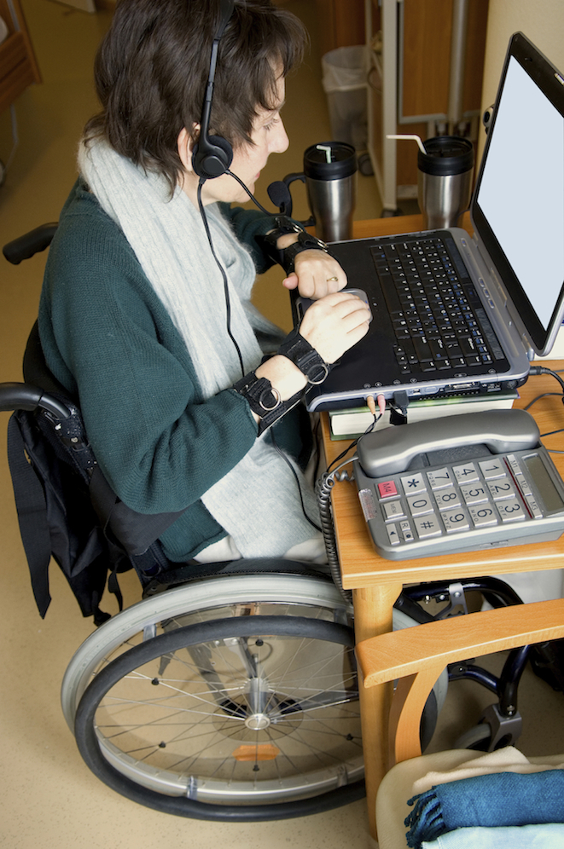

Mid Term Progress Report for the Disability Employment Services (DES) Consumer Engagement Project

FEBRUARY 2014

Mid Term Progress Report for the Disability Employment Services (DES) Consumer Engagement Project

By Carolyn Frohmader for Women With Disabilities Australia (WWDA)

© Women With Disabilities Australia (WWDA) February 2014

Winner, National Human Rights Award 2001
Winner, National Violence Prevention Award 1999
Winner, Tasmanian Women's Safety Award 2008
Certificate of Merit, Australian Crime & Violence Prevention Awards 2008
Nominee, French Republic's Human Rights Prize 2003
Nominee, UN Millennium Peace Prize for Women 2000

Women With Disabilities Australia (WWDA) is the peak non-government organisation (NGO) for women with all types of disabilities in Australia. WWDA is run by women with disabilities, for women with disabilities, and represents more than 2 million disabled women in Australia. WWDA’s work is grounded in a rights based framework which links gender and disability issues to a full range of civil, political, economic, social and cultural rights. Promoting the reproductive rights of women and girls with disabilities, along with promoting their rights to freedom from violence and exploitation, and to freedom from torture or cruel, inhuman or degrading treatment are key policy priorities of WWDA.

WWDA’s human rights based approach recognises that the international human rights normative framework, including the international human rights treaties and their optional protocols, and the general comments and recommendations adopted by the bodies monitoring their implementation, provide the framework to delineate the respective obligations and responsibilities of governments and other duty-bearers in relation to the human rights of women and girls with disabilities. It is this framework that WWDA utilises to promote and indeed demand, accountability from Governments and other duty bearers in relation to recognising and addressing the violations of human rights and fundamental freedoms experienced by women and girls with disabilities.

DISCLAIMER

This publication has been prepared by Woman with Disabilities Australia (WWDA) for the Australian Government, represented by the Department of Social Services. The views expressed in this publication are those of Women with Disabilities Australia (WWDA) and do not necessarily represent the views of the Australian Government.

CONTACT DETAILS

Women With Disabilities Australia (WWDA)
PO Box 605, Rosny Park, Tasmania 7018 AUSTRALIA
Ph: +61 3 62448288 Fax: +61 3 62448255
Mobile: 0438 535 123
Email: wwda@wwda.org.au
Web: www.wwda.org.au
Facebook: http://www.facebook.com/WWDA.Australia
Executive Director: Carolyn Frohmader

Contents

Background 5

The Context 6

The Project Activities and Outcomes 9

Development of WWDA’S DES Consumer Engagement Strategy 2013 9

Development of an effective Participation, Engagement and Consultation Mechanism 9

Participation In DES Consumer Engagement Forum 12

Systemic Advocacy Initiatives 13

Future Initiatives 19

‘We recognise that women, children and Indigenous Australians with disabilities may face multiple intersecting disadvantage. The Australian Government is taking steps to ensure the specific needs of these vulnerable groups are considered during the development and implementation of relevant policies and programs….’

Australian Government Delegation
Closing Statement to the Committee on the Rights of Persons with Disabilities
Delivered by Mr Peter Woolcott; Australian Ambassador, Permanent Mission to the United Nations
4 September 2013

‘The Committee is concerned that employees with disabilities in Australian Disability enterprises (ADE) are still being paid wages based on the Business Services Wage Assessment Tool (BSWAT). The Committee recommends that the State party:
- Immediately discontinues the use of the BSWAT;
- Ensures that the Australians Supported Wage System (SWS) is changed to secure the right assessment of the wages of persons in support employment;
- Adopts initiatives to increase employment participation of women with disabilities by addressing the specific underlying structural barriers to their workforce participation.’

Committee on the Rights of Persons with Disabilities
Concluding Observations [Australia] 4th October 2013, UN Doc. CRPD/C/AUS/CO/1

‘Australia is [also] committed to ensuring people with disabilities receive opportunities to reach their potential by participating in the community and the workforce. Work is essential to an individual's economic security and is important to achieving social inclusion. Employment contributes to physical and mental health, personal wellbeing and a sense of identity…….the Australian Government Disability Employment Services program encourages employment of people with disabilities - by not only helping job-seekers with disability to build their skills, but also building the disability awareness of employers and helping employers meet the costs of making adjustments for employees with disabilities.’

Australian Government Delegation
Opening Statement to the Committee on the Rights of Persons with Disabilities
Delivered by Mr Peter Woolcott; Australian Ambassador, Permanent Mission to the United Nations
3 September 2013

BACKGROUND

In July 2013, the then Minister for Employment Participation, Hon Kate Ellis, advised Women With Disabilities Australia (WWDA) that the Australian Government would be providing $41,000 to a number of national disability organisations, including WWDA, to assist in improving the delivery of Disability Employment Services (DES). The specific purpose of the one of funding grant is to lift consumer engagement and knowledge of the DES program, facilitate provision of consumer advice to the Government about the needs of women with disabilities in the context of the DES, and look at ways to improve future disability employment services. The Australian Government further indicated that a major focus of the funding is to enable the Government:

‘to hear about issues affecting the client group your organisation represents in order to improve DES,’ in order to ‘better assist this group to effectively access information on DES and to hear how we could improve program performance.’

The project commenced early in the 2013/14 financial year and is to be completed by 30 June 2014. WWDA’s obligations in accepting the one off funding grant included:
- a consumer engagement strategy to be provided no later than 1 September 2013;
- a mid-term progress report to be provided by 1 February 2014;
- a statement or declaration that funds made available under the project were expended for the project, by 31 July 2014.

Regardless of the substantive issue, gaining public recognition of the human rights and fundamental freedoms of women with disabilities, and the violations of these rights and freedoms, is always high on WWDA’s agenda. This includes undertaking systemic advocacy in an effort to reform and shape legislation, policies and programs to be more inclusive of the human rights of women and girls with disabilities. WWDA is particularly committed to working to achieve long-term sustainable systemic change – identifying and raising awareness of the human rights violations of women with disabilities, and advocating for structural reforms so that women with disabilities are able to realise their rights and freedoms on an equal basis as others.

This mid-term progress Report from WWDA details work undertaken on the Project to 31 January 2014. In the context of WWDA’s human rights based approach, WWDA’s report not only provides information on specific activities and deliverables of the Project, but highlights a range of key systemic advocacy and public policy themes that WWDA has identified during the Project to date. Furthermore, the Report includes information on systemic advocacy initiatives undertaken by WWDA in response to those issues and themes identified.

THE context

Australian Governments have committed, internationally and domestically, to enshrine gender equality into legislative and policy frameworks, and implement parallel strategies in order to promote gender equality and denounce discrimination against women. In recognition of the fact that women with disabilities face multiple discriminations and human rights violations and are often profoundly more disadvantaged than disabled men, Australia has agreed to take all appropriate measures, including focused, gender-specific measures to ensure that women and girls with disabilities experience full and effective enjoyment of their human rights. The need to incorporate a gender perspective in all efforts to promote the full enjoyment of human rights and fundamental freedoms by persons with disabilities is expressly stated in the United Nations Convention on the Rights of Persons with Disabilities (CRPD), to which Australia is a party.

In addition to the CRPD, Australia is a party to seven core international human rights treaties, all of which create obligations to address discrimination against women, including women with disabilities. WWDA’s work, grounded in a rights based framework which links gender and disability issues to a full range of civil, political, economic, social and cultural rights, reflects and emphasises Australia’s obligations to these international human rights treaties in the context of gender and disability.

It is widely recognised that women with disabilities in Australia are significantly disadvantaged in employment in relation to access to jobs, in regard to remuneration for the work they perform, and in the types of jobs they gain. Working-age women with disabilities who are in the labour force are half as likely to find full-time employment (20%) as men with disabilities (42%); twice as likely to be in part-time employment (24%) as men with disabilities (12%); and regardless of full-time or part-time status, are likely to be in lower paid jobs than men with disabilities.

A 2004 Senate Inquiry into Poverty and Financial Hardship concluded that women with disabilities are also affected by the lower wages paid to women relative to men and are more likely to be in casual jobs with little job security.

In 2009 the Parliament of the Commonwealth of Australia undertook a national Inquiry into Pay Equity and associated issues relating to female participation in the workforce. The Report of the Inquiry ‘Making It Fair’ recommended, amongst other things that:

‘the Government as a matter of priority collect relevant information on workforce participation of women with disabilities to provide a basis for pay equity analysis and inform future policy direction.’

This recommendation has never been enacted.

Successive Australian Governments have recognised that there is a significant gender gap in support and assistance for people with disabilities, with disabled women’s access to disability support services substantially less than disabled men’s access, across all age groups. In so doing, Governments have acknowledged that this gender gap in support and assistance often perpetuates other inequalities in everyday life experienced by many Australian disabled women, including for example, their access to, and experiences of, the paid workforce.

In 2010, the United Nations Committee on the Elimination of Discrimination against Women (CEDAW), in its country review of Australia, expressed concern at the continued disadvantage experienced by women with disabilities with regard to educational and employment opportunities; including the limited access to job opportunities for disabled women. The CEDAW Committee had identified this as a major issue of concern in its 2006 review of Australia, but the Australian Government did not act upon these concerns and/or implement the relevant recommendations from the Committee. In 2010, the CEDAW Committee once more re-iterated that the measures taken by the Australian Government to enhance the participation of women with disabilities in public life, including their access to employment opportunities, remains inadequate. The Committee recommended that the Australian Government undertake a comprehensive assessment of the situation of women with disabilities in Australia; adopt urgent measures to ensure that women with disabilities are better represented in decision-making and leadership positions; and employ special measures with clear time frames, to ensure the equal participation and representation of women with disabilities in public and political life.

These recommendations are yet to be taken up by Australian Governments.

In October 2013, the Committee on the Rights of Persons with Disabilities in its Concluding Observations following its Review of Australia’s compliance with the Convention on the Rights of Persons with Disabilities (CRPD), recommended that the Australian Government:

‘adopt initiatives to increase employment participation of women with disabilities by addressing the specific underlying structural barriers to their workforce participation’.

The CRPD Committee further expressed its ‘regret’ at the low level of disaggregated data collected and publically reported on persons with disabilities, particularly the lack of data about the specific situation of women and girls with disabilities. The Committee recommended that the Australian Government develop nationally consistent measures for data collection and public reporting of disaggregated data across the full range of obligations contained in the Convention, and that all data be disaggregated by age, gender, type of disability, place of residence and cultural background. The CRPD Committee further recommended that the Australian Government:

‘commissions and funds a comprehensive assessment of the situation of girls and women with disability, in order to establish a baseline of disaggregated data against which future progress towards the Convention can be measured.’

In giving the Australian Government’s Closing Statement to the CRPD Committee as part of Australia’s Review, Mr Peter Woolcott (Australian Ambassador, Permanent Mission to the United Nations) said:

‘We recognise that women, children and Indigenous Australians with disabilities may face multiple intersecting disadvantage. The Australian Government is taking steps to ensure the specific needs of these vulnerable groups are considered during the development and implementation of relevant policies and programs….’

Despite the concerns expressed by the United Nations treaty monitoring bodies regarding the continued disadvantage experienced by women with disabilities in Australia with regard to employment, successive Australian governments have failed to implement the treaty monitoring bodies recommendations in this area. There is also no evidence to indicate that the Australian Government is taking ‘steps’ to increase employment participation of women with disabilities. In practice, this means that women with disabilities in Australia continue to experience marginalisation, exclusion from, and discrimination in the Australian labour market – a situation that has remained unchanged for more than two decades.

THE PROJECT ACTIVITIES AND OUTCOMES

WWDA has undertaken a significant amount of work during the first phase of the Disability Employment Services (DES) Consumer Engagement Project. This section of the Report provides information on a number of activities and initiatives employed by WWDA during the term of the Project to date.

1. Development of WWDA’s DES Consumer Engagement Strategy 2013

In September 2013, WWDA developed its Disability Employment Services Consumer Engagement Strategy 2013, which represented the first key deliverable of the funding contract. WWDA’s DES Consumer Engagement Strategy was developed in consultation with women with disabilities and further informed by research and by WWDA’s extensive experience. It provided detailed information on the key elements of WWDA’s Engagement Strategy and key activities for the Project. The Strategy was provided in draft form to the funding body for approval and subsequently approved without change. A key Project component highlighted in WWDA’s Engagement Strategy, was the urgent need for WWDA to develop a more effective and efficient mechanism for information dissemination, constituent consultation, participation and engagement. The key Project activity to address this was the complete re-development of WWDA’s 17 year old website.

2. Development of an Effective Participation, Engagement and Consultation Mechanism

Fulfilling the right to information is a key prerequisite for the active, free, informed, relevant and meaningful participation of women and girls with disabilities. Yet many women and girls with disabilities are denied the right to seek, receive and impart information about decisions affecting their lives. They are far less likely than their non-disabled counterparts to receive general information or information that is gender and disability-specific, particularly relating to issues such as prevention of violence, sexual and reproductive rights, and how to see redress for violations of their human rights.

Websites remain an important mechanism to make information available, freely and in forms that are easily accessible for women with disabilities. WWDA’s website was developed manually 17 years ago by the WWDA CEO and since that time has been maintained and updated manually by the CEO in her own time. Although primitive in design and functionality, it became one of the most widely known disability websites in Australia, and indeed internationally, and is now recognised as a leading centre for information and resources on disability, both in the Australian and international contexts. In order to be able to effectively promote information about DES services and programs to women with disabilities, and to engage with WWDA constituents on issues relating to their access to, and utilisation of DES services, WWDA recognised the urgent need for it’s website to be totally re-developed into a much more user friendly and functional site. To this end, one of the key components of the first stage of WWDA’s DES Consumer Engagement Project was to re-develop the WWDA website to a content management platform system, to promote and enhance useability and to enable comprehensive information about DES and related policy, programs and services to be available and, importantly, accessible on the WWDA site. The re-development included a total re-design, building a new site utilising the WordPress platform; migrating existing content of more than 500 HTML pages and more than 2500 separate publications; building navigation links; researching and updating existing material and researching and adding new resource materials and information; testing the beta site with potential users; ensuring accessibility including the development of alt tags for all images and graphics; categorising and organising information into categories and themes that are easily navigated; developing and testing an in-site search facility; and much more.

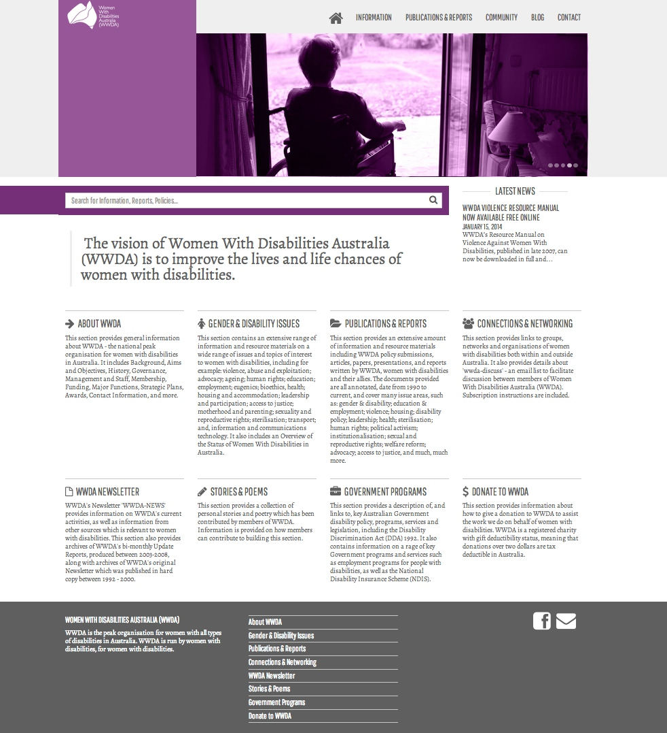

Screenshot of the Home Page of the new WWDA Website

The re-development of the WWDA website site also involved establishing a Blog site to be housed within the website, as an additional mechanism to provide and promote interactive opportunities for closer engagement with and between women with disabilities to participate in WWDA initiatives and projects, including the DES Consumer Engagement Project.

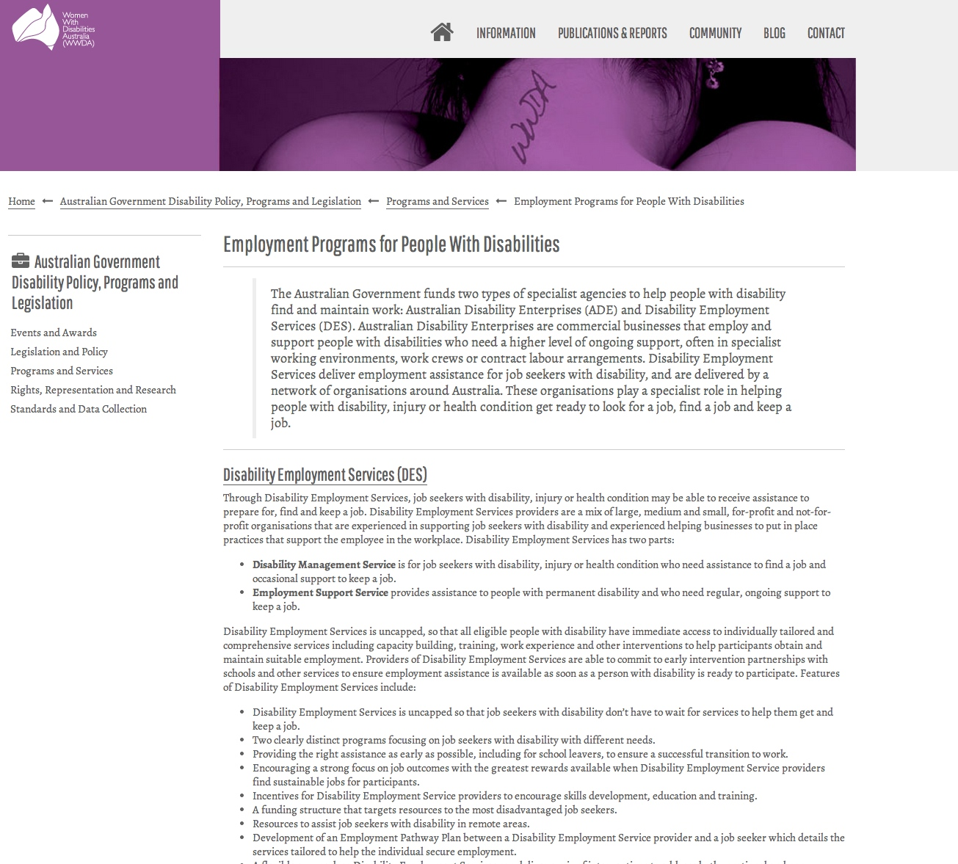
Screenshot of the Disability Employment section of the new WWDA Website

A key activity of the website re-development Project included researching current, relevant information for WWDA’s constituents and other stakeholders, on employment programs, policies and services within Australia. This work also included researching and providing information on the broader Australian Government disability legislative and policy context.

WWDA’s newly released website now contains a dedicated, comprehensive section devoted to Australian Government Disability Policy, Programs and Legislation. This section includes sub-categories of information under the category headings of: Events and Awards; Legislation and Policy; Programs and Services; Rights, Representation and Research; and, Standards and Data Collection.
WWDA’s website now incorporates detailed, accessible information on disability employment programs, policies and services within Australia. The dedicated section on Employment Programs for People With Disabilities contains information and resources on the following:
- Disability Employment Services (DES) (Disability Management Service, and Employment Support Service);
- Australian Disability Enterprises;
- The Employment Assistance Fund;
- JobAccess;
- The Supported Wage System;
- The Workplace Adjustment Tool;
- JobSearch;
- SEEK Jobs, SEEK Volunteer, SEEK Learning;
- Mobility Allowance;
- The Remote Jobs and Communities Program (RJCP);
- The Fair Work Ombudsman;
- The Fair Work Commission.

3. PARTICIPATION IN DES CONSUMER ENGAGEMENT FORUM

WWDA Member Christina Ryan

WWDA participated in the DES Consumer Forum Day on 14th November in Canberra. Senior WWDA delegate Ms Christina Ryan, represented WWDA at the Forum. Christina has extensive experience in issues relating to the intersection of disability and gender, including employment. Christina has regularly represented WWDA at high level international forums, including at the United Nations, and has also accompanied the Australian Government delegation to UN Reviews of Australia, and to the Commission on the Status of Women (CSW) in New York. Christina is also the CEO of a territory based human rights organisation of and for people with disabilities.

In participating in the DES Consumer Forum, Christina raised a long standing issue of concern to WWDA - the need for more meaningful data (and data collection processes) on the workforce participation of women with disabilities, including those using disability employment services and Australian Disability Enterprises.

4. SYSTEMIC ADVOCACY INITIATIVES

In the context of the DES Program, WWDA is of the view that it is potentially ineffective and tokenistic to promote DES services to women with disabilities, without at the same time, maxisimising opportunities for reform and improvements in these services and the broader disability and employment policy environment. Such an approach works towards ensuring that DES become better equipped to understand the intersection of disability, gender and employment and subsequently re-orient their practices and environmental cultures to be more inclusive of, and responsive to, women with disabilities who access (or who could potentially access) such services.

4.1. DEPARTMENTAL BRIEFINGS REGARDING Violence and Abuse of Women With Disabilities in Employment

Successive Australian Governments have increased their focus on getting people with disabilities into employment, including into open employment and/or supported employment. The current Federal Government has signalled its intent to reduce the number of persons on ‘welfare’, including those in receipt of the Disability Support Pension (DSP). Whilst WWDA supports initiatives that enable women with disabilities to find, secure and maintain meaningful employment, WWDA remains deeply concerned at the high incidence of violence, abuse, exploitation, bullying and harassment perpetrated against women with disabilities in the workplace. There would appear to be no national policy response to this widespread issue. Commonwealth Government funded initiatives and programs (such as the Job Access Program) fail to address violence and abuse (including sexual violence) perpetrated against women with disabilities in employment settings.

The following two recent case examples from WWDA are used here to highlight the pressing need for improvements in DES as they relate to women with disabilities in the context of violence, abuse.

Fran is a young woman in her mid 20’s. Fran has a cognitive disability. She has always wanted a job that pays her proper wages and that is interesting. She hasn’t ever had much success at getting a job. She finally gets some help from a Disability Employment Service (DES), which finds her a job in open employment. Fran is over the moon. The DES support worker visits Fran at work every few weeks to see how she is getting on. Fran loves her job and for the first few months everything goes well. Over a period of several weeks, Fran’s demeanour changes. She appears withdrawn and sad. She is having trouble sleeping and suddenly wont go to bed without the lights on. Fran finally discloses to her DES support worker, that she is being repeatedly raped in the workplace by an employee. The perpetrator told Fran that if she told anyone she would get into lots of trouble and would lose her job. Fran’s parents are notified and they call in the police. An investigation commences. The manager of the company where Fran works thinks Fran might be ‘making it up’. Already, seeds of doubt are being sown about Fran’s credibility. Fran’s parents ask the DES support worker for support, including where they can access counselling support for their daughter. The DES worker doesn’t know. WWDA is contacted for help. WWDA sources and organises a sexual assault crisis support service for Fran and her family. The police investigation continues.

Mia is 40 and lives in a regional and remote area of Australia. Mia is desperate to work in paid employment. She loves working and feels she has a lot to contribute. She stayed in her last job for 10 years and was a highly valued employee. She only left her job because her [then] partner had secured a good job in regional Australia. Mia has a disability which affects her vision at times, however, with appropriate aids and equipment, she is a productive employee. Mia has difficult finding a job in her new area. She seeks the help of a Disability Employment Service (DES), which helps her to apply for a job in a call centre. At interview, Mia advises the manager that she has a disability which affects her vision but that it will not affect her work performance. Mia gets the job. Mia requests an orientation to her new job, but the Manager says she doesn’t have time and Mia will just have to figure it out. Within days of commencing her new job, Mia starts to experience bullying from the Manager. Mia is placed in a dark corner of the office space where she has difficulty seeing. She is given a chair that doesn’t allow her to get close enough to the desk to see the computer screen. Mia’s request for minor adjustments to her work station (including a light) are denied by the Manager. The discrimination intensifies. Mia is frightened of going to work but she wants to keep her job and doesn’t understand why she is being treated so cruelly. Mia doesn’t take any time off, despite her doctors concerns at the effect the discrimination is having on her. Mia keeps her DES support worker updated about all the incidents she is experiencing. Her DES support worker agrees Mia is experiencing disability discrimination but says there is nothing that she or the DES can do about it. One day Mia goes to work and is introduced to a young man who has been employed by the Manager. He is in the process of receiving an orientation from the Manger. Later that day, Mia is told by the manager that she is being sacked. Mia is not given any reasons why her employment is being terminated. She is given one day’s notice. When Mia advises her DES support worker what has happened, the DES worker re-iterates that there is nothing the DES can do about it. The DES worker gives Mia WWDA’s phone number and tells her to contact WWDA to see if WWDA can help her. WWDA is able to find Mia a solicitor who is currently working with Mia to lodge a formal disability discrimination complaint against the call centre.

In relation to these two recent case examples, WWDA Executive Director Carolyn Frohmader spent more than 10 hours working on finding appropriate responses for the two women with disabilities concerned. Although WWDA is a national systemic advocacy organisation, and does not get funded to undertake individual advocacy, WWDA is often contacted by people with disabilities, service providers, families and carers, for direct assistance with individual advocacy. On many occasions, those contacting WWDA have been given WWDA’s details by another service or individual, and been advised to contact WWDA. These referrals to WWDA have even come from crisis services and services which are specifically funded to undertake individual advocacy. Many of those contacting WWDA have often been on a ‘referral merry-go round’ and still not managed to secure any support or service response to their issues. More often than not, these issues are urgent and require an immediate response – as in the two case examples highlighted above.

In response to these and other issues stemming from the work of WWDA and the DES Consumer Engagement Project, WWDA Executive Director, Carolyn Frohmader, initiated a briefing with Mr Matt Gardiner (Disability Employment Services Policy, Department of Social Services), to discuss, amongst other things, WWDA’s concerns at the apparent lack of a clear national policy response to the issue of violence and abuse of women with disabilities in employment. WWDA also advised Mr Gardiner of our concern at the apparent lack of understanding on the part of DES personnel, regarding the intersection of disability and gender, particularly around issues to do with violence, sexual assault, sexual harassment, abuse and neglect. WWDA highlighted the fact that the Job Access website (for example), has no information for job seekers with disabilities, or potential employers, regarding the issues of violence and sexual assault in the workplace. A simple search of the Job Access website, using the terms ‘sexual assault’, returns no results. Using the search term ‘violence’ yields just 2 results, one related to ‘Employee assistance programs’, where the information provided states:

‘Trauma counselling is another common service provided by employee assistance programs, typically offered to police and other emergency service workers, as well as other employees who have experienced violence, armed hold ups or workplace accidents. Immediate support of this nature is understood to reduce the likelihood of subsequent conditions such as post-traumatic stress disorder.’

However, in relation to the case example of Fran outlined above, the DES worker did not have any knowledge of this Program, and hence, Fran and/or her family were not provided with this information.

The only other reference to ‘violence’ on the Job Access website, is in relation to Dealing with Stigma’, where the information states, in part:

‘Stigma about mental illness creates a climate in which someone who has a problem or needs help may not seek help for fear of being labelled. Many employers and employees hold false beliefs and fears about people who have a mental illness. People may assume that they are likely to be unproductive, unreliable, violent or unable to handle workplace pressures.’

WWDA also raised concerns about the usefulness of the Disability Services Standards in the context of preventing and addressing violence and abuse perpetrated against women with disabilities in employment settings. Disability Employment Services (DES) are one of the primary mechanisms to get people with disabilities into the workforce, are required to comply with the Disability Services Standards. The new edition of these Standards came into effect on 1st January 2014, and Standard 1 [Rights] states in part that:

‘The standard acknowledges the risks of harm, neglect, abuse or violence which some people with disability may face when using services or supports. The standard highlights the roles for services and supports, families, friends, carers and advocates in reducing these risks.’

Examples of the Indicators for Practice in relation to this Standard include:
- The service has preventative measures in place to ensure that individuals are free from discrimination, exploitation, abuse, harm, neglect and violence.
- The service addresses any breach of rights promptly and systemically to ensure opportunities for improvement are captured.
- The service supports individuals with information and, if needed, access to legal advice and/or advocacy.

However, it is clear from the two case examples provided earlier in this paper, that the Disability Service Standards, particular Standard 1 and its Indicators for Practice, were ineffective. It remains unclear as to how these Standards can be enforced at the service level, and how services will be required to effectively report on their implementation. It is problematic at the outset, that the Disability Service Standards rely on service providers possessing the knowledge of what constitutes violence against women and girls with disabilities.

Research undertaken by WWDA and the ‘Stop the Violence Project’ (STVP), has found that disability service providers have little knowledge, skill, and/or capacity to recognise, identify and respond to violence against women with disabilities. In 2013, the STVP conducted a national survey of service providers, representative organisations and policy makers across all jurisdictions regarding the work that they do, their knowledge and experiences of the policies and legislative frameworks that guide their work, and the challenges they face in responding to the needs of women and girls with disabilities experiencing or at risk of violence. More than 367 agencies responded to the survey; with 102 of these respondents being disability service providers across Australia.

The survey findings strongly suggest that, via their own admission, disability services generally do not have the capacity or expertise to recognise overt forms of violence. This has significant implications also for services capacity to identify ‘covert’ forms of violence. Women and girls with disabilities are more likely to experience covert and subtle forms of violence rather than blatant overt violence and abuse. Therefore, if disability services, where much violence prevails against this population group, are unable to readily acknowledge and identify overt violence, it is possible to infer even less capacity to identify subtle, covert and disability specific forms of violence. Thus, the findings suggest that disability services may be unable to meet their legal duty of care obligations, as defined in both the relevant Commonwealth and State/ Territory disability services legislation contractual obligations.

Following briefings with Mr Gardiner on WWDA’s concerns, he agreed to follow it up with his colleagues and get back to WWDA. Mr Gardiner and Carolyn Frohmader subsequently had a follow up meeting whereby Mr Gardiner agreed that, following meetings and discussions with his Departmental colleagues, the issues WWDA raised appear not to have been addressed adequately within the DES policy context, and within DES services themselves. Mr Gardiner has advised WWDA that the Department of Social Services (DES Policy) will be taking this issue on as a priority and will maintain links with WWDA as work in this area progresses. WWDA recognises that there is a significant amount of advocacy work required by WWDA into the future to ensure that Disability Employment Services (DES) become better equipped to address the myriad forms of violence, abuse, exploitation and neglect that women with disabilities experience, and are at risk of experiencing.

4.2. ADDITIONAL WORK REGARDING Violence and Abuse of Women With Disabilities in Employment

WWDA has utilised a number of opportunities to highlight the issue of violence and abuse of women with disabilities in employment, and seek policy and program responses to address this widespread issue. In October 2013, WWDA held a ‘National Symposium on Violence Against Women and Girls with Disabilities’, as part of its National COAG Reform Project entitled ‘Stop the Violence Project’. The Stop the Violence Project and the outcomes of the National Symposium, are being used by WWDA to advise the Federal and State/Territory Governments of areas of key reform required to better respond to women with disabilities experiencing, or at risk of experiencing violence, including violence experienced in the workplace. WWDA has recently met with Minister Michaelia Cash around these issues as part of the National Roundtable held by the Minister to seek advice on the development of the Second Action Plan of the National Plan to Reduce Violence against Women and their Children 2010-2022 (the National Plan). WWDA has also provided written Submissions and Reports to Governments on the need for the National Plan to be broadened in scope so that it can address violence against women with disabilities in all its forms, including workplace violence.

In late 2013, WWDA was invited by the Department of Prime Minister and Cabinet to provide a written Submission regarding priority areas for consideration at the 2014 session of the United Nations Commission on the Status of Women (CSW). CSW is a functional commission of the United Nations Economic and Social Council (ECOSOC), and the principal global policy-making body dedicated exclusively to gender equality and advancement of women. The theme for the 2014 session of CSW is ‘Challenges and achievements in the implementation of the Millennium Development Goals for women and girls’, where Employment will be a central issue. The 2014 session of CSW will also include a review of the Agreed Conclusions from its 55th session, the theme of which was: Access and participation of women and girls to education, training, science and technology, including for the promotion of women’s equal access to full employment and decent work.

WWDA’s CSW Submission to the Department of Prime Minister and Cabinet, identifies the persistent inequality of women with disabilities’ access to employment opportunities as a key issue for consideration. WWDA’s Submission further highlights that for women and girls with disabilities, participation in social and political life and ensuring an adequate standard of living depends on their access to fundamental social structures such as education, employment, health care, housing, and free enjoyment of the most fundamental human rights, such as the right to sexuality and reproduction and freedom from all forms of violence.

In early 2014, WWDA researched and published its major Submission to the National Inquiry into Equal Recognition Before the Law and Legal Capacity for People With Disability. This national Inquiry was announced by the Australian Government in July 2013. The Inquiry, being undertaken by the Australian Law Reform Commission (ALRC) will examine laws and legal frameworks within the Commonwealth jurisdiction that deny or diminish the equal recognition of people with disability as persons before the law and their ability to exercise legal capacity, and consider what, if any, changes could be made to Commonwealth laws and legal frameworks to address these matters. The ALRC’s final report is due in August 2014. WWDA’s Submission to the National Inquiry into Equal Recognition Before the Law and Legal Capacity for People With Disability examines six key priority areas for women with disabilities that are considered crucial in the context of the National Inquiry. These six areas are: 1) Gendering the National Inquiry into Equal Recognition Before the Law and Legal Capacity for People With Disability; 2) Sexual and Reproductive Rights and Freedoms; 3) The Right to Freedom from Violence, Abuse, Exploitation and Neglect; 4) The Right to Found and Maintain a Family; 5) The Right to Work; and, 6) The Right to Participate in Political and Public life.

WWDA’s Submission highlights the fact that the determination of capacity is inextricably linked to the exercise of the right to autonomy and self-determination. To make a finding of incapacity results in the restriction of one of the most fundamental rights enshrined in law, the right to autonomy. Yet many women with disabilities throughout Australia are stripped of their legal capacity, due to stigma and discrimination, through judicial declaration of incompetency or merely by a third party’s decision that the woman “lacks capacity” to make a decision. WWDA’s Submission to the Inquiry examines the issue of the right to work in the context of women with disabilities’ equal recognition before the law and legal capacity.

WWDA’s Submission is available on the WWDA website in both PDF and Word formats.

4.3. COMMITTEE ON THE RIGHTS OF PERSONS WITH DISABILITIES

In September 2013, WWDA Executive Director Carolyn Frohmader was selected as one of the six representatives of the NGO delegation to the 10th session of the Committee on the Rights of Persons with Disabilities, held in Geneva 30 August – 6th September 2013, where Australia was formally reviewed for its compliance with the United Nations Convention on the Rights of Persons with Disabilities (CRPD). Carolyn spent a week at the United Nations in Geneva, working with the CRPD Committee as a member of the Civil Society Parallel Report Group, as well as participating in a number of other meetings and events during the week. During her time in Geneva, Carolyn was also able to take up a range of opportunities to meet with several key stakeholders to specifically focus on WWDA’s work and also to provide advice and expertise on issues concerning women and girls with disabilities, including employment. The CRPD Committee members were particularly interested in finding out more information about how women with disabilities fared in relation to access to employment, compared to men with disabilities, and what specific gendered measures and initiatives the Australian Government had in place regarding improving the employment situation of women with disabilities. It was acknowledged by both the NGO delegation and the Australian Government delegation, that there was a need for greater focus in this area.

As highlighted earlier in this paper, In October 2013, the Committee on the Rights of Persons with Disabilities in its Concluding Observations for Australia, recommended that the Australian Government:

‘adopt initiatives to increase employment participation of women with disabilities by addressing the specific underlying structural barriers to their workforce participation’.

Carolyn’s detailed Report from the United Nations Committee on the Rights of Persons with Disabilities (CRPD) 10th Session - Review of Australia, is available for download from the WWDA website in both PDF and Word versions.

5. FUTURE INITIATIVES

As canvassed in WWDA’s Disability Employment Services Consumer Engagement Strategy 2013, WWDA has a range of initiatives planned for the second phase of the DES Consumer Engagement Project. These initiatives include:

a) Conducting Focus Groups with Women With Disabilities – these Focus Groups will include consulting with women with disabilities regarding their access to and experience of, disability employment services. The Focus Groups will also provide a forum for women with disabilities to identify specific barriers and issues in relation to their access to employment. WWDA will also utilise the Focus Groups as an opportunity to promote information about the Disability Employment Services, and related employed programs and services.

b) Utilising Mechanisms to Disseminate Information – WWDA will actively use its new website, including the WWDA blog and Facebook Page to promote information about the Disability Employment Services, and related employed programs and services. WWDA will also use these mechanisms to consult more broadly with WWDA members and constituents regarding their access to and experience of, disability employment services.

c) CRPD Concluding Observations Follow Up – WWDA Executive Director Carolyn Frohmader is a member of the CRPD NGO Delegation Monitoring Taskforce, which is working to progress the implementation of the CRPD Concluding Observations from the 2013 Review of Australia. Carolyn will be specifically focusing on those Concluding Observations relating to women and girls with disabilities, including the recommendations regarding employment.

d) Working with DSS on Building DES Capacity – WWDA Executive Director Carolyn Frohmader will continue to act as the conduit between WWDA and DSS [DES Policy and Programs] to identify and progress work required at the national level to build the capacity of DES services around Australia to better respond to the issue of violence, abuse and exploitation of women with disabilities in the workplace.

Australian Bureau of Statistics, ‘Labour Force Characteristics of People with a Disability’ in Year Book Australia (2006); Sue Salthouse, ‘Jumping Through Hoops — Welfare and Industrial Relations Reform Implications for Women with Disabilities’ (Paper presented at the What Women Want Workshop — A Workshop on the Effect of the Federal Government’s Recent Policy Changes on Women of Working Age, Canberra, 12 July 2005) www.wwda.org.au/w2wjuly05.htm.
In ‘Disability Rights Now’ Civil Society Report to the United Nations Committee on the Rights of Persons with Disabilities; August 2012.
Commonwealth of Australia (2009) Making it Fair: Pay equity and associated issues related to increasing female participation in the workforce. Report of the House of Representatives Standing Committee on Employment and Workplace Relations. Accessed online December 2012 at: http://www.aph.gov.au/Parliamentary_Business/Committees/House_of_Representatives_Committees?url=ewr/payequity/report.htm
Australian Government (2013) Women’s Budget Highlights 2013-14. Department of Families, Housing, Community Services and Indigenous Affairs (FaHCSIA), Canberra.
The Committee further expressed its concern at the slow progress in ensuring the equal participation of women with disabilities in leadership and decision-making positions, in public and political life as well as their equal access to education, employment and health.
UN Committee on the Elimination of Discrimination against Women, Concluding comments of the Committee on the Elimination of Discrimination against Women: Australia, 3 February 2006, CEDAW/C/AUL/CO/5.
Committee on the Elimination of Discrimination against Women (2010) Concluding observations of the Committee on the Elimination of Discrimination against Women: Australia. CEDAW Forty-sixth session, 12 – 30 July 2010.
Committee on the Rights of Persons with Disabilities (2013) Concluding observations on the initial report of Australia, adopted by the Committee at its tenth session (2-13 September 2013); UN Doc. CRPD/C/AUS/CO/1; Available at: http://tbinternet.ohchr.org/_layouts/treatybodyexternal/Download.aspx?symbolno=CRPD%2FC%2FAUS%2FCO%2F1&Lang=en
Ibid.
Frohmader, C. (2013) Report from the United Nations Committee on the Rights of Persons with Disabilities (CRPD) 10th Session - Review of Australia, Geneva, 2-13 September 2013. Available at: http://www.wwda.org.au/WWDA_CRPD_Review_Australia_ReportOct13.pdf
UN Committee on the Elimination of Discrimination against Women, Concluding comments of the Committee on the Elimination of Discrimination against Women: Australia, 3 February 2006, CEDAW/C/AUL/CO/5.

