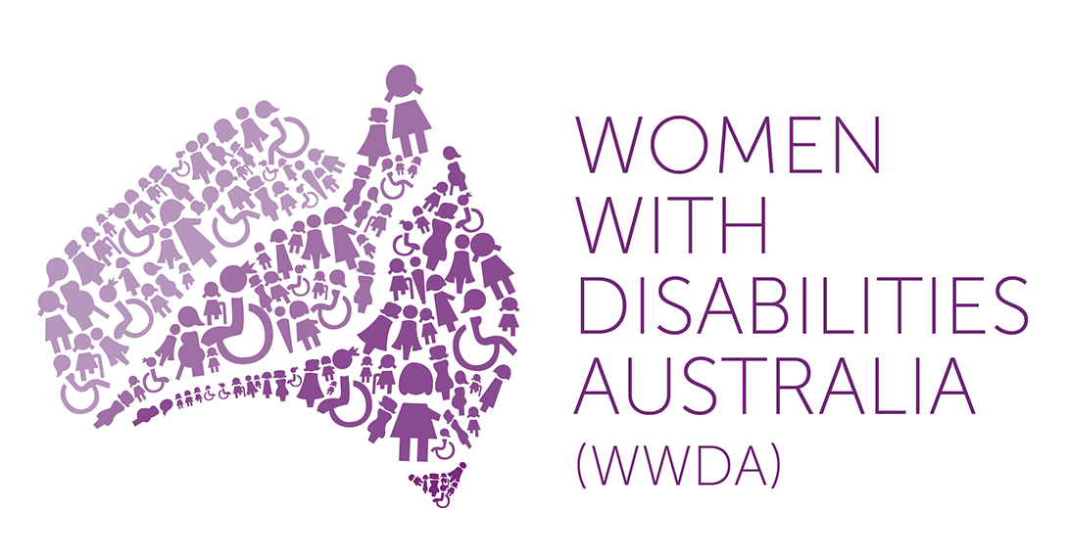

Women With Disabilities Australia (WWDA)

Response to the National Disability Insurance Scheme (NDIS) Framework for Information, Linkages and Capacity Building Consultation Paper

March 2015

Winner, National Human Rights Award 2001
Winner, National Violence Prevention Award 1999
Winner, Tasmanian Women's Safety Award 2008
Certificate of Merit, Australian Crime & Violence Prevention Awards 2008
Nominee, French Republic's Human Rights Prize 2003
Nominee, UN Millennium Peace Prize for Women 2000

PO Box 407, Lenah Valley, 7008 TASMANIA
Ph: +61 438 535 123
Email: carolyn@wwda.org.au
Web: www.wwda.org.au
Facebook: http://www.facebook.com/WWDA.Australia
Twitter: https://twitter.com/WWDA_AU

Contact: Carolyn Frohmader, Executive Director

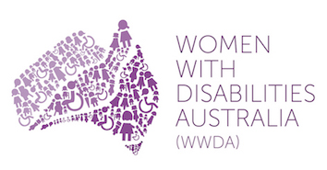 | Response to the National Disability Insurance Scheme (NDIS) Framework for Information, Linkages & Capacity Building Consultation Paper

Women With Disabilities Australia (WWDA) is the peak organisation for women with all types of disabilities in Australia. WWDA is run by and for women with disabilities. Our work is grounded in a human rights based framework which links gender and disability issues to a full range of civil, political, economic, social and cultural rights. A rights based approach recognises that equal treatment, equal opportunity, and non-discrimination provide for inclusive opportunities for women and girls with disabilities in society. WWDA represents over two million women and girls with a disability in our capacity as an internationally recognised Australian disability, women’s and human rights organisation

WWDA thanks the Australian Government for the opportunity to contribute this brief submission in response to the National Disability Insurance Scheme (NDIS) Framework for Information, Linkages & Capacity Building Consultation Paper.

WWDA endorses a National Disability Insurance Scheme (NDIS) that is sufficiently resourced and consistently responsive to all people with a disability, across all their life stages, and which particularly supports and recognises the capacity of Australian women and girls with disabilities to live in the ways they wish to live. WWDA makes the following brief recommendations in regard to the design and implementation of the ILC Framework.

1. ILC must be gender cognizant and responsive across the five ILC activity streams.

2. ILC must acknowledge and build on the existing and unique capacities, strengths and resources of women and girls with a disability at local and systemic levels.

3. ILC must acknowledge and engage the capacity and rights for all people with a disability to lead the decision-making processes that affect their lives, consistent with the United Nations Convention on the Rights of Persons with a Disability (CPRD).

4. ILC must clearly distinguish between the needs, identities and rights of individuals with a disability, and the rights of families and carers in all aspects of design, implementation and evaluation.

5. Capacity building with mainstream organisations needs to foremost address existing gaps in service access and support for women with disabilities.

6. A strong evaluation framework that has places the expertise of people with a disability and their representative organisations front and centre, must underpin ILC.

Recommendation 1:

ILC must be gender cognizant and responsive across the five ILC activity streams

ILC must explicitly recognise the impact of the multiple discriminations experienced by women with disabilities accessing mainstream services and supports and include specific program components to ensure that disabled women can experience full and effective enjoyment of their fundamental freedoms, equal participation and access to supports as and when required.

There are four million people in Australia with a disability, making up twenty percent of the population. Just over fifty percent (50.5%) of people with disabilities in Australia are women. Women with disabilities are one of the most excluded, neglected and isolated groups in society. They experience multiple discriminations arising from the intersection gender, disability and economic status, which are further confounded by myriad cultural identities and contexts. The contextual and systemic issues that disable women face are often overlooked at a service-delivery level and absent from policy-making processes. A gender cognizant and responsive ILC would give particular attention to the needs and rights of women and girls with a disability accessing mainstream services, including identifying and addressing existent disparities, inequalities and difficulties concerning access to and responsiveness of mainstream services.

Recommendation 2:

ILC must acknowledge and build on the existing and unique capacities, strengths and resources of women and girls with a disability at local and systemic levels

A strong and effective ILC framework would focus on strengthening natural supports, skills and expertise of women and girls with a disability at local and systemic levels. It is vital that any assessment and engagement processes do not duplicate or ignore the strengths and capacity of women and girls with a disability to navigate existing systems. In particular, it is important that the individual and community capacity building components of the ILC map the range of local and contextual knowledges of services, issues, gaps and needs that women and girls with a disability have expertise on. Continuing to consult with women and girls with a disability and their representative organisations including WWDA at every stage of the design, implementation and evaluation of the ILC will assist with ensuring that supports provided through the ILC are appropriate, specific and address the self-identified needs of women and girls with a disability.

Recommendation 3:

ILC must acknowledge and engage the capacity and rights for all people with a disability to lead the decision-making processes that affect their lives, consistent with the United Nations Convention on the Rights of Persons with a Disability (CPRD)

Consistent with the content and spirit of the CPRD, a core focus of the ILC should be on maximising individual agency by supporting individual capacity to exercise real choice and control over decision-making processes within each stream of the ILC. To assist with this, the individual and community capacity building elements of the ILC should include broad supports and resources that build capacity of individuals to advocate on their own behalf in relation to accessing ILC supports, and externally developed and evaluated self-advocacy training for women and girls with a disability to support this.

Recommendation 4:

ILC must clearly distinguish between the needs, identities and rights of individuals with a disability, and the rights of families and carers in all aspects of design, implementation and evaluation

The ILC must centre people with disabilities at the core of all design, implementation and evaluation frameworks. While recognising the importance of including family members, carers and service providers in the process of supporting individuals to access ILC supports, this involvement should remain distinct from the primary involvement, investment and control over decision-making processes of people with disabilities themselves. While the interests and concerns of families, parents and carers are often assumed to be consistent with the needs and desires of individuals, this is not always the case. The ILC framework must incorporate vital safeguards and external review mechanisms that ensure the best interests of individuals accessing support are primary. Incorporating support and individual capacity building around self-advocacy will assist with this aim. The ILC design must address people with disabilities as the primary target of support and families and carers as a secondary target of ILC supports.

Recommendation 5:

Capacity building with mainstream organisations needs to foremost address existing gaps in service access and support for women with disabilities

WWDA sees capacity building with mainstream organisations as vital to addressing persistent systemic gaps in the availability of meaningful and targeted supports for women and girls with a disability. The ILC framework should more clearly define what mainstream capacity building projects will and will not be funded under the ILC. In our previous policy submissions and in our international work WWDA has clearly identified that mainstream services consistently fail to meet and address the needs of women and girls with a disability. This is particularly evident in the provision of housing and employment support services.

In relation to capacity building in mainstream organisations, the ILC should include a stronger emphasis on promoting access to mainstream services as a human right. Mainstream services for women need the expectation that they will serve women with disabilities. Further, an emphasis on capacity building must correlate with adequate ILC funding for capacity building that goes beyond ensuring basic access requirements. Without encouragement to pursue education and program development, experience has shown that mainstream services do not reliably respond and do not see women with disabilities as ‘their responsibility’. The justice, domestic violence and homelessness sectors are specific examples within mainstream service delivery where this occurs.

Representative disabled people’s organisations (DPOs) including WWDA must continue to have a key advisory role in the design and delivery of capacity building projects for mainstream services. Many DPOs including People with Disabilities Australia (PWDA) have extensive experience and expertise in designing and delivering inclusive capacity building training with mainstream organisations. Such expertise must be matched by adequate community capacity building funding to DPOs through the ILC streams.

How the ILC component of the NDIS can work with mainstream services is critical to the success of the new directions. One mechanism proposed to ensure the NDIS can influence mainstream service development is through high level MOUs and, where possible, funding agreements and contractual obligations. Such MOUs could include expectations such as employment affirmative action on disability and women; having a disability action plan which incorporates a diversity and gender approach and involvement of people with disabilities in governance; co-case management practices; and the incorporation of disability access in accreditation standards. Stronger anti-discrimination legislation is another mechanism, which could be utilised in this area.

Recommendation 6:

A strong evaluation framework that has places the expertise of people with a disability and their representative organisations front and centre, must underpin ILC

The ILC framework must incorporate an external, ongoing evaluation mechanism and review process that tracks changes and identify persistent gaps in mainstream service provision to all people with disabilities and particularly women and girls with a disability. People with disabilities and DPOs should form the core of this evaluation framework as they are best placed to identify issues, gaps and areas for improvement. An appropriate evaluation framework would be external to the delivery of ILC supports.

At the local level, evaluation of referral systems and pathways must continually assess the appropriateness of referrals and their outcomes. Referring individuals to services that do not have the resources, capacity or willingness to provide inclusive and adequate supports is a persistent issue for women and girls with a disability. Consistent with the CPRD, the ILC evaluation framework must include focused measures that recognise and measure the impact of multiple and specific discriminations that occur at the intersection of gender and disability.

An ongoing issue for the ILC evaluation framework concerns how to measure inclusiveness and responsiveness and real access to supports in a consistent way across jurisdictions, that takes into account local knowledge and experience. Including people with disabilities and DPOs at all levels of evaluation will assist with accessing these local expert knowledges and experiences. All components of the NDIS, including the ILC, can and should reflect the perspective of women and girls with disabilities. All data, quality measures, monitoring, research, complaints and governance systems should reflect gender, including the 2020 review of the NDIS. Attention to gender across all of these systems would be consistent with reporting other equity issues such as rural versus urban or non English-speaking access and best practice. There are logical further comparisons across several variables when considering the performance of the ILC and best practice such as women and men in indigenous communities; access to employment for women and men in rural and urban settings.

WWDA works at regional, state/territory, national and international levels; services a direct and fast growing individual membership; undertakes substantial evidence-based research; implements projects at national and international levels; undertakes individual and systemic advocacy; and provides extensive policy advice and expertise to a wide and growing range of stakeholders, including at all levels of government, non-government, researchers, industry groups, United Nations machinery, and more. For more detailed information on WWDA, go to: http://www.wwda.org.au

