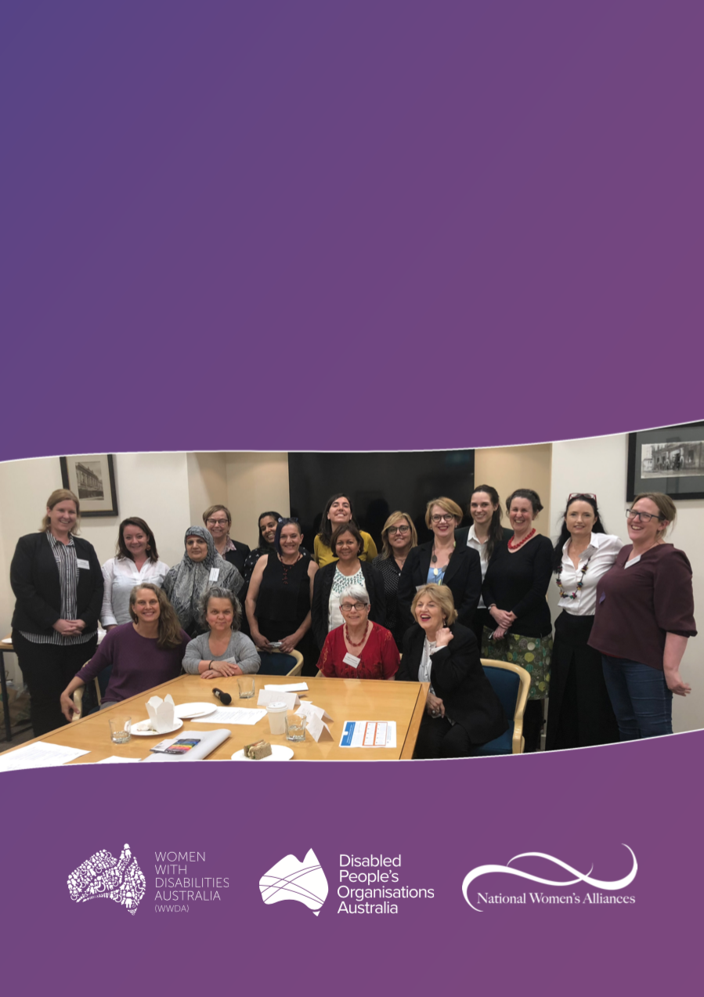

REPORT ON OUTCOMES

National Women’s Alliances and Disabled People’s Organisations Australia Workshop

November 2018

Publishing Information

Women with Disabilities Australia (WWDA) (2018). Report on Outcomes: National Women’s Alliances and Disabled Peoples Organisations Australia Workshop. November 2018. WWDA: Hobart, Tasmania.

Acknowledgments

WWDA acknowledges the traditional owners of the land on which this publication was produced. We acknowledge Aboriginal and Torres Strait Islander people’s deep spiritual connection to this land. We extend our respects to community members and Elders past, present and becoming.

The National Women’s Alliances and Disabled Peoples Organisations Workshop was funded by a project grant from the Australian Government Department of Prime Minister and Cabinet, Office for Women.

This document was prepared by Liz Forsyth (KPMG), Carolyn Frohmader (WWDA), and Chris Brophy (WWDA).

Contact

Women with Disabilities Australia (WWDA)
Contact: Carolyn Frohmader, Executive Director
PO Box 407, Lenah Valley, 7008 Tasmania, Australia
Phone: +61 438 535 123
Email: carolyn@wwda.org.au
Web: www.wwda.org.au
Facebook: www.facebook.com/WWDA.Australia
Twitter: www.twitter.com/WWDA_AU

Winner, National Human Rights Award 2001
Winner, National Violence Prevention Award 1999
Winner, Tasmanian Women's Safety Award 2008
Certificate of Merit, Australian Crime & Violence Prevention Awards 2008
Nominee, National Disability Awards 2017
Nominee, French Republic's Human Rights Prize 2003
Nominee, UN Millennium Peace Prize for Women 2000

Disclaimer

The views and opinions expressed in this publication are those of Women with Disabilities Australia (WWDA) and not necessarily those of our funding bodies. All care has been taken in the preparation of the information contained in this document. WWDA disclaims any liability for the accuracy and sufficiency of the information and under no circumstances shall be liable in negligence or otherwise in or arising out of the preparation or supply of any of the information aforesaid.

This work is copyright. Apart from any use as permitted under the Copyright Act 1968, no part may be reproduced without written permission from Women with Disabilities Australia (WWDA).

© 2018 Women With Disabilities Australia (WWDA). ABN: 23 627 650 121

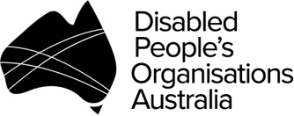 | WWDA is a founding member of Disabled People’s Organisations Australia (DPO Australia), an alliance of four national Disabled People’s Organisations in Australia. Visit http://www.dpoa.org.au

Contents

Introduction 4
Project Overview 5
Workshop Outcomes and Agreed Strategies 6
Background 13
Appendix 1 – List of Delegates 18
Appendix 2 – Summary of Recommendations from Review of NWA model 19
Appendix 3 – Agenda 20
Appendix 4 – Delegate Details Form 23
Appendix 5 – Photo Release Form 25
Appendix 6 – Emergency Contact Form 26

Introduction

In March 2016, KPMG was engaged by the Australian Government Department of Prime Minister and Cabinet, Office for Women, to conduct a review of the National Women’s Alliances (the Alliances) model. The review focused on assessing the coherence the model; strategies and outputs; alignment of the model with Australian Government priorities; and, whether the model was functioning as intended.

Key recommendations from the review were for the Alliances to (i) increase inter-alliance collaboration; (ii) increase the representation of marginalised populations, including women with disability, women from migrant and refugee backgrounds, and members of the LGBTI communities in the work of the Alliances. The report further recommended that engagement with marginalised groups should be embedded within the work of the Alliances, as opposed to reliance on cohort-specific organisations to represent the interests of these populations.

In order to support these recommendations, the Office for Women provided project funding to Women with Disabilities Australia (WWDA) to organise and host a one-day workshop with key decision makers from each of the six Alliances and the four member organisations of Disabled People’s Organisations Australia (DPO Australia). The purpose of the workshop was to explore how the organisations could collaborate to strengthen representation and engagement of women with disability across the women’s sector.

The workshop was held on 18 October 2018 in Sydney and was facilitated by Liz Forsyth from KPMG. The DPO Australia members and the six National Women’s Alliances were represented by their Chairpersons and CEOs, or other senior representatives as necessary.

Representatives of the four DPO Australia members comprised women who identified with, and could speak to, the diverse needs and rights of women with disability in their areas of expertise and representation. Organisations represented included:

DPO Australia | National Women’s Alliances
- Women with Disabilities Australia  - First People’s Disability Network  - National Ethnic Disability Alliance  - People with Disability Australia | - Australian Women Against Violence Alliance  - Equality Rights Alliance  - Economic Security4Women  - National Rural Women's Coalition  - Harmony Alliance  - National Aboriginal and Torres Strait Islander Women’s Alliance

The following section of this report provides an overview of the project objectives, deliverables and outcomes, followed by a description of the proceedings, outcomes and actions arising from the workshop.

Project Overview

Objectives

The objectives for this project were to:

- Strengthen representation and engagement of women with disability within the work of the National Women’s Alliances (the Alliances).
- Strengthen relationships and networks between the Alliances and the Disabled People’s Organisations Australia (DPO Australia) members.
- Develop a sustainable engagement mechanism between the Alliances and DPO Australia members.

Deliverables

The final deliverables for the project were:

- Women with Disabilities Australia (WWDA) to organise and host a one-day facilitated workshop in the second half of 2018 with key decision-makers from each of the Alliances, along with DPO Australia members (WWDA, First People’s Disability Network, National Ethnic Disability Alliance, People with Disability Australia), and others as relevant.
- Stakeholders to identify key priorities for strengthening representation of women with a disability within each organisation’s work.
- A final report of the workshop to be provided to the Office for Women, the Alliances, the DPO Australia members, and other stakeholders as relevant.

Anticipated Outcomes

The anticipated outcomes from the workshop were:

- Alliances are supported to increase sustainable engagement and representation of women with disability within their organisations and activities.
- Relationships between the Alliances, WWDA and other DPO Australia members are strengthened.
- Women with disability have increased opportunities to inform Australian Government decision-making and policy outcomes.

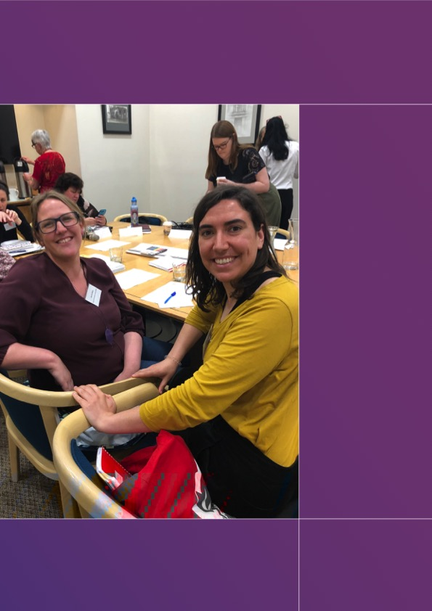

Workshop Outcomes and Agreed Strategies

Overview of the National Women’s Alliances

The Australian Government Department of Prime Minister and Cabinet, Office for Women (OFW) funds six National Women’s Alliances. The purpose of the Alliances is to:

- Bring together women’s organisations and individuals from across Australia to share information, identify issues that affect them, and identify solutions.
- Engage actively with the Australian Government on women’s policy issues.
Each Alliance develops an annual work plan, as well as an overarching three-year work plan that aligns with funding cycles. These plans are approved by the OFW. Each has different governance and corporate structures, and membership bases.

The six Alliances include Australian Women Against Violence Alliance (AWAVA), Equality Rights Alliance (ERA), Economic Security4Women, National Aboriginal and Torres Strait Islander Women’s Alliance (NATSIWA), National Rural Women’s Coalition (NRWC), and the Harmony Alliance.

Overview of Disabled People’s Organisations Australia

Disabled People’s Organisations Australia (DPO Australia) is an unincorporated alliance of four national Disabled People’s Organisations (DPOs), including Women with Disabilities Australia (WWDA), First Peoples Disability Network Australia (FPDN), National Ethnic Disability Alliance (NEDA), and People with Disability Australia (PWDA).

The purpose of DPO Australia is to:

- Promote, protect and advance the human rights and freedoms of people with disability in Australia by working collaboratively on areas of shared interests, purposes, strategic priorities and opportunities.
The member organisations of DPO Australia have different governance and corporate structures, and membership bases. They are funded through the Australian Department of Social Services (DSS). Some are reliant on the Australian Government for all operational funding, while others receive additional funding through State and Territory governments, as well as donations. The DPO Australia members develop individual annual work plans, as well as an overarching annual work plan for collective DPO Australia work.

DPO Australia is recognised as a key coordinating point between Government/s and other stakeholders, for consultation and engagement with people with disability in Australia.

OUTCOME 1

Increased engagement and representation of women with disability within the work of the Alliances.

Attendance and collaboration at the workshop demonstrated that both the Alliances and the DPO Australia members are committed to improving the representation and engagement of women with disability in their work. In particular, there was a strong commitment to strengthening input into women’s policy; strengthening the relationships and networks between each organization; and developing engagement mechanisms between the Alliances and the DPO Australia members.
It was noted that the Alliances require support to fully understand disability issues and policy and how to best engage with women with disability across their respective priority areas. It was further noted that while all organisations are subject to funding constraints, there was a shared commitment to work together and support each other wherever possible.
The DPO Australia members noted that they remain committed to engaging with the Alliances to support their work. It was also noted the they have expertise on reaching diverse populations of women with disability, including women who may be hard to reach or have complex access needs, which can assist the Alliances.
In order to facilitate and maintain the involvement of women with disability in the work of the Alliances, a range of strategies were identified:

Strategy 1
The Alliances will increase the involvement of existing or new member representatives from their organisations who have a disability in their activities and engagement mechanisms.
Information sharing between the Alliances and DPO Australia members was deemed critical to supporting existing and new member representatives. The Alliances will work to break down siloed ways of working and seek to proactively understand their membership bases and share information between Alliances and DPO Australia members wherever possible.

Strategy 2
The Alliances will work toward digital accessibility standards that will facilitate effective engagement of women with disability.
Each Alliance agreed to work towards the following communication accessibility standards:
- Ensuring that communications are available in accessible Plain English and Easy English versions where possible.
- Assessing their websites for compliance with accessibility requirements, as well as their level of functionality for a diverse range of people with disability.
- Producing web documents and publications that meet Web Content Accessibility Guidelines (WCAG) 2.0 standards.
- Meet digital communication standards.

Strategy 3
The Alliances will work toward accessibility supports that will facilitate effective engagement of women with disability.
It was noted that additional supports may also be required to facilitate effective engagement with women with disability, including:
- Consideration and support with transport options when inviting women with disability to attend meetings or events.
- Accessible physical environments including venues and meeting rooms.
- Creating a safe space for women with disability to be engaged in.
- Providing opportunities for feedback from women with disability on their experiences working with the Alliances.
- Providing appropriate remuneration to women with disability who are sharing their expertise and time.

Strategy 4
The Alliances will develop and implement disability action plans and communication plans.
Development and implementation of disability action plans will support the Alliances to ensure representation of women with disability within their work and memberships. Communications plans that specifically engage with women with disability will assist with increasing engagement.

Strategy 5
The Alliances and DPO Australia members will increase the level of communication, collaboration and partnerships between the organisations.
Increasing communication between the Alliances and DPO Australia members will ensure that previous work is leveraged, and additional input is sought where required. With regard to this, the Alliances and DPO Australia members will strive to ensure that communiques from both the Alliances and DPOs are aligned on similar issues, so that new reports or initiatives are promoted consistently between organisations.

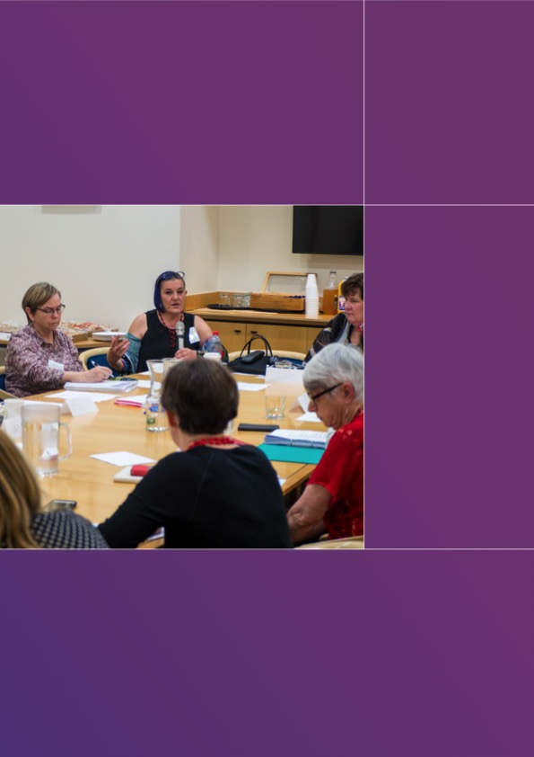

OUTCOME 2

Improved relationship and engagement mechanisms between the Alliances and DPO Australia members

To support the engagement of women with disability, all workshop delegates recognised the need to strengthen the working relationship between the Alliances and the DPO Australia members. Engagement between organisations in the past has been informal, and often based on existing relationships. To improve this working relationship, the Alliances and DPOs will implement the following strategies:

Strategy 1
The Alliances and DPO Australia members will share organisational work plans through a central distribution list.
Following the development and sign off of each organisation’s work plan, these will be shared through a central distribution list with other Alliances and DPO Australia members. This will give both sides the opportunity to identify similarities in work plans, areas where previous work might be beneficial to other organisations, and opportunities for expert input into priority areas. In turn, this will increase opportunities for collaboration between organisations.

Strategy 2
The Alliances and DPO Australia members will establish regular communication channels between the organisations.
The DPO Australia members and Alliances will establish recurrent communication through both email and communiques as well as regular scheduled videoconferences between all organisations to discuss progress against key shared initiatives and to continue to work towards great involvement of women with disability. Where possible, these meetings may be held in person to facilitate greater engagement.

Strategy 3
The Alliances and DPO Australia members will establish and maintain a shared calendar.
The DPO Australia members and Alliances will establish a shared calendar of events attended/hosted by each organisation to ensure that there is transparency between the Alliances and the DPO Australia members, and each organisation has the opportunity to potentially provide information or feedback from its members in those forums.

Strategy 4
The Alliances will seek to include the perspectives of women with disability at international fora.
The Alliances and DPO Australia members identified that wherever possible when attending international events for treaties such as CSW and CEDAW, the Alliances should also focus on keeping the perspectives of women front of mind, so that their views are also represented as part of policy debate.

NEXT STEPS

To facilitate implementation of the strategies discussed at the workshop, the immediate next steps for the Alliances and DPO Australia members organisations are to:
- Share work plans across the group and identify potential areas for collaboration.
- Establish regular email communication through an Alliance/DPO Australia distribution list.
- Initiate regular quarterly or similar videoconferences for engagement between the organisations.

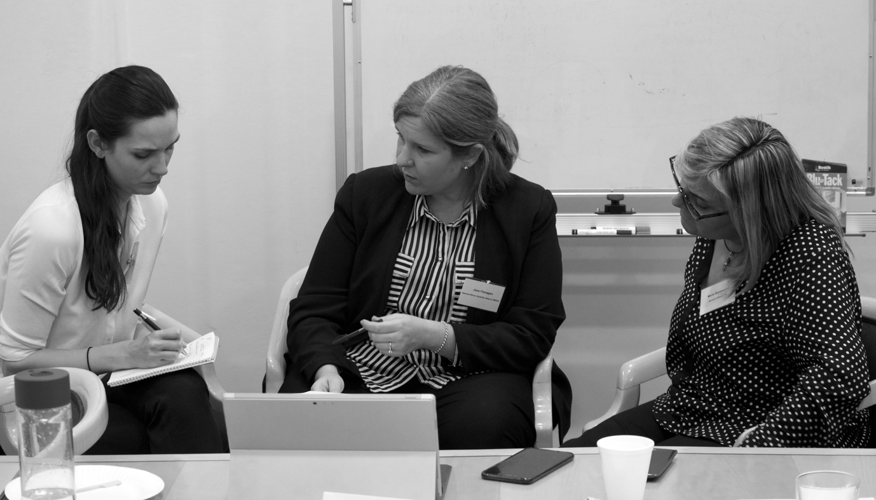
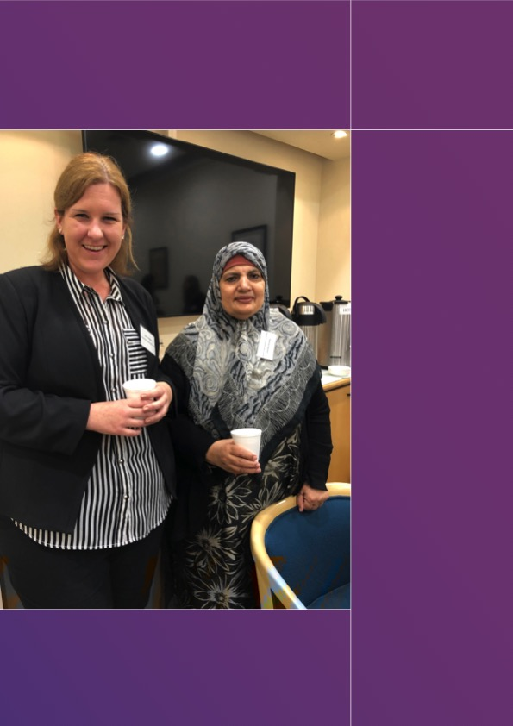

Background

Overview of National Women’s Alliances

The Australian Government funds six National Women’s Alliances (the Alliances) which are networks of issues-based and sector-based women’s groups. Each Alliance has a distinct focus and capacity for networking and advocacy activities. Their roles are twofold:

- Bring together women’s organisations and individuals from across Australia to share information, identify issues that affect them, and identify solutions.
- Engage actively with the Australian Government on policy issues as part of a better more informed and representative dialogue between women and government.
The Alliances represent over 180 women’s organisations. They bring forward the views, voices and issues of Australian women and, in particular, women from marginalised and disadvantaged groups. The Alliances take the lead in ensuring that the voices of as many women as possible are heard, especially those who in the past have found it difficult to engage in advocacy and decision making.

The Alliances have been funded since 1999 and were originally envisaged as one peak body. However, existing women’s organisations advocated for separate bodies that represented the varied and unique challenges faced by women.

Originally, there were three secretariats which were increased to four to include rural women. Since 2010, the six current Alliances have been in existence. Each alliance is funded through the Department of Prime Minister and Cabinet, Office for Women (OFW), and is required to develop an annual work plan, as well as an overarching three-year work plan that aligns with funding cycles. These work plans are approved by the OFW. The Alliances each have different governance and corporate structures, and membership bases.

The six currently funded National Women’s Alliances are:

Australian Women Against Violence Alliance (AWAVA) | 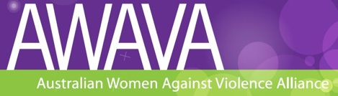
The Australian Women Against Violence Alliance (AWAVA) works towards ensuring that all women and children are able to live free from all forms of violence and abuse. The Alliance recognises that gender-based violence is both a consequence and cause of gender inequality and so it must be addressed by promoting women’s empowerment. AWAVA’s role is to ensure that women’s voices, particularly marginalised women’s voices, are heard by government, harnessing and amplifying the work of its member organisations and Friends and Supporters.

Equality Rights Alliance (ERA) | 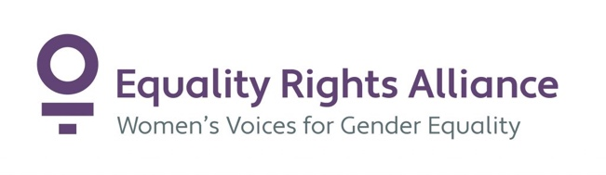
Equality Rights Alliance is one of Australia’s largest networks advocating for women’s equality, women’s leadership and recognition of women’s diversity. ERA brings together 61 organisations with an interest in advancing women’s equality. Its members are non-government organisations and social enterprises with a focus on the impact of policy or service delivery on women. Policy areas include appropriate and affordable housing for women, women’s health, gendered policy and machinery of government, young women, and women’s engagement in international human rights processes.

Economic Security4Women | 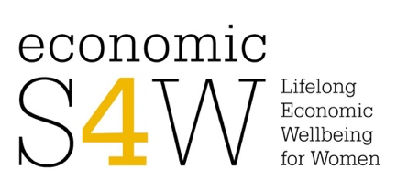
Economic Security4Women is an alliance of women’s organisations united in the belief that economic wellbeing and financial security are essential for women and will enable women of all ages to have an equal place in society. The role of eS4W is to: 1) bring together women’s organisations and individuals from across Australia to share information, identify barriers to women’s economic security and to identify solutions by prioritising the key issues for action to bring about change; and 2) engage actively with the Australian Government on policy issues as part of a better more informed and representative dialogue between women and government.

National Aboriginal and Torres Strait Islander Women’s Alliance | 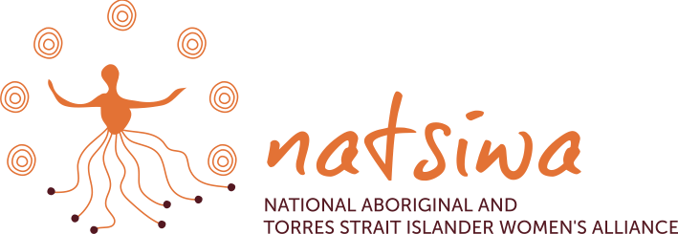
National Aboriginal and Torres Strait Islander Women’s Alliance (NATSIWA) aims to empower Aboriginal and Torres Strait Islander women to have a strong and effective voice in the policy advocacy process. NATSIWA works to deepen the skills Aboriginal and Torres Strait Islander women have in telling their stories, identifying solutions for individuals and communities, and advocating for powerful and long-lasting change.

National Rural Women's Coalition | 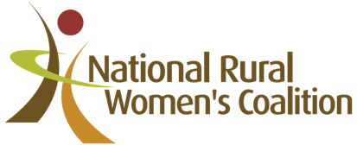
The National Rural Women’s Coalition is a company which works to support and grow vibrant rural, regional and remote communities. The NWRC provides a collaborative platform for women to engage in and influence policy decisions and debate issues impacting rural, remote and regional communities. We do this through online webinars, networking, events, advocacy and educational programs.

Harmony Alliance
The Harmony Alliance aims to provide a national inclusive and informed voice on the multiplicity of issues impacting the experiences and outcomes of migrant and refugee women in Australia. The Alliance seeks to combine grass roots participation and strong community voices with institutional reach and powerful policy advocacy networks, enabling opportunities for migrant and refugee women to directly engage in driving positive change.

Overview of Disabled Peoples Organisations Australia (DPO Australia)

Disabled People’s Organisations Australia, known as ‘DPO Australia’ or ‘DPOA’, is an alliance of four national Disabled People’s Organisations (DPOs) in Australia. The key purpose of DPO Australia is to promote, protect and advance the human rights and freedoms of people with disability in Australia by working collaboratively on areas of shared interests, purposes and strategic priorities and opportunities.

The term ‘Disabled People’s Organisation’ or ‘DPO’ is used to describe non-government, self-determined organisations that are led by, controlled by, and constituted of, people with disability. DPOs are representative organisations of people with disability, and distinct from representative organisations for people with disability. DPOs collectively form a disability rights movement that places people with disability at the centre of decision-making in all aspects of their lives. This is known internationally through the motto, “Nothing About Us, Without Us”.

In 2014, DSS undertook reforms to the way national representative disability peak bodies were funded, and in response to this, the DPOs formed an Alliance and tendered for the available funding as individual organisations which if successful, would work as an alliance.

DPO Australia is recognised as a key coordinating point between Government/s and other stakeholders, for consultation and engagement with people with disability in Australia.

The four founding member organisations of DPO Australia each have different governance and corporate structures, and membership bases. They are funded through the Australian Department of Social Services (DSS) under the Disability Representatives Organisations program. Some of reliant on the Australian government for their operational funding, others receive additional funding through state and territory governments, as well as donations.

As part of their funding agreements, the DPOs are required to have individual annual work plans, as well as an overarching annual activity work plan for the whole Alliance. These work plans include priorities of the DSS for the coming year and are signed off by DSS before work can commence. Find out more about DPO Australia on the joint website, http://www.dpoa.org.au

DPO Australia was founded by, and is comprised of four national cross-disability DPOs:

Women With Disabilities Australia (WWDA) | 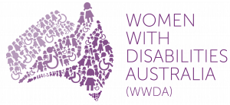
Women with Disabilities Australia is the national cross-disability DPO for women and girls with all types of disability in Australia. It operates as a transnational human rights organisation and is run by women with disability, for women with disability. WWDA represents more than 2 million disabled women in Australia, has affiliate organisations and networks of women with disability in most States and Territories, and is internationally recognised for its global leadership in advancing the human rights of women and girls with disability.

National Ethnic Disability Alliance (NEDA)
National Ethnic Disability Alliance (NEDA) is the national peak organisation representing the rights and interests of people from Culturally and Linguistically Diverse (CALD/NESB) people with disability, their families and carers throughout Australia. NEDA advocates at the federal level so that CALD/NESB people with disability can participate fully in all aspects of social, economic, political and cultural life.

First Peoples Disability Network (Australia) (FPDN) | 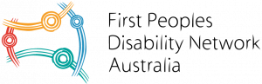
First Peoples Disability Network (Australia) (FPDN) is the national cross-disability DPO representing Aboriginal and Torres Strait Islander people with disability and their families. FPDNA utilises a range of strategies in its representative role, including through the provision of high-level advice to governments, and educating the government and non-government sectors about how to meet the unmet needs of Aboriginal and Torres Strait Islander people with disability.

People with Disability Australia (PWDA) | 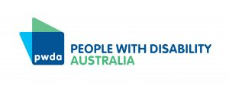
People with Disability Australia (PWDA) is a national cross-disability DPO, representing all people with disability. Its primary membership is made up of people with disability and organisations primarily constituted by people with disability. It also has a large associate membership of other individuals and organisations committed to the disability rights movement. Founded in 1981, the International Year of Disabled Persons, PWDA seeks to provide people with disability with a voice of their own.

Appendix 1 – List of Delegates

The workshop in Sydney was attended by representatives of the six National Women’s Alliances and the four DPO Australia members.

Delegate | Organisation
Fiona Strahan | Women with Disabilities Australia
Carolyn Frohmader | Women with Disabilities Australia
Jess Jacobson | Women with Disabilities Australia
Therese Sands | People with Disability Australia
Bonnie Millen | People with Disability Australia
Robina Yasmin | National Ethnic Disability Alliance
Jane Flanagan | National Ethnic Disability Alliance
June Riemer | First Peoples Disability Network Australia
Merrindahl Andrew | Australian Women Against Violence Alliance
Gayatari Nair | Australian Women Against Violence Alliance
Roselynne Anderson | Economic Security4Women
Maryanne Maher | Economic Security4Women
Helen Dalley-Fisher | Equality Rights Alliance
Hannah Gissane | Equality Rights Alliance
Iona Roy | Harmony Alliance
Maria Dimopoulos | Harmony Alliance
Alwyn Friedersdorff | National Rural Women’s Coalition
Keli McDonald | National Rural Women’s Coalition
Sandra Creamer | National Aboriginal and Torres Strait Islander Women’s Alliance

Appendix 2 – Summary of Recommendations from the Review of the National Women National Women’s Alliance Model

The Office for Women (OFW) should consider developing an overarching document that links Australian Government’s priorities, the Desired Outcomes of the Operating Framework, and the work of Alliances. Current practices enable the links between government priorities and the desired outcomes of the Operating Framework to occur through the work plans, however these links are not understood more broadly, and a more transparent expression of the links could be beneficial for all parties.
Update the Operating Framework to reflect the desired purpose of the Alliances. Many of the current challenges with the coherence of the Operating Framework, the functioning of the Alliance model and the ability to represent government’s priorities stem from the fact that the Operating Framework was developed under a different government with different intentions for the Alliances.
Update the Operating Framework to include measurable and achievable outcomes. The current outcomes are high level, out of step with the Alliances’ level of funding, difficult to measure or to attribute progress, and provide no indication of timeframes. This is making it difficult for OFW and for Alliances to determine whether they are meeting their objectives.
Consider revising the OFW Alliance grant management approach to take a risk-based approach to dealing with individual Alliances. This would enable OFW to focus their limited resources on the Alliances that require closer scrutiny, while rewarding the Alliances that have, over time, been able to demonstrate sound governance and achievement of outputs.
Redefine the relationship between Alliances and OFW to be more strategic and mutually beneficial. This would allow a more broadly focussed relationship to evolve rather than one focussed on compliance. In doing this, implications for changes to the operating model of the Alliances may emerge.
Encourage and support Alliances to increase inter-Alliance collaboration. This should increase the quality and amount of work that Alliances are able to undertake.
Direct and support Alliances to increase representation of marginalised women. This would require Alliances to develop a renewed focus on women with disability, women from CALD backgrounds and members of the LGBTI community.

Full report and recommendations are available at:
https://www.pmc.gov.au/sites/default/files/publications/review-nwa-report.pdf

Appendix 3 – Agenda

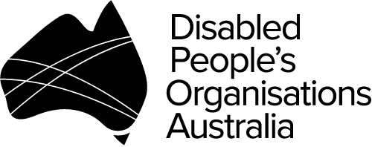
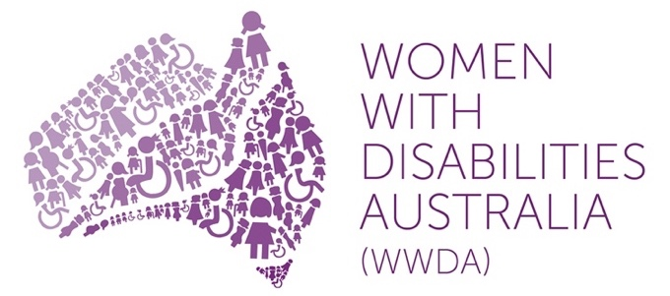

WWDA/DPO Australia and
National Women’s Alliances Workshop

Thursday 18th October 2018 – 10.00am – 4.00pm

Sydney Mechanics’ School of Arts – Boardroom

280 Pitt Street, Sydney NSW 2000

Facilitator:

Liz Forsyth, Chair Global Government, KPMG

Agenda
10.00am | Welcome  - Acknowledgement to traditional owners of the land  - Introductions  - Objectives to be achieved  - Overview of the day
10.10am | Background  - What is a DPO? Who are their members? How do they work? What are their priorities?  - What are the National Women’s Alliances? Who are their members? How do they work? What are their priorities?  Each organisation to provide a 5-10 minute presentation on their operating model and how they work
11.30am | Morning tea
11.45am | Workshop session – Engaging women with disability  - In pairs (one set of representatives from one DPO and one set of representatives from one of the Women’s Alliances) – discuss how best to engage with women with disability. Consider for example:  - How to access women with disability within the community? Please give specific consideration to women with significant support requirements.  - What sorts of communications supports might be required to facilitate the effective engagement of women with disability in issues of concern for the Alliances?  - What other supports might be required to facilitate the active engagement of women with disability in the Alliance networks?  - What strategies need to be put in place to maintain and evaluate the involvement of women with disability in the Alliance networks?  - What role could the DPOs play in supporting these processes?  Small groups – with each group allocating a scribe to take notes and to assist in the plenary
1.00pm | Lunch
1.30pm | Plenary from workshop session
2.30pm | Moving forward – Working together – DPOs and the Women’s Alliances  - Thinking about the importance of the voice of women with disability in the work of the Alliances – how can the DPOs and Alliances work more effectively to ensure that this voice is actively heard and maintained?  - What processes and mechanisms need to be put in place so the voice of women with disability is more effectively heard in the international and national policy debates concerning women?  Plenary
3.30pm | Next steps  - Summary of today’s proceedings  - Review of write up of the workshop outcomes  - Next steps
3.45pm | Close

Appendix 4 – Delegate Details Form

Women With Disabilities Australia (WWDA) in conjunction with
Disabled People’s Organisations Australia (DPO Australia)

National DPO’s and National Women’s Alliances Workshop
18th October 2018

‘Delegate Information Form’

Please complete the relevant details on this form and return by Friday 5th October 2018:

By email to: chris@wwda.org.au

If you would like assistance to complete this form, please contact Carolyn Frohmader at WWDA on Mobile 0438 535 123 or by email carolyn@wwda.org.au

A. Delegate Details

Name: ____________________________________________________________________

Organisation: ______________________________________________________________

Address:__________________________________________________________________

State: Postcode: __________________________

Phone: ________________________________ Mobile: ____________________________

Email: ____________________________________________________________________

B. Transport Arrangements

(1) Do you require taxi vouchers to attend the National Workshop?

Yes No

(2) Do you have any other transport requirements? (eg: train fares, bus fares etc)

Yes No

If Yes, please specify

C. Communication and Information Requirements

(3) Do you require any communication support? For example: hearing loop, Auslan Interpreter, real time captioning, note taker etc.

Yes No Not Applicable

If Yes, please specify

D. Dietary Requirements

(4) Do you have any dietary requirements (including any food allergies)?

Yes No Not Applicable

If Yes, please specify

E. Any Further Information?

(5) If you have any particular access, support, or other requirements which we have not mentioned, please specify them below.

THANK YOU FOR COMPLETING THIS FORM.

Please return by Friday 5th October 2018:

By email to: chris@wwda.org.au

Appendix 5 – Photo Release Form

Women With Disabilities Australia (WWDA) in conjunction with
Disabled People’s Organisations Australia (DPO Australia)

National DPO’s and National Women’s Alliances Workshop
18th October 2018

‘Photo/Video Consent and Release Form’

The ‘National DPO’s and National Women’s Alliances Workshop’ is being hosted by Women With Disabilities Australia (WWDA) in conjunction with Disabled People’s Organisations Australia (DPO Australia) on Thursday 18th October in Sydney. This Workshop is being made possible through a small funding grant from the Department of Prime Minister and Cabinet (Office for Women).

At the ‘National Workshop’ we will be taking photographs and video footage. The information that comes from the ‘National Workshop’ will be documented and recorded and used in a report of the proceedings, which will be provided to Government and made publicly available.

We would like your permission to use your photograph and video footage to promote the ‘National Workshop’. Your photo and/or video footage may be used in our newsletters, reports, publications on our websites and our social media sites (Facebook and Twitter). We will also make any photographs and video footage available to the NWA’s, for use in your own publications and websites etc, although copyright will remain with WWDA.

If you agree to us taking and using your photographs and/or video footage please sign here.

I agree to having my photo and/or video footage taken and reproduced for the purposes of the ‘National DPO’s and National Women’s Alliances Workshop’.

Signature: _________________________________________________________________

Name: _________________________________________________________________

Date: _________________________________________________________________

If you disagree to us taking and using your photographs and/or video please sign here.

I disagree to having my photo and/or video footage taken and reproduced for the purposes of the ‘National DPO’s and National Women’s Alliances Workshop’.

Signature: ______________________________________________________________________

Name: _________________________________________________________________________

Date: _________________________________________________________________________

Please return by Friday 5th October 2018:

By email to: chris@wwda.org.au

Appendix 6 – Emergency Contact Form

Women With Disabilities Australia (WWDA) in conjunction with
Disabled People’s Organisations Australia (DPO Australia)

National DPO’s and National Women’s Alliances Workshop
18th October 2018

‘Emergency Contact Form’

Please complete the relevant details on this form and return by Friday 5th October 2018:

By email to: chris@wwda.org.au

If you would like assistance to complete this form, please contact Carolyn Frohmader at WWDA on Mobile 0438 535 123 or by email carolyn@wwda.org.au

Participants Name
Emergency Contact Name
Emergency Contact Phone Number/s
Relationship to Participant
Participant Allergies
Any Other Relevant Medical Information

In Australia there are six National Women’s Alliances (the Alliances) who represent over 180 women’s organisations. They bring forward the views, voices and issues of Australian women and, in particular, women from marginalised and disadvantaged groups. The Alliances take the lead in ensuring that the voices of as many women as possible are heard, especially those who in the past have found it difficult to engage in advocacy and decision making. Visit: https://nationalwomensalliances.org.au
https://www.pmc.gov.au/news-centre/office-women/review-national-womens-alliances
For full list of recommendations, please see Appendix 2.
Lesbian, Gay, Bisexual, Transgender and Intersex.
A DPO is a non-government, self-determining organisation that is governed, controlled by, and constituted of, people with disability. For further information visit: http://dpoa.org.au/about/terminology/
‘DPO’ became the internationally accepted term at the time of the International Year of Disabled Persons in 1981, when people with disability all over the world began to organise themselves into their own organisations. The United Nations Convention on the Rights of Persons with Disabilities (CRPD) outlines the obligation of States Parties to guarantee the participation and involvement of representative organisations of people with disability in decision-making in all aspects of their lives [Article 4(3)], to promote the establishment of organisations of people with disability [Article 29(b)(ii)] and ensure their participation in CRPD implementation and monitoring [Articles 4(3) and 33(3)]. The CRPD provides the framework to ensure that people with disability, through their representative organisations are the main participants in CRPD implementation, and their voices, views, opinions and preferences should always be given priority in all matters affecting their lives.

