Women With Disabilities Australia (WWDA)

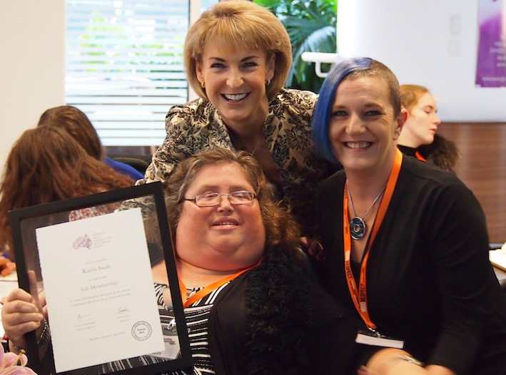

The National Forum for Women
and Girls with Disability

Wednesday 6 April 2016
Melbourne

Appendices

Publishing Information

Women With Disabilities Australia (WWDA) The National Forum for Women and Girls with Disability; Appendices to the Proceedings and Outcomes Report. Written by Carolyn Frohmader on behalf of Women With Disabilities Australia; November 2016, Hobart, Tasmania. Copyright.
ISBN: 978-0-9775305-4-0

Contact

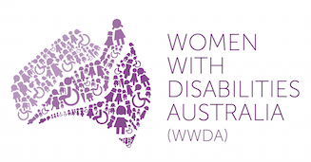

Winner, National Human Rights Award 2001
Winner, National Violence Prevention Award 1999
Winner, Tasmanian Women's Safety Award 2008
Certificate of Merit, Australian Crime & Violence Prevention Awards 2008
Nominee, French Republic's Human Rights Prize 2003
Nominee, UN Millennium Peace Prize for Women 2000

Women With Disabilities Australia (WWDA)
PO Box 407, Lenah Valley Tasmania 7008 AUST
Ph: +61 438 535 123 E: carolyn@wwda.org.au
W: www.wwda.org.au FB: www.facebook.com/WWDA.Australia
Twitter: https://twitter.com/WWDA_AU
Contact: Carolyn Frohmader, Executive Director

Disclaimer Statement

The contents of this report reflect the information and views provided by women and girls with disability who attended and contributed to the National Forum for Women and Girls with Disability, held in Melbourne on 6 April 2016. The opinions, views and opinions expressed in this publication are those of Women With Disabilities Australia (WWDA) and not necessarily those of the funding bodies and/or sponsors.

Funding

The National Forum for Women and Girls with Disability was made possible through project funding from the Australian Government (Department of Prime Minister and Cabinet and the Department of Social Services), and generous in-kind support provided by Medibank Health Solutions Pty Ltd.

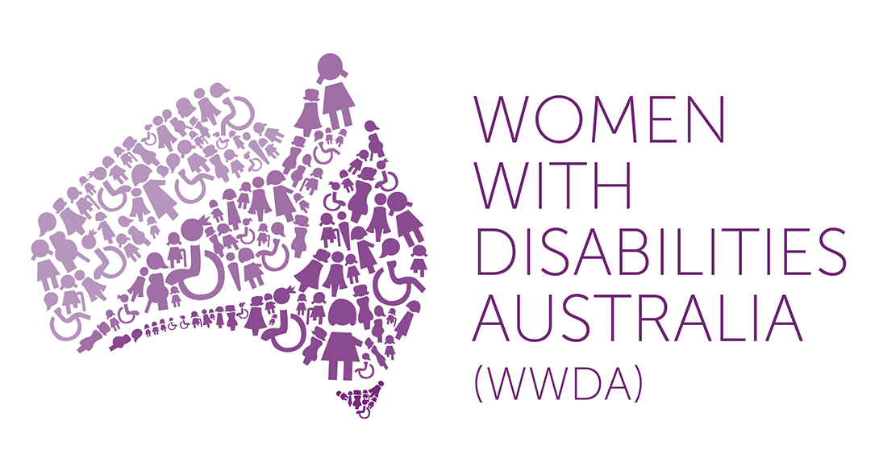 | 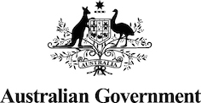

Contents

Publishing Information 2
Contents 3
Appendix 1: Attendee list 4
Appendix 2: Forum Invitation Letter & Information Flyer [Standard Version] 7
Appendix 3: Forum Invitation Letter & Information Flyer [Easy English Version] 10
Appendix 4: Participant Information Survey Form 13
Appendix 5: Participant Emergency Contact Form 20
Appendix 6: Participant Photo/Video Consent & Release Form 21
Appendix 7: Participant Information Kit [Standard Version] 23
Appendix 8: Participant Information Kit [Easy English Version] 40
Appendix 9: Background Reading [Easy English Version] 57
Appendix 10: Forum Agenda [Standard Version] 62
Appendix 11: Forum Agenda [Easy English Version] 63
Appendix 12: Forum Media Release 67
Appendix 13: National Forum Run Sheet 69

Appendix 1: Attendee list

Women and Girls with Disability

Amanda Lawrie-Jones
Amy Deguara
Ariane Garner-Williams
Bonnie Millen
Cheryl McDonnell
El Gibbs
Ellen Read
Gayle Rankine
Jane Rosengrave
Jax Jackie Brown
Jen Hargrave
Jessica White
Jody Barney
Judy Huett
Jules Anderson
Julia Pillai
Kara May
Karen Burgess
Karin Swift
Kath Duncan
Kay Sadler
Kelly Cox
Keran Howe
Leah Van Poppel
Liz Reid
Margherita Coppolino
Margie Charlesworth
Marlena Katene
Monique Crowden
Nihal Iscel
Pamela Menere
Rayna Lamb
Rebecca Evans
Rebecca Hell
Samantha Connor
Stella Barton
Suzy Kemp
Terri Rule
Therese Sands
Tricia Malowney
Trudy Ryall
Tully Zygier
Wendy Wright
Zhila Hasanloo

Women and Girls with Disability Support Persons

Amorette Garner Williams
Julie Phillips
Louise Stott
Lia McLachlan
Albert Hibbert
Jenny Dixon
Ilsa Knauf
Peta Green
Catherine Evans
Sarah Hona
Catherine Beasleigh
Cherohn Rule

Australian Government Representatives

Lara Purdy
Louise McSorley
Sharon Stuart
Vicki Rundle

National Women’s Alliances Representatives

Karin Williams
Megan Morris
Pat Hamilton
Sandra Triulzi

Women with Disabilities Australia (WWDA) Staff & Support

Carolyn Frohmader – WWDA Staff/Support
Chris Brophy – WWDA Staff/Support
Cashelle Dunn – WWDA Staff/Support
Cristina Ricci – WWDA Staff/Support
Nina (Oronzina) Ricci – WWDA Support

Welcome to Country

Aunty Georgina Nicholson
Wurundjeri Tribe Council

Auslan Interpreters & Attendant Care

Auslan Interpreter - Kelly North
Auslan Interpreter - Erin Goon
Auslan Interpreter – Name TBA
Auslan Interpreter – Name TBA
TravellersAid Support Worker (Attendant Carer) - Casey Mauricio

Support Staff

Counsellor Tarja Malone, Medibank 1800RESPECT
Photographer Medibank 1800RESPECT
Nigel Davis - Organisational Development Partner (Diversity, Inclusion + Employee Experience) – Medibank Health Solutions
Jane French – Manager, 1800RESPECT, Medibank Health Solutions

Appendix 2: Forum Invitation Letter & Information Flyer [Standard Version]

Dear friend,

Women With Disabilities Australia (WWDA) is excited to be able to host a ‘National Forum for Women and Girls with Disability’ and we are inviting you to attend this important event. The National Forum will be held in Melbourne on Wednesday 6th April 2016.

Up to 42 women and girls with disability from around Australia will be invited to attend the Forum. Participants will be selected from each State and Territory.

The aim of the National Forum is for women and girls with disability to identify the issues that affect you, identify solutions, prioritise actions and help set the strategic direction of WWDA for the next 5 years.

Information about the Forum is attached, and we would be delighted if you could attend. WWDA will pay for your travel, accommodation and access expenses (including support person/s) to attend and participate in the National Forum. All participants will be sent a ‘Participant Information Form’ to complete so that we can organise all travel bookings and access requirements. The ‘Participant Information Form’ must be completed and returned to WWDA no later than Wednesday 9th March 2016. Assistance is available for anyone who requires support to complete the forms.

We hope that you will be able to join us at the ‘National Forum for Women and Girls with Disability’ in Melbourne on Wednesday 6th April 2016.

If you would like to accept this invitation, please RSVP by MONDAY 29th FEBRUARY 2016 via email or phone to:

Cashelle Dunn
WWDA
Mobile 0477 074 289
Email cashelle@wwda.org.au

We look forward to hearing from you,

Women With Disabilities Australia (WWDA)

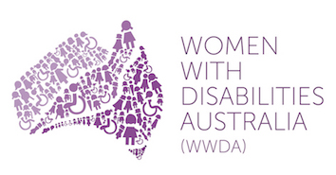 | Women With Disabilities Australia (WWDA)  National Forum for  Women and Girls with Disability 2016

Women With Disabilities Australia (WWDA) is the national Disabled People’s Organisation (DPO) for women and girls with all types of disability in Australia. It operates as a cross-disability, transnational human rights organisation and is run by and for women with disability.

WWDA has obtained funding from the Department of the Prime Minister and Cabinet (Office for Women) to conduct a ‘National Forum for Women and Girls with Disability.’ Up to 42 women and girls with disability from around Australia will be invited to attend the National Forum in Melbourne. Participants will be selected from each State and Territory.

The aim of the National Forum is for women and girls with disability to identify the issues that affect you, identify solutions, prioritise actions, and provide an opportunity to engage actively with the Australian Government on issues relevant to Australian women and girls with disability. The Forum will include a specific focus on the strategic priorities affecting women and girls with disability, including: gendered disability violence; gender equity and gender equality; leadership and participation; economic empowerment; and, sexual and reproductive rights. The National Forum will provide an opportunity for women and girls with disability to come together to help set the strategic direction of WWDA for the next 5 years.

Date: Wednesday 6 April 2016

Place: Medibank, 720 Bourke Street, Melbourne, VIC

What we provide: Accommodation, travel, access support, breakfast, lunch, travel allowance

What you provide: Experience, energy, knowledge, ideas, commitment

What’s in it for you?

- Have access to innovative engagement, information, and participation mechanisms;
- Contribute to setting the strategic direction of WWDA for the next 5 years.
- Have your priority issues heard and contribute to problem-solving.
- Build your education and information on human rights;
- Build your capacity on engagement with the Australian Government on policy issues;
- Learn more about the work of WWDA;
- Network with women and girls with disability from around Australia.

What’s in it for WWDA?

- Build the capacity of women and girls with disability to become better informed about their human rights;
- Ensure informed and representative dialogue between women with disability and government;
- Greater participation of women with disability in policy-making processes;
- Enhance WWDA’s capacity to contribute to the Australian Government’s work to promote gender equality and ensure the voices of women and girls with disability are included.
- Active contribution by women and girls with disability toward setting the strategic direction for WWDA 2016-2021 through identification of the priority issues and development of strategic solutions.

The National Forum for Women and Girls with Disability will be an intensive exchange of information, collectively identifying priority issues for women and girls with disability and developing strategic solutions.

Please note, participants will be required to prepare for the National Forum by reading some essential documents that will sent 2 weeks in advance of the National Forum in preparation for workshop discussions.

RSVP’s are due no later than MONDAY 29th FEBRUARY 2016 via email or phone to:

Cashelle Dunn
WWDA
Mobile 0477 074 289
Email cashelle@wwda.org.au

Participant Information Forms must be completed and returned to WWDA no later than Wednesday 9th March 2016.

If you would like further information about the National Forum, and/or you require assistance to complete the ‘Participant Information Form’ please contact Cashelle Dunn.

Appendix 3: Forum Invitation Letter & Information Flyer [Easy English Version]

Invitation

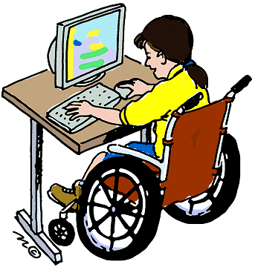 | Women With Disabilities Australia is an organisation that stands up for women and girls with disability.  Women with disability are in charge of our organisation.  We work to make life better for all women and girls with disability.
We are having a meeting in Melbourne to talk to women and girls with disability from all over Australia.

We would like you to come to this meeting.

At the meeting we want to talk to you about:

- What is important to you

- What we can do to help women and girls with disability

- What the Australian Government needs to do to help women and girls with disability.

 | After the meeting we will write to the Australian Government to tell them what women and girls with disability said at the meeting.
 | We will also write a plan about the important things we will work on for the next 5 years.
If you come to the meeting we will pay for your

- plane tickets

- taxis

- hotel room

- breakfast, lunch and dinner while you are away.

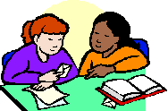 | We will also pay for a support person if you need someone to come with you.

 | The meeting is on Wednesday 6 April 2016 in Melbourne.
Please tell Cashelle Dunn if you can come to the meeting.

Please tell her before Monday 7 March 2016.

You can call Cashelle on 0477 074 289

Or

You can email Cashelle cashelle@wwda.org.au

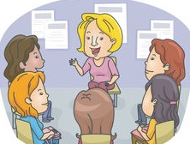 | We hope you can come to the meeting.

Appendix 4: Participant Information Survey Form

Women With Disabilities Australia (WWDA)
National Forum for
Women and Girls with Disability 2016
‘Participant Information Form’

Please complete all details on this Form and return by 9 March 2016:

By email to: cashelle@wwda.org.au

By post to: PO Box 407, Lenah Valley TASMANIA 7018

If you would like assistance to complete this Form, please contact Cashelle Dunn at WWDA on Mobile 0477 074 289 or by email cashelle@wwda.org.au

A. Participant Details

Name:

Organisation (if applicable) _________________________________________________________

Address:

State: Postcode:

Phone: Mobile:

TTY:

Email:

(1) If you are being sponsored by an organisation, please confirm that the organisation that you are representing is assisting financially with all of the expenses associated with you attending this National Forum and making all arrangements for you to attend (that is: flights, taxi’s accommodation and per diem)?

Yes No

If yes, please go to Question 23

B. Air Travel and Transport Arrangements

(2) Do you prefer your flights to be booked with Qantas Airlines or Virgin Australia?

Qantas Virgin Not Applicable

(3) Do you have a Frequent Flyer Number?

Yes No Not Applicable

Frequent Flyer Number

(4) What airport will you be departing from?

(5) Will this be the airport that you will be returning to?

Yes No Not Applicable

If No, please specify

(6) Do you have any specific requirements related to your departure time on Tuesday 5 April 2016?

Yes No Not Applicable

If Yes, please specify

(7) Do you have specific requirements related to your departure time on Wednesday 6 April or Thursday 7 April 2016?

Yes No Not Applicable

If Yes, please specify

(8) Do you require airport assistance on check-in?

Yes No Not Applicable

If Yes, please specify

(9) Do you require assistance to board the flight?

Yes No Not Applicable

If Yes, please specify

(10) Do you require a wheelchair to get from airport check-in to your flight?

Yes No Not Applicable

(11) Do you have a scooter or wheelchair that requires special handling by airport staff?

Yes No Not Applicable

(12) If you are flying to and from the National Forum, and will be travelling with a wheelchair or scooter, please provide the following information about your wheelchair/scooter.

Brand and Model:

Total Weight:

Total Width:

Total Height:

Height with Backrest folded down:

Total Length:

Battery Type:

Any Other Details:

(13) Do you require any specific assistance from flight staff during the flight?

Yes No Not Applicable

If Yes, please specify

(14) Do you have any other specific requirements related to the flight?

Yes No Not Applicable

If Yes, please specify

(15) Do you require taxi vouchers to attend the National Forum?

Yes No

(16) Do you have specific taxi requirements?

Wheelchair Accessible taxi Standard Taxi

Other (please specify)

(17) Do you have any other transport requirements? (eg: train fares, bus fares etc)

Yes No

If Yes, please specify

C. Accommodation Requirements

(18) Will you be requiring accommodation for:

Tuesday night 5 April Wednesday Night 6 April Not Applicable

(19) Do you require a room with an accessible bathroom only?

Yes No

(20) Do you require a fully accessible accommodation room?

Yes No

(21) If you have a support person staying with you, do you require your support person to share your room?

Yes No

If Yes, please specify

(22) Do you have any other requirements related to accommodation? (eg: bed configuration, close proximity to support persons room, etc)

Yes No

If Yes, please specify

D. Communication and Information Requirements

(23) Do you require any communication support? For example: hearing loop, Auslan Interpreter, real time captioning, note taker etc.

Yes No Not Applicable

If Yes, please specify

(24) Do you require written information to be provided in a specific format? For example: Large Print, Electronic, Easy English?

Yes No Not Applicable

If Yes, please specify

E. Personal Care Assistance Requirements

(25) If you require personal care assistance, will you be bringing a support person with you or will you require a personal care assistant to be booked for you?

I will bring my own support person/ personal care assistant

I will require a personal care assistant to be booked

(26) Do you have any specific requirements in relation to personal care assistance?

Yes No Not Applicable

If Yes, please specify

E. Dietary Requirements

(27) Do you have any dietary requirements (including any food allergies)?

Yes No Not Applicable

If Yes, please specify

F. Any Further Information?

(28) If you have any particular access, support, or other requirements which we have not mentioned, please specify them below.

THANK YOU FOR COMPLETING THIS FORM.

Please return by 9 March 2016:

By email to: cashelle@wwda.org.au

By post to: PO Box 407, Lenah Valley TASMANIA 7018

Appendix 5: Participant Emergency Contact Form

Women With Disabilities Australia (WWDA)
National Forum for
Women and Girls with Disability 2016
‘Emergency Contact Form’

Please complete all details on this Form and return by 9 March 2016:

By email to: cashelle@wwda.org.au

By post to: PO Box 407, Lenah Valley TASMANIA 7018

If you would like assistance to complete this Form, please contact Cashelle Dunn at WWDA on Mobile 0477 074 289 or by email cashelle@wwda.org.au

Participants Name
Emergency Contact Name
Emergency Contact Phone Number/s
Relationship to Participant
Participant Allergies
Any Other Relevant Medical Information

Appendix 6: Participant Photo/Video Consent & Release Form

Women With Disabilities Australia (WWDA)
National Forum for
Women and Girls with Disability 2016
Photo/Video Consent and Release Form

The ‘National Forum for Women and Girls with Disability’ is being conducted by Women With Disabilities Australia (WWDA) on Wednesday 6th April in Melbourne, Victoria. The National Forum is being made possible through a funding grant from the Department of Prime Minister and Cabinet (Office for Women) and the Department of Social Services (National Disability Conference Initiative).

The aim of the National Forum is for women and girls with disability to identify the issues that affect you, identify solutions, prioritise actions, and provide an opportunity to engage actively with the Australian Government on issues relevant to Australian women and girls with disability. The Forum will include a specific focus on the strategic priorities affecting women and girls with disability, including: gendered disability violence; gender equity and gender equality; leadership and participation; economic empowerment; and, sexual and reproductive rights. The National Forum will provide an opportunity for women and girls with disability to come together to help set the strategic direction of WWDA for the next 5 years.

At the ‘National Forum for Women and Girls with Disability’ we will be taking photographs and video footage of the proceedings of the Forum. The information that comes from the ‘National Forum for Women and Girls with Disability’ will be documented and recorded and used in a report to the Australian Government, and also in WWDA’s 5 year Strategic Plan 2016 – 2021.

We would like your permission to use your photograph and video footage to promote the ‘National Forum for Women and Girls with Disability’. Your photo and/or video footage may be used in our newsletters, reports, publications on our websites and our social media sites (Facebook and Twitter).

If you agree to us taking and using your photographs and/or video footage please sign here.

I agree to having my photo and/or video footage taken and reproduced for the purposes of the ‘National Forum for Women and Girls with Disability’.

Signature: _________________________________________________________________

Name: _________________________________________________________________

Date: _________________________________________________________________

If you disagree to us taking and using your photographs and/or video please sign here.

I disagree to having my photo and/or video footage taken and reproduced for the purposes of the ‘National Forum for Women and Girls with Disability’.

Signature: _________________________________________________________________________

Name: ________________________________________________________________________________

Date: _________________________________________________________________________

NB: If you require assistance to complete this ‘Photo/Video Consent and Release Form’ please contact:
Cashelle Dunn (WWDA)
Mobile: 0477 074 289
Email: cashelle@wwda.org.au

Appendix 7: Participant Information Kit [Standard Version]

Women With Disabilities Australia (WWDA)

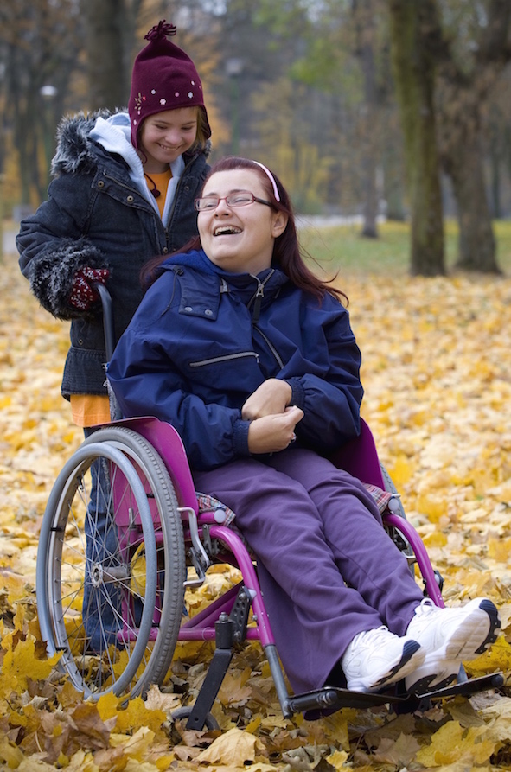
National Forum for
Women and Girls with Disability 2016

Participant Information Kit

Wednesday 6th April 2016
Medibank Head Offices
720 Bourke Street, Melbourne, Victoria
9:00am – 5:00pm

Contents

About Women with Disabilities Australia (WWDA)

About the National Forum for Women and Girls with Disability

Forum Participants (Confirmed)

Forum Facilitators and Support Staff

Forum Venue

Travel Information

Accommodation Information

Agenda for the National Forum on Women and Girls with Disability

Emergency Information

About Women with Disabilities Australia (WWDA)

Women With Disabilities Australia (WWDA) is the award-winning national non-government organisation (NGO) for women and girls with all types of disability in Australia. Over the past 20 years, WWDA has grown from a small group of women with disability concerned primarily with building individual confidence and self-esteem, to an internationally acclaimed transnational human rights advocacy organisation enabling and representing the collective interests of women and girls with disability and promoting and advancing their rights and freedoms. WWDA’s work is grounded in a human rights based framework which links gender and disability issues to a full range of civil, political, economic, social and cultural rights. WWDA initiates and conducts ground-breaking and critically acclaimed national and international programs which address a wide range of issues for women and girls with disability. WWDA provides rigorous, informed, and evidence based input into policy development at state/territory, national and international levels. The organisation is widely respected for its high quality, professional, and intellectually rigorous research that continually builds the evidence base in respect of legislation, policies, services, supports and programs for all people with disability.

WWDA has, in its short life, developed a critical mass of expertise on the human rights of women and girls with disability. It utilises the energies and experiences of women with disability as activists, researchers, consultants, representatives, advocates and service providers. It builds the capacity of women with disability to develop knowledge, confidence and skills to enable them to speak out about their experiences and take action to collectively improve their lives. Importantly, WWDA's approach recognises that developing a sense of personal worth, autonomy and agency for women with disability is fundamental to advancing their individual and collective human rights.

Underpinning WWDA’s work, and implicit in WWDA's Strategic direction, is a commitment to human rights, which directs all aspects of WWDA’s work. This means that WWDA believes that:

1. We are all born free and equal. We all have our own thoughts and ideas. We should all be treated in the same way.

2. We all have the right to freedom from discrimination.

3. We all have the right to life, and to live in freedom and safety.

4. Nobody has any right to hurt us or to torture us.

7. The law is the same for everyone. It must treat us all fairly.

8. We all have the right to make up our own minds, to think what we like, to say what we think, and to share our ideas with other people.

9. Every adult has the right to marry, have a partner and have a family if they want to.

10. We all have the right to affordable housing, medicine, education, healthcare, childcare, and enough money to live on.

11. Every adult has the right to do a job and to get a fair wage for their work.

12. Nobody has the right to come into our home, open our letters, or bother us or our family without a good reason.

13. We all have the right to take part in the government of our country. Every grown-up should be allowed to choose their own leaders.

14. Nobody has the right to put us in prison without good reason and keep us there, or to send us away from our country.

15. Nobody should be blamed for doing something until it is proven.

16. We all have the right to meet our friends and to work together in peace to defend our rights.

17. We all have the right to go where we want in our own country and to travel as we wish.

18. We have a duty to other people, and we should protect their rights and freedoms.

The key purpose of WWDA is to promote and advance these human rights and freedoms for women and girls with disability. WWDA’s aim is to be a national voice for the needs and rights of women and girls with disability and a national force to improve the lives and life chances of women and girls with disability. WWDA is also a founding member of the Australian Cross Disability Alliance (ACDA), which is an alliance of national disabled person’s organisations (DPO’s) in Australia. The key purpose of the ACDA is to promote, protect and advance the human rights and freedoms of people with disability in Australia by working together on areas of shared interests, purposes, priorities and opportunities.

Each year, WWDA develops an Annual Work Activity Plan, which sets out in detail what we are working on for the next 12 months.

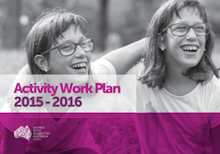

The WWDA Activity Workplan 2015-2016 is available for download from the WWDA website in both PDF and Word formats.

For the PDF version, go to:
http://wwda.org.au/wp-content/uploads/2015/07/WWDA-Workplan-2015-16-SM.pdf

For the Word version, go to:
http://wwda.org.au/wp-content/uploads/2015/07/WWDA_Workplan_2015_16_Final1.docx

About the National Forum for Women and Girls with Disability

The WWDA National Forum for Women and Girls with Disability 2016 will support women and girls with disability to identify the issues that affect them, identify solutions, prioritise actions, and engage actively with the Australian Government on issues relevant to Australian women and girls with disability. The National Forum will include a specific focus on the strategic priorities affecting women and girls with disability, including: violence against women and girls with disability; leadership and participation; economic empowerment; sexual and reproductive rights, and more. The National Forum will provide an opportunity for women and girls with disability to come together and ensure that their voices and experiences are heard. Representatives from the Australian Government will be attending to provide an overview of the Government’s priorities for women and for people with disability.

The aim of the National Forum is for women and girls with disability to:

- Identify the issues that affect you and other women and girls with disability in Australia
- Identify solutions, prioritise actions and provide an opportunity to engage actively with the Australian Government on issues relevant to Australian women and girls with disability
- Contribute toward setting WWDA’s strategic direction for the next five years.

The Forum will be accessible to women and girls with disability and supports have been made available to attendees to ensure that the forum is inclusive, meaningful and empowering for all women and girls with disability.

In addition to the Forum itself, outputs will include the production of a Report on the planning and proceedings of the national forum that will be provided to government and disseminated widely through the WWDA member and stakeholder networks. Proceedings and outcomes from the forum will inform the development of WWDA’s five-year strategic plan and priorities for 2016 to 2021.

Forum Participants (Confirmed)

Name | Organisation | State
Ellen Read | Self | ACT
Cristina Ricci | Women with Disabilities Australia (WWDA) | NSW
El Gibbs | Women with Disabilities Australia (WWDA)  People with Disabilities Australia (PWDA) | NSW
Cheryl McDonnell | Self | NSW
Terri Rule | Self | NSW
Kay Sadler | Self | NSW
Kelly Cox | Self | NSW
Samantha French | People with Disabilities Australia (PWDA) | NSW
Therese Sands | People with Disabilities Australia (PWDA) | NSW
Liz Reid | Self | NT
Rebecca Hell | Self | NT
Karin Swift | Women with Disabilities Australia (WWDA) | QLD
Jess White | Self | QLD
Marlena May Katene | Self | QLD
Amy Deguara | Self | QLD
Suzy Kemp | First People’s Disability Network Australia (FPDNA) | QLD
Bonnie Millen | Women with Disabilities Australia (WWDA) | SA
Margie Charlesworth | Self | SA
Gayle Rankine | First People’s Disability Network Australia (FPDNA) | SA
Carolyn Frohmader | Women with Disabilities Australia (WWDA) | TAS
Judy Huett | Self | TAS
Monique Crowden | Self | TAS
Jenny Dixon | Speak Out Association of Tasmania | TAS
Rayna Lamb | Women with Disabilities Australia (WWDA) | WA
Wendy Wright | First People’s Disability Network Australia (FPDNA) | WA
Samantha Connor | Women with Disabilities Australia (WWDA) | WA
Rebecca Evans | Self | WA
Nihal Iscel | Self | WA
Pamela Menere | Women with Disabilities Australia (WWDA) | VIC
Jody Barney | Self | VIC
Cashelle Dunn | Women with Disabilities Australia (WWDA) | VIC
Margherita Coppolino | Women with Disabilities Australia (WWDA) | VIC
Jen Hargrave | Women with Disabilities Australia (WWDA) | VIC
Tricia Malowney | Self | VIC
Jax Jackie Brown | Self | VIC
Karen Burgess | Self | VIC
Keran Howe | Self | VIC
Julia Pillai | Self | VIC
Kath Duncan | Self | VIC
Jane Rosengrave | Self | VIC
Jules Anderson | Self | VIC
Amanda Lawrie | Self | VIC
Leah Van Poppel | Self | VIC
Tully Zygier | Self | VIC
Trudy Ryall | Self | VIC
Ariane Garner-Williams | Self | VIC
Kara May | Self | VIC

Forum Facilitators and Support Staff

Carolyn Frohmader
Forum Organiser
Executive Director, Women With Disabilities Australia (WWDA)
Email: carolyn@wwda.org.au
Phone: 0438 535 123

Christopher Brophy
Forum Organiser
Director, Strategic Communications
Email: chris@wwda.org.au
Phone: 0405 789 142

Cristina Ricci
Forum Co-Facilitator and Forum Organiser
Director, Strategic Policy and Programs
Email: cristina@wwda.org.au
Phone: 0413 249 385

Cashelle Dunn
Forum Co-Facilitator and Forum Organiser
Project Officer
Email: cashelle@wwda.org.au
Phone: 0477 074 289

Forum Venue

The National Forum for Women and Girls with Disability 2016 is being held at:

Medibank Head Office (Docklands)
720 Bourke Street, Melbourne, VIC
Phone: 03 9322 8000

A street map showing the location of the venue is provided below. You can also access directions on Google Maps (internet access required).

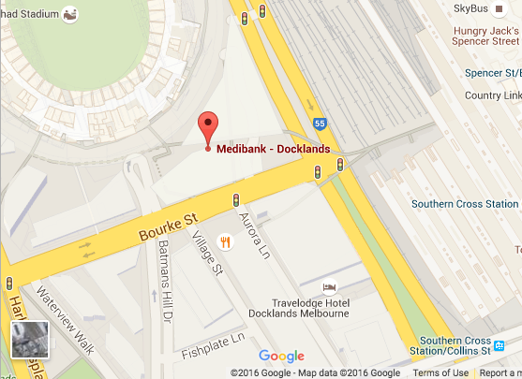

Below is a photo of the Forum Venue – the Medibank Head Office at 720 Bourke Street, Melbourne. Alt text is provided with the image for people who use screen readers.

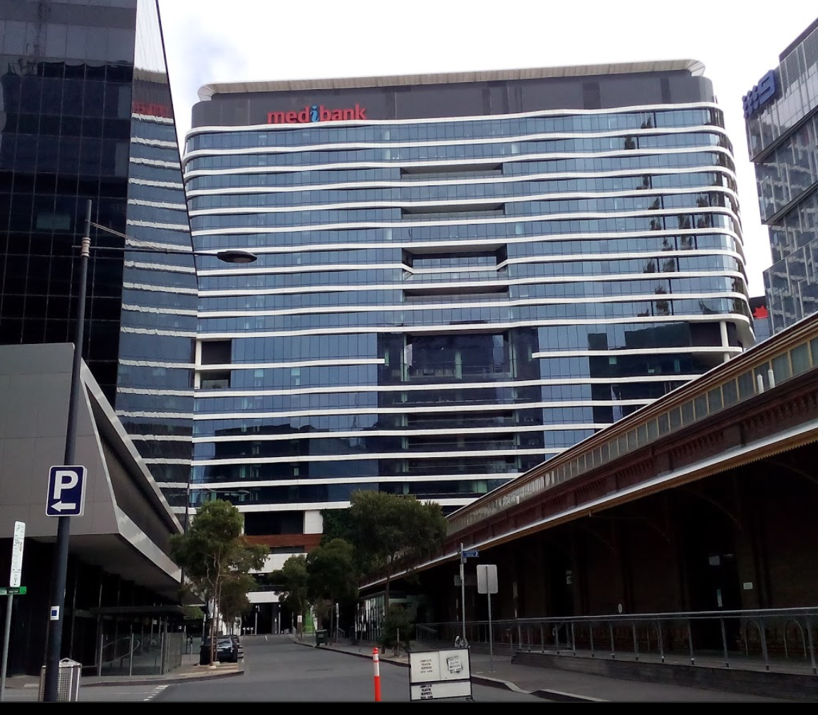

There will be people to meet you in the foyer on the day of the Forum and take you to the part of the building where the Forum is being held.

Travel Information

Flight Information
Participants (and support person where applicable) who are flying to Melbourne for the National Forum will find a copy of their itinerary/booking confirmation sheet included with this information package. The itinerary/booking confirmation sheet has already been emailed to each participant, but a hard copy is also provided in this Information Kit for your convenience.

Your booking information sheet includes your booking number and it would be advisable to carry a copy of this sheet with you during your flights. The forum organisers also have a copy of your booking details.

All participants will be required to produce photo-identification upon check-in for each flight.

All flights have been booked by Women With Disabilities Australia (WWDA) using our Travel agent, Susan Matthew, of Andrew Jones Travel in Tasmania.

Susan’s contact number for your information is (03) 6221 3412. The Emergency Number for Andrew Jones Travel is: 0409 245 508.

Taxis
It is the responsibility of each participant (and support person where applicable) to arrange their own taxi travel to and from the ‘National Forum for Women and Girls with Disability’. CabCharge e-tickets have been issued to each participant (and support person where applicable) to cover this cost. Please find these enclosed in a sealed envelope at the back of this document. If any participant requires additional CabCharge e-tickets during the National Forum, please contact one of the Forum Organisers, Co-Facilitators and/or support staff.

CabCharge e-tickets can be used to pay for:

- Taxi to get from your home to your local airport;
- Taxi to get from Melbourne Airport to your hotel;
- Taxi to get from your hotel to Melbourne Airport;
- Taxi to get from your local airport to your home;

For Melbourne based participants, CabCharge e-tickets can be used to pay for:

- Taxi to get from your home or workplace to the forum venue.
- Taxi to get from the forum venue to your home or workplace.

Each participant is required to return their CabCharge receipts, including ticket stub, along with any unused CabCharge e-tickets to Women With Disabilities Australia (WWDA) in the stamped addressed envelope, enclosed with the CabCharge e-tickets in this information package.

If it is easier, WWDA can also accept photos of each taxi receipt and these can be emailed to carolyn@wwda.org.au and/or chris@wwda.org.au

NB. CabCharge e-tickets should be treated as cash and should be kept in a secure place at all times. Allocated CabCharge e-tickets should not be transferred to any other person/s.

Taxi Contacts in Melbourne

Taxi Cabs
Silver Top Taxis
+61 3 8413 7202
www.silvertop.com.au

Yellow Cabs
13 6294
www.13cabs.com.au

Wheelchair accessible taxis are available in Melbourne. Ask when you book.

Accommodation Information

Accommodation
Accommodation for those participants (and support person where applicable) who are flying and/or driving long distances to Melbourne for the National Forum has been organised, booked and pre-paid by WWDA. Room allocations have also been organised. Participants are being accommodated at the Travelodge Hotel Docklands Melbourne (which is directly across the road from the Forum venue and less than 2 minutes walk) and the Quest Serviced Apartments (which is in the same street as the Forum venue and less than 2 minutes walk).

The Travelodge Hotel Docklands Melbourne is located at:
66 Aurora Lane,
Docklands, Melbourne VIC 3008
Ph: (03) 8615 1000
Website:
https://www.tfehotels.com/brands/travelodge-hotels/travelodge-docklands

The Quest Serviced Apartments are located at:
750 Bourke St,
Docklands, Melbourne VIC 3008
Ph:(03) 9630 1000
Website: http://www.questapartments.com.au/Accommodation/6/Australia/Melbourne_CBD_Fringe/Quest_Docklands/Welcome.aspx

All accommodation has been booked and confirmed by WWDA and has been pre-paid prior to the National Forum. Your specific accommodation details are included with this package.

Accommodation Related Payment Information
All participants (and support person where applicable) will be individually responsible for any costs that they incur during their stay including minibar, telephone calls, additional internet access, dry cleaning, in-house videos, room service etc. WWDA is pre-paying the accommodation charge (and continental breakfast for participants staying at the Travelodge Hotel Docklands Melbourne). Any other expenses will be the responsibility of each participant and must be paid in full on checkout from the hotel.

Participant Per Diem and Catering
Continental breakfast is included in the accommodation cost for all participants (and support person where applicable) staying in the Travelodge Hotel Docklands Melbourne. Participants staying at the Quest Serviced Apartments will receive additional per diem (travel allowance) to cover the cost of breakfast. Morning tea, lunch and afternoon tea will be provided for all attendees, including support persons, at the National Forum on 6th April.

For those participants (and support person where applicable) who are staying overnight and who are not attending in a paid capacity for their organisation, a per diem (travel allowance) amount will be deposited into your bank account and/or your support person as per your information that was provided to the forum organisers. The travel allowance amount will cover the cost of meals that are not provided at the Forum and not included in your accommodation. A small amount will also be provided for incidental expenses. These amounts are calculated by the Australian Taxation Office (ATO) and are:

Item | Cost
Evening meal | 49.65
Incidentals (daily) | 18.75

Agenda for the National Forum on Women and Girls with Disability

9.00 | Registration
9.30 | Welcome and Introductions
9.35 | Welcome to Country
9.40 | Opening –Rayna Lamb, President, Women With Disabilities Australia
9.50 | Overview of the Forum and Forum objectives
9.55 | PANEL - OVERVIEW OF CURRENT CRITICAL POLICIES FOR WOMEN AND GIRLS WITH DISABILITY IN AUSTRALIA  Government representatives provide an overview and answer questions  - Second/Third Action Plan of the National Plan to Reduce Violence against Women and their Children 2010-2022  - The National Disability Strategy  - The National Disability Insurance Scheme  - Policies targeting Australian women in relation to economic participation and young women
10.40 | MORNING TEA
11.00 | The Minister for Women, Senator the Hon Michaelia Cash  Current landscape and Government priorities for Australian women: 1. Economic participation; 2. Young women. How will women with disability be included in these priorities?
11.20 | PANEL – WOMEN AND GIRLS WITH DISABILITY IN AUSTRALIA  Women and girls with disability set the scene and answer questions  - Overview of key issues  - Economic participation and empowerment  - Violence against women and girls with disability  - Sexual and reproductive rights  - Leadership and participation  - Young women and girls with disability  - Aboriginal women and girls with disability
12.10 | Identifying solutions and priority actions for government in relation to women and girls with disability
12.50 | LUNCH
1.30 | What are human rights? Why are they important for women and girls with disability?
1.45 | WWDA’s current strategic priorities affecting women and girls with disability  Overview of WWDA’s current strategic priorities affecting women and girls with disability:  - Violence against women and girls with disability;  - Equality for women and girls  - Leadership and participation  - Economic empowerment  - Sexual and reproductive rights
1.55 | Identifying current priorities affecting women and girls with disability in Australia today
3.00 | AFTERNOON TEA
3.20 | Identifying solutions and priority actions for WWDA, Government and women and girls with disability
4.40 | Recap of the day and where to from here?
4.50 | Evaluation
5.00 | Close

Emergency Information

Emergencies call 000
Ambulance, Police, Fire.

The Royal Melbourne Hospital
+61 3 9342 7000
http://www.thermh.org.au/
RMH City Campus (24-hour Emergency Care)
300 Grattan Street (corner of Royal Parade)
Parkville, Victoria 3050

Amcal Southern Cross Pharmacy
Mon to Fri: 7.00am – 8.00pm
+61 3 9600 0294
www.amcal.com.au/store-locator
Southern Cross Station
Level 1, 99 Spencer Street
Docklands, VIC, 3008

National Home Doctors Service
13 7425 (13 SICK)
www.homedoctor.com.au
If you or your family need an after hours GP in Melbourne on a weeknight, weekend or public holiday, call NATIONAL HOME DOCTOR SERVICE on 13 7425 (13 SICK) for a bulk billed doctor to your door. Any time from 4pm Monday to Friday.

Appendix 8: Participant Information Kit [Easy English Version]

Women With Disabilities Australia (WWDA)

National Forum for
Women and Girls with Disability 2016

Information Kit

What is in this Information Kit?

This Information Kit is about the big meeting that Women With Disabilities Australia (WWDA) is having in Melbourne on Wednesday 6th April. The meeting is called the “National Forum for Women and Girls with Disability”.

Lots of women and girls with disability are coming. We are very happy that you are coming!

In this Information Kit, you will find:

 | - some information about Women With Disabilities Australia (WWDA) and what WWDA does.
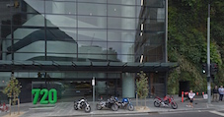 | - information about where the National Forum for Women and Girls with Disability is being held.
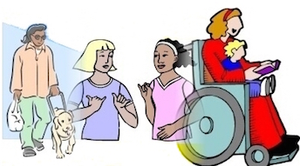 | - information about what will happen on the day of the National Forum.
 | - information about how you will get to the Forum.

- information about your hotel if you are staying in Melbourne for one or two nights.

- information about the WWDA staff who will be at the National Forum.

- There will be lots of support and help at the meeting for women and girls with disability who are coming.

About Women with Disabilities Australia (WWDA)
 | Women With Disabilities Australia is a national organisation for all women and girls who have a disability. Women With Disabilities Australia is also known as WWDA.
WWDA is run by women with disability.

This means that women with disability are in charge of our organisation.

At WWDA we:
- care about women and girls with disability
- work to make life better for all women and girls with disability.

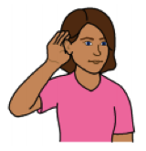 | WWDA believes that all women and girls with disability have the right to:  - Be safe  - Make decisions  - Be confident  - Feel supported  - Be listened to and believed

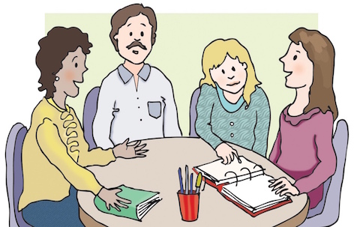 | WWDA works with the Australian Government and many other people to make sure that women with disability are:  - Safe  - Able to make decisions  - Confident  - Supported  - Listened to and believed
 | WWDA is a human rights organisation.

What are human rights?

Everyone has human rights.
Human rights are the basic things that all people need to live with dignity and to enjoy peace and freedom.

Everyone has the right to basic things like food, water and a place to live.

Human rights protect you from other people hurting you.

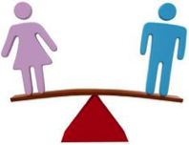 | Everyone’s human rights are equal.
 | It doesn’t matter where you live, how old you are or whether you have a disability or not, you have the same human rights as everyone else.
 | No one should stop you from enjoying your human rights.

Where is the National Forum for Women and Girls with Disability being held?

The National Forum for Women and Girls with Disability 2016 is being held at:
Medibank Head Office (Docklands)
720 Bourke Street, Melbourne, VIC
Phone: 03 9322 8000

Here is a picture of what the Medibank Head Office building looks like.

There will be people to meet you in the foyer on the day of the Forum and take you to the part of the building where the Forum is being held.

Here is a picture of a street map which shows where the Medibank Head Office is. You can also get directions on Google Maps (but you will need the internet).

What will happen on the day of the National Forum?

9.00 | 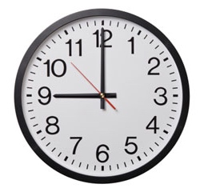 | Come to the meeting room. You can get your name tag.
9.30 | 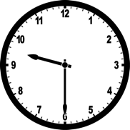 | The meeting starts at 9.30.
9.35 |  | An Aboriginal person welcomes everyone at the meeting to Aboriginal Country.
9.40 | 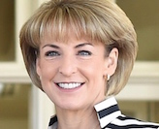 | The Minister for Women, Michaelia Cash talks about what the government is doing to help women and girls with disability.
10.00 |  | A talk about why this meeting is important.

10.05 |  | Women and girls with disability talk about what needs to change for women and girls with disability in Australia.
11.00 |  | Tea and coffee and something to eat.
11.20 | 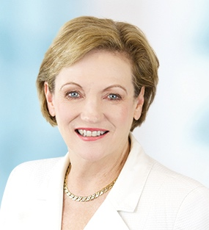 | The Assistant Minster for Disability Services, Jane Prentice talks about what the government is doing to help women and girls with disability.
11.30 | 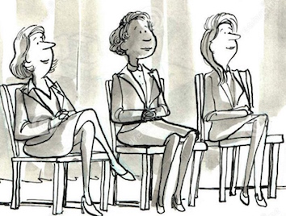 | Some people from government talk about what the Australian Government is doing:  - to stop people hurting you;  - to help make life better for all people with disability;  - to help women and girls.
12.10 |  | Small groups of women and girls with disability talk about what the government needs to do to make life better for women and girls with disability in Australia.

12.50 |  | Lunch
1.30 |  | Talk about what are human rights? Why are they important for women and girls with disability?
1.45 |  | Talk about the work of Women With Disabilities Australia to help women and girls with disability.
1.55 |  | Small groups of women and girls with disability talk about what are the most important things that have to change to make life better for women and girls with disability in Australia?
3.00 |  | Tea and coffee and something to eat.
3.20 |  | Small groups of women and girls with disability talk about what everyone has to do to make life better for women and girls with disability in Australia.

4.40 |  | What will happen after this meeting.
4.50 |  | Everyone writes down, or tells WWDA, what they thought about the meeting.
5.00 | 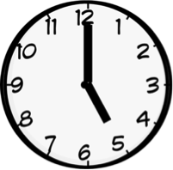 | Meeting ends.

WWDA Staff who will be at the National Forum
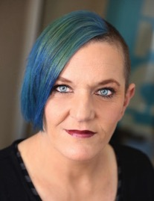 | This is Carolyn Frohmader. She is the Executive Director of WWDA. Carolyn will be at the Forum and can help you if you have any questions.  Phone: 0438 535 123  Email: carolyn@wwda.org.au
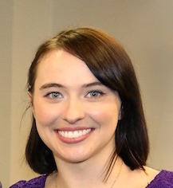 | This is Cashelle Dunn. She works at WWDA. Cashelle will be at the Forum and can help you if you have any questions.  Phone: 0477 074 289  Email: cashelle@wwda.org.au
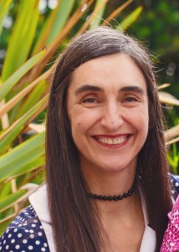 | This is Cristina Ricci. She works at WWDA. Cristina will be at the Forum and can help you if you have any questions.  Phone: 0413 249 385  Email: cristina@wwda.org.au
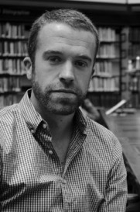 | This is Christopher Brophy. He works at WWDA. Christopher will be at the Forum and can help you if you have any questions.  Phone: 0405 789 142  Email: chris@wwda.org.au

How will I get to the National Forum?

 | If you are coming by plane to Melbourne for the Forum, a copy of your plane ticket is in this Information Kit. You have to take your plane ticket with you to the airport.
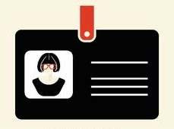 | Don’t forget to take some Photo Identification with you to the airport.
 | There are some taxi vouchers in this Information Kit in case you need to catch taxis to get to the airport, or to the Forum. It is very important that you get the receipts from the taxi drivers.
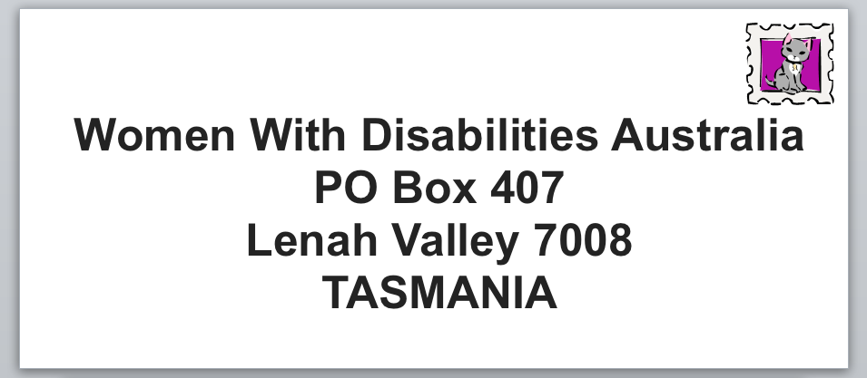 | After the Forum, you must post all your taxi receipts to WWDA. There is a stamped envelope in this Information Kit so you can post your taxi receipts to WWDA.
 | If you have any taxi vouchers left over, you must also post them to WWDA in the stamped envelope in this Information Kit.

Where will I be staying?

If you are coming by plane to Melbourne for the Forum, you will be staying in a hotel. WWDA has booked and paid for your hotel room.

The information about the hotel where you are staying is in this Information Kit.

If you are driving a long way get to the Forum, you will be staying in a hotel. WWDA has booked and paid for your hotel room.

The information about the hotel where you are staying is in this Information Kit.

If you are staying for one or two nights in the hotel, WWDA will give you some money to pay for your food and drinks.

Carolyn from WWDA will put the money in your bank account before you come to Melbourne.

Emergency Information

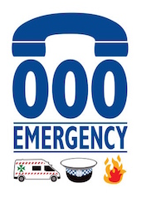 | In an Emergency, ring 000. This is the emergency number for Ambulance, Police, Fire Brigade.
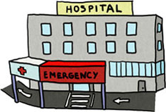 | If you need to go to hospital, the closest hospital is the Royal Melbourne Hospital. It is at:  300 Grattan Street  Parkville, Melbourne 3050.  The phone number is: 03 9342 7000
 | If you need to see a doctor after hours, you can ring the National Home Doctor Service on 13 7425. The doctor will come to see you and it will not cost you any money.

Appendix 9: Background Reading [Easy English Version]

Some Information for you to read before the National Forum

The Minister for Women, Michaelia Cash, is coming to the “National Forum for Women and Girls with Disability”.

The Assistant Minster for Disability Services, Jane Prentice, is coming to the “National Forum for Women and Girls with Disability”.

The Ministers and some other people from government are going to talk about what the Australian Government is doing to make life better for women and girls with disability.
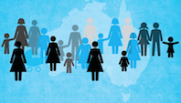 | The Ministers and the people from government will talk about “The National Plan to Reduce Violence against Women and their Children”.
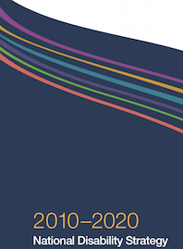 | They will also talk about the “National Disability Strategy”.
 | WWDA has put some easy to read information in this Kit about the “The National Plan to Reduce Violence against Women and their Children” and the “National Disability Strategy”.

The National Plan to Reduce Violence against
Women and their Children

 | The “National Plan to Reduce Violence against Women and their Children 2010-2022” is about working together to reduce violence against women and their children in our community.
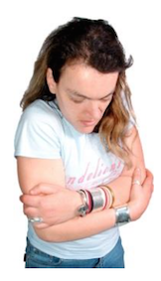 | Violence is an act that hurts another person. It may be:  - hurting your body  - hurting your feelings  - making you do sexual things you don’t want to do  - threatening you, making you feel bad, trying to control you and harming your mind.
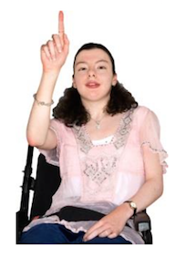 | The Australian Government wants to change this.  They want Australian women and their children to live free from violence in safe communities.

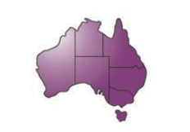 | The National Plan explains what the Australian Government are doing to make this happen all around Australia.
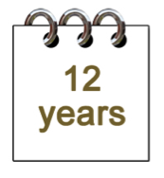 | The National Plan goes for 12 years from 2010 to 2022.  There are 4 parts to the National Plan. Each part is called an Action Plan and goes for 3 years.
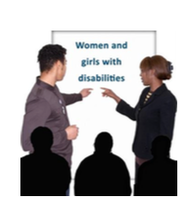 | The Second Action Plan had a focus on women with disability.  The Australian Government is now working on the Third Action Plan.
 | Women and girls with disability can help the Government make the Third Action Plan. We can tell them our ideas for how to stop violence against us.

The National Disability Strategy

The National Disability Strategy is an important part of making things better for people with disability in Australia.

People with disability helped the Australian Government make the National Disability Strategy in 2010.

The National Disability Strategy is a plan for improving the lives of people with disability.

It goes for ten years from 2010 to 2020.

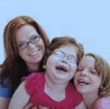 | The National Disability Strategy says that Australians with disability want the same things as everybody else:  - somewhere to live  - a good job  - good health  - to spend time with family and friends  - to do fun things like go to the movies or the footy.

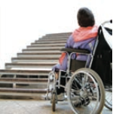 | But there are many barriers that stop people with disability from doing these things.
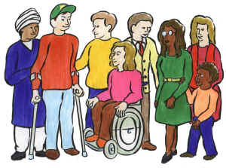 | The National Disability Strategy has ideas for improving many different parts of life, including:  - Taking part in the community  - Our rights to be treated fairly  - Work, money and housing  - Getting support  - Learning and skills  - Health and wellbeing.
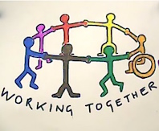 | The National Disability Strategy says that everyone needs to work together to make things better for people with disability.
 | Women and girls with disability can help the Government make the National Disability Strategy work better for us. We can tell them our ideas for how to make it better.

Appendix 10: Forum Agenda [Standard Version]

WWDA National Forum for Women and Girls with Disability
Wednesday 6 April 2016, Melbourne, Victoria
AGENDA

9.00 | Registration
9.30 | Welcome and Introductions
9.35 | Welcome to Country
9.40 | Opening –Rayna Lamb, President, Women With Disabilities Australia
9.50 | Overview of the Forum and Forum objectives
9.55 | PANEL - OVERVIEW OF CURRENT CRITICAL POLICIES FOR WOMEN AND GIRLS WITH DISABILITY IN AUSTRALIA  Government representatives provide an overview and answer questions  - Second/Third Action Plan of the National Plan to Reduce Violence against Women and their Children 2010-2022  - The National Disability Strategy  - The National Disability Insurance Scheme  - Policies targeting Australian women in relation to economic participation and young women
10.40 | MORNING TEA
11.00 | The Minister for Women, Senator the Hon Michaelia Cash  Current landscape and Government priorities for Australian women: 1. Economic participation; 2. Young women. How will women with disability be included in these priorities?
11.20 | PANEL – WOMEN AND GIRLS WITH DISABILITY IN AUSTRALIA  Women and girls with disability set the scene and answer questions  - Overview of key issues  - Economic participation and empowerment  - Violence against women and girls with disability  - Sexual and reproductive rights  - Leadership and participation  - Young women and girls with disability  - Aboriginal women and girls with disability
12.10 | Identifying solutions and priority actions for government in relation to women and girls with disability
12.50 | LUNCH
1.30 | What are human rights? Why are they important for women and girls with disability?
1.45 | WWDA’s current strategic priorities affecting women and girls with disability  Overview of WWDA’s current strategic priorities affecting women and girls with disability:  - Violence against women and girls with disability;  - Equality for women and girls  - Leadership and participation  - Economic empowerment  - Sexual and reproductive rights
1.55 | Identifying current priorities affecting women and girls with disability in Australia today
3.00 | AFTERNOON TEA
3.20 | Identifying solutions and priority actions for WWDA, Government and women and girls with disability
4.40 | Recap of the day and where to from here?
4.50 | Evaluation
5.00 | Close

Appendix 11: Forum Agenda [Easy English Version]

What will happen on the day of the National Forum?

9.00 |  | Come to the meeting room. You can get your name tag.
9.30 |  | The meeting starts at 9.30.
9.35 |  | An Aboriginal person welcomes everyone at the meeting to Aboriginal Country.
9.40 | 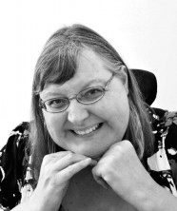 | The President of WWDA, Rayna Lamb, will open the meeting.
9.50 |  | A talk about why this meeting is important.

9.55 |  | Some people from government talk about what the Australian Government is doing:  - to stop people hurting you;  - to help make life better for all people with disability;  - to help women and girls.
10.40 |  | Tea and coffee and something to eat.
11.00 |  | The Minister for Women, Michaelia Cash talks about what the government is doing to help women and girls with disability.
11.20 |  | Women and girls with disability talk about what needs to change for women and girls with disability in Australia.
12.10 |  | Small groups of women and girls with disability talk about what the government needs to do to make life better for women and girls with disability in Australia.

12.50 |  | Lunch
1.30 |  | Talk about what are human rights? Why are they important for women and girls with disability?
1.45 |  | Talk about the work of Women With Disabilities Australia to help women and girls with disability.
1.55 |  | Small groups of women and girls with disability talk about what are the most important things that have to change to make life better for women and girls with disability in Australia?
3.00 |  | Tea and coffee and something to eat.
3.20 |  | Small groups of women and girls with disability talk about what everyone has to do to make life better for women and girls with disability in Australia.

4.40 |  | What will happen after this meeting.
4.50 |  | Everyone writes down, or tells WWDA, what they thought about the meeting.
5.00 |  | Meeting ends.

Appendix 12: Forum Media Release

MEDIA RELEASE

[TITLE]

Wednesday 6th April 2016

Today, the Minster for Women, Senator the Hon. Michaelia Cash will attend the National Forum for Women and Girls with Disability 2016 – an initiative of Women With Disabilities Australia (WWDA) - at the Medibank Head Office in Melbourne. WWDA is the national Disabled People’s Organisation (DPO) for women and girls with all types of disability in Australia. It operates as a transnational human rights organisation and is run by and for women with disability.

The National Forum will provide an opportunity for Australian women and girls with disability to come together and ensure that their voices, experiences and ideas are listened to. The one-day forum will bring together over fifty delegates including women and girls with disability from across Australia, along with policy makers and representatives from the women’s and disability sectors.

The National Forum will include a specific focus on the strategic priorities affecting women and girls with disability, including: gendered disability violence; leadership and participation; economic empowerment; young women; and, sexual and reproductive rights. Representatives from the Australian Government will be attending to provide an overview of the Government’s priorities for women and for people with disability.

For Carolyn Frohmader, CEO of WWDA, the National Forum “represents a timely and significant opportunity for women with disability to raise awareness in the broader community of the issues and multiple discriminations that they face and identify how WWDA and women with disability globally are working for change in regard to those issues”.

The National Forum will provide a unique opportunity for women and girls with disability to identify the issues that affect them, identify solutions, prioritise actions, and engage with the Australian Government on future directions and strategic priorities.

“One of the most important steps we can take to empower women and girls with disability is to make sure they have access to information, and are better informed about their human rights and freedoms”, Ms Frohmader said.

The National Forum for Women and Girls with Disability 2016 has been funded by the Australian Government with in-kind support provided by Medibank Private Limited

Media Contact
El Gibbs

Event Details
WWDA National Forum for Women and Girls with Disability 2016
9:00am to 5:00pm, Wednesday 6th April 2016
Medibank Head Office
720 Bourke Street, Docklands, Melbourne, Victoria 3000

Note to editors
www.wwda.org.au

WWDA is the national peak organisation for women with all types of disabilities in Australia. WWDA is run by women with disabilities, for women with disabilities. It is the only organisation of its kind in Australia and one of only a very small number internationally. WWDA's work is grounded in a human rights based framework which links gender and disability issues to a full range of civil, political, economic, social and cultural rights.

Appendix 13: National Forum Run Sheet

WWDA National Forum for Women and Girls with Disability
Wednesday 6 April 2016, Melbourne, Victoria
RUN SHEET

9.00 | Registration | - Registration desk – Chris Brophy, WWDA Staff  - Registration desk – Bonnie Millen, WWDA Management Committee  - Registration desk – Pamela Menere, WWDA Management Committee  - Registration desk – Jen Hargrave, WWDA Management Committee, to ensure everyone has signed photo consent form  - Registration desk - Nigel Davis, Catherine Clereha and Ellie Bradford, Medibank Staff, and assistance with meeting and escorting participants  - Carolyn Frohmader, WWDA Executive Director, to meet and greet government representatives and participants  - Cristina Ricci, WWDA Staff, to meet and greet government representatives and participants  - Cashelle Dunn, WWDA Staff, to meet and greet participants and assist with taking photos and signing canvas  - Matthew Jones, Medibank Staff, to take photos all day  - Nikita Fernandez, Medibank Staff, to assist with note-taking for one of the participants for the day  - Tarja Malone, Counsellor, Medibank Staff, available for participants as needed all day  - Traveller’s Aid Attendant Carer available for participants as needed all day  - Ai Media ready to commence live captioning for the day  - Auslan interpreters (4) arrive and will be present for the day
9.30 | Welcome and Introductions | - Rayna Lamb, WWDA President, to welcome all participants and introduce key people  - Rayna Lamb, to introduce Aunty Georgina Nicholson who will be providing the Welcome to Country
9.35 | Welcome to Country | - Welcome to Country – Aunty Georgina Nicholson  - Rayna Lamb to thank Aunty Georgina Nicholson
9.40 | Opening – Rayna Lamb, President, Women With Disabilities Australia | - Rayna Lamb to open the National Forum  - El Gibbs and Bonnie Millen, WWDA Management Committee, to discuss Housekeeping including:  - WWDA staff available to assist at all times  - WWDA Management Committee available to assist at all times  - Counsellor available at all times  - Rest room available at hotel if needed  - Attendant carer available if needed  - Rules of participation and respect  - Speaking Rules with Auslan interpreters present  - Role of support people  - Meal and break times  - Location of exits and toilets  - Location of smoking area  - Emergency information
9.50 | Overview of the Forum and Forum objectives | - Rayna Lamb to introduce Carolyn Frohmader and Cashelle Dunn  - Carolyn Frohmader and Cashelle Dunn to provide overview of the Forum and Forum objectives  - Rayna Lamb to thank Carolyn Frohmader and Cashelle Dunn
9.55 | PANEL - OVERVIEW OF CURRENT CRITICAL POLICIES FOR WOMEN AND GIRLS WITH DISABILITY IN AUSTRALIA  Government representatives provide an overview and answer questions  - Second/Third Action Plan of the National Plan to Reduce Violence against Women and their Children 2010-2022  Lara Purdy, Branch Manager, Family Policy and Programmes, Department of Social Services  - The National Disability Strategy  Sharon Stuart, Branch Manager, Disability Carers Policy and Access, Department of Social Services  - The National Disability Insurance Scheme  Vicki Rundle, General Manager Operations, National Disability Insurance Agency  - Policies targeting Australian women in relation to economic participation and young women  Louise McSorley, Assistant Secretary, Office for Women | - Margherita Coppolino, WWDA Management Committee, to MC this session:  - Introduce session  - Introduce government representatives  - Moderate discussion and Q&A  - Thank panel members
10.40 | MORNING TEA | - Carolyn Frohmader to meet and greet the Minister for Women, Senator the Hon Michaelia Cash  - Nigel Davis, Lia Neverson, Felicity Tann, Ellie Bradford and Samantha Multari, Medibank Staff, providing assistance to participants as needed
11.00 | The Minister for Women, Senator the Hon Michaelia Cash  Current landscape and Government priorities for Australian women: 1. Economic participation; 2. Young women. How will women with disability be included in these priorities? | - Rayna Lamb to introduce the Minister for Women, Senator the Hon Michaelia Cash  - The Minster for Women, Senator the Hon Michaelia Cash to speak for 10 minutes  - Rayna Lamb to thank the Minister for Women, Senator the Hon Michaelia Cash for her presentation and ask if there are any questions.  - Q&A  - Rayna Lamb to thank the Minister for Women, Senator the Hon Michaelia Cash
11.20 | PANEL – WOMEN AND GIRLS WITH DISABILITY IN AUSTRALIA  Women and girls with disability set the scene and answer questions  - Overview of key issues - Rayna Lamb  - Economic participation and empowerment - Therese Sands  - Violence against women and girls with disability - Jen Hargrave  - Sexual and reproductive rights - Jax Jacki Brown  - Leadership and participation - Judy Huett  - Young women and girls with disability - Cashelle Dunn  - Aboriginal women and girls with disability - Gayle Rankine | - Karin Swift, WWDA Management Committee to MC this session:  - Introduce session  - Introduce women with disability on the panel (5 minutes)  - Panellists to speak 5 minutes each (total 35 minutes)  - Karin Swift to moderate discussion Q&A (15 minutes)  - Karin Swift to thank panel members
12.10 | Identifying solutions and priority actions for government in relation to women and girls with disability | - Cristina Ricci to facilitate session:  - Introduce task  - Introduce how group work activity will run  - Moderate discussion / Q&A during report back  - 4 working groups (One government representative from relevant office/agency per group):  - Third Action Plan to Reduce Violence  - NDS  - NDIS  - Women’s policies  - Approximately 10 participants per group  - Government representative from each group to report
12.50 | LUNCH | - Nigel Davis, Lia Neverson, Felicity Tann, Ellie Bradford and Samantha Multari, Medibank Staff, providing assistance to participants as needed
1.30 | What are human rights? Why are they important for women and girls with disability? | - Cashelle Dunn and Cristina Ricci - presentation about human rights  - Cashelle Dunn and Cristina Ricci moderate Q&A
1.45 | WWDA’s current strategic priorities affecting women and girls with disability  Overview of WWDA’s current strategic priorities affecting women and girls with disability:  - Violence against women and girls with disability  - Equality for women and girls  - Leadership and participation  - Economic empowerment  - Sexual and reproductive rights | - Carolyn Frohmader and Karin Swift - overview of WWDA’s current strategic priorities  - Carolyn Frohmader and Karin Swift moderate Q&A
1.55 | Identifying current priorities affecting women and girls with disability in Australia today | - Cristina Ricci to facilitate session:  - Introduce task  - Introduce how group work activity will run  - Moderate discussion Q&A during report back  - Group work to identify current priorities  - 8 groups, 6 participants each  - 40 minutes for group work  - 2 minutes report back per group
3.00 | AFTERNOON TEA | - Nigel Davis, Lia Neverson, Felicity Tann, Ellie Bradford and Samantha Multari, Medibank Staff, providing assistance to participants as needed
3.20 | Identifying solutions and priority actions for WWDA, Government and women and girls with disability | - Carolyn Frohmader and Karin Swift - Recap of top priorities identified in previous session (Brief)  - Cristina Ricci to facilitate session:  - Introduce task  - Introduce how group work activity will run  - Moderate discussion Q&A during report back  - Group work to identify solutions and priority actions  - SAME GROUPINGS AS PREVIOUS SESSION  - 50 minutes for group work  - 4 minutes report back per group
4.40 | Recap of the day and where to from here? | Cashelle Dunn - Recap of day and where to from here
4.50 | Evaluation | Cristina Ricci - Evaluation
5.00 | Close | Rayna Lamb to thank everyone for their participation and close the meeting

