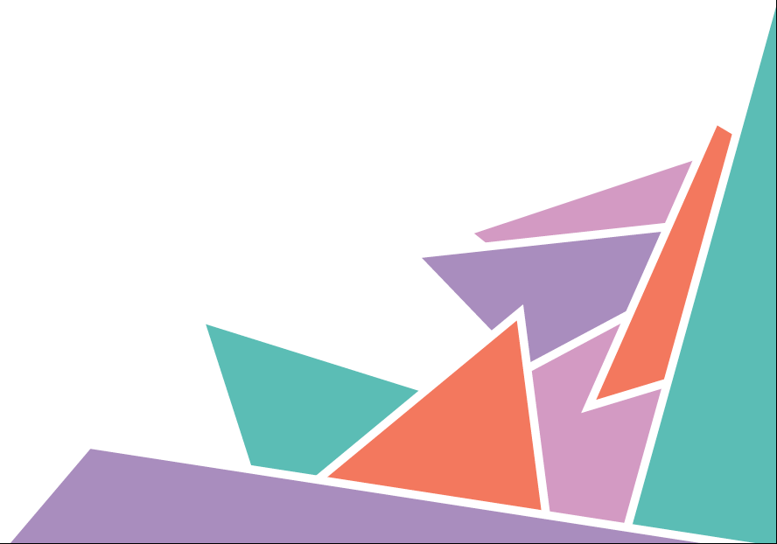
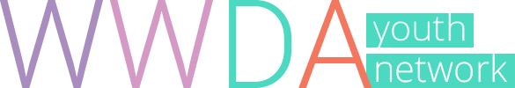

Position Statement 4

Sexual & Reproductive Rights

WWDA Youth Believe
- We all have the right to express our sexuality, have relationships and make choices about our bodies, free from violence and discrimination.

- No child or young person should be sterilised.

- Women and girls with disability have the right to make a family.

- We all have the right to information about Sexual and reproductive health.

The Facts
- Sex education often excludes young women and girls with disability.

- Forced sterilisation, forced abortion and forced contraception are forms of violence.

- Authorities take away the children of people with disability at a rate up to ten times higher than other parents.

- More than 70% of women with disability have experienced sexual violence.

- Girls with disability are 3-4 times more likely to experience violence than their friends.

What It Means

Violence
Using force or power against another person, group or community, which results in them being hurt, feeling pain or fear. Violence can be physical, emotional, sexual, and psychological, among others. Violence can be committed by an individual, a group, or by the State (a country).

Sterilisation
A medical procedure that removes a person’s capacity to have children.

Sexual and Reproductive Health
Means physical, mental and social wellbeing in all matters relating to your sexuality, your gender identity and the reproductive system. This includes having a safe sex life; having access to acceptable feminine hygiene products and contraception methods of your choice; being informed on how to protect against sexually transmitted diseases; and the freedom to decide if, when and how often you wish to have children.

Learn More

Human Rights
Human rights are protected under international law. These rights are described in documents called conventions or treaties. Countries such as Australia can agree to be bound by these laws.

Convention on the Rights of the Child (CRC)
The CRC describes and protects the human rights of children and young people. Check out the “For Youth” page to learn more about your rights:
www.unicef.org/rightsite/433.htm

Convention on the Rights of Persons with Disabilities (CRPD)
The CRPD describes and protects the rights of all people with disability. You can find an easy to understand version of the convention at:
www.unicef.org/publications/index_43893.html

Family Planning New South Wales
You can find loads of resources about puberty, the body, relationships and sex at the FPNSW BodyTalk website specifically designed for under 25s.
www.bodytalk.org.au

Women with Disabilities Australia (WWDA) Human Rights Toolkit
WWDA has created a toolkit for women and girls with disability to learn about their human rights and demand their rights.
www.wwda.org.au/papers/toolkit

Help & Support

In an Emergency
If you or another person is in immediate danger, Call 000 (Triple Zero)

eheadspace
The eheadspace online and telephone service supports young people and their families going through a tough time. Visit: https://www.eheadspace.org.au/

Kids Helpline
If you need to talk about anything, you can call, email, or have an online chat
with Kids Helpline. Visit www.kidshelpline.com.au or call 1800 55 1800

1800 RESPECT
Support if you have or are currently experiencing sexual, domestic or family violence. Visit www.1800respect.org.au or call 1800 737 732

Disability Advocacy Services
A disability advocate can help you to access support around your human rights. To find an advocate near you, visit: http://finder.dss.gov.au/disability/ndap/

Get Involved
United Nations Youth Association Australia (UNYA)
UN Youth Australia is a national youth-led organisation that aims to educate and empower young Australians on global issues. Visit: www.unyouth.org.au
Women with Disabilities Australia (WWDA)
WWDA represents more than 2 million disabled women and girls in Australia. We are run by and for women with disabilities. We operate as a transnational human rights and systemic advocacy organisation. www.wwda.org.au

WWDA Youth Network

WWDA Youth Network aims to empower young women and girls with disabilities to become strong, confident, proud and educated on their rights and options. Follow us and get involved at:

Web http://youth.wwda.org.au
Facebook http://www.facebook.com/WWDAYouth
Twitter http://www.twitter.com/WWDA_Youth
YouTube http://goo.gl/BqDQ47
Instagram http://www.instagram.com/WWDA_Youth

WWDA Youth Network, Position Statement 4: Sexual and Reproductive Rights, Women With Disabilities Australia (WWDA): Hobart, Tasmania, 1st Edition, June 2017.
ISBN: 978-0-9775305-9-5
The development of this position statement was made possible through project funding from the Australian Government, Office for Women. WWDA thanks the women and girls with disability who contributed to the development of this statement.
Prepared by Cashelle Dunn and Chris Brophy.
For further information, please access the full Human Rights Toolkit and comprehensive WWDA Position Statements available at, http://www.wwda.org.au/papers/toolkit
© Women with Disabilities Australia (WWDA) 2017.

