Report from the United Nations Human Rights Committee 121st Session, Review of Australia’s Compliance with the International Covenant on Civil and Political Rights

United Nations Office of the High Commissioner on Human Rights,
Geneva, Switzerland, 13th to 20th October 2017

November 2017

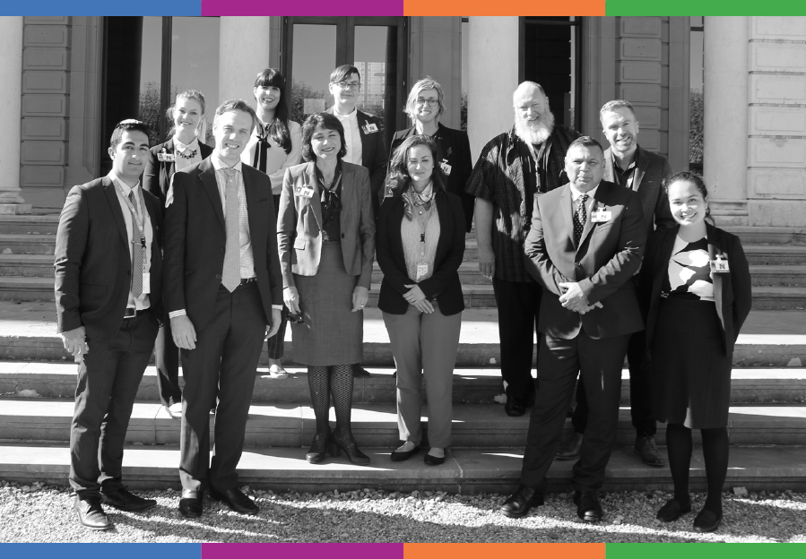

Publishing Information

Disabled People’s Organisation’s Australia (2017). Report from the United Nations Human Rights Committee 121st Session, Review of Australia’s Compliance with the International Covenant on Civil and Political Rights. Sydney: DPO Australia.

Report written and compiled by Christopher Brophy for and on behalf of DPO Australia.

Disabled People’s Organisations Australia (DPO Australia)
PO Box 666
STRAWBERRY HILLS
NSW, Australia 2012
+61 2 9370 3100
director@dpoa.org.au
http://dpoa.org.au
https://twitter.com/DPOAustralia

Unless otherwise noted, this work is copyright. Apart from any use as permitted under the Copyright Act 1968, no part may be reproduced without written permission from Disabled People’s Organisations Australia (DPO Australia). While all possible care has been taken in the preparation of the information contained in this document, DPO Australia disclaims any liability for the accuracy and sufficiency of the information and under no circumstances shall be liable in negligence or otherwise in or arising out of the preparation or supply of any of the information aforesaid.

DPO Australia gratefully acknowledges travel funding provided by the Australian Government Department of Social Services.

DPO Australia content © Disabled People’s Organisations Australia, November 2017.

Contact

Therese Sands  Director  DPO Australia  +61 2 9370 3100  +61 412 935 128  director@dpoa.org.au  http://www.dpoa.org.au | Christopher Brophy  Strategic Policy and Communications  Women with Disabilities Australia  +61 405 789 142  chris@wwda.org.au  http://www.wwda.org.au

About Disabled People’s Organisations Australia (DPO Australia)

Disabled People’s Organisations Australia (DPO Australia) is an alliance of four national, population specific and cross-disability Disabled People’s Organisations (DPO’s) in Australia. DPO Australia was founded by, and is comprised of: Women With Disabilities Australia (WWDA); First Peoples Disability Network Australia (FPDNA); People with Disability Australia (PWDA); and, National Ethnic Disability Alliance (NEDA). As DPOs, these four national organisations are self-determining organisations led by, controlled by, and constituted of, people with disability.

The key purpose of DPO Australia is to promote, protect and advance the human rights and freedoms of people with disability in Australia by working collaboratively on areas of shared interests, purposes and strategic priorities and opportunities. DPO Australia is a recognised coordinating point between Government/s and other stakeholders, for consultation and engagement with people with disability in Australia.

The four member organisations of DPO Australia have extensive experience working collaboratively with the machinery of the United Nations (UN), including human rights treaty monitoring bodies and UN special procedures. DPO Australia has coordinated and led Civil Society delegations to a range of UN processes, including treaty body reviews of Australia, the Commission on the Status of Women (CSW), and the CRPD Conference of States Parties (COSP). DPO Australia has hosted, conducted and sponsored a number of UN Side Events.

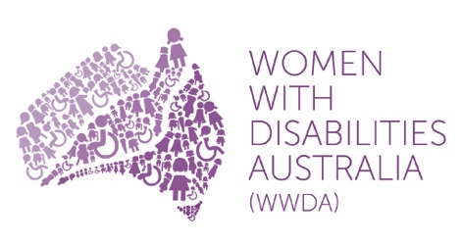
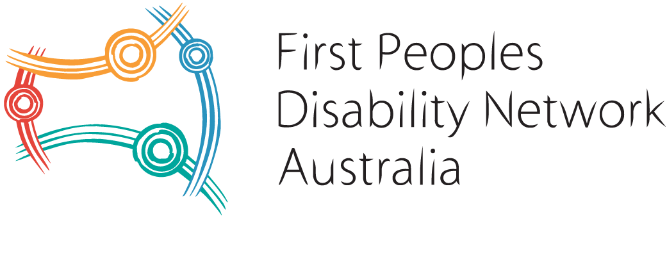
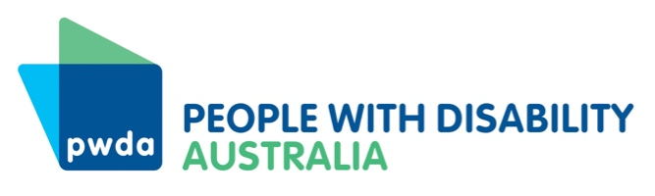
DPO Australia is regularly invited to participate in UN Expert Group Meetings (EGM), with recent examples being the EGM on the Sexual and Reproductive Rights of Girls with Disability (hosted by the Special Rapporteur on Disabilities during the 10th session of COSP), the EGM on Advancing the Rights and Perspectives of Women and Girls with Disabilities in Development and Society (hosted by UNDESA and ECLAC), and the EGM on ‘Youth and Disability: Policies of Social Inclusion, Gender Equality, Non-Discrimination and Prevention of Sexual Violence’ (UNFPA). Two of the DPO Australia member organisations, Women With Disabilities Australia (WWDA) and People with Disability Australia (PWDA), hold Special Consultative Status with the UN Economic and Social Council (ECOSOC).

Contents

Overview 6
Background 7
International Covenant on Civil and Political Rights (ICCPR) 7
United Nations Human Rights Committee (HRC) 7
Australian Government Reporting 9
Civil Society Reporting 9
National Human Rights Institutions Reporting 10
Delegation Members 11
Key Activities 12
Key Outcomes 18
Appendix 1: Formal Briefing Statements 20
Delegation Opening Statement 21
Aboriginal and Torres Strait Islander Peoples 23
Refugees and People Seeking Asylum 25
People with Disability; Prison Conditions 28
Violence Against Women 30
Appendix 2: NGO Delegation Factsheets 32
Appendix 3: Additional Factsheets 33
Factsheet: Forced, Coerced and Involuntary Sterilisation of People with Disability 34
Factsheet: Violence Against Women with Disability 36
Factsheet: Violence Against People with Disability 38
Appendix 4: Australian Government Opening Statement 40
Endnotes 45

Overview

In October 2017, DPO Australia joined a delegation of non-government representatives in Geneva to brief the UN Human Rights Committee – the panel of independent human rights experts tasked with assessing Australia’s adherence to the International Covenant on Civil and Political Rights (ICCPR).

The review took place at the Office of the United Nations High Commissioner for Human Rights in Geneva, Switzerland, during the Human Rights Committee’s 121st Session 16th October to 10th November 2017.

In addition to several formal and informal briefings with Committee members, the delegation presented a shadow report on Australia’s implementation of the ICCPR, and met twice with the Australian Government delegation.

Ngila Bevan and Christopher Brophy represented the four Disabled People’s Organisations Australia (DPO Australia) members in Geneva – Women with Disabilities Australia, People with Disability Australia, First People’s Disability Network, and National Ethnic Disability Alliance.

This report includes information about United Nations treaty body review process and a brief overview of the delegation’s activities. Some the material that was formally presented to the committee is provided in the appendices.

The Human Rights Committee released their draft Concluding Observations on Australia’s Compliance with the ICCPR on 9th November 2017.

Background

International Covenant on Civil and Political Rights (ICCPR)

The International Covenant on Civil and Political Rights (ICCPR) is a binding international agreement between countries that describes the civil and political rights that all people have. Civil and political rights can include things like the right to freedom of conscience and religion, the right to freedom from violence and torture, along with a range of legal rights. The ICCPR is one of two covenants that obligate countries to protect and promote the human rights of all people under the Universal Declaration of Human Rights (1948).

Australia agreed to be bound by the ICCPR on 13 August 1980, subject to several reservations, which it maintains. Australia has also agreed to be bound by the two Optional Protocols to the Covenant. These Optional Protocols obligate countries to outlaw the death penalty and enable people to lodge a complaint with the United Nations Human Rights Committee where they believe their rights have been violated by Government. The Australian Human Rights Commission has primary responsibility for monitoring Australia’s compliance with the ICCPR.

You can find out more about the United Nations treaties to which Australia is a State Party on the Australian Human Rights Commission website.

United Nations Human Rights Committee (HRC)

The Human Rights Committee (the Committee) is the body of eighteen independent experts who monitor implementation of the ICCPR by State Parties, including Australia. All State Parties must submit periodic reports to the Committee that describe how rights under the Covenant are being implemented and protected domestically. The Committee also accepts reports from national human rights institutions, such as the Australian Human Rights Commission, civil society and non-government organisations as an important part of their reviews.

At the conclusion of the review process, and based on reports received and any other available information, the Committee makes a series of recommendations (‘Concluding Observations’) to the State Party as to how they should improve domestic implementation of civil and political rights under the covenant.

We have included a summary of the Committee’s Concluding Observations on Australia’s Sixth Report under the ICCPR under Outcomes. The full Concluding Observations document is provided at Attachment 1.

Australian Government Reporting

The Australian Government submitted its Sixth Report under the ICCPR to the Committee in March 2016. The Australian Government report formally responded to questions posed by the Committee in a List of Issues Prior to Reporting document, adopted by the Committee in November 2012. List of Issues Prior to Reporting processes allow the Committee to request detailed information from Government about specific human rights issues and areas of concern. Prior to 2017, Australia’s previous appearance before the Committee was in April 2012.

The Australian Government’s Sixth Report under the ICCPR is available from the Attourney-General’s Department website.

Civil Society Reporting
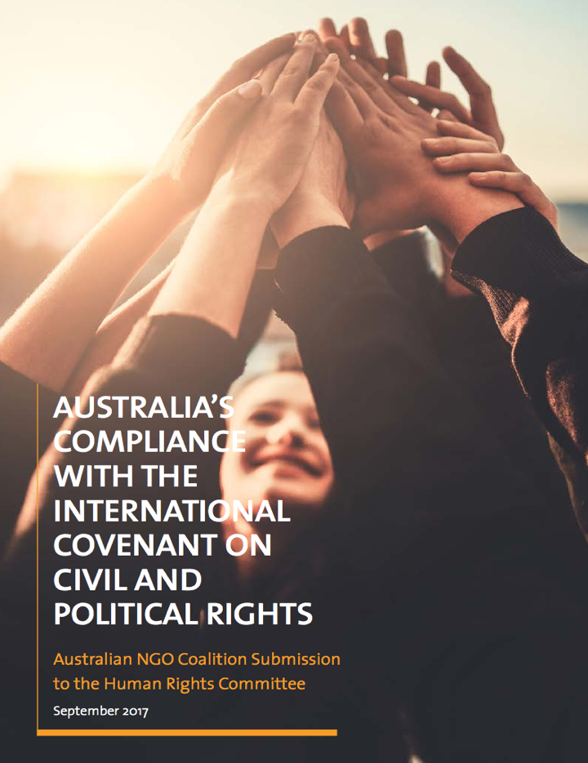
In September 2017, a coalition of Australian NGOs launched a shadow report on Australia’s Compliance with the ICCPR. The NGO coalition report was coordinated by Kingsford Legal Centre and the Human Rights Legal Centre, and prepared with input from 32 NGOs from across Australia, including the DPO Australia members, and was further endorsed by 56 NGOs. The report was provided to the Committee to inform the sixth review of Australia during at the Committee’s 121st session in October 2017.

The shadow report addressed key areas identified in the Committee’s List of Issues Prior to Reporting and expanded on eighteen issue areas where Australia can and should improve domestic implementation and protection of civil and political rights under the ICCPR. The shadow report is available from the Human Rights Law Centre website.

Several Australian NGOs also made independent submissions to the Committee, including Organisation Intersex International Australia, Amnesty International, Autistic Self Advocacy Network, Franciscans International and Edmund Rice International.

National Human Rights Institutions Reporting

The Australian Human Rights Commission, which monitors Australia’s implementation of United Nations treaties to which it is a party, submitted a report to the Committee prior to Australia’s review. It is available from the Australian Human Rights Commission website.

Delegation Members

The NGO delegation to Australia’s review under the ICCPR was led by Anna Cody (Kingsford Legal Centre) and Emily Howie (Human Rights Law Centre), and included broad representation from across civil society. DPO Australia sent Ngila Bevan, Co-CEO of People with Disability Australia (PWDA), and Christopher Brophy, Director Strategic Policy and Communications, Women with Disabilities Australia (WWDA). The full delegation included:

Amy Frew, Human Rights Law Centre
Anna Cody, Kingsford Legal Centre
Annabelle Pendlebury, Remedy Australia
Arash Bordbar, The Refugee Council of Australia
Christopher Brophy, Women With Disabilities Australia / DPO Australia
Emily Howie, Human Rights Law Centre
Ivy Keane, Human Rights Law Centre
Maria Nawaz, Kingsford Legal Centre
Michael Coughlan, Indigenous Peoples Organisation
Ngila Bevan, People with Disability Australia / DPO Australia
Paul Levett, Support Person
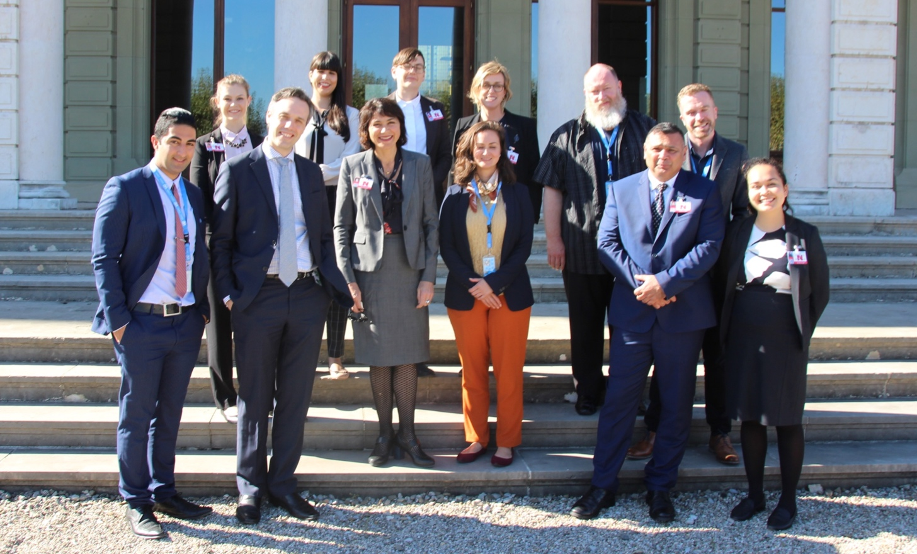
Members of the NGO Delegation stand in front of Palais Wilson, Geneva,
with Ed Santow (Australian Human Rights Commissioner)

Key Activities

Preparation

- Prior to leaving for the ICCPR review, Chris and Ngila met several times to plan the work in Geneva, discuss strategy and identify what materials and resources to take.
- Delegation members met by teleconference.
- Delegation members prepared factsheets for Human Rights Committee members that highlighted key issues covered in the NGO shadow report. Ngila and Chris prepared factsheets on issues facing people with disability in Australia and a fact sheet on prison conditions. Further details on factsheets are provided at page 29.
- Delegation members who were to present oral statements at the formal briefing with the Committee prepared 3-5 minute oral presentations around specific issues, drawing on information from the factsheets and NGO shadow report. Chris and Ngila prepared a presentation on people with disability and prison conditions. The short presentation is available on page 25.
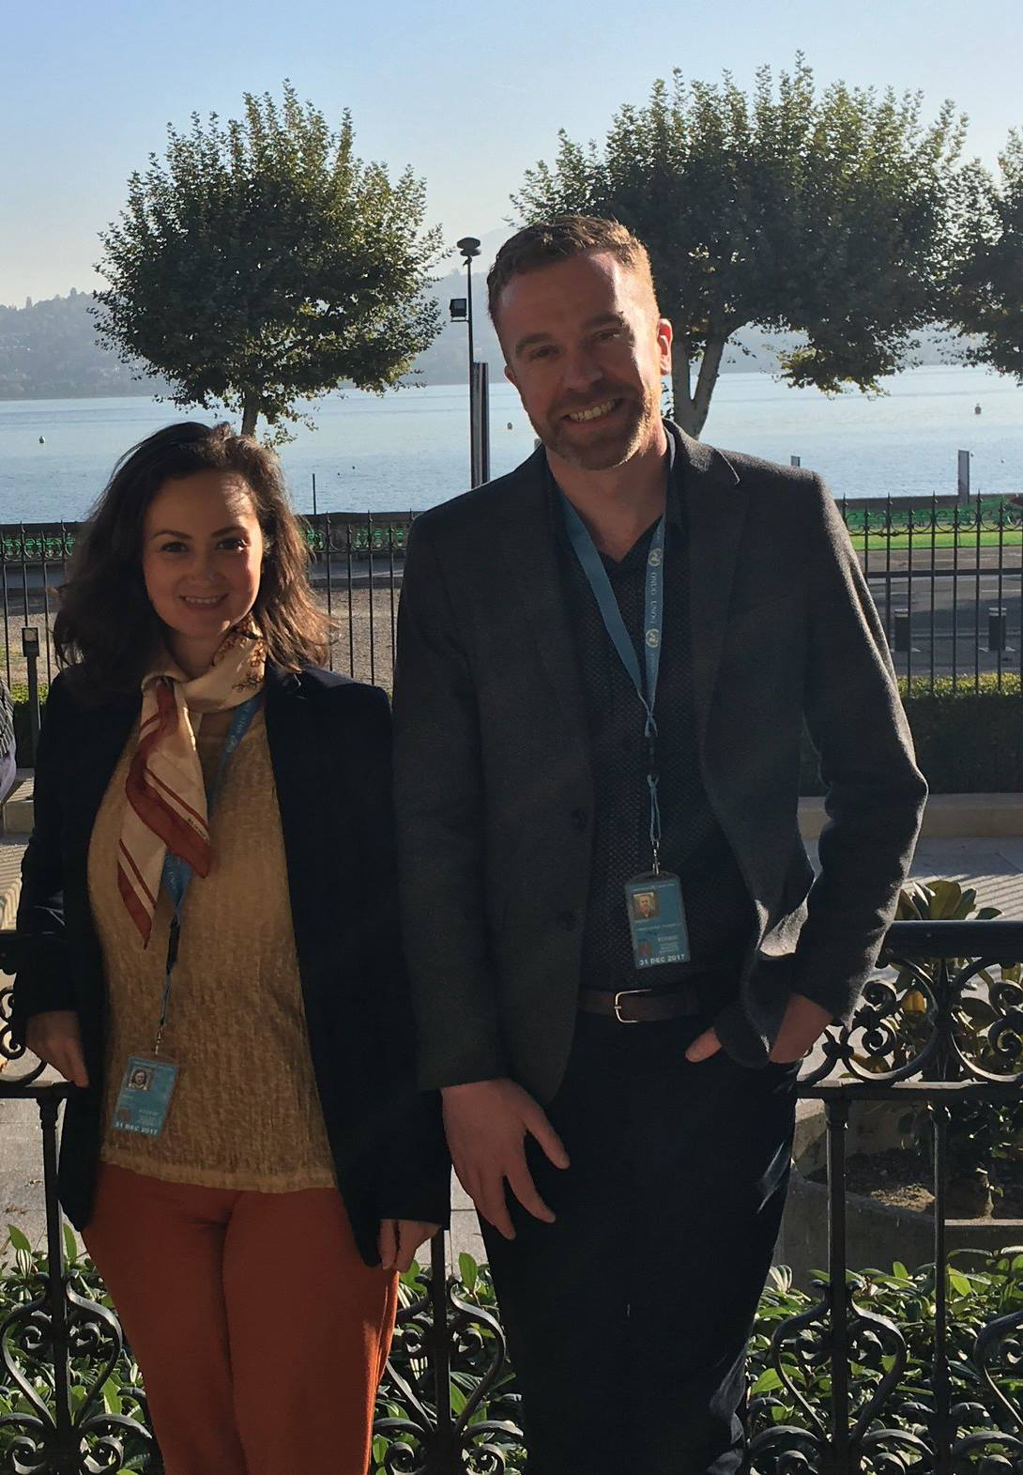
DPO Australia delegates to the ICCPR review, Ngila Bevan and Christopher Brophy, standing outside Palais Wilson, Geneva
Saturday 14th October 2017

- Delegation members arrived in Geneva.

Sunday 15th October 2017

- Ngila and Chris met at their hotel to make a plan for the week, identify key Committee members to lobby, and organise information packs on key issues, which would be provided to Committee members.
- The NGO delegation met face to face at the office of the Global Human Rights Centre to discuss practicalities, the work of the week and preparation for the formal briefing of the Committee.

Monday 16th October 2017

- The NGO delegation met over coffee at Palais Wilson prior to the formal briefing session to discuss order of speakers and practical issues.
- The delegation provided their formal briefing to the Committee in the main conference hall at Palais Wilson, the United Nations Office of the High Commissioner on Human Rights. The NGO delegation was allotted 30 minutes to make an opening statement and present on key issues from the NGO shadow report.
- The Australian Human Rights Commissioner, Mr Ed Santow made a presentation to the committee on behalf of the Australian Human Rights Commission.
- Chris and Ngila made a joint five-minute oral presentation on people with disability, drawing attention to key issues including violence against people with disability, legal capacity, substitute decision making regimes, restrictive practices, inadequate mental health legislation, and forced sterilisation. A copy of the presentation is provided on page 25.
- Prior to and after the formal briefing, delegation members had conversations with individual Committee members where possible to provide further information and discuss specific human rights issues that were detailed in the NGO shadow report.
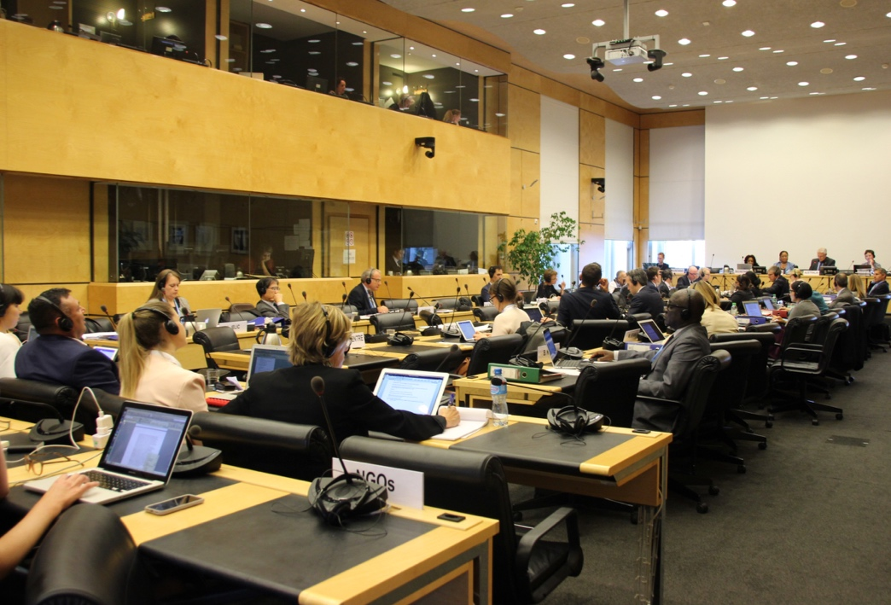
NGO Delegation presenting at formal briefing with the Committee
Tuesday 17th October 2017

- By invitation, the NGO delegation met with the Australian Government delegation for a pre-briefing meeting and lunch at the Australian Permanent Mission to the United Nations in Geneva. The meeting was an opportunity to discuss key human rights issues that the NGO delegation would be raising and to ask questions of the Australian Government delegation. The meeting was chaired by Mr John Quinn, Ambassador and Permanent Representative to the United Nations and to the Conference on Disarmament.
- Following the meeting, Ngila and Chris prepared further information for specific Committee members on key issues that Committee members has indicated a strong interest in, including violence against people with disability, sterilisation and sexual and reproductive rights.

Wednesday 18th October 2017

- The NGO delegation had an informal briefing with Committee members in a meeting room at Palais Wilson. This was an opportunity to have a more intimate conversation with key committee members. Committee members asked a range of questions which the NGO delegation were able to answer and was also an opportunity to provide more specific information about specific human rights issues, prior to the formal review of Australia.
- NGO delegation members attended the first part of the Committee’s formal review of Australia in the main conference hall of Palais Wilson. The session went for 3 hours with a short break. The session was opened and chaired by Human Rights Committee member and country rapporteur, Ms. Margo Waterval. An uncaptioned video recording of the session is available at UN TV.
- The Australian Government delegation presented key information from Australia’s Sixth Report under the ICCPR. Several Committee members then asked a range of follow up questions. The Australian Government delegation provided answers to some of these questions and others were taken on notice to be answered in writing shortly after the two-day session concluded.
- Before and after the formal review of Australia, NGO delegation members met with Committee members to clarify issues, provide further information and suggested questions to ask the Australian Government delegation.
- NGO delegation members also took this opportunity to provide further written material and resources to Committee members who had expressed interest in relevant issues.

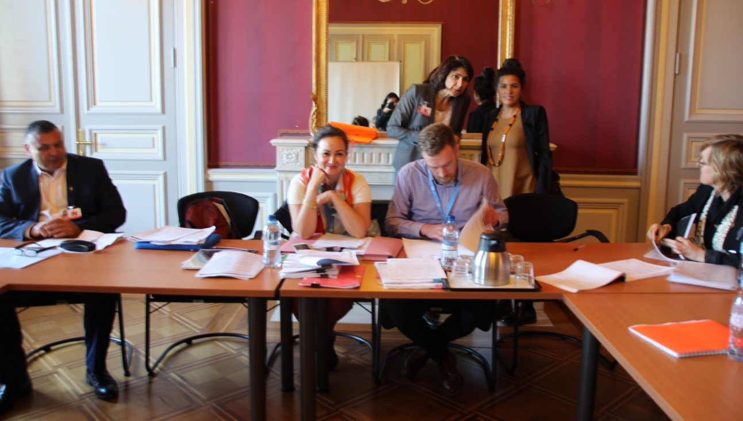

NGO Delegation preparing for informal briefing with the Committee

Thursday 19th October 2017

- NGO delegation members attended the second part of the Committee’s formal review of Australia in the main conference hall of Palais Wilson. The session went for 3 hours with a short break. The session was opened and chaired by Human Rights Committee member and country rapporteur, Ms. Margo Waterval. An uncaptioned video recording of the session is available at UN TV.
- The Australian Government answered outstanding questions from the previous day, and then Committee members asked a range of further questions of the Government delegation. Due to time constraints, the Government delegation opted to answer many of these questions in writing within 48 hours of the session’s close as per UN procedures.
- Following the conclusion of the session, the NGO delegation met with the Australian Government delegation for a post-briefing meeting at the Australian Permanent Mission to the United Nations in Geneva. The meeting was an opportunity to discuss issues raised during the session, clarify Government positions on particular issues and identify opportunities to continue working together post-Geneva.
- In the evening, members of the NGO delegation met for an informal de-brief and catch-up.

Key Outcomes

On 9th November 2017, the Human Rights Committee released its draft Concluding Observations on Australia’s Sixth Report under the ICCPR. The Committee’s Concluding Observations are currently available on the UN Website. When released, the final version will be available from the OHCHR Australia homepage.

The Committee commended Australia for several positive developments, including, Australia’s commitment to ratify the Optional Protocol to the Convention Against Torture (OPCAT); Adoption of Human Rights (Parliamentary Scrutiny) Act 2011 (Cth); Mechanisms to strengthen engagement with human rights reporting; Legislation that prohibits discrimination on the basis of sexual orientation, gender identity and intersex status.

However, the Committee strongly criticised Australia for failing in its treatment of refugees, indigenous rights, LGBTI people, women, violence against people with disability, and the lack of a national human rights act. Australia was roundly criticised for failing to implement previous views and recommendations from the Committee.

The DPO Australia delegation was pleased that the Committee made recommendations on the rights of Aboriginal and Torres Strait Islander peoples, ending forced involuntary sterilisation, the rights of people with disability to vote, the rights of intersex people, and the need to improve responses to violence against women with disability.

The Committee made further recommendations across a range of areas including,

- Establishing a national human rights act
- Reviewing Australia’s interpretive declarations to several articles of the ICCPR
- Acting on previous recommendations of the Committee
- Improving scrutiny of federal legislation for compatibility with human rights
- Maintaining funding for the Australian Human Rights Commission
- Reviewing counter-terrorism laws and policies for compatibility with the ICCPR
- Improving anti-discrimination legislation in regard to religion
- Strengthening efforts to address racism and hate speech
- Improving protections around sexual orientation, gender identity and intersex status
- Use of excessive force by police
- Ensuring Australia maintains its non-refoulement obligations
- Ending offshore immigration detention
- Ending mandatory immigration detention
- Addressing the overrepresentation of indigenous Australians in prisons
- Improving treatment of prisoners
- Improving juvenile justice
- Reviewing metadata retention legislation

For a brief overview of the concluding observations, written by Anna Cody and Maria Nawaz, access https://theconversation.com/un-slams-australias-human-rights-record-87169.

Appendix 1: Formal Briefing Statements

At the appearance before the Human Rights Committee, the NGO delegation had thirty minutes to formally brief the Committee on the key civil and political rights issues facing people in Australia. Several members of the delegation, including DPO Australia, made formal statements to the Committee. These statements are provided here in the order in which they were presented:

- Opening statement – Emily Howie
- Aboriginal and Torres Strait Islander Peoples – Michael Coughlan
- Refugees and asylum seekers – Arash Bordbar and Amy Frew
- People with disability; prison conditions – Ngila Bevan and Christopher Brophy
- Violence against women and Lesbian, Gay, Bisexual, Transgender and Intersex (LGBTI) People’s Rights– Maria Nawaz and Anna Cody

Delegation Opening Statement
Emily Howie
Formal briefing of the Committee (Australia)
16th October 2017

Chairperson,

Thank you for the opportunity to address the Committee on Australia’s implementation of the rights in the Covenant. We have a delegation here to represent our report, which was submitted on behalf of a broad Australian NGO coalition of over 50 civil society organisations.

Shortly, members of our delegation will brief the committee on:
- the rights of Aboriginal and Torres Strait Islander people;
- ongoing concerns for people with disability;
- abuses of the rights of refugee and asylum seekers;
- Australia’s poor response to the views of this committee;
- violence against women; and
- human rights challenges for LGBTI Australians.

First, I would like to highlight that human rights are still not comprehensively or consistently protected in law in Australia – we remain the only western democratic nation without a bill of rights. Australia’s parliamentary joint committee on human rights has limited effectiveness and influence.

Australia’s anti-discrimination laws are also inconsistent, limited in scope and fail to address systemic or intersectional discrimination.

In the absence of legal protection, Australian governments are gradually chipping away at the basic democratic rights and freedoms and limiting civil society space.

- Anti-protest laws at the state level are preventing people from standing together and speaking out on issues they care deeply about
- Press freedom is under threat from metadata retention laws that jeopardise the ability of journalists to keep sources confidential
- Government is using funding pressures and financial levers to stifle the free and independent participation of civil society organisations
- People declared to be of “unsound mind” are denied the right to vote across Australia, whilst the state of Queensland bans all prisoners from voting
- Australia’s network of stifling secrecy laws prevents people from speaking out, even where they witness serious human rights abuses.

I will now pass to Michael Coughlan to speak on Aboriginal and Torres Strait Islander rights.

Aboriginal and Torres Strait Islander Peoples

Michael Coughlan (Indigenous People’s Organisation)
Formal briefing of Committee (Australia)
16th October

Dear Chairperson,

Thank you for the opportunity to address the Human Rights Committee. While acknowledging some instances of good practice. The NGO Submission documents a gross under performance in Aboriginal and Torres Strait Islander outcomes and questions Australia’s assertion that it is a fair and democratic society predicated on a system of ‘representative democracy’, as claimed by the Australian Government in the 6th Report to the UNHRC.

The reality is that Australia’s system of ‘representative democracy is failing Aboriginal and Torres Strait Islander people. This is despite our rights being internationally recognised in the United Nations Declaration on the Rights of Indigenous Peoples, which Australia formally adopted in 2009 but is yet to implement and ILO 169, which Australia has failed to ratify.

Section 9 Aboriginal and Torres Strait Islander Incarceration

The overrepresentation rates of Aboriginal and Torres Strait Islander people in the Australian justice system and the incarceration rates of Aboriginal and Torres Strait Islander men, women and children in Australia are a tragedy and indefensible. Comprising just 2% of the Australian population, Indigenous people represent 27% of the national prison population as at June 2016, with mandatory sentencing and incarceration for fine defaults contributing to this overrepresentation. Mandatory sentencing regimes disproportionately impact Aboriginal and Torres Strait Islander people by creating cycles of criminality. Mandatory sentences are most often used to target ‘crimes of poverty’ such as theft and robbery and consequently leave Indigenous Australians with a low socioeconomic status particularly vulnerable. Imposing prison sentences for fine defaults has adverse economic and social consequences. Economically, the cost of keeping a fine defaulter in prison is estimated at $345-$770 per day, whereas the average unpaid fine was estimated at $250. Socially, automatic prison sentences do not address the underlying factors resulting in defendants being unable to pay fines and prevent Courts from utilising rehabilitation and diversionary programmes.

Section 12 Aboriginal and Torres Strait Islander Children

At 30 June 2015, the rate of Aboriginal and Torres Strait Islander children on child protection orders was 9 times that for non-Indigenous children. Also, 49.1% or nearly half of the Aboriginal and Torres Strait Islander children that are removed via the Out of Home Care (OOHC) systems are placed with non-Aboriginal and Torres Strait Islander families. Data has shown that childhood removal is also associated with high rates of Aboriginal youths and children within the Juvenile Justice system. There is also currently a Royal Commission into the Northern Territories gross treatment of youths in detention centres, with cases of youth and children stripped naked, tear gassed, restrained in a hood and denied food and water. Government reports have found the improper use of isolation, amounting to cruel, inhuman and degrading treatment, which breached article 7 of ICCPR.

Section 14 Minority rights of Aboriginal and Torres Strait Islander peoples

In 2014, national funding for Aboriginal and Torres Strait Islander services, including, Aboriginal Legal Services, were substantially reduced from $2.4 billion in 2014 to a mere $860 million, with 55% of that funding being shifted to non-Indigenous bodies. In the same year. While policies such as the 2007 Northern Territory Intervention deployed military into Aboriginal communities, quarantined welfare payments, and forced the leasing of Aboriginal lands, though criticised by the Special Rapporteur on Indigenous Peoples the government simply replaced the Northern Territory Emergency Response (NTER) laws with the Stronger Futures legislation, this continues to disproportionately impact Aboriginal peoples. The Parliamentary Joint Committee on Human Rights review of Stronger Futures found compulsory income management measures were disproportionate and discriminatory, robbing individuals of their autonomy and dignity.

Recommendations

In closing, Aboriginal and Torres Strait Islander people seek constitutional reform to establish an elected Indigenous body to provide a direct voice to Parliament, greater self-determination and control over solutions that are led by community that strengthen culture and identity, and input into the development of a national action plan to implement the Declaration on the Rights of Indigenous Peoples.

Refugees and People Seeking Asylum

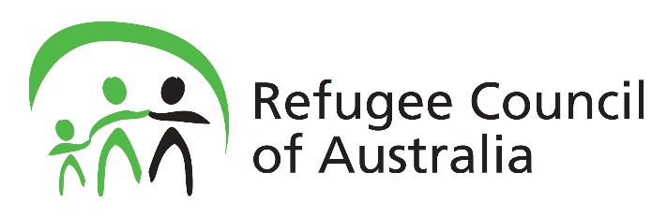

Arash Bordbar and Amy Frew
Formal briefing of the Committee (Australia)
16th October 2017

Chairperson,

Refugees and people seeking asylum

The Australian Government’s current deterrence regime towards people seeking asylum is cruel and inhumane. It rests on three pillars of harm:
- Boat turn backs,
- offshore processing, and
- temporary protection visas.

Boat Turn backs

The Australian Government has a militarised regime to stop people arriving in Australia by boat from seeking asylum. It has the legislative power to detain people at sea, and to transfer them to any country or a vessel of another country, even without that country’s consent. In addition, Australia has an arrangement with Vietnam and Sri Lanka, two refugee producing countries in our region, to return people seeking asylum to their authorities. People who have been returned allege that they have been incarcerated and severely mistreated in their home country. At least 11 people have fled Sri Lanka and Vietnam again and had their refugee status recognised elsewhere, raising serious questions about Australia’s commitment to the non-refoulement obligations of the Refugee Convention.

Offshore processing

In 2013 the Australian Government implemented a cruel regime to ensure that any person seeking asylum by boat would never be resettled in Australia. It then reopened offshore processing centres on the Republic of Nauru and Manus Island, in Papua New Guinea. For more than four years the Australian Government has held over 2000 people in desperate and dangerous conditions offshore, this group have been shot, attacked, and sexually assaulted. Thus far there have been 9 deaths, including one murder.

1783 of these men, women and children have been found to be refugees, but only just over 50 have been resettled in safety in the United States of America. In two weeks, the Manus detention centre will close, but no safe arrangements have been made for the hundreds of men still living there. These men are terrified to be forced into the PNG community where many have been attacked and seriously assaulted. Gay men held in PNG remain trapped where consensual sex between men is criminalised.

Over 400 people previously held on Nauru and Manus have been returned to Australia for medical treatment, and remain there due to legal action. This includes over 50 babies who were born in Australia. 6 weeks ago the Australian Government abruptly cut more than 60 of this group’s income support with no notice. The Australian Government is cruelly forcing them to choose between destitution and deportation. These 400 people are ineligible to apply for Australian visas and continue to face deportation to offshore processing countries. Some of these 400 people have been in detention centres now for over 4 years.

Family reunion

For people who sought asylum by boat, the Australian Government has deliberately obstructed family reunions. For those eligible to apply for citizenship, the Australian Government has excessively delayed granting it. For those who arrived after 12 August 2012, the Australian Government obstructs them by granting only temporary visas, where they are unable to sponsor family members to join them. And for those subject to offshore processing, they are unable ever to be reunited with their family in Australia. In a number of cases this has happened where families were split up in transit countries and arrived in Australia on different dates, some arriving in time to be eligible for a temporary protection visa, while family members arriving days later were removed to indefinite limbo in offshore processing countries.

Australia must,

- immediately evacuate all remaining refugees and people seeking asylum held on Manus and Nauru to Australia;
- It must allow all refugees and people seeking asylum who have been evacuated from Nauru or Manus Island to Australia for medical treatment to apply for refugee status in Australia and to have their protection claims assessed under Australian law;
- It must facilitate family reunions, in particular those families kept indefinitely separated by the Australian Government’s offshore processing regime; and
- it must cease boat turnbacks and detention at sea of people seeking asylum.

People with Disability; Prison Conditions

Ngila Bevan & Christopher Brophy
Disabled People’s Organisation Australia
Formal Briefing of Committee (Australia)
16th October 2017

Chairperson,

Thank you for the opportunity to speak to the status of people with disability and prison conditions, in Australia.

The NGO Coalition report provides clear evidence that the rights of people with disability in Australia continue to be violated.

- People with disability experience extraordinary levels of violence and abuse across a range of private and public settings. Such violence often goes unnoticed, undocumented and unaddressed.
- Many people with disability are denied the presumption and exercise of legal capacity, and full equality before the law.
- Substitute decision making regimes continue to deny people with disability the right to make free, informed and independent decisions about their own lives and bodies.
- Migration laws continue to disproportionately exclude people with disability from living and working in Australia.
- Restrictive practices continue to be used in schools; health facilities; supported environments; prisons; and in the community.
- Inadequate mental health legislation fails to prevent, and in some cases, condones, forced neurological treatments, including electroconvulsive therapy.
- The forced sterilisation of people with disability remains an ongoing and legally-sanctioned practice in Australia. This particularly affects women and girls with disability, and people with intersex variations.

With regard to prison conditions,

- People with disability remain overrepresented among the prison population, often languishing in poorly managed facilities without adequate support.
- People with intellectual, cognitive or psychosocial disabilities are often detained indefinitely and without criminal conviction.
- Overcrowding is contributing to deteriorating prison conditions, including the escalation of violence and self-harm.
- Solitary confinement and unnecessary strip searches against female inmates remain unregulated, with little to no government oversight.

A 2015 Australian Senate Inquiry found that violence against people with disability in institutional and residential settings is a national epidemic, with people with disability experiencing sustained and repeated episodes of violence in such settings.

Women and girls with disability are at greater risk of violence, particularly sexual violence, and experience significantly higher levels of all forms of violence by a greater number of perpetrators compared to their peers.

Children and young people with disability experience violence and abuse at approximately three times the rate of children without disability.

The 2015 inquiry recommended a Royal Commission into violence, abuse and neglect of people with disability. This recommendation was echoed by the Committee on Economic, Social and Cultural Rights at Australia’s review, earlier this year.

To date, however, the Australian Government has ruled out a Royal Commission on the basis that the National Disability Insurance Scheme will offer protection to people with disability. This is contrary to the facts that,

- The National Disability Insurance Scheme’s Quality and Safety Framework will only apply to the 10 percent of people with disability who are eligible to access the scheme.
- The framework will not address the many forms of violence that people with disability experience, nor the range of settings in which violence occurs.
- Further, the framework will not hold people and systems to account for past violence and injustice.

We encourage the committee to prioritise the rights and concerns of people with disability in your considerations. In particular, we strongly urge the committee to recommend that the Australian Government establish a Royal Commission into all forms of violence against people with disability.

We look forward to further discussion with you on these matters.

Violence Against Women

Maria Nawaz
Anna Cody
Formal Briefing of the Committee (Australia)
16th October

Chairperson,

Violence against women in Australia is endemic, with one in three women in Australia experiencing violence during their lifetime. Violence against women has disproportionately impacted Aboriginal and Torres Strait islander women, women with disability and women from culturally and linguistically diverse backgrounds.

- Aboriginal and Torres Strait Islander women are 45 times more likely to experience family violence than non-Aboriginal women;
- One quarter of all rape cases in Australia were perpetrated against women with a disability; and
- the Judicial Council on Cultural Diversity reported that migrant women are more likely to enter the legal system as a result of family breakdown or violence.

Despite the adoption of a third (three year) Action plan under the National Plan to Reduce Violence Against Women and Their Children, the available data shows no decrease in the prevalence of violence against women.

Australia should:

- create an independent mechanism to evaluate the National Plan;
- Engage in genuine consultation with groups disproportionately affected by violence in the development on policy
- amend the Family Law Act 1975 (Cth) to better protect the safety of women and children by removing a presumption of “equal shared parental responsibility” and language of “equal shared time” to shift culture and practice towards a greater focus on safety and risk to children.

LGBTI rights

Lesbian, gay, bisexual, transgender and intersex people continue to experience high levels of violence, abuse and harassment. 61 per cent of same-sex attracted young people report experiencing verbal abuse, and 18 per cent report physical abuse. 80 per cent of homophobic bullying is occurring at school. Despite this, funding for programs to address harassment directed at LGBTI students lapsed in July 2017.
Despite landmark anti-discrimination laws introduced in 2013 to protect against discrimination on the grounds of sexual orientation, gender identity and intersex status, exemptions in key areas such as schools, employment, and service provision mean that LGBTI people continue to face high levels of discrimination.

Similarly, the recognition of sex and gender identity is highly inconsistent. Alteration of sex on birth certificates still requires ‘sex reassignment surgery’ in certain states and territories. Recognition of sex and gender beyond ‘male’ and ‘female’ remains highly limited across Australia.

Another concern is the practice of forced medical interventions on infants and children with intersex variations.

Same-sex marriage is not recognised in Australia and some states deny same-sex couples from adopting children, while others deny them from access to reproductive technologies.

Australia should:

- Fund programs to reduce bullying and harassment of LGBTI people;
- Introduce a comprehensive equality act for stronger protections against discrimination;
- Ban unnecessary medical interventions on people with intersex variations;
- Recognise self-affirmed sex/gender without requiring medical treatment; and
- Legislate for marriage equality

Conclusion

We direct the committee to our NGO Coalition report for further information on these and other issues, including proposed recommendations for concluding observations. The need for a comprehensive Human Rights Act is apparent from all these presentations. It would serve as a means to ensure government accountability for human rights violations across all these areas. We welcome questions from the Committee.

Appendix 2: NGO Delegation Factsheets

Prior to the delegation arriving in Geneva for Australia’s review under the ICCPR, the NGO delegation developed factsheets for Committee members to draw attention and provide further information on the eighteen issue areas contained in the civil society shadow report. The final versions of each factsheet in PDF format are available at the DPO Australia website (http://dpoa.org.au/iccpr-2017-report). The following factsheets were developed:

- General information
- Constitutional frameworks and access to remedies
- Counter-terrorism
- Equality and non-discrimination
- Violence against women
- Law enforcement
- Detention practices
- Elimination of slavery and servitude
- Incarceration of Aboriginal and Torres Strait Islander peoples
- Prison conditions
- Rights of children
- Aboriginal and Torres Strait Islander children
- Vilification and hate speech
- Minority rights of Aboriginal and Torres Strait Islander peoples
- Minority rights of ethnic communities
- Democratic rights and freedoms
- Rights of people with disability
- Sexual orientation, gender identity and intersex status

Appendix 3: Additional Factsheets

The DPO Australia delegation developed three additional factsheets while in Geneva for the ICCPR review. These factsheets provided further detail on specific issues to relevant Committee members.

- Forced, Coerced and Involuntary Sterilisation of People with Disability
- Violence Against Women with Disability
- Violence Against People with Disability

Factsheet: Forced, Coerced and Involuntary Sterilisation of People with Disability

- Forced, coerced and otherwise involuntary sterilisation of people with disability is an ongoing practice in Australia. Women and girls with disability, young men with disability, and people with intersex variations are most likely to be sterilised.

- There is no uniform or robust data collection on the incidence of sterilisation in Australia. Data that is collected is piecemeal, and not comparable across jurisdictions.

- The monitoring bodies of the core international human rights treaties to which Austalia is a State Party have all found that forced sterilisation, forced abortion and forced contraception breach multiple provisions of the respective human rights treaties.

- Surgical and chemical involuntary sterilisation has been described as an act of violence, torture and social control, by several UN committees and Special Rapporteurs. Recommendations to prohibit it have been made CEDAW, CRPD, HRC, CRC and CAT committees.

- Forced and coerced sterilisation, including involuntary sterilisation authorised under substitute decision making regimes (involuntary sterilization), breaches multiple articles under the CRPD, CEDAW, ICCPR, ICESCR, CRC, and CAT.

- Australia has failed to implement recommendations to prohibit sterilisation made by the Committee on the Rights of the Child, the Working Group on the Universal Periodic Review and the Special Rapporteur on torture and other cruel, inhuman or degrading treatment or punishment.

- Australia has not legislated to prohibit and eliminate forced, coerced and involuntary sterilization, and appears to have no intention to do so.

- The Australian Government’s reasoning for not legislating to prohibit forced, coerced and involuntary sterilisation at Australia’s Universal Periodic Review in 2015 was that “an outright ban of non-therapeutic sterilisation procedures would potentially deny the rights of persons with disability to access all available medical support on an equal basis with persons without disability”.

Recommendations

Australia should immediately adopt uniform national legislation prohibiting domestic and offshore sterilisation of children and adults with disabilities, in the absence of their prior, fully informed, independent and free consent. All forms of coerced and involuntary sterilisation of children and adults with disability should be prohibited except where necessary to preserve life.

Australia should establish uniform national disaggregated data collection mechanisms on sterilisation procedures across all settings and jurisdictions.

Factsheet: Violence Against Women with Disability

- More than 70% of Australian women with disability have experienced violent sexual encounters at some time in their lives.

- 90% of women with intellectual disability have been subjected to sexual abuse. More than two-thirds (68%) have been sexually abused before they turn 18 years of age.

- More than a quarter of rape cases reported by females in Australia are perpetrated against women with disability.

- Women with disability are 40% more likely to be the victims of domestic violence than women without disability. In Australia, three women are hospitalised every week with a brain injury as a direct result of domestic violence.

- Indigenous women are 35 times more likely to suffer family violence and 80 times more likely to sustain serious injury requiring hospitalisation, and 10 times more likely to die due to family violence, than non-Aboriginal women.

- More than 25% of all women with intellectual disability are subject to some form of restraint and/or seclusion. 44% to 80% of people with disability who show ‘behaviours of concern’ are administered a form of chemical restraint, between 50% and 60% are subjected to regular physical restraint.

- Violence is present in the lives of approximately 22 percent of women with disability who access service support.

- Women and girls with disability in Australia are more exposed to practices, which qualify as torture or inhuman or degrading treatment, including state sanctioned practices such as forced sterilisation, forced abortion, and forced contraception.

- Forced contraception through the use of menstrual suppressant drugs is widespread in Australia, particularly affecting girls and women with intellectual and/or cognitive impairment.

Recommendations

Establish a Royal Commission into violence and abuse against people with disability. The Royal Commission should have specific and broad powers to compel witnesses, undertake a comprehensive investigation of all forms of violence and refer matters to law enforcement agencies.
Through the National Disability Strategy, establish nationally consistent measures to address all forms of violence against people with disability in a broad range of settings.

Factsheet: Violence Against People with Disability

- 18% of people with disability report being victims of physical or threatened violence compared to 10% without disability.

- People with disability experience, and are a greater risk of crimes from both strangers and people who are known to them.

- 71% of people with disability report feeling very unsafe ‘after dark’ compared to 47% of people without disability.

- People with intellectual disability are ten times more likely to experience violence than people without disability, and are three times more likely to be victims of assault, sexual assault and robbery compared with people who do not have an intellectual disability.

- People with psychosocial disability continue to be over-represented in Australian prison systems. Between 50-78% of prisoners have experienced a ‘psychiatric disorder’ compared with 11% of the general population, with 46% of prisoners on discharge identifying as having a psychosocial impairment.

- Twenty per cent (20%) of prisoners have an intellectual disability compared with 2–3% of the general population.

- Approximately 150 people around Australia are currently detained under mental impairment legislation in prisons and psychiatric units. At least 20% of children in residential care facilities have an intellectual disability.

- Seventy-five per cent of reported elder abuse cases involve the abuse of an older person with cognitive impairment. Forty-four to 80% of people with disability who show ‘behaviours of concern’ are administered a form of chemical restraint, between 50% and 60% are subjected to regular physical restraint, and those with multiple impairment and complex support needs are subjected to much higher levels of restraint and seclusion.

- More than a quarter of all people with intellectual disability will be subject at some time in their life to some form of restraint and/or seclusion.
- Sixty-nine per cent of a people with cognitive impairment who used an Independent Third Person (ITP) have experienced sexual assault. A further 25% have experienced other crimes against the person.
Recommendations

Establish a Royal Commission into violence and abuse against people with disability. The Royal Commission should have specific and broad powers to compel witnesses, undertake a comprehensive investigation of all forms of violence and refer matters to law enforcement agencies.
Through the National Disability Strategy, establish nationally consistent measures to address all forms of violence against people with disability in a broad range of settings.

Appendix 4: Australian Government Opening Statement

18 October 2017
Mme/r Chairperson and Committee Members
Australia is pleased to appear before the Human Rights Committee to discuss civil and political rights in Australia.
Australia is a vibrant, culturally diverse nation. The First Australians, the Aboriginal and Torres Strait Islander peoples, are the oldest continuous living culture in the world. They make a unique and vital contribution to our nation.
Australia is also a migrant nation. One in four Australia’s was born overseas. We celebrate our cultural diversity - speaking hundreds of languages alongside English, and being home to people from over 300 nationalities.
We have generous immigration and humanitarian programmes. In 2017–18, Australia will provide a minimum of 16,250 places under our Humanitarian Migration Programs. Since July 2015 Australia has granted permanent protection to over 44,000 people through this program.
From this diversity we have built a cohesive society based on shared common values - respect, equality, inclusion, freedom, the rule of law.
Two days ago Australia was elected to the Human Rights Council for 2018 to 2020. As a country that takes its human rights obligations with the utmost seriousness, we are conscious of the further expectations and responsibilities placed upon Council members.
Australia is proud of our record of engagement with UN Treaty Bodies and other parts of the UN human rights system. This helps us to improve and strengthen human rights outcomes, for Australians and globally.
Rights and Freedoms
The Australian Government is committed to upholding the civil and political rights of all Australians, and to ‘leave no one behind’ to use the language of the SDGs.
Freedom of expression, association and belief underpin the principles of democracy, and must be protected.
Australia welcomes robust but respectful debate on human rights issues.
In this context, I would like to thank Australian civil society and the Australian Human Rights Commission, whose representatives are here today, for their interest and participation in our appearance. We may sometimes differ in opinions, but we are united by a common purpose of ensuring all Australians are able to realise their rights. We reaffirm our commitment to ongoing dialogue with civil society, and look forward to our debrief with their representatives tomorrow.
Human rights record and improvement
When it comes to giving effect to the rights set out in the Covenant, Australia has a lot to be proud of.
However, we are not complacent. We acknowledge there are things we could do better.
The Government is committed to working with relevant communities to identify and implement appropriate solutions.
Access to Justice
The rights to equality before the law and to a fair trial are imperative in a democratic society.
Reflecting the importance the Australian Government places on ensuring all Australians are able access the justice system, it has committed record funding to the legal assistance sector - over 1.7 billion dollars over five years to 2020 to fund Legal Aid Commissions, Community Legal Centres, and Aboriginal and Torres Strait Islander Legal Services.
National Security Scrutiny
We are conscious of the imperative to protect public safety. At the same time, our efforts to counter terrorism are informed by our commitment to human rights and the rule of law. As Prime Minister Turnbull reaffirmed earlier this year, Australia strives to get the balance right between security, and individual rights and civil liberties.
Australia therefor maintains a comprehensive regime of safeguards to ensure that security considerations do not erode Australians’ fundamental rights and freedoms.
The Independent National Security Legislation Monitor, is an independent agency tasked with the ongoing review of the operation, effectiveness and implications of Australia’s counter‑terrorism and national security legislation. This oversight addresses whether legislation contains appropriate safeguards to protect rights, is proportionate to any threat of terrorism or threat to national security or both, and remains necessary. In addition, the independent Inspector General of Intelligence and Security reviews the actions of the Australian Intelligence Community, to ensure that Government agencies act legally and with propriety, comply with ministerial guidelines and directives, and respect human rights.
The Australian Government is further strengthening its oversight, accountability and integrity structures by increasing the powers of the Attorney-General relating to Australia’s intelligence communities and domestic security arrangements.
Gender Equality
All Australian jurisdictions share a responsibility for delivering equality for women. The Australian Government has three priorities to address remaining obstacles to substantive equality:
- strengthening women’s economic security, including women’s workforce participation
- supporting more women into leadership positions; and
- ensuring that women and their children are safe from violence.
Women in Australia continue to experience unacceptable levels of violence. Addressing this issue is a particular focus of Australian governments.
Indigenous People, particularly Indigenous Incarceration Rates
Aboriginal and Torres Strait Islander Australians continue to experience poorer outcomes than non-Indigenous Australians across a range of measures.
The Closing the Gap Strategy contains measures to improve the education, health and employment outcomes for Indigenous Australians.
2018 marks the 10-year anniversary of the Closing the Gap Strategy. We have had some success, but there is still a long way to go.
All Australian Governments are working together to refresh the Closing the Gap framework. Central to this work is consulting Aboriginal and Torres Strait Islander people and peak Indigenous bodies and leaders, including the Aboriginal and Torres Strait Islander Social Justice Commissioner and the National Congress of Australia’s First Peoples.
The Australian Government is also committed to meaningful recognition of Indigenous Australians in the Australian Constitution. Changes to the Constitution can only occur following a successful referendum where the majority of votes in a majority of states and an overall majority of voters vote yes to the proposition.
On 30 June 2017 the Referendum Council on this issue delivered its Final Report to the Prime Minister and Leader of the Opposition. The Australian Government is now considering the Council’s advice and will work with the Parliament towards a proposition that is most likely to succeed at a referendum.
It is of particular concern that Indigenous Australians are over- represented in the criminal justice system. As at 30 June 2016, 27% of prisoners in Australia identified as Indigenous, despite comprising only 3% of the total population.
The Australian Government is alarmed by these figures, concerned for the individuals and families they represent, and committed to working with Indigenous communities to take decisive action to change this situation.
In 2017-18, the Australian Government will provide $264 million through the Indigenous Advancement Strategy to improve community safety and address the drivers of violence, abuse and neglect in Indigenous communities. These include:
- crime prevention and diversion activities;
- prisoner through care to support intensively people leaving prison to reintegrate back into their communities and families;
- alcohol and substance misuse treatment services; and
- family safety activities to reduce family and domestic violence.
The Government is also prioritising indigenous economic participation and empowerment as a means of addressing underlying drivers of the gap between Indigenous and non-Indigenous Australians. One success story has been the Indigenous Procurement Policy, which aims to increase government procurement from Indigenous owned businesses. This has supported such businesses to win more than half a billion dollars in Government contracts in its first two years.
Rights of People with a Disability
Australia is undertaking ground- breaking work on disability. The National Disability Strategy 2010-2020 provides a ten-year national policy framework for improving the lives of persons with disabilities in Australia, working with people with a disability, their families and carers.
A specific plan to Improve Outcomes for Aboriginal and Torres Strait Islander People with Disability was released this week. The plan helps to identify potential solutions that communities, in partnership with the Australian Government, can drive for better access to culturally appropriate and sustainable support and services.
In addition, the Australian Government is committed to engaging people with disabilities in our aid program, reflected in the strategy Development for All 2015-2020.
Rights of Older Australians
Over the next few decades, Australia’s ageing population will have a range of implications on the Australian economy. The Australian Government is investigating measures to ensure that Australians’ continue to realise their rights as they age.
Under Australian law, age discrimination is prohibited, and Australia has a dedicated Age Discrimination Commissioner, the Hon Dr Kay Patterson AO.
The Australian Government is concerned by reports of elder abuse in Australia. In 2016 it requested the Australian Law Reform Commission to inquire into this subject. The Australian Government has committed $15 million specifically to protect the rights of older Australians, including funding for research and for an online Knowledge Hub to bring together relevant knowledge.
Conclusion
Mme/r Chair, this Australian delegation is honoured to engage in constructive dialogue with the Committee.
The Head of our delegation is Mr Andrew Walter, from the Attorney-General’s Department. Mr Walter will draw on the expertise of the other members of our delegation in order to provide detailed responses to your inquiries.
The multi-departmental composition of our delegation demonstrates our commitment to the Committee process:
- Ms Autumn O’Keeffe, Attorney-General’s Department
- Ms Tarja Saastamoinen, Indigenous Affairs Group, Department of the Prime Minister and Cabinet
- Dr Tim Reddel, Department of Social Services
- Mr Luke Mansfield, Department of Immigration and Border Protection; and
- Mr Kevin Playford, Department of Foreign Affairs and Trade
We are eager to discuss our experiences and to learn from your insights.
Thank you for your kind attention.

Endnotes

People With Disability Australia, Submission No 50 to Senate Standing Committee on Community Affairs, The Involuntary or Coerced Sterilisation of People with Disabilities in Australia, March 2013; Women With Disabilities Australia, Submission No 49 to Senate Standing Committee on Community Affairs, The Involuntary or Coerced Sterilisation of People with Disabilities in Australia, March 2013; Organisation Intersex International Australia, Submission No 23 to Senate Standing Committee on Community Affairs, The Involuntary or Coerced Sterilisation of People with Disabilities in Australia, 15 February 2013.
Reasons for this is that there are (1) No Medicare Item Number for sterilisation procedures and therefore they are not recorded in any systemic way by hospitals and medical professionals; (2) Applications for sterilisation are dealt with differently in each jurisdiction – in some states this is done by a Guardianship Tribunal and in others through the Family Court or other court procedure. (3) There is no consistency in how these applications are recorded and assessed across jurisdictions; (4) There is no uniform data collection across jurisdictions.
OHCHR, The Core International Human Rights Instruments and their monitoring bodies. See: http://www.ohchr.org/EN/ProfessionalInterest/Pages/CoreInstruments.aspx
Frohmader, C. (2013) OpCit.
CEDAW/C/Aus/CO/5
CRPD/C/AUS/CO/1
HRI/GEN/1/Rev.7
Human Rights Committee, General Comment No 13: The Right of the Child to Freedom from All Forms of Violence, UN Doc CRC/C/GC/13 (18 April 2011) [16], [21].
Juan E. Mendez, Special Rapporteur on torture and other cruel, inhuman or degrading treatment or punishment, 22nd Session, Agenda Item 3, UN Doc A/HRC/22/53 (1 February 2013) para 48.
For a list of relevant articles under each convention, see WWDA Position Statement 4: Sexual and Reproductive Rights, pp. 15-28. Available at: http://wwda.org.au/wp-content/uploads/2016/10/Position_Statement_4_-_Sexual_and_Reproductive_Rights_FINAL_WEB.pdf
CRC/C/15/Add.268; CRC/C/AUS/CO/4
A/HRC/17/10
A/HRC/22/53
A/HRC/WG.6/23/AUS/1
Stimpson & Best; cited in Elman, A. (2005). Confronting the Sexual Abuse of Women with Disabilities. Harrisburg, PA: VAWnet, a project of the National Resource Center on Domestic Violence/Pennsylvania Coalition Against Domestic Violence.
Australian Law Reform Commission (ALRC) (2010) Family Violence — A National Legal Response. ALRC Final Report 114. Accessed online January 2013 at: http://www.alrc.gov.au/publications/family-violence-national-legal-response-alrc-report-114
Heenan, M., & Murray, S. (2006). Study of reported rapes in Victoria 2000–2003. Summary research report. Melbourne: Statewide Steering Committee to Reduce Sexual Assault. Published by the Office of Women’s Policy, Department for Victorian Communities.
Brownridge, D. (2006) ‘Partner violence against women with disabilities: Prevalence, risks and explanations’, Violence against Women, vol. 12, no. 9, pp. 805–22.
Brain Injury Australia (August 11, 2015) Media Release: Every week in Australia, one woman is killed - the result of family violence. Every week in Australia, three women are hospitalised with a brain injury - the result of family violence. http://www.braininjuryaustralia.org.au/
In Frohmader, C. (2011) OpCit. See also Sutton, C. Violence against Aboriginal women 80 times worse. Perth Now Newspaper, June 10, 2013; accessed online at: http://www.perthnow.com.au/news/violence-against-aboriginal-women-80-times-worse/story-fnhnv0wb-1226661209335?nk=15a73840245f7154a7d4daaca2fc800f; See also: VicHealth (2011) Preventing violence against women in Australia: Research summary. Victorian Health Promotion Foundation. Available at: http://www.vichealth.vic.gov.au
Australian Psychological Society (May 2011) Psychologists call for prompt end to restrictive practices in disability sector. Media Release; May 2011.
Lynne Webber, Mandy Donley and Hellen Tzanakis, ‘Chemical Restraint: What Every Disability Support Worker Needs to Know’ (Article, Office of the Senior Practitioner, 2008).
Ibid.
Dowse, L. et al (2013) OpCit.
Committee of Ministers of the Council of Europe (2009) Declaration: Making gender equality a reality. 119th Session of the Committee of Ministers, Madrid, 12 May 2009.
Frohmader, C. (2013) ‘Dehumanised: The Forced Sterilisation of Women and Girls with Disabilities in Australia’, Women with Disabilities Australia (WWDA), Rosny Park, Australia. See also: Frohmader, C., & Sands, T. (2015) OpCit. See also: Frohmader, C. (2014) ‘Gender Blind, Gender Neutral’: The effectiveness of the National Disability Strategy in improving the lives of women and girls with disabilities. Prepared for Women With Disabilities Australia, Hobart, Tasmania. ISBN: 978-0-9585268-2-1.
In Frohmader, C. (2011), OpCit.
Council of Australian Governments (2011) National Disability Strategy 2010-2020, Commonwealth of Australia.
Groce, N. (2006) People with Disabilities, in Social Justice and Public Health, Barry S. Levy & Victor Sidel (Eds), accessed online April 2011 at: http://www.aidslex.org/site_documents/DB-0018E.pdf
National Disability Strategy 2010–2020: Progress report to the Council of Australian Governments 2014; unpublished draft.
Council of Australian Governments (2011) National Disability Strategy 2010-2020, Commonwealth of Australia.
Carlene Wilson and Neil Brewer, ‘The incidence of criminal victimisation of individuals with an intellectual disability’ (1992) 27(2) Australian Psychologist, 114–117, 115
Available research and data tends to focus on people with intellectual and psychosocial disability. There is a tendency to overlook the significant over-representation of people with acquired brain injury in the criminal justice system, as well as other impairments/disability – such as over-representation of deaf people and hearing impaired people.
NSW Law Reform Commission, ‘People with Cognitive and Mental Health Impairments in the Criminal Justice System: An Overview’ (Consultation Paper No 5, January 2010) 13–15.
Joint NGO report to the United Nations Committee Against Torture; Torture and cruel treatment in Australia. October 2014; Human Rights Law Centre, Victoria.
NSW Law Reform Commission, ‘People with Cognitive and Mental Health Impairments in the Criminal Justice System: An Overview’ (Consultation Paper No 5, January 2010) 13–15.
Senate Standing Committee on Legal and Constitutional Affairs; Attorney-General’s Department; Group 2; Program 1.3, Question No. 88, 16 October 2012.
Commission for Children and Young People, “...as a good parent would...” Inquiry into the adequacy of the provision of residential care services to Victorian children and young people who have been subject to sexual abuse or sexual exploitation whilst residing in residential care (Melbourne: Commission for Children and Young People, August 2015).
Black, B. (2008) ‘The human rights of older people and agency responses to elder abuse’, research report, Centre for Human Rights Education, Curtin University of Technology, Perth; Boldy, D., Webb, M., Horner, B., Davey, M., and Kingsley, B. (2002) ‘Elder Abuse in Western Australia: Report of a Survey Conducted for the Department for Community Development - Seniors' Interests’, Curtin University of Technology: Division of Health Sciences. Freemason’s Centre For Research Into Aged Care Services, Perth.
Lynne Webber, Mandy Donley and Hellen Tzanakis, ‘Chemical Restraint: What Every Disability Support Worker Needs to Know’ (Article, Office of the Senior Practitioner, 2008).
Ibid.
Ibid.
Australian Psychological Society (May 2011) Psychologists call for prompt end to restrictive practices in disability sector. Media Release; May 2011.
Independent Third Persons (ITPs) are used in Victoria to attend police interviews for adults and young people with disability to ensure that they are not disadvantaged during the interview process. The ITP Program is made up of volunteers. See: http://www.publicadvocate.vic.gov.au/our-services/volunteer-programs
Victorian Equal Opportunity and Human Rights Commission (2014) Beyond doubt: The experiences of people with disabilities reporting crime – Research findings. ISBN 978-0-9875444-9-3; Melbourne, Victoria.
https://www.malcolmturnbull.com.au/media/press-conference-announcing-the-establishment-of-the-home-affairs-portfolio

