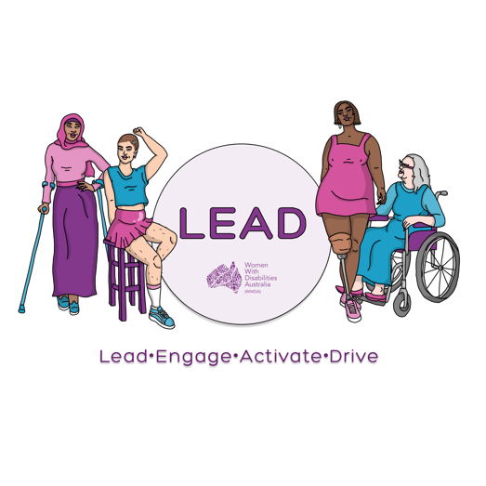
0438 535 123
officeadmin@wwda.org.au
www.wwda.org.au/project/lead

WWDA LEAD Scholarships Application form

Thank you for your interest in the WWDA LEAD Scholarship Program.

Return this form
Please return this form by Friday 16th April 2021.
- Email to Spo@wwda.org.au
- OR
- Send to us at PO Box 407 Lenah Valley TAS 7008 Australia
Successful Applicants will be notified on Monday 3rd May 2021.

Name:___________________________________________________
Organisation (if applicable):__________________________________
Postal Address:___________________________________________
_________________________________________________________
Postcode:_____________________ State:_______________________
Phone:___________________________________________________
Email:______________________________ ______________________

Are you a current WWDA Member? Yes No
Please note you will need to sign up to be a WWDA member to take part in the WWDA LEAD Scholarship program.
To sign up please click here WWDA Membership form.

Please note that applicants must also:
- Identify as a woman, girl, feminine identifying or non-binary person with disability.
- Be aged 15 years or above.
- Be currently living in Australia.
- Have an interest in disability rights, women’s rights, leadership and / or pursuing that work that WWDA does.
Important dates
Date | Activity
24 March | Information session on WWDA LEAD Scholarships
24 March | Applications open
31 March | Call in WWDA LEAD Information day  9am-8pm (AEST)
9 April | Call in WWDA LEAD Information day  9am-8pm (AEST)
16 April | Applications close
16 April-29 April | Applications reviewed
3 May | Successful applicants announced

Selection Criteria Questions
Selection of participants will be based on the answers to the following questions. If you require more space, please attach further pages.

- Can you tell us why you would like to be involved in the WWDA LEAD Scholarship program?

- What is the most important issue/s that you would like to learn about or take action on that affects women, girls, feminine identifying and / or non-binary people with disabilities?

- How do you think taking part in a leadership or training course would help you to do this?

- Do you know of a course or other opportunity that you would like to take part in?

  - If yes, can you please name the course, course cost and dates?

- By the end of the WWDA LEAD Scholarship opportunity what do you want to have achieved?

- Would you like to be involved in mentoring other women with disability as part of the WWDA LEAD project? Are there particular things you would like to mentor others in (i.e.: running support groups; doing representation work; writing submissions, public speaking, etc)

- In what ways could you help with WWDA’s work after participating in the WWDA LEAD Scholarship Program?

Do you have any other comments you wish to make?

Access & Support Needs

Do you have any access and/or support needs in relation to participating in WWDA’s LEAD Scholarship Program? (i.e.: information in large print; Easy Read materials; etc.).

Return this form
Please return this form by 5pm Friday 16th April 2021 AEDT
- Email to Spo@wwda.org.au
- OR
- Send to us at PO Box 407 Lenah Valley TAS 7008 Australia

Successful Applicants will be notified on Monday 3rd May 2021

Contact us
If you require any further information you can contact us in the following ways.
- Email Libbi Cunnington at SPO@wwda.org.au
- Call or text Libbi on 0488 758 539
- You can use the National Relay Service to call us. Call 1800 555 677. Ask for 0488 758 539
- Need a translator? Call 131 450 Ask for 0488 758 539.
- Send a letter to PO Box 407 Lenah Valley TAS 7008 Australia

Women With Disabilities Australia (WWDA)
PO Box 407, Lenah Valley, Tasmania 7008, Australia

