‘Women with Disabilities and Employment: the double-glazed glass ceiling!’

Queensland Forum with Women with Disabilities

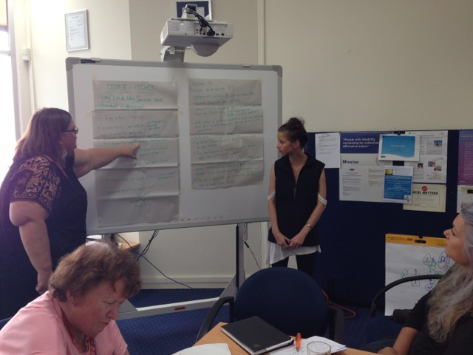

Women With Disabilities Australia (WWDA) and
Queenslanders with Disability Network’s (QDN’s) Women’s Network

for the

WWDA Disability Employment Services (DES)
Consumer Engagement Project

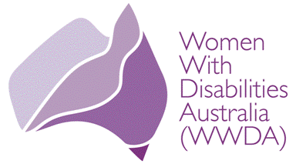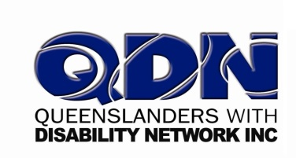

Prepared by Karin Swift, on behalf of WWDA, June, 2014

Executive Summary

This report outlines a process of engaging with Queensland women with disabilities regarding their access to Disability Employment Services (DES) and key issues affecting women with disabilities in finding and maintaining employment. The Women With Disabilities Australia (DES) Consumer Engagement Project was led by Women With Disabilities Australia (WWDA) with funds from the Australian government. WWDA facilitated a number of forums around Australia. This report details the outcomes of the Queensland Forum, held in partnership with Queenslanders with Disability Network’s (QDN’s) Women’s Network in May, 2014.

The main objectives of the forum were to:
- Identify issues affecting women with disabilities in relation to their access to, and use of, Disability Employment Services (DES);
- Identify ways that future Disability Employment Services can be improved to better meet the needs of women with disabilities;
- Provide information to women with disabilities about the DES Program; and,
- Identify any other issues that impact on women with disabilities seeking, finding and maintaining employment.

Feedback about the forum process was generally positive, with women responding well to learning more about DES services and being able to contribute their ideas on how to improve the DES system and the current barriers for women with disabilities in relation to employment.

It became apparent however that the employment of women with disabilities is a complex issue requiring deeper analysis and a more targeted response than the current ‘carrot and stick’ approach to welfare reform that is being proposed.

The following Recommendations came out of the forum:

- The disability support system needs radical reform to ensure women with disabilities have the capacity to get the formal support they need to actually get to work, for example, personal care support, reliable, functional equipment and aids in good working order, organisational support, assistance with health and wellbeing issues, managing medications.

- Infrastructure such as transport systems and the built environment need to be accessible and affordable so women are able to move about freely and independently and get to work.

- Workplaces and society in general need to be welcoming of women with disabilities and accessible.

- DES services and employers need to have a greater understanding of the needs and issues of women with disabilities in the workplace, so that women can be protected from workplace violence, discrimination, unfair treatment and have the same rights as other workers, such as fair pay, protection against unfair dismissal, equal access to promotion, parental leave, union representation.

- DES services should be required to collect keep gender disaggregated data.

- Women with disabilities need to be represented on government boards, DES boards, and other decision-making bodies.

- Income support systems (ie Centrelink) should not punish women with disabilities for being unable to work, due to structural circumstances beyond our control. This is cruel and unfair and creates much anxiety among all people with disabilities. Rather than punitively punishing individuals for systemic issues, systems should be doing all they can to remove these structural barriers so that everyone can make a meaningful contribution to society.

Background

Women With Disabilities Australia (WWDA) is the peak organisation for women with all types of disabilities in Australia. WWDA is run by women with disabilities, for women with disabilities. It is the only organisation of its kind in Australia and one of only a very small number internationally. WWDA’s work is grounded in a human rights based framework which links gender and disability issues to a full range of civil, political, economic, social and cultural rights. This rights based approach recognises that equal treatment, equal opportunity, and non-discrimination provide for inclusive opportunities for women and girls with disabilities in society. It also seeks to create greater awareness among governments and other relevant institutions of their obligations to fulfil, respect, protect and promote human rights and to support and empower women with disabilities, both individually and collectively, to claim their rights.

In July 2013, the then Minister for Employment Participation, Hon Kate Ellis, advised WWDA that the Australian Government would be providing $41,000 to a number of national disability organisations, including WWDA, to assist in improving the delivery of Disability Employment Services (DES). The specific purpose of the one of funding grant is to lift consumer engagement and knowledge of the DES program, facilitate provision of consumer advice to the Government about the needs of women with disabilities in the context of the DES, and look at ways to improve future disability employment services. The WWDA DES Consumer Engagement Project has been undertaken in two phases.

In the second phase of the WWDA DES Consumer Engagement Project, WWDA engaged with its affiliate networks of women with disabilities in Western Australia, South Australia, the Australian Capital Territory and Queensland, to host forums for women with disabilities. This report summarises the process and outcomes of the Queensland Forum, which was a joint event held by WWDA and QDN in Brisbane in May, 2014.

About QDN

QDN is a state-wide network of people with disability. QDN is for people with disability, with people with disability, by people with disability, for citizenship and social justice. QDN has a Women’s Network that meets on occasion to discuss issues of key importance to women with disabilities in Queensland. They have gathered regularly over the years to respond to key social policy issues. WWDA has valued the opportunities to collaborate with QDN’s Women’s Network on several occasions around key policy and human rights priorities, including:

- National Women’s Health Policy (NWHP): QDN Women’s Group assisted WWDA to develop their organisational response to the National Women’s Health Policy. As part of this work WWDA ran a consultation with QDN’s Women’s Network on issues to be included in the Policy. WWDA paid for QDN Women’s Network members to attend this consultation as well as some catering for the day. This consultation greatly informed WWDA’s response to this national policy.

- National Disability Insurance Scheme (NDIS): QDN’s Women’s Network assisted WWDA by running a joint consultation on providing a gendered perspective to the NDIS. WWDA was also pleased that several participants have since became members of WWDA through attending the consultation.

- Senate Inquiry into Involuntary or Coerced Sterilisation of People with Disabilities in Australia: QDN and WWDA jointly supported a group of women with disabilities to share their experiences at a Senate Inquiry Hearing at Parliament House in Brisbane. WWDA is indebted to those women for being prepared to share their lived experiences with the Senate Committee. WWDA received positive feedback from the Senate Committee regarding the value that this Hearing added to the Inquiry and the sensitive way the women were supported throughout the Hearing.

The Forum Process

Eleven women with disabilities from QDN Women’s Network attended the forum. These women represented a broad cross-section of the disability community in Queensland (including women with physical, intellectual and neurological disabilities and mental health issues) and were also representative of various age groups and socio-economic backgrounds. The women in attendance were able to offer robust discussion on a range of issues related to providing a gendered perspective on employment issues and access to DES services, including:
- their lived experiences and impacts of various disabilities;
- the impact of gender and disability on employment;
- discrimination against women with disabilities in employment;
- the right to bodily integrity and to be free from violence, abuse, exploitation and neglect, both in the workplace and whilst in receipt of DES services;
- parenting issues as they relate to employment (ie. the right of women with disabilities to paid parental leave and to return to work after to birth of a child);
- child protection issues; and,
- living inclusive lives in the community.

Funding from the Australian Government grant, administered by WWDA, ensured women with disabilities could participate equitably in the consultation process. Funding provided:
- assistance with transport costs to and from the forum;
- a support worker;
- a forum facilitator; and,
- catering.

The main objectives of the forum were to:
- Identify issues affecting women with disabilities in relation to their access to, and use of, Disability Employment Services (DES);
- Identify ways that future Disability Employment Services can be improved to better meet the needs of women with disabilities;
- Provide information to women with disabilities about the DES Program; and,
- Identify any other issues that impact on women with disabilities seeking, finding and maintaining employment.

The Forum utilised a range of strategies, including:

- Inviting Lisa Huntly, MYE Job Development Officer, Mylestones Employment as a guest speaker to attend the forum to provide participants with Information about the DES Program. As part of her presentation, Lisa also disseminated printed and other promotional materials (ie pens and stickers etc) to participants regarding the DES program;

- Using photography to record components of the forum. Consent was gained from participants to be photographed.

- Using creative approaches to elicit information from participants;

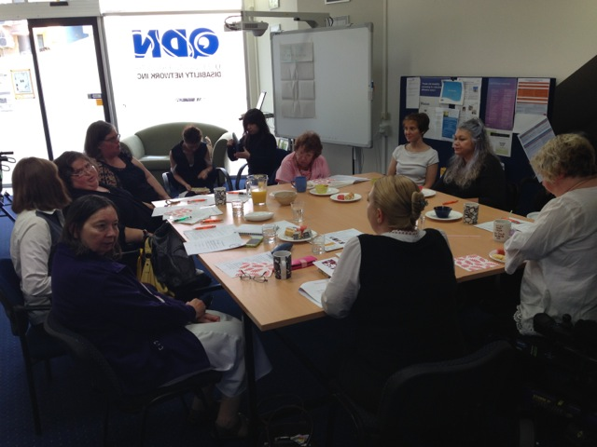

To meet objective 3 of the Forum, Lisa Huntly from Mylestones Employment was asked to give a twenty minute presentation at the beginning of the forum. The guest speaker spoke about how to access a DES service and the typical process a DES service undertakes to find employment for an individual. She also highlighted aspects of service delivery that were specific to Mylestones and addressed issues and barriers specific to women with disabilities in employment. During question-time, participants had the opportunity to clarify points made in the presentation and ask further questions.
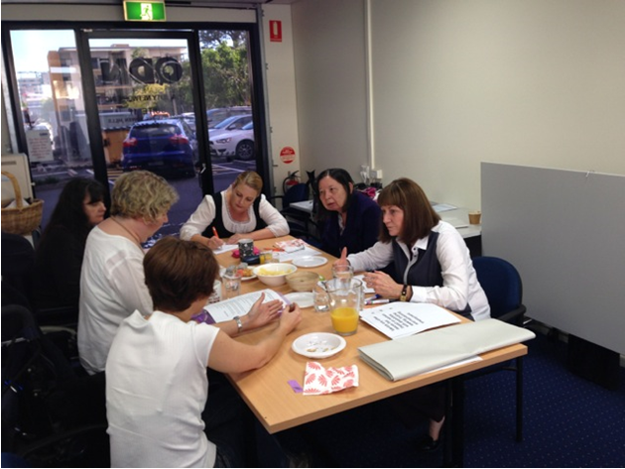
The guest speaker was asked what Mylestone Employment’s policies and procedures were for dealing with discrimination, sexual harassment and workplace violence. Lisa asserted that Mylestones did have policies and procedures in place for dealing with discrimination. She said the service took on a community education role with workplaces. She also asserted that in the case of workplace violence and assault/ rape occurring, the work placement would be shut down and the woman would be supported by Mylestones to seek advocacy, press charges and link with appropriate support services. Lisa was also asked whether Mylestones Employment kept sex disaggregated data. The response to this question was no and that people were seen as individuals.

The next part of the forum focussed on eliciting responses from participants to forum objectives 1, 2 and 4. The group broke into two smaller groups to focus on these areas in more detail. Groups worked separately for over an hour with Group A starting with issues affecting women with disabilities in relation to their access to and use of DES Services and Group B starting with any other issues impacting on women with disabilities seeking, finding and maintaining employment. At the end of the group work, there was an opportunity for each group to creatively reflect back to the whole group what they had contributed and to ask if there was anything missing or anything more people had to say and to do a whole-group reflection on what women had got out of the day. Lunch was served at the end of the forum to thank participants for their attendance and active contributions.

Women’s Access to DES Services

This section of the report will focus on feedback from each of the groups to Forum objectives 1, 2 and 4.

Issues affecting women with disabilities in relation to their access to, and use of, DES Services

Key points made under this area included:

- Difficulty for women with disabilities to build rapport and a trusting relationship with a DES worker, especially when the worker is not consistent/ short-term. Women should be able to choose a female DES worker if that is their preference.
- Potential conflicts of interest when a DES worker advocates for their clients. There may be a tendency not to advocate for fear of affecting further employment placements. This highlights the need for independent advocacy and for clear pathways for women with disabilities to further services, supports, legal protection when needed.
- Potential funding cuts to DES services and other disability support services, leading to uncertainty and times of change. It is unfair to expect women with disabilities to work and threaten them with cuts to their pensions, when there is no guarantee of available jobs or the formal services and equipment needed to support them.
- Possible stigma associated with a DES worker being present in a workplace, thus affecting a worker’s capacity to ‘blend in’ to a workplace, be seen as an independent and competent worker, fit in socially to a workplace culture and be trusted with confidential information.
- Uncertainties around DES workers reaching out to clients, for example: outreach services for women who are geographically marginalised or socially isolated.
- Training needs of DES workers to meet the needs of women with disabilities from CALD backgrounds.

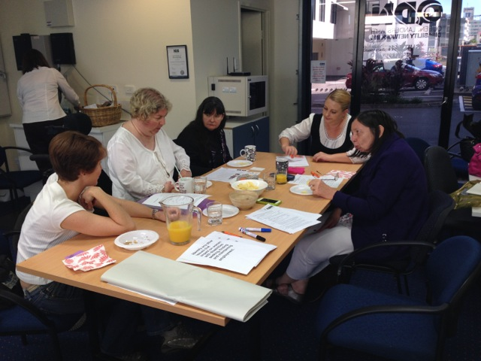

Ways that future DES Services can be improved to better meet the needs of women with disabilities

The following key points were made under this topic:

- DES services keeping gender disaggregated data, so they can be more gender responsive in their service provision.
- DES services respecting women’s existing knowledge, skills, strengths and goals.
- Having women with disabilities on each DES management board.
- More effective communication between DES services and women with disabilities.

Any other issues that impact on women with disabilities seeking, finding and maintaining employment

The following key points were made under this topic:

- Access to internet (education/ training) – women with disabilities can experience limited or unreliable internet access due to poverty
- Access to JobAccess technologies prior to employment would increase the opportunities for women with disabilities to gain employment
- Assistive technologies being available at work and at home
- Disclosure of disability affecting career progression
- Disclosure of disability to employers – there is no formal way to formally disclose disability in some workplaces. If you do disclose disability after commencement, continuation of your employment could be an issue
- Disclosure or the lack thereof and the social expectations to conform to a certain expectation
- Equality – level playing field considering disability and gender – double disadvantage
- Family responsibilities – women with disabilities carry the majority of the responsibilities around family (ie caring for children and ageing parents and relatives, keeping families together)
- Lack of awareness of disabilities on behalf on employers and how it impacts on the individual
- Lack of awareness around women with multiple disadvantages (eg disability, mental illness, homelessness)
- Level of disclosure can impact on a woman maintaining a job and what level of assistance or resistance they will experience
- Limited opportunities versus token jobs
- More education around disability is required in the workplace
- Older women with disabilities face increased discrimination because of their age
- People assuming what your limitations are and the required supports not being available leading to missed opportunities
- Personal care in the workplace – issues around access to efficient services and acceptance of this support within the workplace culture
- Pregnancy issues in the workplace: puts on hold employment, education, training; will women with disabilities have the same access to paid maternity leave and return to same work position post-pregnancy?; women with disabilities have the added disadvantage/ stressor of Child Safety intervening and removing their children with little or no evidence of a woman’s parental capacity.
- The difference between women with a physical disability and disclosure and those who have a hidden disability and the attitudes/ perceptions co-workers/ managers/ CEOs
- The energy levels/ infrastructure required for women with disabilities to be able to work – support workers to assist women to get ready in the morning, accessible and affordable transport systems, accessible and accommodating workplace cultures
- The higher the position (ie CEO), the more difficult it is to disclose and the less likelihood of a candidate with a disability being successful
- Transport issues – public transport not linking, being timely, accessible, safe and affordable
- What is relevant to the job regarding disclosure?
- What is the definition of disability?
- Women with disabilities are more vulnerable to sexual exploitation both in the workplace and in the wider community – but support is lacking: “Disability is seen but not heard”.
- Women with disabilities are not just dealing with their disabilities, they are dealing with assumptions, stereotypes and prejudice ie. the often held view that impaired speech = impaired mind
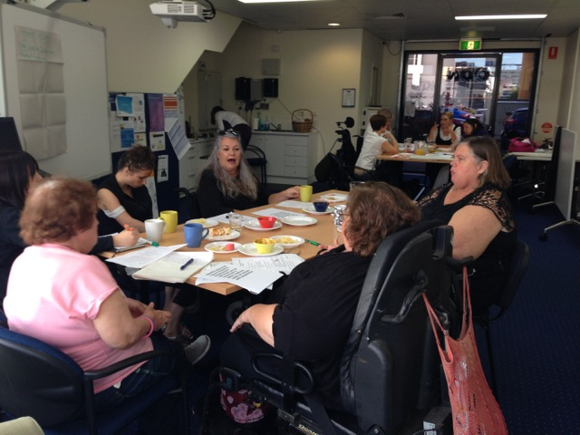
- Work/life balance – sometimes having a disability is hard enough without the added pressure to work or meet Centrelink obligations and family commitments

Concluding Remarks

Feedback about the forum process was generally positive, with women responding well to learning more about DES services and being able to contribute their ideas on how to improve the DES system and the current barriers for women with disabilities in relation to employment.

It became apparent however that the employment of women with disabilities is a complex issue requiring deeper analysis and a more targeted response than the current ‘carrot and stick’ approach to welfare reform that is being proposed. For women with disabilities to be able to compete on an equal playing field in an extremely competitive job market, much structural change needs to occur.

First, the disability support system needs radical reform to ensure women with disabilities have the capacity to get the formal support they need to actually get to work, for example, personal care support, reliable, functional equipment and aids in good working order, organisational support, assistance with health and wellbeing issues, managing medications. Second, infrastructure such as transport systems and the built environment need to be accessible and affordable so women are able to move about freely and independently and get to work. Third, workplaces and society in general need to be welcoming of women with disabilities and accessible.

This is perhaps the biggest stumbling block of all as without targeted approaches, women with disabilities will always remain under-represented in the workplace and in cycles of poverty. Forth, DES services and employers need to have a greater understanding of the needs and issues of women with disabilities in the workplace, so that women can be protected from workplace violence, discrimination, unfair treatment and have the same rights as other workers, such as fair pay, protection against unfair dismissal, equal access to promotion, parental leave, union representation. One way to ensure issues of women with disabilities are taken into account is for DES services to keep gender disaggregated data. Another way is to ensure women with disabilities are on government boards, DES boards, and other decision-making bodies. Fifth, income support systems (ie Centrelink) should not punish women with disabilities for being unable to work, due to structural circumstances beyond our control. This is cruel and unfair and creates much anxiety among all people with disabilities. Rather than punitively punishing individuals for systemic issues, systems should be doing all they can to remove these structural barriers so that everyone can make a meaningful contribution to society.

WWDA would like to thank QDN for another collaborative effort with the QDN Women’s group. WWDA looks forward to further opportunities to work together on important issues of mutual interest affecting women.

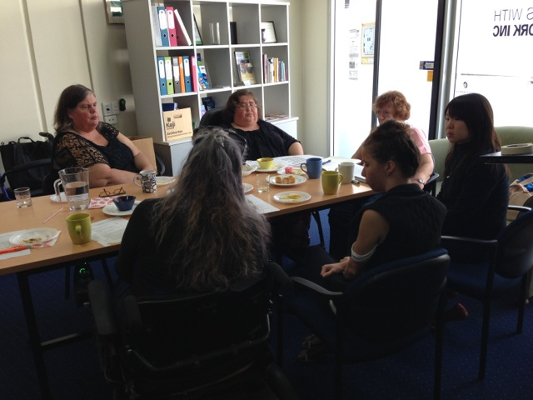

Taken from WWDA Disability Employment Services (DES) Consumer Engagement Project, Background Briefing Note, March 2014
From WWDA Website, see www.wwda.org.au
Opcit
Ibid
For more information, see QDN’s website: www.qdn.org.au.
Opcit
This point was seen as highly important by all forum participants.
This point was seen as highly important by all forum participants.

