‘BUILDING ON THE MILLENNIUM DEVELOPMENT GOALS FOR WOMEN AND GIRLS WITH DISABILITIES – A LONG WAY TO GO’
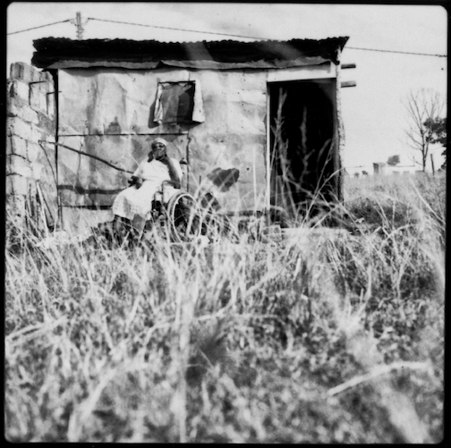

Presentation for the Parallel Event ‘Disability and Inclusion’ at the 58th session of the United Nations Commission on the Status of Women (CSW)

© Written by Carolyn Frohmader and Margie Charlesworth

12th March 2014, Guild Hall of the Armenian Convention, New York

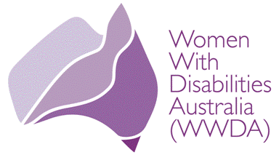 | 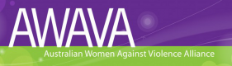 | 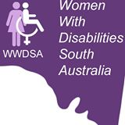 | 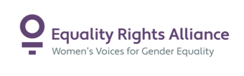

Introduction
The eight Millennium Development Goals (MDGs), established in the Millennium Declaration, were approved by 191 Heads of State and Presidents at the General Assembly of the United Nations in the year 2000. They pledged to adopt new measures and join efforts in the fight against poverty, illiteracy, hunger, lack of education, gender inequality, infant and maternal mortality, disease and environmental degradation. A series of discussions and consultations are now underway to shape a new development agenda to succeed the Millennium Development Goals (MDGs) when they expire in 2015. The debates have so far been led by the United Nations, with the active participation of many other development actors, including governments, civil society, international institutions and the private sector. At the same time, governments have been working to agree on a set of Sustainable Development Goals (SDGs), which was mandated by the Rio+20 conference in 2012. The outcomes of this debate will intersect with the Post-2015 agenda in defining a future path for sustainable development, building on environmental, social and economic issues as the three main pillars of the new global development framework.

This brief presentation will highlight some of the key shortcomings of the MDG’s as they relate to women and girls with disabilities. It will also canvass the main principles that women with disabilities argue must be embedded in the Post 15 Development Agenda, in order to ensure that the new global development framework is inclusive of, and responsive to, women and girls with disabilities all over world.

The Millennium Development Goals and Women with Disabilities
Approximately 15% of the world’s population (one billion persons) lives with some form of disability. There are significant differences in the prevalence of disability between men and women in both developing and more developed countries: the male disability prevalence rate is 12% while the female disability prevalence rate is 19.2%. However, a detailed global picture on how gender and disability intersect is not yet possible as data collection and research has been extremely limited. We do know of course, that disability is not restricted to any one social or economic group, culture or age group. We also know that disability is both a cause and a consequence of poverty, with women and children with disabilities over-represented amongst the world’s poor.

It has been widely acknowledged that the achievement of the Millennium Development Goals (MDG’s) has been disparate and uneven across and within regions and countries. It is the poorest and those most marginalised and discriminated against on the basis of, gender, disability, age and ethnicity who have seen the least progress. Extreme poverty, hunger and under-nutrition, particularly amongst children, remain the most critical of global challenges. Despite the fact that some progress has been made towards greater gender equality, women remain profoundly disadvantaged in many fields, particularly in terms of access to sexual and reproductive health care, decision-making, productive employment opportunities, and productive resources. One of the biggest obstacles to progress on the achievement of all the MDG’s, is the plague of violence against women and girls, including conflict-related sexual violence. In addition to inequalities between men and women, inequalities that exist among women, including on the basis of disability, have also served as obstacles to the realisation of the MDG’s.

Whilst the MDGs have been an important tool for sustaining global attention and galvanising international support to promote development, they have had definite shortcomings for women, particularly women with disabilities and women from other marginalised and disadvantaged groups. For example, Goal 3, which specifically calls for the promotion of gender equality and women's empowerment, does not recognise that gender equality is not just an objective by itself but is also critical to achieving the other seven MDG’s. The MDGs do not take into account women's diversity: women with disabilities, indigenous women, and others - who generally belong to the poorest groups; have less access to health, education and other services, and are subject to multiple discriminations.

The MDGs exclude sexual and reproductive rights, yet international human rights norms recognise that reproductive rights are women’s rights, and clarify that violations of reproductive rights are primarily manifestations of discrimination, poverty, and violence. No group has ever been as severely restricted, or negatively treated, in respect of their reproductive rights, as women with disabilities. The omission of sexual and reproductive rights from the MDG’s has had profound implications for women and girls with disabilities, who continue to be subjected to multiple and extreme violations of their sexual and reproductive rights, through practices such as forced sterilisation, forced contraception, forced abortion, and termination of parental rights, just to name a few. Women with disabilities also experience systemic exclusion from sexual and reproductive health care services. These practices and violations are framed within traditional social attitudes and entrenched disability-based and gender-based stereotypes that continue to characterise disability as a personal tragedy, a burden and/or a matter for medical management and rehabilitation.

The MDGs do not integrate the principle that human rights are indivisible, integral and interrelated. For example, economic empowerment of women with disabilities without ensuring their reproductive rights and freedom from violence does not allow for the full exercise of their human rights or full citizenship. It is not possible, for example, to think about promoting education for girls and women with disabilities if at the same time they cannot access school due to lack of transport, or inaccessible venues, or the fact that they are expected to look after younger siblings and complete household chores; or if the are sent out into the streets to work as beggars to generate income for their families. We know for example that, in developing countries very few disabled girls attend school. We also know that because there has been little consideration put towards educating girls and women with disabilities, their prospects for meaningful long-term employment are few. Regardless of country, the employment rates of women with disabilities are significantly lower than those of their male peers. Worldwide, less than 25 per cent of women with disabilities are in the workforce. When women with disabilities do find employment, it is likely to be in low skilled, low paid jobs which have little or no opportunity for promotion; and they are usually the first to be fired when there are job cuts. Women with disabilities earn less than their male counterparts, and in countries where social welfare is available, women with disabilities often receive fewer entitlements in comparison to men with disabilities. However, in developing countries, many women with disabilities have no income at all and are totally dependent on others for their very existence. Neglect, lack of medical care and less access to food or related resources have resulted in a higher mortality rate for girls with disabilities. In the face of limited resources, disabled girls are more likely than their male counterparts to be deprived of basic necessities such as food and medicine.

The MDG’s have essentially failed many women and girls with disabilities, as they have not given due recognition of the structural determinants of gender inequality and discrimination.

The Rights of Women and Girls with Disabilities in the Future Development Agenda
In December 2012, the UN General Assembly reiterated that the full, effective and accelerated implementation of the Beijing Declaration and Platform for Action and the outcome of the twenty-third special session of the General Assembly are essential to achieving internationally agreed development goals. In this regard, the Assembly called for the goal of gender equality and the empowerment of women to feature prominently in the discussions of the post-2015 development framework, bearing in mind the importance of mainstreaming a gender perspective.

On 23rd September 2013, Heads of State and Government gathered at a high level meeting of the UN General Assembly, to reaffirm the need for a disability-inclusive development agenda towards 2015 and beyond. The Outcomes Document from the meeting, adopted by the General Assembly, specifically reaffirms the need for the emerging Post-2015 Development agenda to recognise persons with disabilities as agents and beneficiaries of development, acknowledging the value of their contribution to the general well-being, progress and diversity of society. It calls on the international community to include disability as a cross-cutting issue in the global development agenda, and makes specific recommendations regarding the need for strengthening efforts to address the rights and needs of women and children with disabilities in this context.

Clearly then, in order to address the widespread and deeply rooted inequalities experienced by women and girls with disabilities the world over, including the pervasive human rights violations they experience, disability and gender must be mainstreamed as cross-cutting issues throughout the whole future development agenda. The post-2015 development framework must therefore incorporate the following elements.

The new post-2015 development agenda and framework must be universal, as agreed by all Member States in the Outcome Document of the Special Event on post-2015 during the General Assembly in September 2013. There should be a single, coherent, universal framework which applies to all countries. As highlighted by the global civil society Beyond2015 campaign, the framework must endorse a new agenda that recognises shared global challenges and includes obligations, ownership and accountability of all relevant actors, including the private sector. The goals must be global and universally resonant, with universally-applicable targets.

The new development framework must be grounded in the universal human rights framework. Any new framework of goals, targets and indicators must fully reflect the fundamental human rights principles of universality, indivisibility, equality, non-discrimination, participation, transparency and accountability. It must also clearly state that existing international law and human rights norms, standards and commitments set the baseline for the new agenda and each focus area. Recognising that the respect, protection and fulfilment of all human rights should be both the purpose and the ultimate litmus test of success for the Post 2015 development agenda.

The new development agenda must prioritise and contain a transformative, standalone goal on eliminating and addressing all forms of violence. It is undisputed that violence, in all its forms, is the most pervasive human rights abuse in the world today, happens in all countries, is the biggest impediment to development and has been the over-arching major obstacle to progress on the achievement of all the MDG’s. No other goals and targets in the future development agenda framework can possibly be achieved without prioritising the elimination of all forms of violence. This is particularly critical for women and girls with disabilities. Although women and girls with disabilities experience many of the same forms of violence that all women experience, when gender and disability intersect, violence has unique causes, takes on unique forms and results in unique consequences. Women and girls with disabilities also experience forms of violence that are particular to their situation of social disadvantage, cultural devaluation and increased dependency on others. Compared to non-disabled women, women with disabilities experience violence at significantly higher rates, more frequently, for longer, in more ways, and by more perpetrators, yet legislative responses, programs and services for this group either do not exist, are extremely limited, or simply just exclude them. Whilst it is recognised that violence, in all its forms, disproportionally affects women and girls, is one of the most telling signs of gender-based inequalities in society, and remains the most egregious violation of women and girls’ human rights, there is a risk that linking violence only to gender equality goals, may in fact, minimise the imperative for the elimination of violence throughout and across the Post 2015 development agenda.

The new development agenda must prioritise and contain a standalone goal on equality and non-discrimination. Given the undisputed fact that it is those most marginalised and discriminated against (on the basis of, gender, disability, age and ethnicity) who have seen little benefit from the MDG’s to date, the post-2015 development agenda must make equality and non-discrimination a priority. Clearly, for women and girls with disabilities, this includes the need to ensure that disability and gender specific targets and indicators are embedded throughout the new development framework. The new framework must reflect the range of measures states are already obliged to take to ensure the equal enjoyment of human rights by people with disabilities, women, indigenous people and others facing systemic discrimination.

The new development agenda must prioritise and contain a standalone goal on gender equality with gender-sensitive and gender-disaggregated indicators mainstreamed across and throughout the new development framework. Women the world over have largely failed to benefit from the MDG’s, in fact, they have been heavily impacted by the global crises that have arisen or intensified since the establishment of the MDGs, including the global financial and economic crisis, climate change, the food and fuel crises, and the increasing rates of violence perpetrated against them. A standalone goal on gender equality must be transformative and address the structural determinants of gender inequality in the economic, social, political, and environmental realms. Without a dedicated focus on gender equality in the new development framework, the risk is that gender-based differences in power and resources that block the realisation of women’s rights are rendered invisible and the structural causes of discrimination on the basis of gender remain unaddressed.

Effective civil society inclusion and participation is not only a human rights imperative, but will be critical to the success of the Post 2015 development processes and framework. The participation of women with disabilities in all areas of public and community life has been and remains woefully inadequate. Women and girls with disabilities must be meaningfully involved in all decision-making processes of the new development agenda and frameworks. Critically, the role of civil society organisations of women and girls with disabilities, is vital in this process. They must be empowered with sufficient resources (including financial), capacity building, training and opportunities to enable them to effectively and meaningfully participate and engage in, the development agenda and framework. Women with disabilities must be viewed as agents of development in their own right.

The new development agenda must ensure that accountability and good governance is built into all facets of the Post 2015 development framework. Any new global review mechanism for post-2015 development commitments should explicitly refer to international human rights treaty standards, and should ensure rigorous independent review, effective civil society participation and high-level political accountability. In turn, international human rights mechanisms should be strengthened, and should take more consistent and explicit account of monitoring and reporting processes for new global development goals. The data generated by the review mechanisms for post-2015 global development goals should feed systematically into international human rights review and reporting processes.

Contact Information
Women With Disabilities Australia  (WWDA)  Web: www.wwda.org.au  Facebook: www.facebook.com/WWDA.Australia  Executive Director: Carolyn Frohmader | Women With Disabilities Australia (WWDA) is the peak non-government organisation (NGO) for women with all types of disabilities in Australia. WWDA is run by women with disabilities, for women with disabilities, and represents more than 2 million disabled women in Australia. WWDA’s work is grounded in a rights based framework which links gender and disability issues to a full range of civil, political, economic, social and cultural rights.

Women With Disabilities South Australia (WWDSA)  Facebook: https://www.facebook.com/pages/Women-With-Disabilities-South-Australia/190331824319014  Convenor: Margie Charlesworth | Women With Disabilities South Australia (WWDSA) is a new organisation formed on 16 October 2010. It represents women with disabilities in the state of South Australia. It is run by women with disabilities, for women with disabilities.

Australian Women Against Violence Alliance (AWAVA)  Web: http://awava.org.au  Facebook: https://www.facebook.com/AWAVAaustralia  Chairperson: Julie Oberin | The Australian Women Against Violence Alliance (AWAVA) was established in March 2010 as one of six National Women’s Alliances funded by the Australian Government. AWAVA’s focus is addressing all forms violence against women, to ‘ensure that all women and children are able to live free from all forms of violence and abuse’.

Equality Rights Alliance (ERA)  Web: http://www.equalityrightsalliance.org.au/  Facebook: https://www.facebook.com/equalityrightsalliance  Manager: Helen Dalley-Fisher | The Equality Rights Alliance is one of six National Women’s Alliances funded by the Australian Government. ERA’s members are non-government organisations and social enterprises with a focus on the impact of policy or service delivery on women. ERA is Australia’s largest network of women’s advocates.

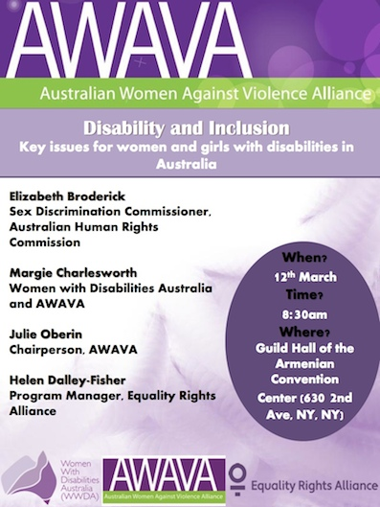

Association for Women’s Rights in Development (2014) Special Focus: Post 2015 Development Agenda. Accessed February 2014 at: http://www.awid.org/News-Analysis/Special-Focus-Post-2015-Development-Agenda
WHO and the World Bank (2011) World report on disability. Geneva. Available at: http://www.who.int/disabilities/world_report/2011/en/index.html United Nations, Some Facts about Persons with Disabilities. Accessed online October 2009 at: http://un.org/disabilities/convention/facts.shtml
Ibid.
The World Bank (26 January 2010), Poverty and Disability. Available at: http://go.worldbank.org/IMVL0SHUT0
UN General Assembly (2012) Accelerating progress towards the Millennium Development Goals: options for sustained and inclusive growth and issues for advancing the United Nations development agenda beyond 2015. Annual report of the Secretary-General. UN. Doc. No. A/67/257
Ibid.
Commission on the Status of Women (2013) Emerging issues, trends and new approaches to issues affecting the situation of women or equality between women and men; “Key gender equality issues to be reflected in the post-2015 development framework”; Issues Paper.
Frohmader, C. and Ortoleva, S. (July 2013) The Sexual and Reproductive Rights of Women and Girls with Disabilities; Issues Paper commissioned by the ICPD International Conference on Human Rights, The Hague, July 2013. Available at: http://www.wwda.org.au/issues_paper_srr_women_and_girls_with_disabilities_final.pdf See also: Association for Women’s Rights in Development (2008) Women And The Millennium Development Goals; Accessed February 2014 at: http://www.awid.org/Library/Women-and-the-Millennium-Development-Goals
Centre for Reproductive Rights (2014) ‘Substantive Equality and Reproductive Rights’. Centre for Reproductive Rights, New York.
Manjoo, Rashida (2012) Report of the Special Rapporteur on violence against women, its causes and consequences; UN General Assembly; UN Doc. A/67/227.
Frohmader, C. (2013) ‘Dehumanised: The Forced Sterilisation of Women and Girls with Disabilities in Australia’. Women with Disabilities Australia (WWDA), Rosny Park, Australia. At: http://www.wwda.org.au/WWDA_Sub_SenateInquiry_Sterilisation_March2013.pdf See also: Ortoleva, S. & Lewis, H. (2012) ‘Forgotten Sisters- A Report on Violence Against Women with Disabilities: An Overview of its Nature, Scope, Causes and Consequences’; Northeastern University School of Law Research Paper No. 104-2012. At: http://ssrn.com/abstract=2133332
In Frohmader, C. & Meekosha, H. (2012) ‘Recognition, respect and rights: Women with disabilities in a globalised world.’ In Disability and Social Theory, Edited by Dan Goodley, Bill Hughes and Lennard Davis, London: Palgrave Macmillan.
Women With Disabilities Australia (WWDA) (2008) Submission to the Parliamentary Inquiry into pay equity and associated issues related to increasing female participation in the workforce. WWDA, Tasmania. Available online at: http://www.wwda.org.au/subs2006.htm
United Nations 2011, Disability and the Millennium Development Goal Effort: “A Review of the Millennium Development Goal Process and Strategies of Inclusion of Disability Issue in the Millennium Development Goal Effort. New York.
Frohmader, C. and Meekosha, H. (2012) Op Cit.
United Nations, The Beijing Declaration and the Platform for Action: Fourth World Conference on Women, Beijing, China, 4-15 September 1995; A/CONF.177/20/Add.1.
UN General Assembly (2000) Further actions and initiatives to implement the Beijing Declaration and Platform for Action. Resolution adopted by the General Assembly: S-23/3.A/RES/S-23/3 [para.27].
UN General Assembly (2013) Follow-up to the Fourth World Conference on Women and full implementation of the Beijing Declaration and Platform for Action and the outcome of the twenty-third special session of the General Assembly. UN.Doc. A/RES/67/148.
Beyond 2015, Beyond 2015's reaction to the Open Working Group's 'Focus Areas Document'. Accessed online March 2014 at: http://www.beyond2015.org/sites/default/files/Beyond%202015%20reaction%20to%20the%20Open%20Working%20Group%20final%203%20March%202014.pdf
Center for Economic and Social Rights (CESR)(2013) High Level Panel recommendations fall short of the human rights litmus test. Available at: http://cesr.org/downloads/cesr_hlp_statement.pdf
UN General Assembly (2012) UN. Doc. No. A/67/257 OpCit.
Frohmader, C. (2014) Submission to the National Inquiry into Equal Recognition Before the Law and Legal Capacity for People With Disability. Prepared for Women With Disabilities Australia (WWDA); Rosny Park. Available online at: http://wwda.org.au/wp-content/uploads/2013/12/WWDA_SUB_ALRC_IP44.pdf
UN Women (June 2013) A Transformative Stand-Alone Goal on Achieving Gender Equality, Women’s Rights and Women’s Empowerment: Imperatives and Key Components. In the context of the Post-2015 Development Framework and Sustainable Development Goals. Available online at: http://www.unwomen.org/2013/06/un-women-launches-global-call-for-a-transformative-agenda-to-make-womens-rights-a-reality/

