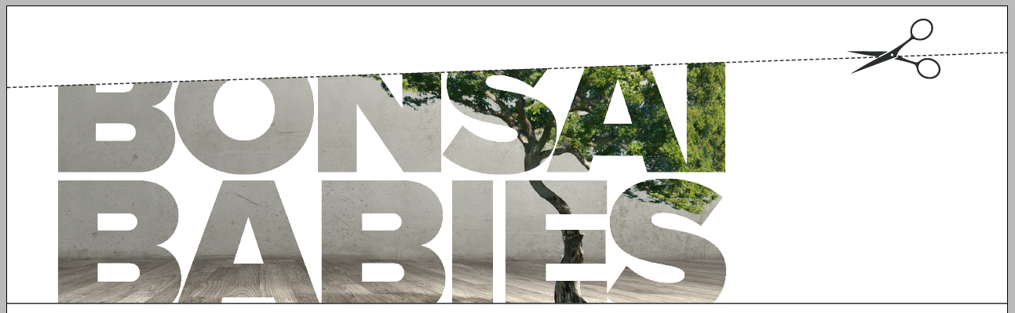

**“BONSAI BABIES”**

**OPINION**

**Cheryl McDonnell**

**22 June 2016**

*In June 2016, SBS Television aired a program which focused on growth attenuation therapy (GAT) - the deliberate stunting of children with disability*[1] *In this opinion piece, Women with Disabilities Australia (WWDA) member, Cheryl McDonnell, writes about ‘The Ashley Treatment’ and its failure to respect even the most fundamental of human rights.*

Many people would agree that small children are cute. Sometimes they might even inspire a faint wish in their parents’ minds to keep them small and cute forever; a whimsical thought that can creep into the minds of adoring parents when their little prince or princess does that little something extra cute. For most parents, it is a just a fleeting thought - one that quickly disappears into the busyness of the day.

For some children this wistful thought stays in the mind of their parents and becomes entangled in a web of worries and conflict. Sometimes these parents may cling to these thought tangles because their child has a disability and they just want what is best for their child now, and into the future.

Some parents become increasingly convinced that they are the only one who can or will care for their child properly. They may start to believe that the only way that can happen is for the child to stay small and manageable. Parents’ desire to be in charge and in control of every detail of their child’s life grows stronger. They might seek medical advice.

At this point that the tangled thought processes of the parent should be addressed. It is at this point that the human rights of the child should be paramount, and mostly, this is what happens. The doctor listens to the parent talk about all of the issues they are facing, gently acknowledges the difficulties. They may refer the parents to additional supports for both the child and themselves. But sometimes, this doesn’t happen. Instead of being referred to further support, the parents are presented with information on growth attenuation or ‘The Ashley Treatment’ – a series of invasive medical interventions that will stop the child’s body from developing further; a process that will in effect, bonsai the child.

Ashley, the first documented child subjected to what is now referred to by the misnomer ‘The Ashley Treatment’ has undergone a series of unnecessary and irreversible radical medical interventions and surgeries including administration of high doses of oestrogen; hysterectomy; breast bud removal; and, appendectomy. These interventions are not treatments. A treatment would imply that there is a medical necessity for the interventions.

This series of interventions has rendered Ashley with a permanent child-like body instead of the body of a full grown woman as should be the case for a woman who is now approaching 20 years of age. A doctor involved in this case is quoted as saying that this gives Ashley a body more appropriate to her cognitive abilities. The absent factor in the public blog produced by Ashley’s parents is the factor of Ashley’s inalienable right to the integrity of her body and mind.

Repeatedly, Ashley’s parents refer to Ashley as having a mind of a three-month-old baby.[2] The one point that they have not addressed is that Ashley has 19 years of experience of life. Ashley will continue to develop life experience and awareness. In describing their daughter, the parents declare that she laughs and smiles at familiar voices and when they visit her room. Later, during their justifications for the ‘Ashley Treatment’ the same parents declare they are not sure that Ashley recognises them. It seems they cannot agree with themselves about Ashley’s level of awareness and cognition.

No human being is static. Despite the best of efforts of Ashley’s parents and the doctors involved to maintain Ashley’s body in a static stage of development they have not achieved a static rate of development for Ashley’s life experience.

Ashley’s parents refer to their daughter as a ‘Pillow Angel’ a dehumanising phrase that does not give Ashley the dignity of a living human being, but rather, alludes to a being that has already died and become an ‘angel’.

Children with disability, made vulnerable by the dehumanising language used about disability in general and about them in particular, are consistently subject to attitudes in society that vary between ‘the most pitiable of pitiable’ to ‘mystical & mythical’ and from ‘a curse from the devil’ to a ‘gift from god.’ The use of this language creates a chasm of difference between children with disability and the general population; it dehumanises children with disability and implies that rules, rights, ethics, and laws are somehow not applicable.

Parents of children with disability can also be subject to patronising and dehumanising language. Words and phrases such as ‘super-mum’, ‘God’s special mother’, ‘heroic’, and ‘amazing’, and, ‘incredible’, falsely inflate the image of parents of children with disability, giving them an almost godlike status. In reality, parents of children with disability are just people, like all other people. Like all parents, parents of children with disability vary from ‘good and dedicated’ to ‘abusive’.

The use of such superlative language to describe parents of children with disability is employed by the rest of the community to relieve themselves of any responsibility to those same children. By creating this image of uber-human parents as the ones with children who have a disability, the rest of the community can be rest assured that they need do nothing to help, aid or assist these children because they themselves are not ‘fantastic’, ‘amazing’ or ‘incredible’. But this is a cop out. It is not a compliment; it is a con job. A con job people use to excuse themselves from having to bother doing anything except maybe throw a few dollars in a tin.

Parents of children with disabilities are an assorted bunch of people from all walks of life and all manner of interests and abilities. Some of them are particularly skilled at what they do, and some are not, but they are just people, just like you. Parents of children with disabilities are worn out, tired, and usually aged beyond their years, not because they are the parent of a child with disabilities but because society has so skilfully excused itself from the actual work involved in supporting people with disability. With the incoming National Disability Insurance Scheme (NDIS) this might begin to change, but there is an increased need for people to be trained as support workers, and enter the disability industry to work with the people who have disability to support them meet their potential. The NDIS National Disability Insurance Scheme is one answer, and it needs to be rolled out in full across Australia to benefit everyone with disability.

The simple test to understand whether ‘The Ashley Treatment’ would be an appropriate treatment or not for a child with a disability is to first ask: “Would you do this to a child who did not have disabilities?”. Of course, the answer of course is a resounding “No!”.

The United Nations Convention on the Rights of Persons with Disabilities (CRPD)[3] is clear about the rights of persons with disabilities having a right to physical and mental integrity. In Article 17 it states:

*Every person with disabilities has a right to respect for his or her physical and mental integrity on an equal basis with others.*

Further the UNCRPD deals specifically with the issue of fertility at Article 23 : "Persons with disabilities, including children, retain their fertility on an equal basis with others".In Article 25 we read more about the responsibilities of government when it comes to the health of persons with disabilities. In particular,

*States Parties recognize that persons with disabilities have the right to the enjoyment of the highest attainable standard of health without discrimination on the basis of disability. States Parties shall take all appropriate measures to ensure access for persons with disabilities to health services that are gender-sensitive, including health-related rehabilitation.*

From a human rights perspective, it is clear that the series of medical interventions applied in growth attenuation and the processes that make up what is referred to as the “Ashley Treatment”, including forced sterilisation, are fundamental breaches of the rights of the child.

Frohmader[4] explores this point further:

*The right to be free from torture is one of the few absolute and non-derogable human rights, a matter of jus cogens, a peremptory norm of customary international law, and as such is binding on all States, irrespective of whether they have ratified specific treaties.*

*A State cannot justify its non-compliance with the absolute prohibition of torture, under any circumstances. The UN Special Rapporteur on Torture has recently clarified: “Forced interventions [including involuntary sterilization], often wrongfully justified by theories of incapacity and therapeutic necessity inconsistent with the Convention on the Rights of Persons with Disabilities, are legitimised under national laws, and may enjoy wide public support as being in the alleged “best interest” of the person concerned. Nevertheless, to the extent that they inflict severe pain and suffering, they violate the absolute prohibition of torture and cruel, inhuman and degrading treatment.*

Here we are not discussing the medical slowing of growth of a child that has a condition which causes extreme growth with adverse medical effects. We are discussing applying growth attenuation to a child who has no need of such medical intervention, or in other words, a child who is expected to grow to average weight and size. The Ashley Treatment’ constitutes torture, clear and simple.

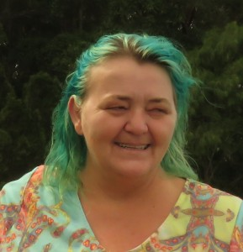**About the Author**

Cheryl McDonnell is a cross-sectional social justice activist and member of Women With Disabilities Australia (WWDA), People With Disabilities Australia (PWDA), and NSW Council of Social Services. She is a person with disabilities and the parent of people with disabilities. Cheryl enjoys gardening and the arts.

Follow Cheryl on Open Forum

http://www.openforum.com.au/blog/45082

©2016 Cheryl McDonnell.  
Published by Women With Disabilities Australia (WWDA).

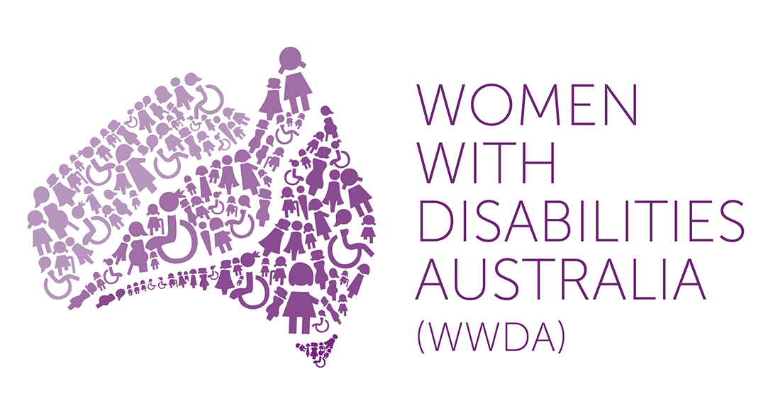

1. <http://www.sbs.com.au/news/dateline/article/2016/06/21/stunting-growth-disabled-children-ethical-debate>
2. [WWDA Submission To The Senate ee from torturethe child.d from developing fiurther accessible anhttp://pillowangel.org/](http://pillowangel.org/)
3. UN General Assembly, Convention on the Rights of Persons with Disabilities : resolution / adopted by the General Assembly, 24 January 2007, A/RES/61/106, available at: <http://www.un.org/disabilities/convention/conventionfull.shtml>
4. Frohmader, Carolyn. Dehumanised: The Forced Sterilisation Of Women And Girls With Disabilities In Australia, WWDA Submission To The Senate Inquiry Into The Involuntary Or Coerced Sterilisation Of People With Disabilities In Australia. Lenah Valley: Women With Disabilities Australia, 2013. Available: <http://wwda.org.au/wp-content/uploads/2013/12/WWDA_Sub_SenateInquiry_Sterilisation_March2013.pdf> [Accessed 22 June 2016].