12 October 2016

Senate Standing Committees on Community Affairs
PO Box 6100
Parliament House
Canberra ACT 2600
Email: community.affairs.sen@aph.gov.au
Dear Committee,
Re: National Disability Insurance Scheme Savings Fund Special Account Bill 2016
Disabled People’s Organisations Australia (DPO Australia) welcomes the opportunity to provide our views to the Senate Standing Committee on Community Affairs inquiry into the National Disability Insurance Scheme Savings Fund Special Account Bill 2016 (the Bill).

DPO Australia is an alliance of national disabled people’s organisations (DPOs), which are organisations constituted and governed by people with disability. Our key purpose is to promote, protect and advance the human rights and freedoms of people with disability by working collaboratively on areas of shared interests, purposes and strategic priorities and opportunities. DPO Australia is made up of First Peoples Disability Network Australia (FPDN); Women With Disabilities Australia (WWDA); National Ethnic Disability Alliance (NEDA) and People with Disability Australia (PWDA).

DPO Australia is funded by the Australian Government as the coordinating point between Government/s and other stakeholders, for consultation and engagement with people with disability.

The NDIS is one of the most significant social reforms ever undertaken in Australia. The NDIS Act 2013 gives effect to key obligations under the Convention on the Rights of Persons with Disabilities (CRPD) as well as the International Covenant on Civil and Political Rights (ICCPR), the International Covenant on Economic, Social and Cultural Rights (ICESCR), the Convention on the Rights of the Child (CRC), the Convention on the Elimination of All Forms of Discrimination Against Women (CEDAW) and the International Convention on the Elimination of All Forms of Racial Discrimination (ICERD).

The scheme rightly has bipartisan political support and the widespread backing of the Australian community, and we agree that it is essential that the NDIS is properly, adequately and sustainably funded. Whilst we welcome the Government’s commitment to ensuring that the NDIS is sustainably funded into the future, we have serious concerns with the proposed Bill which are outlined below.

DPO Australia does not support the NDIS Savings Fund Special Account Bill 2016.

Consultation with people with disability and their representative organisations
Article 4(3) of the CRPD stipulates that in developing and implementing laws and policies, and in decision-making processes affecting people with disability, that people with disability through their representative organisations should be closely consulted and actively involved.

No public consultation has been undertaken with people with disability or their representative organisations, about the need for additional Commonwealth savings for the NDIS or an approach to financially sustain the NDIS into the future that does not result in unnecessary trade-offs between disability support and social security.

This Bill was proposed by Government without consultation. We believe a rational and sensible approach to financial sustainability of the NDIS is in the context of broader discussions about the revenue, tax and spending mix of our nation. A range of options should be on the table to ensure that all who require financial support under the NDIS receive it. People with disability and their representative organisations should be central to this discussion.

Need for additional Special Account
The NDIS is resourced through existing Commonwealth disability funding, redirected State and Territory disability funding and the NDIS component of the Medicare levy credited to the DisabilityCare Australia Fund. The DisabilityCare Australia Fund was established as a Special Account to fund the NDIS, and we are unclear as to why an additional Special Account needs to be established. If additional funding for the NDIS needs to be sourced through alternate revenue measures, this funding could be channelled directly through the existing DisabilityCare Australia Fund.

Operation and structure of the proposed Fund
The NDIS is an independent scheme, run by the independent National Disability Insurance Agency (NDIA). The proposed Bill provides the Minister for Social Services with responsibility for the policy and management of the NDIS Savings Fund Special Account raising concerns about existing NDIS governance arrangements whereby intergovernmental agreements outline shared responsibility between Commonwealth and State and Territory governments and the NDIA board deliver and manage the NDIS. DPO Australia is very concerned that the proposed Bill undermines shared responsibility arrangements between jurisdictions and the neutrality and independence of the NDIA structure.
It also gives the Commonwealth Government significant control over identifying savings and distributing funds. This is highly likely to undermine funding stability as funding will be tied to the budget cycle and political debate.
The Bill proposes an upper limit to the NDIS Savings Fund Special Account, equivalent to the future value of the Commonwealth's NDIS commitment, with any funding over and above this upper limit being returned to consolidated revenue. This raises concern that without review and revision as the NDIS rolls out, the upper limit could potentially result in negative policy changes for funding participants, such as future capping of funds, means testing, or a narrowing of definition of ‘necessary and reasonable support’ in order to save costs.
In light of these concerns, the ten year review period proposed in this Bill is far too long to ensure that the savings fund actually meets objectives of the NDIS Act. There is no requirement for the report of the review to be tabled in both Houses of Parliament or be made public, raising concerns about transparency and accountability.
Unnecessary trade-off between disability support and social security
The Bill allows for government to, “over future budgets, to identify savings from existing programs and set aside those savings to assist in meeting the Commonwealth’s future financial commitments to the NDIS”.
This means that NDIS funding will be determined by the policy priorities of the government of the day, and highly likely to justify cuts and savings measures that target essential human services and welfare. It will result in trade-offs and false economies between disability support and social security support, and link NDIS funding to the budget cycle resulting in ongoing unease and angst about existing programs and services that may be cut in future, potentially creating resentment from the community and other stakeholders who may lose funding.

In the 2016/17 Federal Budget, a number of measures were proposed to shift funding to the NDIS, including removal of the Energy Supplement for new social security claimants, a review of 30,000 Disability Support Pension (DSP) recipients each year for three years and tightening backdating provisions for new Carer Allowance claims. These measures all have a negative impact on people with disability. For example, reviews of DSP recipients are already resulting in people with disability being shifted to the ‘below the poverty line’ Newstart Allowance, resulting in a loss of $175 per week. These people are now struggling to meet daily costs, including costs associated with disability, and are unable to participate in employment due persistent social barriers.

People with disability remain in the most vulnerable and marginalised situations in our community. The inefficient social safety net compounded by persistent inequity in social, educational and economic opportunity means that 45% of people with disability in Australia live in or near poverty. For people with disability, everyday life is more expensive, and the current rate of income support, including the DSP does not adequately compensate for the additional cost of disability. In addition, ongoing barriers to work have resulted in people with disability being reliant on income support when they would much rather have a job and be self-sufficient.

Income support and specialist disability support are different, but complementary, aspects of support for people with disability to be able to participate fully in the economic, social, cultural, civil and political life of Australia. Both income support and specialist disability support are critical measures to progress rights for people with disability as outlined in the CRPD. Creating trade-offs between income support and disability support is counter-productive, short-sighted and does not promote the human rights objectives of the NDIS. It is unconscionable to shift people on low incomes, including people with disability, further into poverty in order to create savings for the NDIS.
Other 2016/17 budget measures, such as the removal of the Energy Supplement for new social security claimants did not proceed after negotiations between the Government and the Opposition. While this averted another negative outcome for people with disability, it highlights the precarious situation of NDIS funding being linked to political priorities and the budget cycle.

DPO Australia thanks the Committee for the opportunity to contribute to this Inquiry, and we would welcome further consultation on any of the matters we have raised.
Yours sincerely
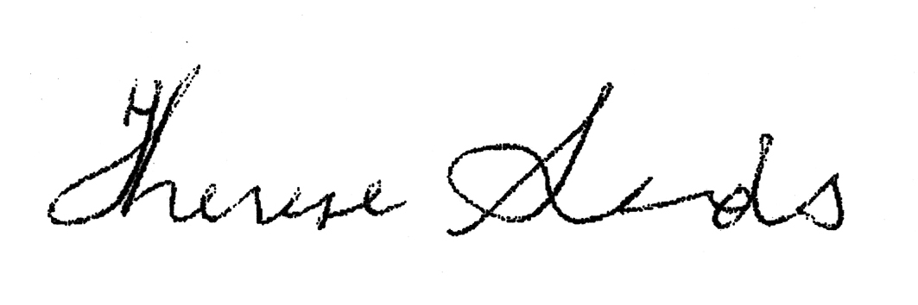
THERESE SANDS
Director

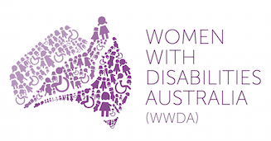 | 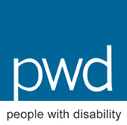

National Disability Insurance Scheme Act 2013, http://www.austlii.edu.au/au/legis/cth/consol_act/ndisa2013341/s3.html
Second Reading Speech for the National Disability Insurance Scheme Savings Fund Special Account Bill 2016, House of Representatives 16 March 2016
The Shut Out Report released in 2012 by the Department of Social Services comprehensively documented what life is like for people with disability in Australia. The report can be accessed here http://www.dss.gov.au/our-responsibilities/disability-and-carers/publications-articles/policy-research

