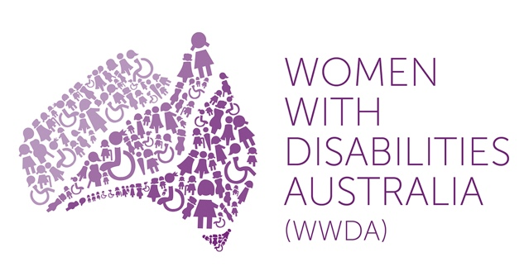 | 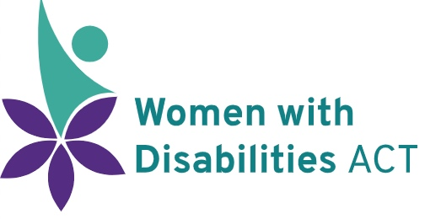
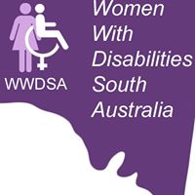 | 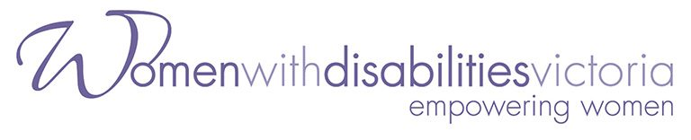

Productivity Commission

National Disability Agreement Review

Roundtable with Women with Disabilities 12th October 2018

Position Statement

25th October 2018

Publishing Information

Women With Disabilities Australia (WWDA), Women With Disabilities Victoria (WDV), Women With Disabilities Australian Capital Territory (WWDACT), and Women With Disabilities South Australia (WWDSA) (2018) Position Statement to the Productivity Commission for the Review of the National Disability Agreement. Prepared by Carolyn Frohmader, Women with Disabilities Australia (WWDA) for and on behalf of WWDA, WWDSA, WWDACT, and WDV.

© 2018 Women With Disabilities Australia (WWDA).
ABN: 23 627 650 121

Contributors

Carolyn Frohmader, Executive Director, Women With Disabilities Australia (WWDA)
E: carolyn@wwda.org.au

Sue Salthouse, Chair, Women With Disabilities Australian Capital Territory (WWDACT)
E: sudata@optusnet.com.au

Margie Charlesworth, Convenor, Women With Disabilities South Australia (WWDSA)
E: eigram1@optusnet.com.au

Leah Van Poppel, CEO, Women With Disabilities Victoria (WDV)
E: leah.vanpoppel@wdv.org.au

Amber Karanikolas, Policy Officer, Women With Disabilities Victoria (WDV)
E: Amber.Karanikolas@wdv.org.au

Acknowledgment

Our organisations acknowledge the traditional owners of the land on which this publication was produced. We acknowledge Aboriginal and Torres Strait Islander people’s deep spiritual connection to this land. We extend our respects to community members and Elders past, present and becoming.

Contact for this Position Statement

Carolyn Frohmader, Executive Director
Women With Disabilities Australia (WWDA)
Phone: +61 438 535 123
Email: carolyn@wwda.org.au

Disclaimer

The views and opinions expressed in this publication are those of Women With Disabilities Australia (WWDA), Women With Disabilities Victoria (WDV), Women With Disabilities Australian Capital Territory (WWDACT), and Women With Disabilities South Australia (WWDSA) and not necessarily those of our funding bodies. All possible care has been taken in the preparation of the information contained in this document. WWDA disclaims any liability for the accuracy and sufficiency of the information and under no circumstances shall be liable in negligence or otherwise in or arising out of the preparation or supply of any of the information aforesaid.

This work is copyright. Apart from any use as permitted under the Copyright Act 1968, no part may be reproduced without written permission from Women With Disabilities Australia (WWDA).

- Introduction

1.1. Women With Disabilities Australia (WWDA), Women With Disabilities Victoria (WDV), Women With Disabilities Australian Capital Territory (WWDACT), and Women With Disabilities South Australia (WWDSA) thank the Productivity Commission for the opportunity to contribute to the Commission’s National Disability Agreement Review, through the Teleconference Roundtable held with our organisations on Friday 12th October 2018.

1.2. Some of our organisations are providing a range of evidence-based documents as follow up to the Roundtable. However, this Position Statement has been developed collectively by our four organisations.

1.3. We submit this Position Statement to the Commission in order to provide a set of coherent, critical messages that we believe must be understood, and reflected in all aspects of the development and iteration of a new National Disability Agreement (NDA).

- Gender & Disability – A Brief Snapshot

  - Disability is a complex, dynamic and evolving concept. How disability is understood is shaped by a complex range of intersecting factors, including individual and social values, contexts, cultures, policy responses, and histories. Critically, contemporary understandings of people with disability now recognise disabled persons as holders of full and equal rights and freedoms, including the right to self-determination and self-representation.

  - Over two-million women and girls with disability live in Australia (20% of the population of women), including more than 100,000 girls with disability aged 0-14 and two million women with disability aged 15 and older.

  - Women with disability come from a range of backgrounds, lifestyles, beliefs and communities. They may be Aboriginal and Torres Strait Islander or come from culturally and linguistically diverse communities. They may have a faith, or not; be married, divorced, partnered, or single; gay, lesbian, bisexual, transgender or intersex; parents, guardians, carers, and friends. They may or may not be in paid work, or they could be engaged in education and training. Each of these contexts can affect how, when, why, and in what form a woman with disability accesses, receives and/or is denied, services and supports.

  - Australian society is permeated by gender differences and gender inequalities. The outcomes of public policy in Australia are not equal for men and women, and this is profoundly worse when we examine the gender inequalities between men and boys with disability and women and girls with disability.

  - Gender is a fundamental tenet in the development of public policy, including public policy affecting people with disability. Promoting gender equity has been a major policy drive of successive governments for more than 40 years. The additional inequity for women with disability arising from disability discrimination is tangible. Gender is one of the most important categories of social organisation, yet people with disability are often treated as asexual, genderless human beings as if unaffected by these acknowledged disparities. This is borne out in Australian disability legislative and policy frameworks - including the NDA - which consistently fail to apply a gender lens. Similarly, gender related policies, programs and services consistently fail to apply an appropriate disability lens. In the Australian context, most policy, program and service development proceeds as though there are a common set of issues – and that men and women, boys and girls, experience disability in the same way.

  - However, more than three decades of evidence - globally and domestically - categorically demonstrates that women and girls with disability face multiple and intersecting discrimination and are overwhelmingly more disadvantaged than men and boys with disability in similar circumstances. Recognising how different systems and structures of oppression intersect to shape the experiences of discrimination is essential to a comprehensive understanding of the complex and diverse effects it has in practice.

  - Intersectional discrimination recognises that women and girls with disability do not experience discrimination as members of a homogenous group but rather, as individuals with multidimensional layers of identities, statuses and life circumstances. Conceptualising intersectional discrimination in the context of disabled women and girls, means acknowledging the lived realities and experiences of the heightened disadvantage of women and girls with disability caused by multiple and intersecting forms of discrimination, which requires targeted and additional measures with respect to disaggregated data collection, consultation, participation, policymaking, enforceability of non-discrimination and provision of effective remedies.

  - Women and girls with disability have fewer opportunities, lower status and less power and influence than men and boys with disability. Women and girls with disability are frequently denied equal enjoyment of their rights and freedoms, in particular by virtue of the lesser status ascribed to them by tradition and custom, or as a result of overt or covert discrimination. They are often denied opportunities to develop their skills, confidence, agency and autonomy.

  - Limited opportunities for participation in all areas of public life in Australia contributes to a lack of awareness of their rights as equal members of society and reinforces negative stereotypes and discriminatory practices. For example: compared to non-disabled women, and disabled men, women and girls with disability experience significantly higher levels of all forms of violence (including particularly egregious forms of violence) more intensely and frequently and are subjected to violence by a greater number of perpetrators. Their experiences of violence last longer, more severe injuries result, and they have considerably fewer pathways to safety.

  - Although the prohibition of discrimination and the promotion of equality are principles enshrined in Australian legislative and policy and frameworks to advance the rights of people with disability, and to end all forms of discrimination against women - women and girls with disability in Australia have failed to be afforded, or benefit from, these provisions. Instead, they continue to represent one of the most excluded groups in Australia, subject to widespread discrimination, systemic prejudice, paternalistic and ableist attitudes that denigrate, devalue, oppress, limit and deny their potential and their rights and freedoms. They are often not afforded dignity, recognition, respect, agency and/or autonomy. Because they are much less ‘visible’ than men with disability in public roles, women with disability lack opportunities to articulate their exclusion, rendering them, and their concerns, invisible in broader society.

  - The voices of women and girls with disability have historically been silenced and they remain disproportionately underrepresented in all forms of public decision-making. Regrettably, in contemporary Australia, it remains commonplace for women and girls with disability to have their views ignored or disregarded in favour of ‘experts’, ‘professionals’, parents, guardians, and carers, as well as representatives of organisations not controlled and constituted by women with disability themselves.

- Gender & Disability in the new National Disability Agreement

3.1. Gender equality must be embedded as a key principle underpinning the NDA and any strategic policy priority areas for reform.

3.2. The focus and emphasis of the new NDA must be on ‘people with disability’ and their rights to self-determination, agency, autonomy, choice and control.

3.3. Participation of women and girls with disability as citizens is at the basis of the recognition of their dignity. A fundamental prerequisite for disabled women and girls to fully participate in all aspects of civil, political, economic, social and cultural life is the freedom to exercise agency - the freedom to make decisions for themselves about issues that affect their lives and those of their families, communities and nations.

3.4. Women and girls with disability are best positioned to identify and determine their own rights, needs, will and preferences and to make decisions concerning their circumstances and conditions. The active, informed, relevant and meaningful participation of women and girls with disability must be central to any and all ongoing work to develop the new NDA.

3.5. Women and girls with disability must be clearly identified in the new NDA as a specific cohort in order to address the undisputed and persistent gender inequalities and to oblige national, state and territory governments to take positive actions and targeted, extra measures to ensure that disabled women and girls can realise their rights and freedoms on an equal basis as others.

3.6. In identifying women and girls with disability as a specific population cohort, the new NDA must oblige national and state/territory governments to employ targeted measures to address the following urgent gaps and issues where the National Disability Strategy (NDS) (and other national and state/territory policy frameworks) have failed women and girls with disability. These areas include:
- the right to freedom from violence, abuse, exploitation and neglect;
- the right to sexual and reproductive freedom, including the right to found and maintain a family;
- the right to work and to economic security;
- the right to access to justice, legal capacity and equality before the law;
- the right to decision-making, participation and representation.

3.7. Gender statistics, gender disaggregated data and the collection of specific information on the situation of women and girls with disability must be built into all aspects of the new NDA, including monitoring, review and evaluation mechanisms and should include both quantitative and qualitative approaches and measures.

3.8. The new NDA must separate the terminology of “people with disability and their carers” (and/or “people with disability and their families”), to “people with disability” - in order to increase the autonomy of people with disability and challenge the prevailing stereotype of people with disability as dependent and burdens of care.

3.9. Women and girls with disability matter. Gender matters. Gender equality matters. Our organisations strongly encourage the Productivity Commission to ensure that gender is firmly embedded in all aspects of the new NDA.

- Endnotes

See: http://wwda.org.au/
See: https://www.wdv.org.au/
See: https://www.wwdact.org.au/
See: https://www.facebook.com/Women-With-Disabilities-South-Australia-190331824319014/
See: Australian Bureau of Statistics (2011) Disability, Australia, 2009, Cat. No. 4446.0. Accessed online July 2014 at: http://www.abs.gov.au/ausstats/abs@.nsf/mf/4446.0
See: http://wwda.org.au/about/snapshot/
Australian Human Rights Commission, (2018) ‘Face the Facts: Gender Equality 2018.’ https://www.humanrights.gov.au/sites/default/files/2018_Face_the_Facts_Gender_Equality.pdf
Frohmader, C. (2014) ‘Gender Blind, Gender Neutral’: The effectiveness of the National Disability Strategy in improving the lives of women and girls with disabilities. Prepared for Women With Disabilities Australia (WWDA), Hobart, Tasmania. ISBN: 978-0-9585268-2-1, Available at: http://wwda.org.au/wp-content/uploads/2013/12/WWDA_Sub_NDS_Review2014.pdf
Committee on the Rights of Persons with Disabilities, General comment No. 3 (2016) Article 6: Women and girls with disabilities. UN Doc. No. CRPD/C/GC/3.
See for example: UN Committee on Economic, Social and Cultural Rights (CESCR), General Comment No. 16: The Equal Right of Men and Women to the Enjoyment of All Economic, Social and Cultural Rights (Art. 3 of the Covenant), 11 August 2005, E/C.12/2005/4.
Frohmader, C. (2014), OpCit.
The influence of ableism is poorly recognised in Australia, but is a term used to capture the way that the construction of social systems with able-bodied people as the norm results in the systemic, structural, intersecting and individual forms of discrimination against and exclusion of people with disabilities. People with disability, by virtue of the exceptional status of falling away from this norm, are often treated as less than fully human. See for example: Campbell, F.K. (2011) Stalking ableism: using disability to expose 'abled' narcissism, in D. Goodley, B. Hughes & L. Davis (eds), Disability and social theory: New developments and directions, Bashingstoke: Palgrave Macmillan.
WWDA (2015) Ableism. Draft Paper for the National Framework to Prevent Violence Against Women and their Children, Our Watch.
Frohmader, C. (2013) ‘Dehumanised: The Forced Sterilisation of Women and Girls with Disabilities in Australia’. Women with Disabilities Australia (WWDA), Rosny Park, Australia.
United Nations General Assembly (12 January 2016) Report of the Special Rapporteur on the rights of persons with disabilities. Human Rights Council, Thirty-first session. UN Doc. No. A/HRC/31/62.

