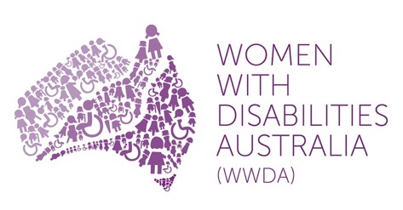

Women With Disabilities Australia (WWDA)

Report from the Women’s Human Rights Education Institute (WHRI)
Toronto, 8-19 August 2016
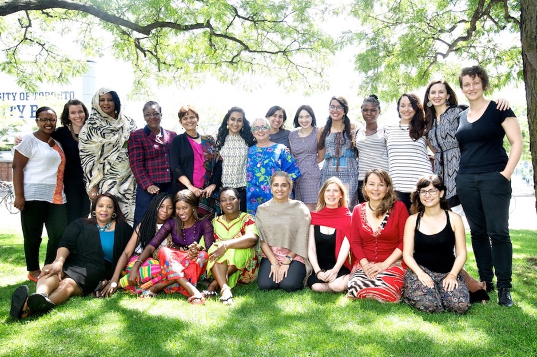

Report prepared by: Cashelle Dunn, WWDA Project Officer and WWDA Youth Network Manager
Participant of the WHRI Intensive Program 2016

Publishing Information

Dunn, C. (2016) ‘Report from the Women’s Human Rights Education Institute (WHRI), Toronto, 8-19 August 2016'. Women with Disabilities Australia (WWDA): Hobart, Australia.
Report prepared by Cashelle Dunn for Women with Disabilities Australia (WWDA) following participation in WHRI Intensive Program 2016, Toronto, Canada.
WWDA's attendance at the Women’s Human Rights Education Institute (WHRI) Intensive Program and the development of this report was partly funded by the Australian Government through the Australian Office for Women.
WWDA acknowledges the traditional owners of the land on which this publication was produced. We acknowledge Aboriginal and Torres Strait Islander people’s deep spiritual connection to this land. We extend our respects to community members and Elders past, present and becoming.
This work is copyright. Apart from any use as permitted under the Copyright Act 1968, no part may be reproduced without written permission from Women With Disabilities Australia (WWDA). All possible care has been taken in the preparation of the information contained in this document. WWDA disclaims any liability for the accuracy and sufficiency of the information and under no circumstances shall be liable in negligence or otherwise in or arising out of the preparation or supply of any of the information aforesaid.
© 2016 Women With Disabilities Australia (WWDA).

Acknowledgements

It was a fortunate and educational opportunity I had to participate in the prestigious Women’s Human Rights Education Institute (WHRI) Intensive Program, and as part of the program attend classes in Toronto, Canada from 8th to 19th August 2016. I would like to acknowledge and thank all those in helped make it possible to participate, including those who supported me through social media, and those who supported me out of public view. It truly was illuminating and beneficial on both professional and personal levels, and I particularly want to thank the individuals who made it such a profoundly memorable experience:
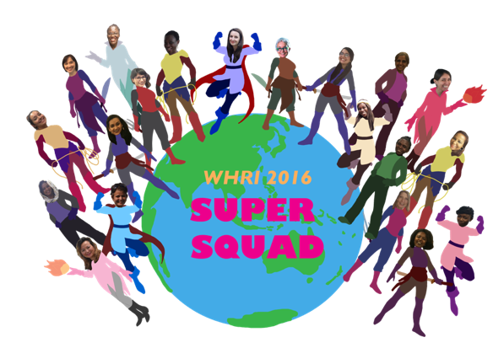

WHRI Founders and Staff (particularly: Alda Facio, Angela Miles, Angela Lytle, Heather Evans, Sarah Anderson and Hala Zabaneh); and my fellow WHRI Intensive 2016 Participants (Lubna Ahmed, Matida Daffeh, Dwynette Dellena Eversely, Meskerem Geset Techane, Lydia Gonzalez, Abigail Edem Hunu, Tarnjit Kaur Johal, Bhavya Joshi, Samantha Letourneau, Winnie Muchuba, Sarah Nakiyimba, Renu Rajbhandari, Sabra Rezaei, Delores Robinson, Mariana Roca Cogordan, Khrista Trani Rivera, Elizabeth Zarpa).

Special thanks go to:
- Board and members of Women With Disabilities Australia (WWDA) – for your assistance, trust and respect;
- Carolyn Frohmader – Executive Director of WWDA, a powerful woman who goes above and beyond to advocate human rights, and who constantly supports and inspires me.
- The Australian Office for Women, particularly Minister for Women Michaelia Cash – for funding WWDA’s participation in this intensive program, and your commitment to advancing the rights of all women and girls in Australia.
Introduction

In early 2016, Women with Disabilities Australia (WWDA) Project Officer and WWDA Youth Network Manager, Cashelle Dunn, was selected as one of eighteen participants in the Women’s Human Rights Education Institute (WHRI) Intensive Program. During July 2016, Cashelle participated in a pre-intensive Online Learning Program for three weeks. From the 8th to 19th of August 2016, Cashelle attended two-weeks of intensive classes held at the Ontario Institute for Studies in Education (OISE), University of Toronto, Canada.

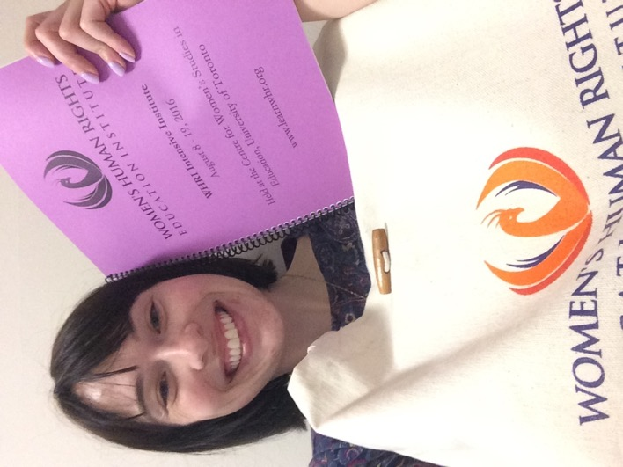

During the program all participants created Post-Intensive projects that aim to be implemented in the months after attending WHRI. All participants presented and discussed their proposed projects whilst in Toronto to lecturers and fellow participants.

This report has been prepared to highlight Cashelle’s work and experiences during her participation both online and in Toronto.

Background

The Women’s Human Rights Education Institute (WHRI) is centred around the Convention on the Elimination of All Forms of Discrimination Against Women (CEDAW). CEDAW is a United Nations Convention adopted in 1979 by the UN General Assembly and entered into force on 3 September 1981. Australia was one of the first States to sign CEDAW on 17 July 1980, and went on to ratify it on 17 August 1983.

The mission of the Women’s Human Rights Education Institute (WHRI) is to cultivate transformative, feminist leadership in the area of the CEDAW and women’s human rights by empowering participants with the knowledge and understanding of how they can use these tools to create change in their own contexts. The WHRI uniquely contextualizes the CEDAW Convention in both jurisprudence and practice, and offers in-depth study of how to apply its principles to diverse issues affecting women around the world.

This unique educational institute brings feminist perspectives and an activist orientation to the inextricably related issues of peace, human rights and life-sustaining development. The program is very selective, with applicants from around the world required to submit criteria demonstrating related work experience, strong personal and professional goals, and a compelling post-institute project proposal. Through the program, participants gain an understanding of the global economic, ecological, legal, cultural and political contexts of this work, as well as of the ground breaking work that is currently being done and has been done over decades by women and men around the world. Participants develop a practical understanding of the UN Human Rights system and how to apply a women’s human rights framework to a multiplicity of issues. Participants also develop practical facilitation skills to help them become human rights educators in their own regions and organizations.

The post-institute project proposals are discussed during the WHRI intensive and feedback provided. Six to eight months after the end of WHRI, participants must submit a report of their post-institute project implementation.

Earlier this year, a competitive application process was undertaken to select participants for the WHRI Intensive. The participants were expected to secure their own funds for tuition and travel costs through their organizations, or by seeking assistance through fundraising. However, participants living in the Global South, and full-time students, were eligible for discounted tuition rates. The eighteen participants of the WHRI Intensive 2016 were:

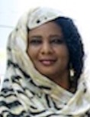  Lubna Ahmed  (Sudan) | Matida Daffeh  (Gambia) | Cashelle Dunn (Australia) | 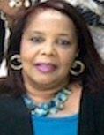  Dwynette D. Eversely  (Trinidad & Tobago)
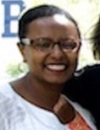  Meskerem G. Techane  (Gambia) | Lydia Gonzalez  (Spain) | Abigail Edem Hunu  (Ghana) | Tarnjit Kaur Johal (Canada)
Bhavya Joshi  (India) | Samantha Letourneau  (Canada) | 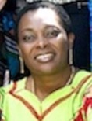  Winnie Muchuba  (Canada) | 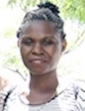  Sarah Nakiyimba  (Uganda)
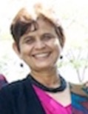  Renu Rajbhandari  (Nepal) | 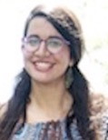  Sabra Rezaei  (Canada) | Delores Robinson (Trinidad & Tobago) | Mariana R. Cogordan  (Mexico)
 | Khrista Trani Rivera (Puerto Rico) | Elizabeth Zarpa (Canada)

WHRI was led by two esteemed facilitators, Alda Facio and Angela Lytle. Alda is a feminist human rights activist, jurist, writer and one of the founders of WHRI. Among other high level positions, she is an Expert Member of the UN Working Group on the issue of discrimination against women in law and practice of the Human Rights Council, and was one of the founders of the Women’s Caucus for Gender Justice of the International Criminal Court (ICC). Angela is an educator who has experience in workshop facilitation, activist work and feminist research, and is the Executive Director of WHRI.

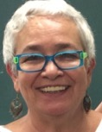  Alda Facio  Women’s Human Rights Institute (WHRI) Co-Founder | Angela Lytle  Women’s Human Rights Institute (WHRI) Executive Director

In addition, there were four specialist guest facilitators: Mary Eberts, Debbie Danard, Zarizana Abdul Aziz, and Kenita Placide. Each provided in-depth knowledge of women’s human rights from different contexts.

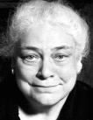  Mary Eberts  Women’s Legal Education and Action Fund (LEAF) | 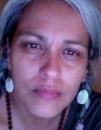  Debbie Danard  Dodem Kanonhsa Indigenous Cultural Centre | 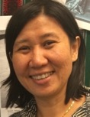  Zarizana Abdul Aziz  Women’s Development Research Centre (KANITA) | 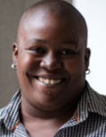  Kenita Placide  Eastern Caribbean Alliance for Diversity and Equality

WHRI Online Learning Program

The online learning program was in place to prepare the participants for the intensive classes in Toronto, and to ensure all participants would have the same basic human rights education prior to engaging in-person. Each of the three weeks online learning had specific focuses. Week one focused on international human rights; week 2 focused on the United Nations human rights system; and week 3 focused on Holistic Perspectives. The online portion required reading specific articles, watching provided videos, reading online articles, and participants were required to post responses to articles and videos in an interactive online group moderated by WHRI staff. At the end of each week, all participants filled out an online quiz. However, the quiz was not a measurement tool for grading, but rather a tool to encourage individuals to see what had been remembered, and areas needing further review.

The first week revolved around our required readings: ‘What is International Human Rights Law?’ (Facio, 2014) and ‘Introduction to Human Rights Law’. It was an introduction week that explained the basic notions of human rights and encouraged us to engage in discussions around the ‘Universality of Human Rights’, and ‘Multifaced Nature of Human Rights’. The second week revolved around the United Nations human rights system. We were provided factsheets and videos on various UN bodies and organs concerned with human rights, including the Office of the High Commissioner for Human Rights (OHCHR) and the Commission on the Status of Women (CSW), to encourage education on the complicated system. More intensive reading was required around women’s rights, including The Evolution of Women’s Human Rights in the United Nations (Facio, 2000). Discussion Forums engaged participants to explore the Special Procedures of the Human Rights Council (HRC); the Human Rights Treaty Bodies; the Universal Periodic Review Process (UPR); and how or where our own countries or regions sat within these areas. The third week embraced discussion around two primary areas: CEDAW and the required reading ‘A Magna Carta for All Women’ (Facio, 2011); and holistic understandings of women’s human rights based on the provided readings ‘Restoring Sacred Vitality’ (Young & Nadeau, 2005) and ‘What’s the Point of the Revolution if We Can’t Dance?’ (Barry, 2010). This week explored ways we hoped to use the CEDAW Convention, and why it is important for us (as human rights defenders) to cultivate self-knowledge and make time for self-care.

The final assignment of the online pre-program was to share a brief description of our post-institute plans, and offer comments or questions to other participants on their plans. By doing this we received feedback from the WHRI moderator as well as other participants to help in the development of our project plans.
In-Person Intensive in Toronto

Week One (8th to 12th August 2016)
As it was Summer in Toronto, the University of Toronto students were on vacation, so I was able to rent a room in the Wycliffe College Residence for two weeks. The location of my residence provided me the privilege of taking the University of Toronto’s ‘Philosopher’s Walk’ each day to get to the OISE building, where the WHRI Intensive was held. The Philosopher’s Walk is a scenic footpath bound by land mark buildings, including the Royal Ontario Museum (ROM). Walking the footpath offered me a profound sense of peace and connection to nature, as squirrels jumped around freely, scuttling through grass and rocks to get up to their homes in the large, leafy trees; and a man daily practiced erecting Inukshuks, which are Native Canadian sculptures created through rock balancing.

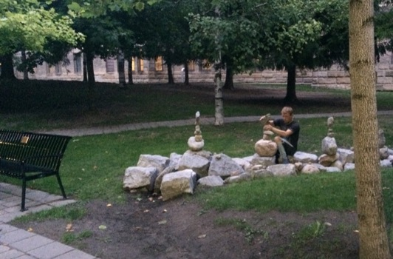
Philosopher's Walk, University of Toronto

The first day of the program, I was nervous and as I walked along the Philosopher’s Walk and I tried to calm myself from the thousands of thoughts and possibilities capitalizing my mind. Thankfully, day one dulled my nerves quickly. It was an informative, yet simple day that revolved around introductions, orientation to the program, and summarizing the information we learnt over the past three weeks. Lunchtime allowed me to engage on a personal level with some of the other participants as we walked to a local Turkish kebab vendor, and learned more about each others work and lives. On this day, we were told about the ‘Wall of Ancestors’, a WHRI project in which each of us would present an inspiring woman who has shaped us, but who has not been recognized by patriarchal history, or has been underappreciated. We each assigned ourselves to a day over the next two weeks in which we would present that individual to the class.

The second day we investigated patriarchal paradigms and feminist frameworks, as well as embodied pedagogy and its relation to women’s rights. The discussions were an important opportunity for the participants to identify our current beliefs and have ideas challenged or questioned in a positive environment. We explored the strong associations that are made between women and the body, and discussed how to question binary dualisms and challenge them through internal and external learning. At the end of the day, WHRI had organized a yoga class. This was an opportunity to engage our bodies and connect to ourselves. We participated in gentle yoga sessions twice a week on both weeks, and it felt really great to focus some time on body wellness.

From day three to five we focused on CEDAW. Through an interactive lecture we examined the history of the Convention; the guiding principles of CEDAW – Equality, Non-Discrimination and State Obligation; and explored our rights under each article. We delved into the features of the Women’s Convention, including Reservations and Temporary Special Measures; and the means for advocates to utilize CEDAW, including through Shadow Reports, General Recommendations and Concluding Observations. On the fourth day, I was extremely excited to present for the ‘Wall of Ancestors’ my chosen ancestor, WWDA’s Executive Director Carolyn Frohmader. I spoke of her accomplishments, personality, and her incredible positive affect on my life. As I said in my speech: “she is a fierce, intelligent, kind, giving and INSPIRING woman, who fights daily for the rights of women and girls with disability”.

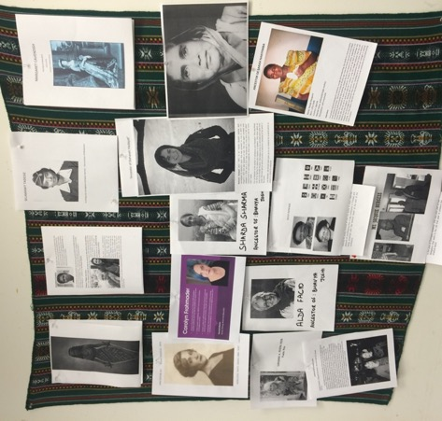
The ‘Wall of Ancestors’

Week Two (15th to 19th August 2016)
Guest lecturer, Mary Eberts, joined us on Monday the 15th of August (day 6 of classes) to educate us on the Canadian human rights context, primarily around Indigenous women’s human rights, and the Canadian Charter of Rights and Freedoms. Mary was a truly engaging and informative lecturer, bringing to life the importance of intersectionality, whilst using examples of how Canada has successfully used this concept. After her lecture, we went on a field trip to the Dondem Kononhsa Indigenous Cultural Centre, where Maria Montejo introduced us to the Canadian treaty context, as well as teaching us about the ‘Authentic-Self’ and the need to find our way back there by listening to our heart and emotions. Debby Danard, the Traditional Anishnaabe Knowledge Keeper (Indigenous Elder) then explained Canadian Indigenous Knowledges to us. This was an emotive experience that made me question many of my existing ways of thinking, and left me wanting to learn more about the culture and beliefs of the Indigenous First People of Australia.

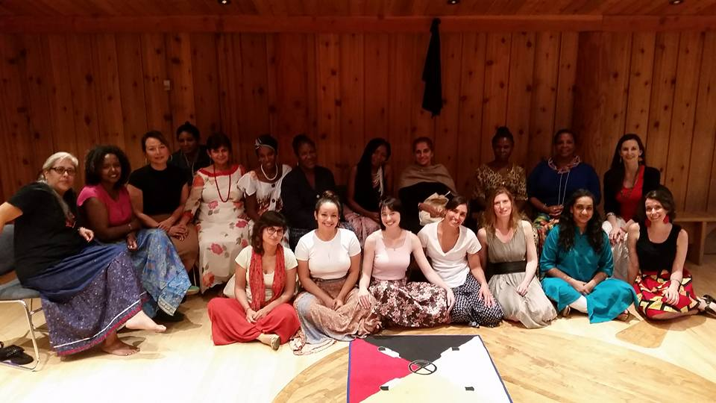
WHRI Participants at the Dondem Kononhsa Indigenous Cultural Centre

The next two days we were joined by guest lecturer, Zarizana Abdul Aziz. Zarizana was an eloquent, educated speaker, who was very informative thanks to her intensive work on the Due Diligence Project. She put the Women’s Human Rights Framework in focus around areas of violence against women, culture, and the principle of due diligence. I learnt a great deal about the State’s Obligation to address and eliminate violence against women through the “5 P’s”: Prevention, Protection, Prosecution, Punishment, and Providing Redress. At the end of our final day with Zarizana, she had us (in groups) role play advocacy scenarios where we created a situation, then tried to convince a person in a position of power why this was an important issue we were advocating. All groups prepared diligently, extensively utilizing the UN Treaties and Due Diligence Principle.

On the ninth day, we explored groupings of rights, particularly grouping the right to be free from violence, with reproductive rights. This was an important area of discussion for me, as women and girls with disability often experience violations of this grouping of rights, for example through forced or coerced sterilization. The area also promoted intense discussion around the grouping of violence against women and harmful cultural practices, such as FGM (female genital mutilation). In the afternoon, we were joined by another guest speaker, Kenita Placide, who furthered the morning’s discussion through educating us on SOGI Rights (sexual orientation and gender identity rights). Kenita discussed her experience in implementation of SOGI Rights, and how to utilize UN mechanisms to achieve our goals.

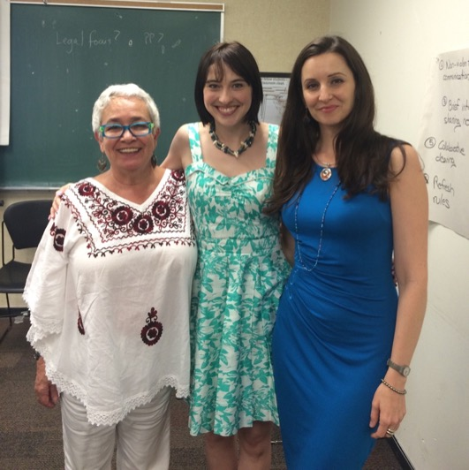
Cashelle with Alda Facio & Angela Lytle

During the two weeks we were expected to write private journal entries recording our emotions, confusions and thoughts on different issues covered in class. We were then required to write an essay reflecting on what we had learned from the journaling and from the course, due on the final day. On the Friday (last day) we all openly discussed major points from our compulsory reflection essays. Angela Lytle discussed the best ways of taking CEDAW home with us, including education, activism, and advocacy. We then presented our Post-Institute Project Plans to Alda, Angela and the other participants for feedback and advice. I worked hard on my presentation, as I wanted my project to be implementable and achievable. I had a positive response to my plan and gained some useful advice and resources to develop the project further. After the presentations were complete, we presented our leaders, Alda and Angela, and some of the WHRI staff, with cards and gifts. We then spent the next few hours eating and drinking, taking photos, and dancing to music from all over the world.

Weekend (13th to 14th August 2016)

The weekend was an excellent time to relax and explore. It was also an amazing bonding opportunity to have with some of the other participants. Myself and six other WHRI participants (Elizabeth, Bhavya, Khrista, Lydia, Mariana, and Renu) met early on Saturday morning and walked together to a bus station to catch a ride to Niagara Falls. Niagara Falls borders Canada and the United States of America, however, the town of Niagara Falls is located in Canada. The Canadian side overlooks the awe inspiring cascade of water, so serves as an amazing viewing point. We ate lunch overlooking the Falls, walked along the path on the cliff face taking hundreds of photos, and even took a boat ride under the Falls, which left us utterly saturated. It was a wonderful chance to see a natural wonder of the world, and spend time bonding with some empowering and amusing ladies.

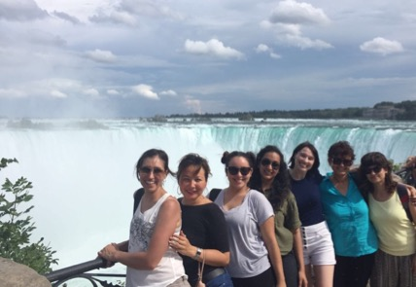

On Sunday, Elizabeth and I set out to be true Toronto Tourists. First, we attended a “Toronto Blue Jays” baseball game, which was an interactive and enjoyable experience. The Blue Jays fans were really passionate, and the game was kept very interesting with multiple home runs. However, a lot of people seemed to get hit by foul balls and flying baseball bats, so Elizabeth and I were pleased to be in the cheap seats where we could avoid getting hit. Fortunately, the Blue Jays won the game, so their massive fan base was very happy. After the game, Elizabeth and I walked to the “CN Tower” where we had made an appointment for dinner. The CN Tower (Canadian National Tower) is an icon of the Toronto skyline, is the highest building in Canada, and is one of the tallest buildings in the world. We ate at the “360 Restaurant” which was 353 metres above ground, and slowly rotated, giving us a 360-degree view of Toronto. After dinner, we walked up to the World’s Highest Glass Floor (above ground level) which was located 342 metres above ground. When I started walking across the floor I was terrified, yet could not stop laughing. Elizabeth and I both laughed with fear, feeling like we could plummet to our death at any minute. However, it ended up being an amazing experience and the whole day was so much fun.
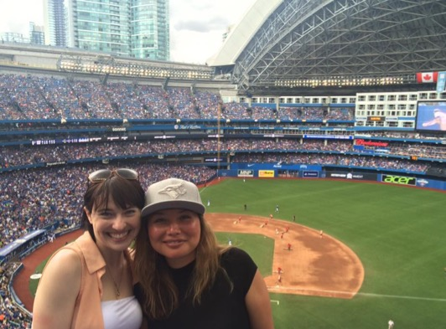
Elizabeth and I at the Blue Jays baseball game

The End
After the party, most of the girls had to go back to their residence and pack as they were leaving early in the morning. Despite having only known them a few weeks, it was hard saying goodbye to them. However, we set up numerous ways of keeping in touch, as we all realized how important support people who understand you are. I was booked to leave on Saturday evening, however, I had seizure in my residence and missed my flight. This caused me a lot of stress, as I was worried I would have to pay for another flight. Fortunately, United Airlines and the Canadian airline staff were really amazing and supportive and rebooked me for Sunday evening. I slept in the airport most of Sunday whilst waiting for my next flight. The journey home was to have stopovers in Chicago and then Los Angeles, before going to Melbourne. Unfortunately, the flights leaving Toronto and Chicago were both delayed, which stressed me again because I was worried I would miss the L.A flight home, and given I was exhausted post-seizure I really just wanted to get home. I did make my flight in L.A, but just as I had boarded (ironically) I had another seizure. I woke up confused and sad at the Marina Bay Hospital in L.A. Thankfully, the hospital staff were very nice and let me sleep for a few hours in the hospital. Around 5am I left the hospital and went back to the Airport to make sure I had been rebooked on a flight back to Melbourne. They had rebooked me onto a flight that evening, so I left the airport and checked into an Airport Hotel for a few hours sleep. I did finally get onto the flight home, and made it back to Melbourne. The experience really alerting me to the fact that I stress too much, and the effects that the anxiety and stress can have on my epilepsy. Definitely something I aim to work on.

Post-Intensive Project Plan

My Post-Intensive Project focuses on developing and implementing a women’s human rights training workshop aimed at young women and girls with all types of disability. Ultimately, I aim to test this workshop in the capital city of every state and territory in Australia. However, the Project report is due back to WHRI in 6-8 months, so in that time period I hope to at least test it in three Australian cities.

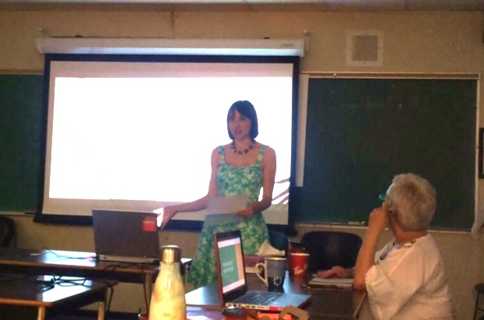
Presenting my Post-Institute Project to the class

The workshop will engage groups of young women and girls with disability in discussions about their current knowledge and understanding of women’s human rights and how these rights apply to them. The workshop will then (in easy language and accessible formats) educate young women and girls on their rights, and ways they can access or advocate for their rights on an individual, grassroots level. More specifically the workshop will, on a basic level, educate the girls on what human rights are; on the social model of disability; and the meaning of gender, equality, and gender equality. The workshop will use CEDAW as the central focus, and educate on the CEDAW articles, and actively engage the girls to see how these articles are relevant to them. It will additionally explore other conventions, for example CRPD (Convention on the Rights of Persons with Disabilities) and CRC (Convention on the Rights of the Child), and demonstrate how the girls have rights under each convention that directly link to their lives. For example, they are not just a person with disability only covered under the CRPD, they are also a young woman covered under CEDAW, and a child covered under CRC. The workshop will encourage young women and girls to propose ideas on how more young women and girls could become better educated on their rights. This will help develop the program for the future. These workshops will utilise a collection of creative educational activities as well as fun and interactive games to ensure these young women are engaged and empowered.

Ultimately, I aim to create a useful and effective program that will increase women’s human rights awareness amongst young women and girls with disability.

Where to from Here

I can incorporate all the new knowledge I gained at WHRI into my work with WWDA. I will also be able to summarize to my colleagues some of the more relevant information, so that they can incorporate it into their work with WWDA. However, I am most excited to commence implementation of the Post-Institute Project in the coming 6-8 months, and another report will be written on the implementation of the Post-Institute Project after it has been completed.

Appendix 1: Wall of Ancestors Presentation

WHRI Ancestor Presentation by Cashelle Dunn
Thursday 11th August, 2016

I would like to introduce my selection for the ‘Wall of Ancestors’, Carolyn Frohmader, my employer, friend and mentor. Carolyn is a fierce, intelligent, kind, giving and INSPIRING woman, who fights daily for the rights of women and girls with disability. She is the Executive director of Women with Disabilities Australia, or WWDA, and has held this position for nearly 20 years. Under her leadership, WWDA has received a number of prestigious award. Carolyn works on national and international levels to promote and protect the rights of women and girls with disability, and individually, she has been the recipient of numerous awards, including the the Australian National Human Rights Award in 2013, primarily for her work in gaining a senate inquiry into forced and coerced sterilisation.

Despite the awards and being amazing, Carolyn remains underrated for her work, and especially for the amount of work she does. She is a single mother to an incredible young woman who makes me feel that future generations are in safe hands. And on a personal note, for me, she inspires passion and drive, she is so supporting and comforting every day, but particularly when I was dealing with my own post-abuse scars. She creates such a supportive work environment which is flexible for the needs of women, and always makes staff feel appreciated. I am honoured to work with Carolyn, to learn from her, and to be empowered every time I am in her presence.

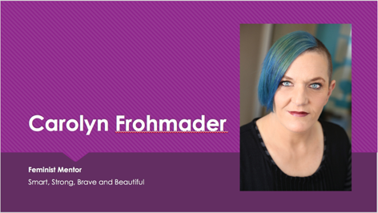  Slide 1 | 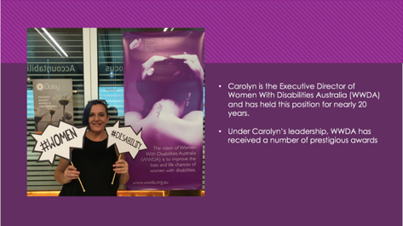  Slide 2
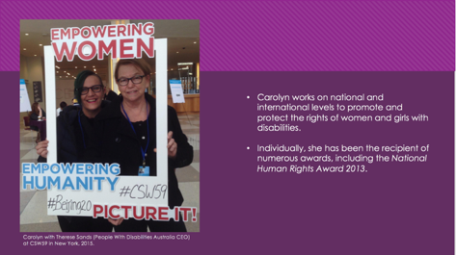  Slide 3 | 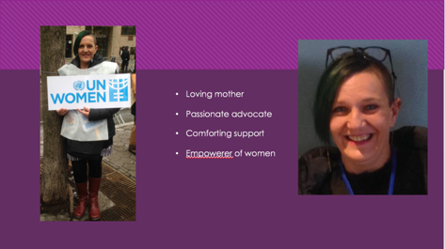  Slide 4
Appendix 2: Post-Intensive Project Plan Slides
Project Plan Presentation by Cashelle Dunn
Friday 19th August, 2016
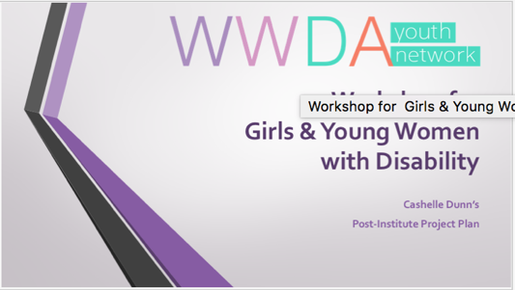
Slide 1
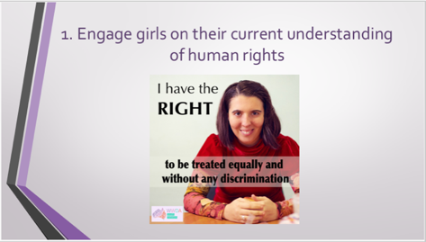  Slide 2 | 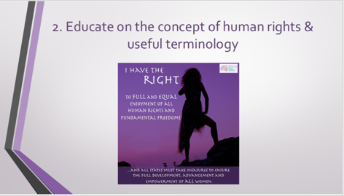  Slide 3
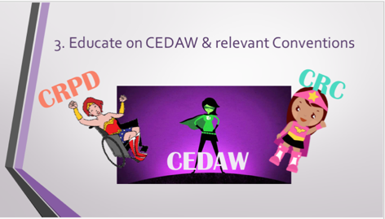  Slide 4 | 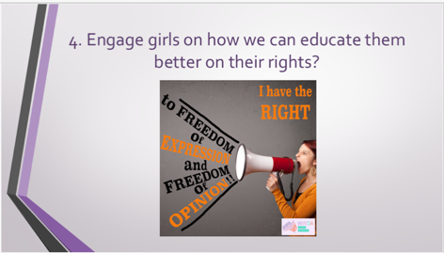  Slide 5
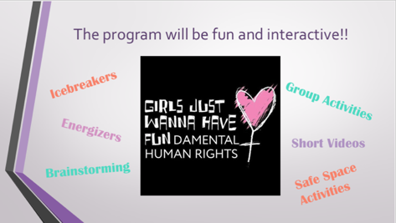  Slide 6 | 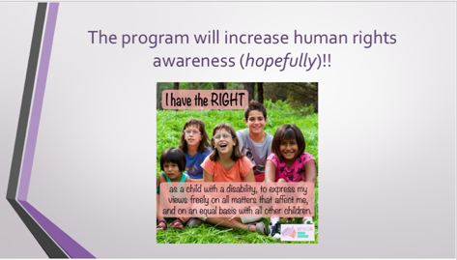  Slide 7

