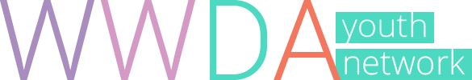
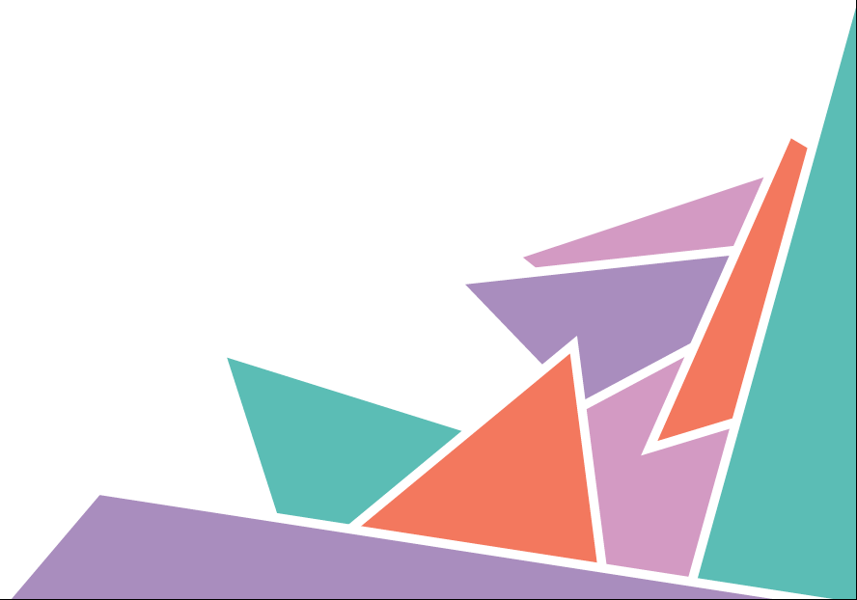

Position Statement 7

Young Women and Girls with Disability

WWDA Youth Believe
- Young women and girls with disability have the right to live free of violence, abuse, exploitation and neglect.

- We have the right to make independent, free and informed choices about their lives, relationships and bodies.

- We have a right to equal participation in social, political and cultural life.

- We all have the right to express our sexuality, have relationships and make choices about our bodies, free from violence and discrimination.

- We have a right to access inclusive, mainstream education, and pathways to meaningful and equally paid work.

- We have a right to justice, including being recognised as having legal capacity and as equal before the law.

The Facts
- Girls with disability are 3-4 times more likely to experience violence than their friends without disability.

- Young women and girls are often denied their right to make decisions about their bodies and lives.

- Women and girls with disability are often denied the right to participate and make choices about their lives.

- Forced sterilisation, forced abortion and forced contraception are forms of violence.

- Limited access to education, discrimination and experiences of violence, can make it hard for young women and girls with disability to do well at school.

- Women and girls with disability are often denied the right to make legal decisions. Instead, decisions are made for them by parents, courts, doctors and government officials.

- Access to justice is a human right.

What It Means

Discrimination
Being treated unfairly or differently because of who you are, where you live, what you believe, or because you have a disability.

Equality
Having access to the same rights and opportunities as everyone else, along with the support to act on those rights and opportunities.

Human Rights
Rights to freedom, dignity and fairness that all people have, no matter their race, ethnicity, nationality, age, sex, gender, sexuality, disability or political beliefs. Human rights are protected by international law.

Inclusion
Having the opportunity to access and participate in the same activities and settings as people without a disability. Full inclusion means that people will feel they belong and will be treated equally as their friends.

Informed Choice
To make a decision or choose to something after you have been provided with information and support to understand the consequences of making that choice.

Mainstream Settings
Mainstreaming means young women and girls with disability are supported to attend the same schools and classes as children and young people without disability.

Participation
Having the opportunity to be involved in events and activities in your school and in your community, that are of interest to you. Participation can also mean being involved in decision-making and having the opportunity to share your ideas and be listened to.

Sexual and Reproductive Health
Means physical, mental and social wellbeing in all matters relating to your sexuality, your gender identity and the reproductive system. This includes having a safe sex life; having access to acceptable feminine hygiene products and contraception methods of your choice; being informed on how to protect against sexually transmitted diseases; and the freedom to decide if, when and how often you wish to have children.

Sterilisation
A medical procedure that removes a person’s capacity to have children.

Violence
Using force or power against another person, group or community, which results in them being hurt, feeling pain or fear. Violence can be physical, emotional, sexual, and psychological, among others. Violence can be committed by an individual, a group, or by the State (a country).

Learn More

Human Rights and Violence
Human rights are protected under international law. These rights are described in documents called conventions or treaties. Countries such as Australia can agree to be bound by these laws.

WWDA Youth Human Rights Workbook
The WWDA Youth Human Rights Workbook explores and explains the Convention on the Right of Persons with Disabilities (CRPD) and the Convention on the Elimination of All Forms of Violence Against Women (CEDAW).
http://youth.wwda.org.au/workbook/

Convention on the Rights of the Child (CRC)
The CRC describes and protects the human rights of children and young people. Check out the “For Youth” page to learn more about your rights:
www.unicef.org/rightsite/433.htm

Convention on the Rights of Persons with Disabilities (CRPD)
The CRPD describes and protects the rights of all people with disability. You can find an easy to understand version of the convention at:
www.unicef.org/publications/index_43893.html

Australian Human Rights Commission
The Commission has put together some great ideas about how to get involved in human rights and make a difference. Visit:
www.humanrights.gov.au/education/students/get-involved-students

Help & Support

In an Emergency
If you or another person is in immediate danger, Call 000 (Triple Zero)

eheadspace
The eheadspace online and telephone service supports young people and their families going through a tough time. Visit: https://www.eheadspace.org.au/

Kids Helpline
If you need to talk about anything, you can call, email, or have an online chat
with Kids Helpline. Visit www.kidshelpline.com.au or call 1800 55 1800

1800 RESPECT
Support if you have or are currently experiencing sexual, domestic or family violence. Visit www.1800respect.org.au or call 1800 737 732

Disability Advocacy Services
A disability advocate can help you to access support around your human rights. To find an advocate near you, visit: http://finder.dss.gov.au/disability/ndap/

Get Involved
United Nations Youth Association Australia (UNYA)
UN Youth Australia is a national youth-led organisation that aims to educate and empower young Australians on global issues. Visit: www.unyouth.org.au
Women with Disabilities Australia (WWDA)
WWDA represents more than 2 million disabled women and girls in Australia. We are run by and for women with disabilities. We operate as a transnational human rights and systemic advocacy organisation. www.wwda.org.au

WWDA Youth Network

WWDA Youth Network aims to empower young women and girls with disabilities to become strong, confident, proud and educated on their rights and options. Follow us and get involved at:

Web http://youth.wwda.org.au
Facebook http://www.facebook.com/WWDAYouth
Twitter http://www.twitter.com/WWDA_Youth
YouTube http://goo.gl/BqDQ47
Instagram http://www.instagram.com/WWDA_Youth

WWDA Youth Network, Position Statement 7: Young Women and Girls with Disability, Women With Disabilities Australia (WWDA): Hobart, Tasmania, 1st Edition, July 2017.
ISBN: 978-0-9876035-3-1
The development of this position statement was made possible through project funding from the Australian Government, Office for Women. WWDA thanks the women and girls with disability who contributed to the development of this statement.
Prepared by Cashelle Dunn and Chris Brophy.
For further information and citations, please access:
- WWDA Human Rights Toolkit and comprehensive WWDA Position Statements available at, http://www.wwda.org.au/papers/toolkit
- WWDA Youth Human Rights Workbook and WWDA Youth Position Statements available at, http://youth.wwda.org.au/workbook/
© Women with Disabilities Australia (WWDA) 2017.

