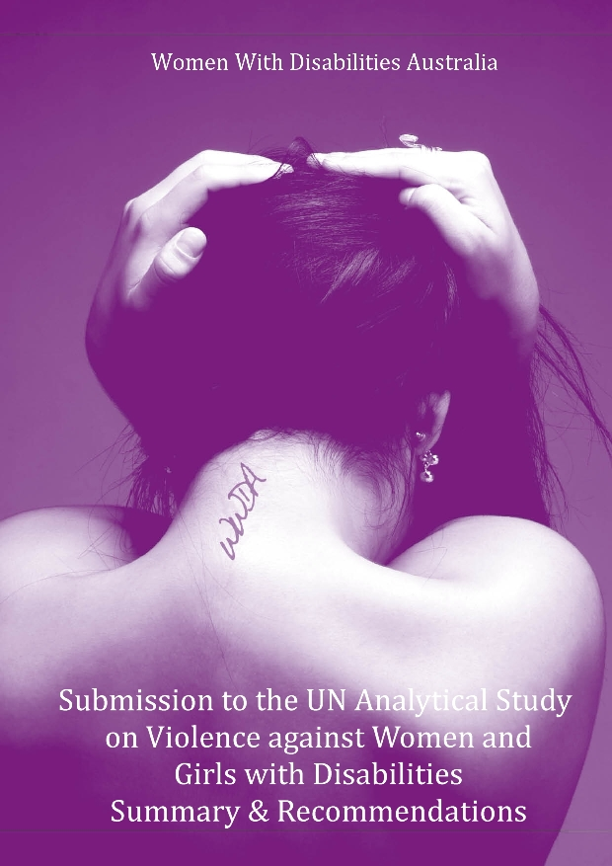
Summary & Recommendations of the WWDA Submission to the Preparation Phase of the UN Analytical Study on Violence against Women and Girls with Disabilities - (A/HRC/RES/17/11)

By Carolyn Frohmader for Women With Disabilities Australia (WWDA)

© Women With Disabilities Australia (WWDA) June 2012

Contact Details:

Women With Disabilities Australia (WWDA)
PO Box 605, Rosny Park 7018 TASMANIA, AUSTRALIA
Ph: +61 3 62448288 Fax: +61 3 62448255
Email: wwda@wwda.org.au
Web: www.wwda.org.au

WWDA on Facebook:
http://www.facebook.com/pages/Women-With-Disabilities-Australia-WWDA/202081393153894

Winner, National Human Rights Award 2001
Winner, National Violence Prevention Award 1999
Winner, Tasmanian Women's Safety Award 2008
Certificate of Merit, Australian Crime & Violence Prevention Awards 2008
Nominee, French Republic's Human Rights Prize 2003
Nominee, UN Millennium Peace Prize for Women 2000

Disclaimer

This Paper has been prepared by Women With Disabilities Australia Inc for the Australian Government, represented by the Department of Families, Housing, Community Services and Indigenous Affairs. The views expressed in this publication are those of Women With Disabilities Australia Inc and do not necessarily represent the views of the Australian Government.

 | WWDA Submission to the UN Analytical Study on Violence against Women and Girls with Disabilities  Summary & Key Recommendations

Summary

In late 2011, Women With Disabilities Australia (WWDA), the national peak organisation representing more than 2 million women with disabilities, was invited by the United Nations High Commissioner on Human Rights, to provide a Submission to the preparation phase of the UN Analytical Study on Violence Against Women and Girls with Disabilities (A/HRC/RES/17/11).

WWDA’s Submission to this global UN study, (available at: http://www.wwda.org.au/viol2011.htm) was published in late December 2011 and aims to provide an overview of the legislation, regulatory frameworks, policy, administrative procedures, services and support available within Australia to prevent and address violence against women and girls with disabilities.

Violence against women with disabilities remains a key factor that undermines the ability of disabled women to participate as full and equal citizens in Australian society. In Australia, women with disabilities experience high levels of domestic/family violence and sexual assault, and have high levels of unmet needs in terms of access to domestic violence, sexual assault and related community support services. It is now widely acknowledged that compared to non-disabled women, women with disabilities are at greater risk of severe forms of intimate partner violence; they experience violence at significantly higher rates, more frequently, for longer, in more ways, and by more perpetrators; they have considerably fewer pathways to safety, and are less likely to report experiences of violence - yet programs and services for this group either do not exist or are extremely limited. In Australia, responses to violence against women with disabilities have traditionally been characterised by limited recognition by governments and the service sector of the nature and extent of the problem; inadequate research; incomplete or partial response structures, and scarce resources to support advocacy in the area.

Due to time and resource constraints, WWDA’s Submission does not provide an authoritative analysis of all mechanisms and programs across Australia’s eight States and Territories. However, the information provided in the Submission clearly demonstrates that there have been, and remain, significant systemic failures - in legislation, regulatory frameworks, policy, administrative procedures, availability and accessibility of services and support - to prevent and address the epidemic that is violence against women and girls with disabilities. Underlying these systemic failures is an entrenched culture throughout all levels of Australian society that devalues, stereotypes and discriminates against women and girls with disabilities, and invariably perpetuates and legitimises not only the multiple forms of violence perpetrated against them, but also the failure of governments to recognise and take action on the issue.

WWDA’s Submission provides detailed information under the several themes, including: data and statistics; legislation and policies; prevention and protection; prosecution and punishment, and recovery, rehabilitation and social integration. There are a number of key recommendations which stem from WWDA’s Submission. There are six major recommendations, and a number of more general recommendations for consideration by Australian Governments, in particular the Australian Department of Families, Housing, Community Services and Indigenous Affairs (FaHCSIA), and the Attorney-General’s Department, which are the Australian Government's principal sources of advice on social policy, and law and justice respectively.

Major Recommendations

Women With Disabilities Australia (WWDA) recommends that the Australian Governments:

- Commission and adequately resource a Royal Commission or Official Public Inquiry into Violence Against People with Disabilities in Australia, both historically and currently. The development of procedures for such an inquiry must be done in consultation with disabled people’s organisations and the Australian Human Rights Commission (AHRC).

- As a matter of urgency, and consistent with recommendations from other key Australian disabled people’s organisations, establish and adequately resource an independent, statutory, national protection mechanism for ‘vulnerable’ adults, where the requirement for mandatory reporting is legislated.

- In keeping with the human rights treaties to which Australia is a party, and consistent with the recommendations to the Australian Government from the United Nations Committee on the Elimination of Discrimination Against Women (2010), the Committee on the Rights of the Child (2005, 2012), the Human Rights Council (2011), along with the International Federation of Gynecology and Obstetrics (FIGO) Guidelines on Female Contraceptive Sterilization (2011), and recommendations of the World Medical Association (WMA) (2011) and the International Federation of Health and Human Rights Organisations (IFHHRO) (2011), enact national legislation prohibiting, except where there is a serious threat to life or health, the use of sterilisation of girls, regardless of whether they have a disability, and of adult women with disabilities in the absence of their fully informed and free consent.

- In consultation with people with disabilities, act immediately to develop and adopt, a gendered National Violence & Disability Prevention Strategy. Such a Strategy must include targeted, gendered initiatives to build capacity of individuals and organisations to prevent violence against people with disabilities and to ensure appropriate responses when it does occur.

- In keeping with recommendations from the Committee on the Elimination of Discrimination Against Women (2010), and utilising the UN Convention on the Rights of Persons With Disabilities (CRPD) as the guiding framework, undertake a national, comprehensive assessment of the situation of women with disabilities in Australia.

- In keeping with recommendations from the Committee on the Elimination of Discrimination Against Women (2010), act to adopt urgent measures to ensure that women with disabilities are better represented in decision-making and leadership positions. Inherent in this is the need for FaHCSIA to undertake an immediate review of the level and adequacy of the annual funding provided by the Australian Government to Women With Disabilities Australia (WWDA) ($163,000) including staffing levels (1.5 EFT).

Additional Key Recommendations for Consideration

Women With Disabilities Australia (WWDA) recommends that the Australian Governments:

- Build the evidence base of women with disabilities experiences of violence in Australia, by commissioning and resourcing a national research study to establish the prevalence, extent, nature, causes and impact of violence against women and girls with disabilities in different settings.

- Act immediately on the urgent recommendation of the Committee on the Elimination of Discrimination Against Women (2010), to address the abuse and violence experienced by women with disabilities living in institutions or supported accommodation.

- Undertake an immediate review of the effectiveness and limitations of the National Disability Abuse and Neglect Hotline as a mechanism in detecting, reporting and responding to violence against women with disabilities. Such a Review should address, as a minimum, the following issues:
- why the Hotline data collected by the Government is not available to the public;
- how data and information is used and whether data collected is disaggregated;
- the Hotline’s lack of statutory functions, powers and immunities, including for eg: the lack of investigating powers, and the lack of power to formally review complaint investigation processes and outcomes;
- the definitions which set the scope of the Hotline’s work;
- the lack of systemic investigative powers, including the Hotline’s inability to initiate actions at its own motion.

- Address, as a matter of urgency, the lack of disability indicators and lack of disaggregated disability data collection within the National Minimum Data Set for Specialist Homeless Services.

- Commission and fund a national audit of crisis accommodation services to determine their levels of accessibility and safety for women with disabilities and to determine service/agency needs in meeting relevant anti-discrimination legislation requirements.

- Work with State and Territory Governments to ensure that all Australian family violence legislation contains the same, comprehensive definition of family violence which includes the broadest possible definition of acts of family violence and relationships within which family violence occurs. Such legislation should be inclusive of the forms of violence as experienced by women and girls with disabilities and encompass the circumstances and contexts within which women and girls with disabilities experience family violence.

- Undertake an immediate review of legislation, policies and processes currently in place for procedures occurring to girls and women with disabilities who are deemed ‘incapable of giving informed consent.’ Any review must address (a) who should determine that a person is incapable of giving informed consent; and, (b) what processes and mechanisms should be used to determine that a person is incapable of giving informed consent.

- Act to redress the human rights violations against women and girls with disabilities who have been sterilised without their consent. In the process of reconciliation, financial compensation and an official apology for discrimination should be provided.

- Ensure that information on women and girls with disabilities is provided in relevant human rights treaties Periodic Reports as a matter of course. This would include information on the situation of women with disabilities under each right, including their current de-facto and de jure situation, measures taken to enhance their status, progress made and difficulties and obstacles encountered.

