5. Violence against people with disability
This is a plain English summary of Australia’s 2019 CRPD Factsheet 5

Facts
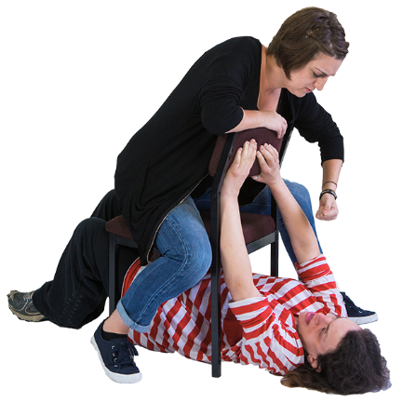
People with disability experience more violence than people without disability.
People with disability are at higher risk of violence.
Violence is often not recognised or dealt with.

Survey of people with disability 2019
Over one third of people said they had been abused.
Almost half of the people said they felt unsafe where they lived.

People at higher risk
Women and girls with disability face more abuse than other women and girls.
Children and young people with disability experience a lot more violence than children without disability.
Aboriginal people have high rates of disability and high rates of violence. So Aboriginal people with disability.

What we recommend
- One national system where people with disability can makes complaints about violence and abuse. Having lots of systems is confusing and hard.
- Domestic violence and sexual assault services to better support women and girls with disability.
- Fund DPOs to run programs that address violence.
- Changes to laws and policies to protect people with disability especially people at higher risk.

Disability Royal Commission
It is good that the Australian government is funding a Royal Commission into violence, abuse, neglect and exploitation of people with disability.
It is good that it will cover all kinds of abuse in all places.
The Royal Commission is now taking submissions from people but there has been no funding made available for support services which puts people with disability at risk.

What we recommend for the Disability Royal Commission
- Have a redress scheme or way to compensate people with disability who have been abused.
- Review the conflicts that some of the Commissioners have.
- Make information easy to read, don’t just call it Easy Read for example the submission form is called Easy read but it’s not easy.
- Fund support, counselling and advocacy services urgently.

