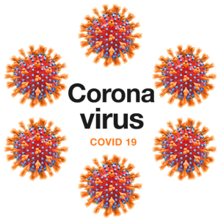
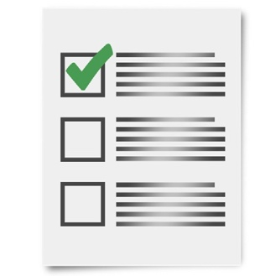
COVID-19
Keep people with disability safe.
A letter to the government.

3 April 2020

Disability advocacy groups sent a letter
to the Prime Minister and the Premiers.

The letter is about COVID-19.

We want people with disability to be
safe and well.

We asked the government to do
10 things to help people with disability.

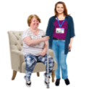
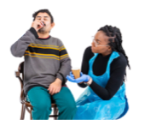

The government must do these
things now.

1. Make sure people with disability have
good support.

2. Make it easy for people with disability
and support workers to be tested for
COVID-19.

3. Make all information about COVID-19
easy to read and understand.

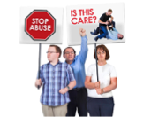

4. Make sure people with disability get
good health care.

5. Give people on the disability pension
more money.

6. Make sure people know what they
can leave the house for.

7. Keep people with disability safe from
violence and abuse.

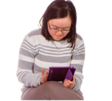
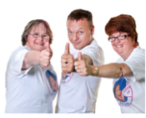

8. Help students with disability.

9. Protect people who live in group
homes or shared accommodation.

10. Give more funding to disability
advocacy services.

We want the Australian and State
governments to act now.

