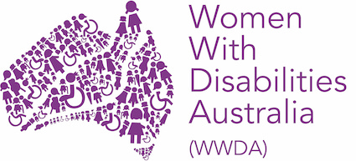

Complaints Policy and Procedure

Drafted by: Carolyn Frohmader
Approved by Board on: February 2021
Responsible person: WWDA CEO
Scheduled review date: February 2024

POLICY
Women with Disabilities Australia (WWDA) is committed to ensuring that all staff, volunteers and members have the opportunity to raise a complaint with the organisation regarding its operations or actions of WWDA personnel and to resolve this grievance in a timely and satisfactory manner. This internal process does not preclude referring the complaint to any appropriate external authority.

All complaints will be dealt with:
- seriously;
- quickly;
- confidentially.

PURPOSE
Grievances are usually concerns about aspects of the way an organisation or service operates.
They may include but are not restricted to:
- concerns about operational procedures;
- communication difficulties;
- time taken to respond to requests;
- treatment by staff or volunteers of the organisation;
- work performance issues (however this is not the same as performance management by a manager to a staff member);
- verbal, emotional, physical, or sexual harassment or abuse.

The aim of this policy is to provide a mechanism to identify and respond to grievances quickly, appropriately, and safely for those involved, in order to resolve issues, improve communication, and create an environment of improved working relationships.

SCOPE
This policy applies to all WWDA Staff, volunteers, members and contractors.

RESPONSIBILITIES
Ultimate responsibility for all grievances rests with the WWDA Board of Management (Board) who may delegate the role to the WWDA Executive Committee.
PROCESS FOR MAKING A COMPLAINT ABOUT WWDA
Start with a conversation
Firstly, speak to the employee who is directly involved with the complaint and try to resolve it. If you feel uncomfortable speaking to that employee or you feel the issue has not be resolved, contact the WWDA Executive Director. The WWDA Executive Director can either try and help resolve the issue or encourage you to make a formal complaint.
Formal Complaint
To make a formal complaint you can speak or write to the
WWDA Office Manager on 0438 535 123 or at officeadmin@wwda.org.au.
If your complaint is about the Office Manager, you can contact the WWDA Executive Director. To contact the Executive Director call 0438 535 123 or email carolyn@wwda.org.au.
Your Formal Complaint
Your formal complaint should say what the problem is and how you think the problem can be fixed. You should also include anything that supports your complaint.
WWDA will try to resolve your complaint
Once you have submitted the formal complaint, you and the employee involved will be informed of the issues and the steps WWDA is taking.
WWDA will keep the matter private and work to resolve the complaint as quickly as possible.

PROCEDURES IN DETAIL
In order to make a complaint about any matter, or to initiate a grievance procedure, the following steps will be taken:

Informal Process
In the first instance, the Complainant should attempt to resolve the grievance with the person(s) (Respondent/s) involved. If the Complainant is able, s/he will contact the person against whom the grievance is directed to make a mutually convenient time to discuss the issues. The goal of this discussion should be on how to reach a positive resolution and focus on issues rather than individuals or ‘blaming’.

Formal Process
If for whatever reason the Complainant does not feel able to discuss the grievance with the Respondent/s involved, or the matter is not resolved to the Complainant’s satisfaction, the individual encouraged to raise the issue with the Executive Director (the Mediator) via the Office Manager. This can be done informally, formally, or if necessary, both informally and formally. The Complainant can seek advice from the Executive Director as to resolving the matter less formally or seek their formal intervention by raising the issue in writing. In this event, the Executive Director will acknowledge receipt of the grievance within 5 working days, notwithstanding planned absences.
If the matter cannot be mediated by the Executive Director (e.g. if the complaint is against a WWDA Board Member or the Executive Director), the Executive Director will refer the matter to the WWDA President. If the complaint is against the Executive Director or the matter is not resolved to the Complainant’s satisfaction by the Executive Director, s/he is encouraged to raise the issue in writing with the WWDA President. The WWDA President (the Mediator) or her delegate/s will acknowledge receipt of the grievance within 5 working days.
If the grievance is directed against the WWDA President, the grievance should be directed in writing to the WWDA Vice-President/s (the Mediator/s).
The Mediator/s will then meet with the Complainant to discuss the grievance, obtain further information and seek their view on what resolution they believe would be fair.
The Mediator/s will meet with the Respondent/s to discuss the nature of the grievance, their understanding of what occurred and what resolution they believe to be fair. The Mediator/s will convene a meeting between both parties to attempt to resolve the issue. A report will be written documenting the agreements of the mediation that all participants will be asked to sign.
If the grievance is not resolved, the WWDA Board of Management (or the WWDA Executive Committee) may make a final binding decision or, on the advice of the Mediator, may refer the issue to an independent external mediator.

Advocates
The Complainant may choose to nominate an advocate to provide support at any point during the grievance process. Such an advocate is to be an individual who preferably does not work at WWDA, and may include a support worker/person, union representative or professional advocate. WWDA will provide advocate options if assistance is requested by the Complainant.

External authorities
If the grievance is still not satisfied, the Complainant is encouraged to seek redress from a relevant external body, such as the Australian Charities and Not-for-Profits Commission, the Australian Securities and Investments Commission Fair Work, a trade union or their state or territory Anti-Discrimination Commission.

PRINCIPLES
All complaints received will be treated in confidence and without fear of reprisal.

Any grievance process shall be resolved within 30 working days of receipt by the Mediator/s of the formal written statement by the Complainant and the formal written response by the Respondent. Where no resolution has been achieved within that time, external professional mediation or an appropriate alternative external process may be engaged to assist to resolve the matter. Alternatively, the barriers to resolving the matter will be documented and provided to the parties involved in the dispute with revised timeframes.

All parties involved in a grievance process should treat the matter confidentially and refrain from involving other parties, with the exception of their advocate/support person(s).
While the grievance is being determined, WWDA’s work will continue in accordance with the mission and values existing before the grievance arose.
The WWDA Board of Management (Board) or the WWDA Executive Committee must ensure that due process and natural justice have been demonstrated throughout the grievance process.

AUTHORISATION
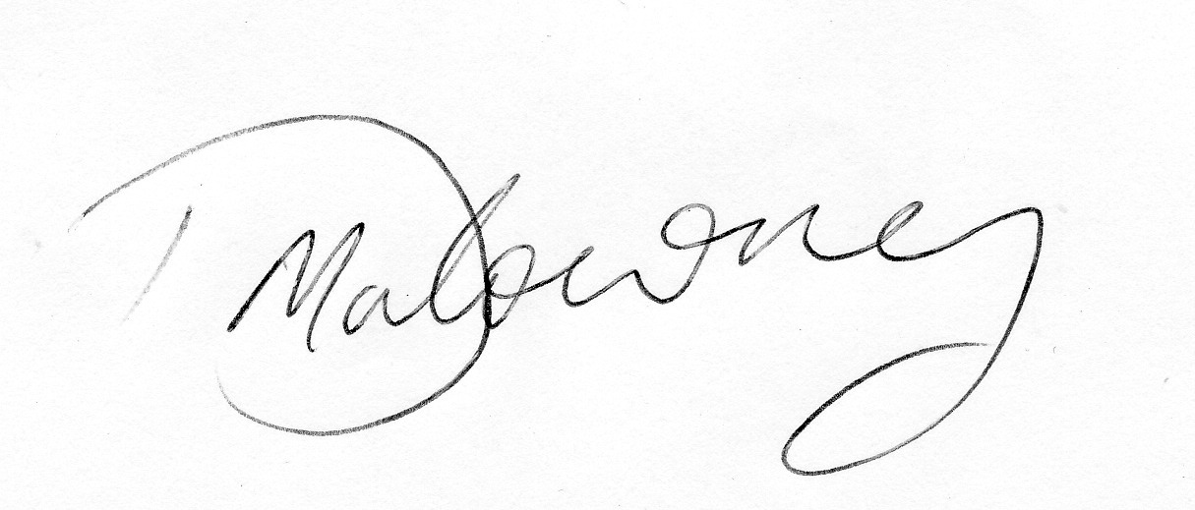

Tricia Malowney
WWDA President
Women with Disabilities Australia (WWDA)
February 2021

