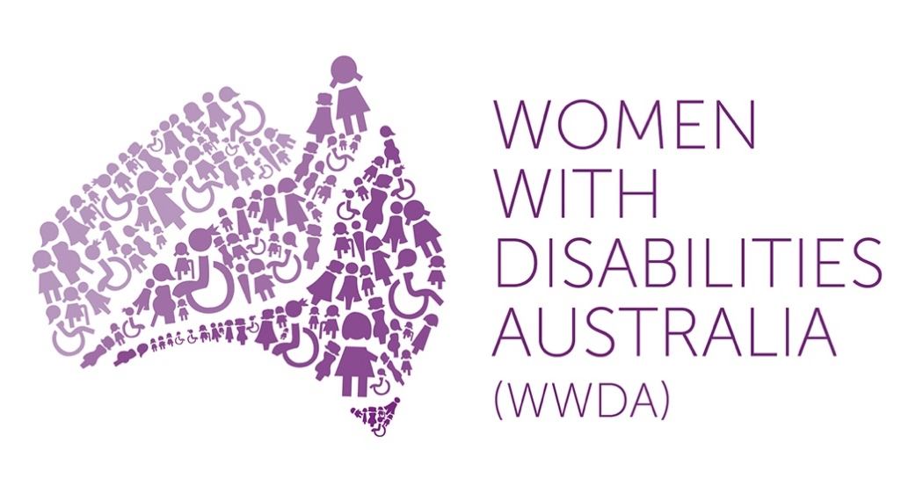

Women with Disabilities Australia (WWDA)

Annual Report

July 2018 – June 2019

Publishing Information

Women with Disabilities Australia (WWDA) (2019), ‘Annual Report for the Period July 2018 – June 2019’, WWDA: Hobart. October 2019. Prepared by Carolyn Frohmader.

Acknowledgments

Women With Disabilities Australia (WWDA) is partly funded by the Australian Government, Department of Social Services.

WWDA acknowledges the traditional owners of the lands on which this publication was produced. We acknowledge Aboriginal and Torres Strait Islander people’s deep spiritual connection to this land. We extend our respects to community members and Elders past, present and becoming.

Disclaimer

The views and opinions expressed in this publication are those of Women With Disabilities Australia (WWDA) and not necessarily those of the funding body. All possible care has been taken in the preparation of the information contained in this document. WWDA disclaims any liability for the accuracy and sufficiency of the information and under no circumstances shall be liable in negligence or otherwise in or arising out of the preparation or supply of any of the information aforesaid.

This work is copyright. Apart from any use as permitted under the Copyright Act 1968, no part may be reproduced without written permission from Women With Disabilities Australia (WWDA).

© 2019 Women With Disabilities Australia (WWDA).

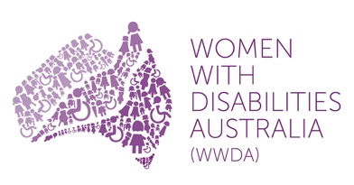 | 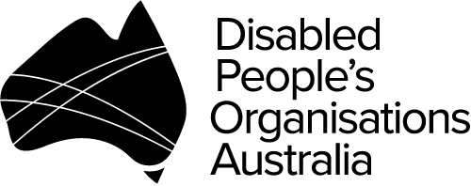

About Women With Disabilities Australia (WWDA)

Women With Disabilities Australia (WWDA) is the national Disabled People’s Organisation (DPO) for women and girls with all types of disability in Australia. DPOs are recognised around the world, and in international human rights law, as self-determining organisations led by, controlled by, and constituted of, people with disability. DPO’s are organisations of people with disability, as opposed to organisations who may represent people with disability. As a DPO, WWDA is run by and for women and girls with disability. WWDA represents more than 2 million women and girls with disability in Australia, has affiliate organisations and networks of women with disability in most States and Territories, and is recognised nationally and internationally for its leadership in advancing the rights and freedoms of all women and girls with disability. Our organisation operates as a transnational human rights organisation - meaning that our work, and the impact of our work, extends much further than Australia. WWDA’s work is grounded in a human-rights based framework which links gender and disability issues to a full range of civil, political, economic, social and cultural rights.

WWDA is a founding member of Disabled People’s Organisations Australia (DPO Australia), an alliance of four national, population specific and cross-disability DPO’s in Australia. DPO Australia was founded by, and is comprised of: Women With Disabilities Australia (WWDA); First Peoples Disability Network Australia (FPDN); People with Disability Australia (PWDA); and, National Ethnic Disability Alliance (NEDA). The key purpose of DPO Australia is to promote, protect and advance the human rights and freedoms of people with disability in Australia by working collaboratively on areas of shared interests, purposes and strategic priorities and opportunities. DPO Australia is a recognised coordinating point between Government/s and other stakeholders, for consultation and engagement with people with disability in Australia.

Contact

Women With Disabilities Australia (WWDA)
PO Box 407, Lenah Valley TASMANIA 7018
Mobile: +61 438 535 123
Email: carolyn@wwda.org.au
Web: www.wwda.org.au
Facebook: www.facebook.com/WWDA.Australia
Twitter: https://twitter.com/WWDA_AU
ABN: 23 627 650 121
Contact: Carolyn Frohmader (Executive Director)

Winner, National Human Rights Award 2001
Winner, National Violence Prevention Award 1999
Winner, Tasmanian Women's Safety Award 2008
Certificate of Merit, Australian Crime & Violence Prevention Awards 2008
Nominee, National Disability Awards 2017
Nominee, French Republic's Human Rights Prize 2003
Nominee, UN Millennium Peace Prize for Women 2000

Contents

About Women With Disabilities Australia (WWDA) 3
Contents 4
About WWDA’s Annual Report 5
WWDA Board 2018-2019 6
WWDA Staff 2018-2019 7
WWDA Presidents Report – by Tricia Malowney 8
WWDA Executive Directors Report – By Carolyn Frohmader 9
Summary of Key Achievements and Outcomes 11

About WWDA’s Annual Report

This Annual Report provides a summary snapshot of just some of WWDA’s key outputs, activities and achievements at the national and international level for the financial year reporting period 1st July 2019 – 30th June 2019. The Report demonstrates the breadth, scope and high standard of WWDA’s work, on a wide range of initiatives and programs, across all portfolio areas and across jurisdictions. Our Annual Report highlights and reflects WWDA’s commitment to promoting and advancing the rights and freedoms of women and girls with disability – both within Australia and around the world. Our Annual Report also reflects the human rights based approach from which we operate.

This Annual Report is structured in line with WWDA’s Strategic Plan 2017-2021, which was published in 2017 after extensive consultation with our members and constituents. WWDA’s Strategic Plan 2017-2021 contains five main goals. Under each goal are listed key objectives which set out how we intend to achieve our goals. The five goals are to:

- Undertake focused systemic advocacy on priority human rights issues identified by women and girls with disability: freedom from all forms of violence; decision-making and participation; sexual and reproductive rights; economic security, justice.

- Build on and further develop WWDA’s profile and reputation at the national and international levels as the globally recognised leader on advancing the human rights of women and girls with disability.

- Contribute to the development, implementation and monitoring of Australian Government legislation and policies that affect women and girls with disability.

- Enhance WWDA’s capacity to consult, engage and represent young women and girls with disability.

- Develop infrastructure, systems and mechanisms to enable WWDA to effect its purpose, goals and objectives.

It is outside the scope of this Report to do justice to the extensive work of WWDA during the reporting period July 2018 – June 2019. However, in compiling this summary report, we have endeavoured to give our members, supporters and funders a synopsis of just some of the key activities our organisation has undertaken, and has been engaged in, as part of our efforts to promote the rights of all women and girls with disability.

Further detail of WWDA’s work can be found on our extensive website at www.wwda.org.au and across our other platforms:

WWDA Facebook: www.facebook.com/WWDA.Australia
WWDA Twitter: https://twitter.com/WWDA_AU
WWDA Youth Website: www.youth.wwda.org.au
WWDA Youth Facebook: https://www.facebook.com/WWDAyouth

WWDA Board 2018-2019

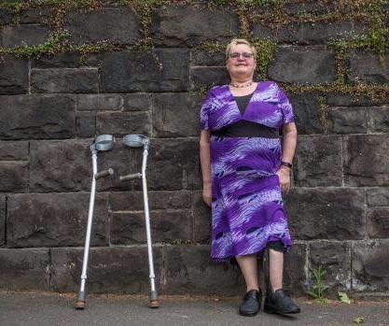  Tricia Malowney  President | 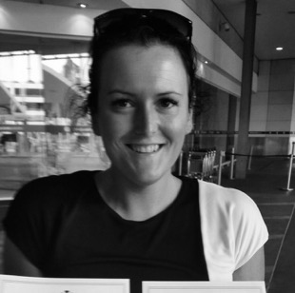  Jess White  Vice President | 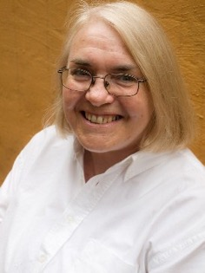  Pamela Menere  Treasurer/Acting President 2018
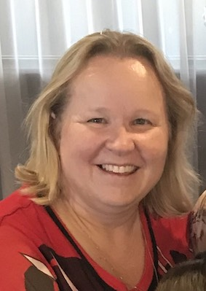  Jody Barney  Committee Member | 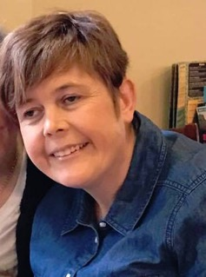  Monique Crowden  Committee Member | 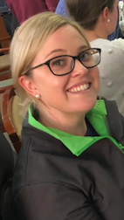  Allira Honner  Committee Member
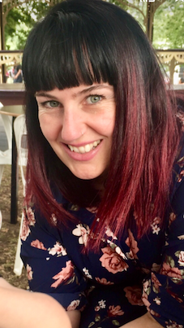  Jen Lowe  Committee Member | 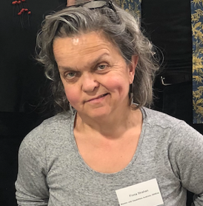  Fiona Strahan  Committee Member  Resigned 2018  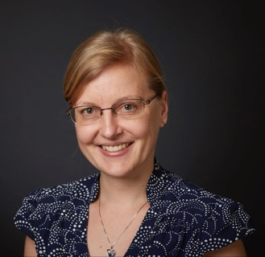  Iva Strnadova  Resigned 2018 | 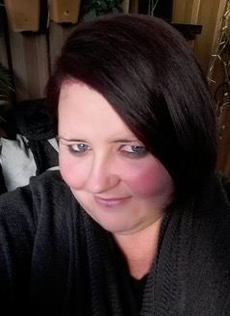  Cherohn Rule  Committee Member  Resigned 2018

WWDA Staff 2018-2019

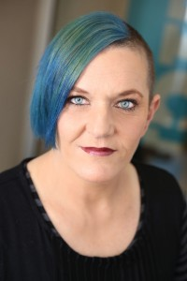  Carolyn Frohmader  Executive Director  (Full Time) | 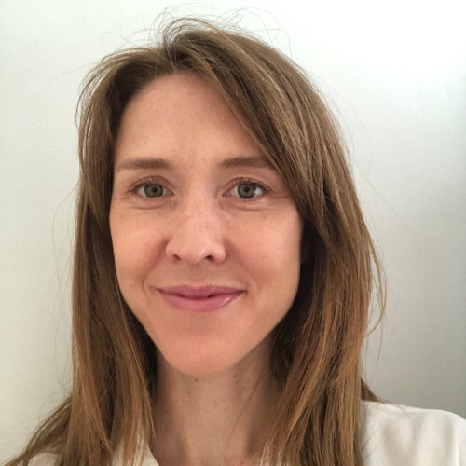  Naomi Thomson  Project Manager, Virtual Centre  (Full Time) | 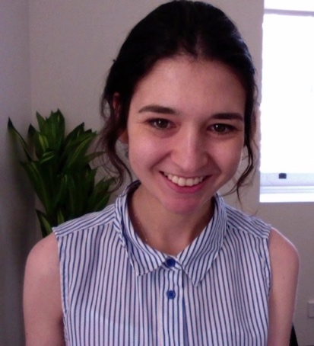  Heidi La Paglia  Senior Content Writer, Virtual Centre  (Full Time)
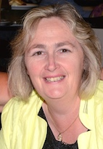  Sharon Williams  Office Manager  (Part Time) | 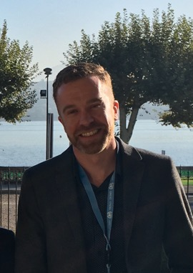  Christopher Brophy  Director, Policy and Communications  (Full Time)  Resigned January 2019

WWDA Presidents Report – by Tricia Malowney

Tricia Malowney
WWDA President

As always, WWDA has worked extremely hard during the reporting period (July 2018 – June 2019) and has achieved some great things, despite many challenges to the organisation due to limited capacity and funding and ongoing uncertainty around our future. Despite the challenges our organisation faced during the reporting period, WWDA still manages to undertake work that is ground-breaking, cutting edge and critically acclaimed. As WWDA President, I am extremely proud of our organisation and what we are able to achieve on such limited resources.

This Annual Report highlights just some of the key outputs and achievements during the reporting period, so I won’t duplicate these in my report. Rather, as WWDA President I would like to make some particular acknowledgments of thanks to those who have contributed to and supported the work of WWDA over the reporting period.

On behalf of the WWDA Management Committee and WWDA’s members and allies, I would like to thank our Executive Director, Carolyn Frohmader, for her ongoing dedication and commitment to our organisation. We were extremely fortunate to be able to recruit new staff, largely due a project funding grant through the NDIS ILC Program. We welcomed Naomi Thomson and Heidi La Paglia in early 2019, to manage and implement our National Project, ‘The Virtual Centre for Women and Girls with Disability’. Naomi was appointed as Project Manager and Heidi to the role of Senior Content writer. We were also pleased to be able to appoint Sharon Williams as WWDA Office Manager on a part time basis.

During the reporting period, we welcomed new Board members, Jen Lowe, Allira Honner, and Jody Barney, who were elected to the Board by WWDA members. Continuing Board member Jess White was elected to the role of Vice-President, and Pamela Menere to the role of Treasurer. During mid-late 2018, Pamela also acted in the role of WWDA President, and I thank her for her work in this capacity. We farewelled Fiona Strahan, Cherohn Rule and Iva Strnadova who resigned from the WWDA Board during the reporting period, and I thank them for their contributions to WWDA during their tenure as Board members. We sadly said farewell to Christopher Brophy, who had worked with WWDA for several years as Director of Strategic Communications and Policy. Chris took up a new position in the Victorian Government, and we wish him all the best and thank him for his contribution to our organisation.

I would like to formally recognise and acknowledge the WWDA Board members for their ongoing commitment and efforts over the past year. I also acknowledge with thanks, the many contributions our members make to the work and success of WWDA. Whether it is through representing WWDA at national or international conferences and events; on state or national boards or committees; contributing to our discussion lists, Facebook page, website and twitter; or sharing with us your lived experiences of being women with disability, we highly value your contributions. It is, after all, the lived experiences of women and girls with disability that inform and direct the work we do, so thank you for your efforts, support and dedication.

In December 2017, WWDA was advised that our tender application for operational funding was successful, and we are now funded until end June 2020. At this time, there is no guarantee of ongoing funding post June 2020, but we remain hopeful that the Australian Government will continue to fund WWDA into the future. We acknowledge, with thanks the Department of Social Services (DSS) for funding WWDA to end June 2020. We also acknowledge the ongoing support of WWDA’s Accountant, Cody Burdon, and thank him for ensuring WWDA maintains the highest level of financial management and accountability.

Tricia Malowney
WWDA President

WWDA Executive Directors Report – By Carolyn Frohmader

Carolyn Frohmader

The 2018-2019 financial year proved another very busy year for WWDA. As many WWDA members and supporters would be aware, in late 2017, WWDA was required to apply for our operational funding through an open public tender process. Our application was successful, and we were funded $300,000 per year for 2 years (to end June 2020).

At this stage, there is no guarantee of ongoing operational funding post June 2020, and this uncertainty makes it difficult to plan into the future and be able to offer staff security of tenure.

WWDA’s key work during the reporting period (1 July 2018 – 30 June 2019) focused on: the priority issues identified by our members; key work areas that are a requirement of our funding contract with the Department of Social Services (DSS); and work relating to Australia’s international human rights obligations as they pertain to people with disability.

Our members have made it clear that there are four key thematic areas that they consider warrant priority from WWDA and from Government. These key areas include:

- The prevention of all forms of violence against women and girls with disability;
- Promoting the sexual and reproductive health and rights of women and girls with disability;
- Promoting decision-making and agency of women and girls with disability; and,
- Promoting leadership and participation opportunities for women and girls with disability.

The following section of this report provides a brief summary overview of some of WWDA’s key achievements and outcomes during the 2018-2019 reporting year. Further detail of WWDA’s work can be found on our extensive website at www.wwda.org.au and across our other digital platforms.

As Executive Director, I would like to take this opportunity to firstly, pay tribute to Dr. Margaret Cooper, who sadly passed away in October 2018. Margaret was one of WWDA’s founding members and also WWDA’s inaugural President following incorporation of the organisation in 1995. I remain indebted to Margaret for the support and advice she gave me during my many years as Executive Director of WWDA. In May 2019, WWDA also lost one of our founding members, Annie Parkinson, who passed away in hospital in Sydney. Annie was a past President and life-member of WWDA, being involved in the organisation since its inception. Annie represented WWDA on many national advisory structures over the years, and also represented WWDA at state, national and international conferences and events.

I would like to thank Tricia Malowney (WWDA President) for your support over the past year, in what has been another very challenging and difficult year for WWDA. I would also like to thank Pamela Menere for her support during her time as WWDA’s Acting President during late 2018.

I would also like to thank the current members of the WWDA Board who have supported me during the reporting period. Thanks too, to Fiona Strahan, Iva Strnadova and Cherohn Rule who stepped down from the WWDA Board during the reporting period. Thank you for your contribution to WWDA and I wish you all well in your future endeavours.

I would like to acknowledge and thank those WWDA members who have undertaken representative work on behalf of our organisation during the reporting period, and also to our members and supporters for their continued faith in WWDA and our work.

I would like to particularly acknowledge the extraordinary contribution to WWDA by Chris Brophy, Director of Strategic Communications and Policy. Chris resigned from WWDA in December 2018 to take up new opportunities. We thank Chris for his wonderful contribution to WWDA over the years he was with us, and wish him all the best in his new job and new travel adventures.

I would not be able to perform my role as Executive Director without the fantastic support from WWDA staff. In early 2019, WWDA was fortunate to welcome Naomi Thomson, Heidi La Paglia and Sharon Williams to the WWDA staff, and as well as performing exceptionally in their own roles, they have also provided significant support to me as Executive Director.

I would like to thank our accountant, Cody Burdon for his exceptional service over the past year. Cody is a wonderful asset to WWDA, and we are very fortunate to have his high-level financial knowledge and skills to support the work of WWDA.

I acknowledge as always, the Department of Social Services (DSS) for providing WWDA’s operational funding, and also the Department of Prime Minister and Cabinet (Office for Women) for providing a small project grant to WWDA to enable us to hold a National Disabled People’s Organisations and Women’s Alliances Workshop in October 2018.

Lastly, but certainly by no means least, I would like to pay particular thanks to my daughter Lottie – for her patience and her “behind the scenes” support of, and contribution to WWDA.

Carolyn Frohmader
Executive Director

Summary of Key Achievements and Outcomes

Royal Commission into Violence, Abuse, Neglect and Exploitation of People with Disability

During the reporting period, WWDA continued our long campaign to advocate for a Royal Commission into all forms of violence against people with disability. WWDA authored the Civil Society Statement calling for a Royal Commission, and co-ordinated the Civil Society campaign, which resulted in 163 civil society organisations and 383 individuals endorsing the Civil Society Statement.

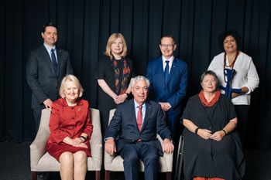

Commissioners
Like many other organisations and individuals, WWDA was relieved and thrilled when Prime Minister Scott Morrison formally announced the Royal Commission into Violence, Abuse, Neglect and Exploitation of People with Disability on 4th April 2019. The Hon Ronald Sackville AO QC has been appointed as Chair of the Royal Commission. Mr Sackville will be supported by six other Royal Commissioners: Hon Roslyn Atkinson AO; Ms Barbara Bennett PSM; Dr Rhonda Galbally AC; Ms Andrea Mason OAM; Alastair McEwin AM; Hon John Ryan AM.

The Royal Commission is the culmination of decades of advocacy by people with disability, their supporters and allies. WWDA has worked collaboratively with the Australian Government to help establish the Royal Commission, including providing advice and expertise on the Terms of Reference for the Royal Commission, and the thematic areas that the Royal Commission will use to frame its work. WWDA co-authored the formal Submission on the Draft Terms of Reference, for and on behalf of Disabled Peoples Organisations Australia (DPO Australia). WWDA’s President and Executive Director also attended the first Roundtable meeting with the appointed Commissioners on 18 June 2019, in order to assist in the development of a framework to guide the work of the Royal Commission.

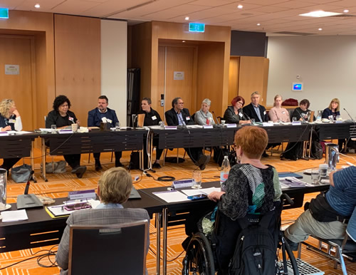

WWDA Executive Director attends first disability advocates workshop

WWDA has written formally to the Minister for Social Services and the Chair of the Royal Commission, requesting funding support to enable our organisation to work with our members to ensure they can engage with the Royal Commission, and also to ensure that WWDA can provide our expertise to all aspects of the work of the Royal Commission. We hope that our organisation will be adequately resourced in the near future to enable us to work with the Royal Commission over its three year term.

The ‘Virtual Centre for Women and Girls with Disability’

During the reporting period, WWDA commenced our major national project to establish ‘The Virtual Centre for Women and Girls with Disability’, which will be a one-stop digital platform gateway to accessible information, support and referral information for all women and girls with disability, their support persons, families and friends. The Virtual Centre will focus on the four thematic priority areas identified by women and girls with disability in Australia – leadership and participation; decision-making and agency; sexual and reproductive health and rights; and safety from all forms of violence. The need for this Project was initially identified during WWDA’s two-year project in 2012-13, called the “Stop the Violence Project” (STVP), and formed one of the recommendations from the Final Report of the STVP. This two year national project is being funded through a grant from the National Disability Insurance Scheme (NDIS) Information, Linkages and Capacity Building (ILC) Program.

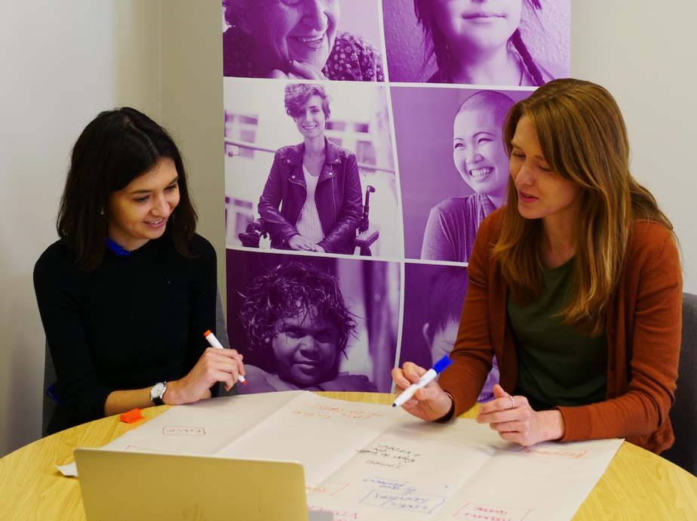
Heidi La Paglia (L) and Naomi Thomson (R)

In early 2019, WWDA recruited new staff to manage and implement the ‘The Virtual Centre for Women and Girls with Disability’ Project. We were delighted to welcome Naomi Thomson to the role of Project Manager for the Virtual Centre Project, and Heidi La Paglia to the role of Senior Content Officer.

Naomi and Heidi have done an incredible job since early 2019, in managing and implementing this critical project for women and girls with disability. From the outset, women and girls with disability from around Australia have been engaged to co-design the Virtual Centre. This project reflects and demonstrates WWDA’s commitment to meaningful and genuine participation of women and girls with disability in all aspects of our work.

Key achievements of the project between January - June 2019 included:

- Establishment of a Project Steering Committee, comprised of seven women with deep networks across the disability and women’s sectors. This committee meets bi-monthly to provide high level guidance and oversight of the project.

- Establishment of an Expert Advisory Panel (EAP), comprised of just over 40 women with disability. This diverse group includes young women (18-25 years), rural and regionally located women, Aboriginal and Torres Strait Islander women, women who identify as LGBTQI+ and culturally and linguistically diverse women. The EAP membership involves representatives from every state and territory and also includes a group of women with intellectual disability who are met with in person. EAP members are engaged regularly to provide feedback and guidance on Virtual Centre structure, design and content. They will continue to be engaged as required throughout the project to ensure that the Virtual Centre is accessible, relevant and high quality.

- Completion of a comprehensive desktop audit of existing information and resources relevant to the four key priority areas.

- Selection of website design agency Handbuilt Creative to undertake the design and development of the Virtual Centre, following a competitive tender process.

WWDA’s Virtual Centre will be launched in March 2020, so stay tuned to WWDA for updates!

The development and launch of ‘Sunny’

A major achievement for WWDA during the reporting period has been the development and launch of ‘Sunny’. WWDA created Sunny with a team of women with disability, and our friends at 1800RESPECT – Australia’s national sexual assault, domestic and family violence counselling service. Designed by and for women with disability, Sunny is a new app that supports women with disability to learn about violence, know their rights and reach out for support.

While the app is designed for use in Australia, the easy to read content on violence and rights is relevant to women with disability everywhere.

Women with disability can use Sunny on their iPhone or Android phone to:

- Tell their story
- Learn about different types of violence and abuse
- Learn about who can do violence and where it happens
- Know their rights
- Contact people who can help.
Sunny has been designed with accessibility in mind so it can be used by everyone. Sunny is compliant to level AA of the Web Content Accessibility Guidelines 2.0 (WCAG) and the Australian Government Digital Service Standard. A suite of in-depth Easy English print resources for women with disability who may not have access to the internet or a smartphone, are currently being developed to support Sunny.

The Sunny app is free and available on iPhone and Android:

App Store: http://bit.ly/SunnyAppStore
Google Play: http://bit.ly/SunnyGooglePlay

Visit: www.1800respect.org.au/sunny to find out more.

Sunny was officially launched at Parliament House, Canberra on 27 November 2018, by Minister Sarah Henderson and Minister Michelle Landry. The women who helped to create Sunny also attended the launch. WWDA Board member Monique Crowden and WWDA member Anj Barker did a brilliant job of introducing Sunny at the official launch. You can watch Anj’s video from the launch at: https://www.facebook.com/watch/?v=321749975078070

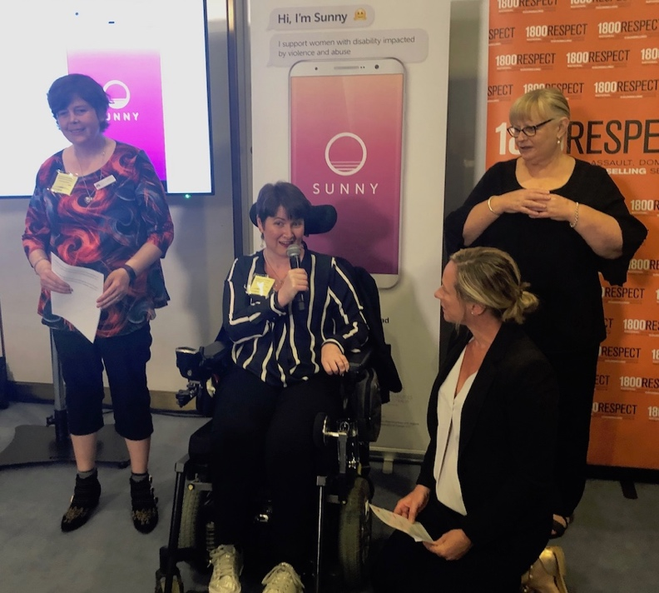

Monique Crowden (L) and Anj Barker (C)

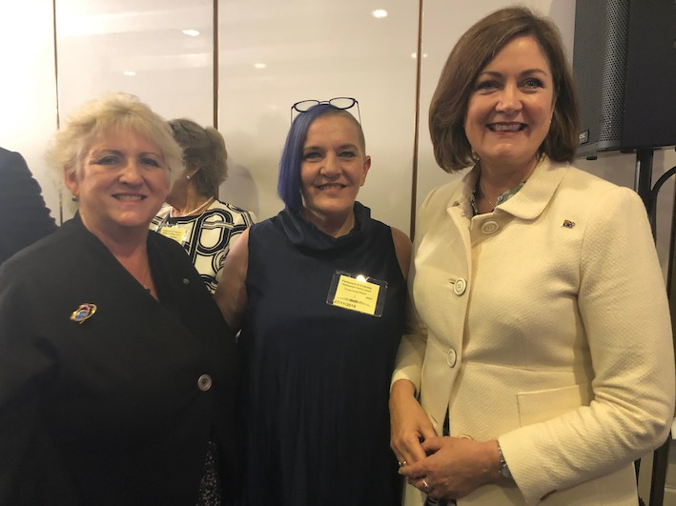

Minister Landry (L) WWDA Executive Director Carolyn Frohmader (C) and Minister Henderson (R)

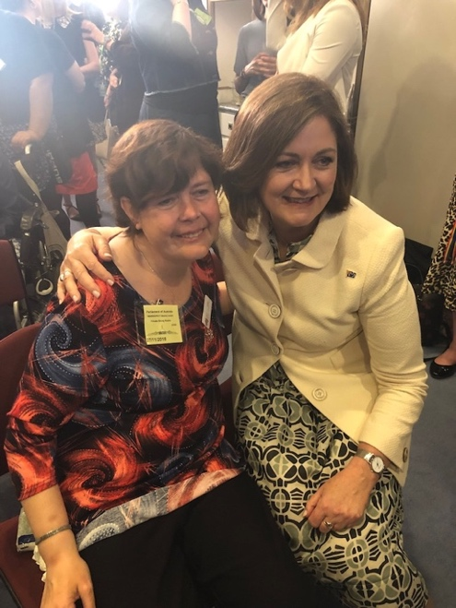

Monique Crowden (L) and Minister Henderson (R)

New National WWDA Office

Between December 2018-Junary 2019, while many people were enjoying their Xmas-New Year break, WWDA staff were busy setting up its new national office in Hobart. For almost ten years, WWDA’s head office had been located in the private home of the WWDA Executive Director, as WWDA did not have the resources within our operational funding, to pay rental costs for a separate office. We were very, very happy to finally be able to secure the funds to have our own national office. So, between Xmas-New Year, WWDA staff and volunteers spent our time unpacking boxes, setting up desks, buying fake potplants, putting up our banners, and generally working hard to have our new premises ready to go for the start of 2019.

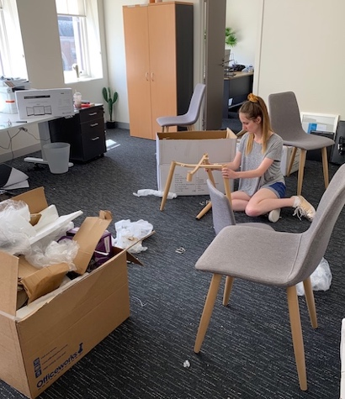  Volunteer Lottie helps to set up the new WWDA Office | 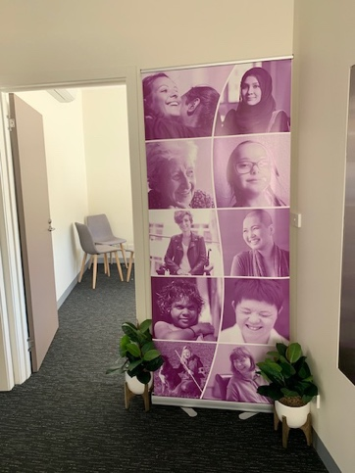  One of WWDA's Banners

In late 2018, we were delighted to welcome Sharon Williams to our team, as part-time Office Manager. Sharon was amazing in co-ordinating the new office set up and since her appointment has kept us on our toes. It is truly fantastic that WWDA now has paid staff, and although Naomi and Heidi are only funded in their roles until end June 2020, we are working hard to secure the resources to keep these amazing women.

1800RESPECT

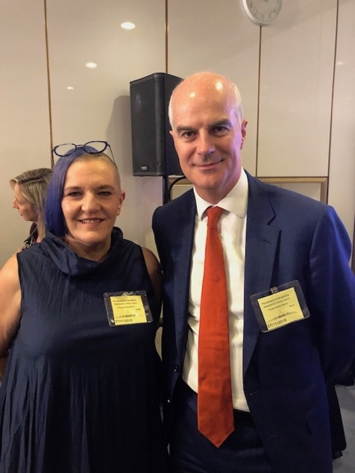

Medibank CEO Craig Drummond (L) with WWDA Executive Director Carolyn Frohmader (R)
Over the past year, WWDA has continued our collaboration with the 1800RESPECT service, administered by Medibank on behalf of the Australian Government. In 2018, the Australian Government provided over $2 million to 1800RESPECT to deliver the Disability Pathways Project. This national project aims to improve pathways to safety for women and girls with disability experiencing or at risk of violence. WWDA is a member of the Expert Advisory Group (EAG) for this Project. The EAG meets monthly to provide advice and assist with the implementation of the Project. During the reporting period, WWDA also developed a suite of Easy English information resources on violence against women and girls with disability. These resources are currently being trialled with ten family violence services throughout Australia.

WWDA Executive Director, Carolyn Frohmader, has continued her role as a member of the 1800RESPECT National Sector Advisory Group (NSAG). This group meets regularly to oversee and provide expert advice on the strategic direction of the 1800RESPECT service, as well as provide expertise regarding how the 1800RESPECT service can better address the needs of all women who experience, or are at risk of experiencing violence.

In April 2019, Carolyn was interviewed for a feature article as part of the ‘Sector In Focus’ series, which highlights members of the NSAG and the key issues they are keen to see 1800RESPECT address.

Australia’s Review under the Convention on the Rights of Persons with Disabilities

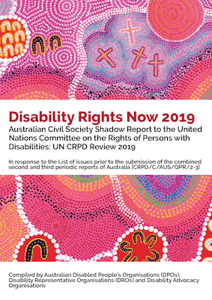

The Committee on the Rights of Persons with Disabilities will be undertaking the Review of Australia’s compliance with the CRPD during the week of 7th-13th September 2019. The Review will take place in Geneva at the Palais de Nations. In 2017, WWDA wrote the List of Issues Submission to the CRPD Committee (on behalf on the disability sector). The List of Issues Submission provided recommendations to the CRPD Committee on the questions they needed to ask the Australian Government as part of the review of Australia’s compliance with the CRPD. The Australian Government has provided its written Report to the CRPD Committee and a Government delegation will also appear before the Committee in September as part of the Review of Australia. The Australian Government’s Report responds to the formal List of Questions asked by the CRPD Committee. This process is known as the List of Issues Prior to Reporting (LOIPR).

A National CRPD Civil Society Working Group was established in 2017, and the WWDA Executive Director has been WWDA’s representative on this Working Group. One of the key tasks of the Working Group is to write the Civil Society Shadow Report for the CRPD Committee as part of Australia’s Review. The ‘Shadow Report’ responds to the formal List of Questions asked by the CRPD Committee, to the Australian Government.

The WWDA Executive Director has researched and written the Australian Civil Society Shadow Report on behalf of the National CRPD Civil Society Working Group, and on behalf of people with disability in Australia. The Shadow Report has to follow strict guidelines, including a Word limit of 10,700 words, including Recommendations. The Report will now be translated into French and Spanish, which along with English, are the key working languages of the United Nations. An Auslan video is also being made of the Reports Executive Summary and key issues.

A non-government delegation will also travel to Geneva in September for Australia’s review under the CRPD. The WWDA Executive Director has been asked by the National CRPD Civil Society Working Group to lead the delegation, along with Damian Griffis from First People’s Disability Network (FPDN). At this stage due to poor health, it is not certain whether Carolyn will be able to travel to Geneva to lead the delegation.

There is a large amount of work still to be undertaken prior to the review in Geneva in September. The WWDA Executive Director is authoring a series of ‘Fact Sheets’ which will be used by the delegation as lobbying material with the CRPD Committee. The Fact Sheets will focus on priority themes, such as Violence; Forced Treatments; Denial of Legal Capacity; Inclusive Education; Forced Sterilisation; Employment and more. These Fact Sheets form a very important part of the lobbying process with the CRPD Committee. There will also be a preparatory Workshop with the non-government delegation prior to leaving for Geneva. This Workshop will likely take place in August.

Once the CRPD Review of Australia is completed, the CRPD Committee will issue their recommendations to the Australian Government, on what the Government needs to do to improve the human rights of people with disability in Australia. These recommendations are known as ‘Concluding Observations’.

The 2019-2020 year will be a busy year for WWDA, as we will need to undertake a significant amount of advocacy to ensure that the Australian Government works towards implementing the recommendations made by the CRPD Committee.

National Women’s Alliances and DPOs Workshop

In March 2016, KPMG was engaged by the Australian Government Department of Prime Minister and Cabinet, Office for Women, to conduct a review of the National Women’s Alliances (NWA) model. The review focused on assessing the coherence the model; strategies and outputs; alignment of the model with Australian Government priorities; and, whether the model was functioning as intended.

Key recommendations from the review were for the National Women’s Alliances to (i) increase inter-alliance collaboration; (ii) increase the representation of marginalised populations, including women with disability, women from migrant and refugee backgrounds, and members of the LGBTI communities in the work of the Alliances. The review report further recommended that engagement with marginalised groups should be embedded within the work of the Alliances, as opposed to reliance on cohort-specific organisations to represent the interests of these populations.

In order to support these recommendations, the Office for Women provided a small amount of project funding to WWDA to organise and host a one-day national workshop with key decision makers from each of the six Alliances and the four member organisations of Disabled People’s Organisations Australia (DPO Australia). The purpose of the workshop was to explore how the organisations could collaborate to strengthen representation and engagement of women with disability across the women’s sector.

The workshop was held on 18 October 2018 in Sydney and was facilitated by Liz Forsyth from KPMG. The DPO Australia members and the six National Women’s Alliances were represented by their Chairpersons and CEOs, or other senior representatives as necessary. The Workshop was a great success and the National Women’s Alliances and DPO Australia organisations are planning for a further forum in 2019.

The final report from the Workshop was published by WWDA in November 2018.

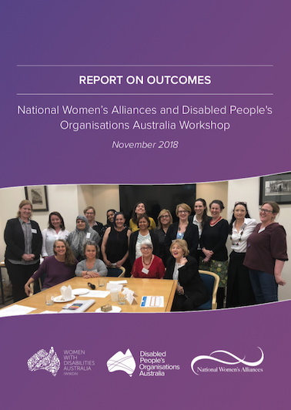

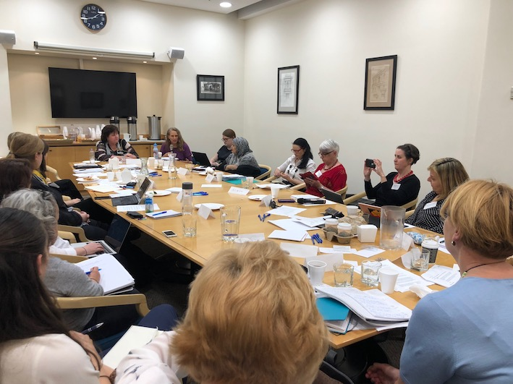

National Women’s Alliances & DPO Australia Forum

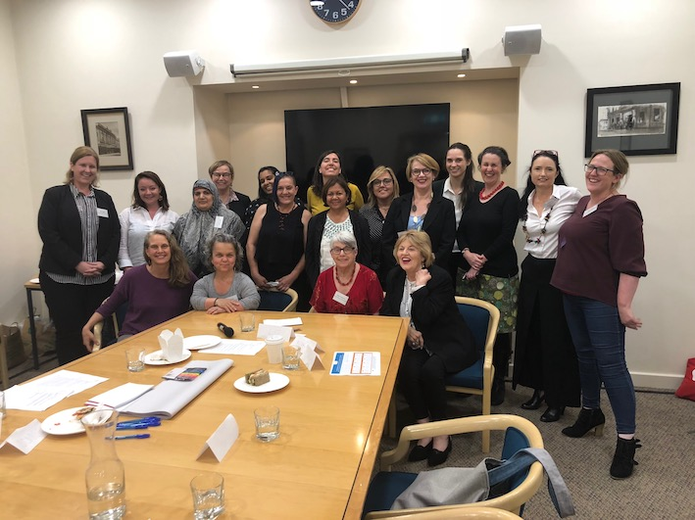

National Women’s Alliances & DPO Australia Forum
Policy Submissions and Representation

During the reporting period, WWDA developed a range of policy submissions to Government across several issue areas; contributed to international initiatives to improve the status of women and girls with disability globally; contributed to disability reforms being undertaken by the Australian Government; undertook extensive representation work; participated as members of the Civil Society delegation to the CRPD Conference of States Parties (COSP); and contributed to a number of national and state/territory research and reform initiatives of interest to women and girls with disability.

Our current operational funding contract with DSS does not permit us to use any of our operational funding for international travel, so WWDA is often unable to be represented at critical international events unless we can source external funding.

Just some examples of WWDA’s Policy Submissions and Representation work during the reporting year included:

- Development and publishing of WWDA’s 2019 Election Platform
- WWDA Submission to inform the Fourth Action Plan to Reduce Violence Against Women and their Children
- WWDA Submission the Productivity Commission National Disability Agreement Review
- Position Statement to the Productivity Commission for the Review of the National Disability Agreement
- Submission to List of Issues and Questions in Relation to the Eighth Periodic Report of Australia to the Committee on the Elimination of Discrimination Against Women (CEDAW)
- Co-authored the formal Submission on the Draft Terms of Reference for the Royal Commission into Violence, Abuse, Neglect and Exploitation of People with Disability
- Conducted the 16 Days of Activism Against Gender-Based Violence Social Media Campaign
- Co-authored the Open Letter to the Prime Minister Scott Morrison calling for Royal Commission into Violence against People with Disability
- Co-ordinated Roundtable of women with disability with the Productivity Commission on the issues relating to the National Disability Agreement (NDA) and women and girls with disability
- WWDA Submission to the Draft Terms of Reference for the Royal Commission into Aged Care
- Member of the AHRC National Advisory Committee for the AHRC National Project on violence against people with disability in institutional settings
- Member of the National Disability Strategy (NDS) Beyond 2020 National Reform Advisory group
- Contribution to the development of the National Disability Strategy (NDS) Third Implementation Plan
- Presentation to the National Advocacy & NDIS Quality and Safeguards 2 day Forum, Melbourne
- Key stakeholder interviews for the evaluation of the Third Action Plan to Reduce Violence against Women and their Children
- Key stakeholder interviews for the evaluation of the 1800RESPECT service
- Participation in Roundtable Consultations to inform the development of the Fourth Action Plan to Reduce Violence against Women and their Children
- Delegate to the ALP Roundtable on the Prevention of Violence against Women
- Submission to the Global thematic study on the role of Disabled Peoples Organisations (DPOs)
- Delegate to the Disability Roundtable with DSS Minister Fletcher
- Delegate to the DSS Workshop for Disabled Peoples Organisations (DPOs) and Disability Representative Organisations (DROs)
- Member, 1800RESPECT National Sector Advisory Group (NSAG)
- Member, 1800RESPECT Disability Pathways Project Expert Advisory Group
- Monthly meetings with NDIA Stakeholder Engagement Team
- Delegate to the Roundtable with DSS Minister Fletcher on the Safe Spaces Program
- Authored Summary Document on Violence Against People with Disability in Australia
- Meetings with Disability Discrimination Commissioners
- Development of Concept Note for Side Event at the CRPD Conference of States Parties
- Contributed to the planning and organising of the National Disability Awards
- Submission to, and meeting with the NDIA CEO and Scheme Actuary regarding gender inequity in the NDIS
- Delegate to the Department of Prime Minister & Cabinet (Office for Women) Webinar on CEDAW
- Contribution to the NDIA CEO’s Forum
- Meetings with Ministers, Shadow Ministers and other politicians

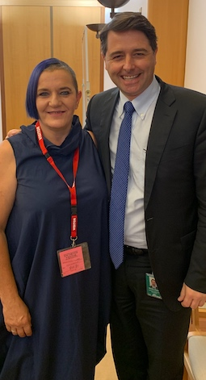  WWDA Executive Director Carolyn Frohmader (L) with DDA Commissioner Alastair McEwin | 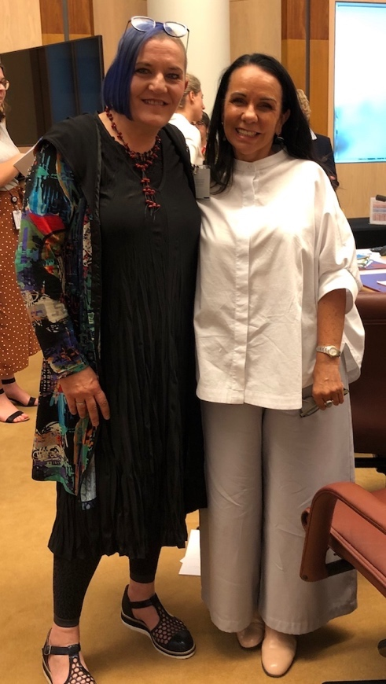  WWDA Executive Director Carolyn Frohmader (L) with Senator Linda Burney

The CRPD Conference of States Parties

The 12th Session of the Conference of States Parties (COSP) to the Convention on the Rights of Persons with Disabilities (CRPD) was held from 11th to 13th June 2019 at the United Nations Headquarters in New York. The annual conference brings together countries that have ratified the UN Convention on the Rights of Persons with Disabilities (CRPD) and representatives from Disabled People’s Organisations (DPOs) and civil society organisations to discuss implementation of the CRPD. The theme of this year’s COSP was awareness-raising and “Ensuring the inclusion of persons with disabilities in a changing world through the implementation of the CRPD”, with three subthemes:

- Technology, digitalization and ICTs for the empowerment and inclusion of persons with disabilities
- Social inclusion and the right of the highest attainable standard of health
- Inclusion of persons with disabilities in society through participation in cultural life, recreation, leisure and sports

As WWDA is unable to use any of our operational funding for overseas travel and/or events, we applied for funding to enable a woman with disability to attend this important Conference. The Convention on the Rights of Persons with Disabilities (CRPD) is clear on the importance of gender and the need for Governments to undertake additional, targeted measures to protect and promote the rights of women and girls with disability. Unfortunately WWDA’s request for funding from the Australian Government to attend the Conference of States Parties (COSP) was unsuccessful. WWDA subsequently made the decision to use some of our leadership and development funds (not government funds) to send a young woman with disability to the COSP to represent our organisation, and to build her knowledge and skills in relation to the CRPD and the United Nations processes regarding implementation of the CRPD.

Heidi La Paglia, who is employed with WWDA and commenced her role in early 2019, was selected to attend the COSP in New York in June 2019.

Heidi had the opportunity to travel with the Australian civil society delegation of people with disability to the UN for the COSP. Along with contributing to work of the civil society delegation, Heidi was able to meet with other women with disability from around the world who were attending the COSP. This opportunity for international networking of women with disability is critical for WWDA, and we will continue to seek funding to enable more WWDA members to participate in international human rights events that are important to disabled women and girls.

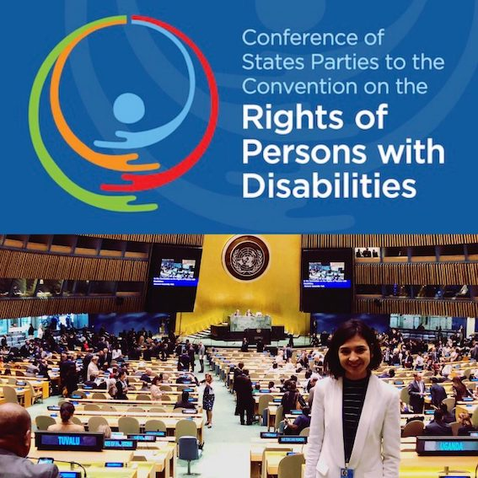

Heidi La Paglia at the 12th Session of the Conference of States Parties (COSP) to the CRPD

On her return to Australia, Heidi prepared a written report on her experience at the 12th Session of the Conference of States Parties (COSP) to the CRPD.

Tender Applications

During the reporting period, WWDA developed a number of Tender Applications in an effort to secure project funding for initiatives on the four priority areas identified by women and girls with disability in Australia. The process of writing tender applications to Government is laborious and time-consuming, but necessary in efforts to secure funding. We applied through a public open tender process for project funding from the NDIS ILC Program for organisational capacity building funding, which was capped at $120,000. This ILC grant opportunity was announced in early 2019 and was only available to ‘Disabled People’s and Families Organisations’. We were delighted to learn that our application had been successful. This grant will be used by WWDA between July 2019 – June 2020 to:
- bring the WWDA Board members together for a residential two-day governance workshop;
- re-develop WWDA’s 25-year old website to be fully accessible; and,
- conduct a 2-day Easy English training workshop for all WWDA staff and volunteers.

In April 2019, WWDA submitted a Tender Application to the advertised NDIS ILC Grants Program Funding Round 2019-2022, to develop a National Youth Network for Young Women and Girls with Disability aged 13-25 years. The proposed project aims to develop the Network across a range of digital platforms, including a dedicated web portal, complimented by social media platforms to foster engagement and promote agency. The Network web portal will house youth-friendly, targeted, accessible and inclusive information resources developed on a range of disability types and on identified issues of concern to young women and girls with disability. The outcomes of the tender process are expected to be announced in August 2019. WWDA will advise our members and constituents of the outcome as soon as we are advised.

Mardi Gras!

In early 2019, WWDA was thrilled to be able to march in the Mardi Gras for the first time. Along with a number of colleague organisations, WWDA was a member of the Planning Committee for the people with disability float in this year’s Mardi Gras. The theme of the float was around accessible transport for people with disability, and our collective float ‘The Fearless Express’ was a crowd favourite.

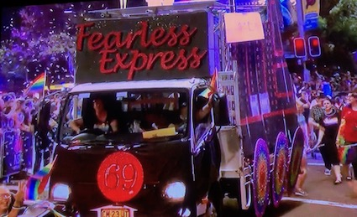

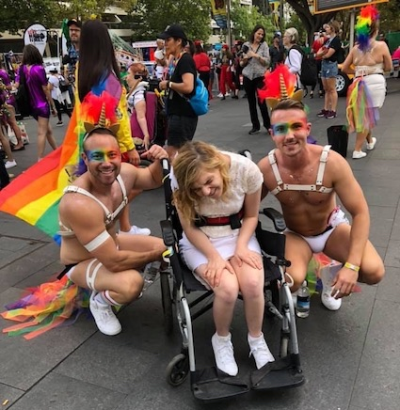

WWDA member Terri Rule at the Mardi Gras

Spotlight Initiative Global Civil Society Reference Group

In December 2018, WWDA was formally advised that our Executive Director, Carolyn Frohmader, had been selected from over 300 nominees worldwide, to be a member of the Global Civil Society Reference Group for the international Spotlight Initiative. The Spotlight Initiative is a global, multi-year partnership between the United Nations and the European Union to eliminate all forms of violence against women and girls. The Spotlight Initiative represents an unprecedented effort to invest in gender equality and women’s empowerment as a precondition and driver for the achievement of the Sustainable Development Goals. Carolyn is the only elected representative on Global Civil Society Reference Group who has disability specific expertise. Carolyn looks forward to representing women and girls with disability on the Global Civil Society Reference Group for this important global initiative.

For more information, go to: http://spotlightinitiative.org

Global WE DECIDE Technical Advisory Group

Since 2014, WWDA has been involved in a global project to address violence and sexual and reproductive rights violations against young people with disability throughout the world. I have been a member of the Technical Advisory Group for this global project for several years, and WWDA has been instrumental in the work of this global initiative. In early July 2015, the WWDA Executive Director was invited by the United Nations Population Fund (UNFPA) to travel to Uruguay to attend and participate in an international meeting of recognised experts on the theme of ‘Youth and Disability: Policies of Social Inclusion, Gender Equality, Non-Discrimination and Prevention of Sexual Violence’. The International Expert Group meeting was conducted specifically to assist the UNFPA and its partners, by informing the development of a four year global initiative aimed at improving the human rights of youth with disability – particularly their sexual and reproductive rights and their right to freedom from violence.

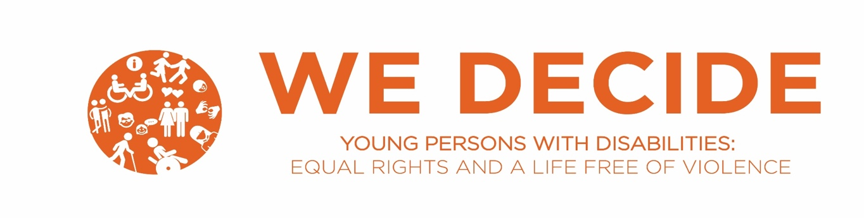

Following the International Expert Group meeting, WWDA was provided funds by the UNFPA to host a National Forum with young people with disability in Australia to get their input into the design, promotion and key themes for the global project. In 2015, WWDA hosted and organised a Youth with Disability National Forum: ‘Promoting Sexual and Reproductive Health and Rights’ which was held in Melbourne. An exciting outcome of this Forum, was that the young people with disability who attended, designed the logo and the name of the Global Project (WE DECIDE). The logo and the name was accepted by the UNFPA and has been used ever since in all initiatives for this global project. In June 2016, WWDA co-hosted the launch of the WE DECIDE Global Project at the CRPD Conference of States Parties (COSP) in New York.

In July 2018, the UNFPA published the report of its global study ‘Young Persons with Disabilities Global Study on Ending Gender-based Violence and Realizing Sexual and Reproductive Health and Rights’. This global study was part of the Project and the WWDA Executive Director was on the Advisory Group for the development of this global Report.

The WE DECIDE Project is now beginning the development of an ENGAGE multimedia presentation that shares a data-driven roadmap on how to better meet the sexual and reproductive rights of women and young people with disabilities and prevent gender-based violence. The output will be a multimedia presentation and accompanying materials that are designed to maximize the dissemination and use of WE DECIDE data and to catalyse momentum and action among global, regional, and country stakeholders. The Technical Advisory Group (of which the WWDA Executive Director is a member) will provide expertise and guidance on content and design of the presentation. It is anticipated that the multimedia presentation and accompanying resources will be completed by December 2019.

Disabled People’s Organisations Australia (DPO Australia)

During the reporting period, WWDA has continued our collaborative work as a member organisation of Disabled People’s Organisations Australia (DPO Australia), which is an alliance of four national Disabled Peoples Organisations (DPOs) in Australia. DPOs are organisations that are led by and made up of people with disability. DPO Australia promotes and advances the human rights and freedoms of all people with disability in Australia by working together on areas of shared interests, strategic priorities and opportunities. DPO Australia is comprised of four national Disabled Peoples Organisations: National Ethnic Disability Alliance (NEDA); First Peoples Disability Network (FPDN); People With Disability Australia (PWDA); and Women With Disabilities Australia (WWDA). During the reporting period, WWDA undertook a significant amount of work for and on behalf of DPO Australia. Detailed information on the work of DPO Australia can be found at the DPO Australia website.

Communications & Engagement

As a Disabled People’s Organisation (DPO), WWDA consistently seeks out opportunities to build its capacity to meaningfully engage with its members and stakeholders. During 2018-2019 we continued to expand and grow our digital media platforms and undertook a series of social media campaigns, including for example, the Social Media Campaign series of infographics over sixteen days as part of the 2018 ‘16 days of activism campaign to raise awareness of gender based violence against women’. WWDA has also used social media campaigns to promote key Government and related initiatives, including for example: the National Disability Insurance Scheme (NDIS) and International Day of People with Disabilities. We wrote, published and disseminated our WWDA Bulletin, including a number of feature editions. During the reporting period, WWDA has expanded its online reach and engagement mechanisms through its digital platforms including Twitter, the WWDA Facebook Page; the WWDA Website; and the establishment of the WWDA YouTube channel. WWDA has undertaken an extensive series of promotional activities during the reporting period across all its digital platforms.

Operational Development & Reporting

WWDA has continued to employ high standard governance and financial management practices. During the reporting year, WWDA has met all reporting and accountability requirements as well as those in relation to our funding bodies. In accordance with the constitutional requirements of the organisation, WWDA’s service agreements; the Associations Incorporation Act 1991 (ACT); and the Charities Act 2013 (Cth), WWDA has undertaken a wide range of internal and external reporting and accountability requirements. During the reporting period, WWDA has also undertaken a significant amount of work in relation to governance, including financial management, human resources, and related reporting.

WWDA’s sound governance, financial and organisational management practices are demonstrated through the following processes:

Undertaking of reporting in accordance with the constitutional requirements of the organisation, WWDA’s service agreements; the Associations Incorporation Act 1991 (ACT); and the Charities Act 2013 (Cth)
- Preparing and completing Annual Reporting requirements of the Australian Charities and Not-for-profits Commission
- Preparing and submitting WWDA Service Agreement (and relevant Project funding contracts) Progress and Project Reports and financial acquittals
- Writing, publishing and disseminating the WWDA Annual Report
- Provision of financial reports prepared by the WWDA Accountant to the WWDA Management Committee
- Annual Auditing of financial statements by registered audit company in accordance with the Australian Accounting Standards and Australian Auditing Standards
- Conducting bi-monthly meetings of the WWDA Board
- Conducting the WWDA Annual General Meeting
- Weekly meetings between WWDA Executive Director and the President of the WWDA Board
- Conducting of annual staff performance reviews
- Review and renewal of WWDA Insurance policies
- Annual review of WWDA Strategic Plan, WWDA Management Committee Orientation Kit
- Review and updating of the WWDA Employee Handbook

WWDA’s organisational management practices and ongoing quality improvement are further supported by the services of Employsure who are available assist WWDA to ensure our organisation maintains compliance with all employment legislation and work health and safety matters.

