Women With Disabilities Australia (WWDA)

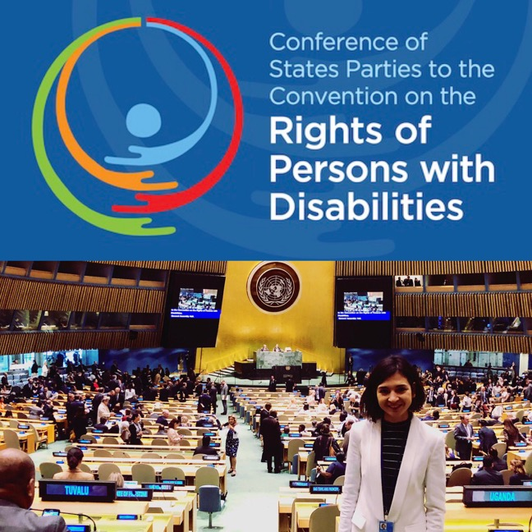
Report from the United Nations Conference of State Parties (COSP) on the Convention on the Rights of Persons with Disabilities (CRPD) 12th Session, New York, 10-13 June 2019
Image 1 (Above): Photo of Heidi La Paglia at United Nations with COSP12
Banner above.
Prepared by: Heidi La Paglia, WWDA Senior Content Officer
and Youth Representative to COSP12

Report from the United Nations Conference on the Convention on the Rights of Persons with Disabilities (CRPD) 12th Session, New York, 10-13 June 2019
By Heidi La Paglia for Women With Disabilities Australia (WWDA) © Women With Disabilities Australia (WWDA) July 2019.

Disclaimer
This post-event report is prepared by Heidi La Paglia for members of WWDA and other interested stakeholders. This report does not reflect the views of the Australian Human Rights Commission or the Australian Government.

About Women With Disabilities Australia (WWDA)
Women With Disabilities Australia (WWDA) is the peak non-government organisation (NGO) for women with all types of disabilities in Australia. WWDA is run by women with disabilities, for women with disabilities, and represents more than 2 million disabled women in Australia. WWDA’s work is grounded in a rights-based framework which links gender and disability issues to a full range of civil, political, economic, social and cultural rights. Promoting the reproductive rights of women and girls with disabilities, along with promoting their rights to freedom from violence and exploitation, and to freedom from torture or cruel, inhuman or degrading treatment are key policy priorities of WWDA.
Winner, National Human Rights Award 2001
Winner, National Violence Prevention Award 1999
Winner, Tasmanian Women's Safety Award 2008
Certificate of Merit, Australian Crime & Violence Prevention Awards 2008 Nominee, French Republic's Human Rights Prize 2003 Nominee, UN Millennium Peace Prize for Women 2000

Contact Details
Women With Disabilities Australia (WWDA)
Po Box 407, Lenah Valley TAS 7008
Email: po@wwda.org.au
Web: www.wwda.org.au / http://youth.wwda.org.au

Acknowledgment
It was an honour to be given the opportunity to represent Australians with disabilities at the 12th Conference of State Parties on the Convention on the Rights of Persons with Disabilities (CRPD), held in New York 10-13 June 2019.
I would particularly like to acknowledge the work of Carolyn Frohmader, the CEO of Women With Disabilities Australia (WWDA) and People With Disabilities Australia for supporting me to attend.

Introduction and Background
The Convention on the Rights of Persons with Disabilities was adopted by the United Nations General Assembly by its resolution 61/106 of 13 December 2006. It came into force on 3 May 2008 upon the 20th ratification. Article 40 of the Convention stipulates that “The States Parties shall meet regularly in a Conference of States Parties in order to consider any matter with regard to the implementation of the present Convention.” Since 2008, yearly sessions of the Conference of States Parties have been held at United Nations Headquarters, New York.
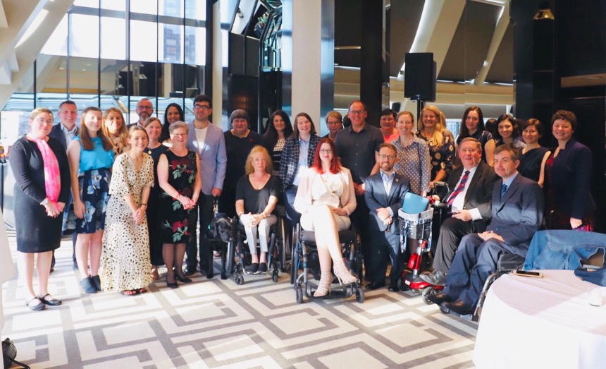
In June 2019, I was supported to join the Australian Delegation’ to represent Women With Disabilities Australia at the 12th Conference of State Parties on the Rights of People with Disabilities. The conference took place at the United Nations Headquarters in New York, 10-13 June 2019.
Image 2 (Above): Photo of full Australian delegation to COSP12.
I spent a week at the United Nations in New York learning about the work that Australia and other countries are doing to support the rights of people with disabilities and representing WWDA through in person and social media discussions.
During my time in New York, I attended a number of side events, where she participated in discussions about how to improve the rights of women and girls with disabilities and met a range of stakeholders in the sector.
This Report has been prepared by Heidi to highlight her work and experiences during her time in New York.

Delegation Preparation Meetings – Sydney
The members of the Australian Government and Civil Society Delegation met in at the Australian Human Rights Commission (AHRC) in Sydney twice prior to travelling to New York for half-day meetings to finalise all materials and preparations for the conference.
This meeting allowed members of the delegation to meet face to face, and was very helpful for me, as I had never attended a United Nations conference before.
At this meeting, I learnt about the proceedings of the conference, and was able to meet individuals from Disability People’s Organisations (DPOA’s) across Australia as well as Government representatives. It was also very important to ensure that, as members of the delegation, we were clear about our roles as delegates, our individual roles and also the imperative of ensuring we presented on the international stage, as a unified, well-organised, and professional delegation.

Travel to New York
To get to New York I left on the 6 June 2019 to meet other members of the delegation in Sydney before travelling to the United States on 7 June 2019. While I did not know anyone well prior to travelling to New York, the CEO of People With Disabilities Australia (PWDA), Therese Sands, as well as individuals from other organisations like the First People’s Disability Network (FPDN), the Council of Intellectual Disabilities NSW (CIDNSW) and Queensland Advocacy Incorporated (QAI) made me feel incredibly welcome as part of the delegation.
While I had travelled a fair amount in the past, I had never gone as far as the United States and was very anxious about the thought of length of the plane trips.
I was particularly worried about the 14-hour stint from Sydney to Las Angeles as I have chronic bowel and autoimmune problems which in the past have not served me well on long travel stints.
As expected, I did suffer a bit during the trip, and did not sleep at all. However, between watching documentaries on the Qantas inflight entertainment, doing some work on my MacBook and planning my personal agenda for the conference, I eventually made it to LA, at which point the five-hour plane trip which remained felt like no time.
When I finally made it to New York I hadn’t slept in over 30 hours. But this didn’t stop me from venturing into the city immediately after checking into the Hotel. Thinking back, I don’t know how I had found the energy, but I think I must have had an adrenaline rush by the fact that I was in a city I thought I would only ever see in movies. After checking out the array of soft drinks and limited options of fresh produce in the convenience stores called ‘Pharmacy’s,’ I navigated my way straight to the Empire State Building to get a sky-high view of the surrounding sky scrapers and city lights.
When I got three quarters of the way up the 102 floors of the building, I got stopped at a quite large line to the last lift to the top. Being used to the quiet and crowd free state of Tasmania, I quickly became impatient and opted to run the last leg of floors via twenty flights of stairs. Admittedly I regretted it half the way up but was relieved when I eventually made it to the top and got to see the full array of NYC lights before starting the United Nations conference.
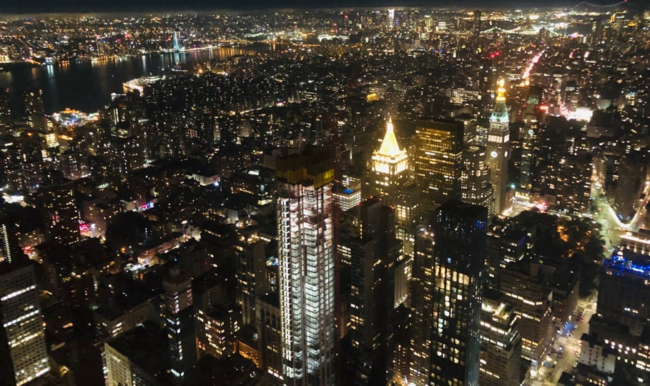

Image 3 (Above): Photo of New York City view from Empire state Building

Civil Society Day
On the first day at the United Nations conference, Monday 11 June, I had the opportunity to meet individuals from Civil Society across the globe, including individuals from non-governmental disability organisations, as well as community activists.
As a young person interested in improving the rights for women and girls with disability, I was particularly excited to meet and get to know people from women with disability organisations and groups as well as young advocates in the sector.
I started the day and the conference by attending a meeting of the UN Women on the participation of women with disabilities at the conference of the Commission on the Status of Women in 2020 – CSW64 / Beijing+25.
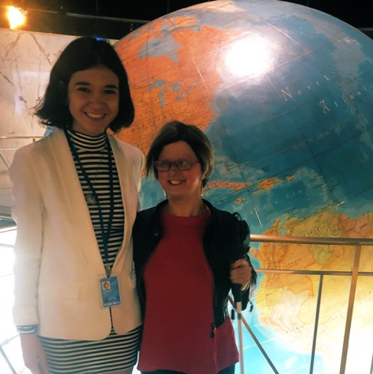
At this session I learnt that that is an extremely limited number of national Women With Disabilities but was able to meet Bonnie from the Disabled Women’s Network Canada (DAWN Canada) and Stephanie from Women’s Enabled International (WEI), who I had previously admired the work of. At this meeting I also made connections with individuals from UN Women and met an Australian performance artist and WWDA member who had previously represented us at the COSP, Sarah Houboult.

Image 4 (Left): Photo of
Heidi La Paglia and
Sarah Houboult standing
in front of world globe.

On the Civil society day of conference, I also attended the main session and discussion, where I was fortunate to hear the passionate words of many civil society advocates who raised a range of issues I am also interested tackling such as the high rates of discrimination, abuse and violence against women with disabilities, people with disabilities’ lack of access to social and community events, the low participation of people with disabilities in education and employment and the need for increased support and mentoring for young people with disabilities.

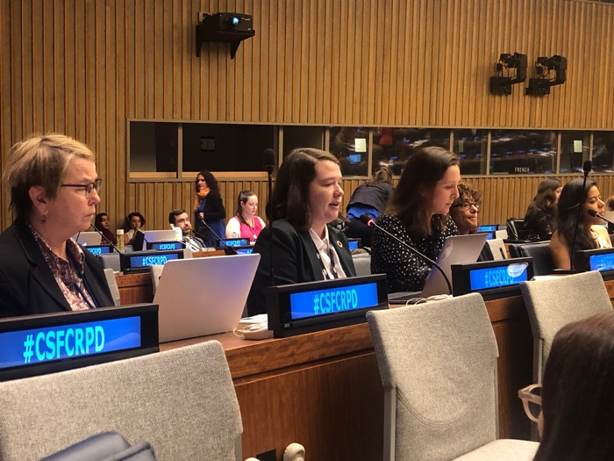
It was particularly inspirational to hear heartfelt statements from individuals from the Australian delegation who I had befriended such as Paige Burton, who is a youth representative and Vice-President for People With Disabilities Australia (PWDA) and Emma, a support worker and lawyer at Queensland Advocacy Incorporated.
Image 5 (Above): Photo of Paige Burton, Youth Representative and
Vice-President for PWDA making a statement.

Paige Burton’s statement about how young people with disabilities are too often left out of human rights conversations in resonated with me in particular. Paige stated… ‘We’ve heard a lot today and it will be said time and time again, ‘nothing about us without us,’ but that principle is rarely extended to children and young people with disability.’ Children and young people with disability have nuanced and important contributions to make but too often don’t have a seat at the table in decisions that affect our lives.’
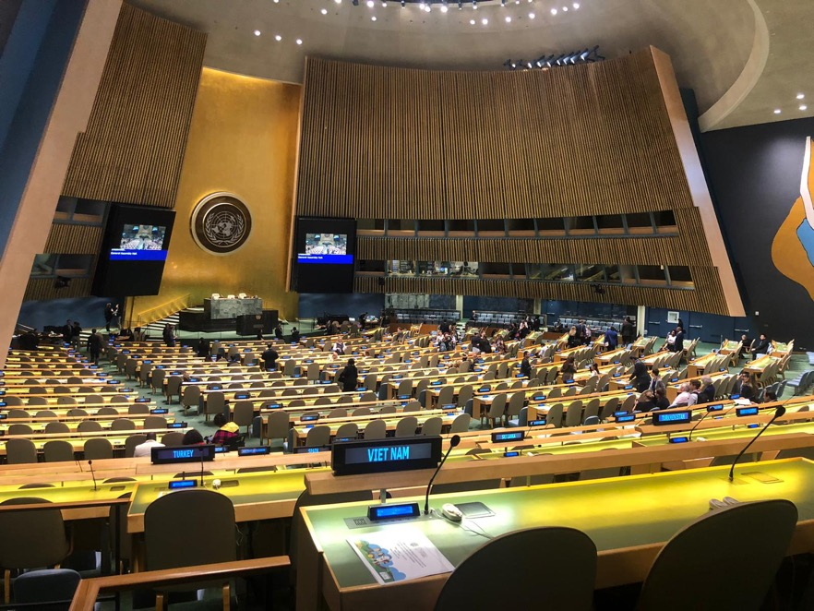
Image 6 (Above): Photo of United Nations General Assembly Room where the opening of the conference was held.

Formal Conference Proceedings
The first day of formal conference proceedings started on Tuesday 12 June, with the official opening of Cosp12 in the morning. The first part of conference included a large amount of commotion as the organisers has not set the conference opening in a room that was Wheelchair accessible. After many complaints and an impromptu protest, the situation was rectified. However, the lack of foresight to do this prior to the start of conference left a considerable amount to be desired and frankly, I was pretty shocked that providing such an obvious accommodation could be overlooked at the headquarters of the United Nations, the body that is supposed to govern the rights of people with disabilities around the globe.

Ironically, during the course of the same day the United Nations did launch a fantastic new Disability Inclusion Strategy, which aims to improve the inclusion of people with disabilities and the issues that face us in all areas of the UN’s work.

This much needed strategy was supported by representatives from across UN departments, including UN Women. It was good to hear the UN Women representatives recognise the importance of responding to issues that affect women with disabilities such as forced sterilisation, violence and access to employment; a sentiment that was reiterated later in the day at the side event, ‘When Women Lead.’

Side Events
As a WWDA staff member and activist for youth and women’s issues, my favourite part of the conference was attending the side events run by disability people’s organisations across the globe.

All of the side events I attended throughout the course of conference were unique and fantastic in their own ways however I will just mention three here that particularly stand out in my memory.

One of these events was an event about the ‘De-institutionalisation’ movement for people with disabilities, where I heard powerful speeches from some young women about how their life has changed since leaving group homes and institutions.
It was heartbreaking to hear about how some of these individuals had been dehumanised by support staff and denied their rights to make decisions by about even minor decisions that most of us take for granted such as what time to go to bed, when to see friends and what to eat for dinner. However, the stories of how some of these individuals had rebuilt their lives and gained a huge amount of independence after leaving institutions gave me a huge amount of hope for the future and eagerness to assist with the advocacy efforts and campaigns for broad de-institutionalisation.

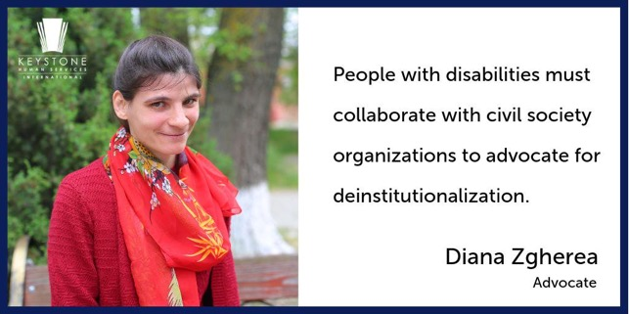

Image 7 (Left): Image of Diana Zgherea, a Self-Advocate who spoke at UN side event, ‘De-institutionalisation,’ about her experience during and after living in an institution for people with intellectual disability.

Another side event that has remained strongly in my memory discussed ‘Violence against people disabilities in Community-Based Care and Residential Settings’ across the globe and had a particular emphasis on women and girls.

It was interesting to hear about how women and girls with disabilities in Australia have similar experiences to in other nations. I was particularly horrified to hear that even countries that have some of the most progressive policies and programs are not getting it right when it comes to supporting the safety of women and girls with disability.

Paula Tesoriero, the New Zealand Disability Rights Commissioner for example raised the fact that women with disabilities in New Zealand are twice as likely to experience violence or abuse as other women and the President of DAWN Canada, Bonnie Brayton raised a number of issues related to violence against women with disability in Canada, including that there is a lack of services to support women and girls with disability who experience violence.
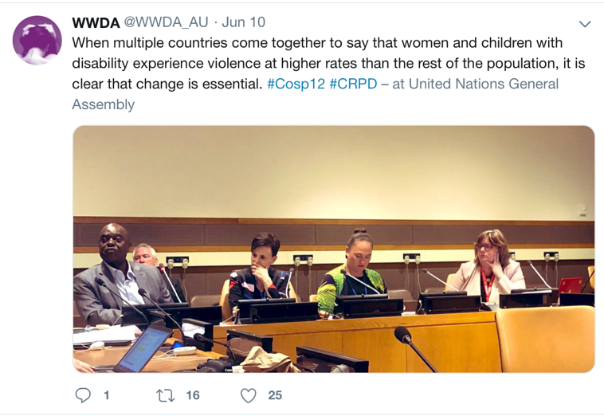

Image 8 (Above): Photo of my tweet on the WWDA Twitter page with Image of panel from the side Event, ‘Violence and Abuse Against People in Community-based Care and Residential Settings.’
Lastly, but certainly not least, another side event that has strongly resonated in my mind is the side event about the ‘Inclusion of Indigenous People With Disabilities’ which was hosted by WWDA’s partner DPOA organisations, People With Disabilities Australia (PWDA) and First People’s Disability Network (FPDN).

The event included four panel members, who included Sereako from FPDN, who told stories from their culture and families and talked about the relationship between the Convention on the Rights of People With Disabilities (CRPD) and the Declaration on the Rights of Indigenous People’s (DRIP).

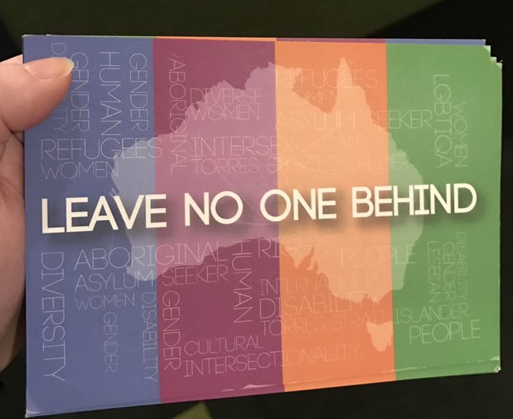

Image 9 (Above): Photo of postcard from side event
‘Inclusion of People With Disabilities’ with text ‘Leave No-one Behind.’
Sereako’s story in particular was moving as he spoke about how he had to move away from his home Island to the city in Sydney so that he could have access to the services and supports he needs. As a young indigenous man with disability, he expressed strong value for being able to have access to his home island and spend time with his family.

At the side event, it seemed that the entire room was mesmerised, and it was great to see him have the same effect to an even larger audience on conference floor in an intervention that he made the next day.
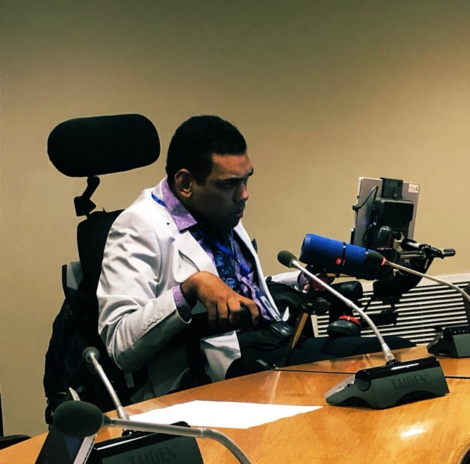
Image 10 (above): Photo of Sereako from FPDN speaking at side
event ‘Inclusion of People With Disabilities’ at Cosp12.

International Networks

On Thursday the 13 June, Women With Disabilities Across the world held an impromptu meeting on the basis that our issues are often left off the agenda of both the disability movement and women’s sector.

After lead up to it throughout the week, this meeting was full of energy, and sparked a plan to set up an International network of Women With Disabilities that will be organised in time for the sixty-fourth session of the Commission on the Status of Women (CSW) in March 2020, and will stay connected into the future.

For me, this was one of the most exciting parts of conference as it fostered connections which could make life impacting changes for women and girls with disability.
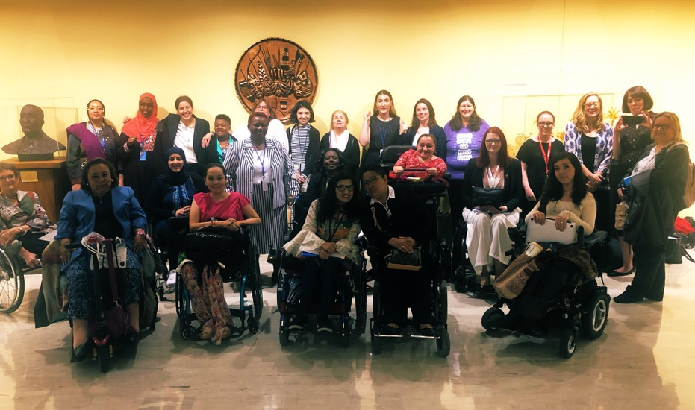
Image 11 (Above): Photo of group of women who attended impromptu meeting of women with disabilities at Cosp12.

The meeting also allowed me to connect with some amazing young women who are working on setting up Commonwealth and global networks of young people with disabilities.

I have connected with both of these networks since arriving back in Australia from the Cosp12 and discussed opportunities to be involved.

Conference Take Aways
Attending the United Nations Conference of State Parties (COSP) on the Convention on the Rights of Persons with Disabilities (CRPD) 12th Session in New York did not give me comfort that countries around the world is supporting the welfare and rights of women and girls with disability. However, it did leave me with many learnings about what I should be advocating for and how to do so, and allowed me to make invaluable connections with activists, NGO’s and governmental personnel.

On Friday the 14 June, after conference the conference had attended, the Australian Government representatives at COSP invited all of the delegation to a post-conference briefing to give feedback about their experiences.

As it was not a public meeting, I will not make comment about what other members of the delegation said at this briefing. However, I will say that I took the opportunity to both emphasise the benefits I gained out of the networking I did throughout the week with other civil society delegations, and to highlight areas where the conference and the attending government delegations can do better. One of these concerns was based on an observation I had made that some Government delegations had appeared to use the conference to promote their own work, rather than to learn from others on how to improve.

Based on this observation, I made the point that it was important that the Australian Government recognises the areas where they need to improve and taking action in those areas, and made suggestions such as the incorporation of an Autism Inclusion Strategy, which is something that I learnt during conference has been done by Malta.

While I was somewhat hesitant to make this statement in front of government representatives, they later thanked for my contributions both at the debrief and throughout the conference.

I even got the opportunity for selfies with the Government’s official mascot, Wagga the Wombassador to end the proceedings.
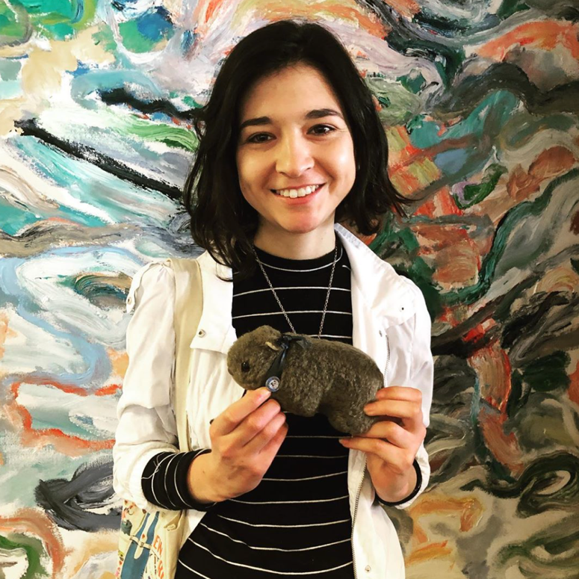

Image 12 (Above): Heidi (me) holding Wagga the official Australian Government
Wombassador in front of Aboriginal style painting.

