Women With Disabilities Australia

wwda.org.au

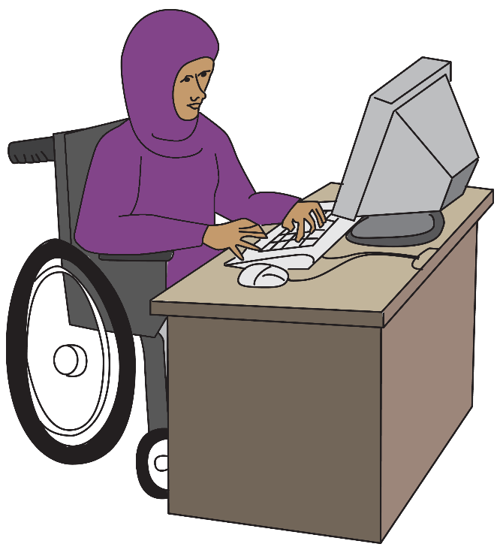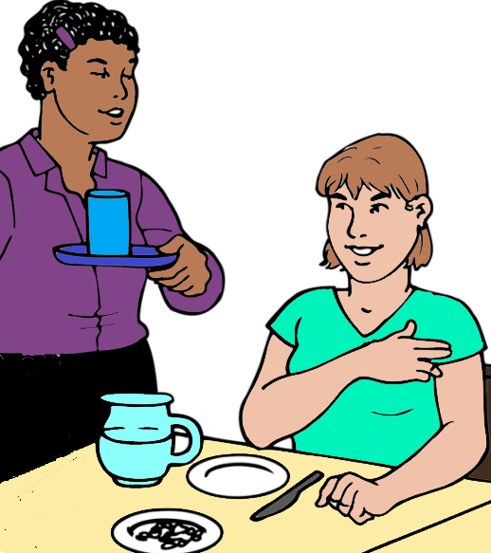

**Our report to the DRC.**

**About work.**

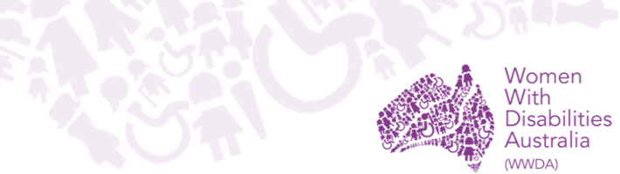

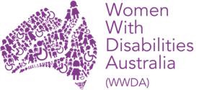We are Women with Disabilities Australia.

We write **WWDA** when we talk about us.

You want to know more about WWDA.

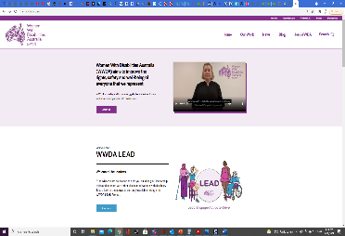

Go to www.wwda.org.au

Click the **About us** button.

**Now.**

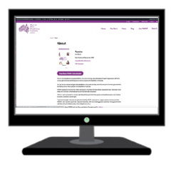

Open the **About WWDA** button.

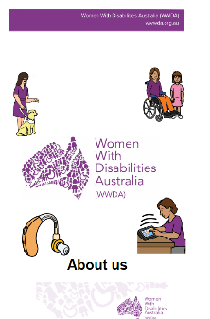

Read **About us.** It is in Easy English.

This is 1 of our reports to the

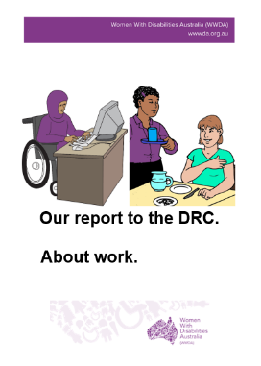

Disability Royal Commission.

We write **DRC** when we talk about the

Disability Royal Commission.

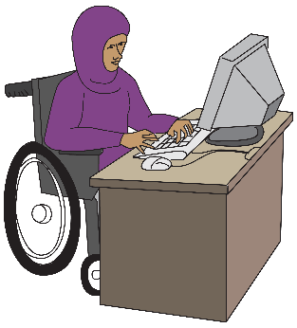

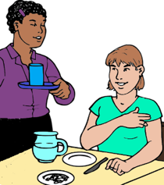This is our report about work.

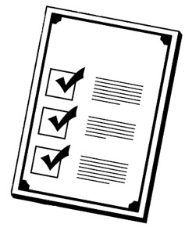**Rules**

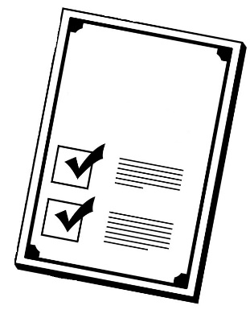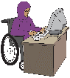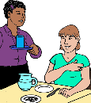

There are laws about how we work.

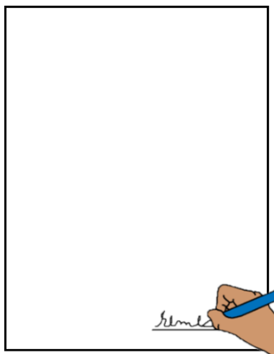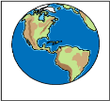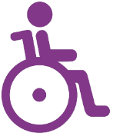

Like The United Nations Convention on the Rights of Persons with Disabilities.

We write **CRPD** to talk about it.



The CRPD are rules for every person in

every country. It tells us about the rights of

all people with disability.

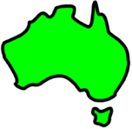The Australian Government signed the CRPD.

They agree to follow these rules.





Australia agrees people with disability have the right to work.

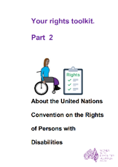

Learn more about the CRPD. Go to page 23.

**Where people work**

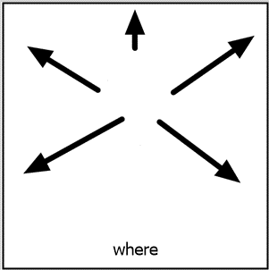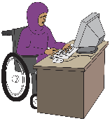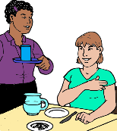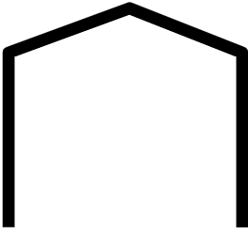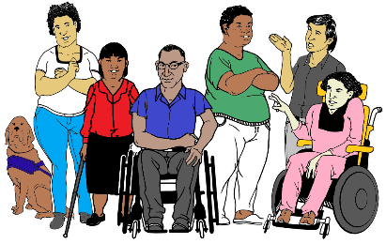

People with disability can work in lots

of places. You may work where

* all workers have a disability.

**or**

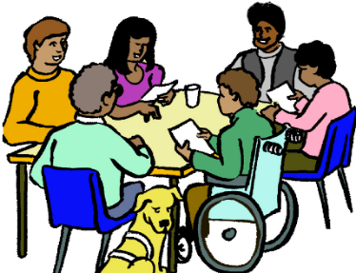

* any person can work.

Your job may pay you

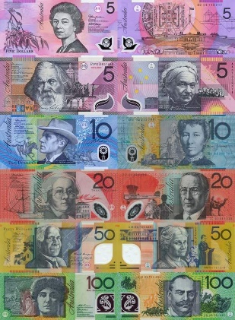

* some money

**or**



* no money. You work for free

**or**

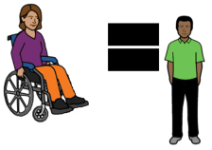

* the same money as other people.

You do the same job. You get the same pay.

**Your Rights**

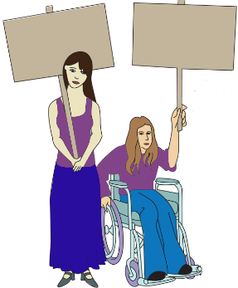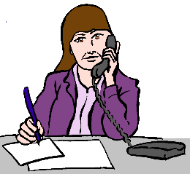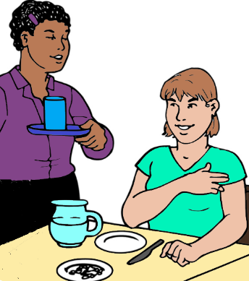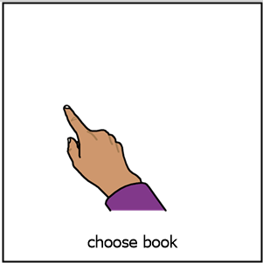

Women and girls with disabilities have the right to

* choose the sort of work they do

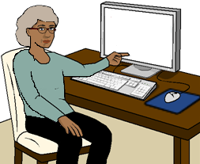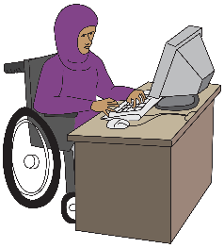

* have the same work choices as other people.



You have the right to

* get paid the same as others

**and**

* you can pay for your every day needs.

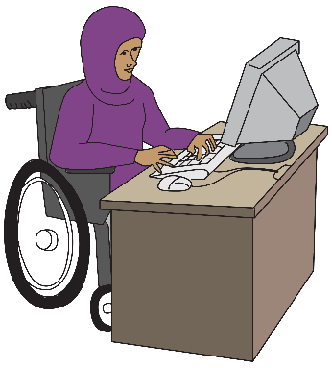You have the help you need to do your job.

You have

* the right things for your computer
* a desk that fits your wheelchair

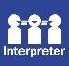

* information in a way you understand.

**And**

It must be easy to move at work.

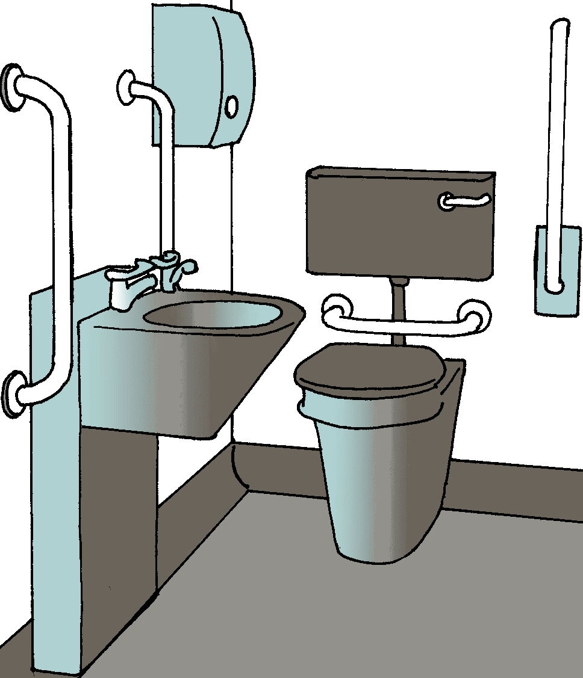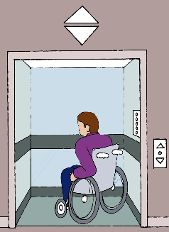

Like you can

* use the toilet
* get in to the building
* 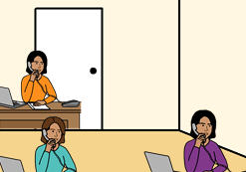there is the right space around your desk.

You can move about in a safe way.

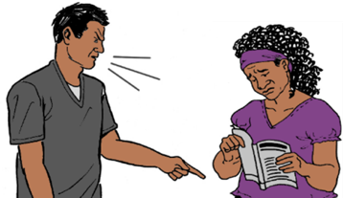You have the right to be safe at work.

People must treat you well at work.

You do **not** get hurt.

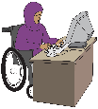

The government must have rules.

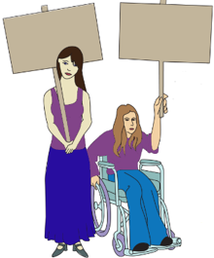

The rules are to make sure women and girls

with disabilities

* have all their rights at work

**and**

* are safe at work

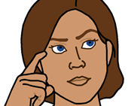**Some problems**

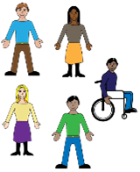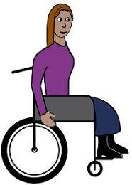

**You do not work in the community**

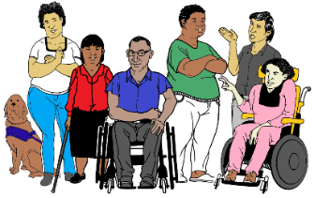

Lots of people with disabilities only work with other people with a disability.



You get less pay.

There can be more violence.

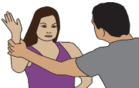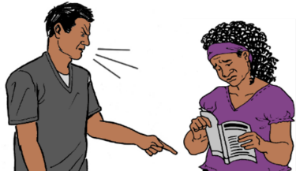

Lots of the workers are men. This can mean more violence for women and girls with disabilities.

You only see staff.

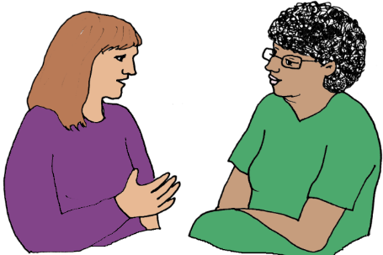

**or**

You only see other people with disability.

You do **not** see other people in the community.

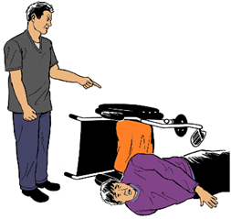You may be hurt. It is all the time.

You do **not** feel safe.

There is **no one** you can tell.

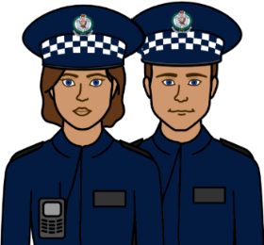

You get hurt at work. Some times you

can **not** talk to

* the police

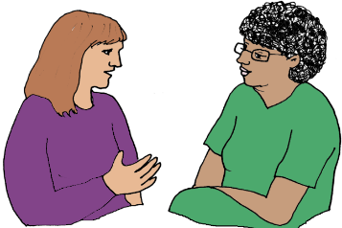

* a therapist.

Only some people with disabilities move to



a new job.

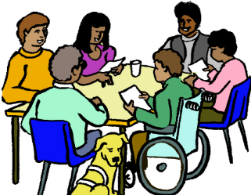

Only some people get a job in the community.

**Violence and abuse at work**

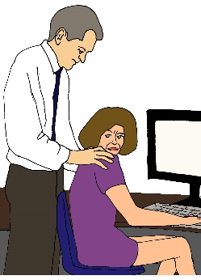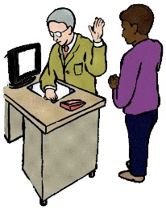

This can be in any work place.

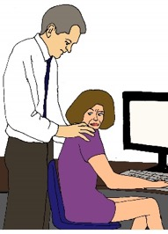It can be you do **not** feel safe with the

people you work with.

**or**

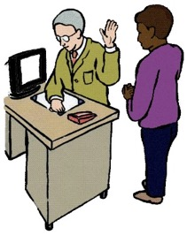

You are **not** treated the same as other workers.

Like your boss is rude to you.

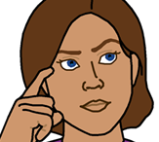**More problems**

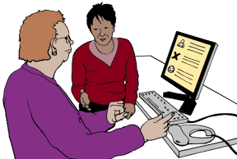

Lots of women and girls with disability say

they do **not** get help. Like

* help to learn your job
* information in a way you can understand.

**or**

* you do not understand what they say.

You can **not** get to work. Like

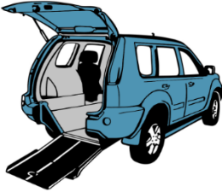

* cars may **not** fit your wheel chair.
* you can **not** get into your work place.

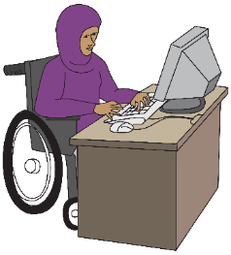

Lots of women and girls with disabilities say they

* do **not** get the same choice of work

**or**



* do **not** get the same pay as others.

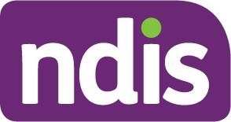The NDIS can help you get a job.

**But**

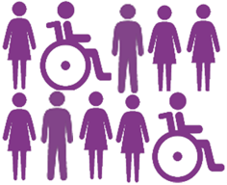

You want a job you can choose.

Only some people with disability say the NDIS help them get a job.

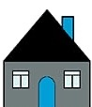Some women and girls with disabilities

* do **not** have a home
* do **not** have money for a home
* can **no**t get help.

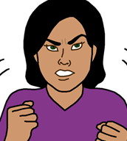

We know this makes it hard to get a job.

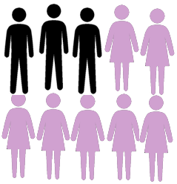We know women and girls have this problem more than other people.

**But**



It is more for women and girls with disability.

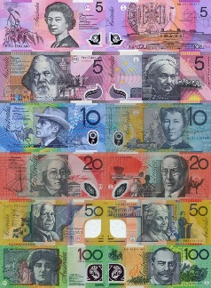

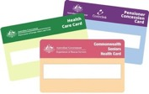Lots of women and girls with disability

* do **not** have paid work
* only get the Centrelink pension.

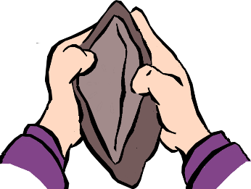

We know lots of women do **not** have the money they need to live.

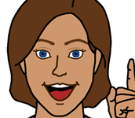**Ideas for change**

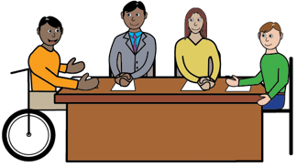

1. Woman and girls with disabilities want the DRC to think about how you work.

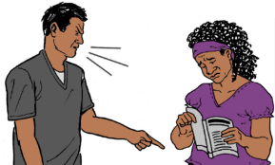

We want the DRC to talk about

* violence and abuse at work



* your work is only for people with disabilities.

There need to be new ideas so



* you can have the same jobs as other people
* you get the same pay for the same job.

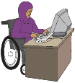

1. Australia needs to make new rules about work.

There may be laws that need to change.



1. Women and girls with disabilities want

the NDIS to think about

* how to help you get work
* how to stop violence.

1. The government needs new ways

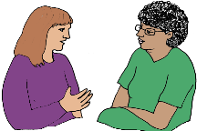

* to keep you safe

**and**

* to help you when you do get hurt.

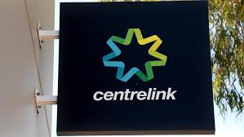

1. Centrelink must give you more money.

**Some other fact sheets**

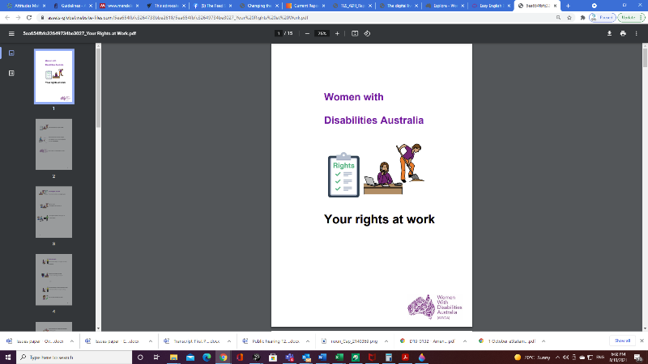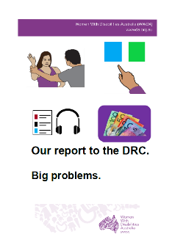

They are in Easy English.

Problems in all parts of our lives. Like

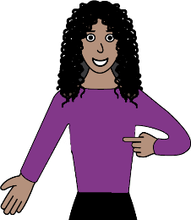

* violence
* how you see yourself.

Front cover

Front cover

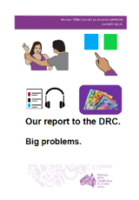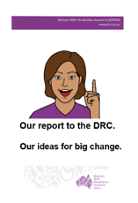

**Our reports to the DRC.**

* **Big problems.**
* **Our ideas for change.**

Learn more about

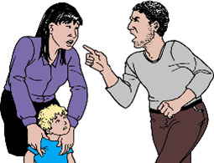

* violence
* abuse.

There is lots of information here. Like

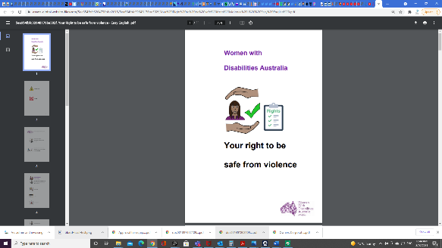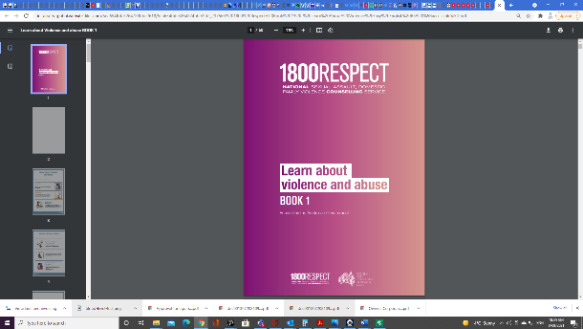

* **Your right to be safe from violence**
* **1800 Respect. Book 1**



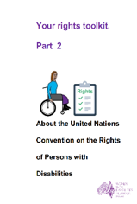**Rights**

* + - * + **Your rights at work.**
        + **About the CRPD.**

Call 0438 535 123.

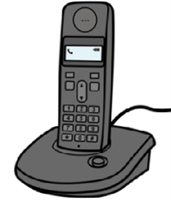

We can send you the fact sheets.

**Or**

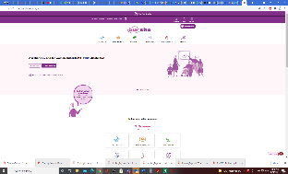

Go to www.oursitewwda.org.au

Click on **Easy English** at the top.

There are different topics. There are

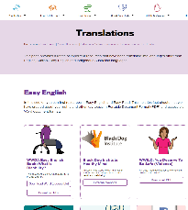

1. Your Rights
2. Learn and take part
3. Life choices
4. Sex and your body
5. Safety and violence.

All our Disability Royal Commission reports are in the last part. It is Safety from Violence

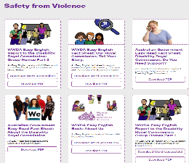

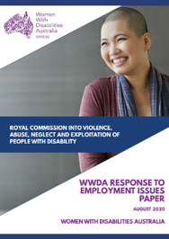This fact sheet is based on the Disability Royal Commission WWDA Response to employment issuespaper. August 2020.

**Images**

We can use these images. They are from

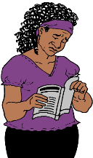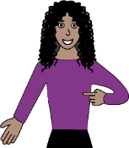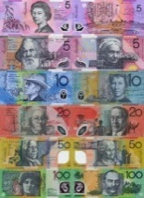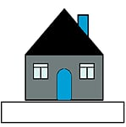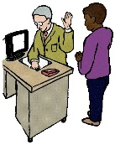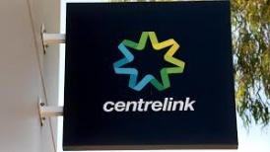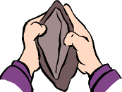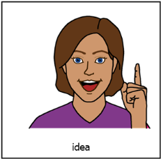

* ChangePeople
* ClipArt
* EasyontheI
* InspiredServices
* Picto-Selector
* Pinterest
* Spectronics
* TheNounProject
* Tobii-Dynavox
* Google Map photos.

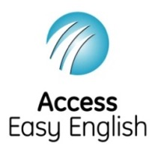Access Easy English wrote the Easy English.

October 2021.