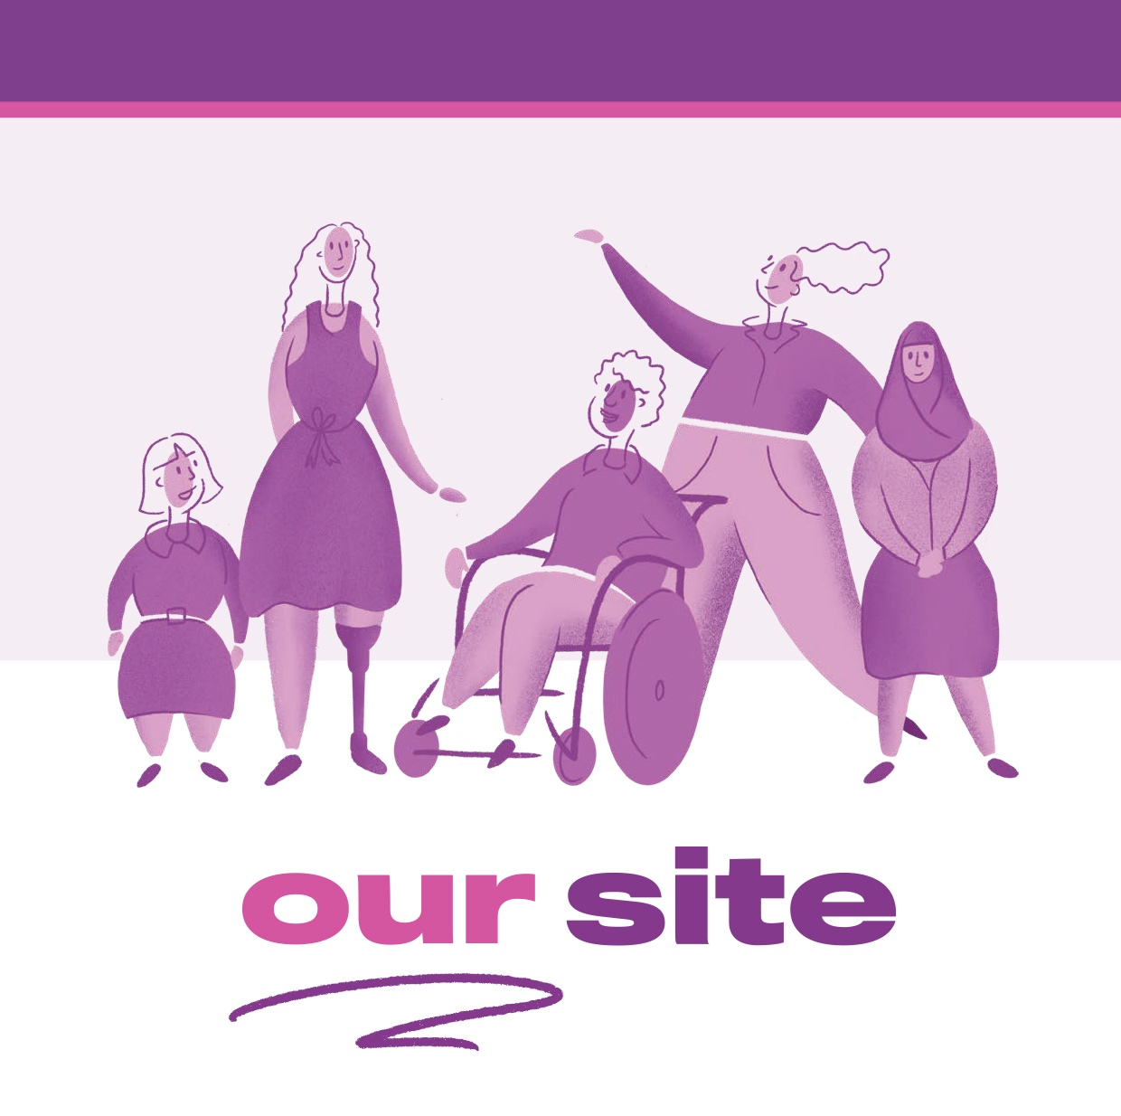

The Our Site project

Co-designing a website by and for
women and girls with disability
August 2020
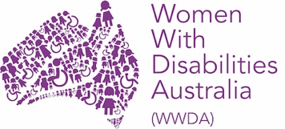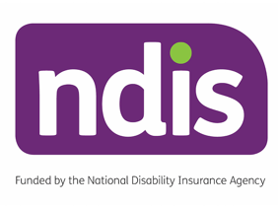

Publishing Information

Women with Disabilities Australia (WWDA), 2020, The Our Site project: co-designing a website by and for women and girls with disability, WWDA: Hobart, Tasmania.

Women with Disabilities Australia (WWDA) acknowledges the traditional owners of the lands on which this publication was produced, and the lands on which the Our Site Project was implemented. We acknowledge Aboriginal and Torres Strait Islander people’s deep spiritual connection to these lands. We extend our respects to community members and Elders past, present and emerging.

Contact

Women with Disabilities Australia (WWDA)
Contact: Carolyn Frohmader, Executive Director
PO Box 407, Lenah Valley, 7008 Tasmania, Australia
Phone: +61 438 535 123
Phone: +61 438 535 535
Email: carolyn@wwda.org.au
Email: officeadmin@wwda.org.au
Web: www.wwda.org.au
Facebook: www.facebook.com/WWDA.Australia
Twitter: www.twitter.com/WWDA_AU

Winner, National Human Rights Award 2001
Winner, National Violence Prevention Award 1999
Winner, Tasmanian Women's Safety Award 2008
Certificate of Merit, Australian Crime & Violence Prevention Awards 2008
Nominee, National Disability Awards 2017
Nominee, French Republic's Human Rights Prize 2003
Nominee, UN Millennium Peace Prize for Women 2000

Disclaimer

The views and opinions expressed in this publication are those of Women with Disabilities Australia (WWDA) and not necessarily those of our funding bodies. All possible care has been taken in the preparation of the information contained in this document. WWDA disclaims any liability for the accuracy and sufficiency of the information and under no circumstances shall be liable in negligence or otherwise in or arising out of the preparation or supply of any of the information aforesaid.

This work is copyright. Apart from any use as permitted under the Copyright Act 1968, no part may be reproduced without written permission from Women With Disabilities Australia (WWDA).
© 2020 Women With Disabilities Australia (WWDA).
ABN: 23 627 650 121

Table of contents
About Women with Disabilities Australia (WWDA) 4
About this report 5
Executive Summary 6
Our practical strategies for co-designing an accessible, high-quality website 9
1. Introduction to Our Site 10
1.1 Why we created Our Site 10
1.2 About the Our Site website 11
2. How we created Our Site 14
2.1 A project created and owned by women with disability 14
2.2 Our approach to project delivery 14
2.3 Successful delivery of a website project 17
3. How we involved women with disability in creating Our Site 18
3.1 The Our Site co-design model and approach 18
3.2 How meaningful the co-design approach was for the women involved 21
3.3 How co-design participants benefited from their involvement 24
3.4 Successful co-design with women with disability 27
4. How we prioritised website accessibility and quality 30
4.1 Our framework for website accessibility and quality 30
4.2 How we assessed the accessibility and quality of Our Site 30
4.3 Creation of an accessible, high-quality website 34
5. The future of Our Site 36
5.1 Priorities for the continued delivery of Our Site 36
5.2 Opportunities to extend and add new functions to Our Site 37
5.3 Opportunities to use Our Site as a platform for change 40
5.4 Opportunities for WWDA beyond the project experience 40
6. Acknowledgments 42
7. Appendices 43
Appendix 1. Mechanisms for involving women with disability in creating Our Site 43
Appendix 2. Our approach to evaluation and monitoring the Our Site project 45
Appendix 3. Assessments against website quality criteria 48
8. References 53

About Women with Disabilities Australia (WWDA)
Women With Disabilities Australia (WWDA) is the award winning, national Disabled People’s Organisation for women and girls with all types of disability in Australia. The key purpose of WWDA is to promote, protect and advance the human rights and freedoms of women and girls with disability in Australia.
WWDA represents more than two million disabled women and girls in Australia, has affiliate organisations and networks of women with disability in most States and Territories of Australia, and is internationally recognised for our work.
WWDA does research and advocacy work that includes writing documents such as policy submissions, reports for government and media statements. WWDA also implements projects to advance and support the rights of women with disability, such as the Our Site project.
All of WWDA’s work is grounded in a human rights-based framework which links gender and disability issues to a full range of civil, political, economic, social and cultural rights. It is this framework that WWDA works from and within, to promote and advance the human rights of women and girls with disability.
As a Disabled People’s Organisation, WWDA is entirely managed and run by and for women and girls with disability. The United Nations Committee on the Rights of Persons with Disabilities has said that States should give priority to the views of Disabled People’s Organisations like WWDA when addressing issues related to people with disability. The Committee also advocates for Disabled People’s Organisations to be properly resourced to support the rights of people with disability on an ongoing basis.
WWDA is a founding member of Disabled People’s Organisations Australia (DPO Australia) along with First People’s Disability Network Australia, National Ethnic Disability Alliance, and People with Disability Australia. DPO Australia is an alliance of four national disabled people’s organisations in Australia. The key purpose of DPO Australia is to promote, protect and advance the human rights and freedoms of people with disability in Australia by working collaboratively on areas of shared interest, purpose and strategic priority.

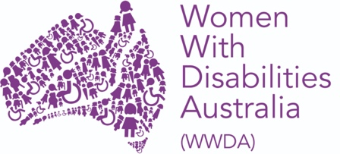 | 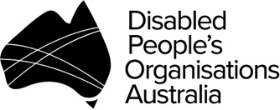

About this report
This is a report on a two-year, national project led by Women With Disabilities Australia (WWDA), to create the Our Site website (https://oursite.wwda.org.au). The project was delivered with funding from the National Disability Insurance Agency (NDIA). The report describes WWDA’s approach to creating a high-quality, accessible website that has been created by women with disability for women with disability. It also includes evaluation findings.

Throughout this report the term ‘women’ is inclusive of feminine identifying and non-binary people.

The main sections of the report are summarised below.

Executive Summary (page 6) provides a brief overview of the report.
Introduction to Our Site (page 10) outlines the reasons that Our Site was created and describes the key elements of the website.
How we created Our Site (page 14) describes the project delivery approaches used to create the Our Site website.
How we involved women with disability in creating Our Site (page 18) describes the project’s unique approach to co-design and how this supported the active participation and meaningful involvement of women with disability in the project.
How we prioritised website accessibility and quality (page 30) outlines the processes used to ensure website quality and accessibility and findings from quality and accessibility assessments.
The future of Our Site (page 36) outlines a range of opportunities for the future.
Appendices (page 43) are included at the end of the report to provide additional details on the ways women with disabiliy were involved in the project, the approach to monitoring and evaluation and detailed assessments of the website quality.
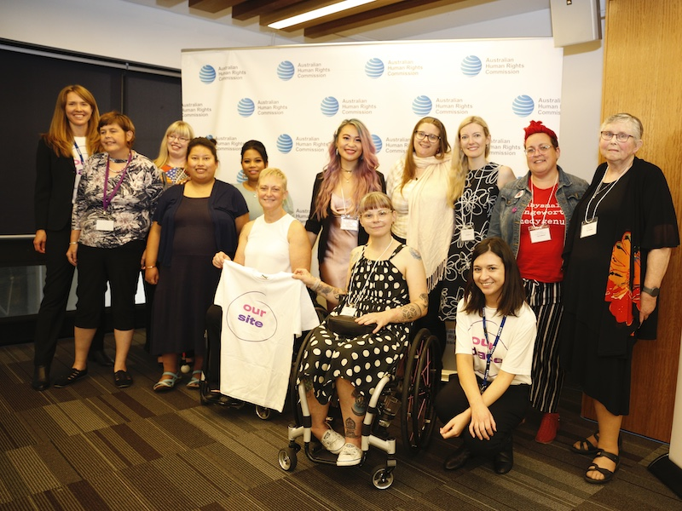
Above: Our Site contributors and project staff at the website launch on 6 March 2020

Executive Summary
Our Site (https://oursite.wwda.org.au) is a website created by women and girls with disability for women and girls with disability. It provides accessible information and practical resources that support women and girls with disability to learn about and stand up for their rights. It was launched in March 2020 by the Minister for Women, the Hon Marise Payne. A stand-alone Easy Read version of the website was added in July 2020.
Women With Disabilities Australia (WWDA) led the national project to create Our Site. The project delivered on a vision that had been conceived by the WWDA community many years earlier, for a website providing accessible, human-rights based information about issues that affect the daily lives of women and girls with disability.
Our Site was created with the support of a funding grant from the National Disability Insurance Scheme (NDIS) Information, Linkages and Capacity Building (ILC) Program.

How we created Our Site
WWDA implemented the Our Site project over two years from mid-2018, with project governance provided through the WWDA Board and an expert Project Steering Committee.
Accessibility, quality and ownership by women with disability were important priorities for the Our Site website. These were also priorities for the project processes that WWDA used to create Our Site. At every stage, the project team aimed to make it as easy as possible, for as many diverse women with disability as possible, to contribute. Project approaches were flexible and responsive to feedback and arising issues.
The website content and design elements were created through a series of website development ‘cycles’ intended to support the development of a high-quality, accessible website. Each cycle involved four distinct phases of discovery, design, development and user testing. Importantly, the leadership, input and advice from women with disability was central to each cycle. This cycle approach will continue to be applied to any future additions and reviews of Our Site.

How we involved women with disability in creating Our Site
WWDA developed and implemented a unique co-design approach to create Our Site. A feature and strength of the Our Site co-design model is that the project was governed and led by the women with disability of WWDA. WWDA project staff facilitated involvement of a large, diverse group of additional women with disability. Over 110 women with disability from across Australia contributed to the creation of Our Site.
The project consistently prioritised the genuine, meaningful participation and involvement of women with disability in every aspect of Our Site creation. This resulted in multiple benefits for participants and a website that is grounded in the diverse experiences of women and girls with disability.
Participants particularly valued the following aspects of the Our Site co-design process:
- a genuine, non-tokenistic approach to involving women with disability that resulted in a sense of shared ownership of the website
- a feeling of being valued and respected for contributions to the co-design process
- a co-design environment that helped participants to feel safe, supported and confident to contribute
- clear evidence that participants’ contributions influenced the content and design of Our Site
- a shared understanding of the Our Site project purpose and co-design participant roles.
Co-design participants are proud of their contribution and many have gained confidence through their involvement. Some participants have experienced benefits in their workplaces and careers. Many have benefited on a personal level through making new connections and friendships with other women with disability.

How we prioritised website accessibility and quality
Creating a high-quality website that is accessible to all women and girls with disability was a top priority for the Our Site project. Quality criteria were defined to support a shared understanding of what it means to achieve a ‘high-quality’ website. The criteria included: website accessibility; understandability and readability; relevance; credibility and trustworthiness; accuracy and completeness; currency; inclusivity; practicality and empowerment; aesthetics and interactivity.
Our Site was rated highly by women with disability against each of the quality criteria. The co-design approach and the inclusion of personal stories on the website were strong influences on these positive perceptions. These real stories are the most visited pages on the website and help women feel connected to the wider community of women with disability.
Project evaluation data have demonstrated that Our Site is a widely accessible website with a high technical accessibility rating. It provides high-quality information to a high volume of visitors (over 11,000 visits as at 31 July 2020).
The co-design approach is considered by women with disability to have strengthened the quality of the website.

The future of Our Site
WWDA and the co-design participants are proud of the quality of the Our Site website and of their collective achievements through the Our Site project. To ensure women and girls with disability continue to benefit from these achievements, WWDA and co-design participants have identified priorities and opportunities for the future of Our Site. The capacity to deliver on these will be dependent on securing further funding.

Priorities for the continued delivery of Our Site
- Continue as a co-designed website for women with disability by women with disability, led by WWDA.
- Maintain the currency and accuracy of Our Site.
- Continue to promote and drive traffic towards Our Site.

Opportunities to extend and add new functions to Our Site
- Add new functions to extend the accessibility of Our Site.
- Build connected communities of women and girls with disability through Our Site.
- Create online learning and skills development opportunities for women and girls with disability.

Opportunities to use Our Site as a platform for change
- Influence community understanding and attitudes.
- Influence mainstream and disability service providers.

Opportunities for WWDA beyond the project experience
- Promote and share the Our Site co-design model.
- Continue to grow and work with the expert panels of women with disability.
- Continue to assess, improve and build the evidence for the effectiveness of Our Site.

Our practical strategies for co-designing an accessible, high-quality website
WWDA’s Our Site project experience has informed the following practical strategies for creating an accessible, high-quality website using a co-design approach.
Deliver the project using established, formal project management and governance approaches, including clear risk management that is reviewed and responded to regularly.
Seek expert advice early across important aspects of project delivery including:
- understanding the critical steps in website planning and development
- stakeholder engagement and co-design methodology
- accessible website design and delivery for people with disability
- definitions of and considerations for ‘website quality’
- the topics/ content areas to be covered by the website
- legal considerations and processes e.g. intellectual property, website and domain names.
Plan human resources (including through outsourcing where necessary) to support busy periods of project activity and have a contingency plan in place for potential staff changes.
Proactively recruit a diverse group of women with disability including those in hard-to-reach groups across all age groups, locations, impairment types, and cultural backgrounds. Partner with a range of groups and organisations to help facilitate diverse input.
Allow adequate time within the project timeline for the meaningful, active participation of women with disability. Balance the intensity of co-design tasks with frequency (e.g. more frequent engagement opportunities requiring shorter periods of focus or intensity).
Offer a wide range of different engagement mechanisms to support varied levels of involvement by diverse groups with different accessibility requirements and workstyle preferences.
Provide clear orientation to co-design participants, via online or face-to-face meetings.
Communicate instructions using multiple mechanisms (e.g. supplement written instructions with verbal instructions provided via video or online meeting).
Facilitate mechanisms for co-design participants to meet with each other, connect and collaborate.
Pay co-design participants for their time spent contributing to the project.
Seek feedback from governance and co-design participants during different stages of project implementation, so that improvements can be made to the process.

Introduction to Our Site

1.1 Why we created Our Site
One in five women and girls in Australia have a disability, yet this group of people is one of the most disadvantaged groups in the country.¹ Women and girls with disability experience widespread discrimination and are often denied access to information about issues affecting their lives. ^{2,3,4} Their views can go unheard and their decisions are often made by others.^{5,6,7}
Women With Disabilities Australia (WWDA) provides a national voice for women and girls with disability. WWDA aims to address discrimination and improve the lives of women and girls with disability, through a human rights-based framework.
The ability to make decisions and choices and to full and effective participation in society is dependent on access to accurate, appropriate information.⁵ For many years the WWDA community of women and girls with disability identified the need for accessible, high-quality, information and resources on the key issues affecting their daily lives.^{8,9} The Our Site website was created to address this need.
Launched publicly in March 2020, Our Site is the result of a two-year, national project led by WWDA. It was created with the support of a funding grant from the National Disability Insurance Scheme (NDIS) Information, Linkages and Capacity Building (ILC) Program.

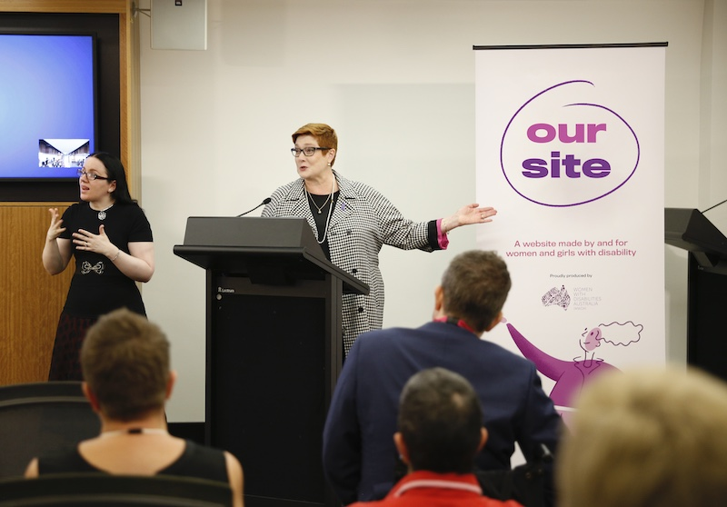
Above: Minister for Women, Senator the Hon Marise Payne, launching Our Site in Sydney, March 2020.

1.2 About the Our Site website
Our Site (https://oursite.wwda.org.au) is a website created by women and girls with disability for women and girls with disability. It provides inclusive and accessible information and practical resources that support women and girls (aged 15 years and above) with disability to learn about and stand up for their rights.
The information focuses on five priority areas, selected by women with disability themselves:
- human rights
- leadership and participation
- decision-making and choices
- sexual and reproductive health and rights
- safety from all forms of violence.
Figure 1. Screenshot of the Our Site homepage
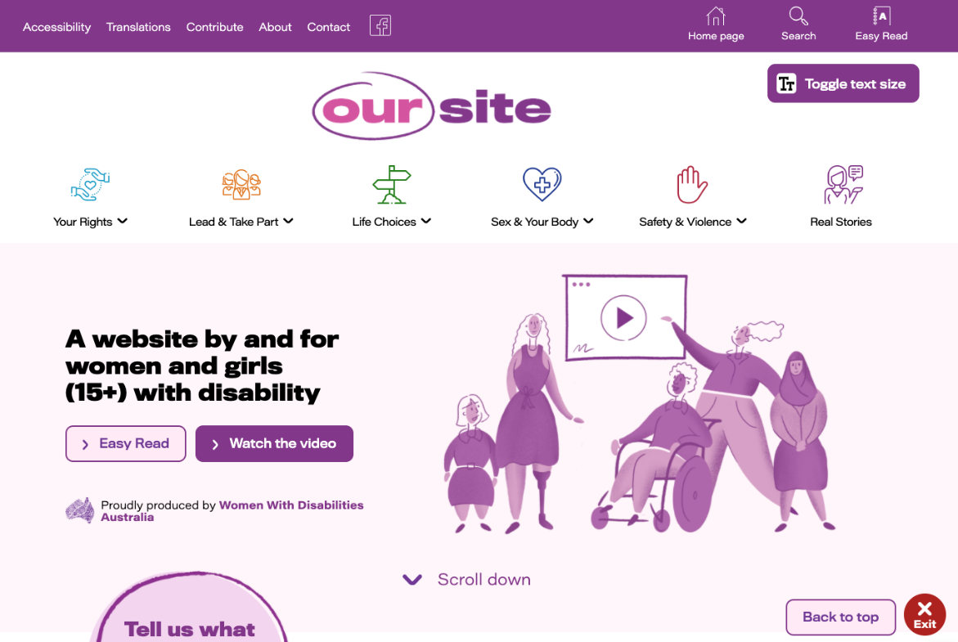
Our Site is designed to enable as many people as possible to easily use, understand, navigate and interact with the over 50 pages of web content. Information is communicated in multiple ways including text, images, videos and Easy English. A selection of resources is available in languages other than English, including some Australian Aboriginal and Torres Strait languages.
A stand-alone Easy Read version of the website (https://oursite-easyread.wwda.org.au) was added to Our Site in July 2020 (Figure 2). Easy Read provides information using clear, simplified language, supported by images. It has been developed with and for women with intellectual disability and women with low literacy. The Easy Read website is also expected to be useful for women for whom English is not a first language.

Figure 2. Screenshot of the Easy Read version of the Our Site homepage
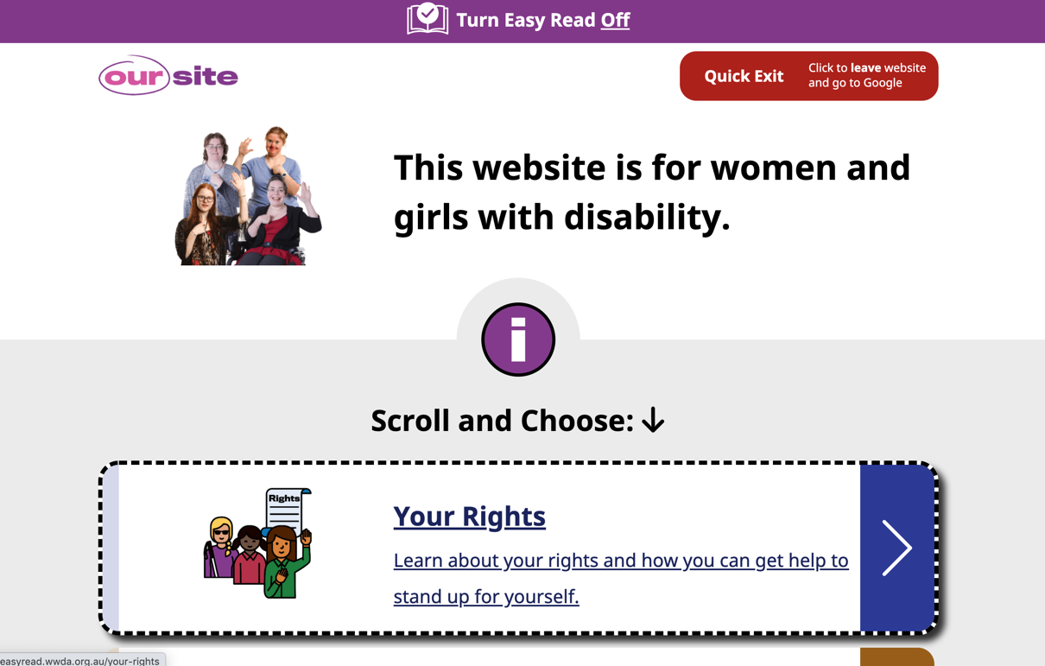

Our Site celebrates the diversity and experiences of women with disability by showcasing over 40 real personal stories (Figure 3). In their stories, women with disability of all ages share their personal experiences, providing relatable, real-life insights into the concepts addressed on Our Site.
Figure 3. Personal stories on the Our Site website
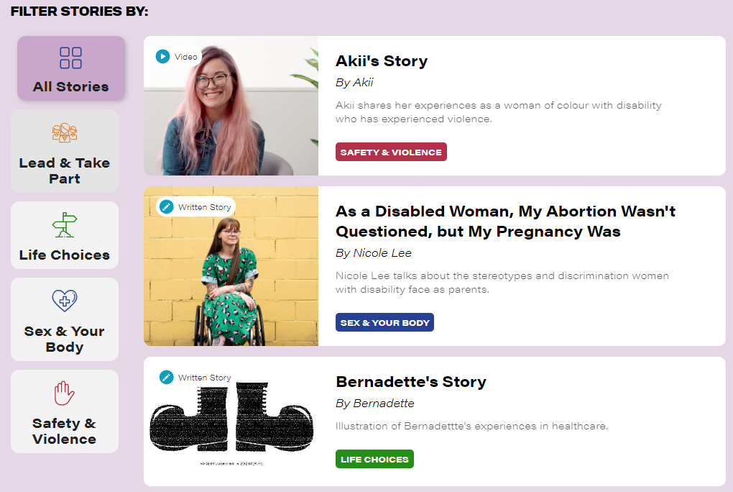

Each of the topic areas also includes a page of information for supporters and services. This information is intended for:
- family, friends and carers of women and girls with disability
- individuals and organisations working to support women and girls with disability such as disability service providers, mainstream service providers, government agencies and policy makers.
Our Site has been developed by and for women and girls with disability in Australia. However, it also has the potential to impact women and girls with disability around the world. While the majority of users are Australian, Our Site has been accessed by users in over 60 different countries.¹⁰

How we created Our Site

2.1 A project created and owned by women with disability
Our Site was created through a national project led by WWDA. The project delivered on a vision that had been conceived by the WWDA community many years earlier, for an accessible, human-rights based website created and owned by women and girls with disability.
“People with disability own Our Site and no one can take this from us. Our Site can be our voice.” (Panel member)¹¹
All aspects of the project were led by women with disability and actively involved women with disability.
- Project governance was provided through the WWDA Board (comprising 7 annually elected women with disability) and a Project Steering Committee (7 leaders in disability and women’s issues, including 4 people with disability).
- Project management was provided by WWDA staff with oversight from the WWDA Executive Director (a woman with disability).
- Website content and design involved multiple layers of contributions by many women with disability:
  - 6 planning workshops (45 women with disability in 6 states/territories) to identify the most important content, design and functionality considerations for the website. These also involved testing initial draft website concepts
  - an Expert Advisory Panel (37 diverse women with disability from across Australia) to develop and edit content and provide design advice
  - a Quality Review Panel (a sub-set of the Expert Advisory Panel, comprising 7 women with disability and 1 additional expert) to provide advice and review the quality of content and design
  - user-testing activities (members of all contributing groups, additional WWDA members) to provide feedback on draft versions of the website
  - individual story contributions for publication on the website (42 women with disability to date).
- The Our Site launch event was attended (or watched online) by the many women with disability who contributed to Our Site.
See Chapter 3 for further information about the Our Site co-design model.

2.2 Our approach to project delivery
WWDA implemented the Our Site project over two years from mid-2018, with project governance provided through the WWDA Board and a Project Steering Committee.
Accessibility, quality and ownership by women with disability were important priorities for the Our Site website. These were also priorities for the project processes that WWDA used to create Our Site. At all project stages, the project team aimed to make it as easy as possible, for as many diverse women with disability as possible, to contribute. The project approaches were flexible and responsive to feedback and arising issues.
The website content and design elements were created through a series of website development ‘cycles’ intended to support the development of a high-quality, accessible website. Each cycle involved four distinct phases of discovery, design, development and user testing (Figure 4). Importantly, the leadership, input and advice from women with disability was central to every phase in every cycle of website development, via the mechanisms detailed in the box above.
Figure 4. The Our Site website creation cycle
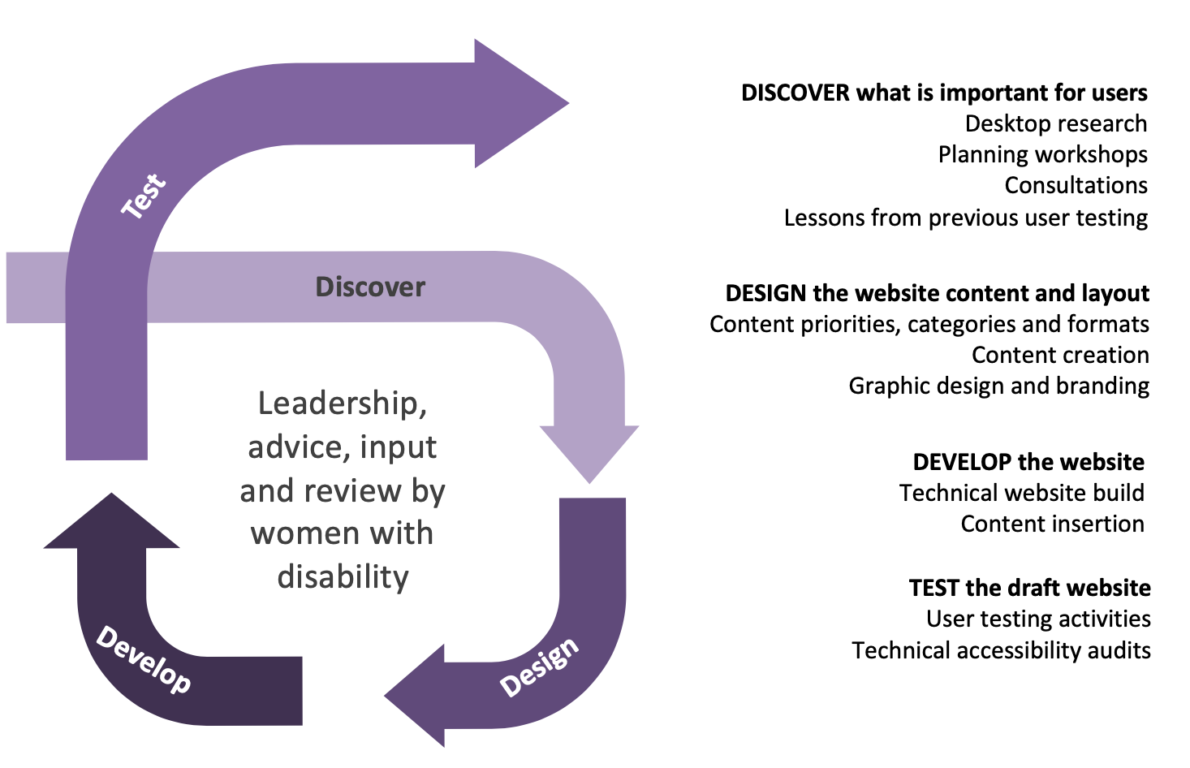
- During the discovery phase, the project team sought to understand what would be most important to users of the website. Activities included desktop research, planning workshops and other consultations. The discovery phase was also informed by feedback received during testing in previous cycles.
- During the design phase, website content was created and decisions were made about how it would be presented. Activities included writing, reviewing and finalising content, categorising content, agreeing formats for presenting content, website branding and graphic design.
- The development phase refers to the technical development of the website itself. Activities included building the website’s design and navigation, adding the content and making changes to support accessibility.
- The final phase was testing the website and seeking feedback from potential users of the website (women with disability). It also included technical reviews of the website against international standards for accessible websites.
Four cycles of development were completed in the lead up to launching Our Site (Table 1). Each cycle built on the outcomes of the previous cycle. This approach provided ongoing opportunities to obtain feedback, incorporate it into the website and test it with potential website users.
Table 1. The cycles of website development prior to launching Our Site
Jan – Jul 2019 | Cycle 1: | Created early website prototypes and identified content topics and key considerations for accessibility and navigation
Aug – Sep 2019 | Cycle 2: | Created a draft website with early draft content, design and structure
Sep – Dec 2019 | Cycle 3: | Delivered a full draft website, incorporating significant content additions and design revisions based on an accessibility audit
Jan- Mar 2020 | Cycle 4: | Delivered a website ready for launch, with finessed content and changes to further improve website accessibility
An additional two cycles were completed after the Our Site launch to create a stand-alone Easy Read version of the website. The cycle approach will continue to be applied to any significant future additions or changes to Our Site.
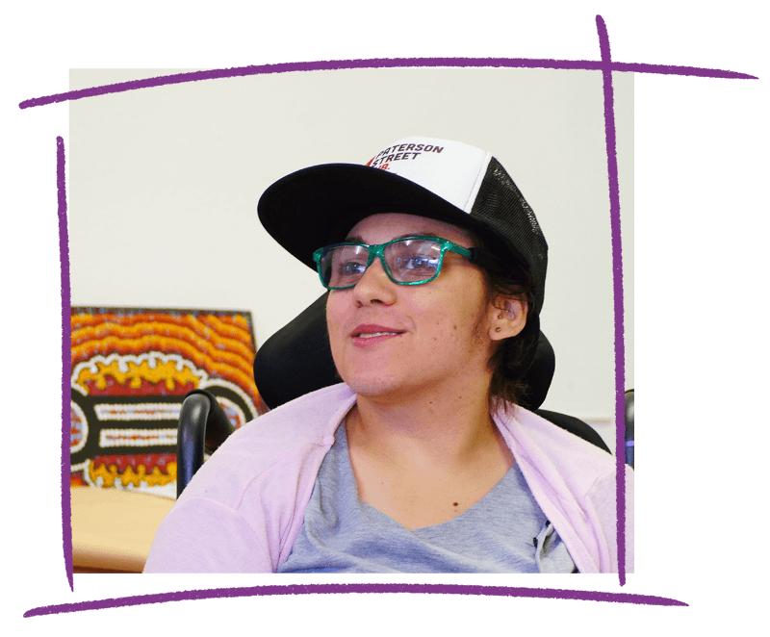

2.3 Successful delivery of a website project

Exceeding our funding requirements
The Our Site project was delivered on time and within budget. Project records demonstrate that project delivery met and, in some respects, exceeded the requirements of the funding contract with NDIA. The project exceeded stakeholder engagement requirements and the website content was developed with a much stronger quality focus than required. The project team also engaged in more comprehensive evaluation, data collection and reporting than required under the contract.

Our practical strategies for project delivery
The practical strategies below are informed by reflections on the project delivery process from the WWDA project team and from many women with disability involved in Our Site project governance and co-design.
Deliver the project using established, formal project management and governance approaches, including clear risk management that is reviewed and responded to regularly.
Seek expert advice early across important aspects of project delivery including:
- understanding the critical steps in website planning and development
- stakeholder engagement and co-design methodology
- accessible website design and delivery for people with disability
- definitions of and considerations for ‘website quality’
- the topics/ content areas to be covered by the website
- legal considerations and processes e.g. intellectual property, website and domain names.
Select an appropriate web development agency to meet project requirements.
Plan human resources (including through outsourcing where necessary) to support busy periods of project activity and have a contingency plan in place for potential staff changes.
Allow adequate time within the project timeline for each co-design cycle to enable the meaningful, active participation of women with disability.

How we involved women with disability in creating Our Site

3.1 The Our Site co-design model and approach
WWDA used a co-design approach to create Our Site. Co-design approaches to design and production aim to involve the target audience in making decisions and providing feedback throughout the entire process.^{12,13} They are generally considered most likely to achieve the best results for those who are intended to benefit from a project’s final product. However, there are many interpretations of ‘co-design’, particularly in the context of disability. ^{12,14,15}
The Our Site co-design model (Figure 5) was influenced by the International Spectrum of Public Participation,¹⁶ which describes different levels of involving members of the public in the design and delivery of an initiative.
A unique feature and strength of the Our Site co-design model is that the co-design process was led and governed by women with disability. WWDA led the process as an organisation run by and representing women with disability. Project staff facilitated the co-design process with many additional women with disability.
“The whole process was managed, driven and run by WWDA and women with disabilities. … This was women with disability consulting with women with disability” (Panel member)¹⁷
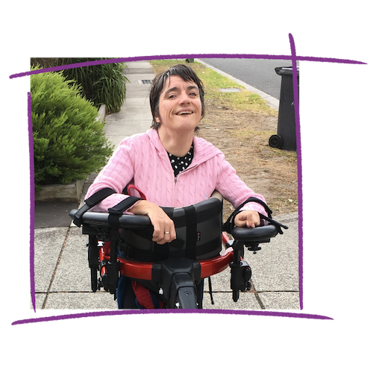
Figure 5. The Our Site co-design model
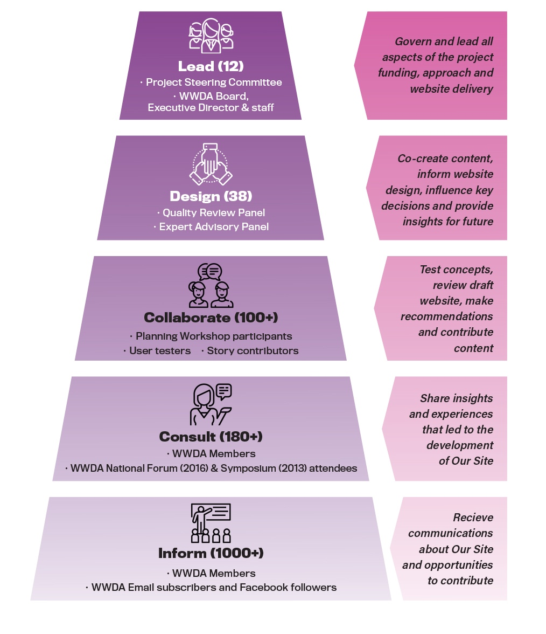
Figure 5 illustrates how different women with disability were involved in contributing to the creation of Our Site in different ways.
- 12 women with disability were involved in leadership and governance of the Our Site project, through membership of the WWDA Board, Project Steering Committee or as WWDA staff.
- 38 women with disability contributed to website content creation and informed website design as members of the Quality Review Panel and/or the Expert Advisory Panel.
- More than 100 women with disability tested concepts, provided feedback and/or contributed content as planning workshop participants, user testing participants, and/or story contributors.
- Over 180 women with disability shared their insights and experiences through consultations that identified the need for women with disability to be able to access relevant, inclusive and accessible information relating to their human rights.
- Over 1,000 women with disability received communications about Our Site and/or were invited to contribute.
This co-design model offered multiple layers of involvement across all aspects of creating Our Site. For example, some individuals were involved in an in-depth way over time, while others contributed to one or two single activities when they were available to do so.
See Appendix 1 for further details about each of the mechanisms for involving women with disability.

Who was involved in creating Our Site
In total, over 110 women with disability were directly involved in the creation of Our Site. Efforts were made to recruit a diverse group of women with disability to governance and advisory roles. Together, the Project Steering Committee, Quality Review Panel and Expert Advisory Panel included women living with many different disabilities/impairments across a range of age groups, geographical locations and cultural backgrounds.
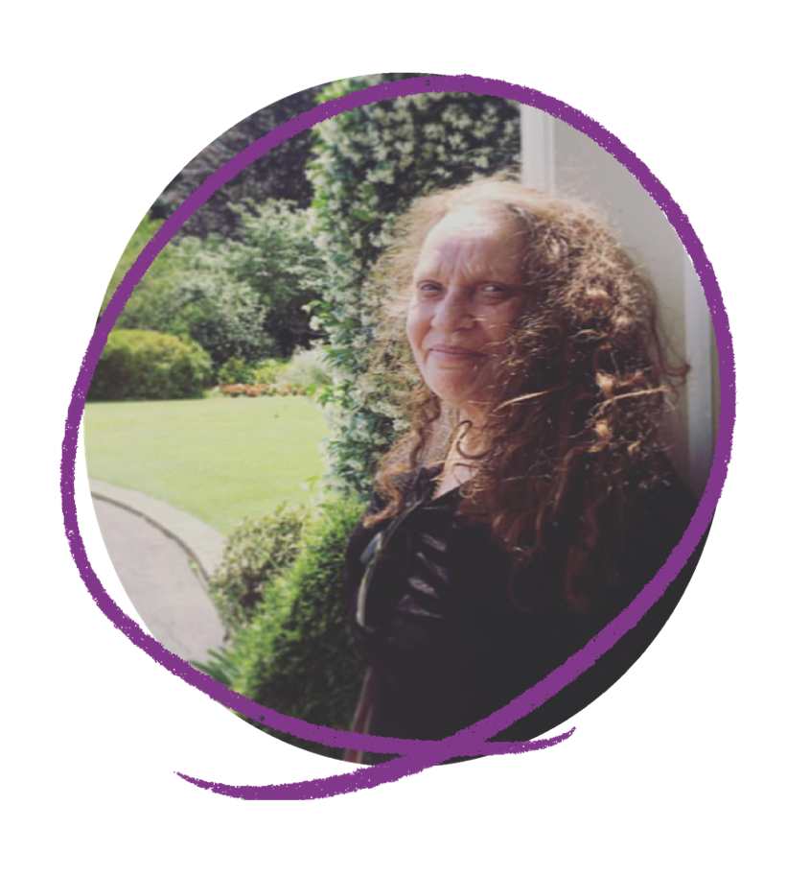
Facilitating the involvement of women from as many diverse backgrounds as possible within limited resources and timeframes was a challenge that the project team and Project Steering Committee were proactive about addressing.
“We were aware of gaps in diversity on the committee and did our best to make up for them, through consulting with different communities” (Project Steering Committee member)¹¹
With additional resources and timeframes, the diversity amongst governance and co-design participants could have been strengthened by involving girls under the age of 19, additional Aboriginal and Torres Strait Islander women and additional women from culturally and linguistically diverse backgrounds.^{11, 18}

3.2 How meaningful the co-design approach was for the women involved
Participating in the Our Site co-design process was a powerful, meaningful process for many of the women involved. Participants particularly valued the following aspects of the co-design process:
- a genuine, non-tokenistic approach to involving women with disability that resulted in a sense of shared ownership over the website
- a feeling of being valued and respected for contributions to the co-design process
- a co-design environment that helped participants to feel safe, supported and confident to contribute
- clear evidence that participants’ contributions influenced the content and design of Our Site
- a shared understanding of the purpose of the Our Site project and participants’ roles in the co-design project.
Each of these aspects are describe below. They all align with key principles for best practice co-design,¹⁹ demonstrating how well the Our Site co-design model was implemented.

Genuine participation and shared ownership
Co-design participants passionately valued what they considered to have been a non-tokenistic, true partnership approach to developing Our Site. Participants said this was highly unusual. ^{11, 17, 20}
“It’s been an absolutely wonderful experience. It could have been a typical experience where people with disability are drawn in a tokenistic way, but that hasn’t happened. It’s really, really refreshing.” (Panel member)¹¹
Co-design participants expressed pride in the website and the genuine collaborative approach to developing a website that is owned by the diverse community of women and girls with disability.^{11, 17, 21}
“Women and girls with a disability joined hearts and minds to create Our Site with their own personal experiences, stories and expertise” (Panel member)²¹
“I don’t think I’ve ever come across anything to do with disability that has not been top down imposed. It is really exciting that this is our product. Our community owns it.” (Panel member)¹⁷
The resulting sense of ownership was clear amongst co-design participants, many of whom have been promoting the website (unprompted) to their own networks and via local media.^{11, 17}
Co-design participants clearly considered Our Site and the co-design processes to be owned by women and girls with disability. However, on an individual level, some participants felt that some improvements to the co-design process could have strengthened their capacity to contribute. These included: more frequent and less intense engagement opportunities; supplementing written instructions with verbal ones (either via video or online meeting); providing more individualised support for participants; and more interactions and collaborations with other participants.

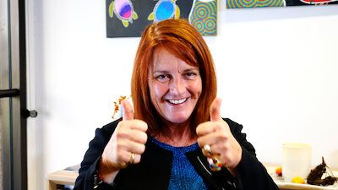

A sense of respect and value in co-design role
Co-design participants reported feeling respected and valued as a participant and as a contributor of relevant, meaningful expertise.
“The project team would defer to our expertise quite a bit because of our practical knowledge. And that respect for the practical knowledge was really apparent.” (Project Steering Committee member)¹¹
Many unique aspects of the co-design approach helped women feel that they and their contributions were respected, valued and useful.
- Communications from the project team helped foster a sense of being respected and valued.
“The communication with us was always positive, it was always respectful. It felt like anything we put in was being respectfully considered and that our input was valued.” (Panel member) ¹¹
- Flexibility to support participants to contribute in a style and timeframe to meet their requirements helped participants to feel their contributions were respected and valued.
“The approach sent a message of respect and value: if you take 10 minutes to do something that I take one minute to do, that’s ok, I still value you. That was a constant, clear message that underpinned everything.” (Panel member) ¹¹
- Evidence of their influence on Our Site showed participants how valuable their input was.
“Because I could see that my contribution was considered and my ideas were put into the website, it made me feel really valued.” (Panel member)¹⁷
- Payment for work completed demonstrated to participants that their contributions were valued by WWDA.¹¹

Safety and confidence to contribute effectively
Co-design participants reported feeling safe, confident and supported to contribute to Our Site. They felt that the project team and the other women involved were supportive and encouraging of all participants which helped them feel confident in their roles.
“Our views and suggestions were warmly encouraged.” (Panel member)¹¹
The co-design process helped participants to feel more accepted than they have felt in other committees and projects.
“I was worried that people would question my disabilities because that’s what happens to me in the outside world. But I found that I was really accepted and that the website embraces all types of disability.” (Panel member)¹⁷
However, on an individual level, some participants experienced barriers to contributing. For example, one participant with dyslexia did not review website drafts because reviewing text is not her strength. She felt that other co-design participants would provide more helpful feedback than she could.¹¹

Clear, effective influence on the Our Site website
Overall, co-design participants believed their contributions were meaningful and worthwhile because there was clear evidence of their feedback influencing the Our Site content and design. This was rewarding for participants.
“One of the favourite things for me, was being able to use my lived experiences as a disabled woman to first help identify & fill the information & resource gaps, and to then see my input & contributions, come to life & be part of the website!” (Panel member)²¹
Co-design participants provided many examples of how their input, and that of other women with disability, had influenced the Our Site content and design elements.^{11,21} Project records also demonstrated the significant influence of co-design participant input on Our Site.²²
“On this [Advisory group], things that I said actually came to fruition. On other advisory panels that doesn’t happen. You are just there to tick the box.” (Panel member)¹⁷
Co-design participants noted how receptive and responsive the project team was to actioning changes following receipt of feedback.
In addition to the collated summaries of feedback and actions provided by the project team, some co-design participants would have liked more personalised feedback about how their individual contribution had been actioned.¹⁷

Clarity around the co-design purpose, roles and processes
To contribute meaningfully to the Our Site project, co-design participants needed to understand the project goal, the creation process and their role in that process. Some co-design Panel participants reported having clearly understood this, which helped facilitate meaningful involvement.
“It’s one of the few group activities I’ve been involved in where I have not felt lost or been left thinking ‘what is this about?’.” (Panel member)¹⁷
Those with clarity around the project goals and processes attributed this in part to the frequent, open communication they received from the project team. Several reported that the questions and structure for providing feedback was very helpful in focusing their input.^{11,17}
However, other co-design Panel members said that they could have provided more meaningful contributions if they’d had a more formal orientation at the project outset, to provide context and clarify the project goals and processes.^{11,17}
“Had I known about the full scope of the project; I think I could have contributed more effectively.” (Panel member)¹⁷
Co-design participants’ reflections highlighted the range of different work style requirements and preferences of different people. The flexibility offered by the project team to support a range of different options for meaningfully participating was clearly noted and valued by participants. However, some participants felt that the process could have further aligned with their accessibility requirements and working style preferences. For example, some would have benefited from more verbal communication and interactions with other co-design participants, longer timeframes for providing feedback, and more individualised support to contribute.
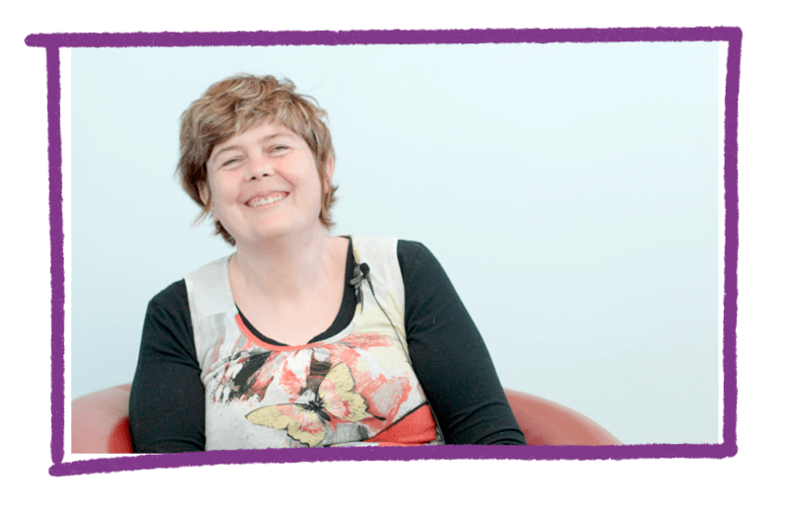

3.3 How co-design participants benefited from their involvement
Participants experienced many benefits from participating in the Our Site co-design process. Most expressed a sense of pride in their contribution and there were many examples of individuals building confidence and feeling empowered through their involvement. Some participants have already experienced benefits in their workplace and careers and further participants expect to do so in the future. Many co-design participants spoke of the significant personal benefits of making new friends and connections with other women with disability through the Our Site project.

Gains in personal confidence, pride and leadership
Most co-design participants reported having benefited significantly on a personal level from participating in the Our Site project. They expressed pride in having been involved and a powerful sense of achievement.^{11,17,21}
“I thought the pinnacle emotional experience for me was going to the Paralympics, but this website, is actually even a higher mountain that I’ve been able to participate in, in achieving the top of the mountain.” (Panel member)¹¹
The anticipation of the website benefiting other women and girls with disability was a source of strong pride for some co-design participants. They view Our Site as an effective vehicle for demonstrating leadership by women with disability, as role models for other women and girls with disability.
“Our Site can showcase to young women and girls with disability, that they can be anything, they can achieve anything. That is often missing in our lives - our own roles, our own examples of who we want to aspire to be like.” (Panel member)¹¹
“I am most proud of the fact that … women and young girls can see what our community is capable of when we come together.” (Panel member)¹⁷
Many co-design participants spoke of growing in confidence in themselves through their participation.
“There has definitely been an increase in confidence, within myself, as a woman and as an advocate.” (Panel member)¹¹
Recording and sharing her story for inclusion on the website was an empowering and healing process for one co-design participant:
“Being a part of this project enabled me to be more courageous and step up by sharing my story on video. Helping me accept the pain and violence I’ve experienced and how I can use my challenges to be my strength.” (Panel member)²¹

Benefits for education, work and career
Participating in the Our Site project was a positive professional experience for many. Benefits were gained through building expertise and having opportunities to demonstrate that expertise.
Several co-design participants spoke about how the Our Site project has extended their expertise in the rights of women and girls with disability. In some cases this has already achieved benefits for their confidence, credibility and security in the workplace.
“If you’re going to discuss or argue a point, you need that credible reference or sources behind you to be confident… So in my workplace [the Our Site experience] has really found me gain a lot more confidence.” (Panel member)¹¹
One co-design participant believed that their participation in the project has contributed to their professional credibility, sense of value in the workplace and job security. Another participant feels their involvement on the Panel may have contributed to a new job opportunity or at least strengthened her ability to deliver the new job.

An education professional’s story
“Participating on the Panel helped me provide the evidence of ‘industry currency’ that I need to retain my work in providing disability studies.
I have made some changes to student course content based on new knowledge I gained through the Our Site project.
My connection with Our Site has proved my expertise to my superiors. The stress about whether I’ll lose my job is gone and I feel really valued at work”.
The process of seeking input about Our Site helped strengthen the dynamics of a support group facilitated by a co-design participant. Another participant experienced a growth in her professional profile through social media interviews following promotion of her involvement with Our Site.
A support group facilitator’s story
“I decided to seek feedback on the website from women in a new support group that I was leading.
Reviewing and talking about the website helped us connect, bond and touch on deeper issues much faster than would normally happen.
It also generated discussions around self-care and professional care and prompted us to find local resources”.
Several participants benefited from insights learned about project aspects such as website design, website accessibility and management of large projects.^{11,17} They plan to draw on these insights in future work contexts. For example, a Panel member plans to review and redesign her own small business website to be more engaging after learning from the Our Site creation process.¹⁷
Several particiants believe that listing their involvement with Our Site on their resume will be helpful for their future work. Contributing to Our Site was considered particularly helpful for illustrating to future employers how sharing lived experience can be so important in developing an exceptional project or product.¹⁷

Benefits of connecting with other women with disability
Many co-design participants spoke of the profound personal benefits of making new friends and feeling connected to other women with disability through the Our Site project. They spoke of feeling understood, connected, inspired, confident and empowered through these connections.^{11,17}
“Before I was pretty isolated, I didn’t really have friends that were disabled. So, to meet lots of other women on this journey was good - Soul Food!” (Panel member)¹⁷

“I really loved linking with so many women from so many diverse backgrounds and life experiences. I find engaging with other women with disability really empowering.” (Panel member)¹⁷
A young woman’s story
“Participating on the Panel was very empowering for me. Since my accident I have felt very lonely and isolated. I’ve struggled to fit in.
On the Panel I found a common understanding and I felt valued for who I am.
For the first time in a long time, I felt free. Free from feeling I had to hide my disability, free from feeling judged. This increased my confidence and brought me joy.
I’ve realised that this is the community that I feel most at home with. It is incredible to be part of a community of women who embrace each other for who they are, regardless of disability”.
Co-design participants expressed a strong sense of inspiration, learning and empowerment gained through meeting women with disability who are disability leaders and advocates.
“I’ve met in just a very short time, a whole heap of movers and shakers in the disability world who I wouldn’t have had the opportunity to meet before. … My aspiration is to do that as well and to push forward some better things for people with disability.” (Panel member)¹⁷
“Being involved with this project gave me the opportunity to be involved with other women who are the fiercest people out there. I have realised I am not just a lone little voice and [that] has made me feel more confident to speak up and own it.” (Panel member)¹⁷
The connections are being supported into the future through ongoing input into the website, a network of Our Site contributors facilitated by WWDA and through the Facebook group linked to Our Site and administered by WWDA.

3.4 Successful co-design with women with disability

Leaders in comprehensive, inclusive co-design
The Our Site co-design model extended usual co-design approaches because the project was led by the women with disability of WWDA, who facilitated involvement of a large, diverse group of additional women with disability. The project consistently prioritised the genuine, non-tokenistic involvement and input of women with disability in every aspect of Our Site’s creation. The approach resulted in a meaningful engagement process with multiple benefits for its participants and a website that is considered to be owned by the diverse community of women and girls with disability.

Our practical strategies for an inclusive co-design process
Our practical strategies are informed by co-design participants feedback on what helped them to provide meaningful input as well as their suggestions for how their input could have been strengthened.
Have strong project governance and a clear plan for involving women and girls with disability at multiple levels in all stages of the website project.
Proactively recruit a diverse group of women with disability including those in hard-to-reach groups across all age groups, locations, impairment types, and Aboriginal and Torres Strait Islander and other cultural backgrounds.
Partner with a range of support groups, disability and community organisations that can help facilitate input from many diverse women, including hard-to-reach groups.
Pay co-design participants for their time spent contributing to the project.
Provide clear orientation to co-design participants, via online or face-to-face meetings.
Facilitate mechanisms for co-design participants to meet with each other, connect and collaborate.
Offer a wide range of different engagement mechanisms to support varied levels of involvement by diverse groups with different accessibility requirements and workstyle preferences including:
- online meetings/ face-to-face workshops to obtain input from women who may be otherwise unable to contribute
- engage via online / face-to-face meetings with women with intellectual disability
- support both individual and collaborative contributions
- offer a wide range of written and verbal feedback mechanisms
- offer individualised support and engagement mechanisms when needed.
Balance the intensity of co-design tasks with frequency (e.g. more frequent engagement opportunities requiring shorter periods of focus or intensity).
Communicate engagement instructions using multiple mechanisms (e.g. supplement written instruction with verbal instructions provided via video or online meeting).
Schedule input/ website-testing rounds well in advance and allow sufficient time for input.
Seek feedback from governance and co-design participants during different stages of project implementation, so that improvements can be made to the process.

A note about the reflections of co-design participants
This chapter is based on the reflections and insights of women involved in the co-design process, which aligns with the Our Site co-design model. Seven co-design participants took part in semi-structured telephone interviews and 22 took part in Panel reflection workshops (online) or equivalent consultations adapted to their requirements (see Appendix 2 for further details).
The input from a wide range of co-design participants has provided a detailed, deep understanding of the co-design process and how meaningful and beneficial it was for them. Those who chose to share their experiences of the project were well-informed, articulate and passionate advocates for women with disability. However, this approach likely missed additional perspectives and experiences, perhaps of women who felt less engaged in the co-design process or who are less aware of or engaged in activism around the rights of women with disability.
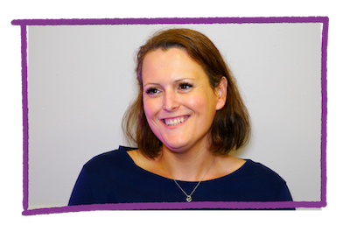

How we prioritised website accessibility and quality

4.1 Our framework for website accessibility and quality
Creating a high-quality website that is accessible to all women and girls with disability was a top priority for the Our Site project. Quality criteria were defined with the Project Steering Committee to support a shared understanding of what it means to create a ‘high quality’ website. The criteria align with factors commonly considered in assessments of the quality of online health information.²³ They cover: accessibility; understandability and readability; relevance; credibility and trustworthiness; accuracy and completeness; currency; inclusivity; practicality and empowerment; aesthetics and interactivity (see definitions in Appendix 3).
The quality criteria guided the Quality Review Panel and additional co-design participants in their reviews of draft versions of the website.
“The quality criteria helped me to give feedback. In the absence of any scaffold, I think I wouldn’t have been as thorough … we needed a guide to give depth to our feedback.”(Panel member)¹¹
In January 2020, the expert Quality Review Panel assessed the final draft website against the quality criteria in a Panel workshop. They considered the criteria had been met sufficiently for the website to be launched.

4.2 How we assessed the accessibility and quality of Our Site
Consistent with the co-design approach, the perspectives and experiences of women with disability using Our Site were prioritised in assessments of the accessibility and quality of Our Site. Our Site was rated highly by women with disability against each of the quality criteria. The co-design approach and inclusion of personal stories were strong influences on these positive perceptions. The personal stories are the most visited section of the website and are considered to be practical, empowering and to help women feel connected to a wider community of women with disability.
Additional data (such as website usage patterns and an independent accessibility audit) were used to supplement user perspectives.

Accessibility & understandability of Our Site
Ensuring that Our Site is accessible to all women and girls with disability, regardless of auditory, cognitive, neurological, physical and visual requirements¹⁷, was a high priority. For example, a report on the planning workshop discussions concluded that Our Site should prioritise accessibility over some aspects of website functionality.²⁰
From a technical perspective, Our Site was independently audited by the Centre for Inclusive Design against the Web Content Accessibility Guidelines (WCAG) 2.1, Level AA published by the international World Wide Web Consortium (W3C) ²⁴. In May 2020, Our Site was rated as having an Accessibility Compliance score of 98%.
From a user perspective, co-design participant feedback led to improvements on a wide array of website design features relevant to accessibility. Examples include changes to the font to support cognitive processing and to colours to improve accessibility for people with vision impairment.¹¹
“As someone on the Autism Spectrum, some websites you go to are an assault on your senses. They’re not easy to use when you have cognitive processing challenges. So, I like that Our Site is simple and doesn’t look like the others that are quite overwhelming.” (Panel member)¹⁷
Co-design participants were satisfied with the accessibility of Our Site. In reviewing the final draft website, 92% of the 23 women with disability involved considered it easy to find their way around Our Site.²⁶
“I really like that Our Site is a one stop shop, so you can just go in there and drop down the menus and go where you want to go. That’s a strength of the website.” (Panel member)¹⁷
Early user-feedback suggests women and girls with disability find the published website reasonably accessible. Within the first 2 weeks following website launch, 70% of the 16 women and girls with disability who responded to the website survey rated the website as ‘easy to use’.²⁷
When asked about accessibility, some co-design participants spoke about how easy it is to understand the information on Our Site and to move around the website.
“The video content makes information so accessible. The impact when you are watching videos is so much stronger.” (Panel member)¹⁷
“I love how the different sections are really intertwined. So, if you go to one section it is really easy to jump to another one.” (Panel member)¹⁷
Following launch, work continued on the Easy Read content and functionality to improve understandability and accessibility for women with intellectual disability and/or lower literacy levels.

Relevance of Our Site
Co-design participants and early website visitors generally considered Our Site content to be relevant to them (Appendix 3). For example, prior to launch 88% of the 21 women with disability involved in the final round of website-testing said they were likely to use the information on Our Site.¹⁹ Following launch, 80% of the 16 women with disability who completed the feedback survey rated the content as relevant and over half (55%) considered it useful to them. ^{27, 28}
Both co-design participants and early website visitors considered the website relevant for other women with disability and were likely to recommend Our Site to others (Appendix 3).^{27, 28, 29}
“Our Site has resources specifically for ‘us’, so instead of having to sift through a lot of information that may not account for the needs of women and girls with disability, we know that if it’s on this site, it’s relevant and accessible to us.” (Panel member)²¹
Our Site is being well used, which suggests it is relevant to an audience far beyond the co-design participants. As at 31 July 2020, Our Site had been accessed over 11,000 times from over 60 countries. The majority (86%) of visits to Our Site were from within Australia.³⁰

Credibility, accuracy & currency of Our Site
Co-design participants believe that the leadership by and involvement of women with disability in all stages of website creation underpins the credibility and quality of Our Site.
“The fact that the input was all from women with disability made me feel that the content was authentic.” (Panel member)¹¹
In addition to having a diverse range of lived experiences as women with disability, the Project Steering Committee members and co-design participants have deep expertise across the website content areas and website development (Box 1). This combination helped ensure that Our Site communicates information that is accurate, current and credible.
“I feel my role was to ensure currency and credibility of information. Currency is a huge thing …I felt confident I’d be able to identify if something was rubbish or out of date.” (Panel member)¹¹
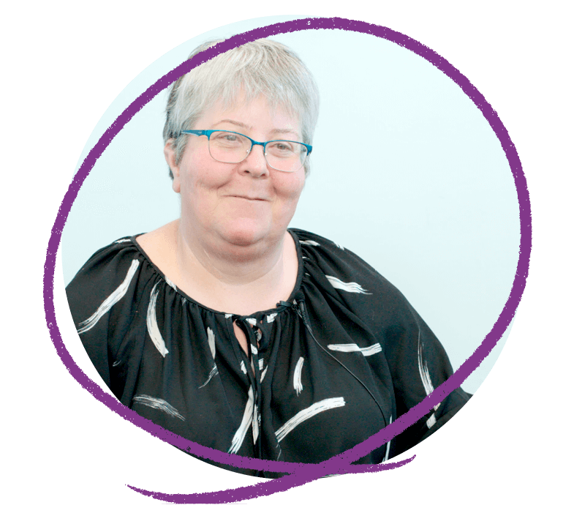
Box 1. Project Steering Committee and co-design participant expertise
- Disability and human rights advocates and peer advocates
- Presidents, CEOs and Board members of disability and women’s advocacy organisations
- Senior staff with roles in: disability and domestic and family violence; women’s rights and gender equality; peer mentor programs
- Health professionals (e.g. social workers, psychologist, occupational therapist, sexual assault counsellor)
- Academic researchers, educators and training providers in relevant disability studies
- Social scientists, health promotion professionals, socio-linguistic anthropologist
- Auslan interpreters
- Senior finance and mortgage broker advisor
- Digital content specialists (e.g. writers, bloggers and social media)
To further ensure accuracy of content, the medical and health content was reviewed by a general practitioner and by relevant health organisations.
In general, co-design participants considered the draft website content to be accurate and current (Appendix 3).²⁹

Inclusivity of Our Site
Co-design participants and early website visitors considered the draft website to be reasonably inclusive of themselves and others with disability (Appendix 3). ^{27, 28, 29} For example, prior to launch 80% of the 20 women with disability involved in the final round of website-testing thought they could see themselves or a woman like them represented on Our Site.²⁶ Following launch, 94% of 17 women with disability who completed the feedback survey considered the website to be respectful of women with disability and about two thirds (68%) thought the website represents a community that they feel they belong to.²⁷

Practicality & empowerment of Our Site: the power of stories
Co-design participants consider the draft website to be practical and empowering (Appendix 3).³¹ The co-design approach used to create Our Site reinforced the sense of empowerment.
“That the website has been built by women with disability sends a really powerful message about empowerment and people’s rights” (Panel member)¹¹
Women’s personal stories are considered by many co-design participants to be the most practical, influential and empowering aspect of Our Site. Personal stories illustrate how the website content can be applied in people’s lives.
“The stories give you a case study for how to use the information that is on Our Site.” (Panel member)¹⁷
“I think the stories are great because they show how the different pieces of information [on Our Site] can apply to different people and how they affect different people’s lives.” (Panel member)¹⁷
The personal stories also help women with disability to feel connected to a wider community of women with disability, to feel understood and not alone. This has been a powerful, positive experience for some women.
“Our Site creates community through the stories, of hearing the voices of people who’ve had lived experiences. Reading through the stories and seeing patterns and recognising you’re part of a wider experience that’s not isolated, that is quite universal for women with disability.” (Panel member)¹¹
“It helped me feel a sense of community … I’ve never had this community. Seeing this space be formed that is a space of community is really exciting.” (Panel member)¹¹
The inclusion of personal stories was a unanimous request from the planning workshops²⁰ and they are proving to be the most frequently visited section of Our Site (beyond the home page).³⁰

Aesthetics, engaging aspects & interactivity of Our Site
Feedback about the aesthetics of Our Site was relatively limited, but co-design participants were positive. In particular, participants liked the depth and diversity of multimedia options and the graphic design elements. One commented on the website being ‘fun’ to use.
“I think it’s really fun. The design is upbeat. … it’s really like, oh what’s over there, and I will click over there. I really like the back to top and exit buttons that move with you as well. Because it moves with you, it keeps you interested.” (Panel member)¹⁷
The main opportunity for visitors to interact with Our Site is through the Facebook group linked to the site. The group was launched just prior to the website launch and rapidly grew to the current membership of 620 women with disability (as at 20 July 2020). The group has been very active and is highly valued by some co-design participants.
“I really like the Facebook group that has come from this. I really like being part of a community of women. It is really nice to be able to connect with people. I always wished I had something like this when I was younger, and now that I’m an adult, I have it and its really great.” (Panel member)¹⁷
Many co-design participants would like additional opportunities for interacting with other women with disability to be facilitated through Our Site (see Chapter 5 – the future of Our Site).

4.3 Creation of an accessible, high-quality website

Exceeding the quality and accessibility criteria
Accessibility and quality were priorities for the Our Site website. Project evaluation data have demonstrated that Our Site is a widely accessible website with a very high technical accessibility rating. Our Site provides high-quality information to a high volume of visitors. The co-design approach and prioritisation of women’s personal stories has strengthened the quality of the website. Co-design has delivered an informative, engaging website that is led by WWDA and therefore truly owned by the large, diverse community of Australian women with disability.

Our practical strategies for creating a high-quality, accessible website
Our practical strategies are informed by reflections on the delivery of a high-quality, accessible website from the WWDA project team and from many women with disability involved in Our Site project governance and co-design.
Articulate an agreed definition of ‘high-quality’ in the context of the website
Agree what it means to be ‘accessible’, how best practice criteria will be applied, and how to make decisions regarding accessibility compromises
Seek technical expertise in website accessibility
Draw on the expertise and lived experience of women with disability to define and test accessibility and quality
Create small teams of experts for content creation

A note about the survey data
This chapter references surveys completed by small numbers of co-design participants who were women with disability. The small numbers pose limitations for comparison across different website sections or aspects of quality. The ratings may not be representative of perceptions held by other members of the community of women with disability.
The post-launch survey of visitors to Our Site was intended to broaden the range of perspectives informing the assessments of website quality. However, the launch of Our Site coincided with the beginning of the COVID-19 pandemic response in Australia which reduced the potential to promote the website and the feedback survey. The numbers of survey responses were low during this time.
(See Appendix 2 for further details).

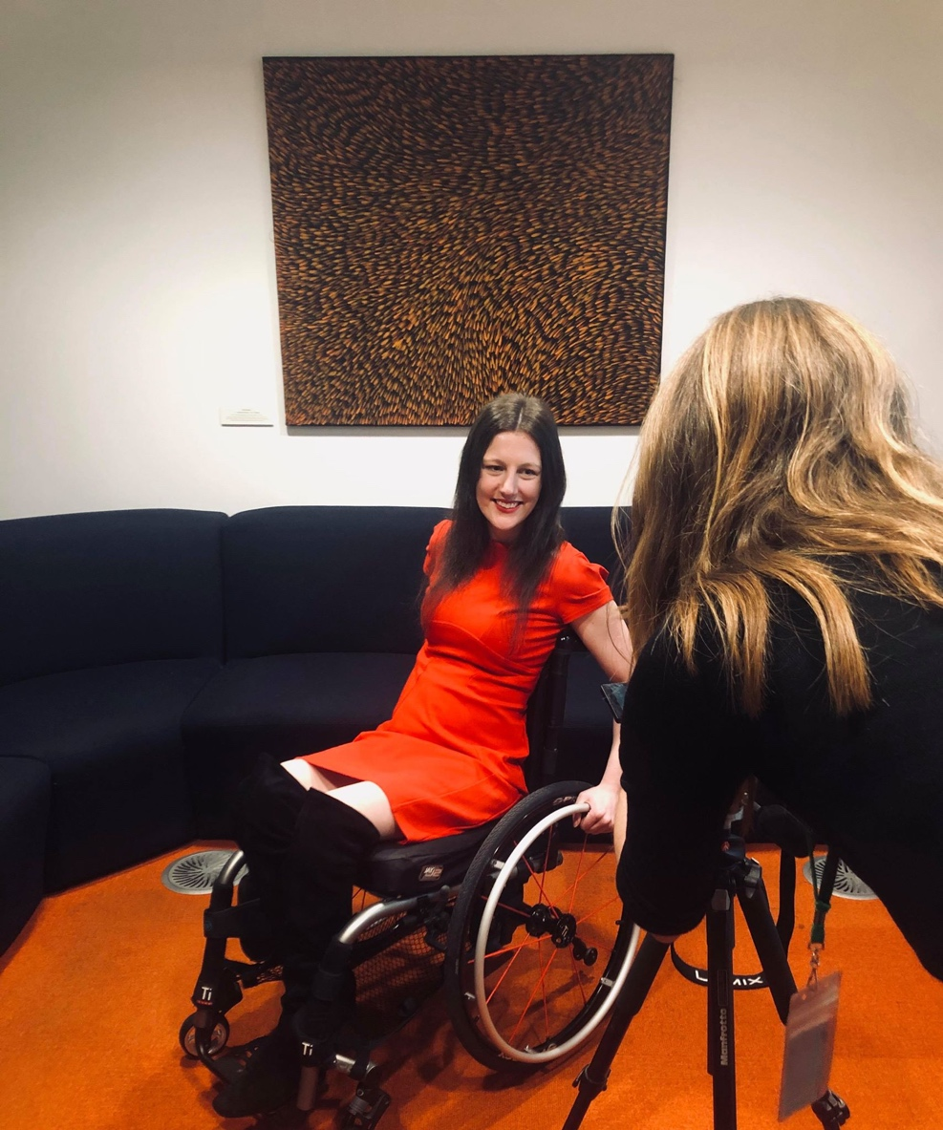

The future of Our Site
WWDA and the co-design participants are proud of the quality of the Our Site website and of their collective achievements through the Our Site project. To ensure women and girls with disability continue to benefit from these achievements, WWDA and co-design participants have identified priorities and opportunities for the future of Our Site. The capacity to deliver on these will be dependent on securing further funding. Some describe large initiatives that would require significant time and resources.

5.1 Priorities for the continued delivery of Our Site

Continue as a co-designed website for women with disability by women with disability, led by WWDA
Continuing to publish and improve Our Site using the Our Site co-design model, led by WWDA, will ensure that the website continues to meet the needs of women with disability. The co-design approach has brought together a diverse community of passionate, influential and capable women, many of whom want to continue to contribute to Our Site.^{11, 17}Ideally, the engagement of women with disability will be extended to ensure Our Site continues to meet the needs of as broad a range of women as possible.¹¹
Suggested ideas for continuing and extending the co-design approach include:
- continue to build and work with the co-design participant community
- create opportunities for women with disability to share relevant information and opportunities
- further engage with Aboriginal and Torres Strait Islander women with disability and develop targeted web content with and for this group
- further engage with young women with disability and older women with disability to develop targeted web content with and for these groups
- increase the availability and scope of content translated into languages other than English.

Maintain the currency and accuracy of Our Site
Ensuring that Our Site continues to be a highly relevant, useful resource for women and girls with disability into the future is a high priority. To achieve this, it is important that Our Site continues to provide current, accurate content and is updated promptly in response to significant changes in context, policy or legislation.^{11, 17, 20}
Suggested ideas for maintaining the currency and accuracy of Our Site include:
- flag and monitor content most likely to require review and updates
- undertake a regular, scheduled review of the full website for accuracy and currency
- add to content, covering topics such as: alcohol and other drugs, working from home, accessible job networks
- regularly post updates via mechanisms such as feature articles, blog-posts by women with disability, links to current issues in the media
- continue to build the personal stories section (see ‘Grow the Stories section’ below).

Continue to promote and drive traffic towards Our Site
In both the immediate and longer term, the promotion of Our Site to women with disability and the broader community is considered a priority.¹⁷ Continuing to add new content will be an important part of encouraging people to visit or return to the website.¹⁷
Suggested ideas for continuing to promote and drive traffic towards Our Site include:
- extend social media engagement beyond Facebook, Instagram and Twitter to include professional networks such as LinkedIn
- further promote Our Site through established community channels e.g. libraries, neighbourhood centres, community services, schools
- further support co-design participants (e.g. with templates, texts, tools) to promote Our Site in their networks, workplaces, communities and invite them to share their stories via local radio and other outlets
- ask NDIA (and other relevant government departments) to promote Our Site in communications with women with disability
- initiate an awards program to highlight issues for women with disability.

5.2 Opportunities to extend and add new functions to Our Site

Add new functions to extend the accessibility of Our Site
Continuing to ensure that Our Site is as accessible as possible for as many people as possible is a high priority.¹⁷
Suggested ideas for adding new functions for extending accessibility include:
- undertake additional targeted website-testing with people with specific accessibility requirements
- add more Auslan-interpreted videos
- add audio descriptions to relevant videos
- add a ‘read aloud’ function to the website (an in-built screen reader)
- provide more Easy Read versions of downloadable resources
- offer some form of support or live chat function to help visitors find the information they need
- create a supporting Our Site app.

Build connected communities of women and girls with disability through Our Site
A recurring request from co-design participants is for Our Site to be a platform that supports the creation of connections, communities and interactions between women and girls with disability.
“People can go to the website and see information they need, but it is also important to connect with others who share or understand our journey. You need that peer support. That is a very powerful way of connecting with people. (Panel member)”¹⁷
Participants recommend building connected communities through growing the stories section, facilitating more online discussion and interaction opportunities and supporting local community connections.
Grow the stories section
It is clear that the stories are a highly valued section of Our Site and an area that could continue to grow. Adding stories is one way to ensure the website maintains currency and draws back previous visitors.
Suggested ideas for growing the stories section include:
- add more stories, especially videos, highlighting current issues. e.g. how Our Site has had a positive impact on someone’s life; how people navigate the NDIS, dealing with the COVID-19 pandemic.
- offer options for website visitors to interact with, discuss and ask questions about the stories.

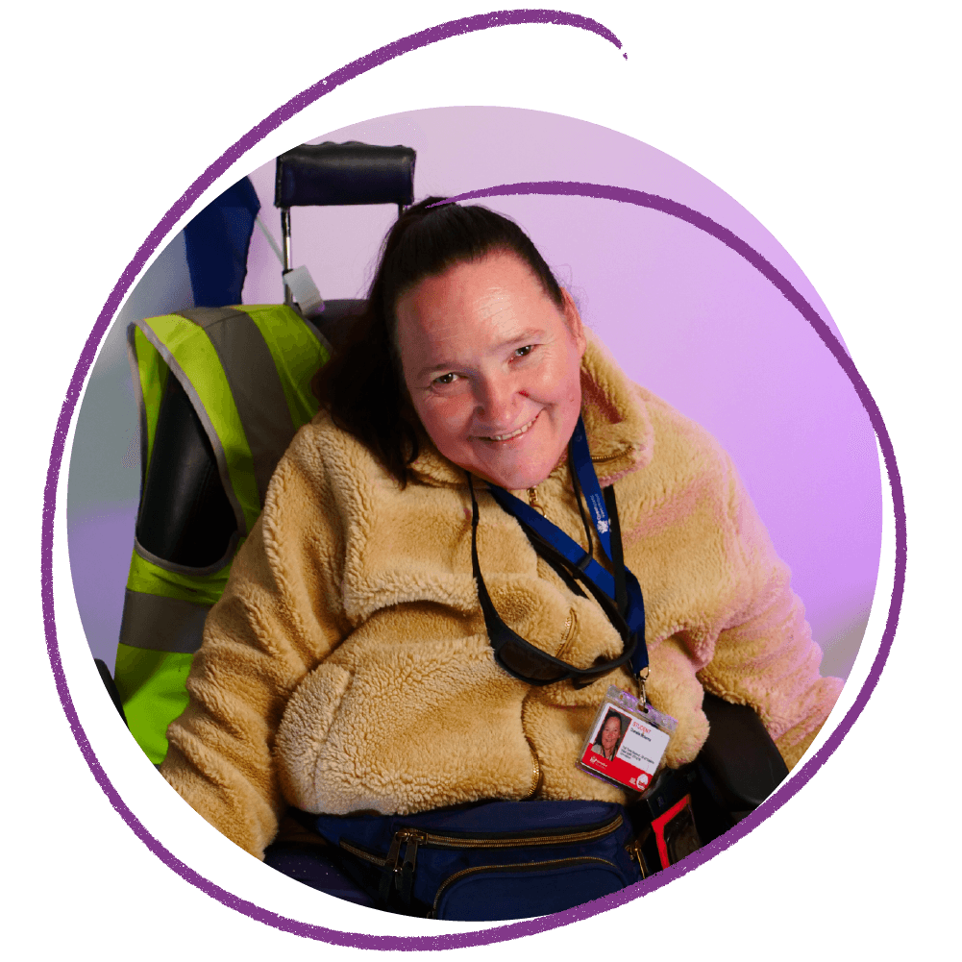

Grow online discussions
Co-design participants want to be able to interact with other women with disability, to discuss issues and experiences related to the website content. This space must feel safe for participants.¹⁷
A Facebook group is linked to the website, but it is recognised that many women with disability do not access Facebook for a range of privacy and security reasons. There are also additional social media platforms that could be used to reach women.¹⁷
Suggested ideas for growing online discussions include:
- facilitate online discussion forums from within the website (i.e. rather than via external social media platforms)
- more clearly link the stories page to the Facebook discussion group
- facilitate live (video) discussion or Question-and-Answer sessions via Facebook and other means
- establish group memberships to address privacy and security concerns
- establish additional interactions via Instagram and LinkedIn
- provide Question-and-Answer sessions/ interviews with women with disability who are advocates, story authors, leaders etc.
Support local connections and communities
Co-design participants want to be able to connect with and support other women with disability in their community.
“It would be nice for people to know that there are people connected to WWDA who could be, almost an ambassador for WWDA in our own communities.” (Panel member)¹⁷
There were many ideas suggested for how Our Site could facilitate connections and communities including:
- create and promote Our Site/WWDA ambassadors across the country and map/ illustrate the locations of Our Site/ WWDA ambassadors to support local connections
- create a platform to support women connecting and seeking information by local region, possibly supported by an Our Site/ WWDA ambassador
- create a platform for people to share and find local information e.g. ratings of accessibility of services, buildings, localities, health professionals.

Create online learning and skills development opportunities for women and girls with disability
Currently Our Site communicates important information to women and girls with disability. There is potential to use Our Site as a platform for offering opportunities that help women and girls with disability to build skills in addition to knowledge.
Suggested ideas for creating opportunities for learning and skills development through Our Site include:
- offer and facilitate a peer support or peer mentoring program for leadership and skills development
- offer webinars and online training programs to support building skills that are a priority for women with disability across work and life
- facilitate connections between women with disability and leadership and training opportunities.

5.3 Opportunities to use Our Site as a platform for change

Influence community understanding and attitudes
The Our Site co-design experience highlighted potential benefits for women with disability and other community members that can result from engaging in deep conversations about the Our Site content.
Suggested ideas for using Our Site to influence community conversations include:
- develop a toolkit and resources to support community and disability organisations to facilitate local group discussions about the key issues in Our Site and to generate local activity linked to the website
- support local disability organisations to run a series of Our Site group discussions, using the toolkit and resources
- through community conversations, extend opportunities for more women with disability to contribute to Our Site (e.g. by inviting feedback on the website or by contributing to the collection of personal stories).

Influence mainstream and disability service providers
Women and girls with disability are the primary target audience members for Our Site. However, the information is also intended to influence secondary target audiences, including providers of mainstream and disability-specific services.
There is the potential for the information on Our Site to reach and influence the diverse range of individuals and organisations providing disability-specific and mainstream services to women and girls with disability. Ultimately this is intended to improve the service experiences of women and girls with disability as well as a range of social and health outcomes.^{11, 17}
Suggested ideas for influencing service providers through Our Site include:
- expand the Our Site content available for ‘services and supporters’, using co-design approaches with service providers and women with disability
- design and implement a targeted strategy for raising awareness amongst service providers of the issues addressed by Our Site and for facilitating engagement with Our Site
- develop a tool kit to support services to implement quality improvement activities that improve service experiences and outcomes for women and girls with disability.

5.4 Opportunities for WWDA beyond the project experience

Promote and share the Our Site co-design model
The Our Site project has clearly demonstrated the benefits of implementing an inclusive co-design methodology grounded in human rights, both for the quality of the project product and for women with disability as co-design participants. There is an opportunity for WWDA to use the expertise gained through the Our Site project experience to support other organisations to take similar approaches in their work with people with disability.
Suggested ideas for promoting the Our Site co-design include:
- develop toolkits and resources to support implementation of similar co-design projects
- provide online webinars to promote and discuss the Our Site co-design methodology
- offer direct consulting services and support in co-design approaches.

Continue to grow and work with the expert panels of women with disability
The Our Site co-design process brought together a diverse group of passionate women with different experiences of living with disability. Co-design participants reported having learned much through the process of developing Our Site and many are interested in continuing to contribute their knowledge and skills to help other women with disability.

Continue to assess, improve and build the evidence for the effectiveness of Our Site
Securing the resources needed to improve Our Site or use Our Site as a platform for creating change will require a strong business case, supported by evidence of the effectiveness of the website. To date, the monitoring and evaluation framework has: supported ongoing improvements of the website; demonstrated the value of the co-design approach to developing the website; and demonstrated delivery of a high-quality, accessible website.
An ideal next step in building the evidence base is to assess the impact of Our Site on the broader community of Australian women and girls with disability (beyond those involved in the co-design), and possibly on others (such as carers, supporters and service providers).

Acknowledgments

WWDA acknowledges, with thanks, all of the women with disability who worked with WWDA on the Our Site Project. The project simply would not have been possible without your ideas, advice, support and creativity Thank you!

In particular, we would like to thank the members of our Project Steering Committee:
Cee, Leah, Leanne, Libbi, Margherita, Merri and Tricia. Members of our Quality Review Panel: Akii, Hannah, Jane, Janel, Kerrie, Monique, Nicole and Patsie. Members of our Expert Advisory Panel: Arlette, Belle, Bridgett, Cheryl, Christina, Cobie, Georgia, Hayley, Jacqui, Jenny, Judy, Kalena, Karen, Kaye, Kerry, Kiara, Jody, Leanne, Leeann, Linda, Lisa, Natasha, Nicole, Raelene, Ricky, Stacey, Stevie, Tammy, Tess, Akii, Hannah, Jane, Janel, Kerrie, Monique and Tully. We would also link to thank all of the women who attended planning workshops across the country in July 2019 and all of the women who have contributed their personal stories to Our Site.

We would also like to acknowledge the WWDA staff who work on the Our Site project:
Naomi Thomson – Our Site Project Manager
Heidi La Paglia – Our Site Senior Content Officer
Carolyn Frohmader – WWDA Executive Director
Jacinta Carlton – WWDA Media and Communications Officer
Sharon Williams – WWDA Office Manager.
‍
WWDA acknowledges with appreciation, the National Disability Insurance Agency (NDIA) for funding and supporting the Our Site project through the NDIS Information, Linkages and Capacity Building (ILC) funding program. We also thank the NDIA for its support and encouragement during the Project, and for participating in the formal launch of Our Site in March 2020.
Finally, we would like to thank all of the many organisations and individuals who provided invaluable support, input and services. Including (but not limited to) Women with Disabilities ACT, Women with Disabilities Victoria, Women with Disabilities WA, WWILD, First People’s Disability Network, National Ethnic Disability Alliance, Speak Out Association of Tasmania, Paterson St Hub, Handbuilt Creative, K2 Strategies, Keith Deverell, Turning Forward, Information Access Group, Expression Australia, Ethnolink, Access Media, Access Easy English.

Appendices

Appendix 1. Mechanisms for involving women with disability in creating Our Site
Women with disability were actively involved through the whole process of creating Our Site, through several different mechanisms (Table 2). Many individuals were involved through more than one mechanism.
Table 2. Mechanisms for involving women with disability in creating Our Site
Mechanism | Role in Our Site | Detail
WWDA Executive Committee  & Executive Director | Lead: Responsible for project governance & delivery | The Executive Committee comprises 7 annually elected women with disability and WWDA’s Executive Director is a woman with disability
Project Steering Committee  (PSC) | Lead: Expert advice across all elements of project governance & delivery | 7 expert leaders in disability and women’s issues, including 4 people with disability
Expert Advisory Panel  (EAP) | Design: Contribute web content and design advice throughout the development process | 37 women with disability from across Australia, from diverse backgrounds and geographic locations
Quality Review Panel  (QRP) | Design: Review, rate and advise on quality of draft web content and design | A sub-set of the EAP (plus 2 additional members), comprising 7 women with disability and 1 additional content expert
Planning workshops  (6 workshops) | Collaborate: Identify the content, design and functionality considerations most important and relevant to women with disability | 45 women with disability (including 4 EAP and 1 PSC members) in 6 states/ territories took part in a one-day face-to-face workshop  A full report on the workshops and their outcomes is available on the WWDA website
User testing activities  (5 rounds of testing) | Collaborate: Review and provide feedback on drafts of the website (focus on content and functionality/ accessibility) | User Test 1: 24 members of PSC & EAP  User Test 2: 25 members of PSC & EAP  User Test 3: 18 members of PSC, EAP, QRP; up to 25 additional women on WWDA contact list  Easy Read tests 1 and 2: 4 members of EAP (women with intellectual disability) and 4 additional women with intellectual disability
Personal stories  (published on Our Site) | Collaborate: Contribute website content by sharing a personal story as a woman with disability | To date, 41 women with disability have shared their personal stories for inclusion on Our Site (including 11 EAP/QRP/PSC members and 2 WWDA Executive Committee members)

Appendix 2. Our approach to evaluation and monitoring the Our Site project

This report is informed by evaluation data collected about the Our Site project.

Evaluation questions to understand Our Site project success
The success of the Our Site project was evaluated by answering three key questions that WWDA and the Project Steering Committee identified as being most important (Box 2). Data collected to answer these questions have been integrated into this report.
Box 2. Key questions to understand project success
- Have the project commitments been delivered?
- How well have women and girls with disability been meaningfully involved in the design and development of Our Site?
- How well has Our Site achieved its goal of providing accessible, high-quality information for women and girls with disability?
These questions align with the NDIA Grant Outcomes that the Our Site project is intended to contribute towards:
- Outcome 1: Women and girls with disability actively contribute to leading, shaping and influencing their community (aligns with Key question 2)
- Outcome 2: Women and girls with disability are connected and have the information they need to make decisions and choices (aligns with Key question 3).

The approach to assessing project success
A monitoring and evaluation framework guided the approach to assessing the success of the Our Site project. The WWDA project team led the monitoring and evaluation process with oversight by the Project Steering Committee and advice from an external consultant.
In their governance role, the Project Steering Committee contributed to the key questions to be addressed, approved the framework for answering the questions and helped interpret the findings.
The approach to evaluating project success made use of successive project reports and cumulative data collected during each project stage. These were supplemented with reflections and insights from co-design participants, obtained through interviews, reflections workshops and written reflections after the launch of the website (Table 3).
Table 3. Data sources used to answer each of the key questions (Q1, 2 and 3)ª
Data source | Details | Q 1ª | Q 2ª | Q 3ª
Project records & reports | PSC reports; Project Activity Workplan & performance measures; Progress Reports | X
Project records & reports | Records of contributors to project engagement |  | X
Planning workshops Report | Outcomes of 6 planning workshops held with 45 women and girls with disability |  | X
Panel advice (EAP & QRP) | Summary reports and logs of advice and actions taken |  | X | X
Website testing reports | Reports from 3 rounds of testing of website iterations. |  | X | X
Accessibility audit report | Centre for Inclusive Design audit of the website’s accessibility against international standards |  |  | X
Live website user survey | An online survey, available on website |  |  | X
Website analytics | Google Analytics to track website usage patterns |  |  | X
Social media analytics | Analysis of WWDA Facebook page participation following launch |  |  | X
Ambassador survey | Survey responses from 15 interested Panel members about their experiences and views on the Our Site project |  | X | X
Co-design participant interviews | Semi-structured telephone interviews with 7 women with disability: 2 PSC members and 5 EAP members (2 of whom were also QRP members) | X | X | X
Panel reflection workshops and adapted consultations | Flexible opportunities for EAP members to reflect on the participation experience and lessons learned  A total of 22 participants via: 4 video conference workshops (16 women), 1 Facebook chat discussion (2 women), reflections via email and phone call (4 women) |  | X | X
ª The key questions to understand project success are:
- Have the project commitments been delivered?
- How well have women and girls with disability been meaningfully involved in the design and development of Our Site?
- How well has Our Site achieved its goal of providing accessible, high-quality information for women and girls with disability?
Many individual co-design participants contributed via more than one data source.

Strengths and limitations of the evaluation approach

Aligning with the co-design model
A strength of the evaluation approach is that it aligned with the Our Site co-design model and prioritised the leadership and input by women with disability. The Project Steering Committee were involved in setting the questions, approving the data collection approach and interpreting the findings. Collected through interviews, surveys, workshops and written reviews, the insights and experiences of women with disability (co-design participants) contributed significantly to the findings.
Input from women with disability provided a detailed, deep understanding of the co-design process and the value and quality of the Our Site website, from the perspectives of a range of women with disability. Those who elected to share their experiences of the project were well-informed, articulate and passionate advocates for women with disability. However, this approach likely missed additional perspectives, perhaps of women who felt less engaged in the co-design process or who are less aware of or engaged in activism around the rights of women with disability.

Balancing efficiency and rigour
Using existing project reports and data collected over the course of the project was an efficient approach to data collection. This was important for the tight project budget. However, there are limitations in data rigour from an evaluation viewpoint. For example, the assessments of website quality and accessibility rely on ratings from small numbers of women with disability which pose limitations for comparison across different website sections or aspects of quality. The ratings may not be representative of perceptions held by other members of the community of women with disability.
The post-launch survey of visitors to Our Site was intended to broaden the range of perspectives informing the assessment. However, the launch of Our Site coincided with the beginning of the COVID-19 pandemic response in Australia which reduced the potential to promote the website and the feedback survey. Numbers of survey responses were low during this time.

The influence of project timing
The evaluation focussed on the co-design process to develop the website and the quality of the final product, both critically important aspects of the Our Site project success. They are both considered elements of a ‘process evaluation’, which examines how well a project’s activities were delivered and what influenced that delivery.
While the evaluation data highlighted how the co-design process could have positive benefits for participants, project timeframes did not allow for an exploration of the reach and impact of the website on the whole target audience of women and girls with disability. An ideal next step would be to assess the impact of Our Site on its target audiences. This could include, for example, looking at the extent to which the website has influenced the awareness, knowledge, actions and lived experiences of women and girls with disability or of those working to support women and girls with disability.

Appendix 3. Assessments against website quality criteria

Quality criterion: Accessibility
Definition: Easy for a user to find the information they need (navigability); Meets WCAG 2.1 AA accessibility requirements; Information satisfies different learning needs and levels of knowledge.
Quality assessment results:
- User testing of final draft website, December 2019: 92% (n=23) of the women with disability involved considered it easy to find their way around Our Site.
- Feedback on live website, March 2020: Within the first 2 weeks following website launch, 70% (n=16 of 23) of women and girls with disability who responded to the website survey rated the website as ‘easy to use’.
- Independent audit against international criteria, May 2020: Rated as having an Accessibility Compliance score of 98% against Web Content Accessibility Guidelines (WCAG) 2.0, level AA.

Quality criterion: Understandability & readability
Definition: Information is in appropriate depth, quantity, and specificity; Information is presented in a form that is easy to read.
- This quality criterion was covered within the assessment of accessibility (above).

Quality criterion: Relevance
Definition: Targeted to women and girls with disability (or individuals and services that support them); Relevant to the topic and/or to information seekers’ situation and background; Relevant to the priority areas (content); Relevant to Australian context.
Quality assessment results:
- Review of each website section against quality criteria (by members of the Quality Review Panel, Expert Advisory Panel, Project Steering Committee and interested service providers), November 2019:
Website section | Rating against ‘relevance’ (draft Website, November 2019)
 | Excellent | Very good | Adequate | Not sure | Negative
Your rights | 67% (n=12) | 11% (n=2) | 22% (n=4) | 0 | 0
Lead & take part | 71% (n=12) | 18% (n=3) | 12% (n=2) | 0 | 0
Life choices | 57% (n=8) | 21% (n=3) | 21% (n=3) | 0 | 0
Sex & your body | 71% (n=10) | 14% (n=2) | 14% (n=2) | 0

- User testing of final draft website, December 2019: 88% (n=21) of the women with disability involved said they were likely to use the information on the Our Site website 92% (n=23) and 90% (n=21) said they were likely to suggest that other women with disability visit Our Site.
- Feedback on live website, March 2020: Within the first 2 weeks following website launch, 80% (n=16) of women and girls with disability who responded to the website survey rated the content as relevant to them. Just over half (55%; n=11) rated the content ‘useful’ or ‘very useful’ and 70% (n=14) said they were likely to recommend Our Site to others.
- Google analytics, July 2020: As at 31 July 2020, Our Site had been accessed over 11,000 times from over 60 countries. The majority (86%) were visitors based in Australia.

Quality criterion: Currency
Definition: Source and/or information is up to date; Most recent information on this area.
Quality assessment results:
- Review of each website section against quality criteria (by members of the Quality Review Panel, Expert Advisory Panel, Project Steering Committee and interested service providers), November 2019:
Website section | Rating against ‘currency’ (draft Website, November 2019)
 | Excellent | Very good | Adequate | Not sure | Negative
Your rights | 71% (n=12) | 12% (n=2) | 6% (n=1) | 12% (n=2) | 0
Lead & take part | 80% (n=12) | 13% (n=2) | 7% (n=1) | 0 | 0
Life choices | 69% (n=9) | 23% (n=3) | 8% (n=1) | 0 | 0
Sex & your body | 57% (n=8) | 29% (n=4) | 14% (n=2) | 0 | 0

Quality criterion: Accuracy & completeness
Definition: Reflects best practice; Evidence-based and referenced appropriately; Error-free; Necessary or expected aspects of a subject/topic are provided.
Quality assessment results:
- Review of each website section against quality criteria (by members of the Quality Review Panel, Expert Advisory Panel, Project Steering Committee and interested service providers), November 2019:
Website section | Rating against ‘accuracy’ (draft Website, November 2019)
 | Excellent | Very good | Adequate | Not sure | Negative
Your rights | 56% (n=10) | 22% (n=4) | 11% (n=2) | 11% (n=2)
Lead & take part | 65% (n=11) | 24% (n=4) | 12% (n=2) | 0 | 0
Life choices | 57% (n=8) | 14% (n=2) | 21% (n=3) | 7% (n=1) | 0
Sex & your body | 57% (n=8) | 29% (n=4) | 14% (n=2) | 0 | 0

Quality criterion: Credibility & trustworthiness
Definition: Information is honest or truthful and can be trusted; Source or author has a sufficient level of subject-related knowledge; Presents facts that are not influenced by personal feelings or commercial interests.
Quality assessment results:
- This quality criterion was not explicitly assessed.

Quality criterion: Inclusivity
Definition: Appeals to wide range of women and girls with disability; Is relevant to women with disabilities from minority groups; Does not use exclusive or ableist language; Recognises the differing experiences of women with disabilities in relation to aspects of their identity.
Quality assessment results:
- Review of each website section against quality criteria (by members of the Quality Review Panel, Expert Advisory Panel, Project Steering Committee and interested service providers), November 2019:
Website section | Rating against quality criterion ‘inclusivity’ (draft Website, November 2019)
 | Excellent | Very good | Adequate | Not sure | Negative
Your rights | 47% (n=8) | 29% (n=5) | 18% (n=3) | 6% (n=1)
Lead & take part | 53% (n=9) | 30% (n=5) | 17% (n=3) | 0 | 0
Life choices | 50% (n=7) | 21% (n=3) | 29% (n=4) | 0 | 0
Sex & your body | 71% (n=10) | 14% (n=2) | 14% (n=2) | 0 | 0

- User testing of final draft website, December 2019: 80% (n=20) of the women with disability involved thought they could see themselves or a woman like them represented on Our Site.
- Feedback on live website, March 2020: Within the first 2 weeks following website launch, 94% (n=17) of women and girls with disability who responded to the website survey considered the website respectful of women with disability and about two thirds (68%, n=13) think the website represents a community that they feel they belong to.

Quality criterion: Engaging
Definition: Engaging to target audience in some way (e.g. appealing to look at, interesting, unique, innovative).
- This quality criterion was covered within the assessment of aesthetics and interactivity (below).

Quality criterion: Practicality and empowerment
Definition: Can be readily applied; Promotes or supports action where relevant; Supports the rights of women with disabilities (e.g. does not promote making unprecedented decisions on behalf of).
Quality assessment results:
- Review of each website section against quality criteria (by members of the Quality Review Panel, Expert Advisory Panel, Project Steering Committee and interested service providers), November 2019:
Website section | Rating against ‘practicality & empowerment’ (draft Website, November 2019)
 | Excellent | Very good | Adequate | Not sure | Negative
Your rights | 72% (n=13) | 17% (n=3) | 11% (n=2) | 0 | 0
Lead & take part | 65% (n=11) | 23% (n=4) | 12% (n=2) | 0 | 0
Life choices | 64% (n=9) | 21% (n=3) | 14% (n=2) | 0 | 0
Sex & your body | 64% (n=9) | 29% (n=4) | 7% (n=1) | 0 | 0
- Reflections with co-design participants (interviews & workshops): Women’s personal stories are considered by many co-design participants to be the most practical, influential and empowering aspect of Our Site. Personal stories illustrate how the website content can be applied in people’s lives. The personal stories also help women with disability to feel connected to a wider community of women with disability, to feel understood and not alone.

Quality criterion: Aesthetics and interactivity
Definition: Appearance of the interface is visually pleasing; Offers sufficient functions to allow users to interact with the source.
Quality assessment results:
- Reflections with co-design participants (interviews & workshops): Feedback about aesthetics and engaging elements of Our Site was relatively limited but positive. Co-design participants liked the depth and diversity of multimedia options and graphic design elements.
- Social media statistics: The main opportunity for visitors to interact with Our Site is through the Facebook group linked to the site. The group was launched just prior to the website launch and rapidly grew to the current membership of 620 women with disability (as at 20 July 2020).

References
- Australian Institute of Health and Welfare, 2019, People with disability in Australia, Cat. no: DIS 72. Available at www.aihw.gov.au/reports/disability/people-with-disability-in-australia/
- Frohmader, C., Dowse, L., and Didi, A, 2015, Preventing Violence against Women and Girls with Disabilities: Integrating A Human Rights Perspective, Women with Disabilities Australia: Hobart, Tasmania. Available at: https://wwda.org.au/2015/06/wwda-think-piece-preventing-violence-against-women-and-girls-with-disabilities-integrating-a-human-rights-perspective/
- Women with Disabilities Australia and People with Disability Australia, 2015, Joint Submission to the Committee on the Rights of Persons with Disabilities - Draft General comment on Article 6: Women with Disabilities. Available at: https://wwda.org.au/publication/subs2011-2/
- Frohmader, C., & Sands, T, 2015, Australian Cross Disability Alliance Submission to the Senate Inquiry into Violence, abuse and neglect against people with disability in institutional and residential settings, Australian Cross Disability Alliance: Sydney, NSW.
- United Nations General Assembly, 2016, Report of the Special Rapporteur on the rights of persons with disabilities. Human Rights Council, Thirty-first session, UN Doc. No. A/HRC/31/62, January 2016.
- Frohmader, C, 2013, Dehumanised: The Forced Sterilisation of Women and Girls with Disabilities in Australia, Women with Disabilities Australia: Rosny Park, Tasmania.
- Women With Disabilities Australia (WWDA), 2010, Women With Disabilities & The Human Right to Health: A Policy Paper, WWDA: Rosny Park, Tasmania.
- Women With Disabilities Australia, 2016, National Forum for Women and Girls with Disability: Proceedings and Outcomes Report, WWDA: Hobart, Tasmania. Available at: https://wwda.org.au/2017/01/report-wwda-national-forum-for-women-and-girls-with-disability-proceedings-and-outcomes/
- Women With Disabilities Australia, 2013, Stop the Violence Project: Report of the Proceedings and Outcomes of the National Symposium on Violence against Women and Girls with Disabilities, WWDA: Hobart, Tasmania. Available at: https://wwda.org.au/publication/stop-the-violence-project-report-of-the-proceedings-and-outcomes-of-the-national-symposium-on-violence-against-women-and-girls-with-disabilities/
- As at 31 July 2020, Our Site feedback surveys had been completed by several women with disability living overseas and Google Analytics showed the website had been accessed from 64 different countries.
- Women with Disabilities Australia, 2020, Co-design participant interviews March-April 2020, unpublished.
- NSW Council of Social Service, 2017, Principles of co-design, Presented at Fair Deal Forum 2017. Available at: https://www.ncoss.org.au/sites/default/files/public/resources/Codesign%20principles.pdf
- Vichealth, 2019, How co-design delivers agency, advocacy and real-world impact. Available at: https://www.vichealth.vic.gov.au/letter/articles/vh-letter-45-co-design
- Hendriks, N, Slegers, K. Duysburgh, P, 2015, Codesign with people living with cognitive or sensory impairments: a case for method stories and uniqueness, CoDesign, volume 11, pp 70–82.
- Sutton-Long C, Skov Aagaard K, Howard Z, Tassone V, 2016, Co-design for community inclusion, Huddle Report, National Disability Services. Available at: https://www.nds.org.au/images/events/files/huddle_report.pdf
- International Association for Public Participation, 2018, IAP2 Spectrum of Public Participation. Available at: https://iap2.org.au/wp-content/uploads/2020/01/2018_IAP2_Spectrum.pdf
- Women with Disabilities Australia, 2020, Panel members’ reflection workshops and adapted consultations April 2020, unpublished.
- Women with Disabilities Australia, 2020, Insights from the WWDA project team April 2020, unpublished.
- NSW Agency for Clinical Innovation (ACI), 2019, A guide to build co‑design capability – Consumers and staff coming together to improve healthcare, NSW Government: Chatswood, NSW. Available at: https://www.aci.health.nsw.gov.au/__data/assets/pdf_file/0013/502240/Guide-Build-Codesign-Capability.pdf
- Wolfson, J and Thomson, N, 2019, Women With Disabilities Australia Virtual Centre Co-Design Workshops 4-19 July, Women with Disabilities Australia: Hobart, Tasmania. Available at: https://wwda.org.au/publication/virtual-centre-our-site-co-design-workshop-report-4-19-july-2019/
- Women with Disabilities Australia, 2019, Our Site Ambassador Survey Results October 2019, unpublished.
- Women with Disabilities Australia, 2019, Codesign participant feedback spreadsheets December 2019, unpublished.
- Sun Y, Zhang Y, Gwizdka J, Trace CB, 2019, Consumer Evaluation of the Quality of Online Health Information: Systematic Literature Review of Relevant Criteria and Indicators, J Med Internet Res volume 21 p.e12522. Available at http://dx.doi.org/10.2196/12522
- W3C Web Accessibility Initiative, 2019, Introduction to Web Accessibility. Available at: https://www.w3.org/WAI/fundamentals/accessibility-intro/
- The World Wide Web Consortium, 2018, Web Content Accessibility Guidelines (WCAG) 2.0 or WCAG 2.1 level. Available at: https://www.w3.org/WAI/standards-guidelines/wcag/
- Women with Disabilities Australia, 2019, User Testing Round 3 Survey Results December 2019, unpublished.
- Women with Disabilities Australia, 2020, Our Site Tell Us What You Think Survey Results, downloaded 31 March 2020, unpublished.
- These survey results are from women with disability who responded to the survey question (findings exclude non-responses and responses from service providers/support persons)
- Women with Disabilities Australia, 2019, Our Site Quality Review Survey Results December 2019, unpublished.
- Women with Disabilities Australia, 2020, Our Site Google Analytics Report, 6 March –31 July 2020, unpublished.
- In the quality review survey, the quality review criteria ‘practical and empowering’ was defined as ‘promoting action and supporting rights of women with disability’

