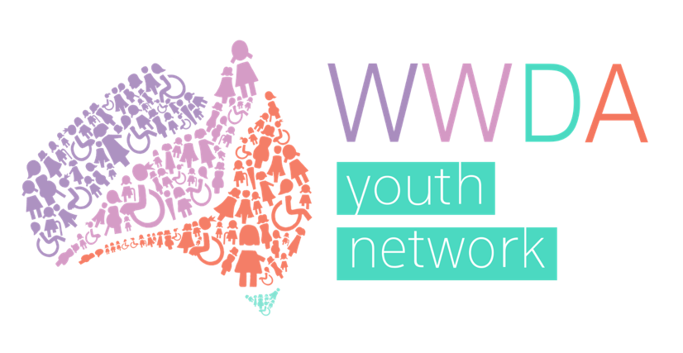

Women With Disabilities Australia

Youth Advisory Group

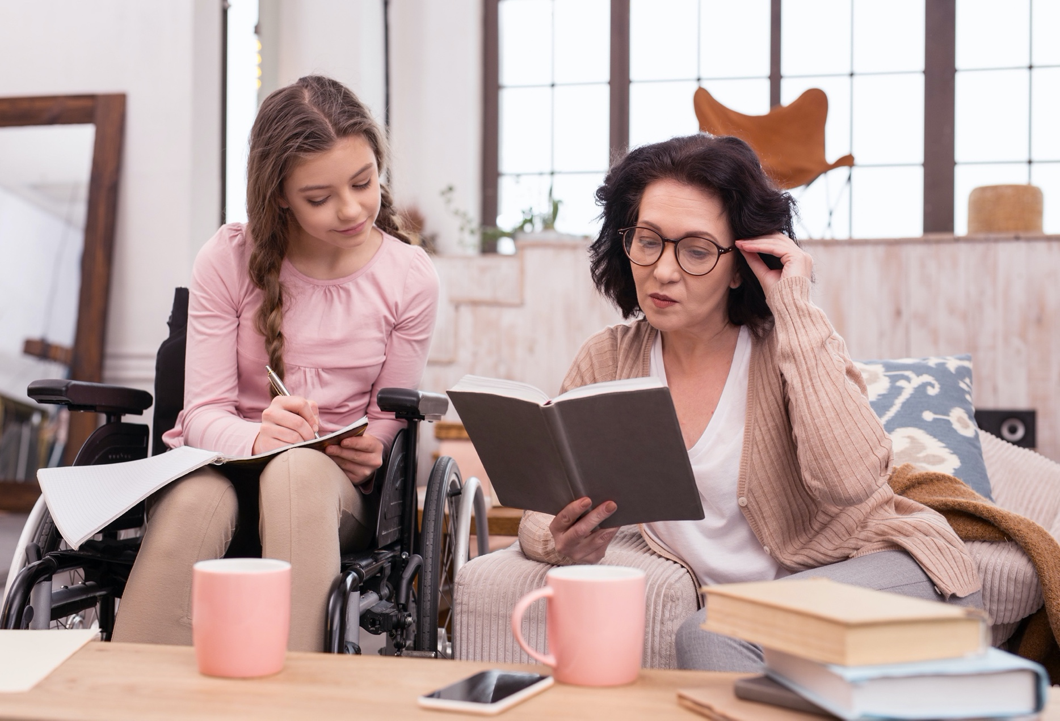
Terms of Reference 2020

Introduction and Background
The WWDA Youth Network is an initiative of Women With Disabilities Australia (WWDA) aimed at providing a voice to young women and girls with disability under the age of 30.

The objectives of the WWDA Youth Network are to:

Actively promote the inclusion and empowerment of young women and girls with disability (under 30) in all areas of life;

To advocate for the issues and needs of young women and girls with disability in Australia;

To educate and build the capacity of girl and young women with disability on their rights and options by:

Creating accessible resources that empower young women and girls with disability to learn about and stand up for their rights;

Keeping girls and young women with disability up to date with related events nationally and internationally;

Supporting young women and girls with disability to participate in leadership opportunities, public consultations and education.

Introducing and sharing the stories of young women and girls with disability.
The WWDA Youth Network was originally launched by WWDA in conjunction with the Minister Assisting the Prime Minister for Women, Senator the Hon. Michaelia Cash on 30 July 2015 at an event at the Australian Human Rights Commission (AHRC) in Sydney.

Cashelle Dunn was the founder of the WWDA Youth Network and managed the WWDA Youth Network between 2015 and 2018. With support from Federal Government grants, Cashelle ran a number of initiatives under the WWDA Youth Network, including developing a human rights toolkit for young women and girls with disability and launching the WWDA Youth Network website, Facebook page, Instagram and Twitter. Since 2018, the WWDA Youth Network has largely been stagnant due to a lack of resourcing and staff members. However, in 2020, WWDA has decided to re-activate the WWDA Youth Network, with the support of new grant funding and staff.

The role of the WWDA Youth Advisory Group
To drive the reinvigoration of the WWDA Youth network, WWDA is setting up a WWDA Youth Advisory Group made up of a diversity of young women with disability (aged 15-30) across Australia. The role of the WWDA Youth Advisory Group that will provide advice to WWDA on the issues facing young women and girls with disability across Australia. Broadly, the WWDA Youth Network will work with WWDA staff to:
- identify issues facing young women and girls with disability in Australia
- promote membership of the WWDA Youth Network to young women and girls with disability in the broader Australian community
- identify information and resources that are needed among young women and girls with disability and develop these resources for the WWDA Youth Network website and / or WWDA’s Our Site website
- represent young women and girls with disability in relevant government and non-government consultations and forums
- develop a plan for and contribute to the maintenance of WWDA Youth Networks social media pages, including Facebook, Twitter and Instagram.
- identify and plan other activities in which the WWDA Youth Network could be involved.

The role of WWDA
Activities of the WWDA Youth Advisory Group will be managed by WWDA’s full-time Project and Policy Officer, Heidi La Paglia, with assistance from WWDA’s part-time Project Officer, Vanamali Hermans.

Once the Advisory Group is formed, WWDA staff will provide the administrative support and resourcing required to support the group to:
- take part in bi-monthly meetings to discuss issues affecting young women and girls with disability across Australia
- run broader online consultations on issues impacting young women with disability. These will be held in various formats online and will be open to all young women with disability across Australia aged 15-30
- take part in training courses and opportunities that build leadership and advocacy skills
- take part in government consultations and inquiries to represent the needs and experiences of young women and girls with disability
- develop information and resources for the for the WWDA Youth Network website and WWDA Our Site website that meet the needs of young women and girls with disability
- take part in other activities which support the rights and empowerment of young women and girls with disability across Australia.

Structure and Membership
The WWDA Youth Advisory Group will consist of up to 12 young women with disability, who will meet once every two months via video conference for one year from November/December 2020 - November/December 2021. Meetings will be coordinated and chaired by WWDA’s Project and Policy Officer, Heidi La Paglia.

When possible, WWDA’s Project Officer, Vanamali Hermans may attend meetings to take meeting minutes and to contribute to the WWDA Youth Advisory Group. However, with the permission of members, meeting will also be recorded for the purpose of minute taking / notes.

WWDA commits to circulating a meeting agenda and all required reading for the meeting one week prior to the meeting date. Meeting dates will be set at least one month in advance. Meeting minutes will be circulated no later than one week after the meeting takes place. Outside of meetings, WWDA Youth Advisory Group may be asked to take part in discussions over email, WhatsApp or another agreed upon platform. Members will also be given opportunities to take part in additional events and forums as representatives of the WWDA Youth Network Advisory Group.

Membership Criteria
The WWDA Youth Advisory Group will consist of up to 12 young women with disability. Expressions of interest to join the WWDA Youth Advisory Group are open to all young people with disability aged between 15 and 30 years who identify as female, non-binary, gender fluid or transgender women.
All of WWDA’s work is grounded in a human rights framework. WWDA practices intersectional feminism and will aim to ensure WWDA Youth Advisory Group members are representative of the needs and views of a diverse range of young women and girls with disability in Australia. For this reason, WWDA will be reserving 3 of the 12 positions on the advisory group for young women with disability who identify as Aboriginal or Torres Strait Islander individuals (relative to the rate of disability among First Nations people). WWDA also strongly encourages young women with disability are who from migrant and refugee backgrounds, living in remote, rural or regional areas and /or identify as LGBTIQA+ to apply.
Remuneration
As a feminist disability organisation, WWDA values the time and contributions of all women and girls with disability. In recognition of this, WWDA will remunerate all WWDA Youth Advisory Group members, or the organisations they represent for their participation at a rate of $50 equivalent per meeting. This may be in the form of gift vouchers or via the payment of an invoice.

