WWDA LEAD Introduction Survey
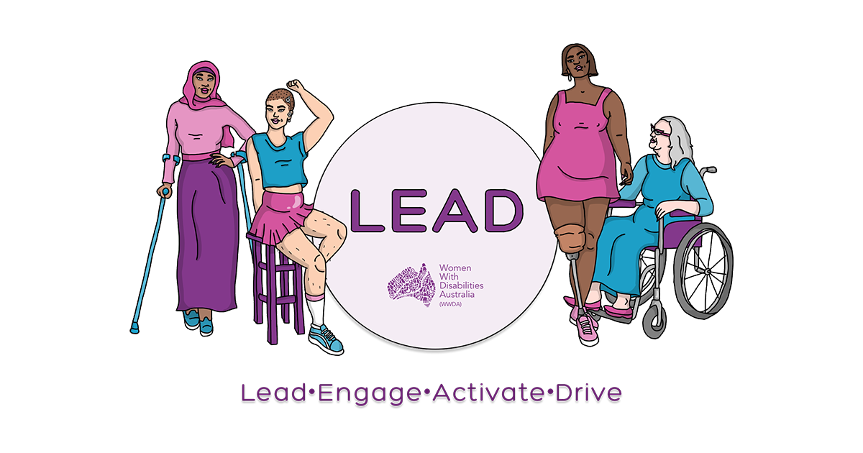

Easy Read Version
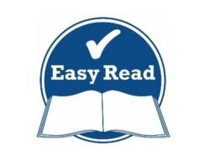

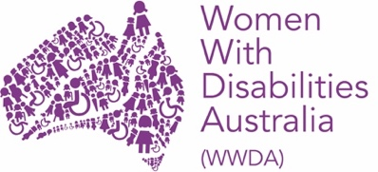
About WWDA

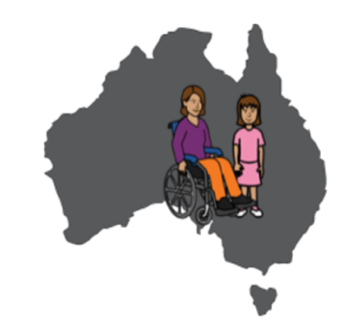
WWDA is for:
- all women and girls who have a disability, and;
- who live in Australia.

WWDA is:
- run by women with disability
- for women and girls with disability.

- WWDA helps all women and girls with disability have good lives.

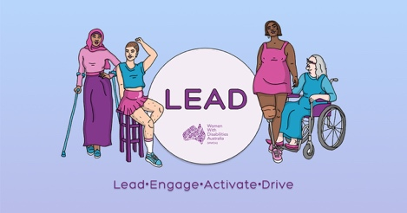
About the WWDA LEAD Project
WWDA is running a project to help women and girls with disability:

- become leaders

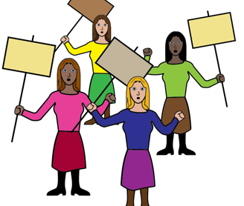
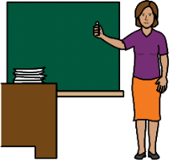
- take part in things like:
-politics
-education
-work,

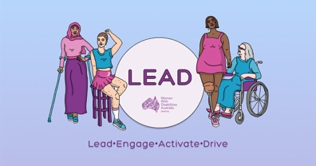
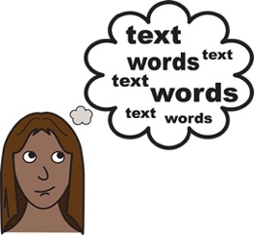
The project is called WWDA LEAD.
WWDA LEAD stands for:
Lead
Engage
Activate
Drive.
-

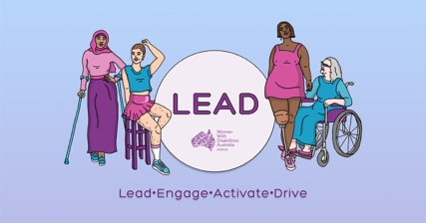
About the WWDA LEAD Project
The WWDA LEAD Project will support women and girls with disability. WWDA will do things like:

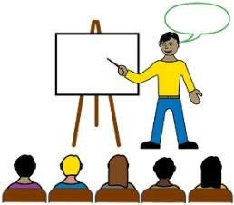
- give money to women and girls with disability to learn how to be a leader

- give information to women and girls with disability about being a leader

- run events for women and girls with disability

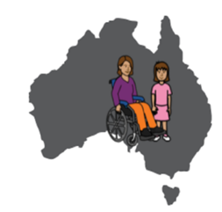
- run a national conference for women and girls with disability around Australia.
We would like to ask you some questions to help us to understand more about you.

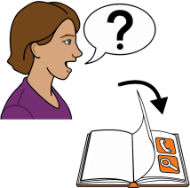
We have listed some questions on the following pages.

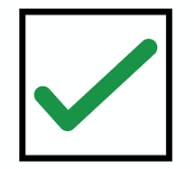
You can colour in or put a tick next to the statements that you agree with.

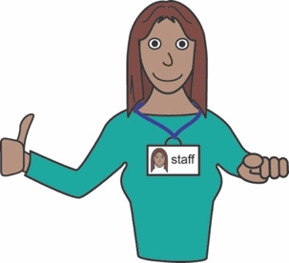
You can ask for help to answer the questions
A support person may be able to help

Question 1
What does leadership mean to you?

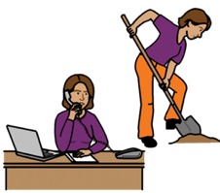

- to have a job

- to learn at school or
- to learn at TAFE or University

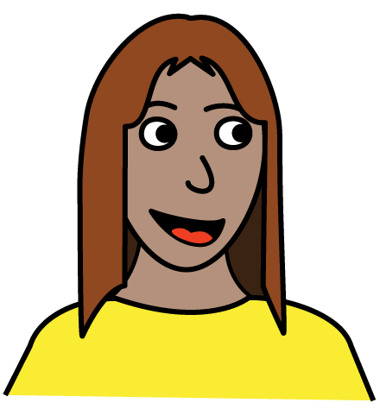

        - to speak up for myself

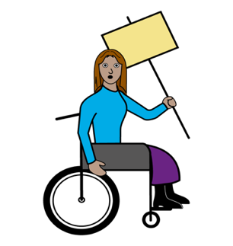
        - to take part in protests or

        - vote in elections
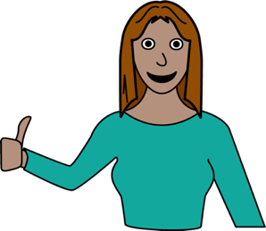

        - to take part in things that
are important to me.

        - Like Sport, going out with friends, learning new things.

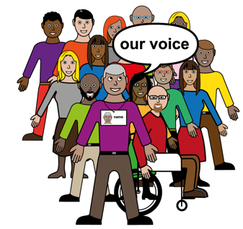

        - to be able to represent myself
and my community

- something else:

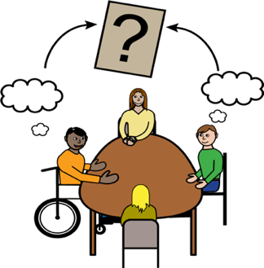
Question 2
What type of leadership activities
would you like to do?

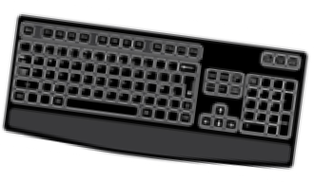
        - attend free webinars on topics
that interest you
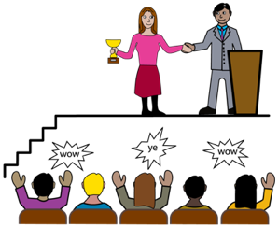

        - take part in leadership programs
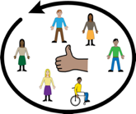

        - take part in groups online
with other women with disability

        - represent myself
and my community

        - take part in online social events.
Like
- quiz nights
- movie nights

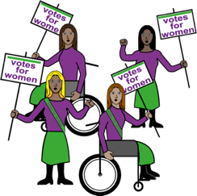

        - hear and learn from well-known
leaders with disability
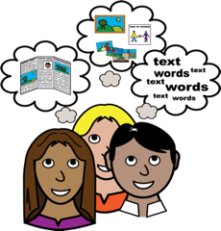

        - share ideas about
leadership with others

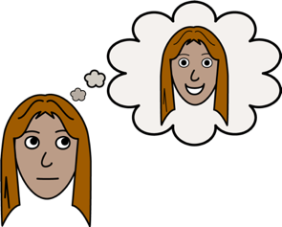
Can you list any other leadership activities that you would like to do?

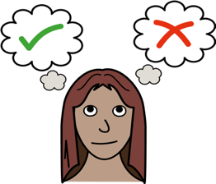
Question 3
Have you been involved in
leadership programs before?

Yes No
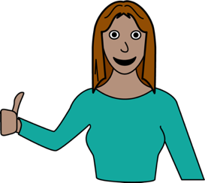
What was good about the program?

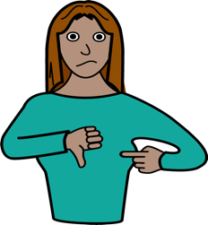
What was bad about the program?

Question 4
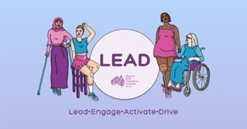
Would you like to be involved in the WWDA LEAD Program?

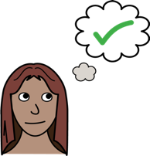

        - Yes

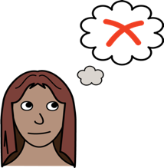

        - No

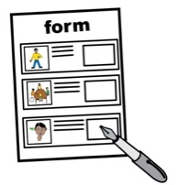
If you said yes please join WWDA as a member.

You can join us on the WWDA website:
wwda.org.au/join-wwda/wwda-member/

Question 5
If yes, please tell us about you.
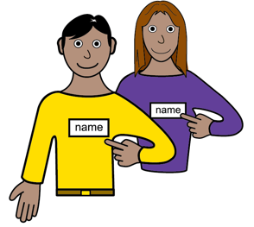
My name is

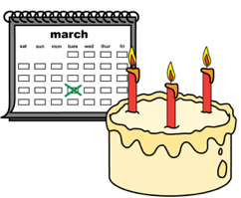
I was born on
Write the day / month / year

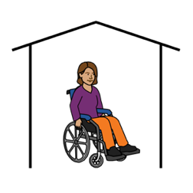
I live at

My phone number is

My email is

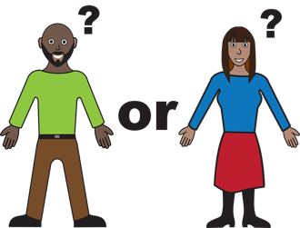
My gender is:
Female

Non-Binary

Other

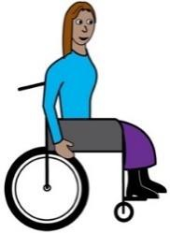

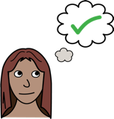
I have a disability?

        - Yes

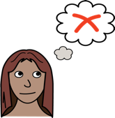

        - No

I am:

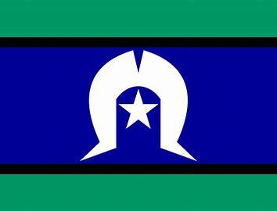

Aboriginal or Torres Strait Islander

Lesbian, Gay, Bisexual, Transgender,
Intersex, Queer or Asexual (LGBTIQA+)
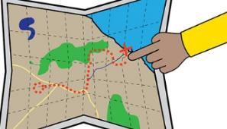

From a rural, regional or remote area
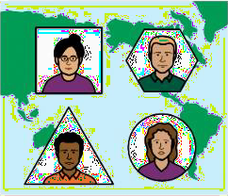

A migrant or refugee.

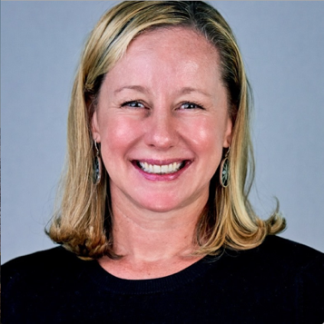
Any questions?
Contact our Senior Project Officer Libbi
        - Email spo@wwda.org.au
        - call or text 0488 758 539

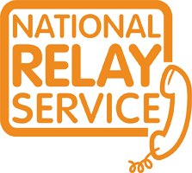
You can use the National Relay service
To call us
Call 1800 555 677
TTY 133 677
Ask for 0488 758 539

Need a translator?
Call 131 450
Ask for 0488 758 539.

