Women
With
Disabilities
Australia

Membership Form

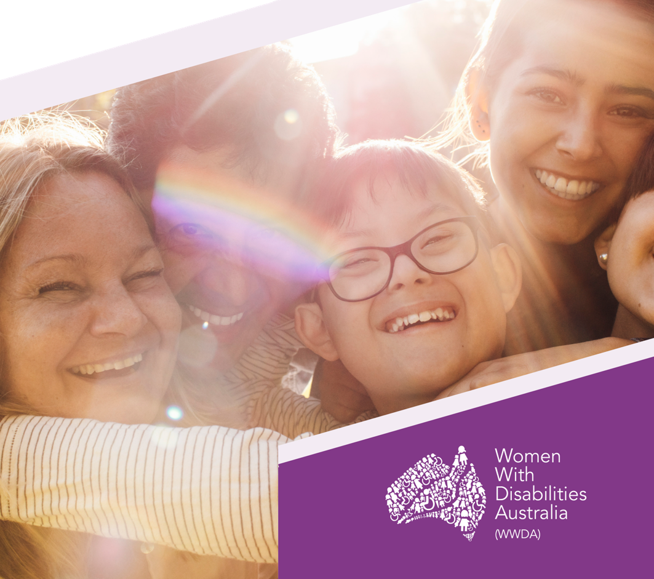

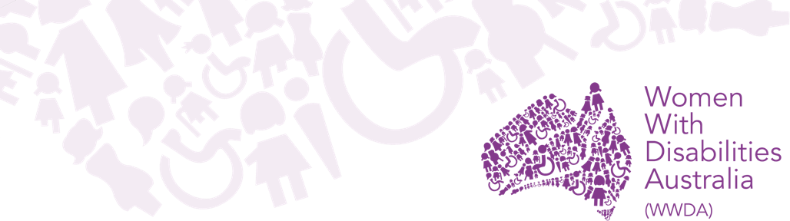

About WWDA

Women with Disabilities Australia (WWDA) is the award winning, national Disabled People’s Organisation (DPO) for women and girls with all types of disability in Australia. As a DPO, WWDA is managed and run by women with disability, for women and girls with disability.
To learn more about WWDA or to find out how you can connect with us go to About Us on WWDA’s website.

Aim and objectives

The aim of WWDA is to promote, protect and advance the human rights and freedoms of women and girls with disability in Australia.

The objectives of WWDA are to:
(a) promote the participation of women with disability in all aspects of social, economic, political and cultural life;
(b) advocate on issues of concern to women with disability in Australia and internationally; and
(c) be the national representative organisation for women with disability in Australia by:
(i) undertaking systemic advocacy;
(ii) providing policy advice;
(iii) undertaking research; and
(iv) developing information and education resources

Privacy and information

You can provide as little or as much information as you like. Information on your age and location helps us to identify members who may wish to attend forums, events etc in particular regions. We do not require you to disclose information about your disability status, however you can choose to do so if you wish. This can help us to identify members for particular consultations, expert groups etc. All personal data about members is stored securely and confidentially.

For more information on privacy, read our Privacy Policy on the WWDA website.

Your details

Please tick one of the following membership types:

☐ Full Membership is open to women, non-binary or gender diverse people with a disability who live in Australia.

☐ Associate Membership is open to women, non-binary or gender diverse people and/or organisations living or based in Australia.

If you do not meet the criteria to become a member, find out other ways to connect and receive information on the WWDA website.

Full Name/
Organisation: Click or tap here to enter text.

Preferred name: Click or tap here to enter text.

Gender: Click or tap here to enter text.

Date of birth: Click or tap here to enter text.

Postal address: Click or tap here to enter text.

Email: Click or tap here to enter text.

Phone: Click or tap here to enter text.

What best describes you?

☐ I am a woman, non-binary or gender diverse person with a disability.
☐ I am a professional working in this or a related field.
☐ I am a parent, carer or family member of a woman/girl with disability.
☐ Other: Click or tap here to enter text.

Your details (continued)

Preferred format: Preferred method of contact:

☐ Plain English ☐ Email

☐ Easy Read ☐ SMS

☐ Easy English ☐ Phone call

☐ Post

☐ Would you be interested in representing WWDA at forums, events, or being contacted for specific consultations?

☐ Would you like to receive WWDA’s emails?

☐ Do you agree to the privacy policy?

☐ Do you agree to WWDA’s aim and objectives?

Would you like to tell us anything else?
Click or tap here to enter text.

Signed: Click or tap here to enter text.

Date: Click or tap here to enter text.
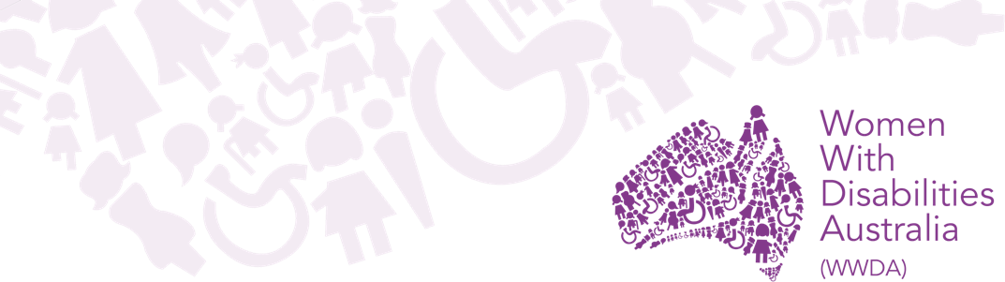

Completed forms

Please send your completed membership form to:
Email: officeadmin@wwda.org.au

Post:
Women With Disabilities Australia (WWDA)
PO Box 407, Lenah Valley 7008 Tasmania, Australia

Alternative methods
If you would prefer not to use this form there are other ways to become a member.
You can:
• Get the Easy Read form
• Call 0438 535 123
• Email officeadmin@wwda.org.au
• Go to the WWDA website

You can also ask a family member, support person, advocate or friend to assist you.

Join our WWDA Community Facebook group!

Donating to WWDA

Membership of Women With Disabilities Australia (WWDA) is free however we do accept donations. Your donation to WWDA no matter how big or small, will help us in many ways.

You can donate on the WWDA website.

