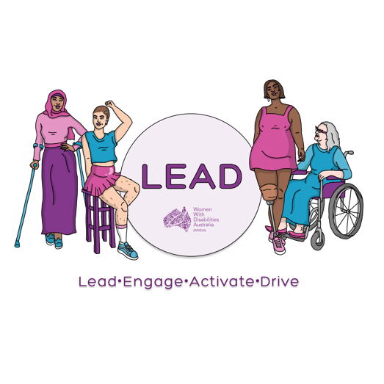
0438 535 123
officeadmin@wwda.org.au
www.wwda.org.au/project/lead

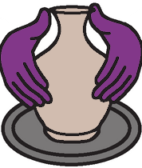

About the
WWDA LEAD Art Contest

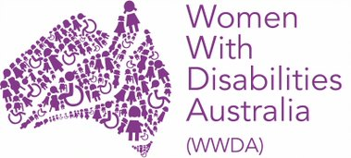
This information is from
Women With Disabilities Australia.
We will write WWDA when we talk about us.

WWDA LEAD Art Contest.
We will write the words Art Contest when we talk
about it.

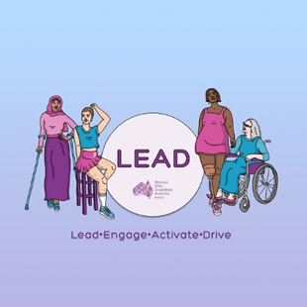

The Art Contest is part of the LEAD project.

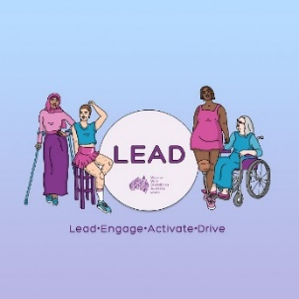
LEAD is a new project for WWDA.
LEAD means

- lead
  - to be at the front

- engage
  - to talk to other people
  - to listen to other people

- activate
  - to start your ideas

- drive.
  - to do your ideas.

The money for LEAD is from the
NDIS Information linkages and
capacity building program.

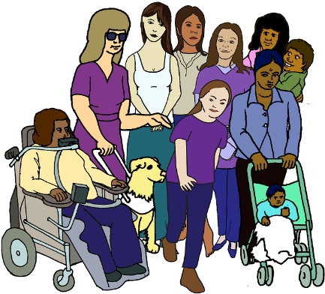
The topic for our Art Contest is
We can all be leaders.

The Art Contest is free.

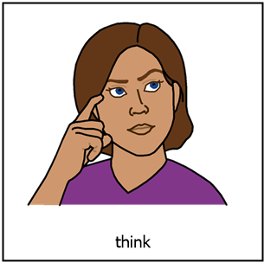
Dates to know about

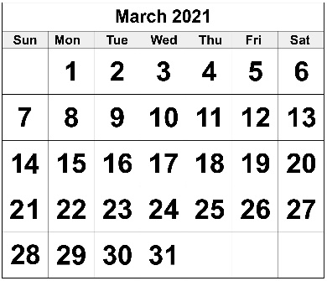
8 March 2021.
You can start to send your art to WWDA.

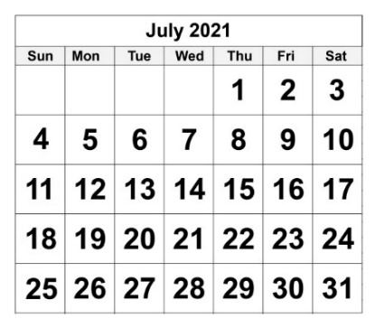
23 July 2021.
The Art Contest is closed now.

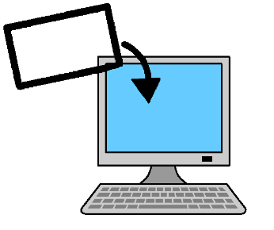

You can not send your art to WWDA now.

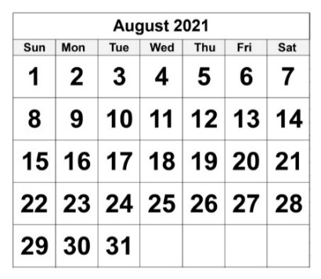
2 August 2021
All the art work is on the WWDA website.

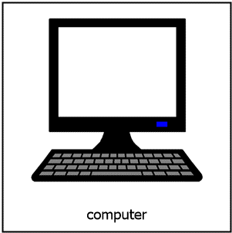
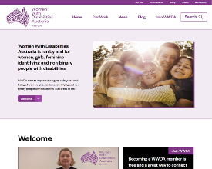
Do these steps to find the Art Contest.
Go to www.wwda.org.au.

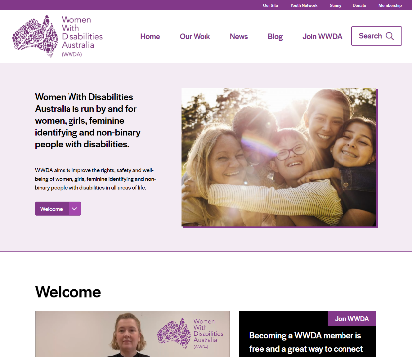
Click on the search window.
Type art prize in the search window.

We will also post about the Art Contest on our
- Facebook page
- Instagram page
- Twitter page.
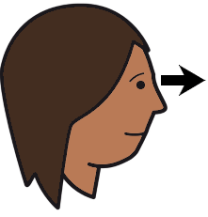
Any one can see your art.
Any one can see all the other art.

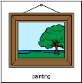
Anyone can vote for your art.
It is for the Peoples Choice Awards.

20 August 2021.
People can still see your art work.

But

They can not vote on it now.

23 August 2021
WWDA tells us

- who won the prizes

and

- who did very well.

Who can go in the Art Contest?

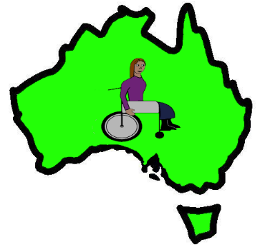
You need to
- live in Australia

and
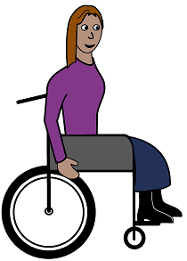

- have a disability?

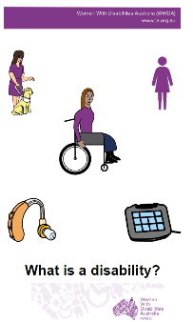

Read What is a disability?

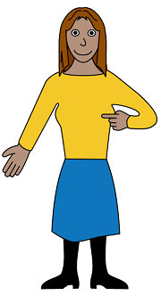
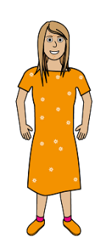
You also need to be a
- woman
- girl

or
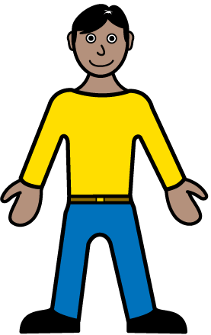
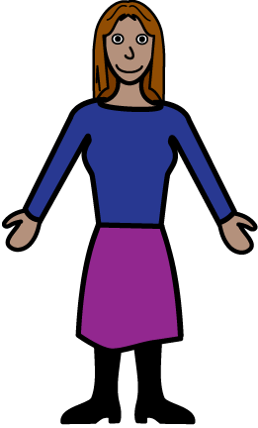

- you see your self as a woman

or

- you see your self as
  - not a man
and
  - not a woman.

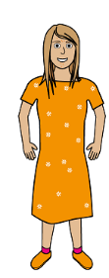
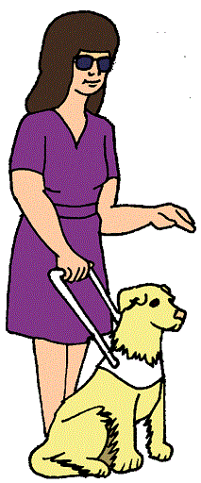
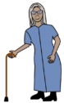
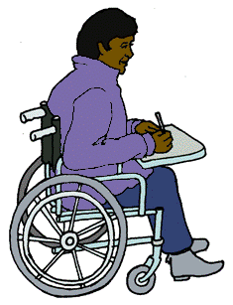
You can be any age from 15 years old.
Like
- 16
- 25
- 40
- 70.

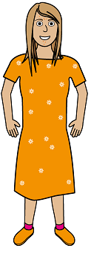

You are 15 16 17 years old.

You need to ask some one you trust to go in the
Art Contest. Like your
- mum
- dad
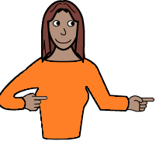
- advocate.
What can you do for the
Art Contest?

You can do some art
- by your self

or

- with a group.

You can put in 1 piece of art you did
by your self.

And

You can put in 1 piece of art you did
in your group.
Your group can only do 1 piece of art.

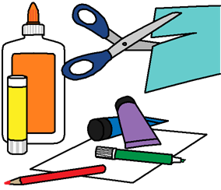
Your art can be
- a painting
- a drawing
- a mix of different things.
- You may call it a collage.

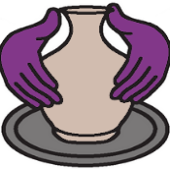
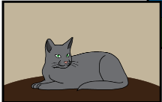
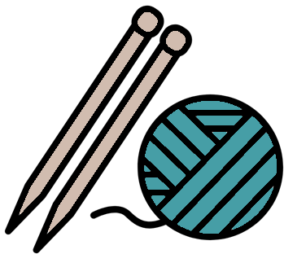
Your art can be
- craft. Like knitting
- some thing you have carved.
  - You may call it a sculpture
- a photo
- a video.

Do not send your art to us.

You must make a copy of your art.

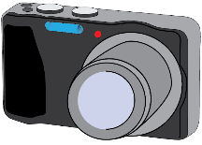
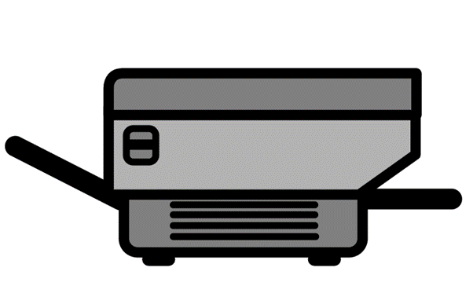
Take a photo of your art.
or
Scan your art.
or
Make a video of your art.

You send this copy to WWDA for the Art Contest.

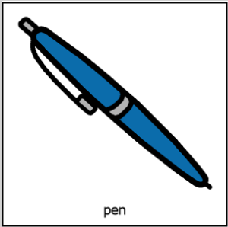
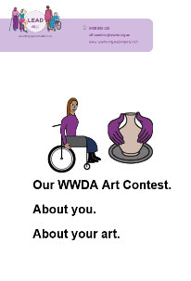
Fill in the form for the Art Contest.
It is called About you. About your Art.

Email to WWDA
- the form
- the copy of your art.

Send by email to project@wwda.org.au

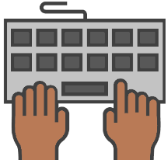
X ________
Type in the topic line Art Contest.

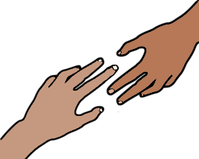
Do you need help to send your art by email?

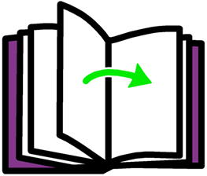

Go to page 23.

What are the
Art Contest prizes?

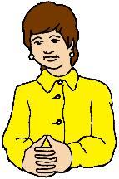
There are 3 judges.
They are not from WWDA.

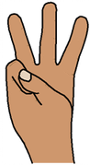
There are 3 contests.
There are prizes for each contest.

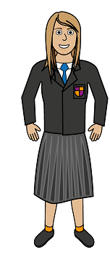
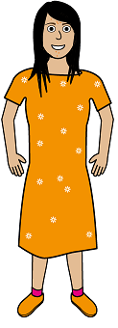
Contest 1.
People who are
- 15
- 16
- 17.
The judges choose these winners.

Contest 2.
Every one else that goes in the Art Contest.
The judges choose these winners.

Contest 3.
Peoples Choice Award.
The judges do not choose this award.
Any one can vote for any art.
The winner is for the art that gets the most votes from other people.

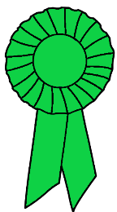
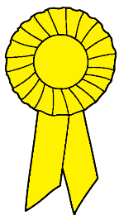
Prizes
Each contest has 3 prizes.

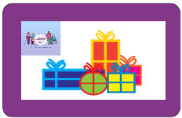
The winner.
The winners gets $ 500 of
- gift cards
- things to do their art. Like an easel.

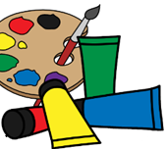
The runner up.
The runner up gets $ 200 of
- gift cards
- things to do their art. Like paints.

The judges may say some one did very well.
They get $ 50 of
- gift cards
- things to do their art. Like some brushes.

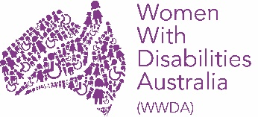
More information

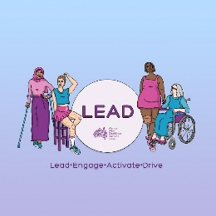

Talk to Mali Hermans.

Email project@wwda.org.au

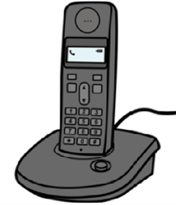
Call 0488 417 875

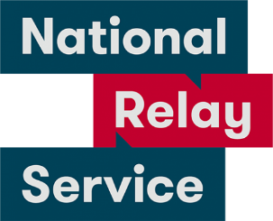
National Relay Service
Call 1800 555 677.
Ask them to call 0488 417 875.

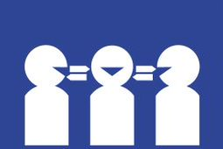
Translator.
Call 131 450.
Ask them to call 0488 417 875.

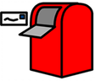
Post
PO Box 407
Lenah Valley
Tasmania 7008.

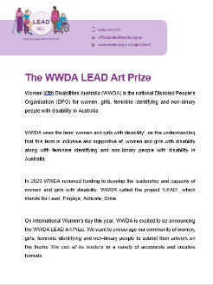
This fact sheet is based on the WWDA LEAD
Art Prize. February 2021.

Images
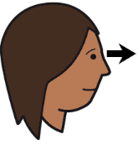
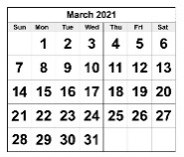
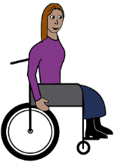
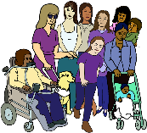
We can use these images. They are from
- EasyontheI
- InspiredServices
- Picto-Selector
- PrintableCalendarTemplate
- Spectronics
- TheNounProject
- Tobii-Dynavox.

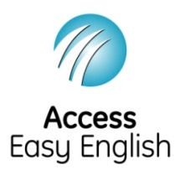
Access Easy English wrote the Easy English.
February 2021.

