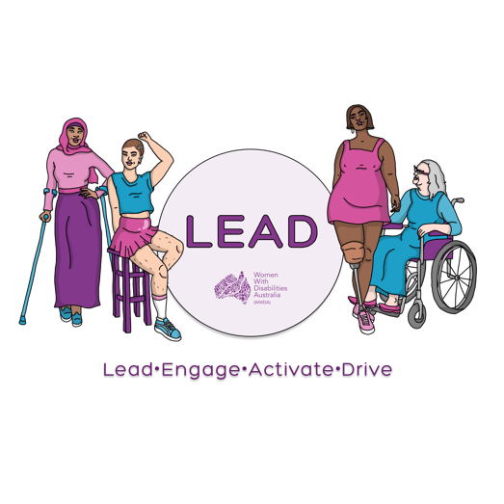
0438 535 123
officeadmin@wwda.org.au
www.wwda.org.au/project/lead

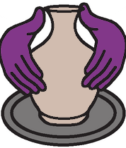
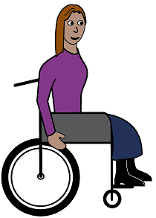

Our WWDA Art Contest.
About you.
About your art.

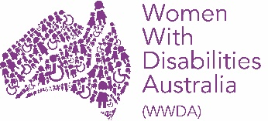
WWDA LEAD Art Contest
We will write the words Art Contest to
talk about it.

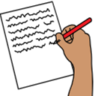

You fill in this form.

You must make a copy of your art.

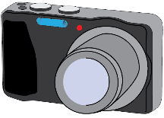
Take a photo of your art.
or
Make a video of your art.

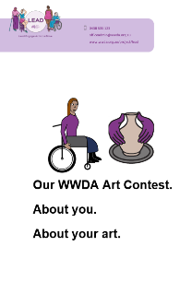
Send us
- this form
- the copy of your art work.

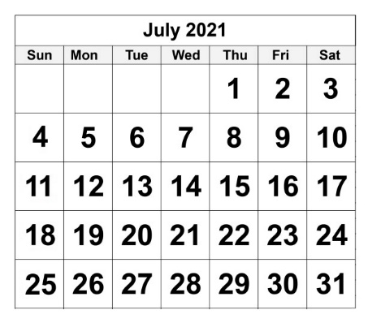

Send by 23 July 2021.

Send by
- email project@wwda.org.au

or

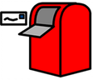
- post to
PO Box 407
Lenah Valley.
Tasmania 7008.
Art Contest questions

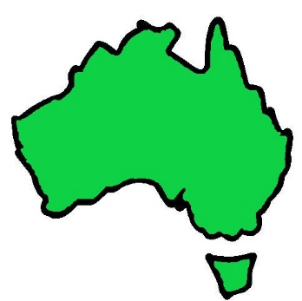

Do you live in Australia?

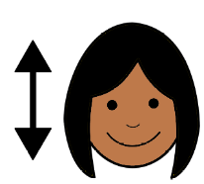
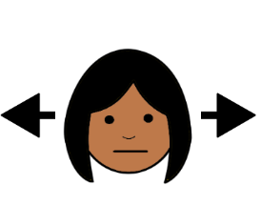

Yes No

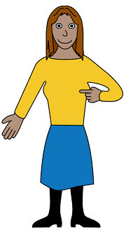
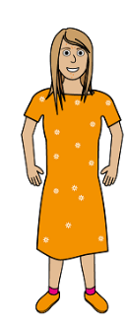
Are you a
- woman
- girl

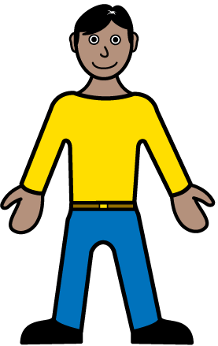
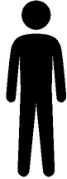
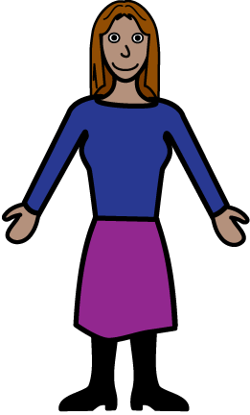
or

- do you see yourself as a woman

or

- do you see your self as
  - not a man
and
  - not a woman.

Yes No
Do you have a disability?

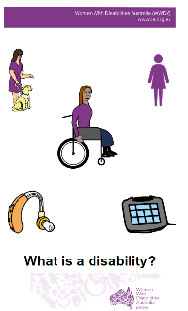

Read What is a disability?

Yes No

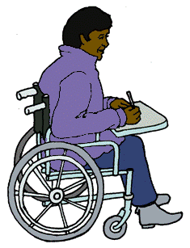
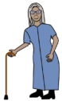
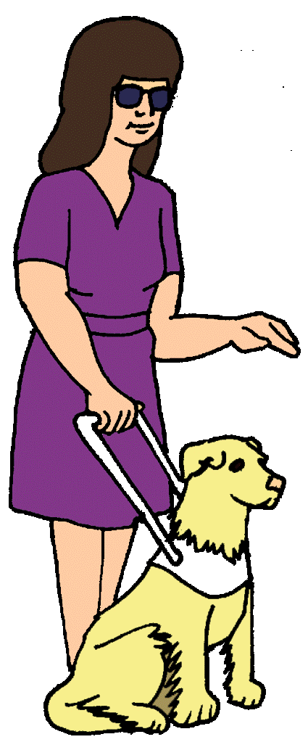
Are you more than 15 years old?
You can be 15 years old too.

Yes No
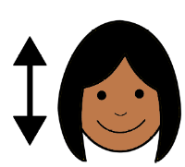
Did you say yes to all these questions?
?

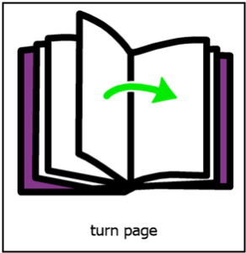
Yes. You can go in the Art Contest.
Go to page 8.

No. You can not go in the Art Contest.

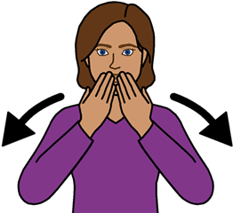

Thank you.

Your name
_______________________________________

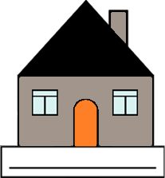
Address
_______________________________________
_______________________________________

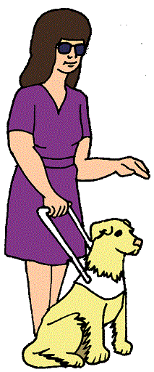

How old are you?

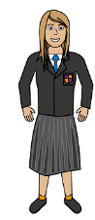

15 16 17 18 More
than 18
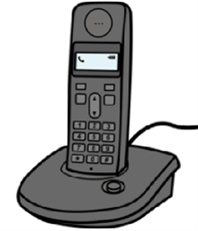
Phone
_______________________________________

Email
_______________________________________

Are you a member of WWDA?

Yes No

Yes. Go to page 12.

No.

You can join WWDA.
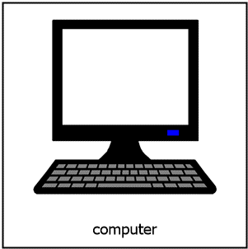
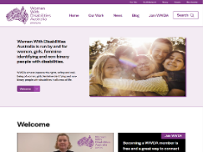
Go to
www.wwda.org.au

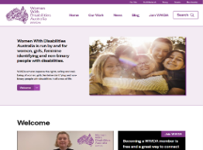

Find the button at the top called Join WWDA

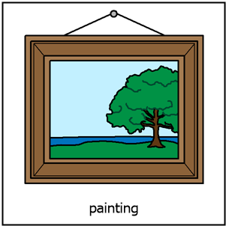
What is the name of your art?

____________________________________

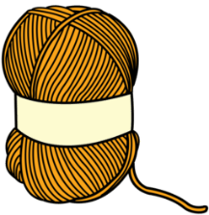
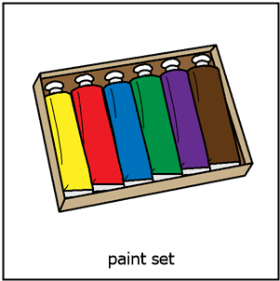
What did you make your art with? Like
- oil paint on paper
- wool.

____________________________________

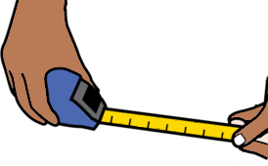
How big is your art? Use a tape measure.
Like 10 cm X 15 cm.

____________________________________

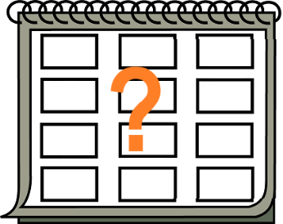
When did you make your art?
____________________________________

You need to write about your art.

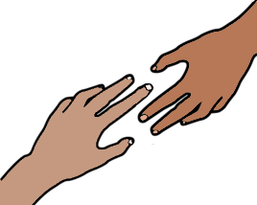
WWDA can help you do this.
Go to page 24 to get help.

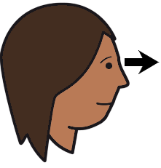
What does your art look like?
Pretend someone can not see your art.
Tell them what it looks like.

___________________________________________________________________________________________________________________________________________________________________________________________________

Tell us why you made your art.
It can be a short answer.
You do not have to do this question.

___________________________________________________________________________________________________________________________________________________________________________________________________
Tell us about you. Like
- what kind of art you like
- where you live in Australia.
You do not have to do this question.

___________________________________________________________________________________________________________________________________________________________________________________________________

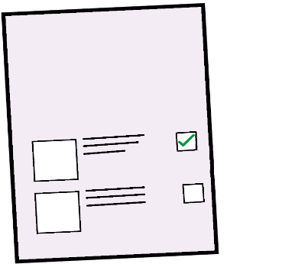
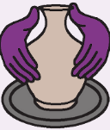
We have rules for the Art Contest.

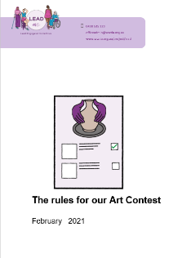
Read The rules for our Art Contest.
Do you agree with these rules?

Yes No

The copy of your art will go on our website.
Can we show your art?

Yes No
What name can we put on your art?

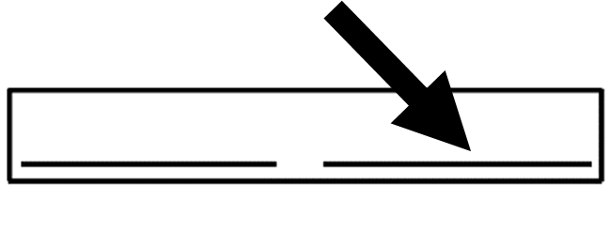
Your first name. And Your last name.

Your first name only.

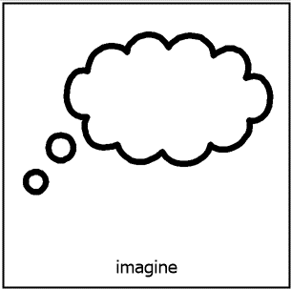
A made up name.

What is your made up name?
_______________________________________

We put your art on our website.

But

You change your mind.
You do not want your art on our website.

You know you can tell WWDA to take your art
off our website.

Yes No

You go in our Art Contest.
It is your art. You own the art still.
You know you can still show your art to anyone.

Yes No

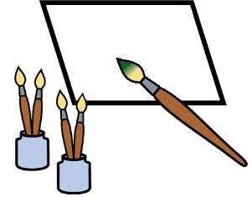
Your art shows some thing private.
Like you have a health problem.
Can WWDA still share your art?

Yes No

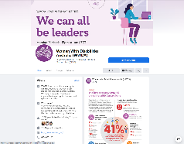
Can WWDA use your art on social media. Like
- our Facebook page?
It is called
Women With Disabilities Australia. (WWDA)

Yes No

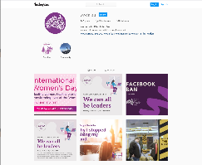
- on our Instagram page.
It is called wwda_au.

Yes No

- on our Twitter page. It is called WWDA_AU.

Yes No

WWDA keeps the copy of your art work.
We keep it on a WWDA computer.
Is this OK?

Yes No

Your private information is in this form.
We keep in on a WWDA computer.
Only WWDA staff who work on the Art Contest can see it. Is this OK?

Yes No

We send emails to other WWDA members.
It tells them about what we do.

Do you want to get emails from WWDA?

Yes No
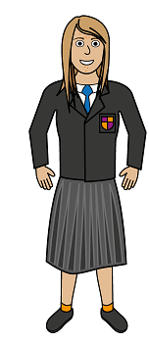
Are you 15 16 17 years old?

Yes No.
Go to page 25

An adult needs to say yes.
You can go in the Art Contest.

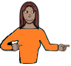
Like your
- mum
- dad
- advocate.

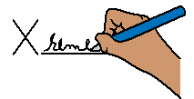
They sign their name.

It means they agree
- you can go in the Art Contest
- to share your art work
- to the rules for the WWDA Art Contest.

Their signed name __________________________

Date ___________________________________

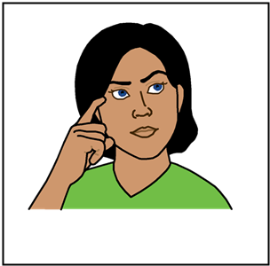
You sign your name.

It means you agree to
- share your art work
- the rules for the WWDA Art Contest.

My signed name __________________________

Date ___________________________________

More information

Email project@wwda.org.au

Call 0488 417 875

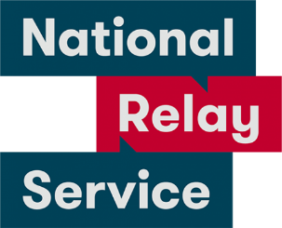
National Relay Service
Call 1800 555 677.
Ask them to call 0488 417 875.

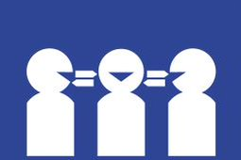
Translator.
Call 131 450.
Ask them to call 0488 417 875.

Post
PO Box 407
Lenah Valley
Tasmania 7008.

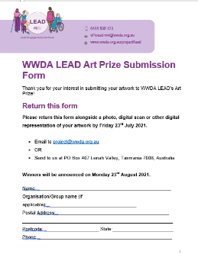
This form is based on the WWDA LEAD Art Prize Submission Form. February 2021.

Images
We can use these images. They are from
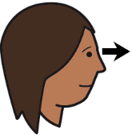
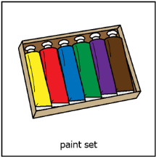
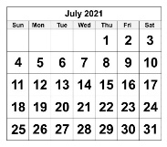
- EasyontheI
- Picto-Selector
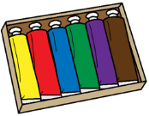
- PrintableCalendarTemplate
- Tobii-Dynavox.

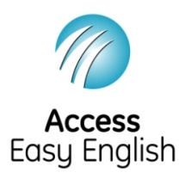
Access Easy English wrote the Easy English.
February 2021.

