­­

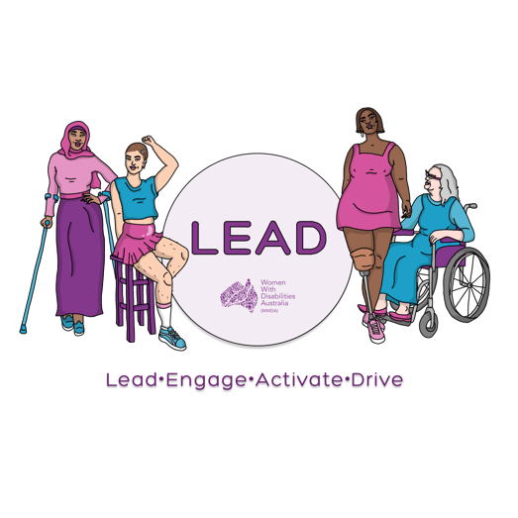

 ­

0438 535 123officeadmin@wwda.org.auwww.wwda.org.au/project/lead

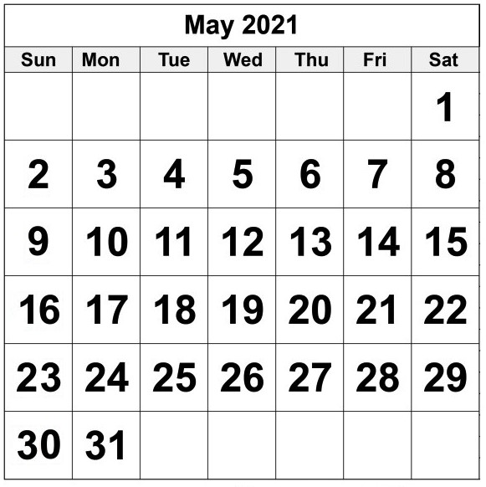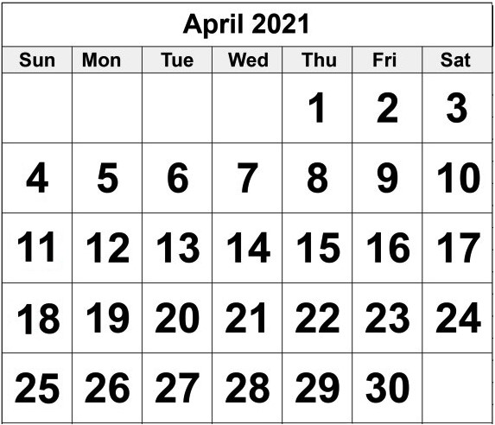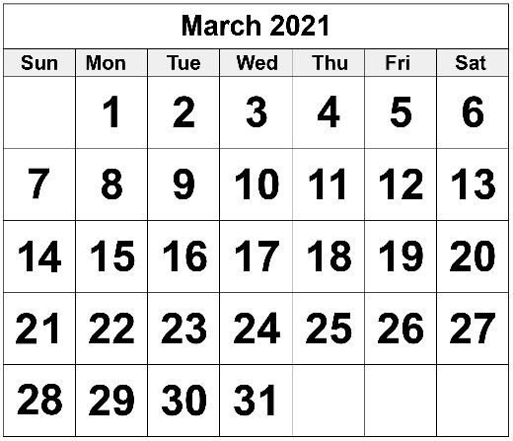

**WWDA LEAD grant.**

**Dates to know about.**

**Dates to know about**

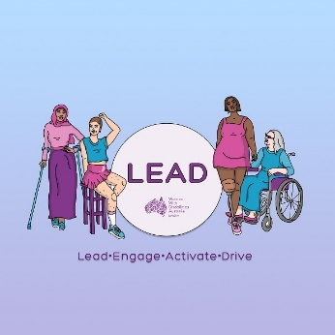

You want to ask for the LEAD grant

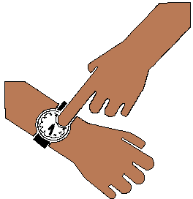

This year. It is 2021. Go to page 3.

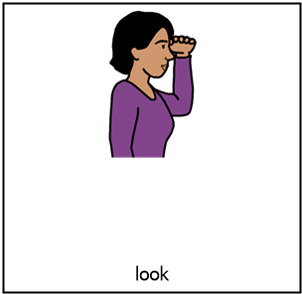

Next year. It will be 2022.

Talk to Libbi. Go to page 8.

From **Wednesday 24 March 2021**

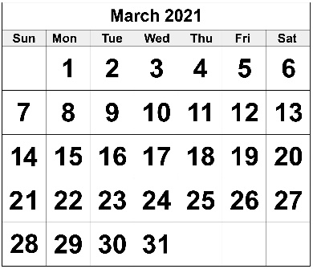

You can send in your form.

**Friday 16 April 2021**

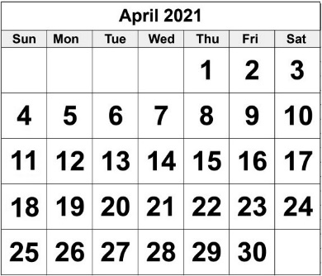

The LEAD grant is closed now.



You can **not** send your form for the LEAD grant to WWDA now.

**Ask about the LEAD grant**



**Wednesday 31 March 2021**

**Or**



**Friday 9 April 2021**

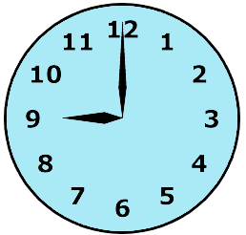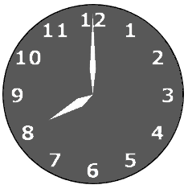

It is open from 9 in the morning

**to**

8 at night.

You can

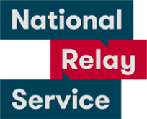

* call
* text
* email
* use National Relay Service.

Go to page 8.

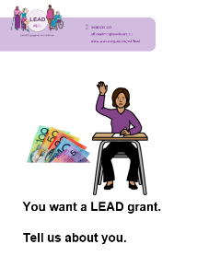

Staff can **not** help you do the questions



in the form.

**But**

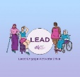

WWDA staff can

* tell you more about the grant
* help you choose what to learn. Like

how to start your own community group.

You can get the LEAD grant for only



some courses.

You can ask about the course you want to do.



You can get help to ask for the grant.



Like you call us.

You tell us your answers.

We write your answers on the form.

We can **not** tell you what to write.

**Monday 3 May 2021**

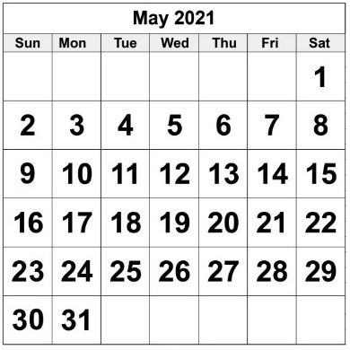

We tell everyone who has the LEAD grants.

**More information**

Talk to Libbi Cunnington

Email spo@wwda.org.au



Call 0488 758 539

Text 0488 758 539

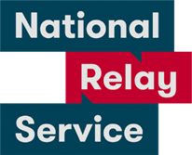National Relay Service

Call 1800 555 677

Ask them to call 0488 758 539

Translator.

Call 131 450

Ask them to call 0488 758 539

Post

PO Box 407

Lenah Valley

Tasmania 7008

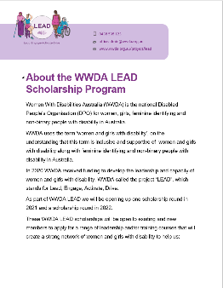This fact sheet is based on About the WWDA LEAD Scholarship Program. February 2021

**Images**

We can use these images. They are from

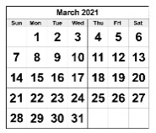

* Picto-Selector
* PrintableCalendarTemplate
* Spectronics
* TheNounProject
* Tobii-Dynavox.

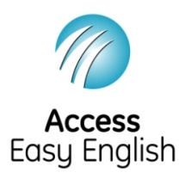Access Easy English wrote the Easy English.

February 2021.