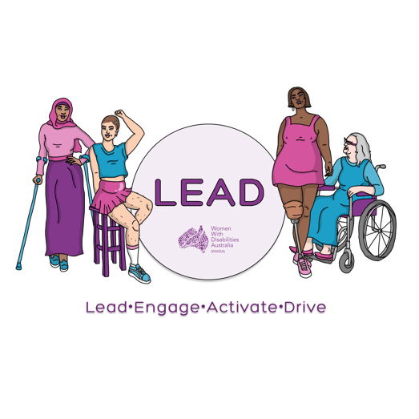

0438 535 123
officeadmin@wwda.org.au
www.wwda.org.au/project/lead

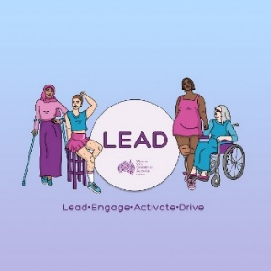

About the WWDA
LEAD grant 2021
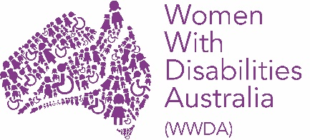
This information is from
Women With Disabilities Australia.
We will write WWDA when we talk about us.

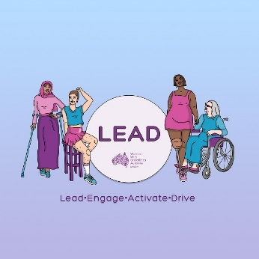
WWDA have a new project. It is called LEAD.
LEAD means

- lead
  - to be at the front

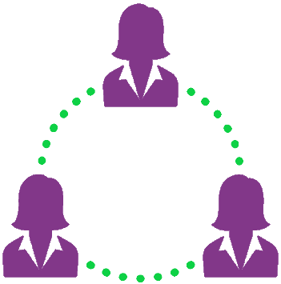
- engage
  - to talk to other people
  - to listen to other people
- activate
  - to start your ideas

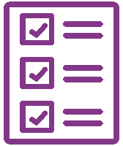
- drive.
  - to do your ideas.

The money for LEAD is from the
NDIS Information linkages and
capacity building program.

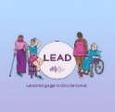
This LEAD grant is part of the LEAD project
The LEAD grant is run by WWDA.

The LEAD grant is to help you
- learn more
- do some thing to make a change.

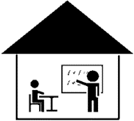
The LEAD grant.
WWDA will pay for you
- to do a course with WWDA
or
- to do a different course.
It is up to $ 2000.

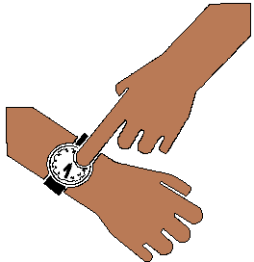
WWDA will do the LEAD grant 2 times. It is
- this year. It is 2021.
and
- next year. It will be 2022.
10 people will get the grant this year.

and

10 people will get the grant next year.

WWDA want their members to
- to lead

and

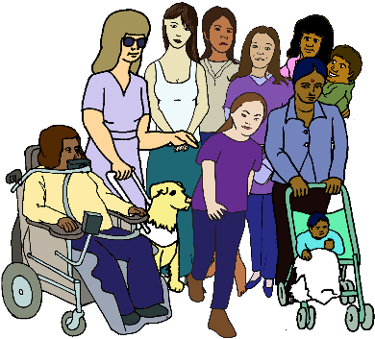
- help other people use the LEAD grant
- meet new people
- work with other people.
Who can ask for the grant?

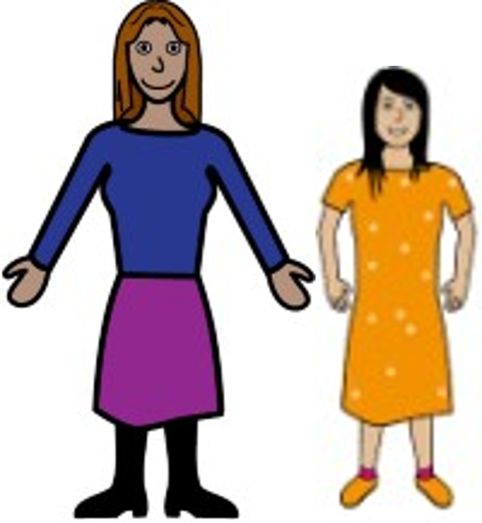
You are
- a woman
- a girl

or

You may see yourself as a woman.

or

You may see your self as
- not a man
and
- not a woman.

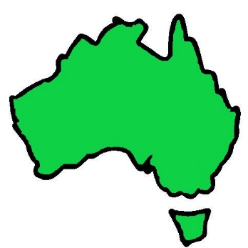
You need to
- live in Australia

and
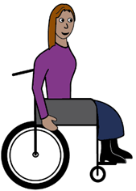

- have a disability?

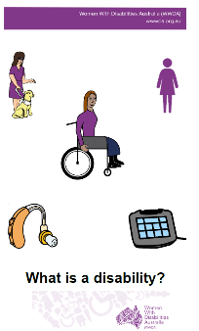

Read What is a disability?
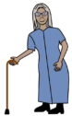
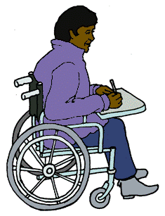
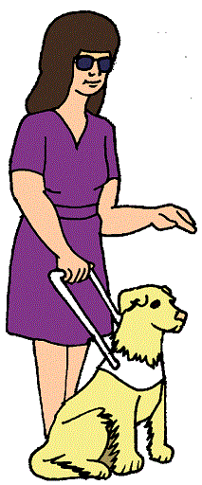
You can be any age from 15 years old. Like
- 16
- 25
- 40
- 70.

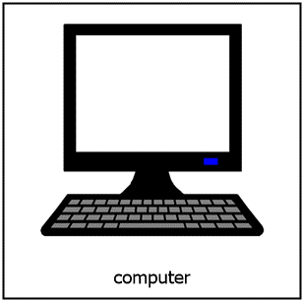
You need a
- computer
or
- tablet

and

- the internet.

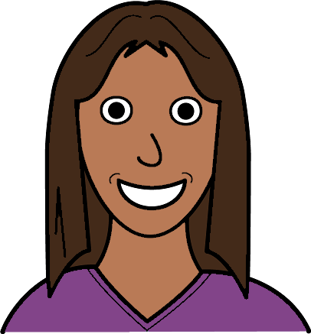
You get the LEAD grant.
What can you do?

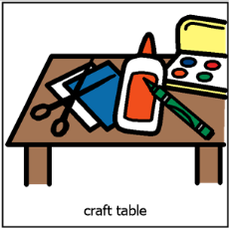
The LEAD grant can pay for you to
- learn new skills.
Like an art class.
- a program to help be a leader.
Like learn to talk in public.

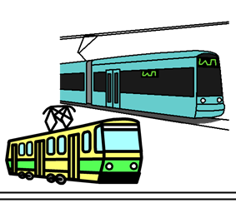
You can not use it to help you get places.
Like train tickets.

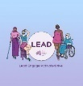
At the end of the LEAD grant

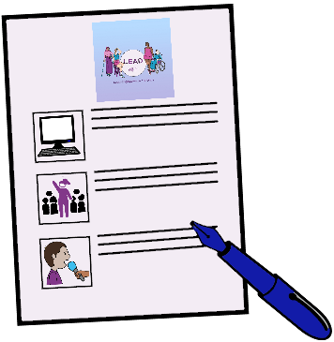
You need to tell us about your LEAD grant.
It will say
- what you learned
- what you want to do now to help
  - WWDA
  - women with disability.

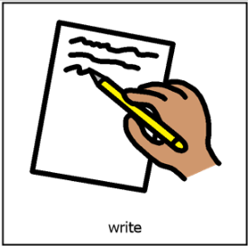
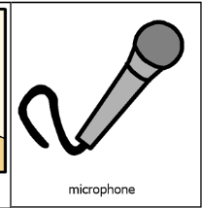
You can tell us in any way you want. Like
- write a story
- some art
- a video
- record your story.

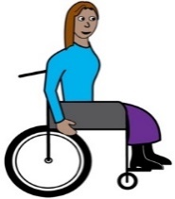
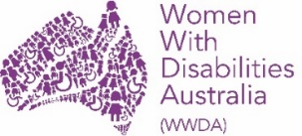
We want you to help
- WWDA
- other women with disability.

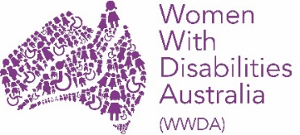
These are some of our new projects
- Help more WWDA members to
- know about our work
- help the people who do the LEAD grant the next time
- do things with WWDA.

- Help WWDA with a big meeting.
It is for all women and girls
- with a disability
- in Australia.
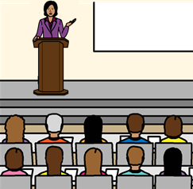
It is called the
LEAD National Leadership Summit.
It is in 2022. It is next year.

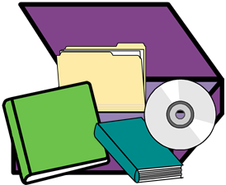
- Help make the
LEAD Leadership and Mentoring toolkit.
We call it a kit.

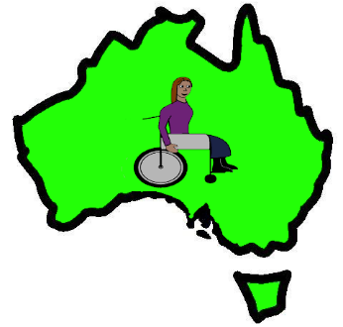
The kit will be for women in Australia

And

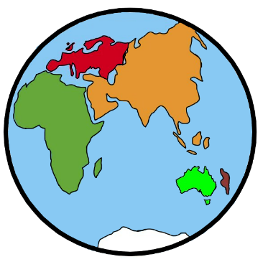
For women in other parts of the world.
Like women in Africa.
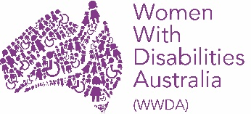
More information

Talk to Libbi Cunnington

Email spo@wwda.org.au

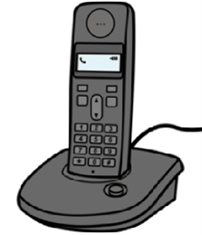
Call 0488 758 539
Text 0488 758 539

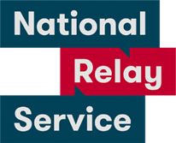
National Relay Service
Call 1800 555 677
Ask them to call 0488 758 539

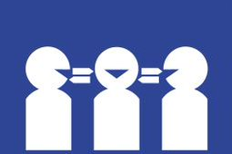
Translator.
Call 131 450
Ask them to call 0488 758 539

Post
PO Box 407
Lenah Valley
Tasmania 7008.

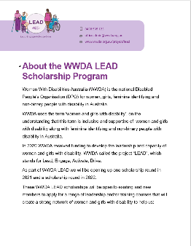
This fact sheet is based on About the WWDA LEAD Scholarship Program. February 2021

Images
We can use these images. They are from
- EasyontheI
- InspiredServices
- Picto-Selector
- Spectronics
- TheNounProject
- Tobii-Dynavox.

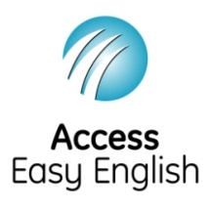
Access Easy English wrote the Easy English.
February 2021.

