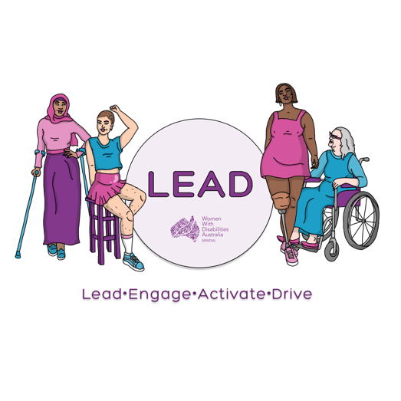 ­

0438 535 123officeadmin@wwda.org.auwww.wwda.org.au/project/lead

­­

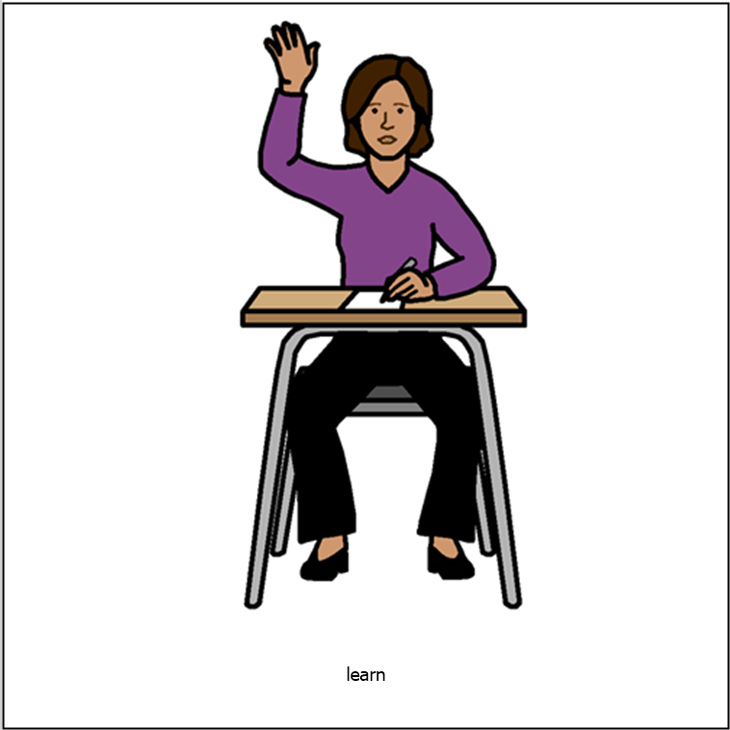

**You want a LEAD grant.**

**Tell us about you.**



Go to the next page.

Read about the WWDA LEAD grant in

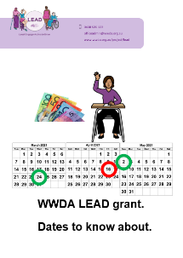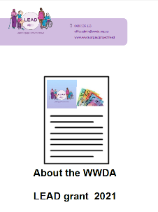

* **About the WWDA LEAD grant 2021**
* **Dates to know about.**



It will help you fill in this form.



Only some people will get the grant.

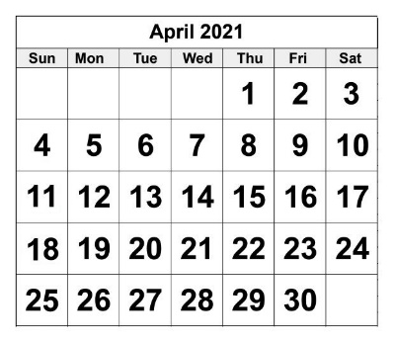

Send to us by 16 April 2021.

**Can you get a LEAD grant?**

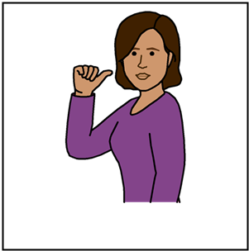

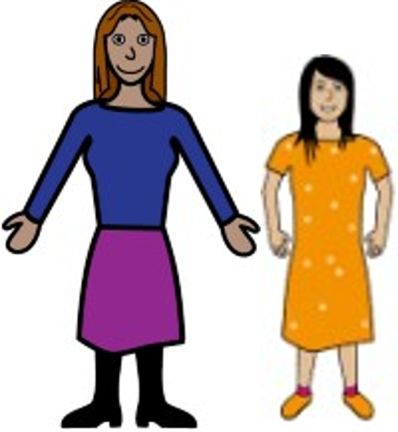Are you a

* woman
* girl

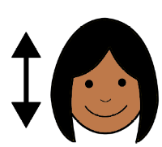

Yes. Go to page 6.

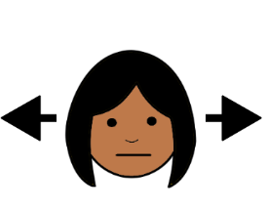

No. Go to the next question.

Do you see yourself as a woman

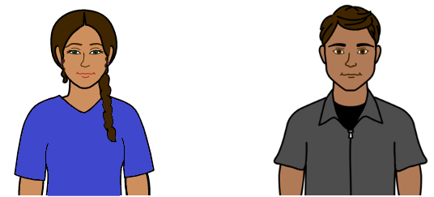

**or**

Do you see your self as



* + **not** a man

**and**

* + **not** a woman.



Yes. Go to page 6.

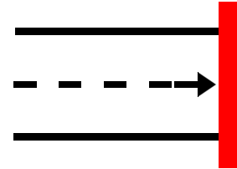

No. You can **not** ask for this grant.

Do you live in Australia?



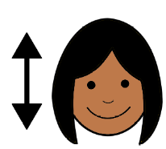



Yes No

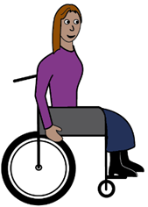Do you have a disability?

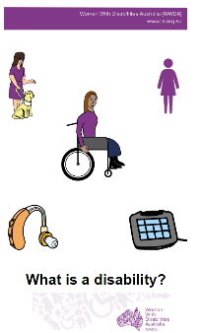

Read **What is a disability?**





Yes No

Are you more than 15 years old?

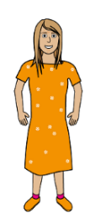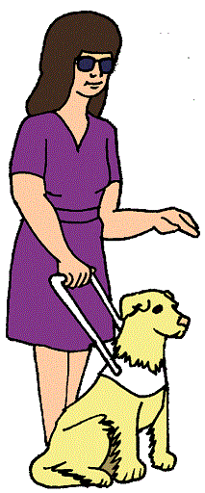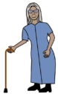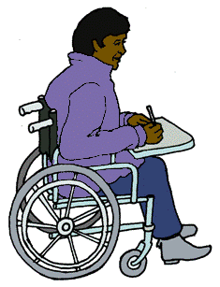

You can be 15 years old too.





Yes No

Did you say yes to all these questions?

**?**



Yes. You can ask for the grant.

Go to page 8.



No. You can **not** ask for this grant.

**Ask for the grant**

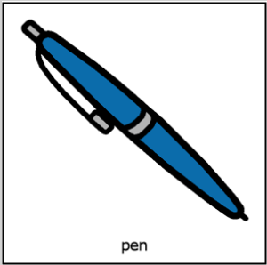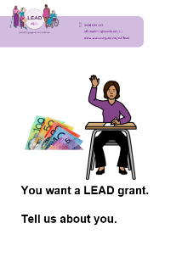



Name __________________________________

Address

_______________________________________

_______________________________________

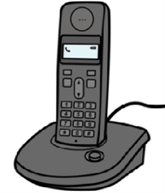

Phone __________________________________

Email _______________________________________

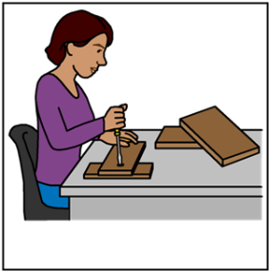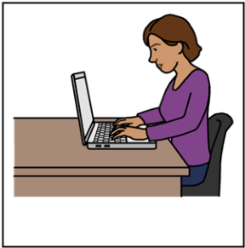

Do you work?





Yes No

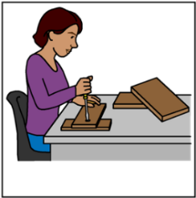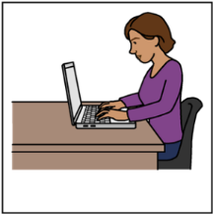

Where do you work?

Are you a member of WWDA?



Yes. Go to page 12.



No.

You need to be a member of WWDA.

You can become a member.

Go to

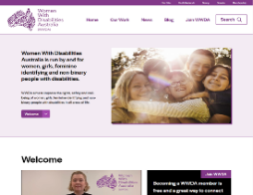

www.wwda.org.au

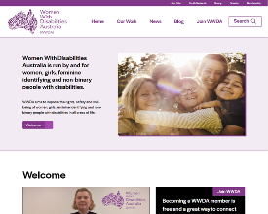

Find the button at the top called **Join WWDA**

You need to write some things about you.



It helps us choose the people for the grant.

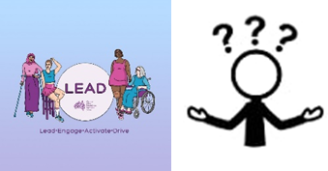

1. You want to do LEAD. Why?

_______________________________________

_______________________________________

_______________________________________

_______________________________________

There is a problem for

* women
* girls

**or**

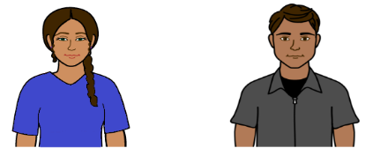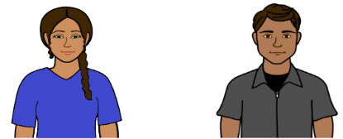

* people who see them self as a woman

**or**

* people who see them self as

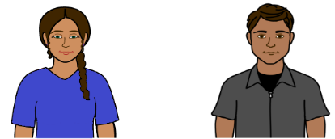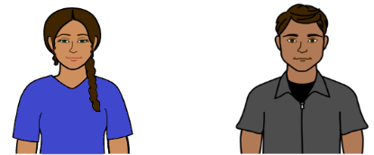

* + **not** a man

**and**

* + **not** a woman.

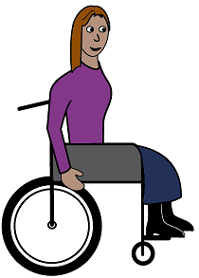

They also have a disability.

You want to do some thing about it. Like

* learn more
* do some thing to make a change.

1. 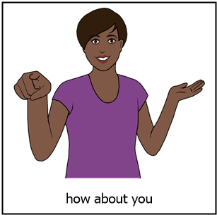What do you want to do?

_____________________________________

_____________________________________

_____________________________________

____________________________________

1. You get the grant.

WWDA will pay for your course.

What course do you want to do?

_____________________________________

_____________________________________

_____________________________________

_____________________________________

1. 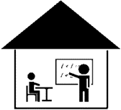Some times you can do things in other places.

Is there a

* course

**or**

* 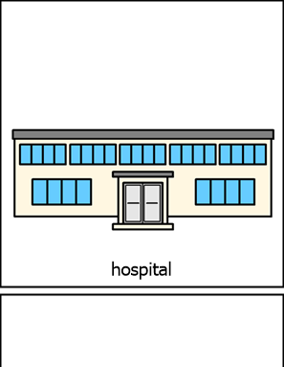different place you want to go. Like

a community centre.



Yes. Go to question 5.

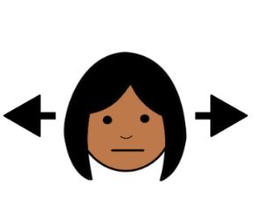

No. Go to question 6.

1. What is the name of the course?

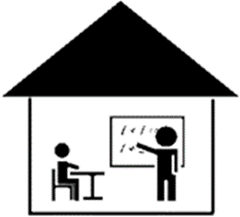

_____________________________________

_____________________________________

How much is the course?

_______________________________________

_______________________________________



What year is the course?

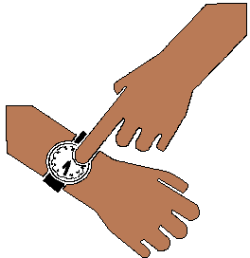

This year. It is 2021.

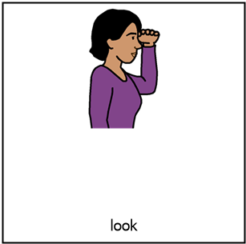

Next year. It will be 2022.

1. 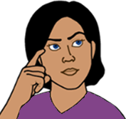What do you want to know more about at the end of the grant? Like
   * the rights of women
   * how to help women.

__________________________________________________________________________

__________________________________________________________________________

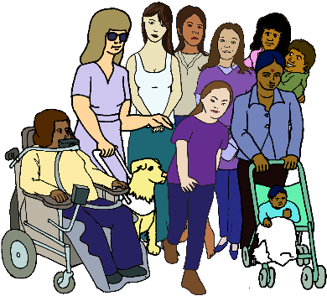

1. What do you want to do after the grant? Like
   * run support groups for WWDA
   * talk about problems with other women.

_____________________________________

_____________________________________

_____________________________________

_____________________________________

1. How will the LEAD grant

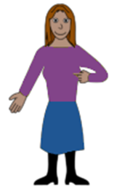

* help you
* help WWDA do their work?

_____________________________________

_____________________________________

_____________________________________

_____________________________________

1. Is there any thing else you want to tell us?

_____________________________________

_____________________________________

_____________________________________

_____________________________________

**Access**



Do you need help to join in? Like

* listen to every thing
* information in large print
* Easy English.



What do you need?

_______________________________________

_______________________________________

_______________________________________

_______________________________________

Send this form by

* email spo@wwda.org.au

**or**

* A picture containing text, clipart

  Description automatically generatedpost

PO Box 407

Lenah Valley

Tasmania 7008.

**When will you hear from us?**

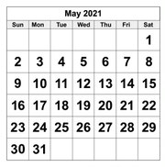

Monday 3 May 2021.

**More information**

Talk to Libbi Cunnington

Email spo@wwda.org.au

Call 0488 758 539



Text 0488 758 539

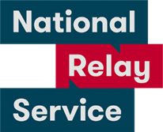National Relay Service

Call 1800 555 677

Ask them to call 0488 758 539

Translator.

Call 131 450

Ask them to call 0488 758 539

Post

PO Box 407

Lenah Valley

Tasmania 7008.

This form is based on the WWDA LEAD Scholarships Application Form. February 2021.

**Images**

We can use these images. They are from

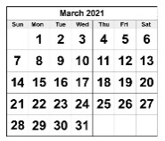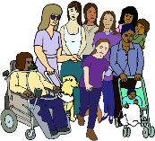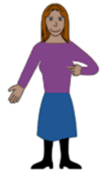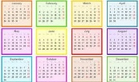

* EasyontheI
* InspiredServices
* Picto-Selector
* PrintableCalendarTemplate
* Spectronics
* TheNounProject
* Tobii-Dynavox
* 123rft.

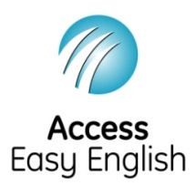Access Easy English wrote the Easy English.

February 2021.