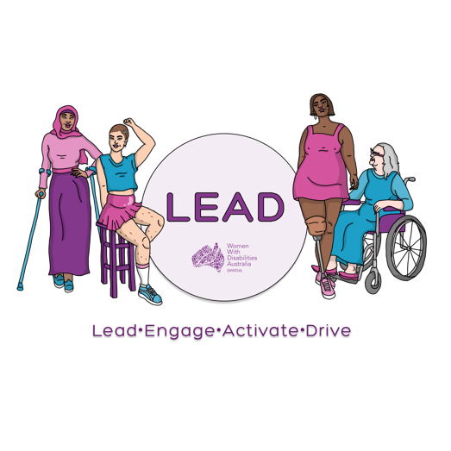
0438 535 123
officeadmin@wwda.org.au
www.wwda.org.au/project/lead

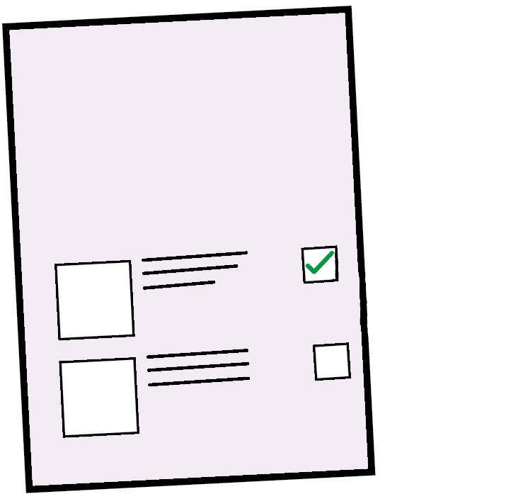
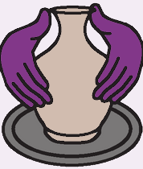

The rules for our Art Contest
February 2021
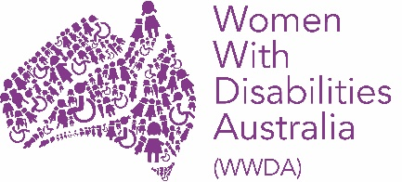
This information is from
Women With Disabilities Australia.
We will write WWDA when we talk about us.

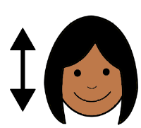
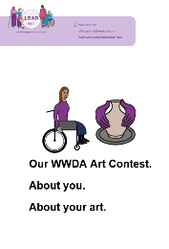
- You must agree to these rules.
Read page 15 in About you. About your art.
There is a question about these rules.

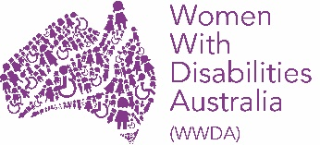
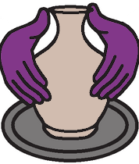
- This Art Contest is run by WWDA.
Find out how to get more information about WWDA on page 21.

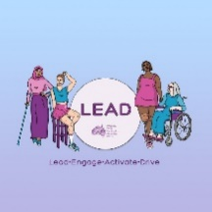
- WWDA have a new project. It is called LEAD.

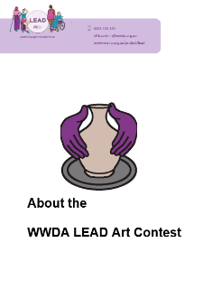
Read more about LEAD in
About the Art Contest page 3.
The Art Contest is part of the LEAD project.

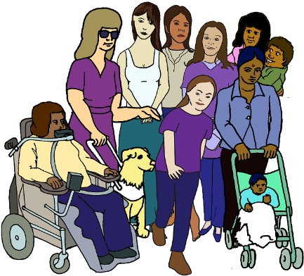
We want your art to be about a topic.
The topic is We can all be leaders.

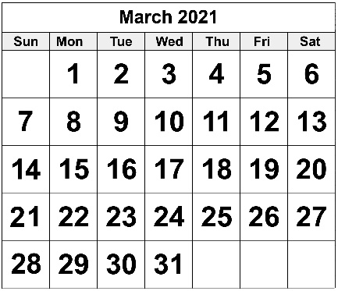
- Our Art Contest starts on
- Monday 8 March 2021

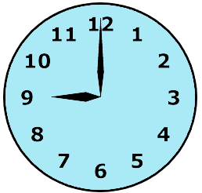

- at 9 in the morning.

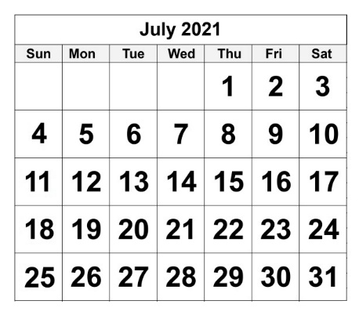
Our Art Contest ends on
- Friday 23 July 2021

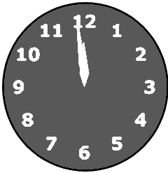
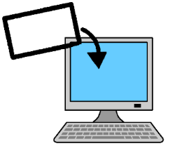
- at 11:59 at night.
It is the same as mid night.
Do not email us your art after this time.

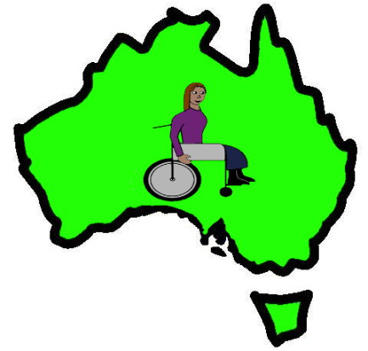
- Only some people can be part of our
Art contest. You need to
- live in Australia
- have a disability.

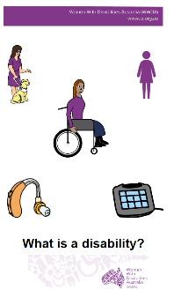

Read What is a disability?

and

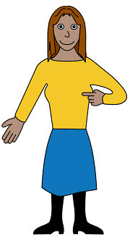
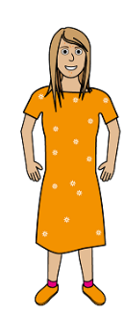
You must also be
- be a
- woman
- girl

or

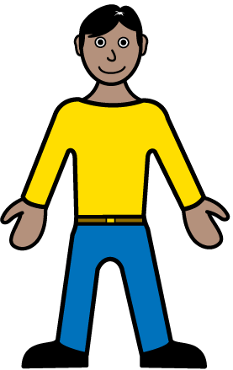
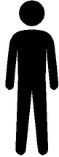
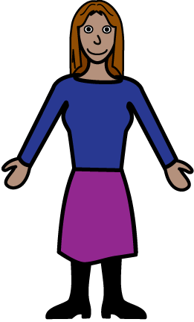
- you see yourself as a woman.

or

- you see your self as
- not a man
and
- not a woman.

- It is free to put your art in the contest.

You can do some art
- by your self

or

- with a group.

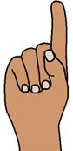
You can put in 1 piece of art you did
by your self.

And

You can put in 1 piece of art you did
in your group.
Your group can only do 1 piece of art.

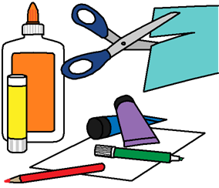
- Your art can be
- a painting
- a drawing
- a mix of different things.
You may call it a collage.

Or
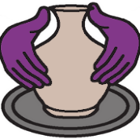
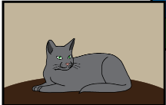
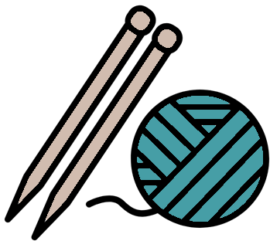
Your art can be
- craft. Like knitting
- something you have carved.
You may call it a sculpture
- a photo
- a video.

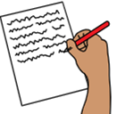
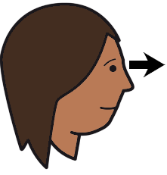
You need to write about your art.
You need to tell WWDA what it looks like.

- You send a copy of your art to WWDA.

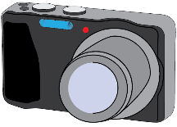
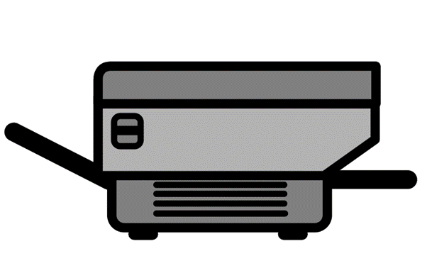
Only send
- a photo of your art
or
- a scan of your art
or
- a video of your art.

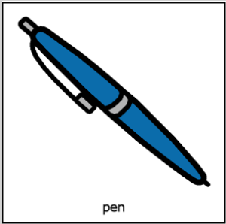
You must fill in the form with your art.
The form is called About you. About your Art.

You email WWDA
- the copy of your art.
- the signed form.

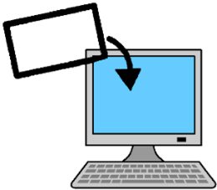
Email project@wwda.org.au
Type in the topic line Art Contest.

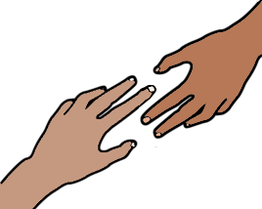
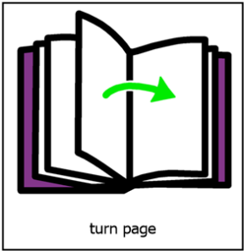
You can get help from WWDA.
Talk to Mali Hermans. Go to page 21.

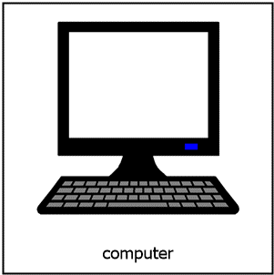
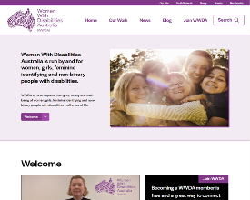
- COVID - 19 means you will see the art on the
- WWDA website
- WWDA Our Site website

- WWDA Facebook page
- WWDA Instagram page
- WWDA Twitter page.

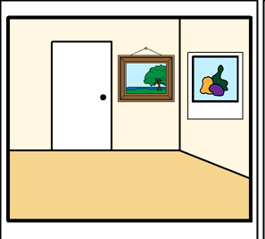
You can not see the art in a room.

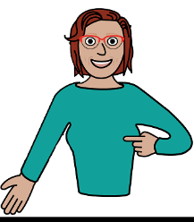
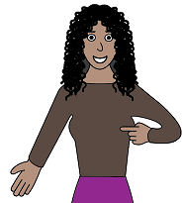
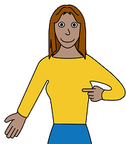
- You own your art.
Your art must be your own work.
You can not send another persons art.
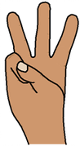
- There are 3 contests for our Art Contest.

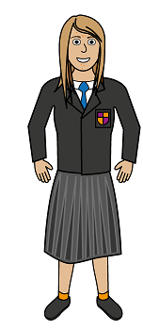
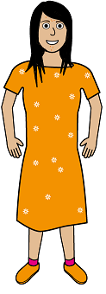
Contest 1.
People who are
- 15
- 16
- 17.

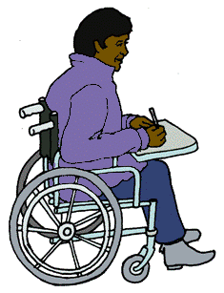
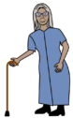
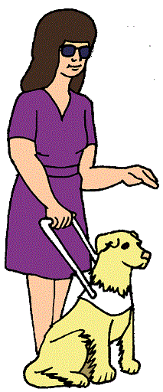
Contest 2.
Every one else that goes in the Art Contest.

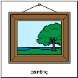
Contest 3.
Peoples Choice Award.
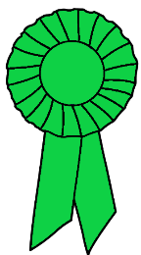
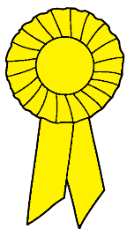
Each contest will have a
- winner
- runner up
- other people who do very well.

- Each contest has 3 prizes.

The winner.
The winners gets $ 500 of
- gift cards
- things to do their art. Like an easel.

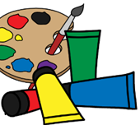
The runner up.
The runner up gets $ 200 of
- gift cards
- things to do their art. Like paints.

The judges may say some one did very well.
They get $ 50 of
- gift cards
- things to do their art. Like some brushes.

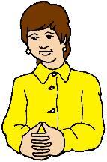
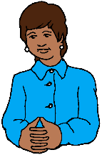
- WWDA will choose judges.
They are not part of WWDA
But
The judges will have disabilities.

The judges choose the winners for
Contest 1.
People who are
- 15
- 16
- 17.

And

Contest 2.
Every one else that goes in the Art Contest.

- WWDA check your art
- agrees to these rules
- is ok to show people in a public space.

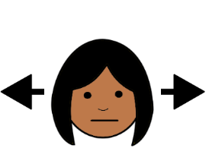
WWDA can say your art can not go in their Art Contest.

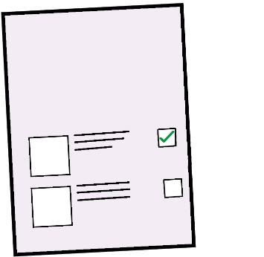
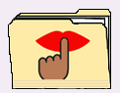
- WWDA need information about you.
WWDA follow the rules about
private information.
You can read how we do this in our rules about private information.

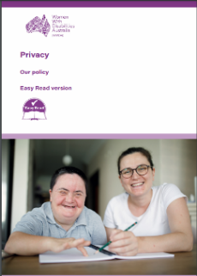
It is in Easy Read.
It is called WWDAs Privacy Policy.

- WWDA will not sell any information we get for the Art Contest.

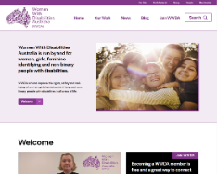
- You agree to have your art on the WWDA
- website www.wwda.org.au

- Our Site website www.oursite.wwda.org.au

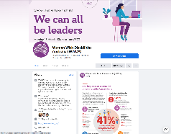
- Facebook page
www.facebook.com/WWDA_Australia

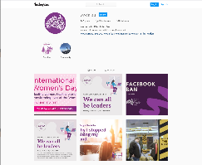
- Instagram page
www.instagram.com/wwda_au

- Twitter page
www.twitter.com/WWDA_AU.

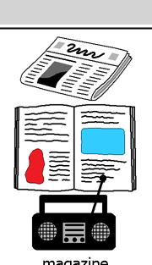
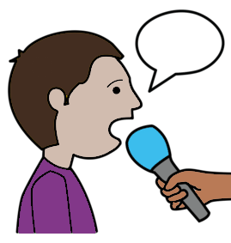
- WWDA may do an interview for
- a newspaper
- a magazine
- radio.

WWDA will ask you before they talk about your art in interviews.

- To run this contest WWDA did
not get money from
- Facebook
- Instagram
- Twitter.

More information

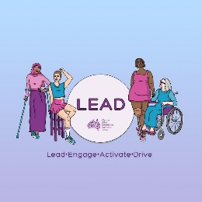

Talk to Mali Hermans.

Email project@wwda.org.au

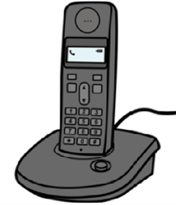
Call 0488 417 875.

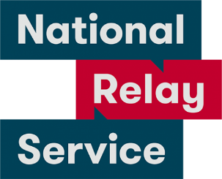
National Relay Service.
Call 1800 555 677.
Ask them to call 0488 417 875.

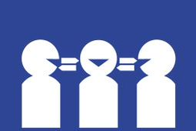
Translator.
Call 131 450.
Ask them to call 0488 417 875.

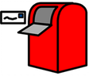
Post
PO Box 407
Lenah Valley
Tasmania 7008.

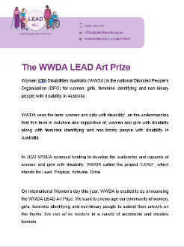
This fact sheet is based on the WWDA LEAD
Art Prize. February 2021.

Images
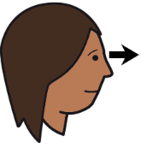
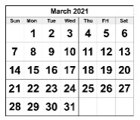
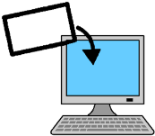
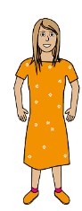
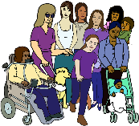
We can use these images. They are from
- EasyontheI
- InspiredServices
- Picto-Selector
- PrintableCalendarTemplate
- Spectronics
- TheNounProject
- Tobii-Dynavox.

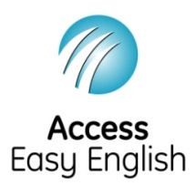
Access Easy English wrote the Easy English.
February 2021.

