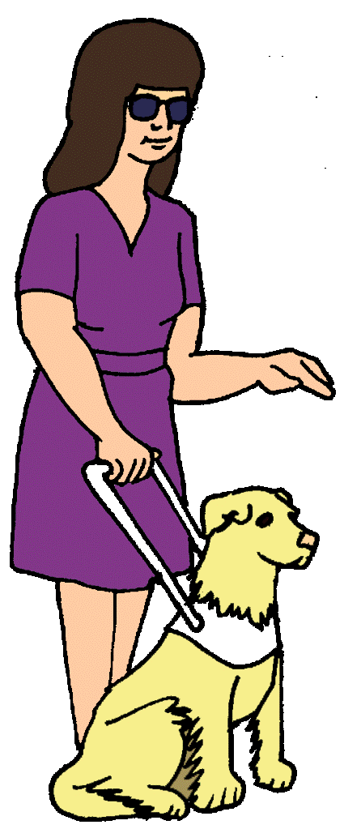
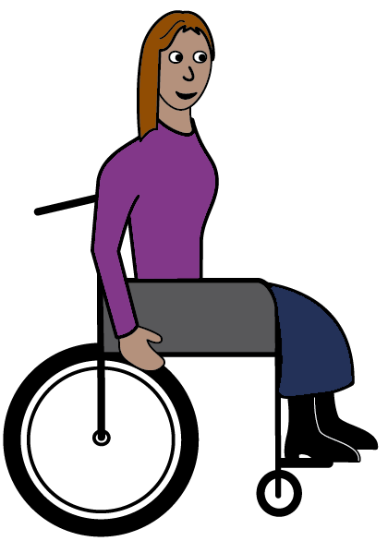

What is a disability?
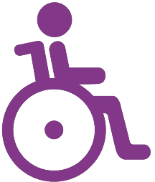
Some women have a disability.
It can be different for every woman.
Sometimes you can see a disability.
Sometimes you can not see a disability.
A disability can make it hard to do things. Like

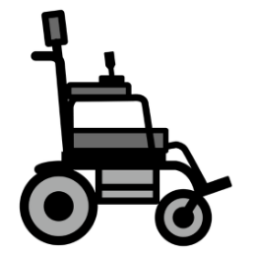
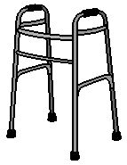
- it is hard to walk. You may need to use
- a wheelchair
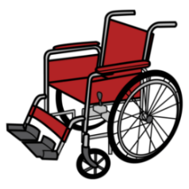
- a scooter
- a walking frame

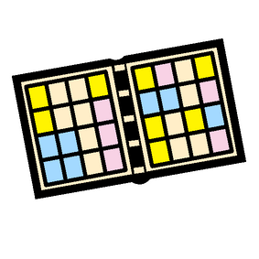
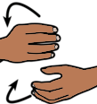
- it is hard to talk. You may need
- a communication board
- to use sign language
- to use objects and photos.

Or

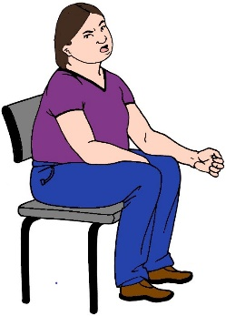
- it is hard to learn. You may need
- the task in tiny steps
- to try a new task many times to know it
- to learn things important to you every day.

A disability can also be when
- it is hard to see
You may need a seeing eye dog

- it is hard to hear
You may need a hearing aid.

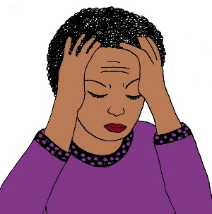
It may be hard to think in a clear way.

Sometimes you can not see a woman
has a disability.

Some times you can see a woman
has a disability.

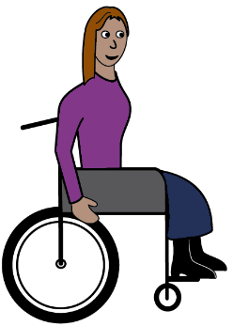
We will use this picture to talk about all women with a disability.

Images
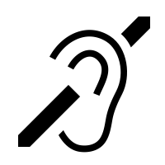
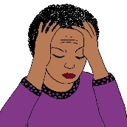
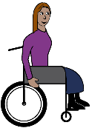
We have used images from
- ChangePeople
- EasyontheI
- Inspired Services
- Picto-Selector
- TheNounProject.

Access Easy English wrote the Easy English. February 2021.

