

**Our Royal Commission  
A fact sheet for   
women and girls with disability**

**Easy Read Version**

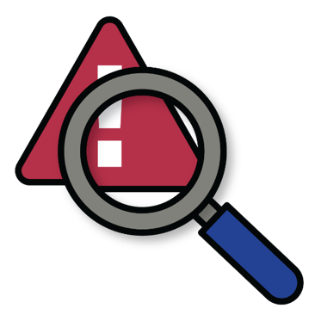**What is the Disability Royal Commission?**

A **Royal Commission** is a way the Australian Government can look into a big problem.

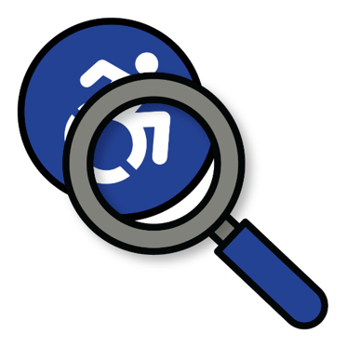In 2019, the **Royal Commission into Violence, Abuse, Neglect and Exploitation of People with Disability** started.

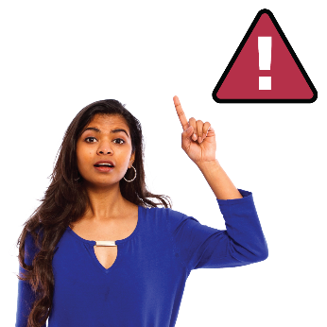

We call it the **Disability Royal Commission**.

The Disability Royal Commission will go until 2023.

**Why was the Disability Royal Commission started?**

We need the Disability Royal Commission because know that people with disability face high rates of:

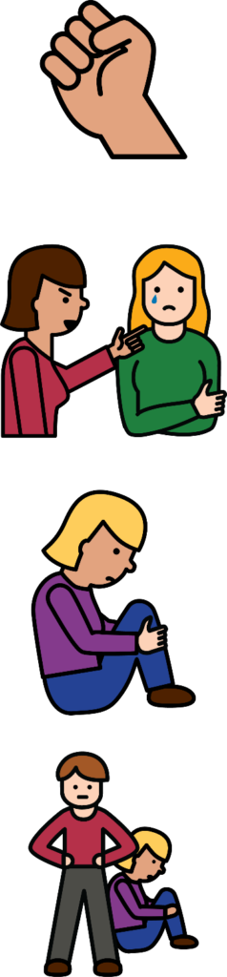

* **violence** – when someone hurts you
* **abuse** – when someone treats you badly
* **neglect** – when does not help you the way they should
* **exploitation** – when someone takes advantage of you.

**Why is the Royal Commission important?**

The Disability Royal Commission collects stories from people with disability.

The Disability Royal Commission will use your stories to make people with disability safer.

People with disability have a right to be safe in all places, including:

* at home
* A picture containing icon

  Description automatically generatedat work
* at school
* in the community.

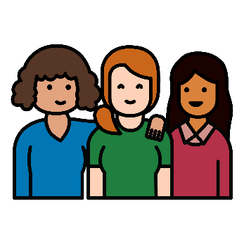**Hearing for women with disability**

The Disability Royal Commission is holding a **public hearing** for women and girls with disability.

The Hearing will be held in August 2021.



A **public hearing** is a meeting where the **Commissioners** listen to people’s stories.



**Commissioners** are the people who work on the Disability Royal Commission.

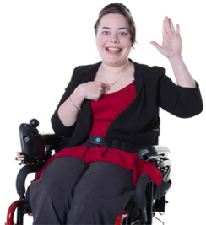

We need women and girls with disability to tell their stories before the public hearing.

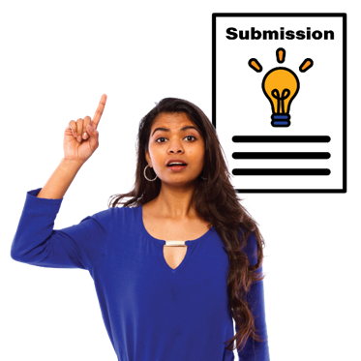**How can I tell my story?**

The main way to share your story with the Disability Royal Commission is to make a **submission**

There are lots of ways you can make a submission. You can:

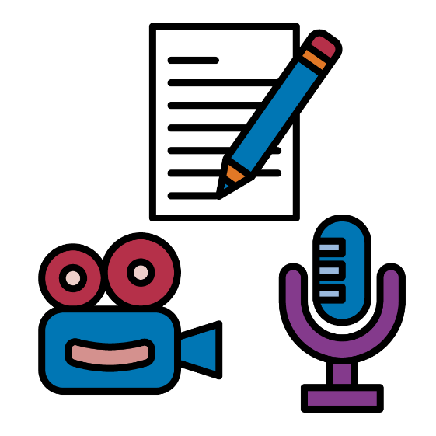

* write it down



* make a video



* make an audio recording
* draw a picture.

You can download a form the [**Disability Royal Commission website**](https://disability.royalcommission.gov.au/submissions/Pages/default.aspx).

There is an **Easy Read** version of the form.

Call [**1800 517 199**](tel:1800517199)

Email  [**DRCenquiries@royalcommission.gov.au.**](mailto:DRCenquiries@royalcommission.gov.au.)**‍**

Your submission can be made in any language.

This includes:

* Auslan
* Languages other than English.

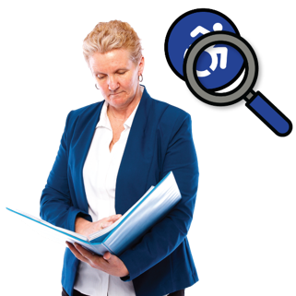**What will happen to my submission?**

After you send your submission, the Commissioners will look at it.

Your submission might be used to help them write their reports.

Your personal information won’t be in the report unless you say it’s OK.

If you want your information kept private, the Disability Royal Commission will do this.

If you are worried about this, you can ask for a **private session**.

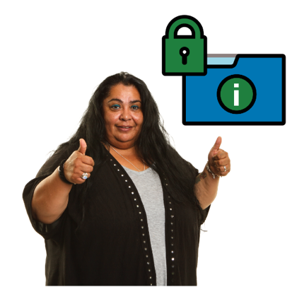**What is a private session?**

If you do not want your information to be public, you can ask for a **private session**.

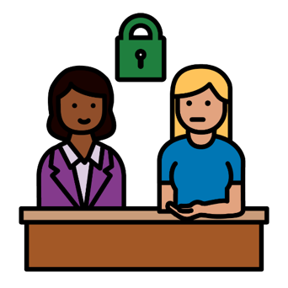

A **private session** is when a person talks to a Commissioner in private about their experiences.

Private sessions can be:

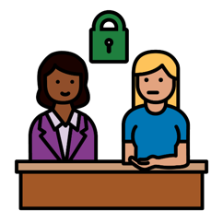

* in person



* on the phone



* on a video meeting

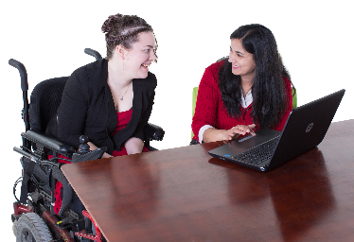**Can I get help to tell my story?**

There is lots of support available to help you take part in the Disability Royal Commission.

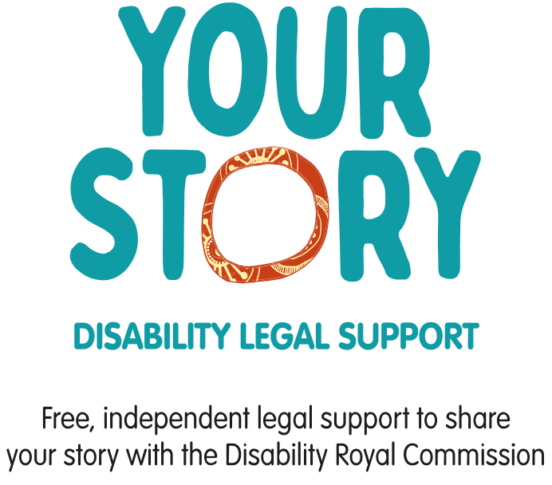

You can get free **legal support** from the Your Story Disability Legal Support service.

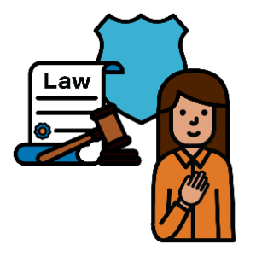

They can help:

* understand your legal rights
* get your submission ready.



Call **1800 771 800**.



Visit [**https://yourstorydisabilitylegal.org.au/Home**](https://yourstorydisabilitylegal.org.au/Home)

**What other support can I get?**

You can get free **advocacy** support to help you make a submission.

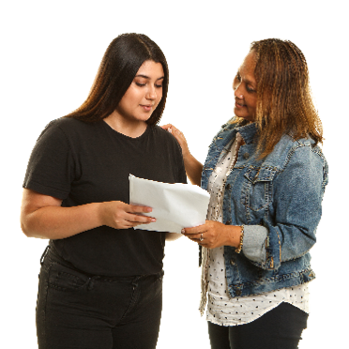

**Advocacy** is when someone helps you to speak up for yourself.

The advocacy services can help you:

* make a submission
* speak at a public hearing.

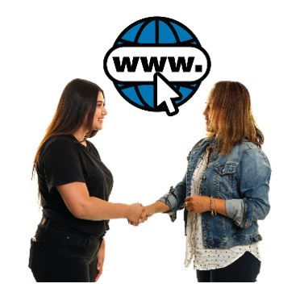

To find a disability advocate

* call **1800 517 199**
* use the online [**Disability Advocacy Finder**](https://disabilityadvocacyfinder.dss.gov.au/disability/ndap/).

**Where can I learn more?**

The following websites can help you learn more about the Disability Royal Commission and how to take part:

* [**Disability Royal Commission website**](https://disability.royalcommission.gov.au/)
* [**WWDA: Disability Royal Commission**](https://wwda.org.au/project/royal-commission/#:~:text=The%20Royal%20Commission%20into%20Violence,Exploitation%20of%20People%20with%20disability.&text=As%20the%20only%20national%20representative,girls%20with%20disability%20are%20heard.)
* [**Our Site: Disability Royal Commission**](https://oursite.wwda.org.au/safety-and-violence/disability-royal-commission)
* [**People With Disability Australia: Royal Commission Hub**](https://pwd.org.au/drc-hub/)
* [**Your Story Disability Legal Support Resources**](https://yourstorydisabilitylegal.org.au/Resources/People-with-disability)

## Thank you

**Thank you!**

**Who wrote this fact sheet?**

Women with Disabilities Australia wrote this document in 2021. This document is for information purposes only.

**Copyright**

© Copyright

Women with Disabilities Australia (WWDA) Inc. 2021.

All intellectual property rights, including copyright and patents, in this book is owned and licensed by Women with Disabilities Australia Inc.

**The images used in this fact sheet**

Information Access Group made the illustrated images for Women With Disabilities Australia in 2020.

Other images used with creative commons licences.