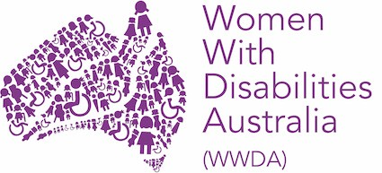
WWDA has Special Consultative Status with the Economic and Social Council of the United Nations

Winner, National Human Rights Award 2001 Winner, National Violence Prevention Award 1999 Winner, Tasmanian Women's Safety Award 2008
Certificate of Merit, Australian Crime & Violence Prevention Awards 2008
Nominee, National Disability Awards 2017 Nominee, French Republic's Human Rights Prize 2003 Nominee, UN Millennium Peace Prize for Women 2000

PO Box 407, Lenah Valley, 7008 TASMANIA
Ph: +61 438 535 123
Ph: +61 438 535 535
Email: carolyn@wwda.org.au Email: officeadmin@wwda.org.au Web: www.wwda.org.au
Facebook: http://www.facebook.com/WWDA.Australia Twitter: https://twitter.com/WWDA_AU
Senator the Hon Michaelia Cash Acting Attorney-General
PO Box 6022
House of Representatives Parliament House CANBERRA ACT 2600
Via Email: senator.cash@aph.gov.au

08 March 2021 Dear Senator Cash,
Firstly, Women With Disabilities Australia (WWDA) congratulates you on your appointment to the position of Acting Attorney-General, and we appreciate the difficult times and context under which you have assumed this role.

As you may be aware, WWDA has a major role in the Royal Commission into Violence, Abuse, Neglect and Exploitation of People with Disability (the Disability Royal Commission), established by Prime Minister Scott Morrison MP, in April 2019. WWDA assisted in the establishment of the Disability Royal Commission, including in the development of the Terms of Reference. WWDA continues to be heavily involved in the work of the Disability Royal Commission.

The Disability Royal Commission is a once in a lifetime opportunity, and one that disabled people and our allies have fought for, for more than two decades. Unfortunately, the impact of COVID19 has affected the work of the Disability Royal Commission, including the roll out of public hearings, private sessions, community information sessions and more.

The Chair of the Disability Royal Commission, the Hon Ronald Sackville AO QC, has previously written to the Attorney-General (in October 2020) to request a 17-month extension of time to

present the Royal Commission’s final report to September 29, 2023. WWDA understands that the Australian Government, through the Attorney-General, has yet to provide a response to this request.

WWDA recognises that the Terms of Reference for the Disability Royal Commission are broad, and that there is still significant work to be done in order for the Disability Royal Commission to give effect to its Terms of Reference.

WWDA is therefore requesting that you, as Acting Attorney-General give assurances to all people with disability, their families, carers and loved ones, that the Disability Royal Commission will be extended until at least September 29, 2023 – in recognition of the significant impact that the COVID19 pandemic has had not only on the Disability Royal Commission – but also the many organisations such as WWDA, which have also been impacted by COVID19, thereby reducing our capacity to undertake the important work we need to do for the Disability Royal Commission.

We look forward to your earliest response, and would be more than happy to speak with one of your advisers to provide any additional information required.

With kind regards,
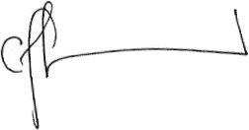

Carolyn Frohmader Executive Director

Finalist, 100 Women of Influence Awards 2015 Australian Human Rights Award (Individual) 2013 State Finalist Australian of the Year 2010 Inductee, Tasmanian Women’s Honour Roll 2009
Australian Capital Territory Woman of the Year Award 2001

