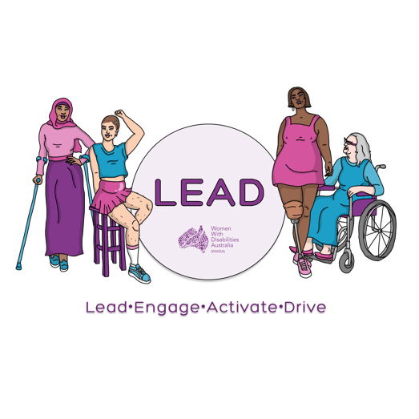
0477 076 098
Lead@wwda.org.au
www.wwda.org.au/project/lead

About the
WWDA LEAD
Mentoring Program

This information is from
Women With Disabilities Australia.
We will write WWDA when we talk about us.

WWDA LEAD Mentoring Program.
We will write the words Mentoring Program when we talk about it.

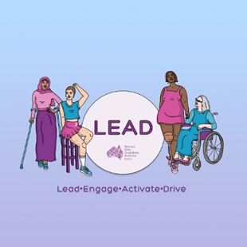
The Mentoring Program is part of the LEAD project.

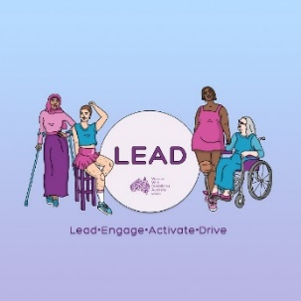
LEAD is a new project for WWDA.
LEAD means

- lead
  - to be at the front

- engage
  - to talk to other people
  - to listen to other people

- activate
  - to start your ideas

and

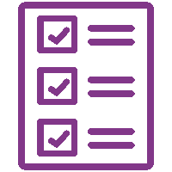
- drive.
  - to do your ideas.

The money for LEAD is from the
NDIS

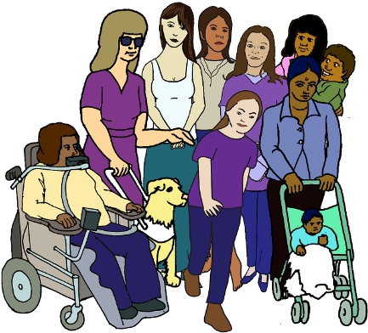
The topic for our Mentoring Program is
To Lead Together.

The Mentoring Program is free.

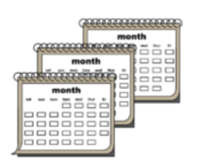
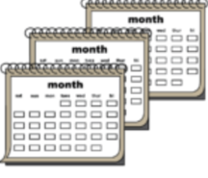
The Mentoring Program goes for 8 months,

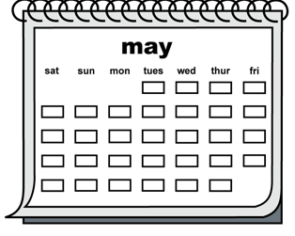
The Mentoring Program will finish in May 2021

The Mentoring Program matches
you with another person.
To help build skills together.

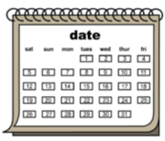
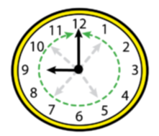
You will meet every month for one hour.

The meetings can be
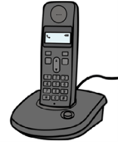
- in person
- on the phone
- online

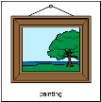
There are 5 online videos to help you.

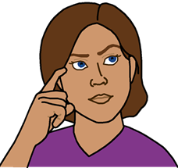
Dates to know about

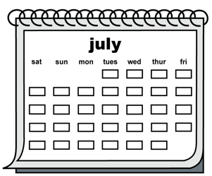
14 July 2021.
You can apply for Mentoring Program.

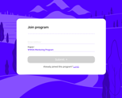
You can fill in an online form.

13 August 2021.
The Mentoring Program is closed now.
You can not apply now.

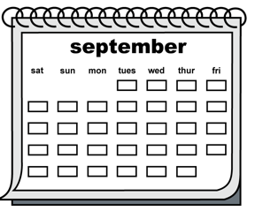
13 September 2021The Mentoring Program starts now.

If a match is found. You will get an email.

31 May 2022
The Mentoring Program is finished now.

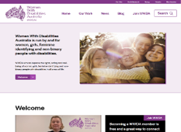
Follow these steps to find the Mentoring Program.
Go to www.wwda.org.au.

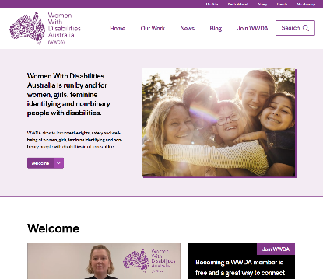

Click on the search window.
Type mentoring in the search window.

We will post about the Mentoring Program on our
- Facebook page
- Instagram page
- Twitter page

Who can go apply for Mentoring Program?

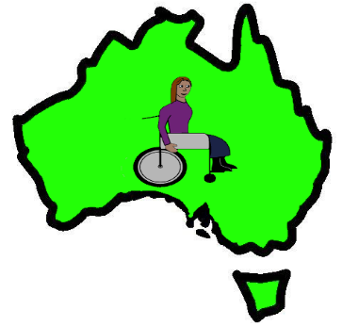
You need to
- live in Australia

and
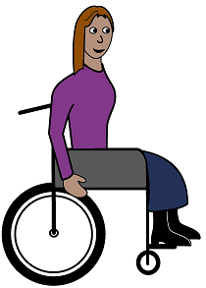

- have a disability.

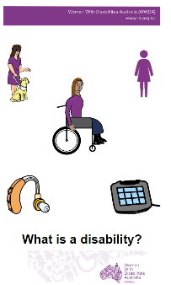
Read What is a disability?
oursite.wwda.org.au/resources/wwda-easy-english-what-is-a-disability
You also need to be a
- woman
- girl

or

- you see yourself as a woman

or

- you see your self as
  - not a man
and
  - not a woman.

You can be any age from 15 years old.
Like
- 16
- 25
- 40
- 70.

You are 15 16 17 years old.

You can ask some one you trust to help you apply for the Mentoring Program. Like your
- mum
- dad
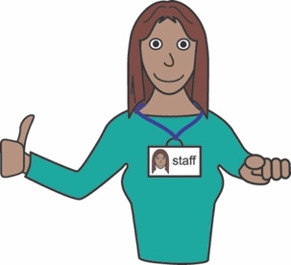
- advocate

- support person.

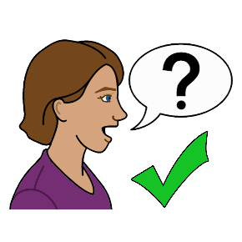
Ask us for help

You can get help to apply for Mentoring Program.

You can call us.
You tell us your answers.
We write your answers on the form.
We can not tell you what to write.

Email lead@wwda.org.au

Call 0477 076 098
Text 0477 076 098

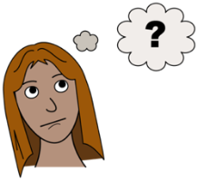
Need more information?

Talk to Saphia Grant

Email lead@wwda.org.au

Call 0477 076 098
Text 0477 076 098

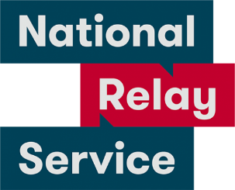
National Relay Service
Call 1800 555 677
Ask them to call 0488 417 875

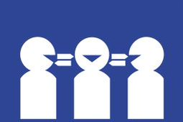
Translator
Call 131 450
Ask them to call 0488 417 875

Post to
PO Box 407
Lenah Valley
Tasmania 7008

Thank you!

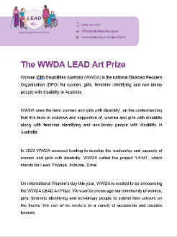
This fact sheet is based on the WWDA LEAD
Mentoring Program Page, July 2021.

Images
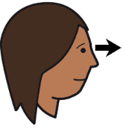
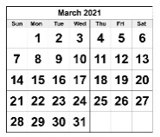
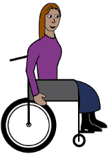
We can use these images. They are from
- EasyontheI
- InspiredServices
- Picto-Selector
- PrintableCalendarTemplate
- Spectronics
- TheNounProject
- Tobii-Dynavox.

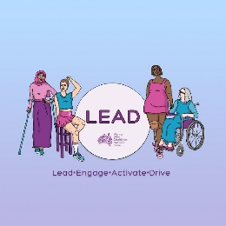
WWDA LEAD wrote this Easy English fact sheet in July 2021.

