Women With
Disabilities Australia

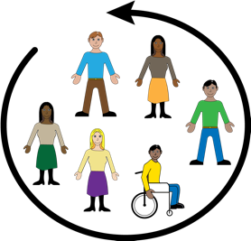

Leadership Toolkit Co-design Committee
Terms of Reference
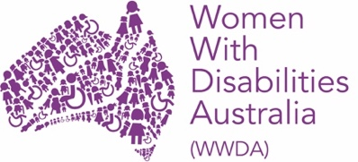
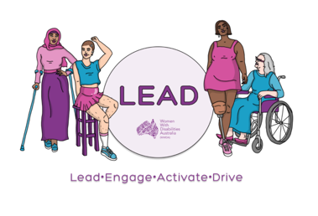

About this document

We are Women With Disabilities Australia. We will write WWDA when we talk about us.

This document is a summary of the WWDA LEAD Toolkit Co-Design Committee Terms of Reference.
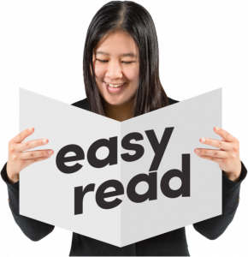
This document is written in an easy to read way.
We have written some words in bold.
We explain these words at the end of the document.

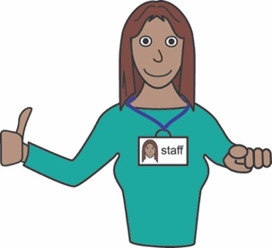
You can ask for help to read this document.
A support person may be able to help.

About WWDA

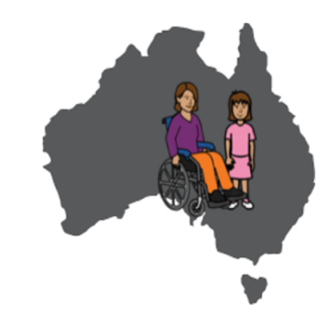
WWDA is for:
- all women and girls who have a disability, and;
- who live in Australia.

WWDA is:
- run by women with disability
- for women and girls with disability.

WWDA helps all women and girls with disability have good lives.

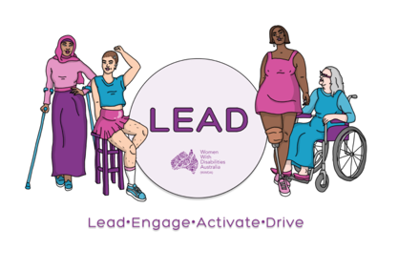
WWDA LEAD
WWDA is running a project called WWDA LEAD to:

- help women with disability be leaders

- develop information about leadership

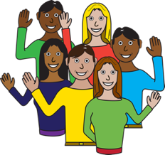
- run events for women with disability

WWDA is developing a toolkit for WWDA LEAD.

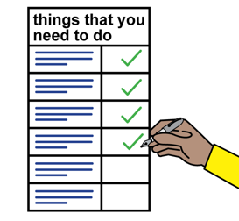
A toolkit is a document or book that helps you do something.

The toolkit will be about leadership.

The toolkit will have information like:
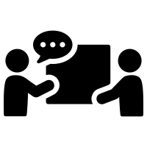
- what is a leader
- where to find out about disability leaders
- how to find a leadership mentor.

About the Co-Design Committee
WWDA is starting a WWDA LEAD
Toolkit Co-Design Committee

The Co-Design Committee will:
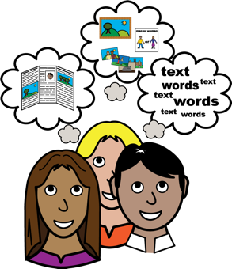

- tell WWDA what they want in the toolkit
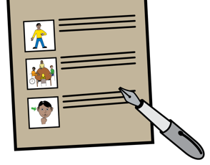
- write words for the toolkit

- say if the toolkit is good or bad!

The Co-design Committee will include up to 12 members who:
- are women, feminine identifying or non-binary people
and
- have any type of disability/
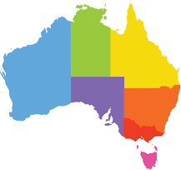
Members of the Advisory Group will include:
- women with disability from different states and places in Australia

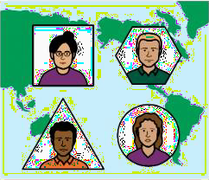
- women with disability from migrant or refugee backgrounds.
- LGBTIQA+ people with disability

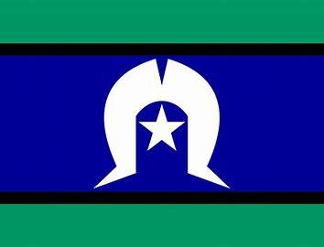
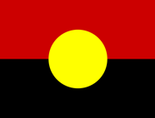
- Aboriginal or Torres Strait Islander women with disability.

Meetings of the Co-Design Committee
The Co-design committee will have meetings:
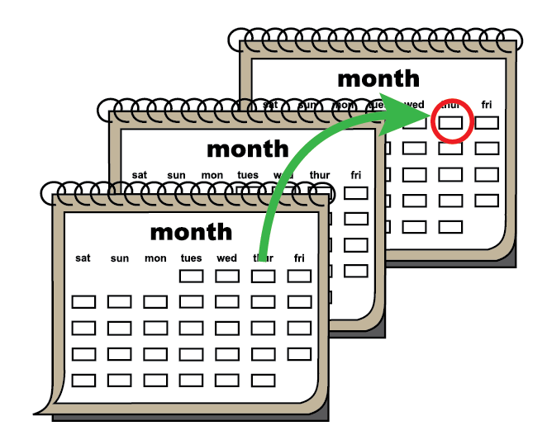
- at least once every 2 months
- until the toolkit is finished.

Meetings will be held on zoom.
Zoom is a program that allows you to run or join a meeting online.

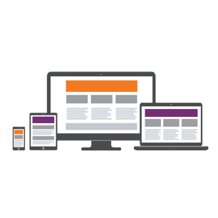
Zoom can be used on:
- a computer or laptop
- a smart phone
- on a tablet or iPad.

Support and Pay
WWDA staff will support members of the Co-design committee by:
- Running meetings
- Giving updates
- Answering questions.
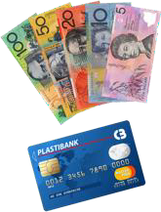
Co-design committee members will be paid
$100 for each meeting:
- as a gift card or
- by invoice.

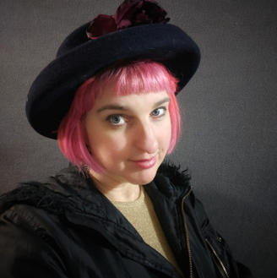
Any questions?
Contact our Project Manager, Saph
- email Lead@wwda.org.au

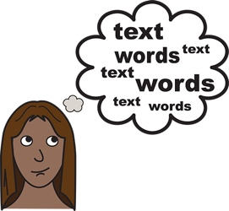
Word list
Non-Binary
Non-Binary is what we call the gender of people who do not identify as male or female.

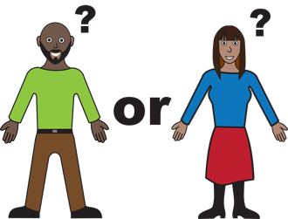
Gender
Your gender It is about how you see yourself or how you identify Like you can identify as a man or woman.

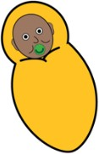
Migrant or Refugee
A migrant or Refugee s someone who lives in a different country to where they were born.

Zoom
A program that allows you to run or join a meeting online.

Invoice
A document with information about money that needs to be paid to a person or organisation.

LGBTIQA+
LGBTIQA+ means diverse sexualities and genders. The letters in LGBTIQA+ stand for Lesbian, Gay, Bisexual, Transgender, Intersex, Queer and Asexual. We explain these words on the following pages.

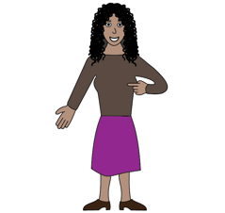
Lesbian
A woman who has romantic feelings for other women.

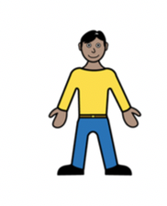
Gay
A man who has romantic feelings for other men.

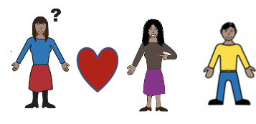
Bisexual
A person who has romantic feelings for more than one gender.

Transgender – a person whose gender does not match the sex they were given at birth. For example, a person who is a woman, but was born male is transgender.

Intersex
A person whose body is not male or female.

Queer
Another word used to talk about the LGBTIQA+ community.

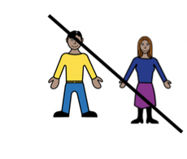
Asexual
A person that does not have sexual feelings for other people.

