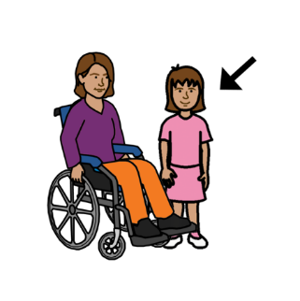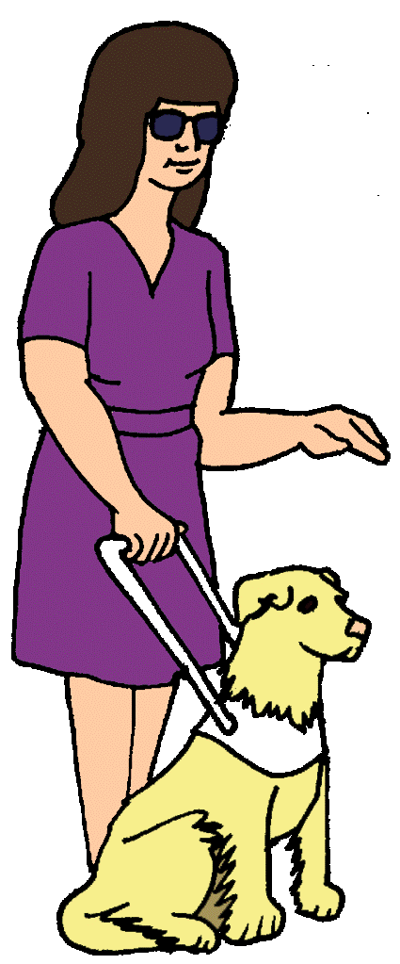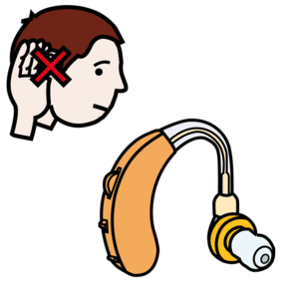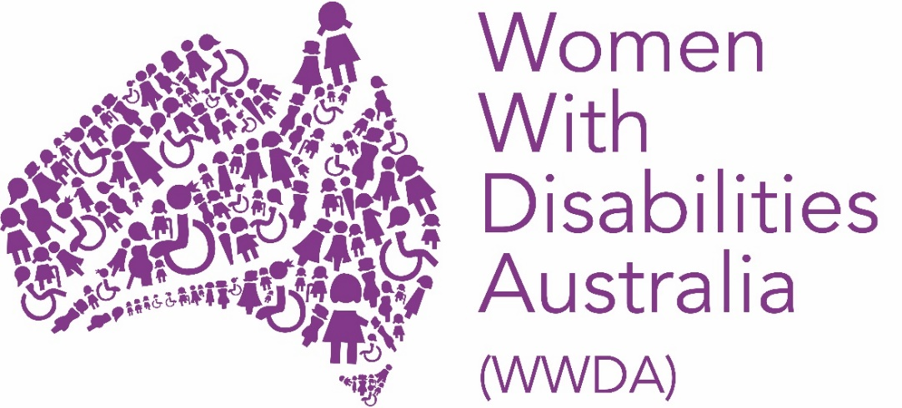

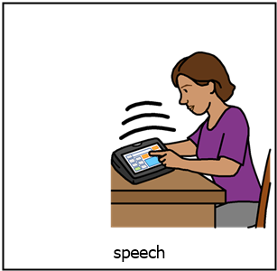

**About us**

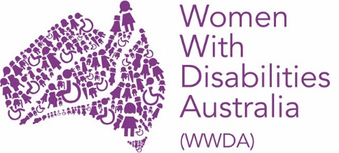

We are

Women with Disabilities Australia

We write **WWDA** to talk about us.

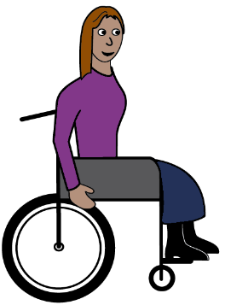

WWDA is run by women with disability.

We work with

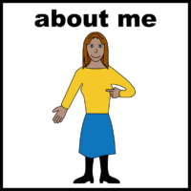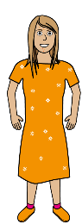

* women
* girls

**and**

* people who see themselves as women.

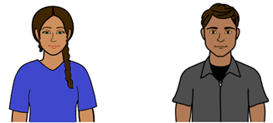

**and**



* people who see themselves as
* **not** a man

**and**

* **not** a woman.

They say they arenon-binary.

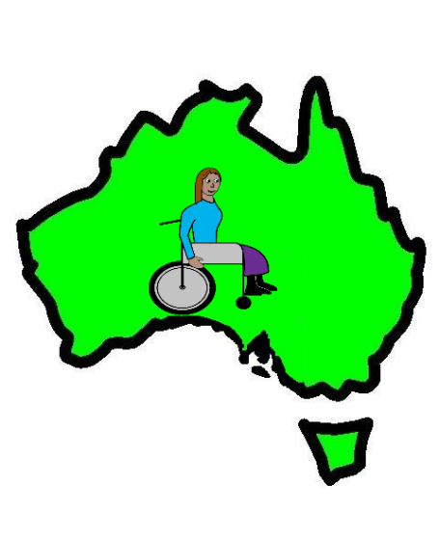We all

* live in Australia

**and**

* have a disability.

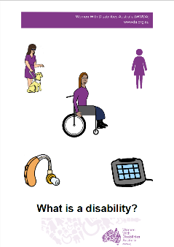Do you think you have a disability?

Find out more. Read it in Easy English.

Go to www.oursite.wwda.org.au

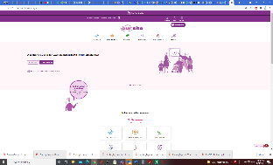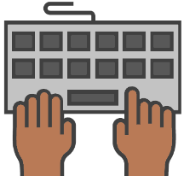

Open the search window

Type **WWDA Easy English Book.**

**What is a Disability?**

**or**

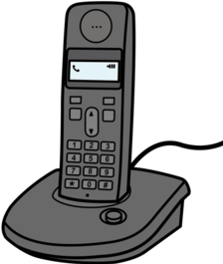

Call 0438 535 123. Ask for a copy.

**You can join WWDA**

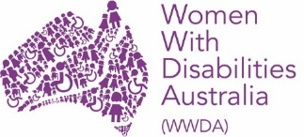



It is free.

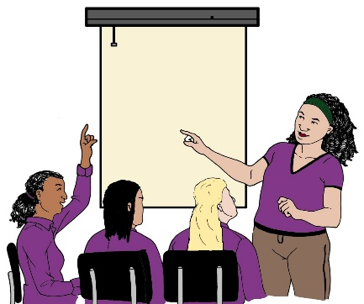You meet other women and girls with disability.

We tell government

* about women and girls with disability
* what needs to be better.

Like we are writing reports to the

Disability Royal Commission.

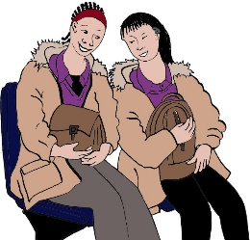We also help each other. Like

* find out about new groups we can join
* 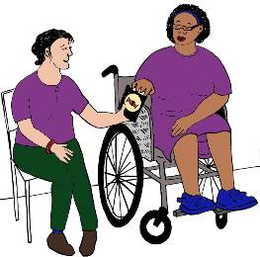make new friends
* find new ways to do things.

Go to www.wwda.org.au

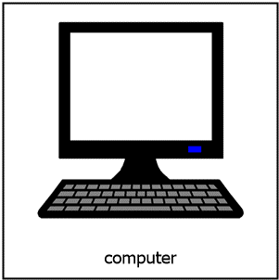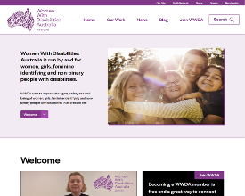

Find the button at the top called **Join WWDA**.

Every person has rights. Like the right



* to be safe from violence

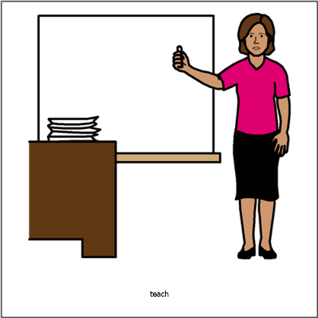

* to go to school



* to make your own choices.

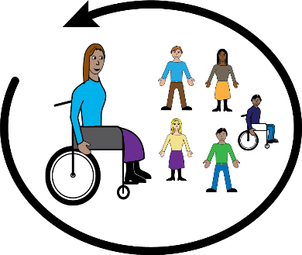

WWDA wants all

women and girls with disability to have the

same rightstoo.

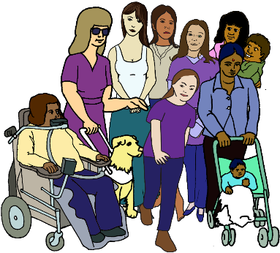Lots of women and girls have a disability.

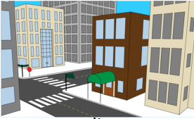We are all over Australia. We live in

* cities
* suburbs

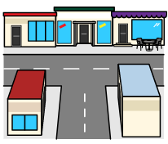

* 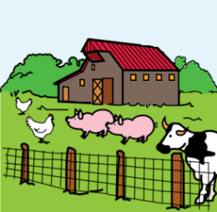big towns
* small towns
* farms
* 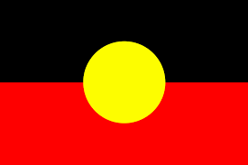in Aboriginal communities
* other places.

We work with other womens groups.

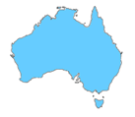

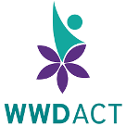They work in different places in Australia. Like

* WWDACT
* 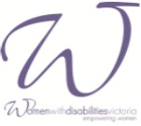Women With Disabilities Victoria
* Women With Disabilities WA.

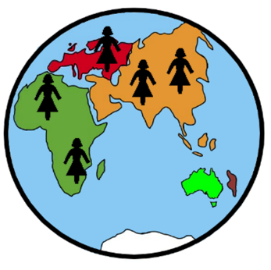

WWDA work with women around the world. Like

* USA
* UK.

We do work with the United Nations too.

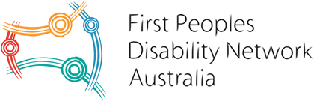We worked with

* First People’s Disability Network Australia
* National Ethnic Disability Alliance
* People with Disability Australia.

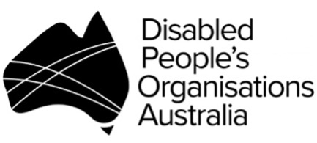We made

**Disabled People’s Organisations Australia**.

We write **DPO** to talk about us all.

The members of DPO work together.

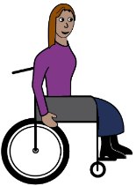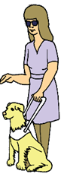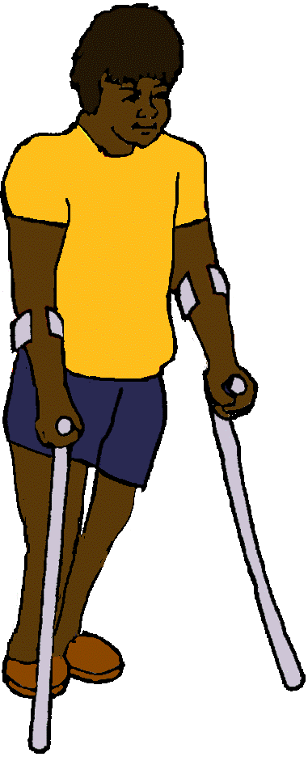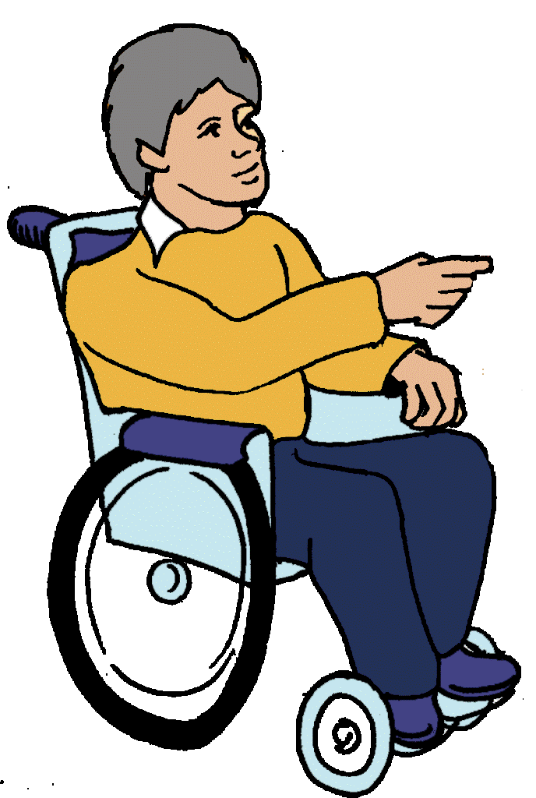

We all make sure all people with disability

have the same rightsas all other people.

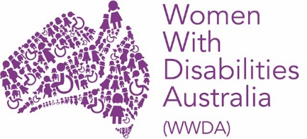**More information**

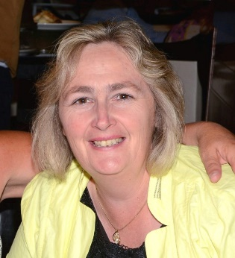

Talk to our office manager

Sharon Williams

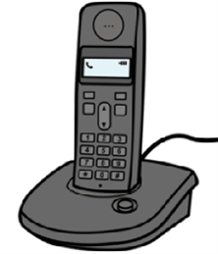



Call 0438 535 123.



Email officeadmin@wwda.org.au

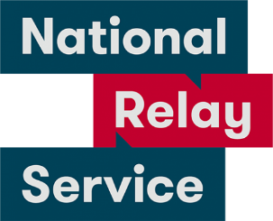National Relay Service

Call 1800 555 677.

Ask them to call 0438 535 123.

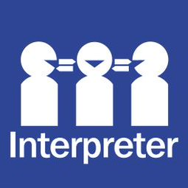

Translator

Call 131 450.

Ask them to call 0438 535 123.

Post

PO Box 407

Lenah Valley

Tasmania 7008.

This fact sheet is based on a page from the Women With Disabilities Australia Disability Royal Commission reports. 2020.

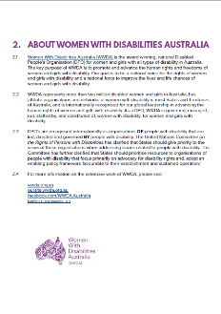

**Images**

We can use these images. They are from

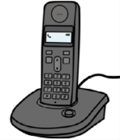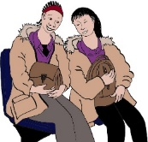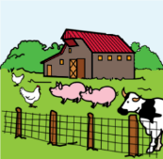

* ChangePeople
* EasyontheI
* InspiredServices
* Picto-Selector
* Spectronics
* TheNounProject
* Tobii-Dynavox.

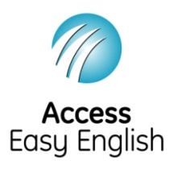Access Easy English wrote the Easy English.

July 2021.