Women with
Disabilities Australia
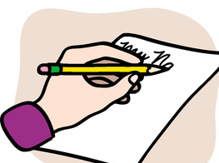

Story / Blog
Consent form

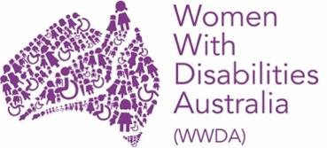

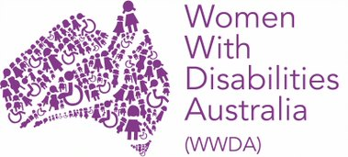
This form is for
Women With Disabilities Australia.
We will write WWDA when we talk about us.

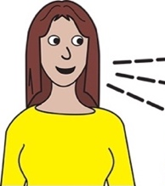
WWDA is collecting stories from women and girls with disability about leadership

This is part of a project called WWDA LEAD.

This form will help you
- learn about WWDA LEAD
- tell your story.
LEAD means

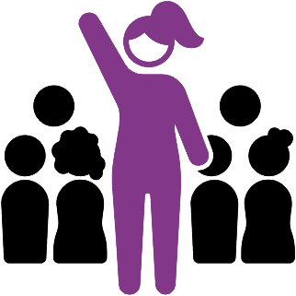
- lead
  - to be at the front

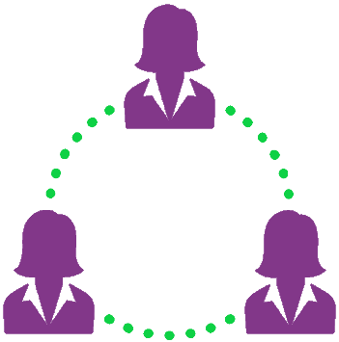
- engage
  - to talk to other people
  - to listen to other people

- activate
  - to start your ideas

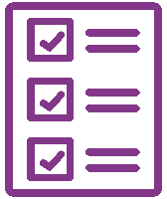
- drive.
  - to do your ideas.

The money for LEAD is from the
NDIS Information linkages and
capacity building program.

WWDA wants you to tell your story for WWDA LEAD.

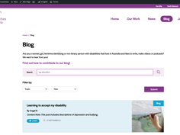
Your story will be put on our website.
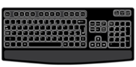
It will be on our Blog.

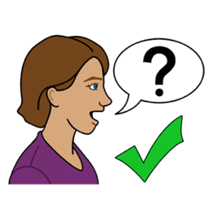
We would like to know if we can
use your story on our Blog.

You can tell us on this form.

Who can tell their story
To tell your story to WWDA you must be

- A woman

or

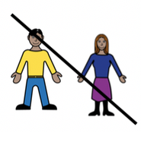
- non-binary person.

A non-binary person is someone who is not a man or a woman.

You must also
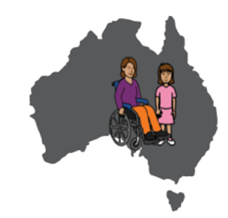
- live in Australia

- be over the age of 18
or
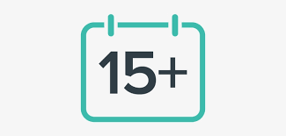
- over 15
- with the support of a parent or guardian

and

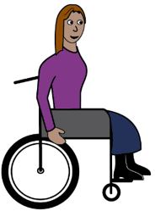
- be a person with disability.

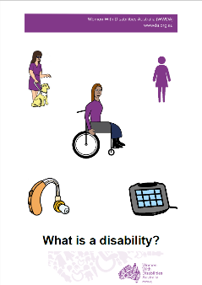
Learn about Disability
Do you think you have a disability?
Find out more. Read it in Easy English.

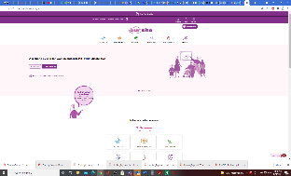
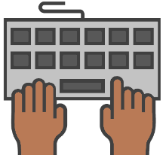
Go to www.oursite.wwda.org.au
Open the search window
Type WWDA Easy English Book.
What is a Disability?
or

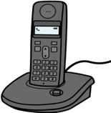
Call 0438 535 123. Ask for a copy.

How to tell your story

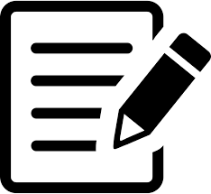
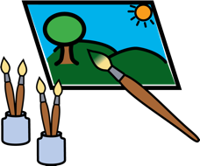
- You can
      - Write it down
      - Draw or paint picture
      - Make a video
      - Make an audio recording

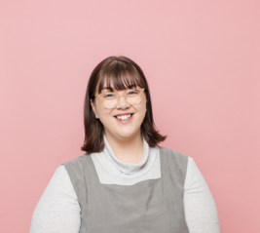
- Send us your story
  - email project@wwda.org.au

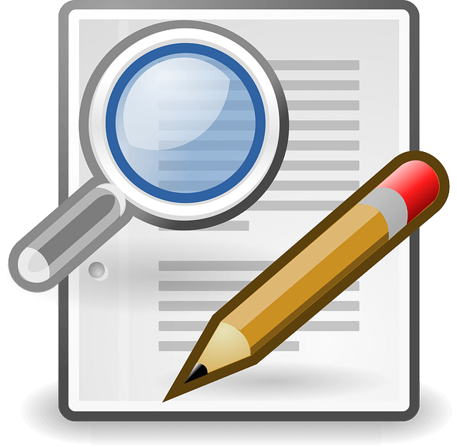

- We may edit the story

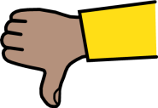
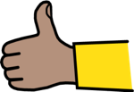
- We will see if you like the final story before we put it on the website.
The story must be yours

You can only submit a story that is your own.
This means you must have created the story.
Like you
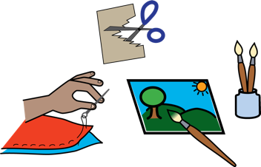
  - wrote the story
  - created the art work
  - made the video.

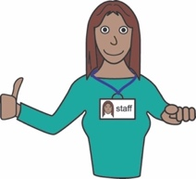
You can get someone to help you with your story.
Like
- a support worker
- a family member or friend.

But the story must be yours.
You cannot send us someone else’s story.
You must not discriminate in your story

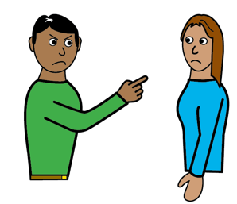
To discriminate means to treat someone badly or say something bad about someone because of something they cannot change.

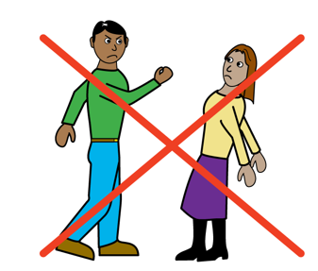
Your story must not discriminate.
This means you cannot say smoething bad about someone’s

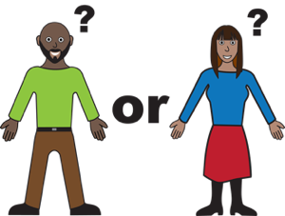
- gender

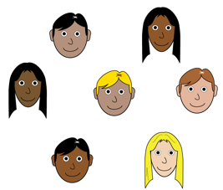
- race

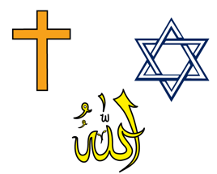
- religion
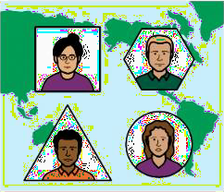
- ethnicity

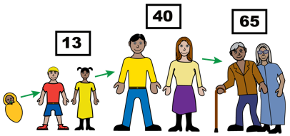
- age

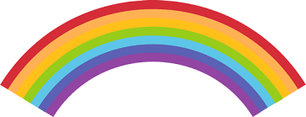
- sexuality

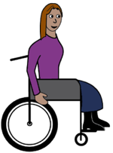
- disability

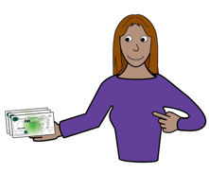
- income

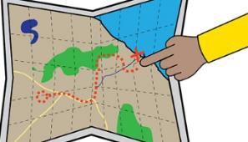
- location

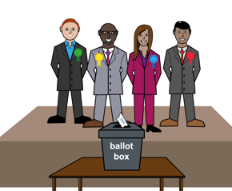
- political views.

After you send us your story
You will still own your story.

This includes

  - your writing

  - your photos

  - your videos

  - anything else you send us.

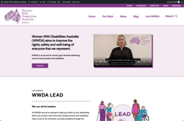
Where will your story go?
We will put your story on our website.
This means it can be seen by anyone.

You can tell us at any time if you decide you do not want your story on the website.

We would also like to use your story for other things.
Like
- newsletters
- social media

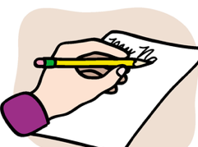
You can tell us if this is ok!
You can tell us on this form!

We will credit you for your work

We will tell people that you created your story.

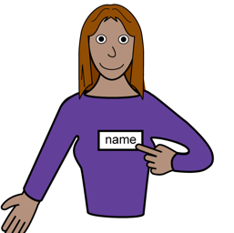
We can use
  - your real name
  - a made up name.

You can tell us on this form!

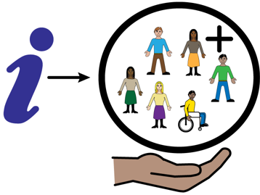
Your information will be kept safe

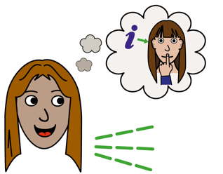
Your privacy is important.

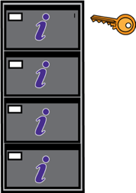
We will keep your information safe at WWDA.

We will not give your information away to anyone else.

How to fill out this form

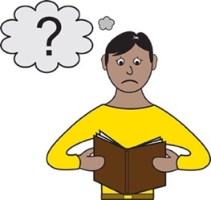

- Read the form.

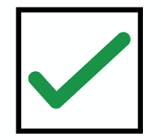
- Tick the boxes next to the things you agree with.

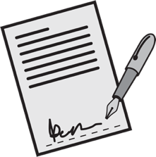

- Sign the form.

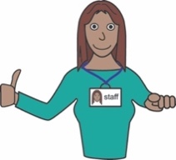
You can ask someone to help you fill out this form.
Like
- a support worker
- a family member or friend.
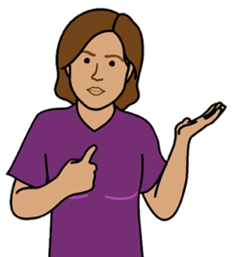
About you

My name is

I was born on
Write the day / month / year

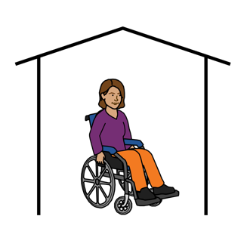
I live at
Write your home address.

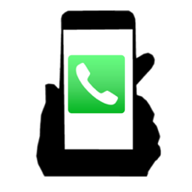
My phone number is

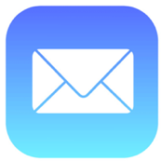
My email address is

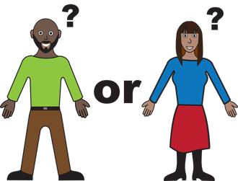
My gender is
Woman

Non-Binary

Other:
_______________________________________

I am happy to have my story
on the WWDA Blog

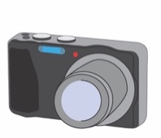
I am happy for WWDA to

use my photos.

I would like WWDA to use my:

- full name

- first name only

- a made-up name:
_______________________________________

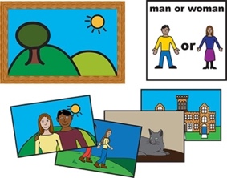
WWDA can also use my story and photos
on social media sites.
Like

- Facebook

- Twitter

- Instagram

In an email newsletter.

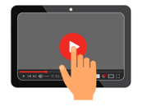
I understand that once my story is on

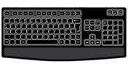
the internet it can be seen by anyone.
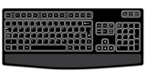
I understand I can change my mind
about my story being on the
internet at any time

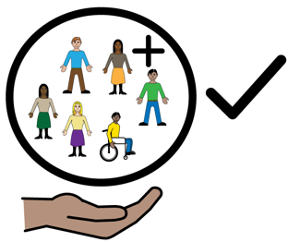

I understand that WWDA will not
give my information to anyone else.

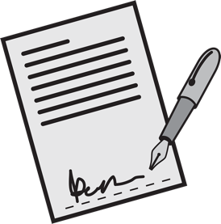
Sign your name here:

__________________________________

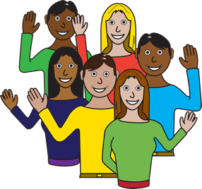
Thank you for your time!

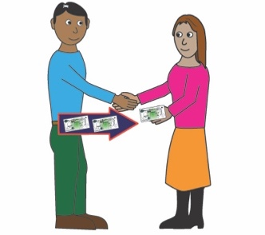
We will give you Vouchers as a payment for sharing your story.

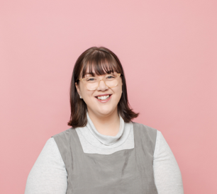
If you have any questions you can
contact Mali
- Email project@wwda.org.au

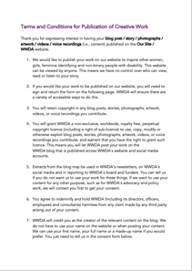
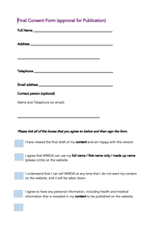
This Form
This form is an Easy English summary of WWDA’s Terms and Conditions for Publication of Creative Work 2021 and WWDA’s Final Consent Form (approval for Publication) 2021.
Who wrote this form?
Women with Disabilities Australia wrote this book in 2019-2021. This book is for general education and information only.
Copyright
© Copyright Women with Disabilities Australia (WWDA) Inc. 2021. All intellectual property rights, including copyright and patents, in this book is owned and licensed by Women with Disabilities Australia Inc.

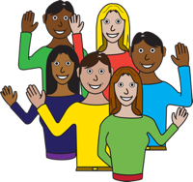
Images
We can use these images. They are from
- EasyontheI
- Google images
- Picto-Selector
- TheNounProject.

