WWDA Youth Network

Report from the United Nations Generation Equality Forum
March 2021

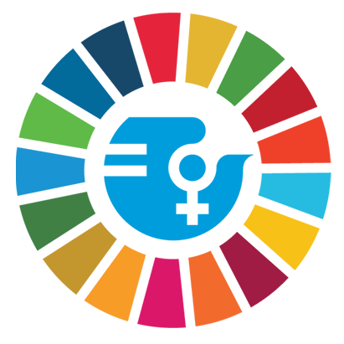

Prepared by: Margherita Dall’Occo
WWDA Youth Advisory Group member.

The UN Generation Equality Forum occurred during the weekend of the 29th of March, all through online platforms. Personally, the experience was enlightening in terms of content, and I was able to connect with a large network of people fighting for various issues around the globe.
The content in of itself had a particularly wide scope. I heard about experiences from women in war torn and developing countries, as well as people from the developed countries.
Coincidentally, I noticed that there were similarities with how women were being treated around the world. I heard from a few Australian First Nations women who spoke of their economic exploitation here, and it compared to the economic exploitation of women in Mexico and India. Similarly, on a panel which had discussed economic problems for queer people, I felt many countries shared the same problems. Although some were more extreme, it seemed there were common threads of non acceptance experienced by queer people.
This brought about the conversation of disabled women particularly. As I attended representing WWDA, I tried to ask questions to different panelists on how they thought disabled women were affected.. How we should include disabled women.. What was their plan for disabled women? Although all the panelists had strong responses to this, I always had to ask. In asking, I discovered that disabled women in developing countries had unique challenges that even I had not necessarily been aware of. Some panelists spoke about having services for these women and how global issues are amplified for disabled women and their families.

In this sense, the content of the forum was valuable. It helped me, and hopefully others, understand how disability affects different people in different ways, and how one's life can be particularly important to how they shoulder the struggle.

On the other hand, the accessibility of the forum was poor and I saw few or no disabled speakers, or disability specific panels, exhibitions or any other information.
I understand not every single group is able to have information displayed or a panel, however there was an ‘Exhibition Hall’ with various groups showcasing their work. Here, a disability focused group would have been valuable.
Furthermore, the accessibility was poor. I spoke with a few other disabled women attending, particularly those who had organised the Inclusive Generation Equality Collective which some WWDA Youth members endorsed. In speaking with these members, as well as other members of the YAC, it was clear that accessibility was an afterthought. Although they had translations for four languages, they only had International Sign. From what I’ve heard, International sign is often used at conferences but is not widely known, especially to young people who may not often go to conferences. Furthermore, there was no captioning for the exhibition halls and the virtual halls themselves were incredibly convoluted and complicated. I heard from others that some disabled women had been unable to attend due to the lack of accessibility.
Overall, there were many wonderful and admirable speakers who were able to give unique perspectives on a series of issues, but accessibility and disabled women in terms of the organised elements of the forum seemed to be overlooked.

