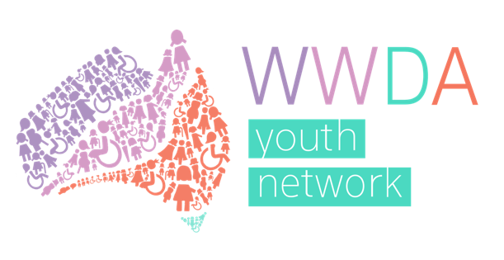

Women With Disabilities Australia
Youth Advisory Group

Terms of Reference

Easy Read version
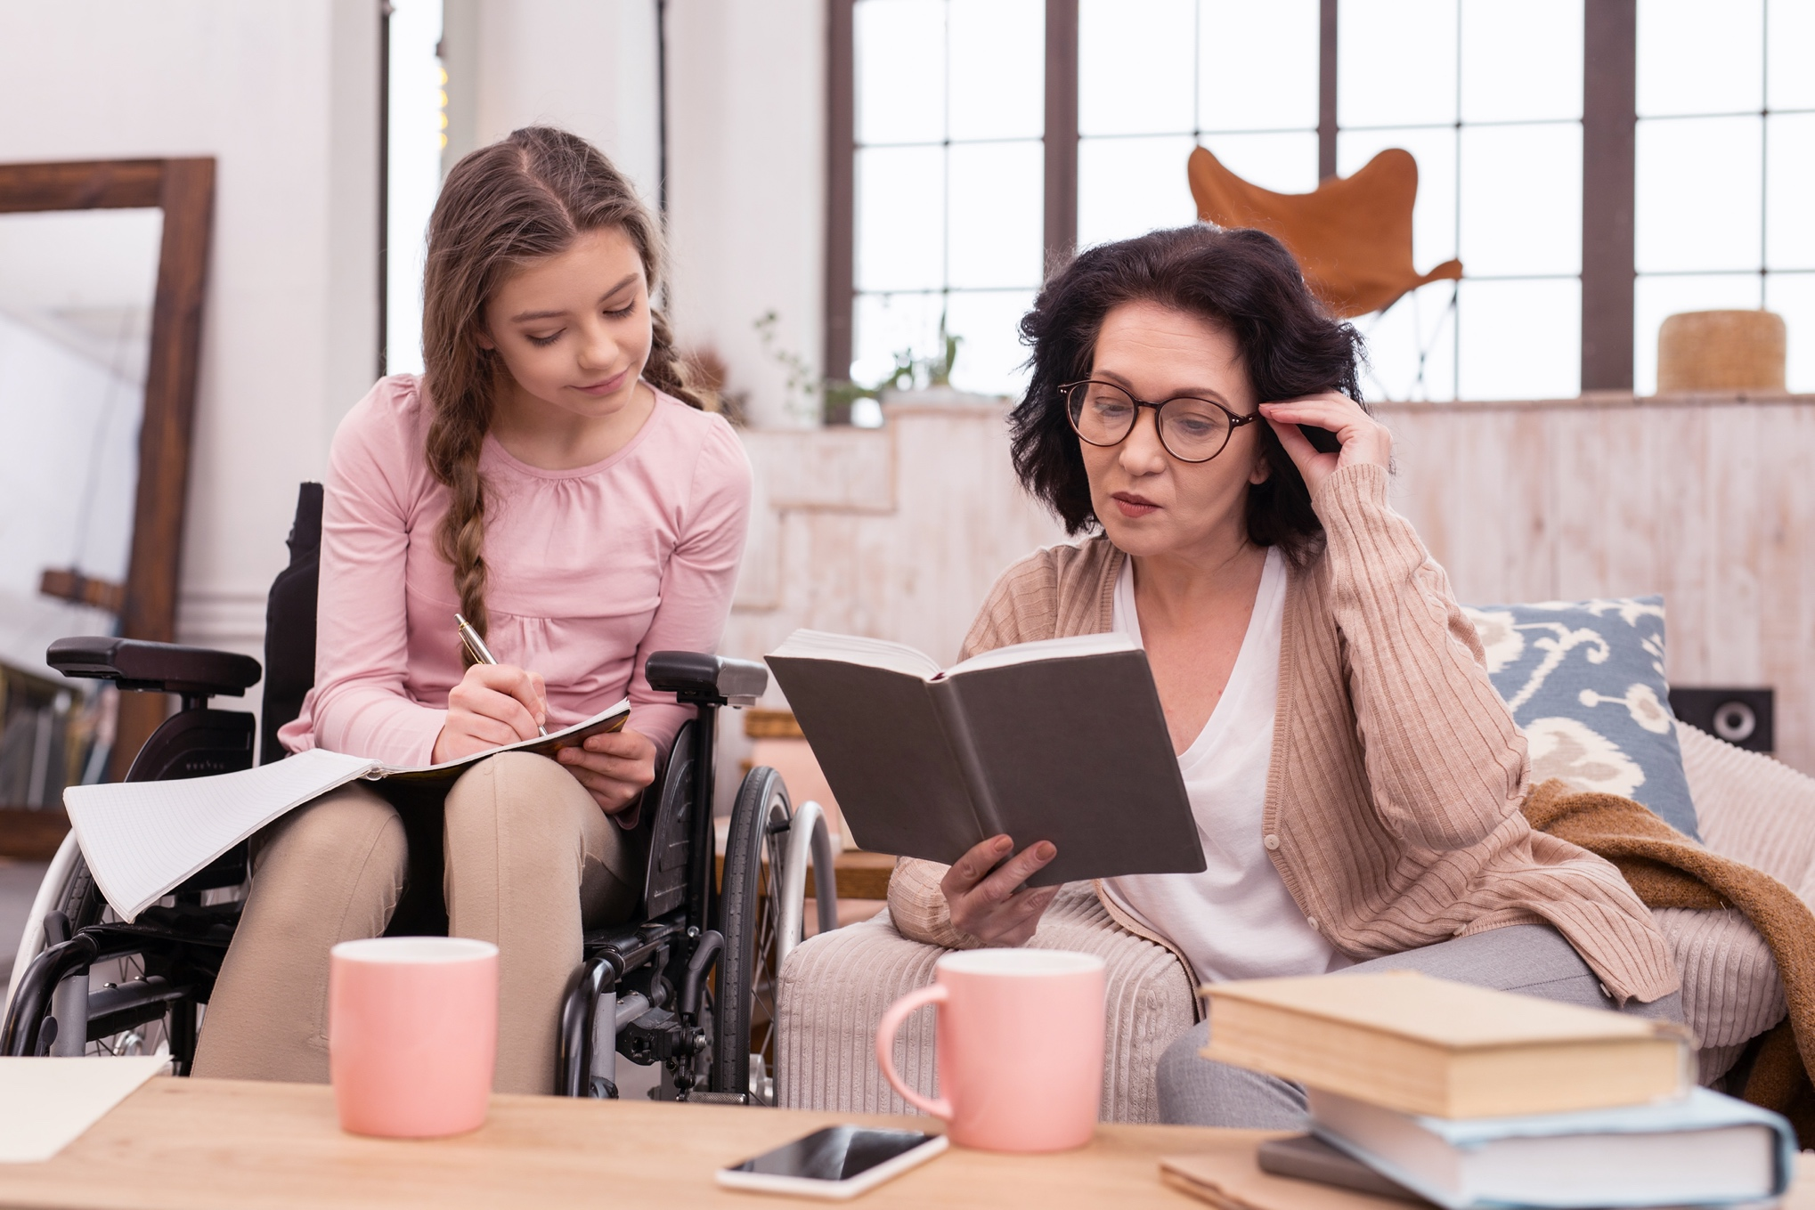

About this document

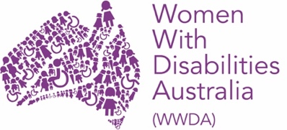
We are Women With Disabilities Australia. We will write WWDA when we talk about us.

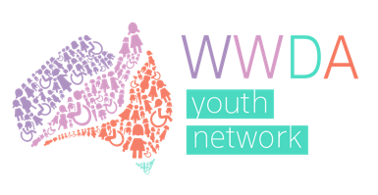
This document is a summary of the WWDA Youth Advisory Group Terms of Reference.
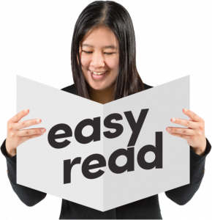
This document is written in an easy to read way.
We have written some words in bold.
We explain these words at the end of the document.

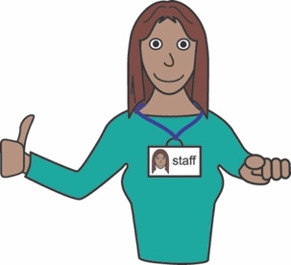
You can ask for help to read this document.
A support person may be able to help

What’s in this document?

About this document 2

About WWDA 4
About the WWDA Youth Network 5

About the WWDA Youth Advisory Group 7

Meetings of the WWDA Youth Advisory Group 9

Support and pay 10

Word list 11

Thank you 15

About WWDA

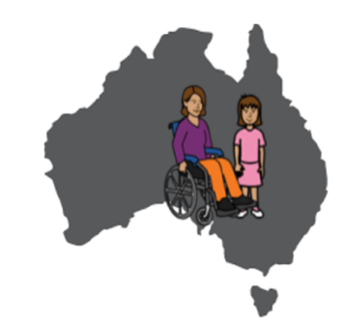
WWDA is for:
- all women and girls who have a disability, and;
- who live in Australia.

WWDA is:
- run by women with disability
- for women and girls with disability.

WWDA helps all women and girls with disability have good lives.

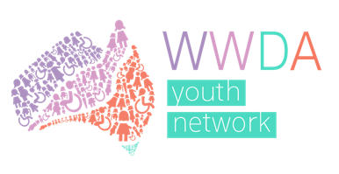
About the WWDA Youth Network

The WWDA Youth Network is a group for young women, girls, feminine identifying and non-binary young people who:
- are under 30
- have a disability.
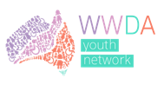
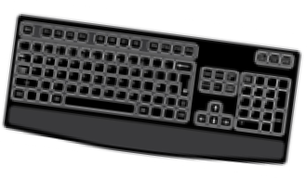
The WWDA Youth Network has
- a website: http://youth.wwda.org.au
- a Facebook: www.facebook.com/WWDAyouth
- a Twitter: twitter.com/wwda_youth
- an Instagram: www.instagram.com/wwda_youth

The WWDA Youth Network supports young women and girls with disability have good lives.

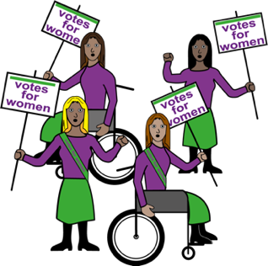
The WWDA Youth Network supports young women and girls with disability to take part in things like:
- education
- politics
- the community.

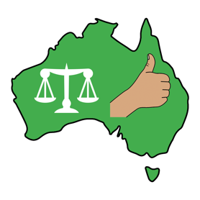
The WWDA Youth Network does things to support young women and girls with disability in Australia. Like:
- talk to government about what young women and girls with disability need
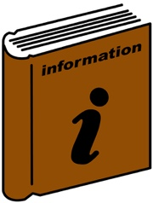
- give information to young women and girls with disability

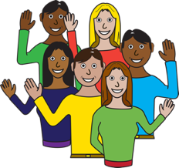
- run events for young women with disability.

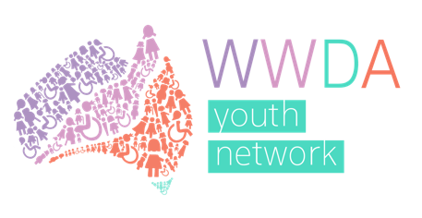
About the WWDA Youth Advisory Group
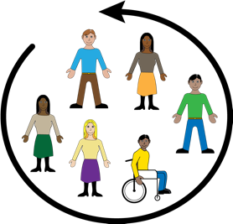
WWDA is starting a WWDA Youth Advisory group.

The WWDA Youth Advisory group will:

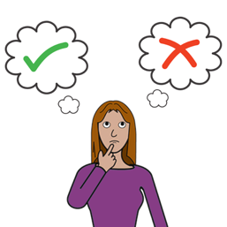
- tell WWDA what they want and need
- make decisions about the WWDA Youth Network
- help make resources for the
WWDA Youth Network website

- help with the WWDA Youth Network social media pages on:
-Facebook
-Instagram
-Twitter.
The WWDA Youth Advisory Group will include up to 15 members who:
- are young women, feminine identifying or non-binary people
- have any type of disability
- are between the ages of 15 and 30.

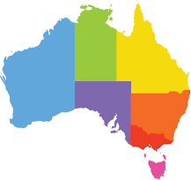
Members of the Advisory Group will include:
- young women with disability from different states and places in Australia

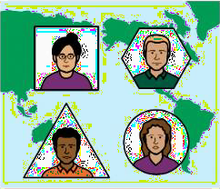
- young women with disability from migrant or refugee backgrounds.
- LGBTIQA+ young women with disability

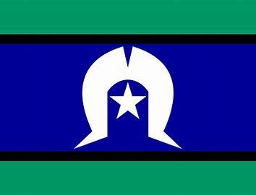
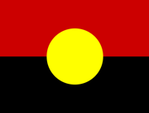
- at least 3 Aboriginal or Torres Strait Islander young women with disability.

Meetings of the WWDA Youth Advisory Group
The WWDA Youth Advisory group will have meetings:
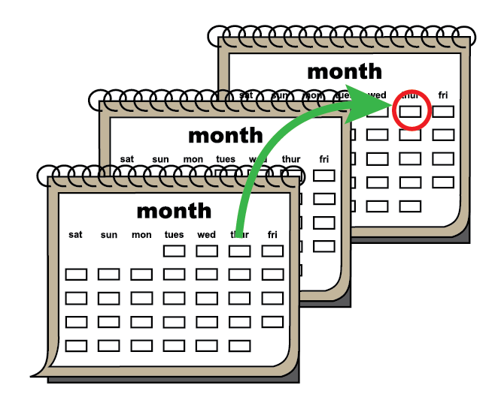
- 6 times
- every second month
- for a year

Meetings will be held on zoom.
Zoom is a program that allows you to run or join a meeting online.

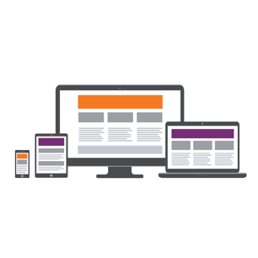
Zoom can be used on:
- a computer or laptop
- a smart phone
- on a tablet or iPad.

Support and Pay
WWDA staff will support members of the WWDA Youth Advisory Group by:
- take part in meetings
- run events
- talk to government.

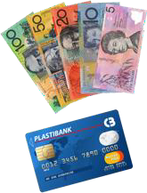
WWDA Youth Advisory Group members will be paid
$100 for each meeting:
- as a gift card or
- by invoice.

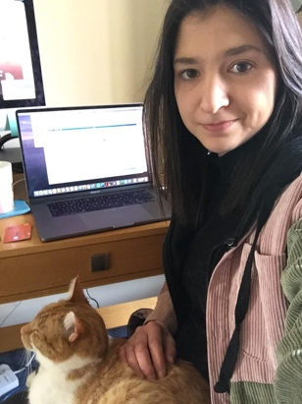
Any questions?
Contact our Project Officer, Heidi:
- email po@wwda.org.au
- call 0448 417 850

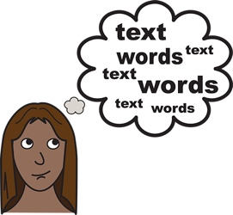
Word list
Non-Binary
Non-Binary is what we call the gender of people who do not identify as male or female.

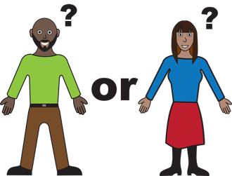
Gender
Your gender It is about how you see yourself or how you identify Like you can identify as a man or woman.

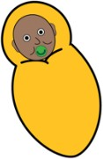
Migrant or Refugee
A migrant or Refugee s someone who lives in a different country to where they were born.

Zoom
A program that allows you to run or join a meeting online.

Invoice
A document with information about money that needs to be paid to a person or organisation.

LGBTIQA+
LGBTIQA+ means diverse sexualities and genders. The letters in LGBTIQA+ stand for Lesbian, Gay, Bisexual, Transgender, Intersex, Queer and Asexual. We explain these words on the following pages.

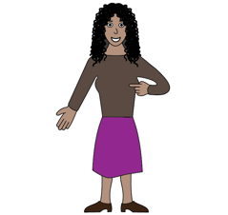
Lesbian
A woman who has romantic feelings for other women.

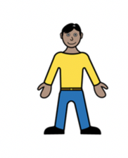
Gay
A man who has romantic feelings for other men.

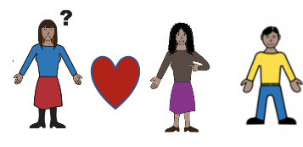
Bisexual
A person who has romantic feelings for more than one gender.

Transgender – a person whose gender does not match the sex they were given at birth. For example, a person who is a woman, but was born male is transgender.

Intersex
A person whose body is not male or female.

Queer
Another word used to talk about the LGBTIQA+ community.

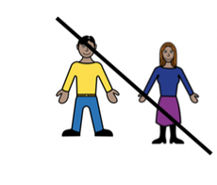
Asexual
A person that does not have sexual feelings for other people.

Thank you

Who wrote this document?
Women with Disabilities Australia wrote this document in 2020. This document is for information purposes only.

Copyright
© Copyright
Women with Disabilities Australia (WWDA) Inc. 2020.

All intellectual property rights, including copyright and patents, in this book is owned and licensed by Women with Disabilities Australia Inc.

The images used in this document
Easy on the I Images © 2018 Leeds and York Partnership NHS Foundation Trust. Used with permission. www.easyonthei.nhs.uk

