Women With Disabilities Australia

wwda.org.au

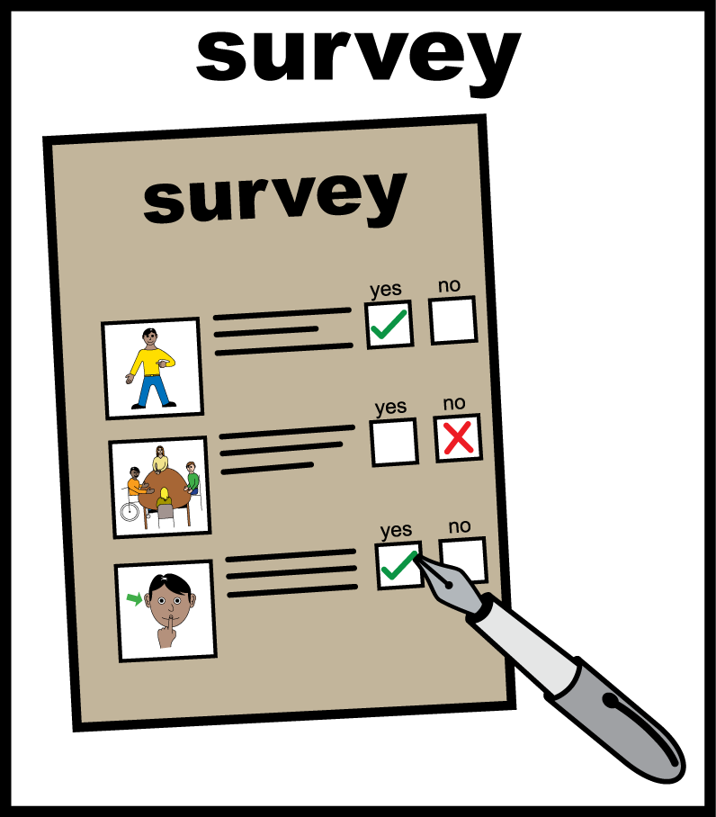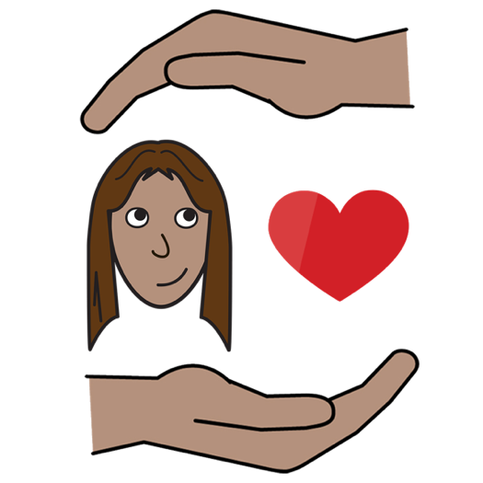**WWDA Youth   
Survey on Your Period and Safer Sex**

**About the questions**

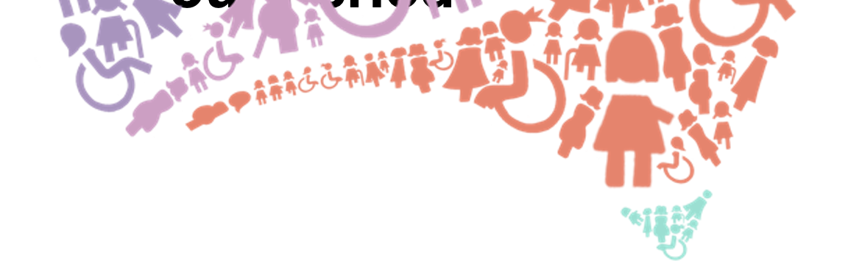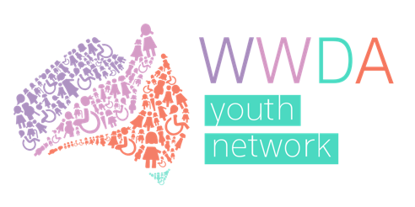

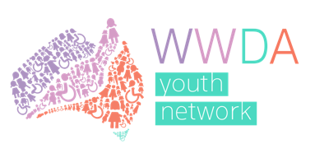**About Us**

We are WWDA Youth.

**WWDA** means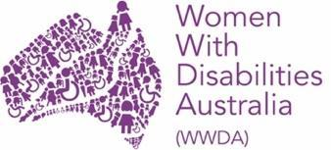

**Women With Disabilities Australia.**

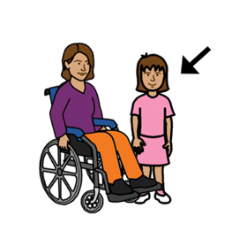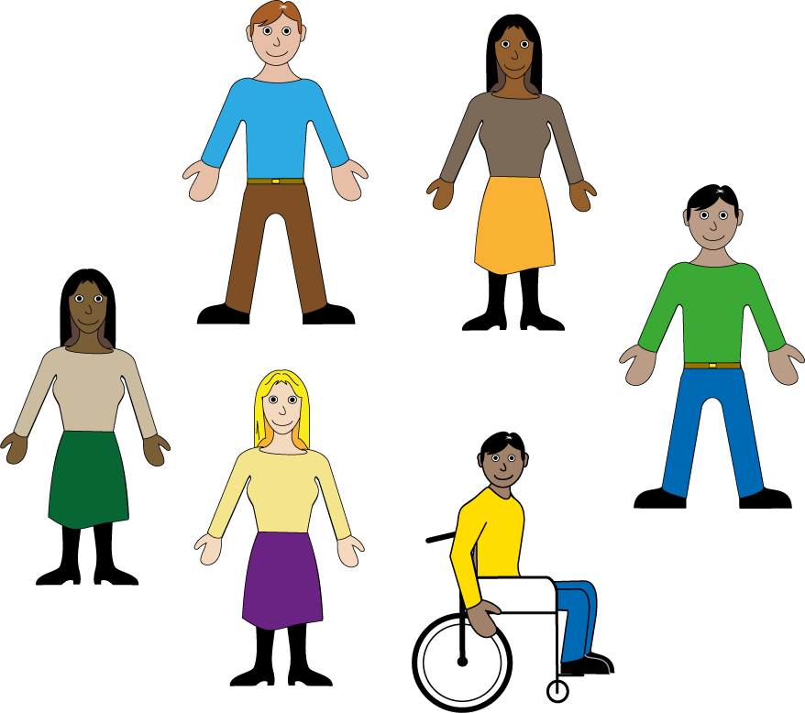

WWDA is the national disability organisation for women and girls with disability.

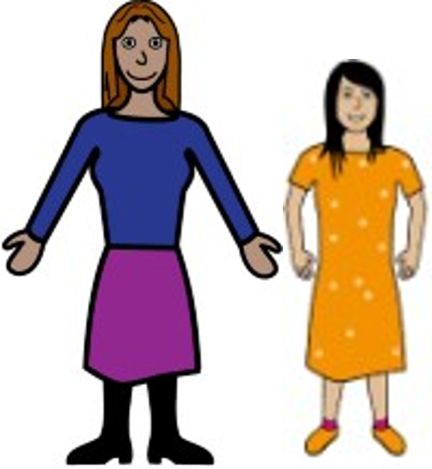

WWDA Youth is for women, girls and non-binary young people with disability aged 15-30.

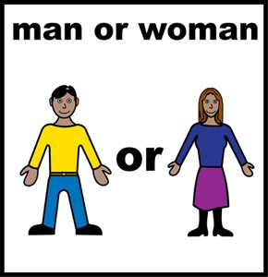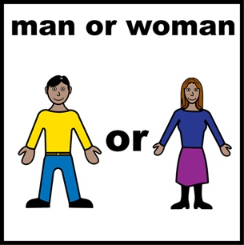**Non-binary** means you are

* not a man
* or a woman.

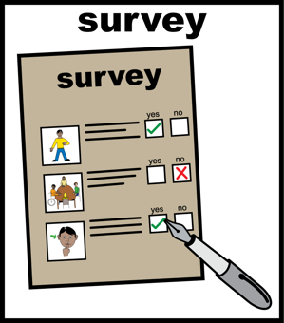WWDA Youth are doing a survey.  
We want to know what you think.

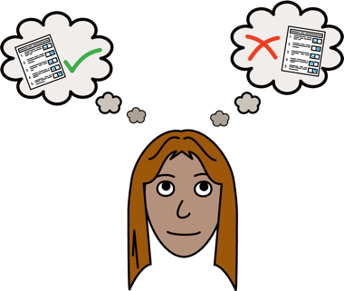

You can answer some of the questions

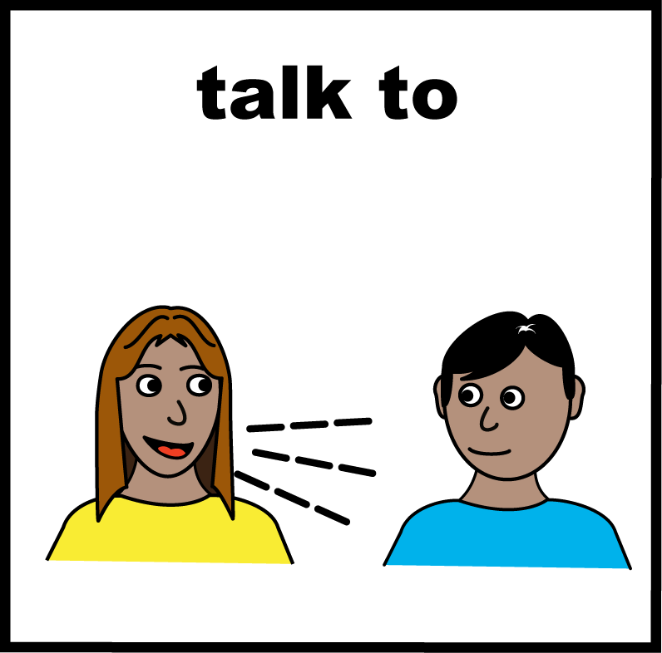Or all of them.

Your views are important.

**About the survey**

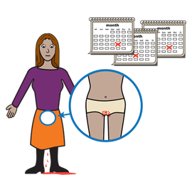

The survey is about **your period**.

Your period is when you bleed from yourvagina or uterus.

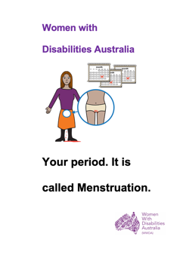Learn more about **your period**.   
Read it in Easy English.

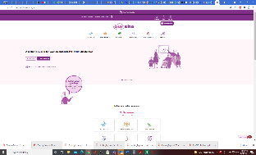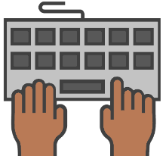

Go to **www.oursite.wwda.org.au**

Open the search window

Type **WWDA Easy English Book.**

**Your period.**

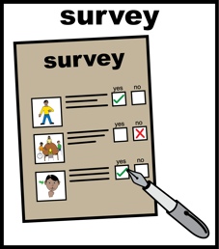**About the survey**

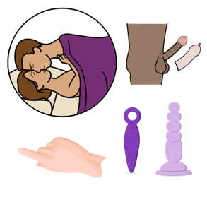

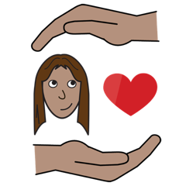

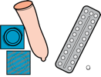The survey is also about safer sex and contraception

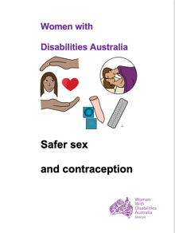

Learn about safer sex and contraception.  
Read it in Easy English.



Go to **www.oursite.wwda.org.au**

Open the search window

Type **WWDA Easy English Book.**

**Safer Sex and Contraception**

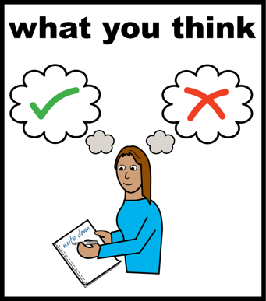What you say helps WWDA learn about what you know about

* periods

and

* safer sex.



We also want your ideas.

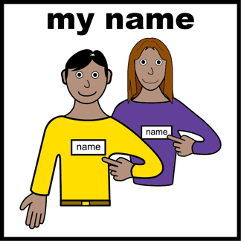

You do **not** write your name in the questions.



What you say will be kept private.

This means we cannot link your answers to you.

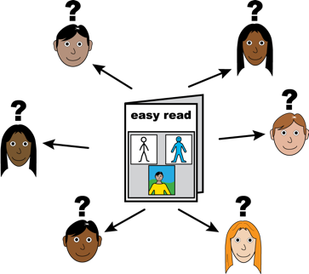**Who can do the survey?**

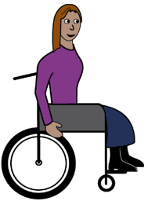

The survey is for

Young people with disability

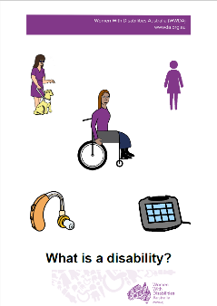Do you think you have a disability?

Find out more. Read it in Easy English.



Go to **www.oursite.wwda.org.au**

Open the search window

Type **WWDA Easy English Book.**

**What is a Disability?**

The young people who do this survey should also be



* young women
* girls

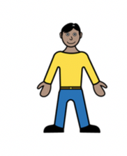

* 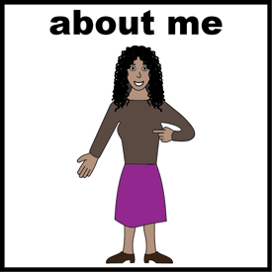young people who see themselves as women  
  or
* have similar lives to women.

and

* 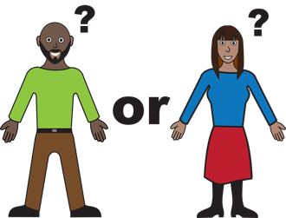**non-binary** young people

Non-Binary means people who see themselves as

* **not** a man

**and**

* **not** a woman.

**Dates to know about**

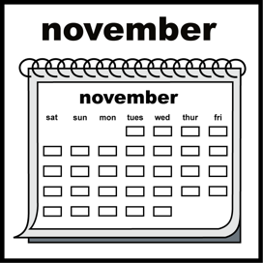

****The survey opens on **Friday 12 November 2021.**

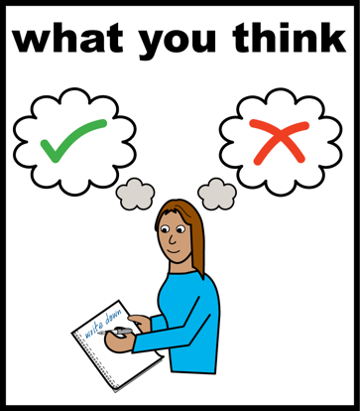

You can tell us what you think.

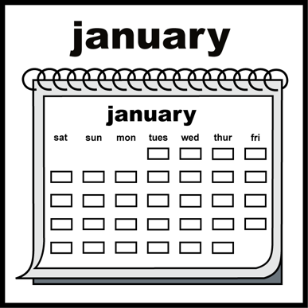



Tell us before **Monday 10 January 2022**.

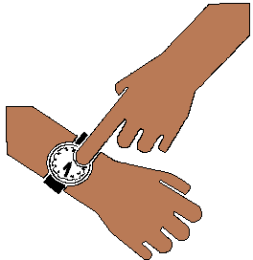**How long is the survey**

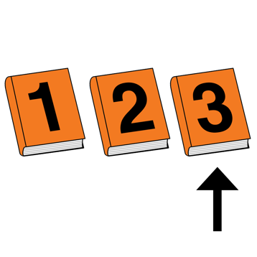

The survey will be in 3 parts.

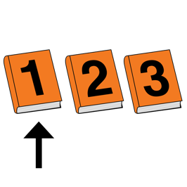

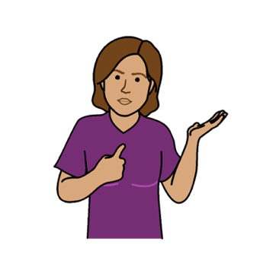

Part 1 is **about you.**

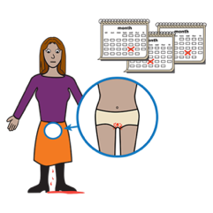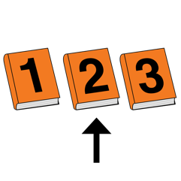

Part 2 is about **your period.**

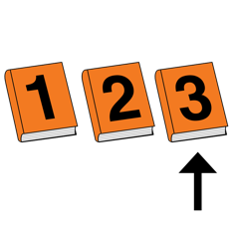

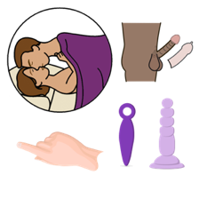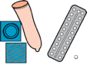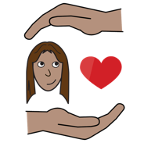

Part 3 is about **safer sex** and **contraception.**

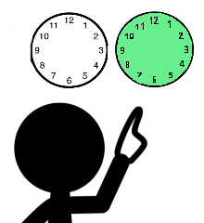  
You do not have to do all parts at once.

You can do some now.

You can do more later.

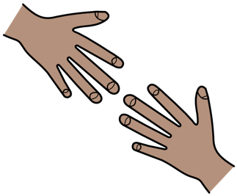**You Need Help**

You can ask for help to do the survey.

You can ask someone you trust. Like

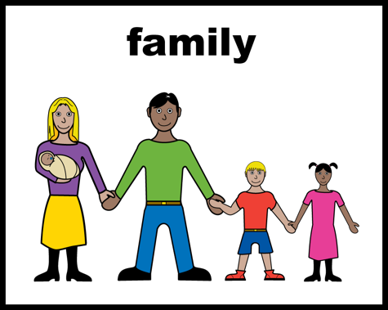

* a family member

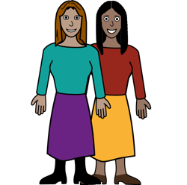

* a friend
* 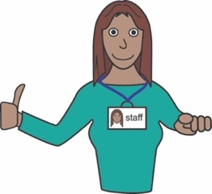a support worker
* a carer

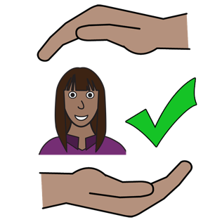**You do not feel safe**

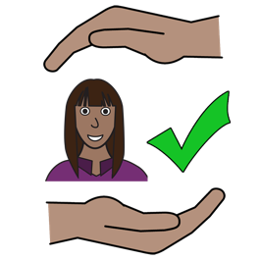

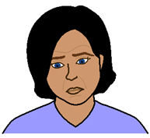You want to tell us what you think.

**But**

you do **not** feel safe.

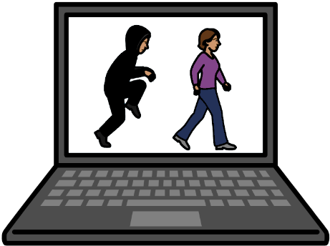

Like

A person checks what you do online.



It is **not** safe to do the questions now.

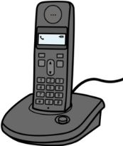Talk to WWDA.

Call **0448 417 850**



You are in danger now.

Like a person wants to hurt you.

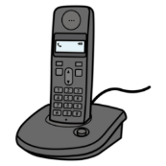

Call **000**.

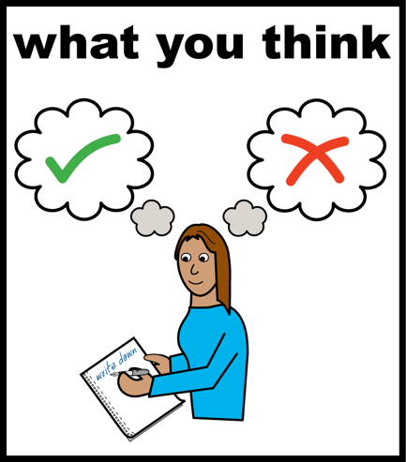**How do you do the questions?**

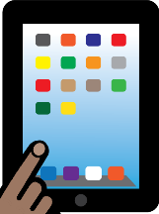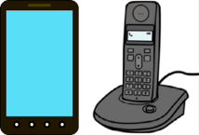

The questions are on the WWDA website.

You do them on a

* computer
* tablet
* smart phone.



Go to [**www.wwda.org.au**](http://www.wwda.org.au)

# Type **WWDA Youth Survey** in the search window.

You can **not** use the computer.

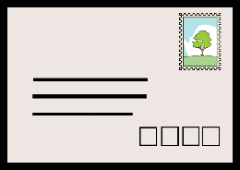

Ask for a copy in the mail.

Call Heidi **0448 417 850**.

**or**

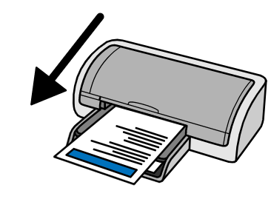

Ask a person to print the questions out.

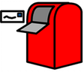Send back to

Women With Disabilities Australia   
PO Box 407  
Lenah Valley TAS 7008

**Questions**



Email Heidi at WWDA **director@wwda.org.au**

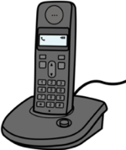

Call or text **0448 417 850**

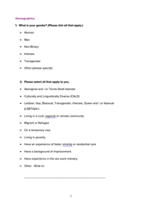**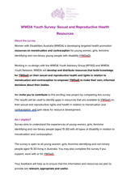This fact sheet**

# This fact sheet is based on the WWDA Youth Survey: Sexual and Reproductive Health Resources.

# **Who wrote this fact sheet?** Women With Disabilities Australia wrote this fact sheet in 2021. This book is for general education and information only.

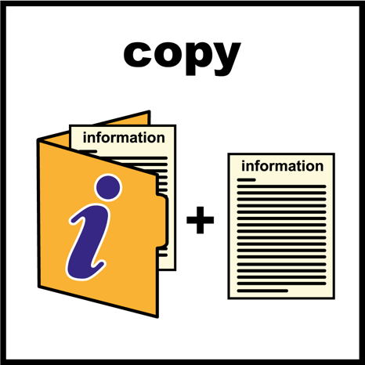  
**Copyright**   
© Copyright Women With Disabilities Australia (WWDA) Inc. 2021. All intellectual property rights, including copyright and patents, in this book is owned and licensed by Women With Disabilities Australia Inc.

**Images**

We have used images from

* ChangePeople
* ****COMPIC

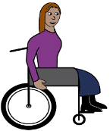

* EasyOnTheI
* InspiredServices
* Picto-Selector
* Spectronics
* TheNounProject