Women With Disabilities Australia

wwda.org.au

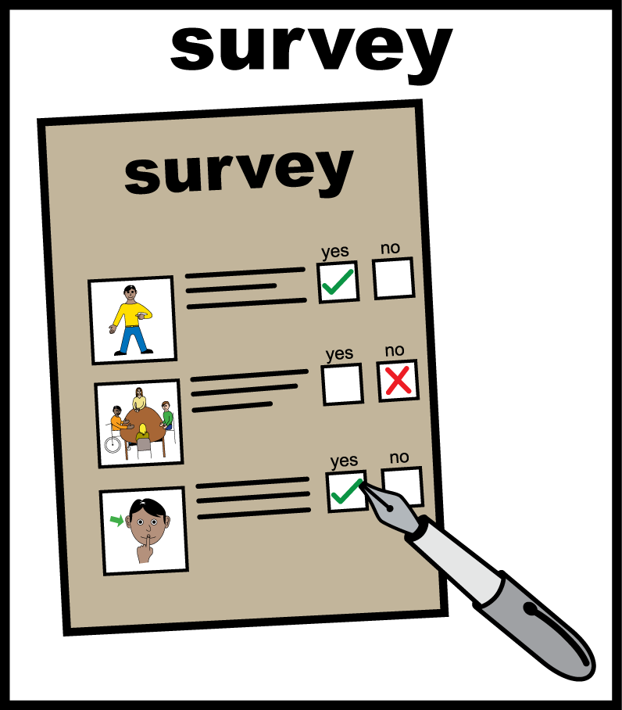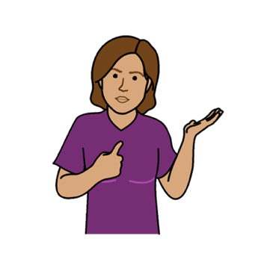**WWDA Youth Survey**

**Part 1.  
About You**

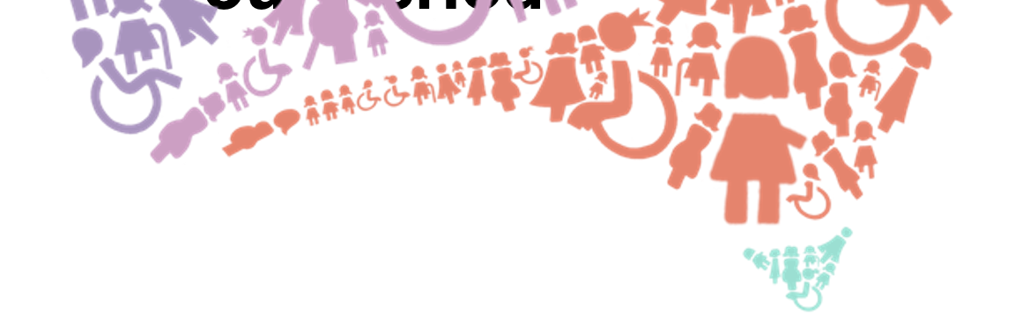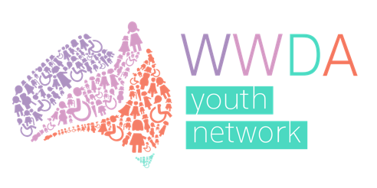

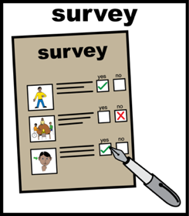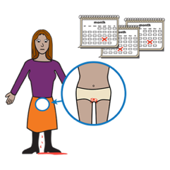**About Part 1**

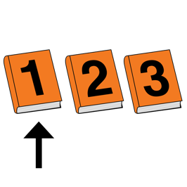  
This is **Part 1** of the WWDA Youth survey about your period and safer sex.



This part is **about you.**

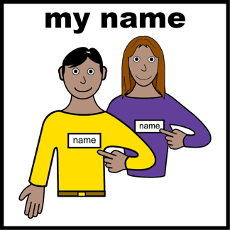

You do **not** write your name in the questions.



What you say will be kept private.

This means we cannot link your answers to you.

1. 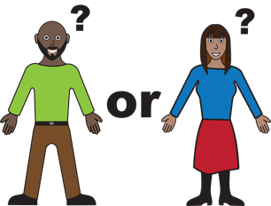**My gender is**

Tick any that are you.

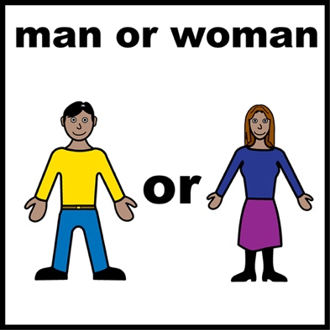

* male



* female

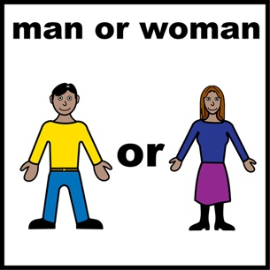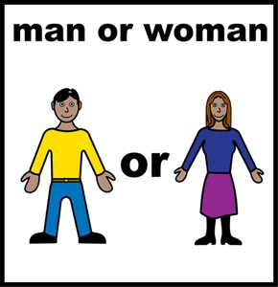

* non-binary

You are

* not a man
* or a woman.

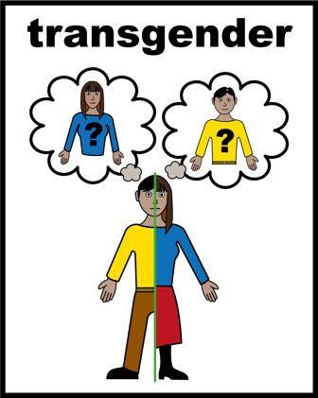

* transgender

You have changed your gender.

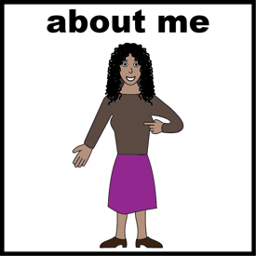

* feminine Identifying

You see yourself as a woman.



* other (tell us below)

1. **Tick any that are you.**

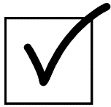

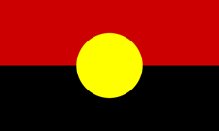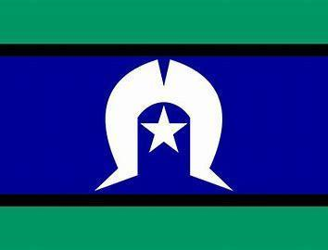

* Aboriginal or Torres Strait Islander



* lesbian, gay, bisexual, transgender,   
  intersex, queer or asexual (LGBTIQA+)

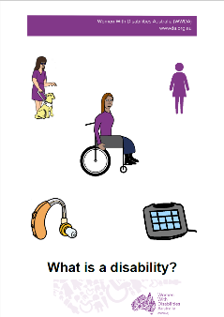Want to know **what Is LGBTIQA+?**

Find out more. Read it in Easy English.

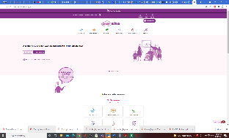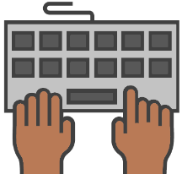

Go to **www.oursite.wwda.org.au**

Open the search window

Type **WWDA Easy English Book.**

**What is a LBTIQA+?**

* 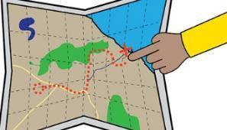rural, regional or remote

This means you are far from a big city.   
Like

* you live on a farm
* you live in the country.

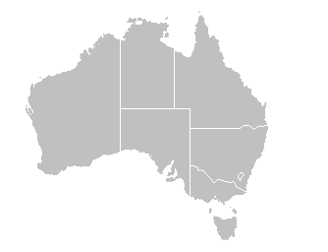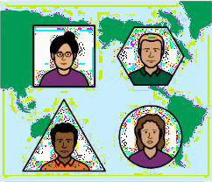

* migrant

This means you moved to Australia.  
You moved from a different country.

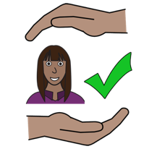

* refugee

You came to   
Australia to be safe.

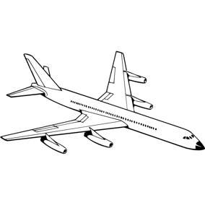

* on a temporary Visa   
  This means you are in Australia for a short time.   
  You will go back to your country.
* 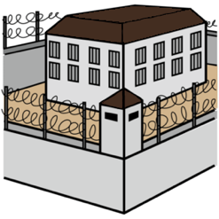you have been in jail

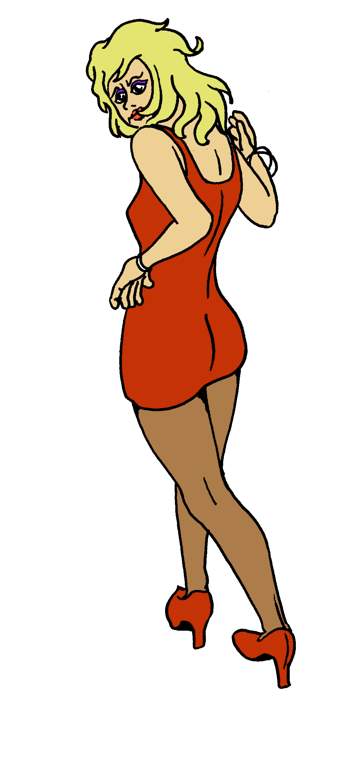

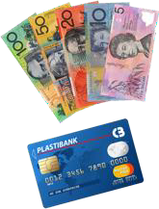

* you have done sex work
* 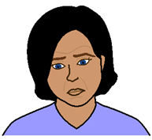you live in poverty

This means you don’t have much   
money for important things. Like

* food
* clothes
* medications.

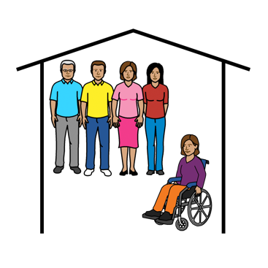

* you have lived somewhere without your family   
  Like
* in foster care
* in a group home for people with disability.

1. 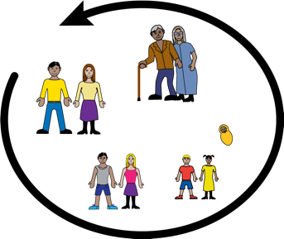**How old are you?**

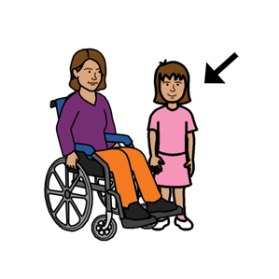

* Under 15

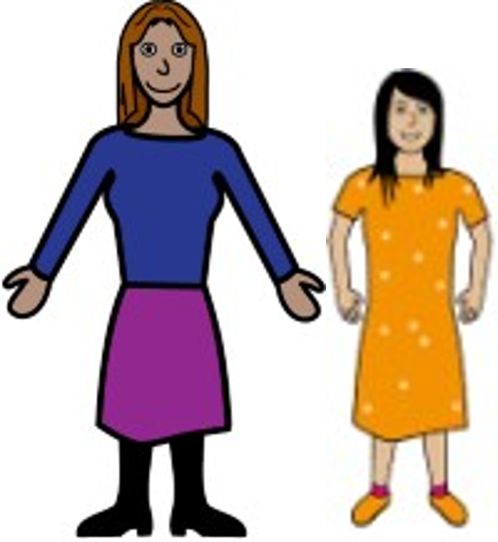

* 15 – 17

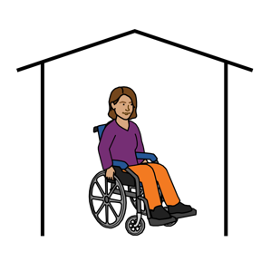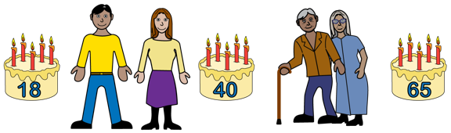

* 18 - 30

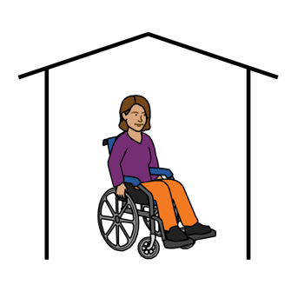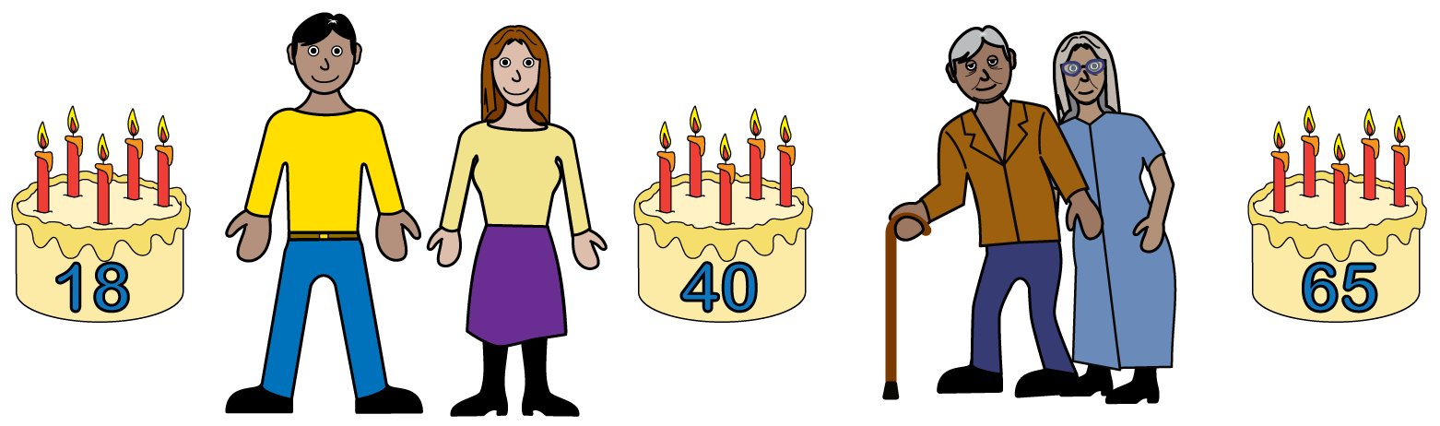

* 31-59

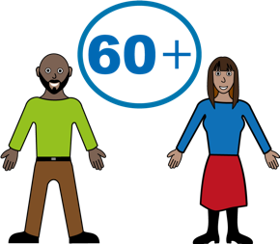

* Over 60

1. **What state or territory do you live in?**

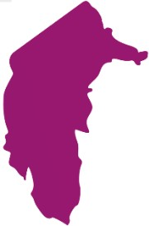

* Australian Capital Territory (ACT)

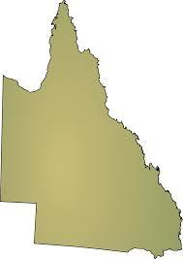

* Queensland (QLD)

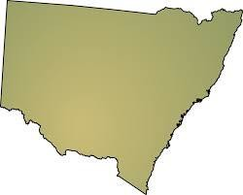

* New South Wales (NSW)

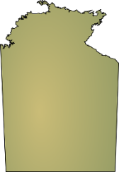

* Northern Territory (NT)

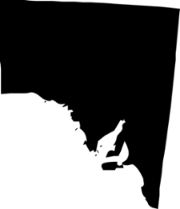

* South Australia (SA)

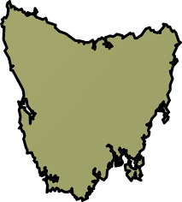

* Tasmania (TAS)

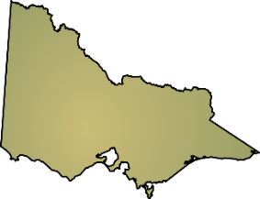

* Victoria (VIC)

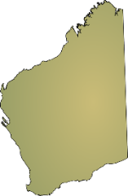

* Western Australia (WA)



* other (tell us)

*_______________________*

1. **Tick any that are you.**



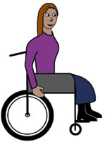

* a person with disability

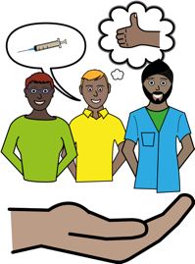

* a carer or family member of a young   
  person with disability

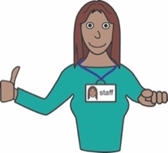

* a support worker

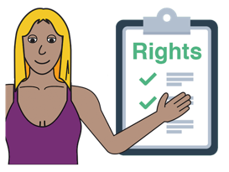

* a person who works in disability advocacy
  + - * + you support the rights of people with disability
* 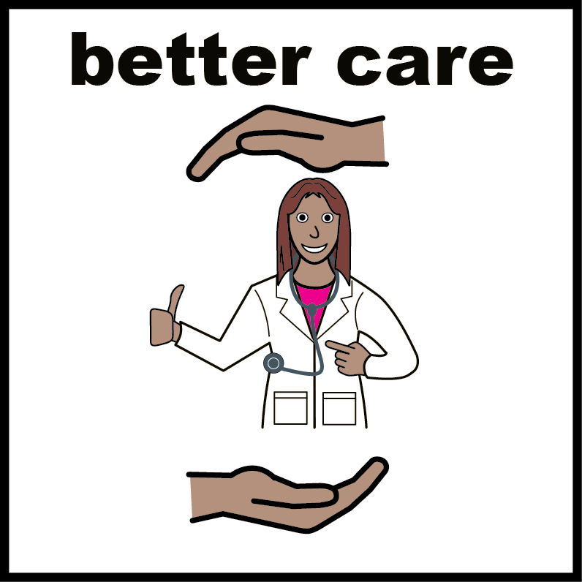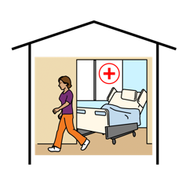a person who works in Health. Like
  + - * + at a hospital
        + as a doctor or nurse
* a person who works in women’s advocacy
  + - * + you support the rights of women

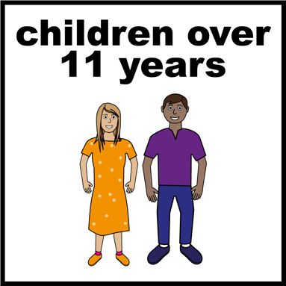

* a person who works in youth advocacy
  + - * + you support the rights of young people



* other (tell us below)

*______________________*

1. **Do you have a disability?  
   Tick any that you have.**

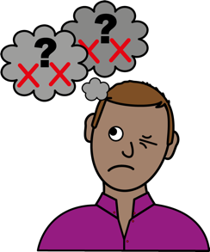

* intellectual disability

Like

* + - * + it is hard to think
        + you need support.
* 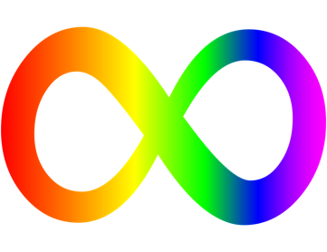neurodiverse  
  Like
  + - * + you are Autistic
        + you have ADHD.

* 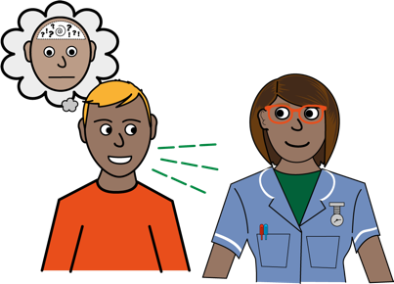psychosocial disability

Like

* + - * + you have schizophrenia
        + you have anxiety.
* 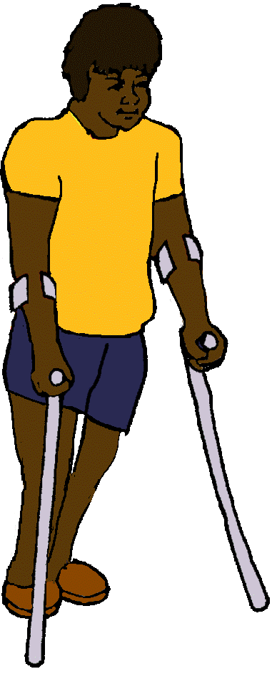physical disability

Like

- you use a wheelchair

- you use a walking stick or frame.

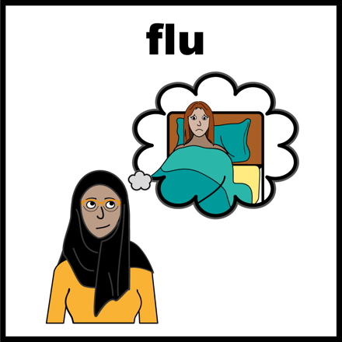

* chronic illness or medical condition

Like

* + - * + you have arthritis
        + you have endometriosis.

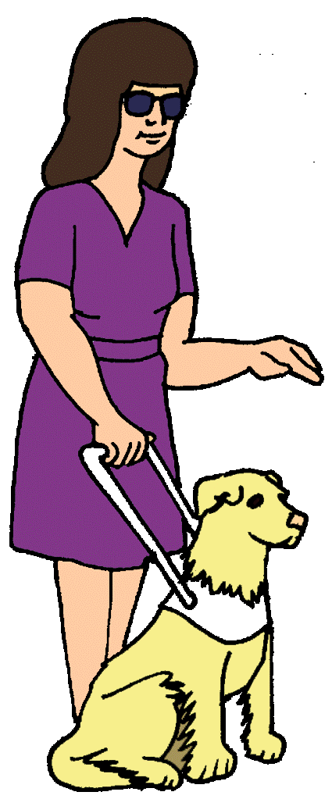

* blind or vision impaired
* 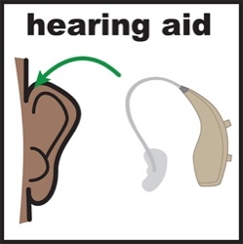D/deaf or hard of hearing



* other (tell us below)

*_______________________*

1. 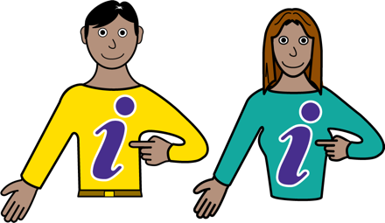**What type of information do you like best?**

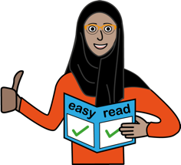

* Easy Read materials

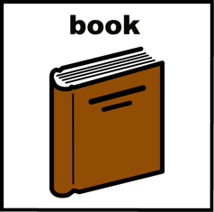

* books

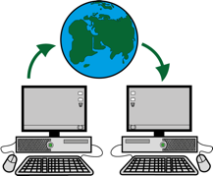

* website information

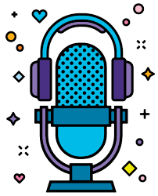

* podcasts



* videos

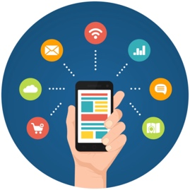

* phone Apps

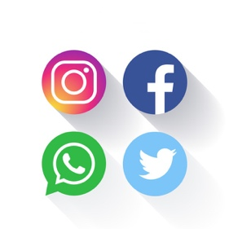

* information on social media



* information on TV



* word documents

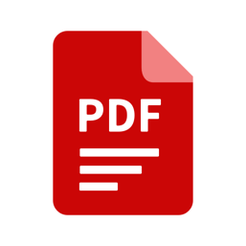

* PDF documents

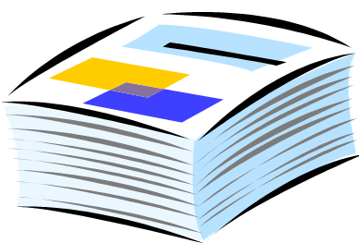

* printed flyers

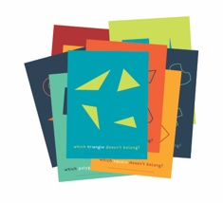

* posters



* information stalls



* other (tell us below)

*_______________________*

1. 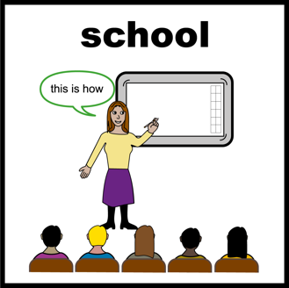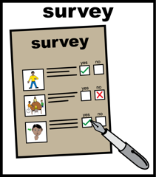**Where did you learn about this survey?**

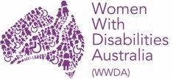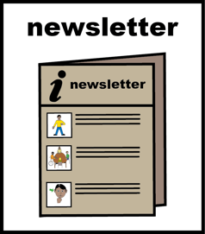

* WWDA Newsletter

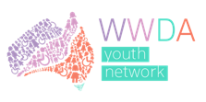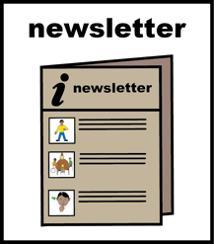

* WWDA Youth Newsletter

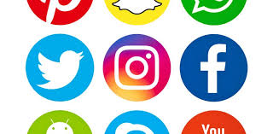

* Facebook



* Instagram



* Twitter

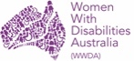

* WWDA website

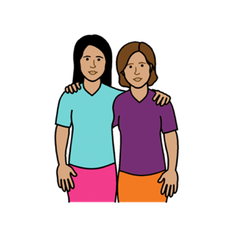

* a friend sent it to me

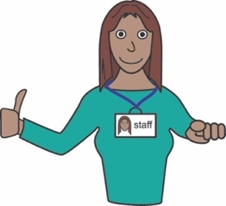

* a support person or service told me



* other (tell us below)

*______________________*

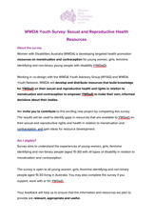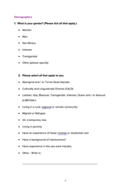**This survey**

# This survey is based on the WWDA Youth Survey: Sexual and Reproductive Health Resources. **Who wrote this survey?** Women With Disabilities Australia wrote this survey in 2021. 2021.

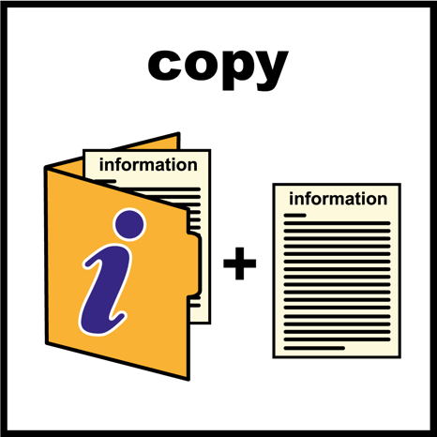  
**Copyright**   
© Copyright Women With Disabilities Australia (WWDA) Inc. 2021. All intellectual property rights, including copyright and patents, in this survey is owned and licensed by Women With Disabilities Australia Inc.

**Images**We have used images from

* ****COMPIC
* 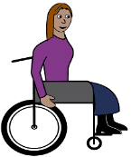Easy On The I
* Google Images
* Inspired Services
* 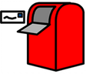Picto-Selector
* Spectronics
* The Noun Project