Women With Disabilities Australia

wwda.org.au

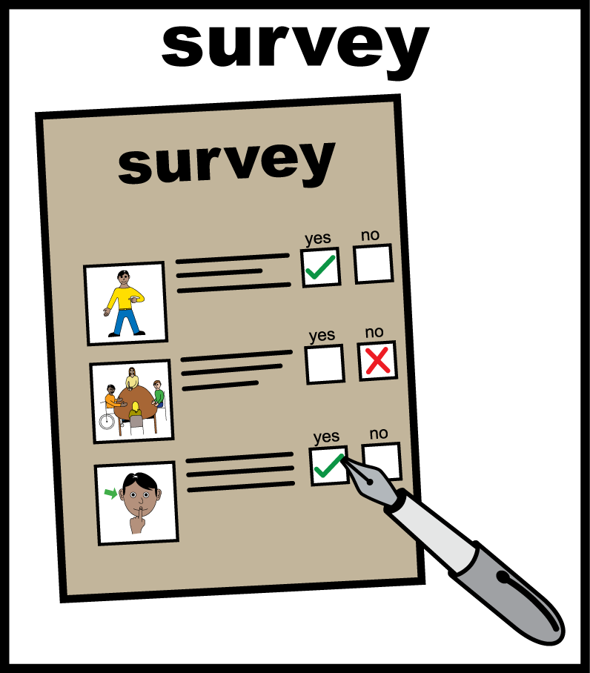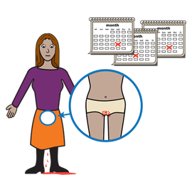**WWDA Youth Survey**

**Part 2.   
Your Period**

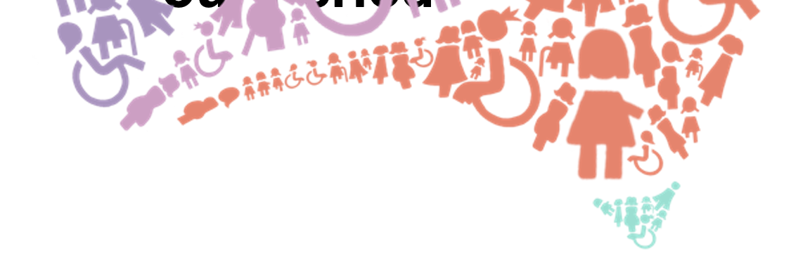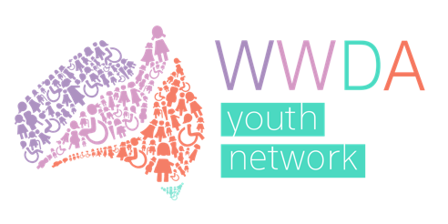

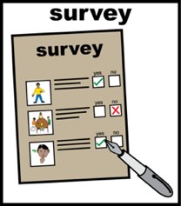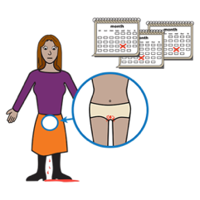**About Part 2**

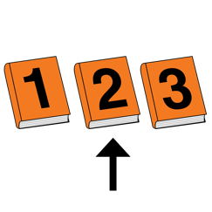  
This is **Part 2** of the WWDA Youth survey about your period and safer sex.



This part is about **your period.**

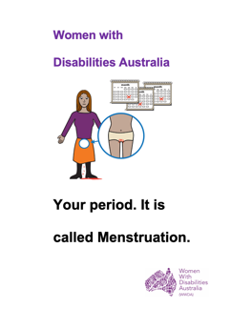Learn about **your period**.   
Read it in Easy English.

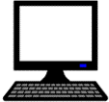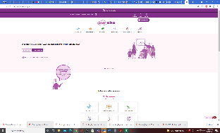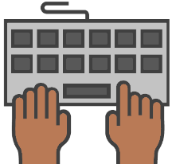

Go to **www.oursite.wwda.org.au**

Open the search window

Type **WWDA Easy English Book.**

**Your period.**

1. 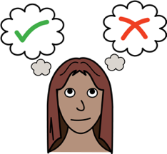**Tick the option that   
   best describes you.**

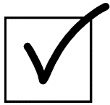

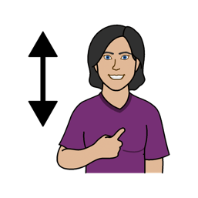



* I currently have a period

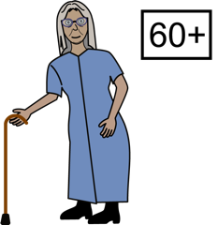

* I used to get a period

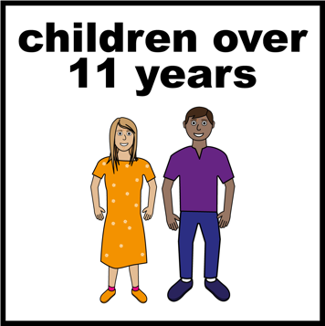

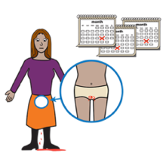

* I will have a period in the future

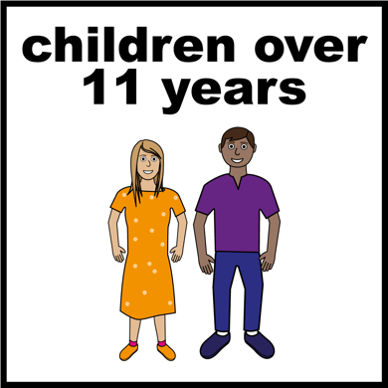



* I have never and will never have a period

1. 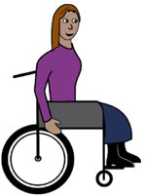**Do you have a disability that changes your period?**

Like

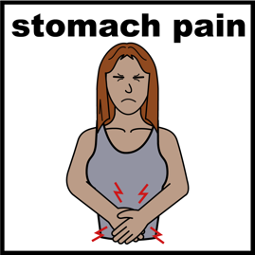

Endemetriosis is a disaility that can make periods hurt a lot.

1. 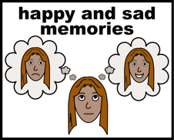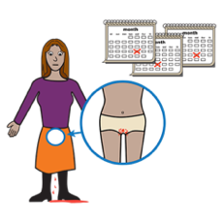**How much do you know about your period?**

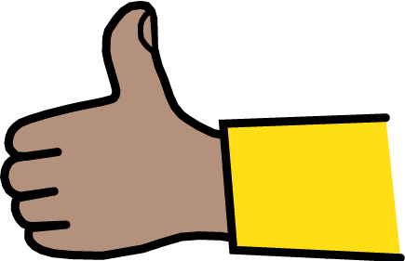

* I know a lot



* I know a little bit

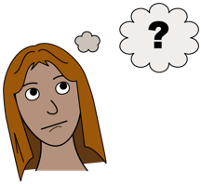

* I am not sure

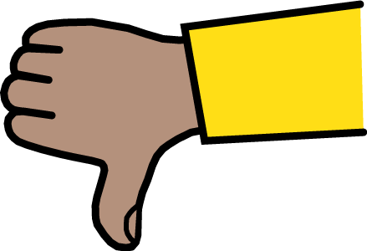

* I do not know much



* I know nothing

1. 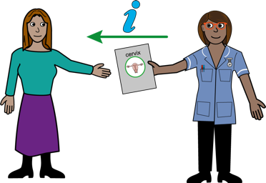**Where did you first learn about your period?**

Like

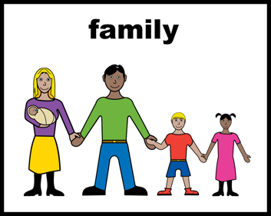

* a parent told you

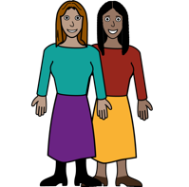

* a friend told you

****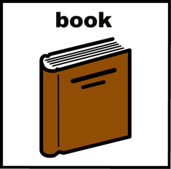

* you read a book about periods.

1. 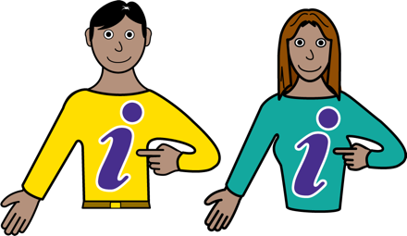**Is there any information on your period that you have found helpful?**

Like

* a book

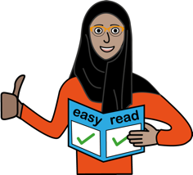

* an Easy English fact sheet

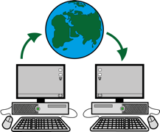]

* a website.

1. ** Is there any information on your period that you have found not helpful?**

Like

* a book



* a website.

1. ****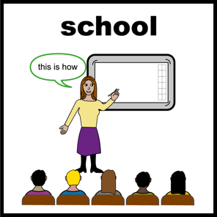**What would help you learn about periods?**

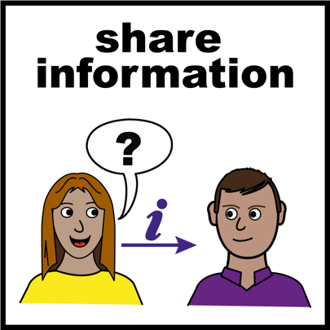  
Like

* information on different period products
* advice from older people.

1. 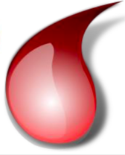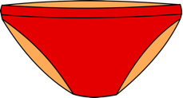**What do you wear to catch the blood when you have your period?**

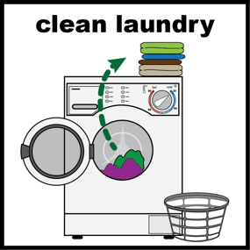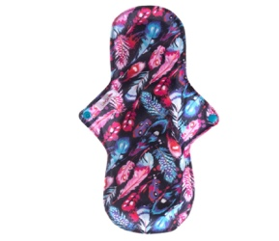

* pads that you can wash.

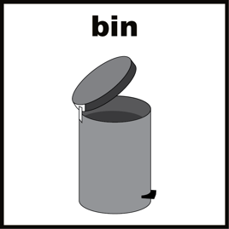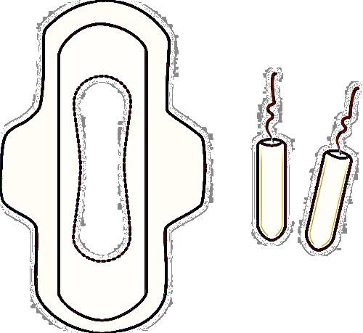

* pads you throw in the bin.

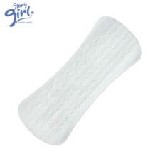

* liners

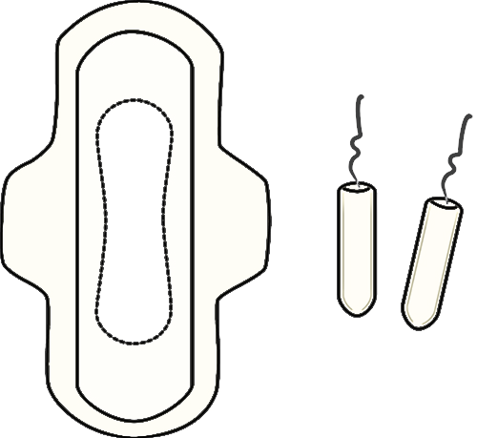

* tampons

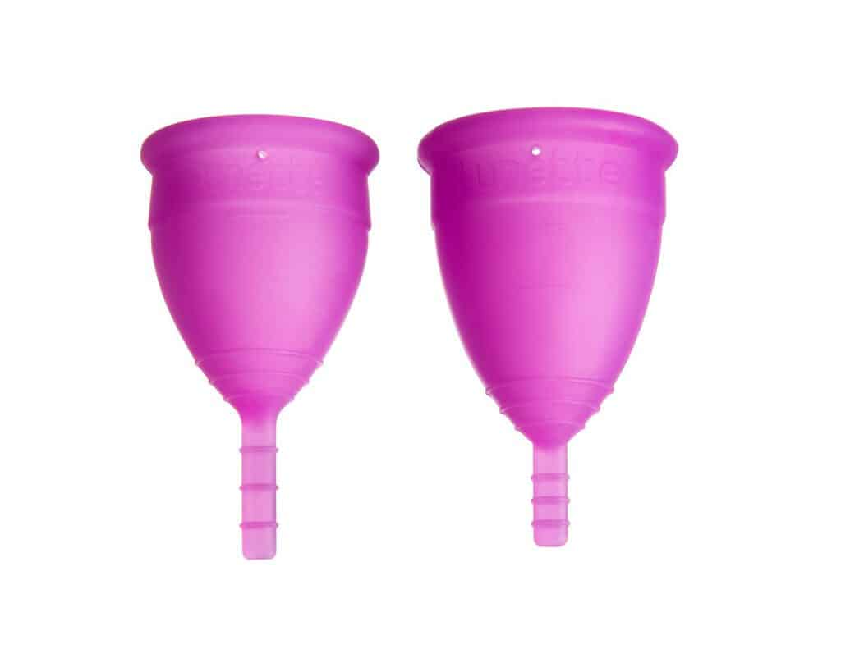

* menstrual cups

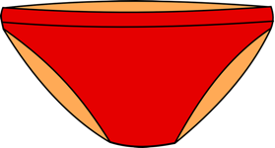

* period underwear

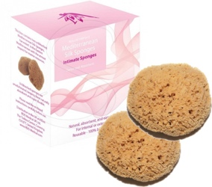

* sea sponges



* other (tell us below)

*____________________*

1. 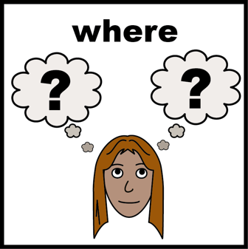**Where do you get your period products?**

* 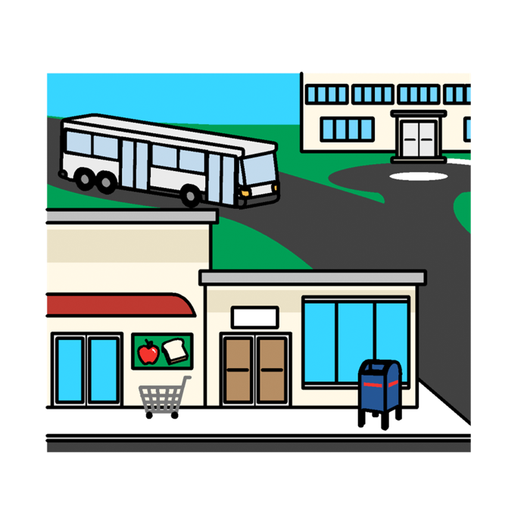a supermarket  
  Like
* Coles
* Woolworths.

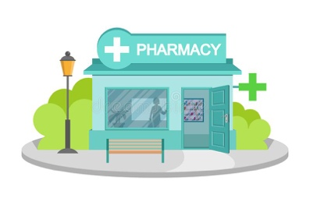

* a pharmacy or chemist

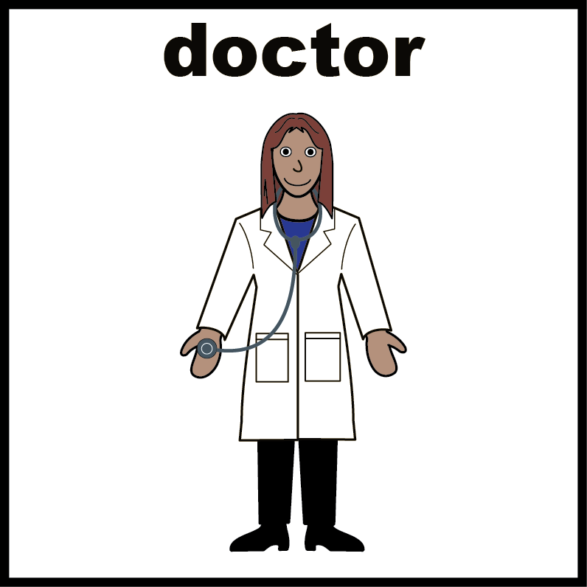

* a doctor or GP

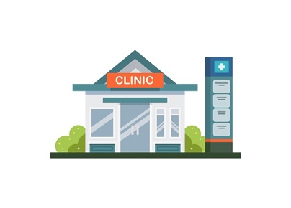

* a sexual health service

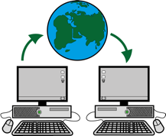

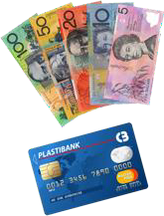

* I buy products on the internet
* 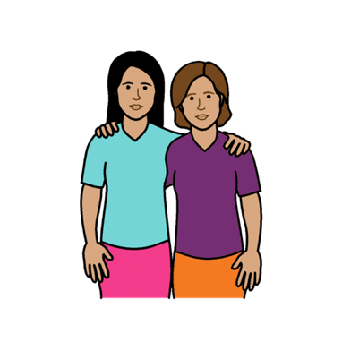I don’t know. Someone else buys them for me.  
  Like
* a parent
* a support worker.

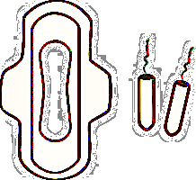

* I don’t buy period products
* ****other (tell us below)

*_____________________________*

1. 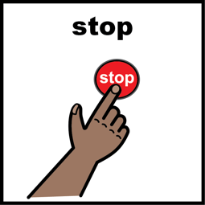**Do you use anything else to help with or stop your periods?**

Like

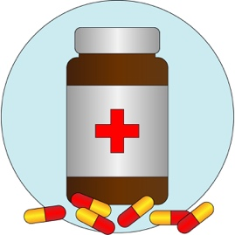

* pills to stop you bleeding

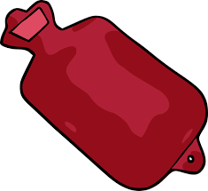

* a heat pack or hot water bottle to help with pain.

1. 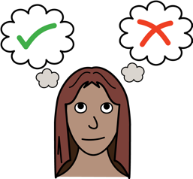**Who chooses what products or medications you use for your period?**



* me



* my mum or dad

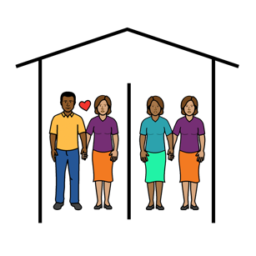

* my boyfriend or girlfriend

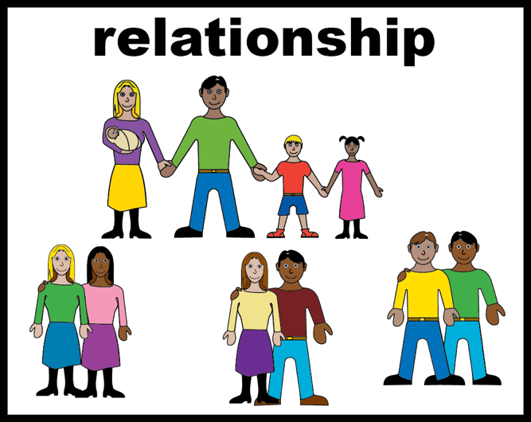

* my sister or brother

* 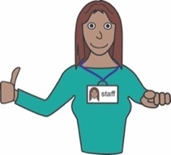my carer or support worker



* my doctor

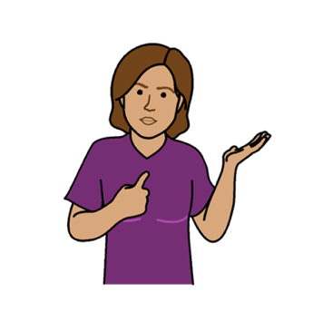

* it changes. Sometimes I choose.   
  Sometimes someone else does.



* I am not sure

* ****other (tell us below)

*__________________________*

1. 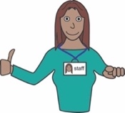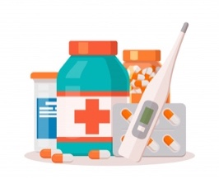**What support do you need to get or use products to help with your period?**

Like

* you need help with the cost
* you need help with putting in a tampon or pad.

1. 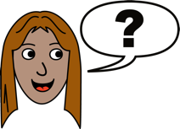**What questions about periods would you like answered?**

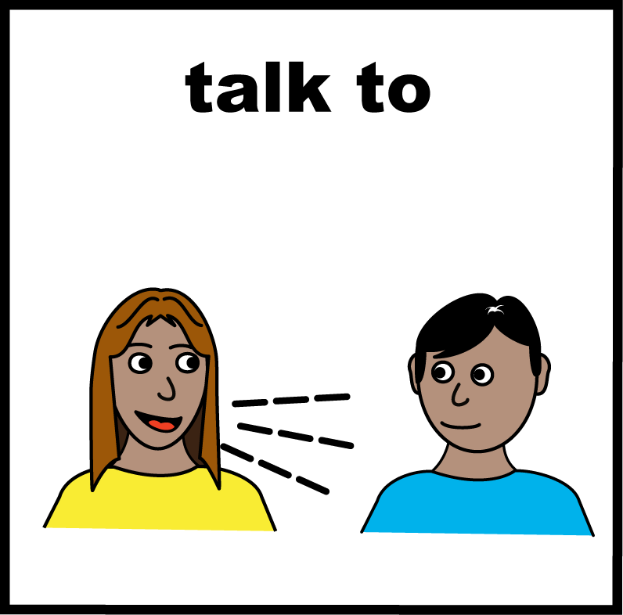

1. **Is there anything else you would like to say?**

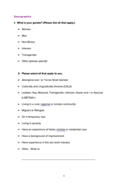 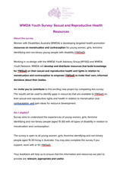**This fact sheet**

# This fact sheet is based on the WWDA Youth Survey: Sexual and Reproductive Health Resources.

# **Who wrote this survey?** Women With Disabilities Australia wrote this survey in 2021. 2021. **Copyright** © Copyright Women With Disabilities Australia (WWDA) Inc. 2021. All intellectual property rights, including copyright and patents, in this survey is owned and licensed by Women With Disabilities Australia Inc.

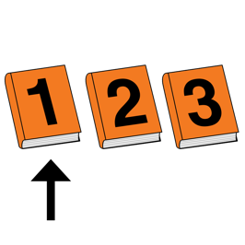**Images**We have used images from

* ****COMPIC
* 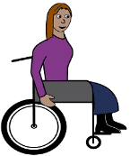Easy On The I
* Google Images
* 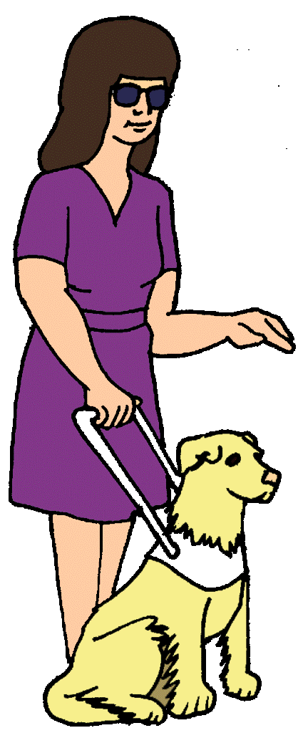Inspired Services
* 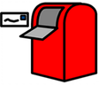Picto-Selector
* Spectronics
* The Noun Project