Women With Disabilities Australia

wwda.org.au

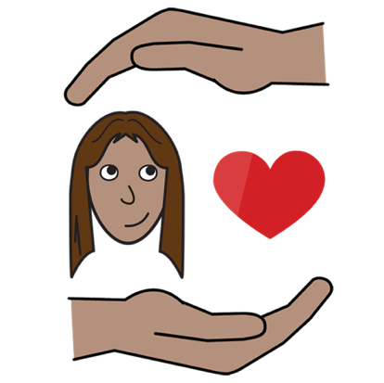**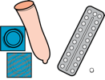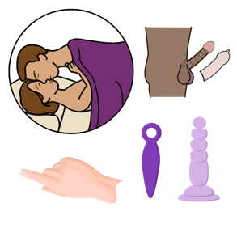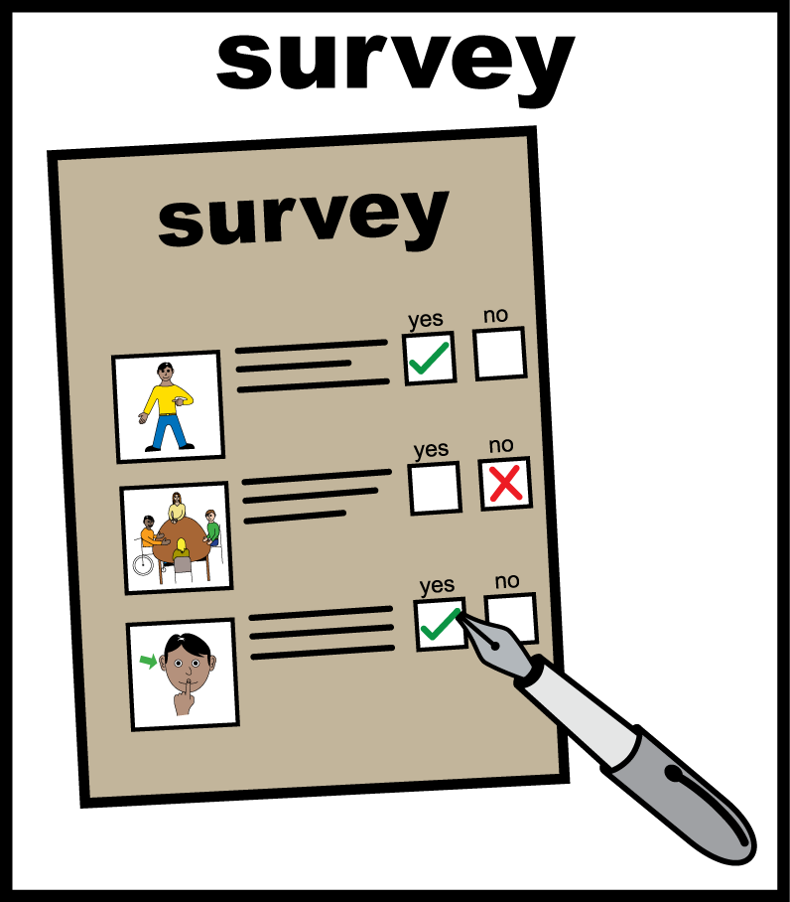WWDA Youth Survey**

**Part 3.   
Safer Sex and Contraception**

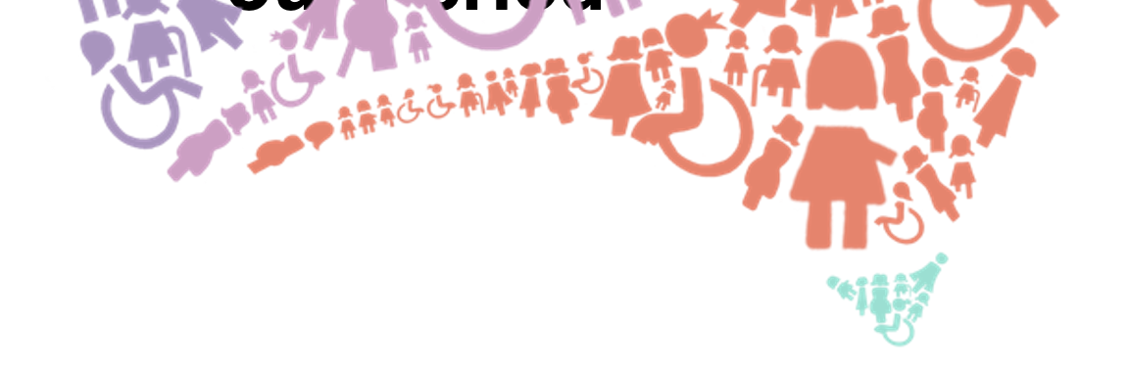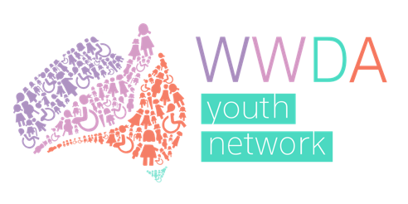

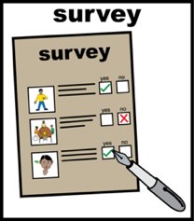**About Part 3**

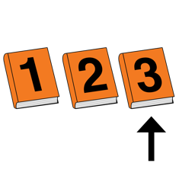  
This is **Part 3** of the WWDA Youth survey about your period and safer sex.

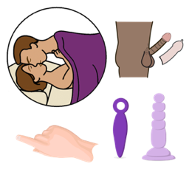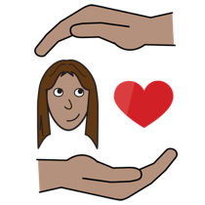

This part is about **safer sex and contraception.**

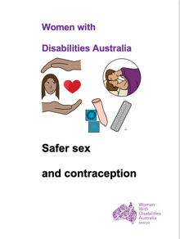

Learn about safer sex and contraception.  
Read it in Easy English.

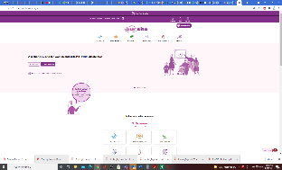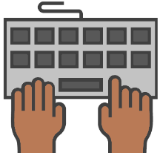

Go to **www.oursite.wwda.org.au**

Open the search window

Type **WWDA Easy English Book.**

**Safer Sex and Contraception**

1. 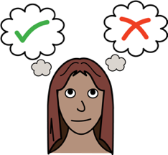**Tick the option that   
   best describes you.**



****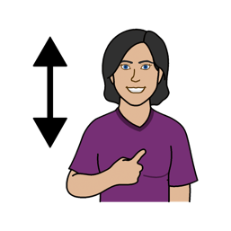

* I currently use contraception

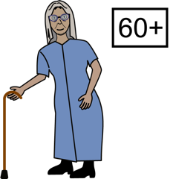



* I have used contraception in the past

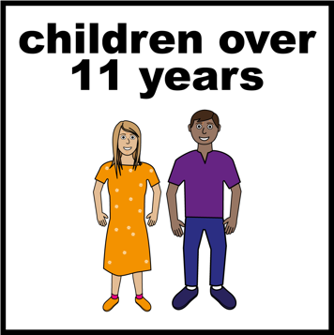



* I plan to use contraception in the future



* I have never used any form of contraception

1. ****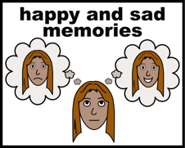**How much do you know about contraception?**



* I know a lot



* I know a little bit

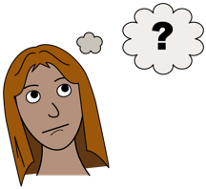

* I am not sure



* I do not know much



* I know nothing

1. **Where did you first learn about safer sex and contraception?**



Like

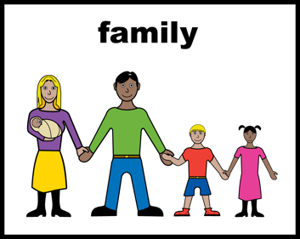

* a parent told you

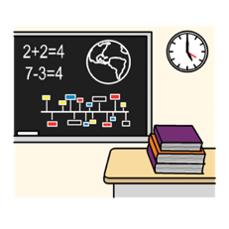

* you were told at school

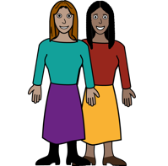

* a friend told you



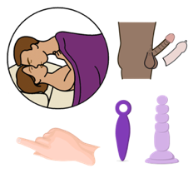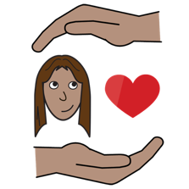

* you read a book about it.

1. 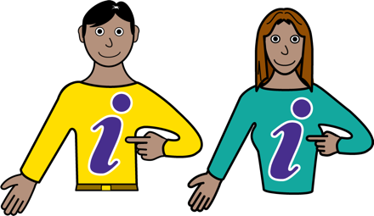 **Is there any information on safer sex and contraception that you have found helpful?**



Like

* a book

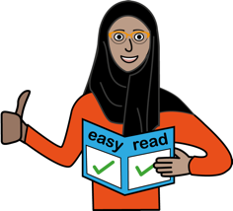

* an Easy English fact sheet

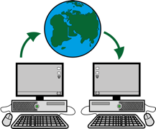

* a website.

1. 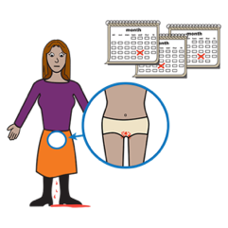**Is there any information on safer sex and contraception that you have found not helpful?**

Like

* a book



* a website.

1. 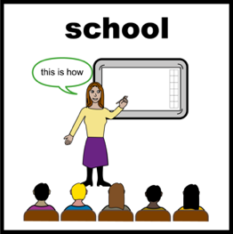**What would help you learn about safer sex and contraception?**



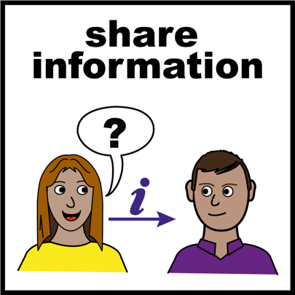  
Like

* information on different types of contraception
* advice from older people.

1. 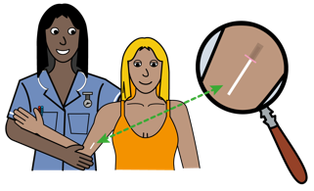**Tick any of the types   
   of contraception that you use.**



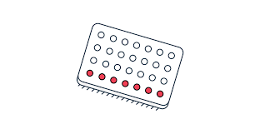

* the pill
* you take this every day.

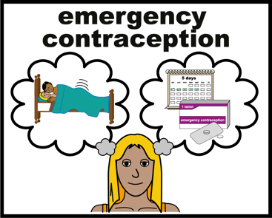

* the morning after pill  
  - after you have had unsafe sex.

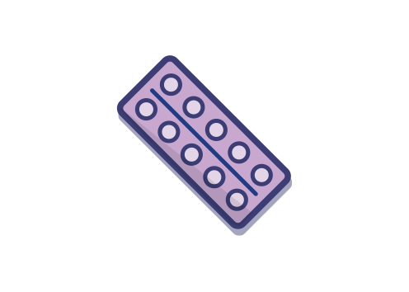

* the mini pill   
  - you take this every day.

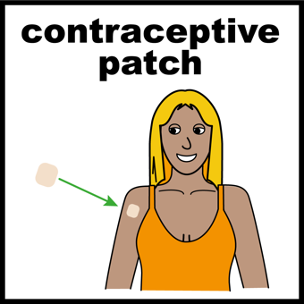

* contraceptive patch
* a patch that goes on your arm.

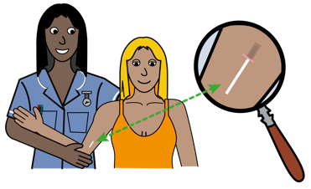

* rod or bar
* a bar that a nurse or doctor puts in your arm.

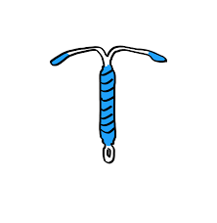

* hormonal IUD
* a doctor or nurse puts this in your vagina.
* 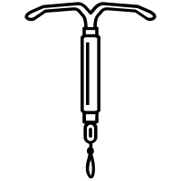copper IUD
* a doctor or nurse puts this in your vagina.

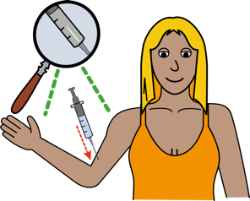

* the jab
* a needle that a doctor or nurse gives you.
* male condom
* a plastic tube you put on a penis.
* 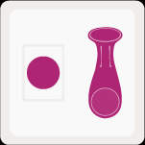female condom
* also called a dental dam
* plastic you put in a vagina.

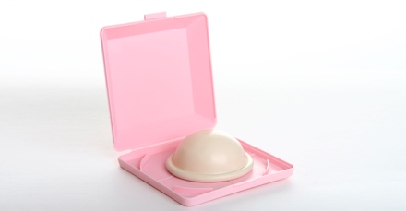

* diaphragm
* you put this in your vagina before you have sex.
* 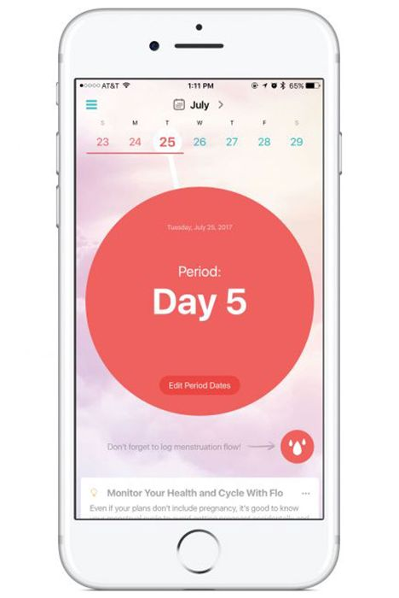period tracking
* this means you track your period
* you learn when you are most likely to get pregnant
* you do not have sex when you can get pregnant.
* 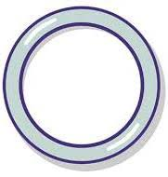vaginal ring
* a soft plastic ring that you put in your vagina
* it stays in for three weeks.

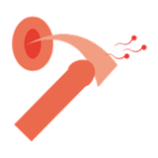

* pulling out
* this is when the penis is pulled   
  out before ejaculation
* this is to avoid pregnancy.

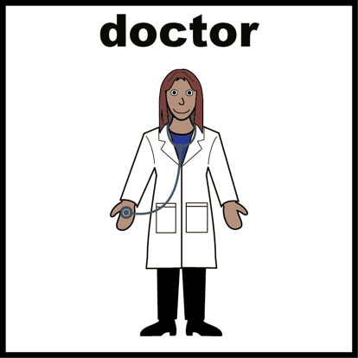

* 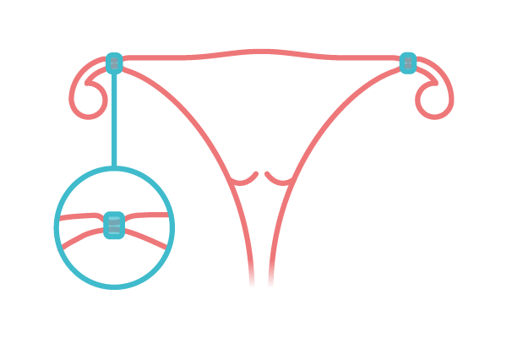sterilisation
* this means you have had an operation
* you can no longer have children.



* I do not use contraception
* ****other (tell us below)

*____________________*

1. 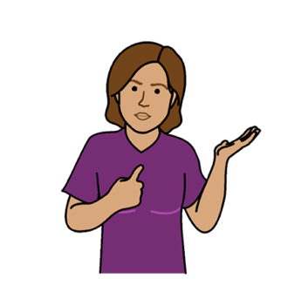**Is there a reason you use or do not use one type of contraception?**

Like



Some people do not like to use the pill.

* it makes them feel bad.

1. **If you do not use contraception.   
   Tell us why?**

****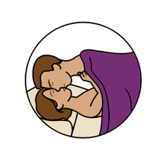

* I do not have sex right now

****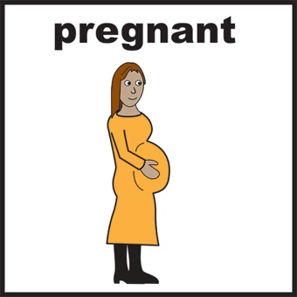

* I cannot have children

****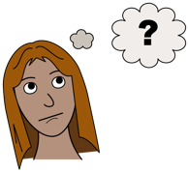

* I don’t know what my options are

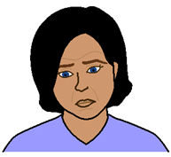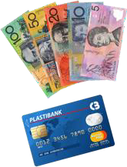

* It is too expensive

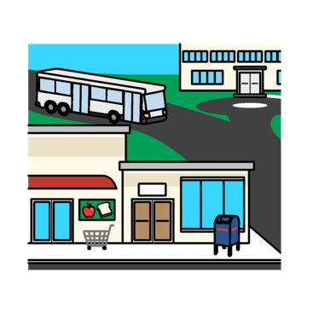

* I do not know where to get it
* 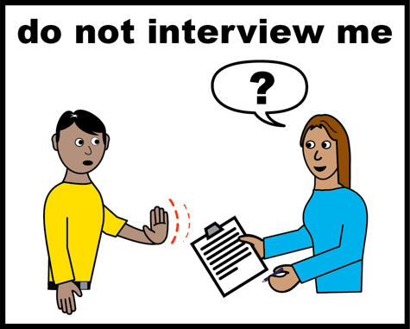someone told me not to



* I would have to hide it from my family



* I am not sure

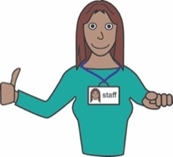

* I do not have the support I need

* I do not have the right health advice
* ****other (tell us below)

*____________________*

1. ******If you do use contraception.   
   Tell us why?**



* so I do not get pregnant

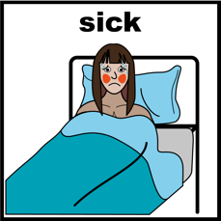

* so I do not get Sexually Transmitted Infections

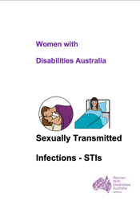

Learn about Sexually Transmitted Infections.  
Read it in Easy English.



Go to **www.oursite.wwda.org.au**

Open the search window

Type **WWDA Easy English Book.**

**Sexually Transmitted Infections - STIs**

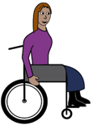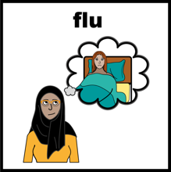

* to help with my disability or health

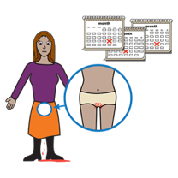

* to control or stop my period



* I am not sure



* other (tell us below)

*____________________*

1. 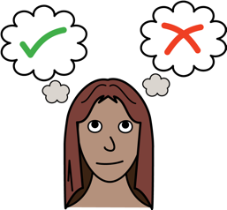**Who chooses what   
   contraception you use?**



* me



* my mum or dad

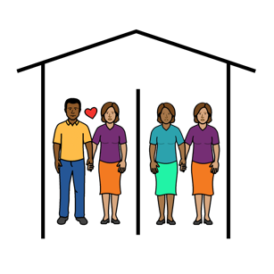

* my boyfriend or girlfriend

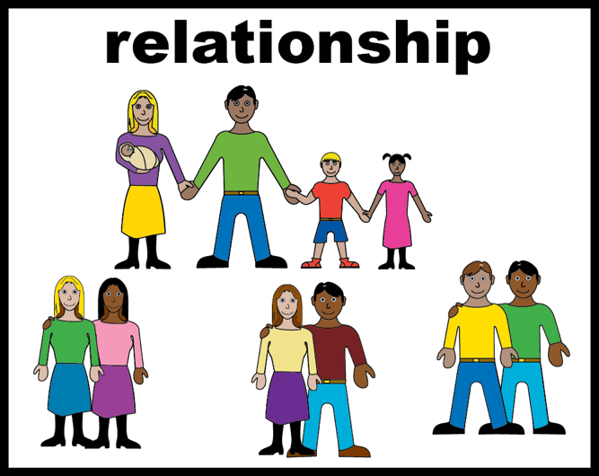

* my sister or brother

* ****my carer or support worker

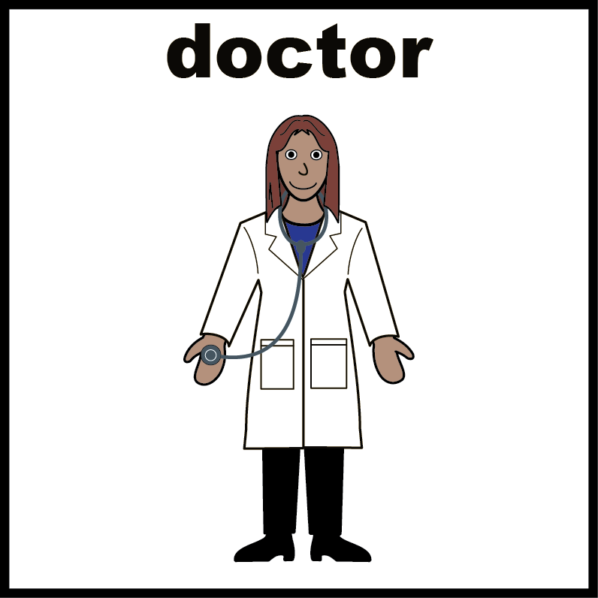

* my doctor



* it changes. Sometimes I choose.   
  Sometimes someone else does.



* I am not sure



* other (tell us below)

1. **What support do you need to get or use contraception?**

Like

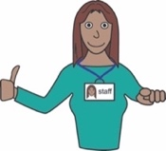

* you need help with the cost

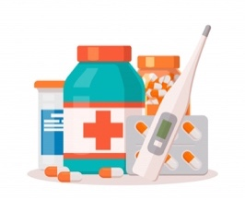

* you need help with taking medication.

1. 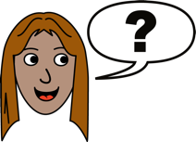**What questions about safer sex or contraception would you like answered?**

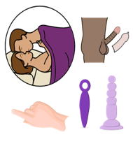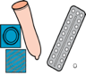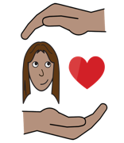

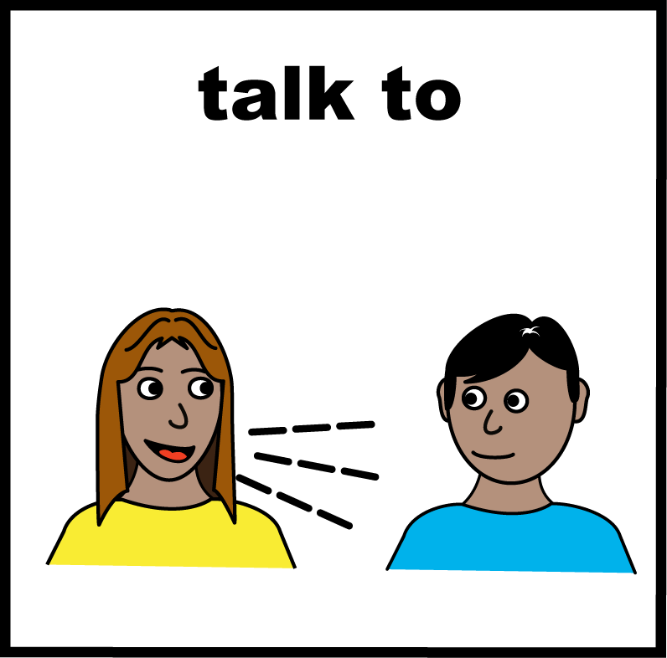

1. **Is there anything else you would like to say?**

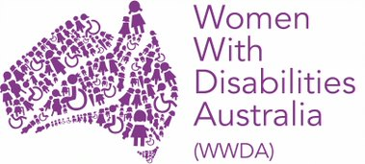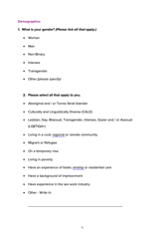**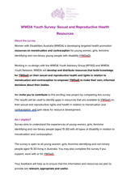This fact sheet**

# This fact sheet is based on the WWDA Youth Survey: Sexual and Reproductive Health Resources. **Who wrote this survey?** Women With Disabilities Australia wrote this survey in 2021. 2021.

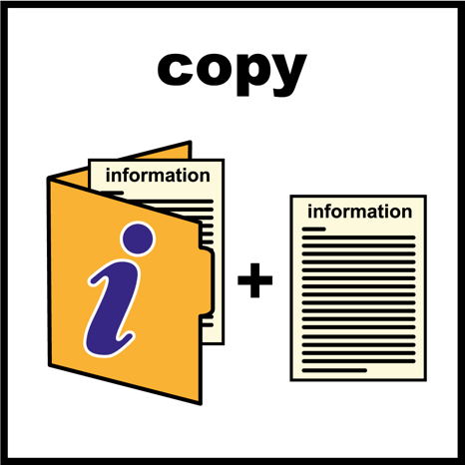  
**Copyright**   
© Copyright Women With Disabilities Australia (WWDA) Inc. 2021. All intellectual property rights, including copyright and patents, in this survey is owned and licensed by Women With Disabilities Australia Inc.

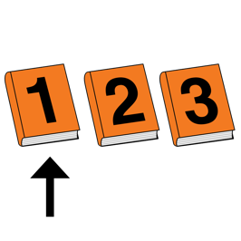**Images**We have used images from

* ****COMPIC
* 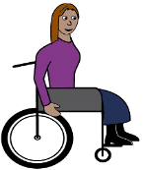Easy On The I
* Google Images
* 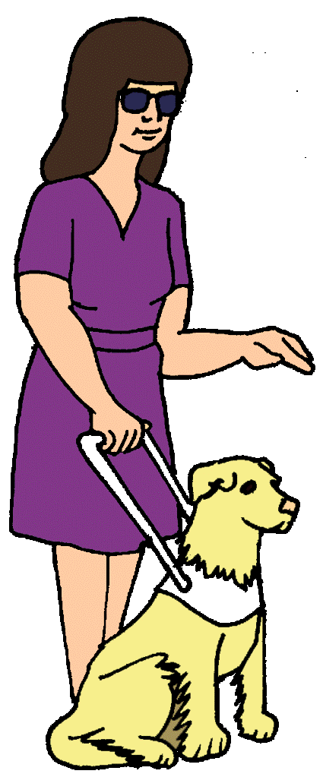Inspired Services
* 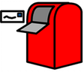Picto-Selector
* Spectronics
* The Noun Project