Women With Disabilities Australia
wwda.org.au
Women With
Disabilities Australia
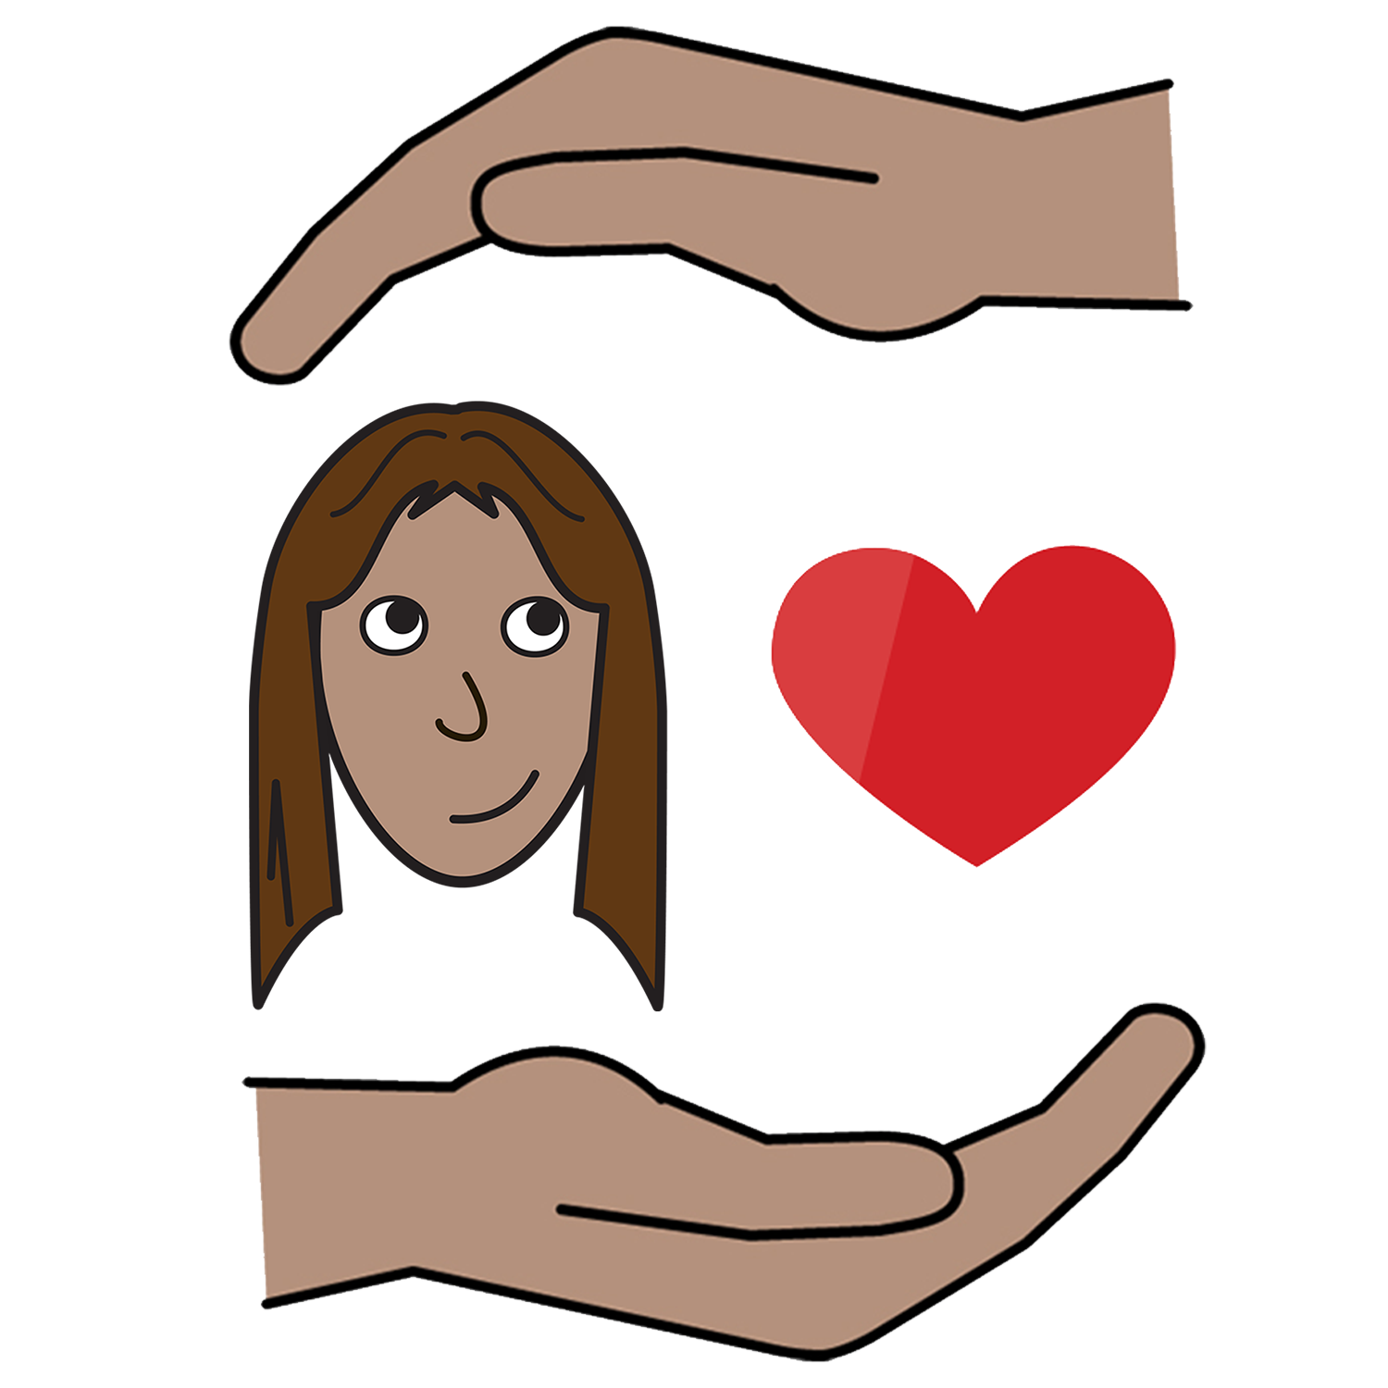

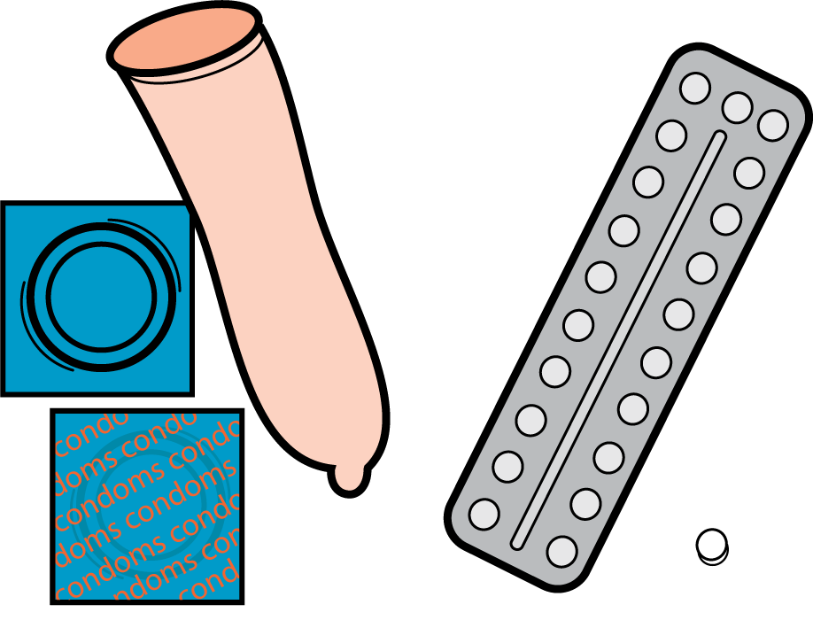

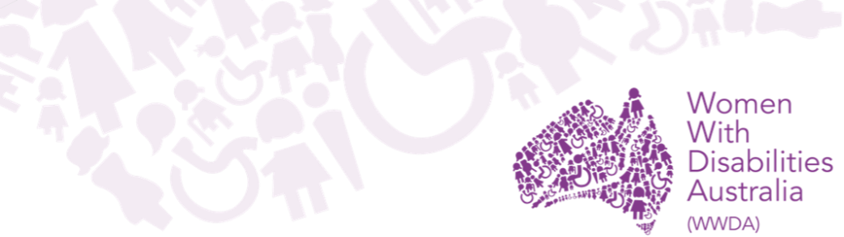
Safer sex
and contraception

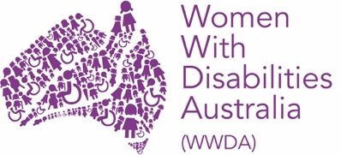
We are Women With Disabilities Australia.

This book is about safer sex and contraception.

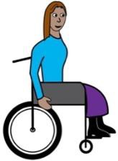

We wrote this book for women and girls with disability.

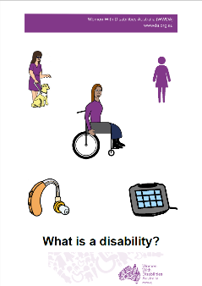
Do you think you have a disability?
Find out more. Read it in Easy English.

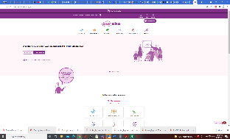
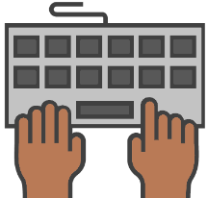
Go to www.oursite.wwda.org.au
Open the search window
Type WWDA Easy English Book.
What is a Disability?

Safer Sex
Safer sex is sometimes called safe sex.

Safer sex is things you do to:

- stay well when you have sex

- only get pregnant when you want to

- feel safe when you have sex
and
- feel happy when you have sex.

Condoms
Condoms help you have safer sex.
They are called contraception.

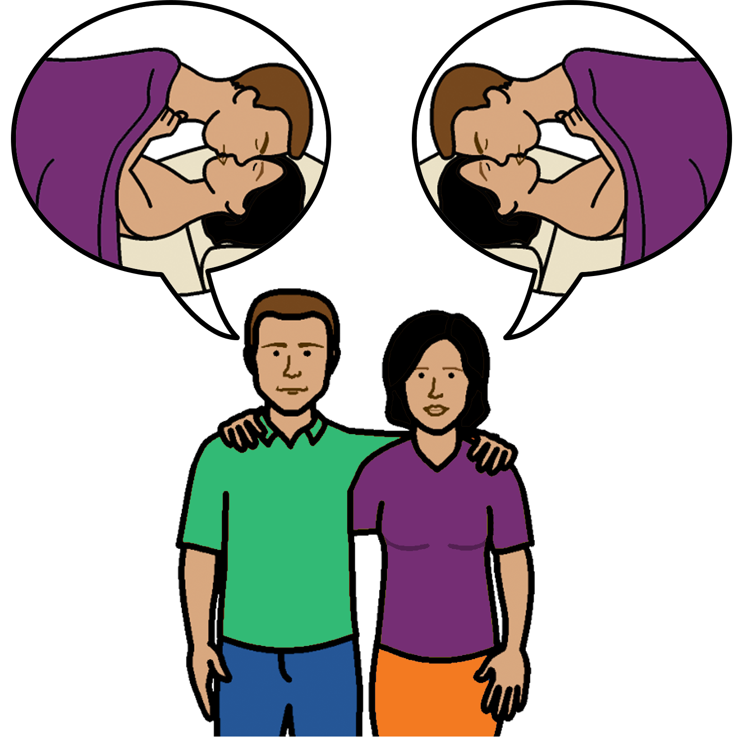

There are condoms for men and women

Condoms can help to stop you

- get pregnant

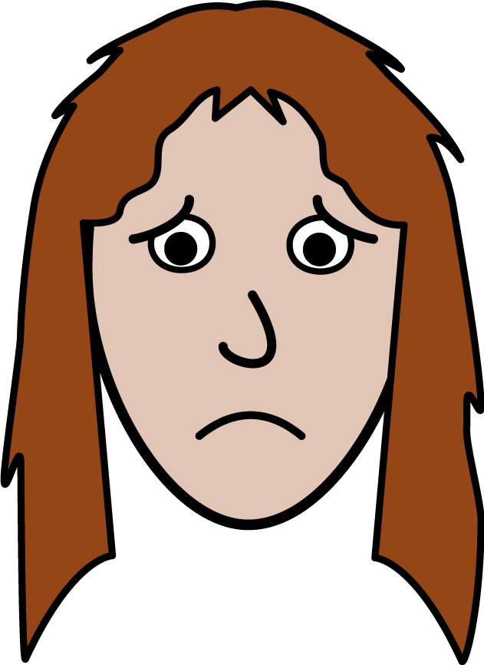

- get sick.

How to use condoms

Put a condom on before you have sex.

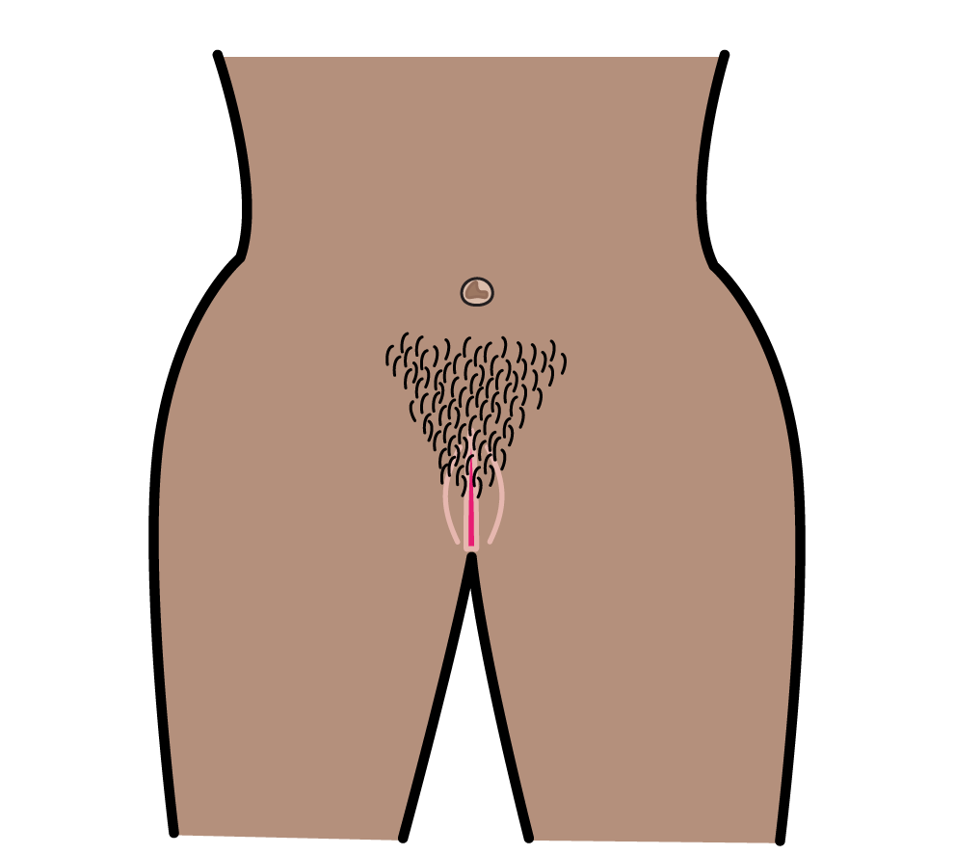
It means before you put:
- a penis in a vagina

or

- a penis in a bottom

or

- a vagina touches another vagina.

Put a condom on a penis when it is hard.
You unroll the condom on to a penis.
The packet of condoms may have pictures to show you how.

or
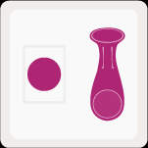
Put a condom in to a vagina.

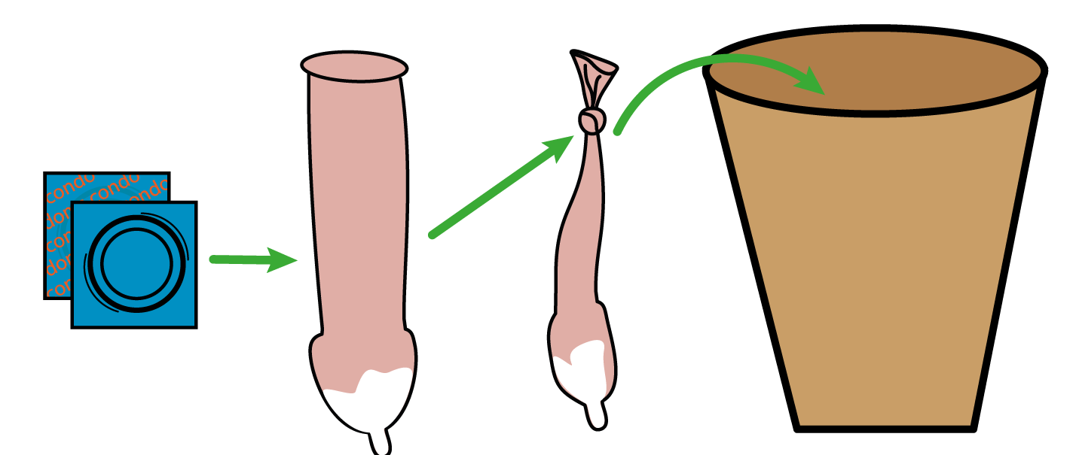
You must use a condom 1 time only.
You need a new condom every time you have sex.
Put the used condom in the bin.

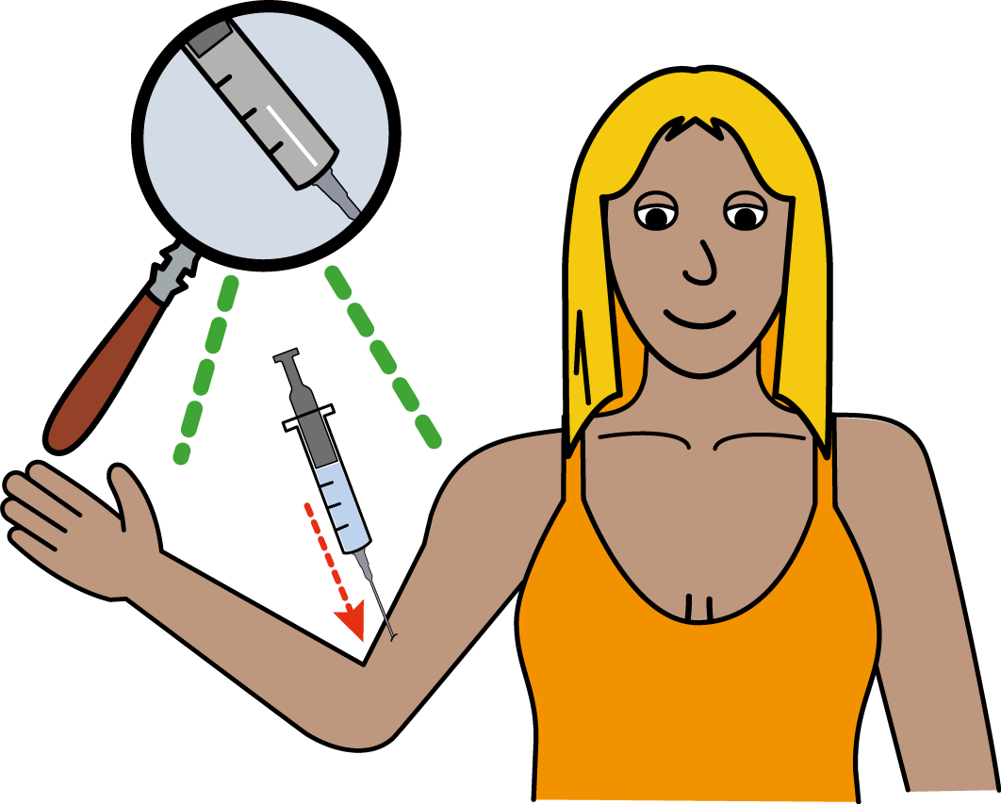
Other things to have Safer Sex.
You can use other things to have safer sex.
These things are also contraception.

You can use a condom and these things at the same time. Some things you can use are

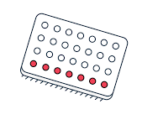
- the pill
- you take this every day.

- the mini pill
- you take this every day.
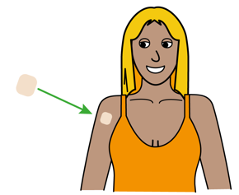
- contraceptive patch
- a patch that goes on your arm.
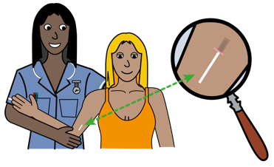
- rod or bar
- a bar that a nurse or doctor puts in your arm.
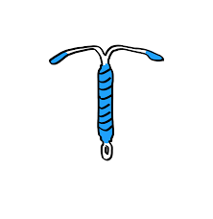
- hormonal IUD
- a doctor or nurse puts this in your vagina.

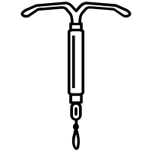
- copper IUD
- a doctor or nurse puts this in your vagina.

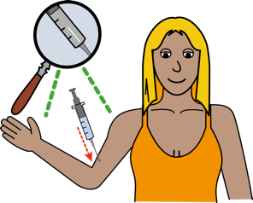
- the jab
- a needle that a doctor or nurse gives you.

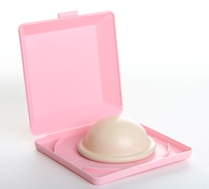
- diaphragm
- you put this in your vagina before you have sex.

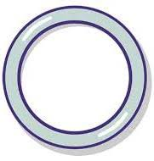
- vaginal ring
- a soft plastic ring that you put in your vagina
- it stays in for three weeks.

Talk to your doctor about which option is best for you.
After unsafe sex
Sometimes you might have unsafe sex.
This means sex without contraception.

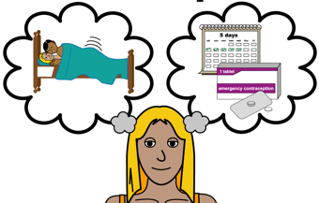
You can use emergency contraception.
It is called the morning after pill.

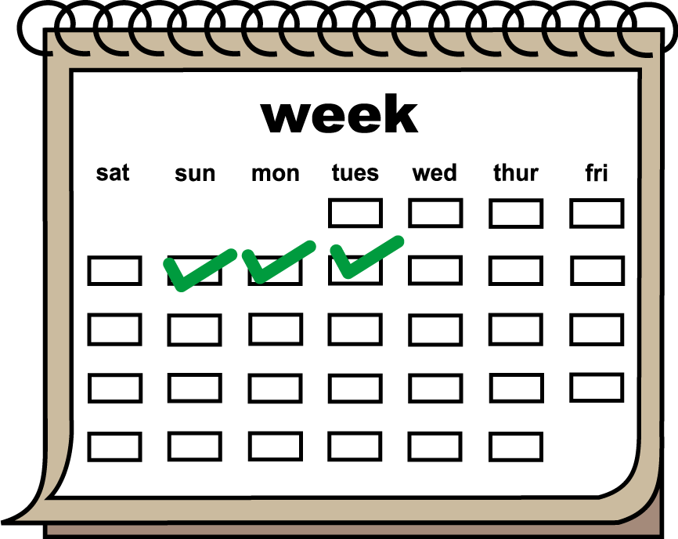
You must take the morning after pill within 72 hours after unsafe sex.
This is 3 days.

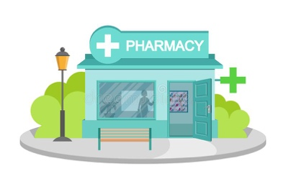
You can get the morning after pill from
a pharmacy or chemist.

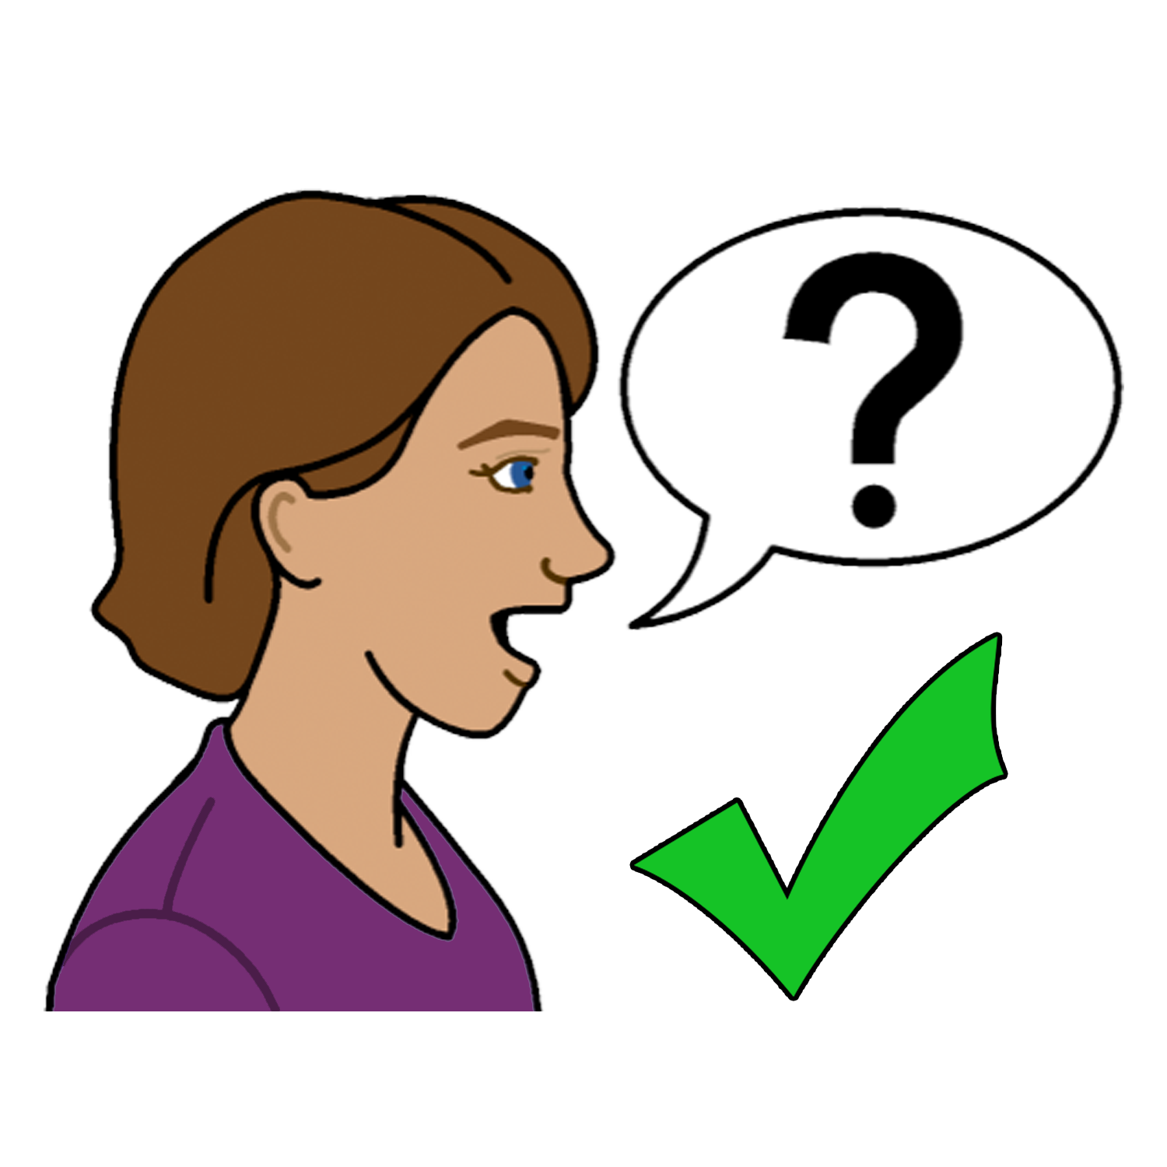
Learn more about emergency contraception

Some people cannot take the morning after pill.

To find out if the morning after pill is good for you.

You can

- talk to your doctor

- talk to a pharmacy

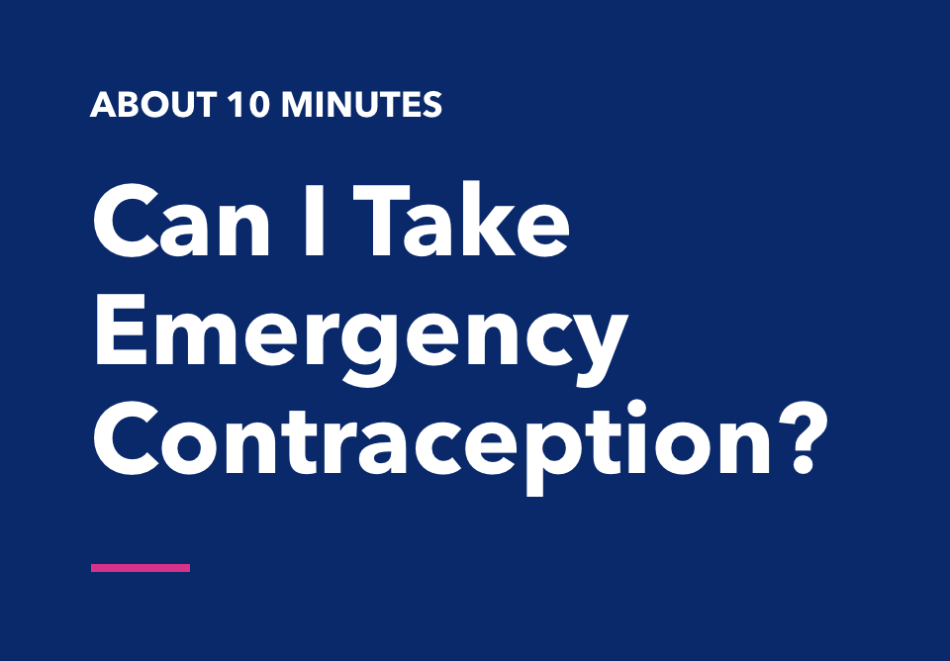
- Do a test on the Planned Parenthood website
https://www.plannedparenthood.org/online-tools/emergency-contraception
How to feel safe

Safer Sex also means

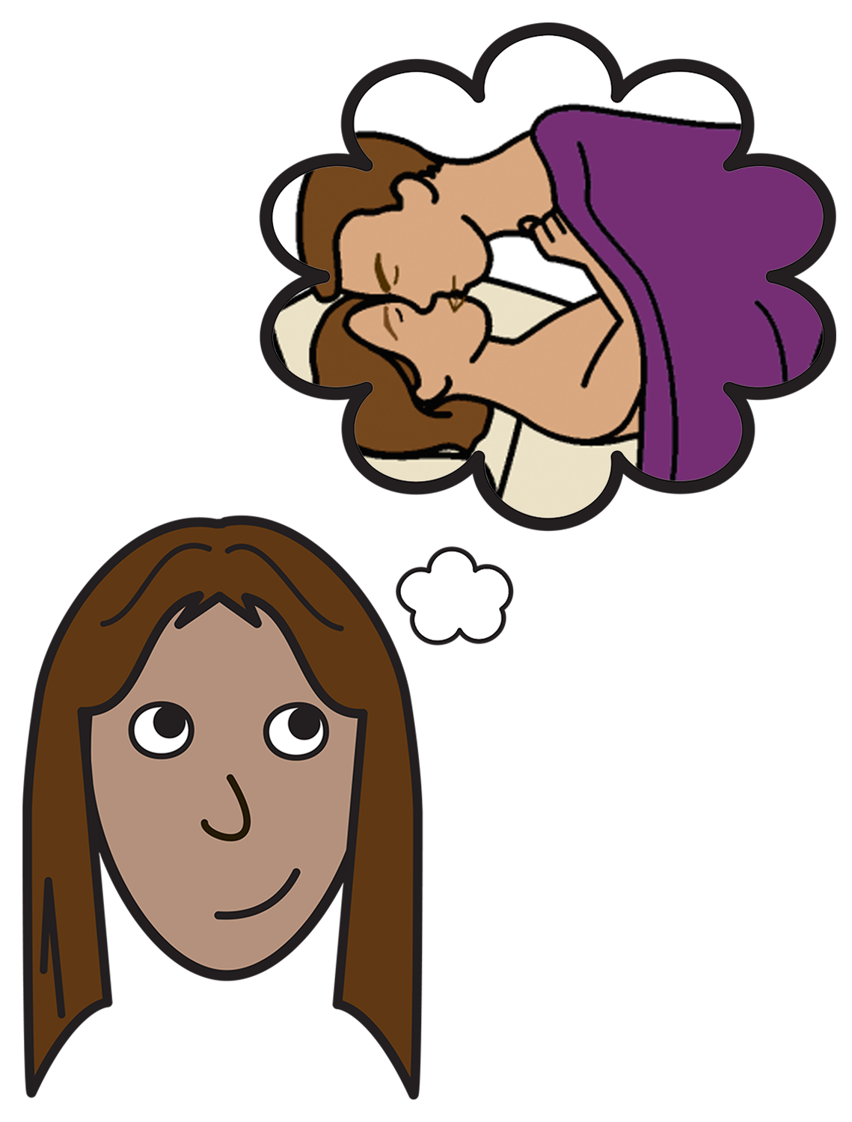

- you have sex when you want to

- the other person respects you and listens to you

- you feel good about the sex.

To find out more
Talk to someone you trust.
Like

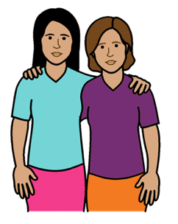
- a friend
- a family member

- your doctor

- your local Family Planning Service.
Go to www.familyplanningallianceaustralia.org.au/services

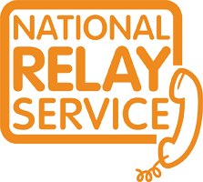
You can use the National Relay Service
when you call a service
Call: ………….. 1800 555 677
TTY: …………. 133 677

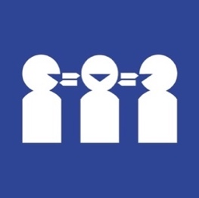

Need a translator
Call ………….. 131 450

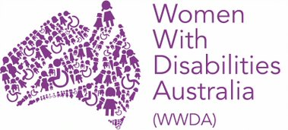
Who wrote this fact sheet?
Women With Disabilities Australia wrote this fact sheet in 2019-2020.
Copyright
© Copyright Women With Disabilities Australia (WWDA) Inc. 2020. All intellectual property rights, including copyright and patents, in this survey is owned and licensed by Women With Disabilities Australia Inc.
Images
We have used images from
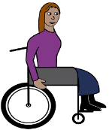
- COMPIC
- Easy On The I
- Google Images

